Report for M4 – Virtualization 1

**Group Members**

**-------------------------------------------------**

**Sing Hong, Qing Ling, Adam, Ray**

Content

* Proposal
* Member Roles
* Timeline
* Pros and Cons of Virtualization Infrastructure
* Topology (Existing)
* Resource Allocation (Physical)
* Configuring of Virtualized Infrastructure
* Topology (New)
* Resource Allocation (Logical)
* Configuring of User Account
* User Account After VCSA is Installed
* Backup & Recovery Procedure
* Backing up of Hypervisor
* Alert Threshold
* Resource Allocation & Sever Roles
* Costs

Proposal (New Virtualized Infrastructure)

The implementation of our new virtualized infrastructure is more physically secured as compared to the existing infrastructure due to the virtual routers connected in the topology below. Remote desktop protocol is also implemented to allow clients to access to the customer relationship manager program. There are also accounts being added with permissions to allow access. Storage systems are modified to be able to withstand the growth of 100 to 400 users within the next three years. The infrastructure that we proposed are built to assist the company to manage the server easily through VCSA which allows all 3 branches to access. Lastly, the baseline for the systems and CPUs have been configured and set to run at 60% performance.

Member Roles

**Sing Hong** – Group leader & System engineer

**Qing Ling** –Solution architect & Storage engineer

**Adam** – Storage manager & Storage Engineer

**Ray** – Test engineer

Timeline

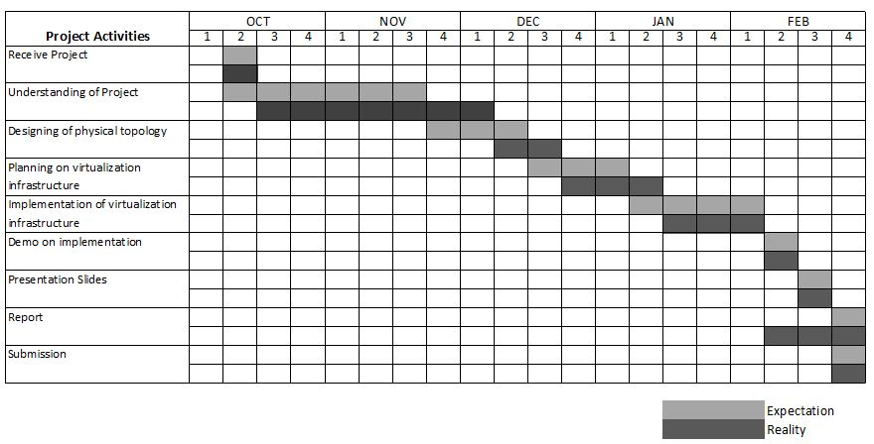

Pros & Cons of using Virtualization

Pros

* Reduced IT Costs
* Efficient Resource Utilization
* Helps with Development
* Faster Deployment
* Promotes Greater Redundancy

Cons

* Hefty Upfront Costs
* Not Compatible with All Hardware and Software
* Puts Data at Risk
* Security Flaws
* Danger of Server Sprawl

Topology

**Existing Physical Infrastructure**

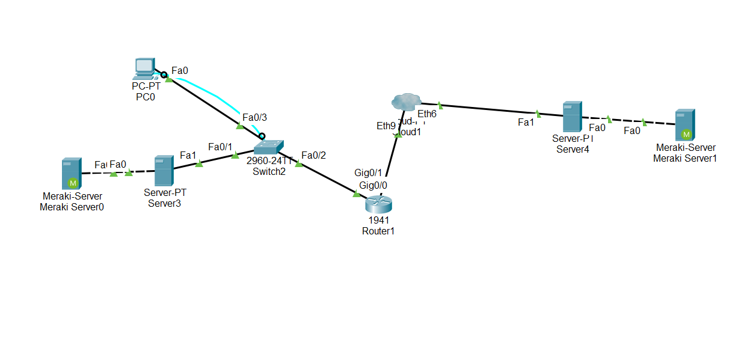

Allocation of CPU, RAM & Storage (Physical)

|  |  |  |  |
| --- | --- | --- | --- |
| Servers | CPU | RAM | Storage |
| EXSI 6.0 | 2 cores | 8GB | 120GB |
| NAS | 2 cores | 8 GB | 1TB |
| EXSI 6.0 | 2 cores | 10GB | 120GB |
| Win 7 | 2cores | 8GB | 100GB |
| Win 10 | 2 cores | 8GB | 100GB |

Configuring of Virtualized Infrastructure

We have decided to use virtual routers as it is able to connect all the servers through high-speed internet via VPN. Routers are also being configured to provide redundancy to mitigate the chances of reliability issues. Other than using virtual routers, we have set the time zones to be synced for the network time protocol so that the graphs and alerts are sent accurately. Virtual machines connectivity are assigned using ICMP, which are located in Singapore’s ESXi to allow each other to ping whilst all 3 branches would be connected at the same time.

Topology of New Virtualized Infrastructure

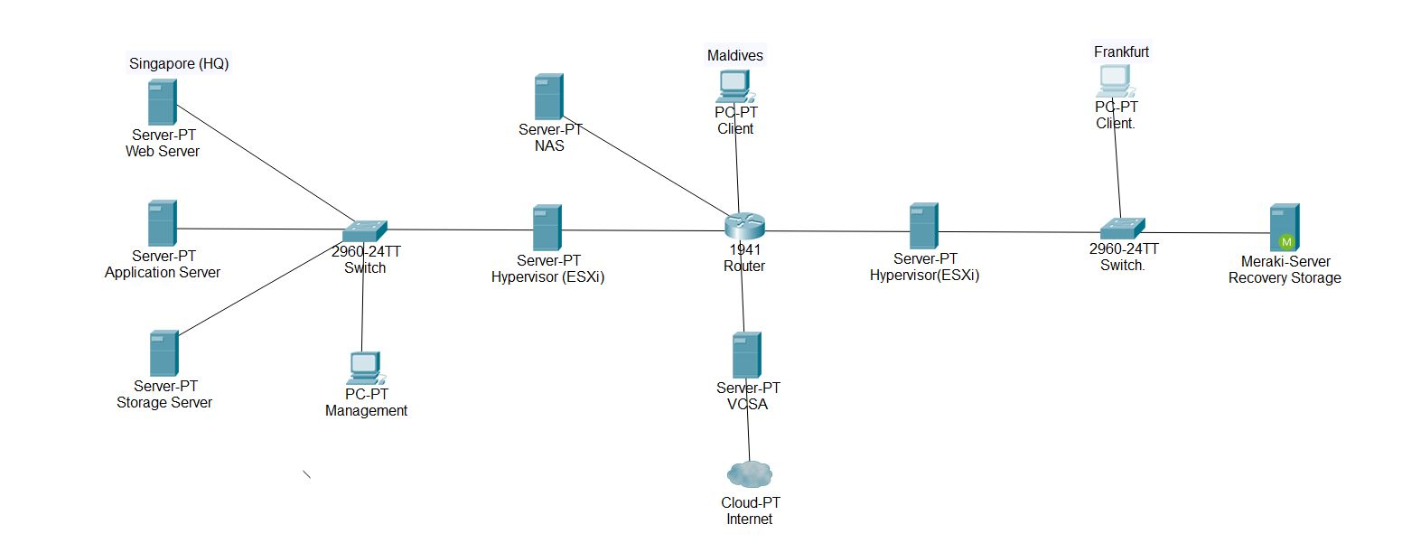

Allocation of CPU, RAM & Storage (Logical)

|  |  |  |  |
| --- | --- | --- | --- |
| VCSA | 2 cores | 8GB | 120GB |
| Storage Server | 2 cores | 8 GB | 1TB |
| Application Server | 4 cores | 16GB | 120GB |
| Web Server | 2 cores | 16GB | 120GB |
| Recovery Storage | 8 cores | 10GB | 1TB |
| PC Client | 2 cores | 8GB | 40GB |
| PC Client | 2 cores | 8GB | 40GB |

|  |  |  |  |
| --- | --- | --- | --- |
| vSphere Web Client | --- | --- | --- |

Configuring of User Account

Accounts will be configured after we have installed VCSA (vCenter Server Appliance). Various content could be installed into different groups which gives them the rights, e.g. creating Hypervisor and Hypervisor manager. Accounts are created with appropriate access for authorized users to be able to access VCSA and complete certain tasks.

User Account After VCSA is Installed

|  |  |
| --- | --- |
| **Accounts** | Roles of the accounts |
| **Administrator (Hypervisor)** | Administrator to manage all the ESXI |
| **Root (Hypervisor)** | Root is to only manage a specific ESXI |
| **User 1** | Administrator for VCSA |
| **User 2** | For operating of VCSA |
| **User 3** | As the user of VCSA but cannot execute or change anything in it |
| **Storage** | To manage the storage server |
| **Backup** | To manage the backup server |
| **Administrator (Management)** | To manage the management |

Configuration of Backup & Recovery Procedure

We have decided to use vMotion to move and migrate the Virtual Machines to the other hypervisor. As vMotion can migrate servers from an ESXi to another in the fastest time possible reducing downtime and allow the company to continue functioning as per normal. Recovery storage is also being verified to perform perfectly through live migration and just to be sure, backup will be made and cloned to ensure nothing would be missing and can be recovered if any errors were to occur while testing the system out.

Backing Up Hypervisor

We have also decided to use a template for the backup and recovering of the systems as it is able to be cloned out and use as backup if anything were to happen. As for why we feel that the template is also a good backup due to it being easily movable (E.G. to Frankfurt or Maldives) in order to change and manage the server. Why we think that this is the best option is due to its slow recovery timestamp. However, it is the safer way to as it can be cloned and saved to multiple places, this is why we feel that if we could use this as a backup for when the Vmotion fails it can still help the company get back the information that is lost and can recover the information back properly.

Configuring of Alert Threshold

We are going to configure alert thresholds by setting up of the alarm systems to monitor the CPU and Ram of the virtual machines. If the alarm triggers for the CPU usage, an email will be sent directly to the administrator to alert them of over usage. We will monitor the system utilization to ensure that the baseline would be kept at 60%. We will be testing the alarms out just to ensure it is being executed and accurately without having any errors while having the time synchronized with the Network Time Protocol for it to have an accurate reading to trigger the alarm.

Alerts for threshold

|  |  |  |
| --- | --- | --- |
| Monitoring of servers | CPU | RAM |
| web | 60% | 60% |
| storage | 60% | 60% |
| application | 60% | 60% |

**Monitoring of baseline**

**Triggering of alerts**

|  |  |  |  |  |
| --- | --- | --- | --- | --- |
| Server | Type | Warning | Alert | Remarks |
| Application | CPU | 75% | 85% | Alerts host when it is at 85% |
| Storage | CPU | 80% | 85% | Alerts host when it is at 85% |
| Web | RAM | 70% | 80% | Alerts host when it is at 80% |

Resource Allocation & Server Roles

|  |  |
| --- | --- |
| Server Hostname | IP Address |
| Web Server | 192.168.18.100 |
| Application server | 192.168.1.101 |
| Storage server | 192.168.1.102 |
| Recovery Storage | 192.168.1.103 |
| ESXI (Singapore) | 192.168.1.125 |
| ESXI (Frankfurt) | 192.168.1.128 |
| VCSA | 192.168.1.130 |
| Management | 192.168.1.129 |
| NAS Server | 192.168.1.127 |
| Client (Maldives) | 192.168.1.126 |
| Client (Frankfurt) | 192.168.1.124 |

Cost

|  |  |
| --- | --- |
| Hardware | Cost |
| CPU x12 ($1000 each) | $12,000.00 |
| ESXi x2 ($9548 each) | $19,096.00 |
| Total Cost of Hardware | $31,096.00 |

|  |  |
| --- | --- |
| Software | Cost |
| Windows 10 Enterprise | $724.00 |
| Windows 7 Professional | $98.00 |
| vSphere Client | $995 per annum |
| vCenter Server | $24,250 |
| Perimeter 81 VPN enterprise | $16,000 |

End of Report