**LAB NOTE**

**Subject: Digital Design Principles**

**Topic: And Gate**

**Student: Minh Quan Tran**

**May 22th, 2024**

Table of Contents

1. Objectives 4

2. Theory 5

2.1 Theory 5

2.2 Truth table 5

2.3 Boolean expression 5

3. VHDL and Verilog 6

3.1 VHDL code 6

3.2 Verilog code 6

4. Pin Planner 17

4.1 Input and Output 17

5. Result 1

**TABLE OF FIGURES**

Figure 2‑1: And Gate 5

Figure 4‑1: SCEMA5F31C6N board 17

Figure 4‑2: SW0 and SW1 Pin No 17

Figure 4‑3: LEDR0's Pin No 17

Figure 4‑4: Quartus's Pin Planner 17

**~~~~~~~~~~~~~~~~~~~~~~~~~~~~~~~~~~~~~~~~~~~~~~~~~~~~~~~~**

**TABLE’S OF TABLE**

Table 2‑1: Truth table for And Gate 5

# Objectives

* To be familiar with Quartus.
* To write a VHDL and Verilog code for And Gate.
* Push the code to SCEMA5F31C6N board.

# Theory

## Theory

AND gate is a simple gate that has 2 inputs and 1 output. The outputs will be true (1) only if all its inputs are true (1).

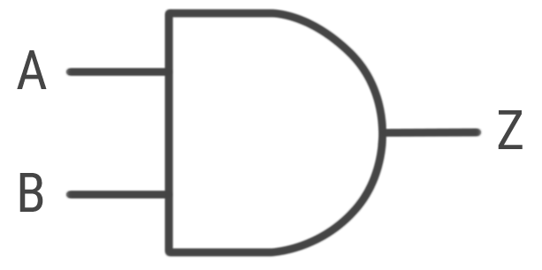

Figure 2‑1: And Gate

## Truth table

|  |  |  |
| --- | --- | --- |
| **A** | **B** | **Y** |
| 0 | 0 | 0 |
| 0 | 1 | 0 |
| 1 | 0 | 0 |
| 1 | 1 | 1 |

Table 2‑1: Truth table for And Gate

## Boolean expression

$$Y=A∙B$$

# VHDL and Verilog

## VHDL code

library ieee;

use ieee.std_logic_1164.all; --should be same through all the lab, except comparator.

-- declaring input and output

entity MTran_Lab1_VHDL_AndGate is

port

-- a,b are SW1 and SW2, output is LEDR0

(

a, b : in std_logic;

output : out std_logic --end of declaration no more ';'

);

end MTran_Lab1_VHDL_AndGate;

-- describing the relationship between output and input

architecture behavioral of MTran_Lab1_VHDL_AndGate is --'behavioral' is a block name (must not same name in library)

begin

output <= a and b; -- <=: assigning variable 'output'

end behavioral;

## Verilog code

module MTran_Lab1_Verilog_AndGate(a,b,y);

input a,b;

output y;

and (y,a,b);

endmodule

# Pin Planner

## Input and Output

Figure 4‑1: SCEMA5F31C6N board

Assigning:

a: SW0

b: SW1

output: LEDR0

From the DE1_SoC_User_Manual,

SW0: Pin_AB12

SW1: Pin_AC12

LEDR0: Pin_V6



Figure 4‑2: SW0 and SW1 Pin No



Figure 4‑3: LEDR0's Pin No

Figure 4‑4: Quartus's Pin Planner

# Result

**REFERENCES**