**ASSIGNMENT NOTE**

**Subject: Embedded Programming Principle**

**Topic: LED Flashing**

**Student: Minh Quan Tran**

**Jun 14th, 2024**

Table of Contents

1. Objectives 4

2. Requirement 5

2.1 Requirement 5

3. Hardware and Software design 6

3.1 Hardware Design 6

3.2 Software Design 6

3.2.1 Assignment design 6

3.2.2 Above and beyond 7

4. Result 9

**TABLE OF FIGURES**

Figure 3‑1: Breadboard's circuit 6

Figure 3‑2: Define Mask 6

Figure 3‑3: Creating Array from MASK 6

Figure 3‑4: blinkLedInitial funciton block 7

Figure 3‑5: Get Initial 1 funciton block 7

Figure 3‑6:Get Initial 2 function block 7

Figure 3‑7: Button Callback function 8

Figure 3‑8: Initialize both initials 8

Figure 3‑9: Loop function 8

Figure 4‑1: Typing initials in Putty 9

Figure 4‑2: When input = ‘000’. 9

Figure 4‑3: When input = ‘111’ 10

# Objectives

* Build a circuit that blink LED.
* Write a C program in STM32 CUBE IDE that blink LED from initials.
* Flash code and debug project.

# Requirement

## Requirement

Wire and code to blink led based on binary equivalent of your initials.

* Example for “AK”  
  A’s binary equivalent is 01000001  
  B’s binary equivalent is 01001011
* Turn on led for every 1 in your initials.
* Turn off your led for every 0 in your initials.
* Delay required for every single 1 or 0 is 300 milliseconds. For consecutive 1/0s add up the delay.
* Delay between two letters must be 1 second.
* Delay between two initials must be 3 seconds.

**Possible above and Beyond Features:**

* Add anything that increases the complexity of the task or adds to the task in an interesting novel way.
* Find a way to make your code work for any set of initials.

Be sure to follow ESD Programming Standards.

# Hardware and Software design

## Hardware Design

Figure 3‑1: Breadboard's circuit

## Software Design

### Assignment design

Create an array Mask[8] that had Mask from the LSB to MSB

Figure 3‑2: Define Mask

Figure 3‑3: Creating Array from MASK

Then use an AND operation for the initials and each MASK to get the respected value from each bit and use those bit to define will the LED be ON or OFF.

Figure 3‑4: blinkLedInitial funciton block

### Above and beyond

Use a button to reset the initials and type in new initials from Putty

Figure 3‑5: Get Initial 1 funciton block

Figure 3‑6:Get Initial 2 function block

Also use external interrupt for the button so that the button won’t interfere with the main code.

Figure 3‑7: Button Callback function

Main code:

Figure 3‑8: Initialize both initials

Figure 3‑9: Loop function

# Result

Choosing input from Putty:

Figure 4‑1: Typing initials in Putty

With input is ‘M’ and ‘T’, result should be:

* ‘M’: 0 1 0 0 1 1 0 1

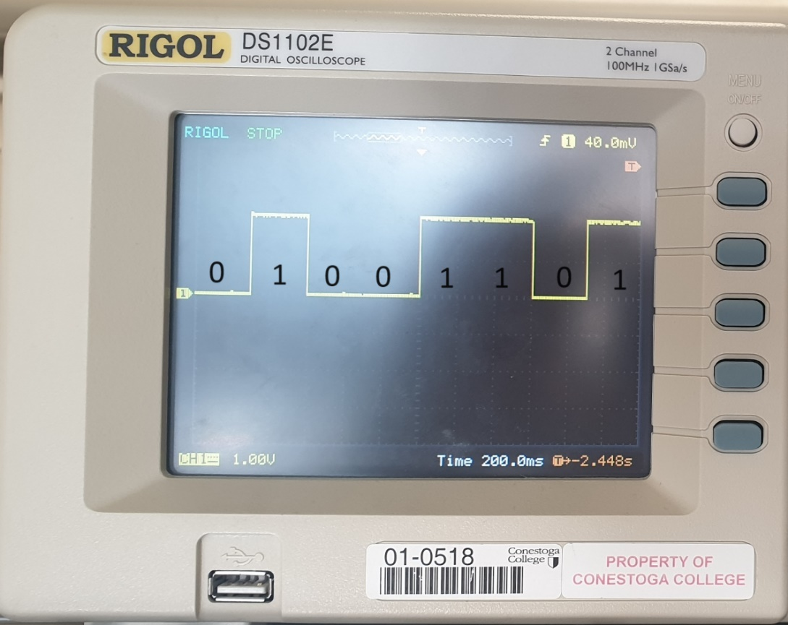

Figure 4‑2: Initials 1 = ‘M’.

* ‘T’: 0 1 0 1 0 1 0 0

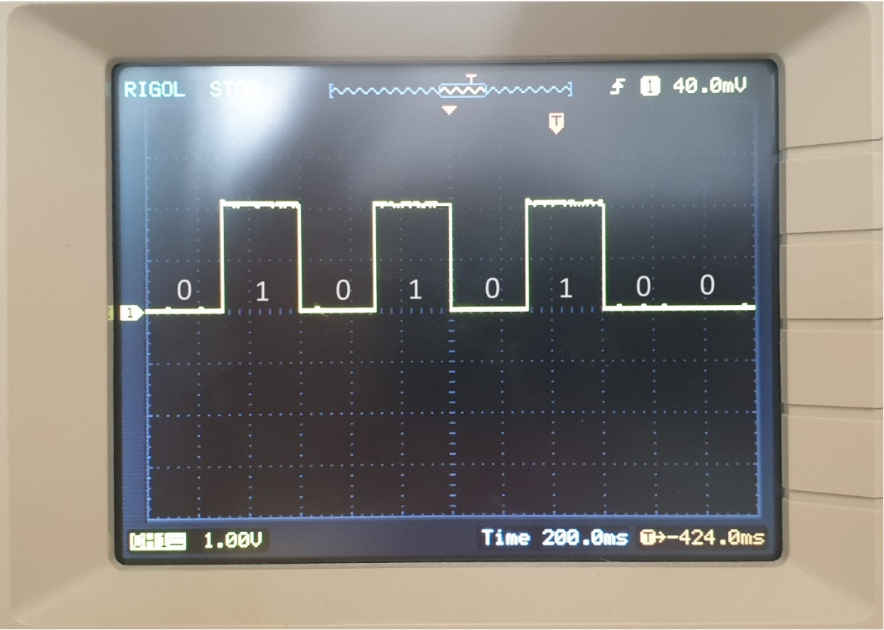

Figure 4‑3: Initials 2 = ‘T’

**REFERENCES**