Student Name:
Minh Quan Tran
Susheela Narayan Hegde
Team Name:
Bin There, Done That
Project Name:
Smart parcel sorting system

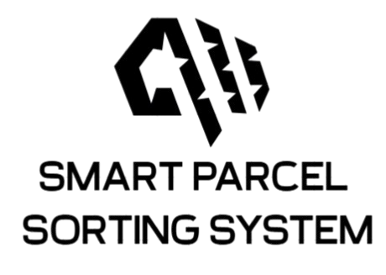
Date: July 2, 2025

LOGBOOK WEEK 9
- Goal Past Week
- Continued to mount all the hardware.
- Start coding for the new state machine
- Achievement
- Draw a SolidWorks design for table legs, step motor mount, sensor mount and shaft actuator.
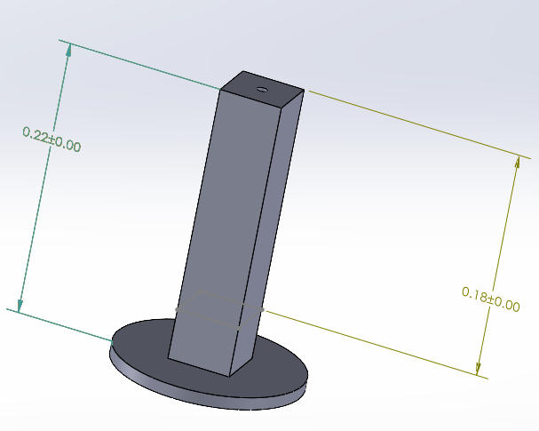
Figure 1: Table legs
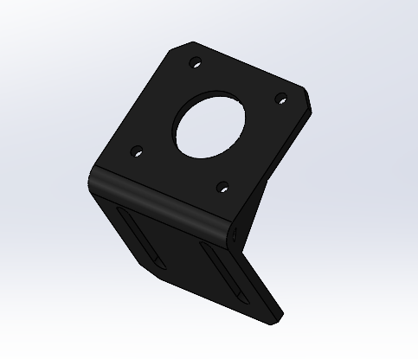
Figure 2: Stepper motor mounting bracket
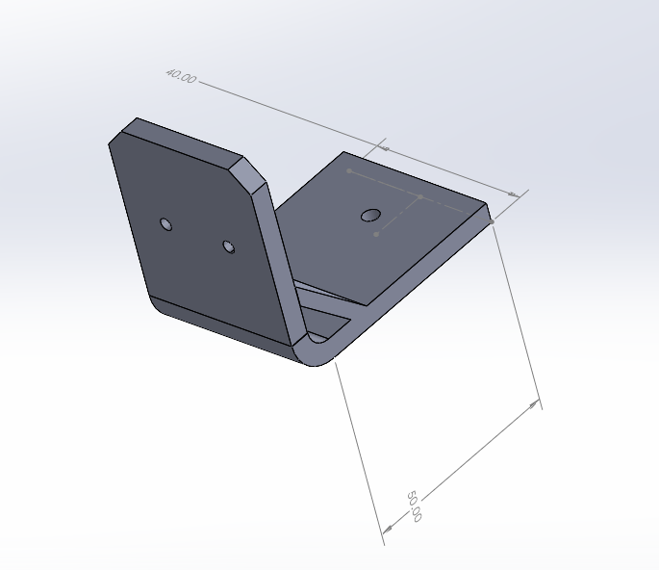
Figure 3: Sensor’s mounting bracket
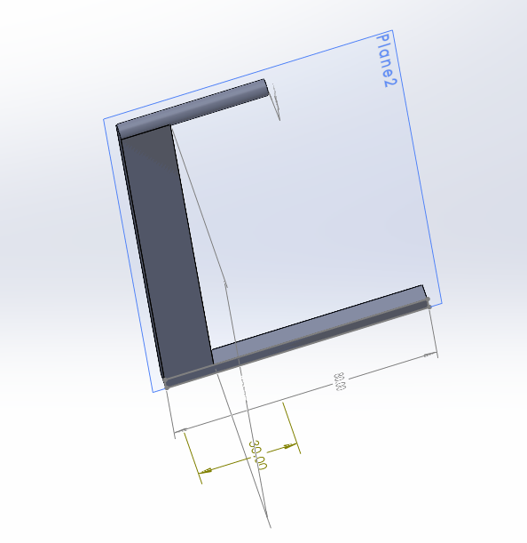
Figure 4: Motor’s shaft
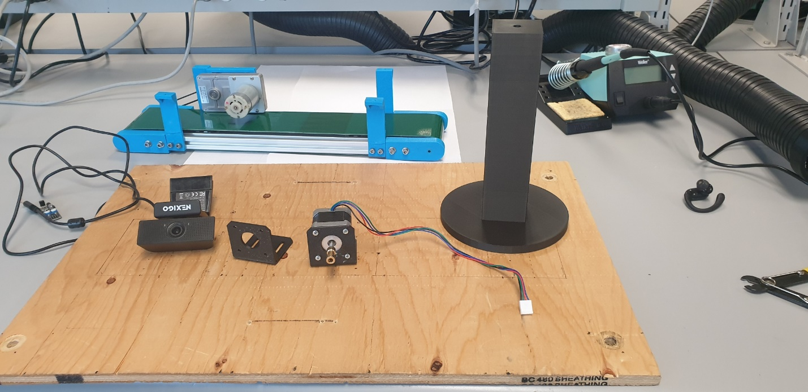
Figure 5: Mounted hardware (In progress)

2.1. Problems occur:
No problem

2.2. Resolve:
Not Applicable
- Goal for Week 10
- Receive all 3d printed designs and start mounting all components.
- Start testing the state machine code on the system.

