Team Members Names:
- Minh Quan Tran
- Susheela Narayan Hegde

Project Name: Smart Parcel Sorting System
Project Overview:
This project aims to build a smart parcel sorting prototype designed for use in Amazon-style fulfillment centers. The system will automatically detect and sort packages using QR/barcode data. A simulated conveyor and slide mechanism will handle the physical sorting, controlled by an embedded system.
The prototype uses an STM32 microcontroller to interface with a QR/barcode scanner and manage real-time sorting logic. An ESP32 or Raspberry Pi module will handle cloud connectivity, enabling the system to log sorting data or send it to cloud services for further processing.

LOGBOOK WEEK 2
- Goal Past Week
- Setup Raspberry Pi 4B.
- Connect and Test run Raspberry Pi Camera Module 3.
- Try to write a code to read the QR code and print out the data embedded in that QR.
- Setup ESP32WROM and found platform to code ESP32 on.
- Create a cloud account on AWSIoT.
- Try to write a code to publish and subscribe to topics from cloud.
- Achievement
- Successfully set up Raspberry Pi 4B and accessed it remotely via RealVNC.
- Connected and verified the functionality of the Raspberry Pi Camera Module 3.
- Developed and tested a Python script that captures and decodes QR codes using the camera.

Figure 1: Tested QR code
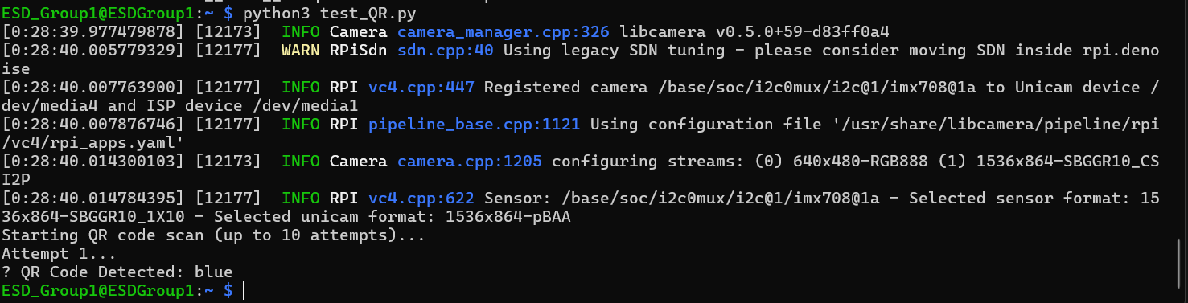
Figure 2: Output python script

… Input Achievement from ESP32

- Goal for Week 3
- Write the ESP32 code to subscribe receive data from cloud and print it out.
- Expand the Raspberry Pi Python code to both publish and subscribe to AWS IoT topics.
- Integrate both systems to establish a working prototype:
  - Raspberry Pi reads and sends QR code data to AWS IoT.
  - ESP32 receives the data from AWS IoT and prints it to the serial monitor.
- Begin planning the hardware requirements by drafting a parts list.

