Student Name:
Minh Quan Tran
Susheela Narayan Hegde
Team Name:
Bin There, Done That
Project Name:
Smart parcel sorting system

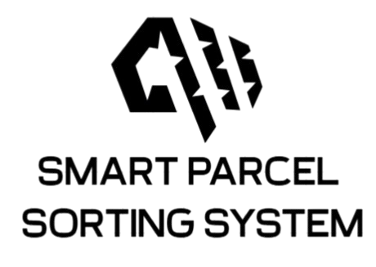

LOGBOOK WEEK 3
- Goal Past Week
- Write the ESP32 code to subscribe receive data from cloud and print it out.
- Expand the Raspberry Pi Python code to both publish to AWS IoT topics.
- Integrate both systems to establish a working prototype:
  - Raspberry Pi reads and sends QR code data to AWS IoT.
  - ESP32 receives the data from AWS IoT and prints it to the serial monitor.
- Begin planning the hardware requirements by drafting a parts list.
- Achievement
- Successfully expanding Raspberry Pi Python code to both read the QR data and publish to AWS IoT topics
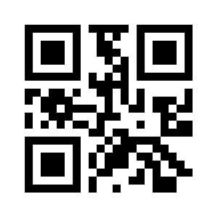
Figure 1: Tested QR code
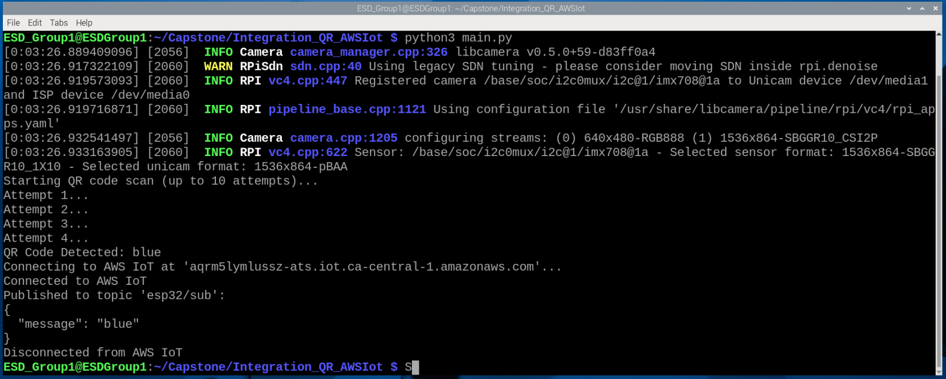
Figure 2: Output python script
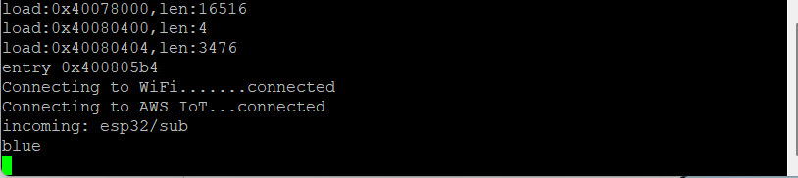
Figure 3: ESP32 received the QR data

- List out all the hardware part that will be required for the project and submitted to econestoga.

- Goal for Week 4
- Received hardware from tool room and start testing each component making sure it will work properly
- Draft state machine for all STM32, ESP32, Raspberry Pi 4.

