Student Name:
Minh Quan Tran
Susheela Narayan Hegde
Team Name:
Bin There, Done That
Project Name:
Smart parcel sorting system

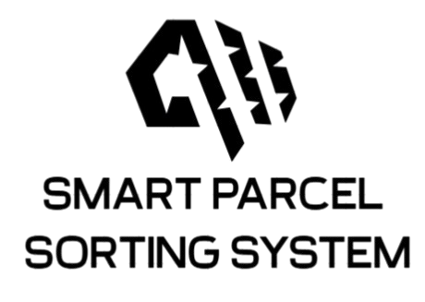
Date: May 22, 2025

LOGBOOK WEEK 4
- Goal Past Week
- Receive hardware from the tool room and start testing each component making sure it will work properly.
- Draft state machine for all STM32, ESP32, Raspberry Pi 4.
- Achievement
- Got the 12V Adapter from the tool room and test run successfully the conveyor.
- Finished drafting the state machine for the whole system
- 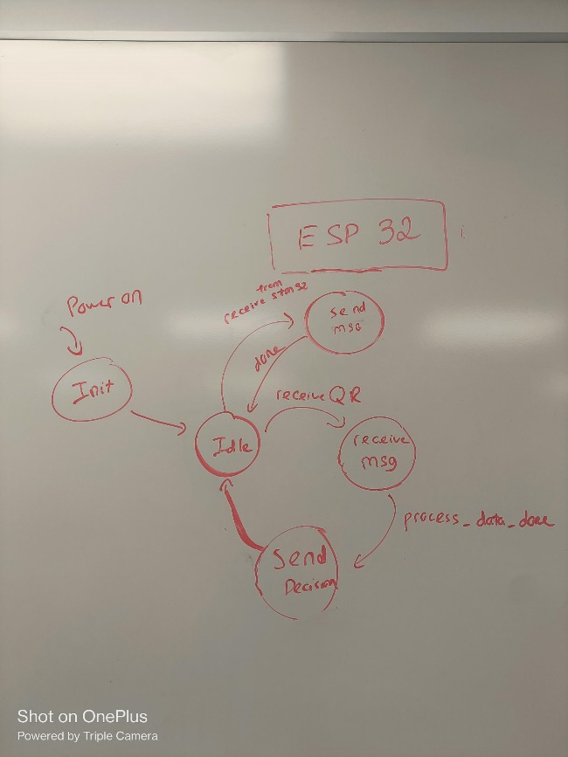
Figure 1: State machine for ESP32
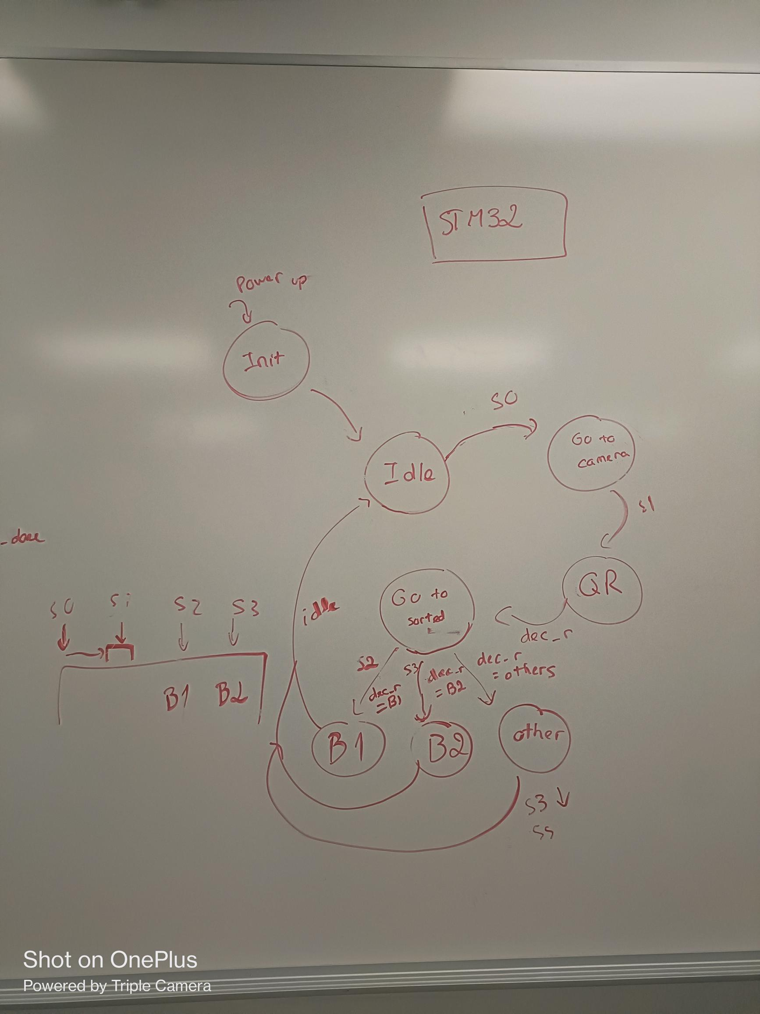
Figure 2: State machine for STM32
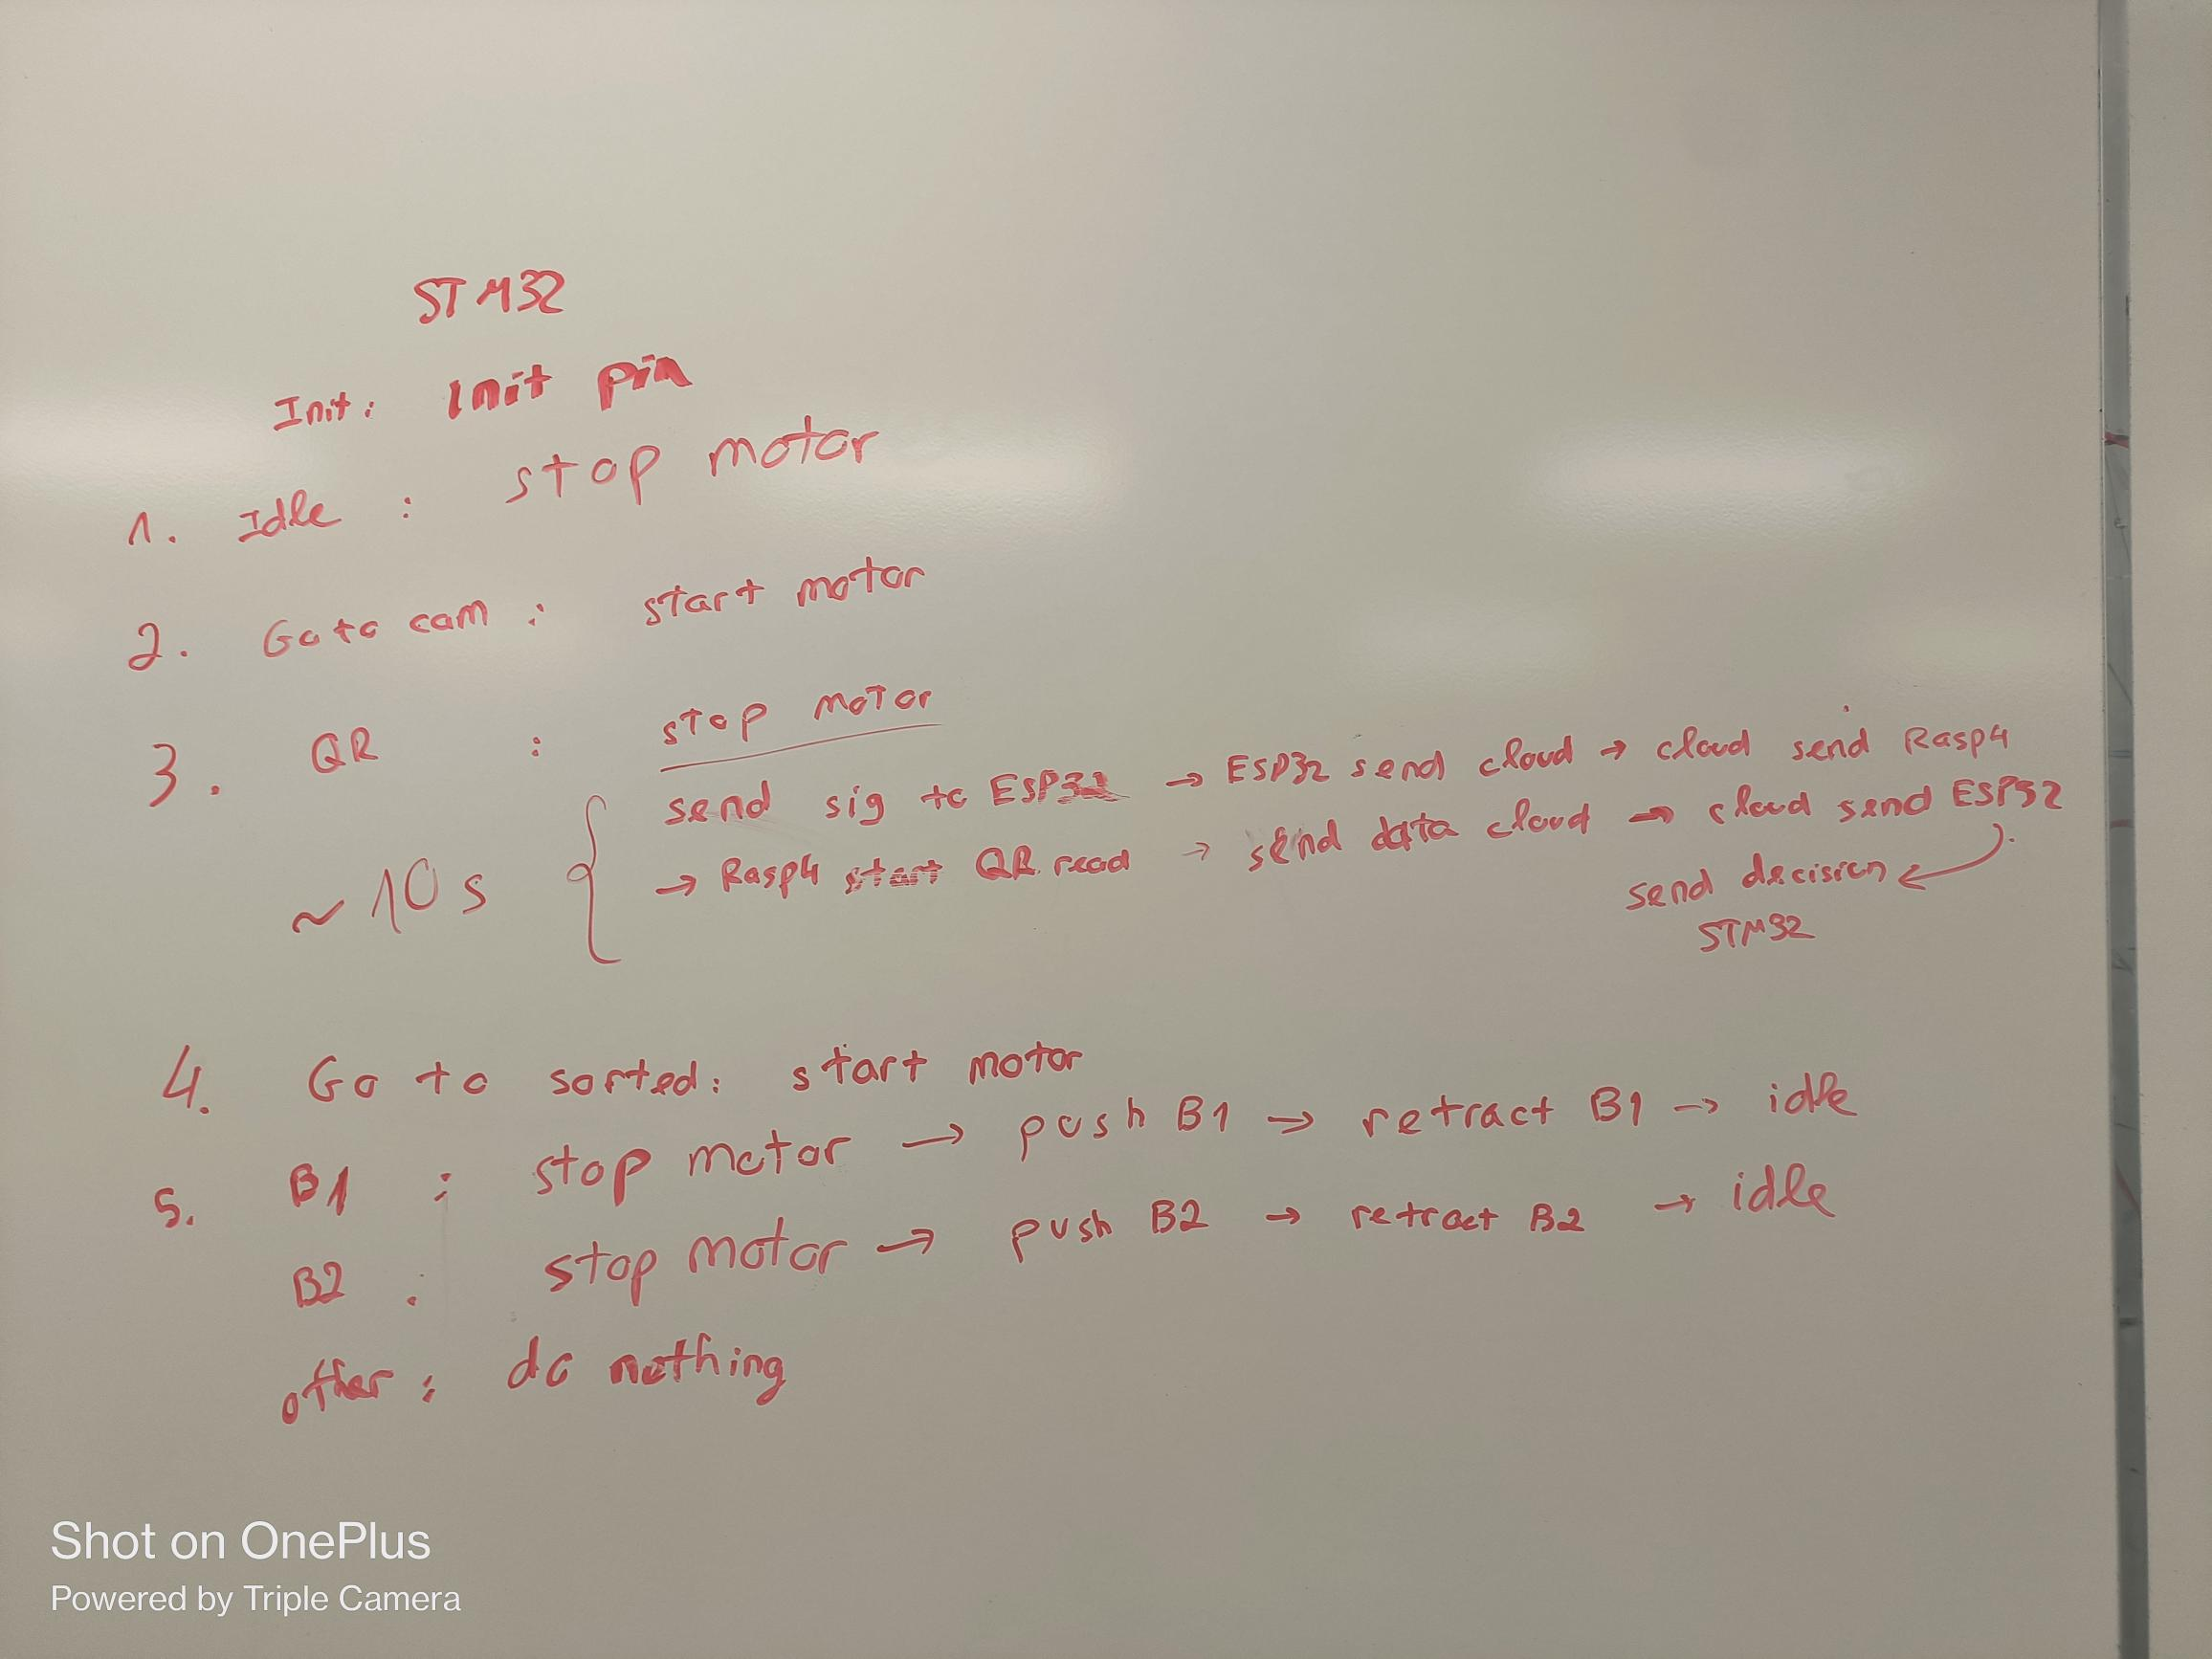
Figure 3: STM32 State’s functionality
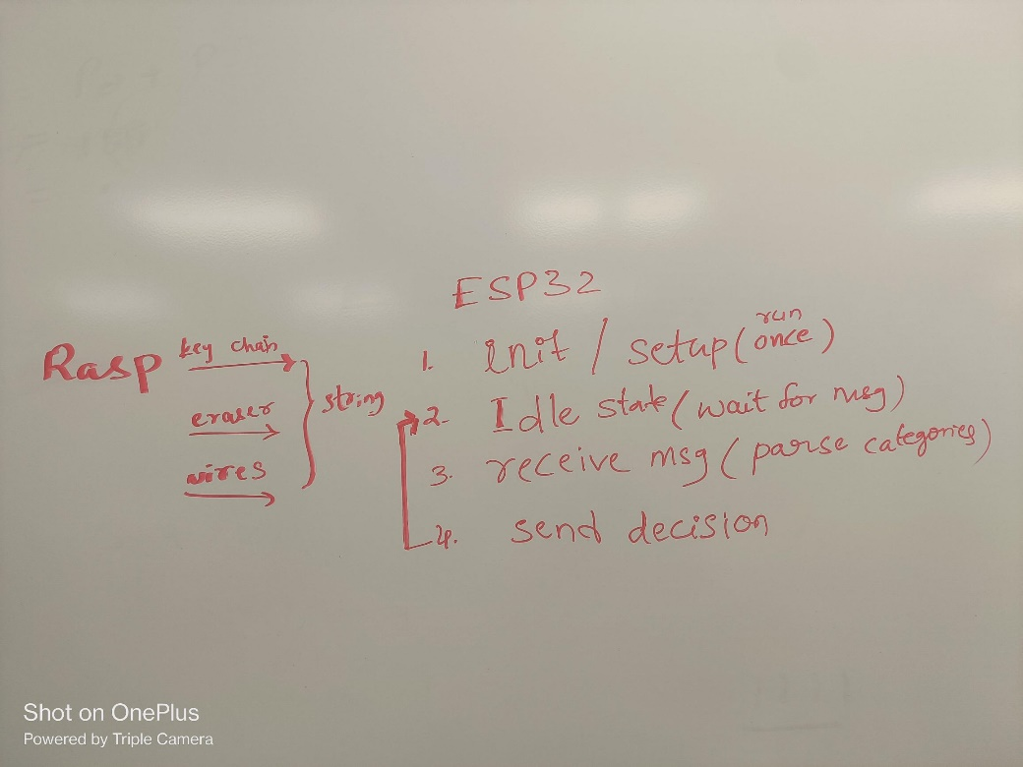
Figure 4: ESP32 State's functionality
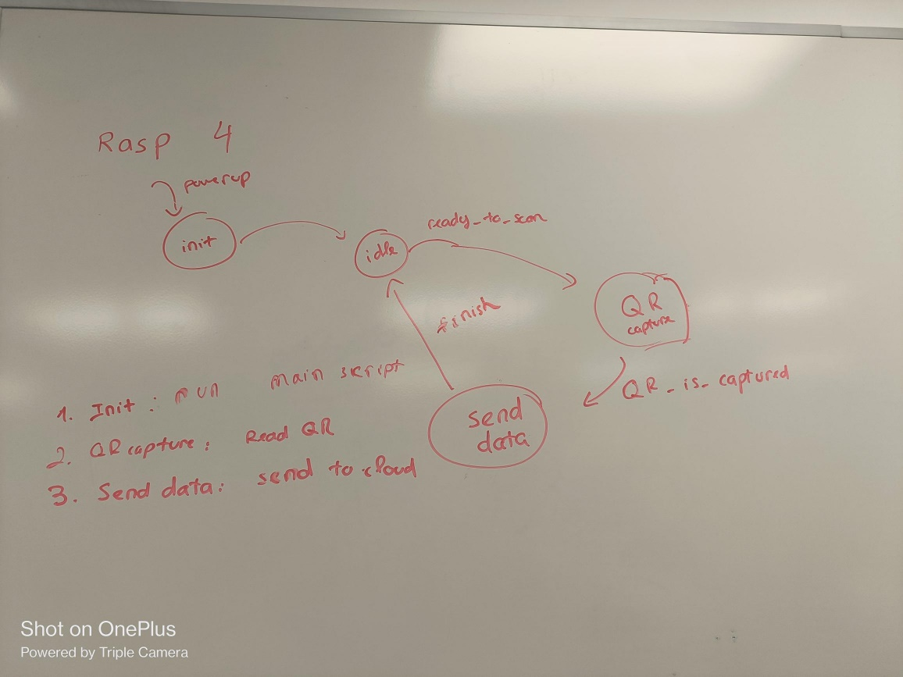
Figure 5: State machine for Raspberry 4

2.1. Problems occur:
ESP32 not connecting to wifi issue.

2.2. Resolve:
- Issue: ESP32 cannot connect to 5GHz band
- Solution: Edited the network band to 2.4GHz because ESP32 does not support 5GHz band
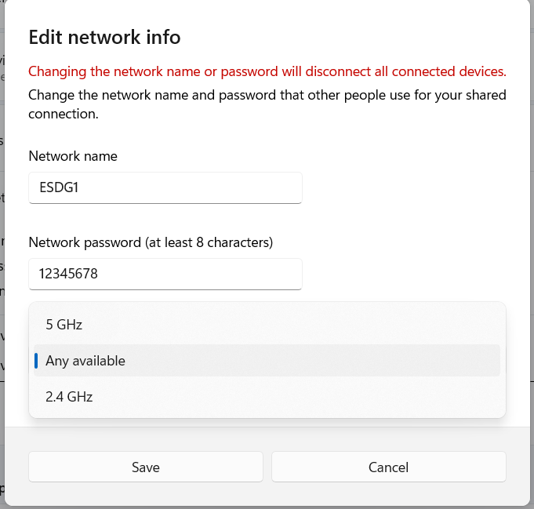
Figure 6: Editing Network Info

- Goal for Week 5
- Receive all hardware and start testing + assembling all components
- Write code to STM32 to control the conveyor and actuator (if time permit)

