Student Name:
Minh Quan Tran
Susheela Narayan Hegde
Team Name:
Bin There, Done That
Project Name:
Smart parcel sorting system

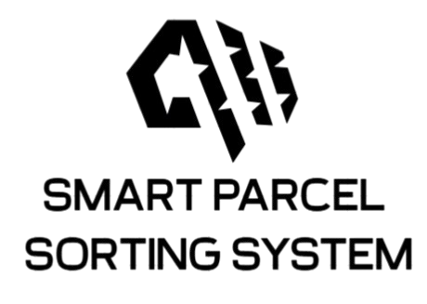
Date: May 22, 2025

LOGBOOK WEEK 5
- Goal Past Week
- Receive all hardware and start testing + assembling all components
- Write code to STM32 to control the conveyor and actuator (if time permit)
- Achievement
- Receive the L298N motor driver
- Successfully write and test wiring and coding to control the DC motor in the conveyor.
- Expand the Raspberry pi 4B to work as a state machine.
- “Idle” state (waiting for esp32_pub signal)
- “QR” state (Read QR data)
- “Send data” state (Publish QR data to AWSIoT cloud).
- Back to “Idle” state after publishing data.
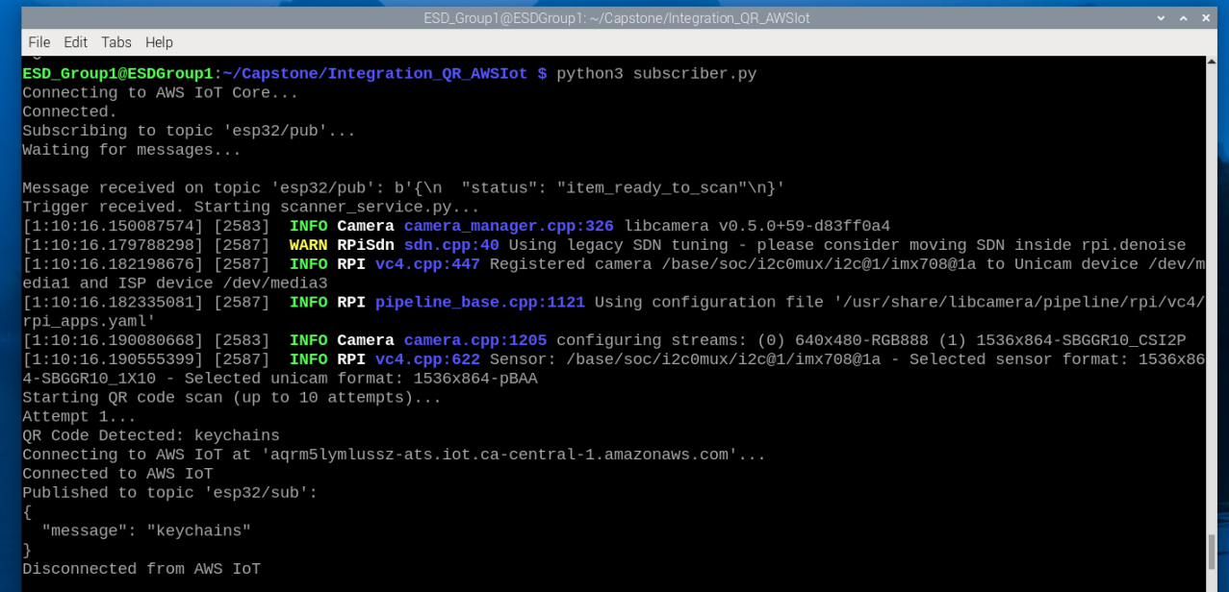
Figure 1: Output of subscriber.py
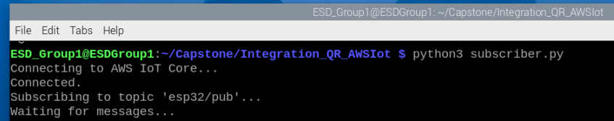
Figure 2: “Idle” state
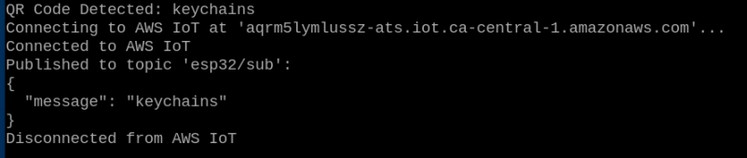
Figure 3: “QR” state
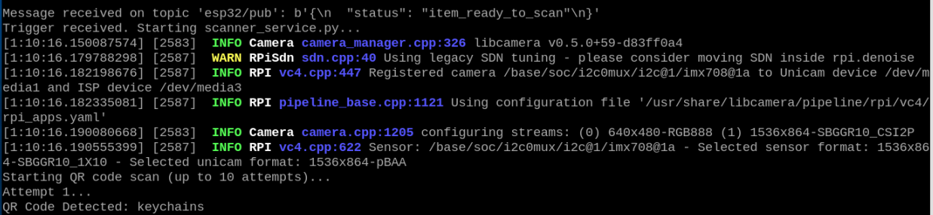
Figure 4: “Send data” state

2.1. Problems occur:
The camera is not fixed, and we still need to manually hold the camera

2.2. Resolve:
Buying all the mounting stuff next week to hold the camera and all the sensors plus actuator.
- Goal for Week 6
- Receive all the hardware and start testing all components.
- Mount all the components camera, raspberry pi 4b, …
- If time permits, start coding the state machine for STM32 to control.

