Student Name:
Minh Quan Tran
Susheela Narayan Hegde
Team Name:
Bin There, Done That
Project Name:
Smart parcel sorting system

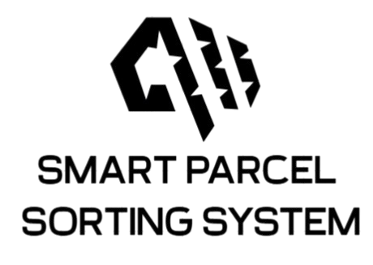
Date: June 5, 2025

LOGBOOK WEEK 6
- Goal Past Week
- Receive all the hardware and start testing all components.
- Mount all the components camera, raspberry pi 4b, …
- If time permits, start coding the state machine for STM32 to control.
- Achievement
- Had received every component (eg: sensors, actuator, driver, ...)
- Test and confirm all components are in working condition.
- Wiring and successfully run test when all components are connected to STM32.
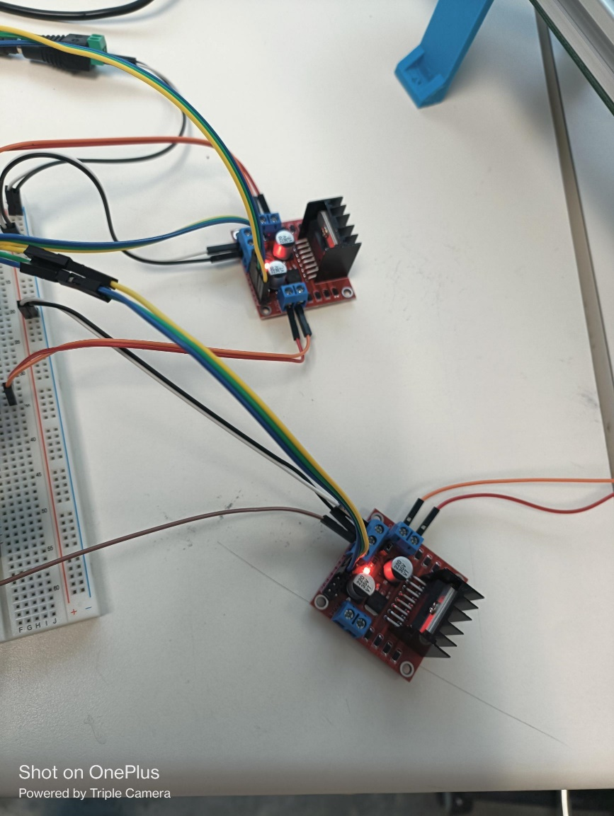
Figure 1: L298 driver connection

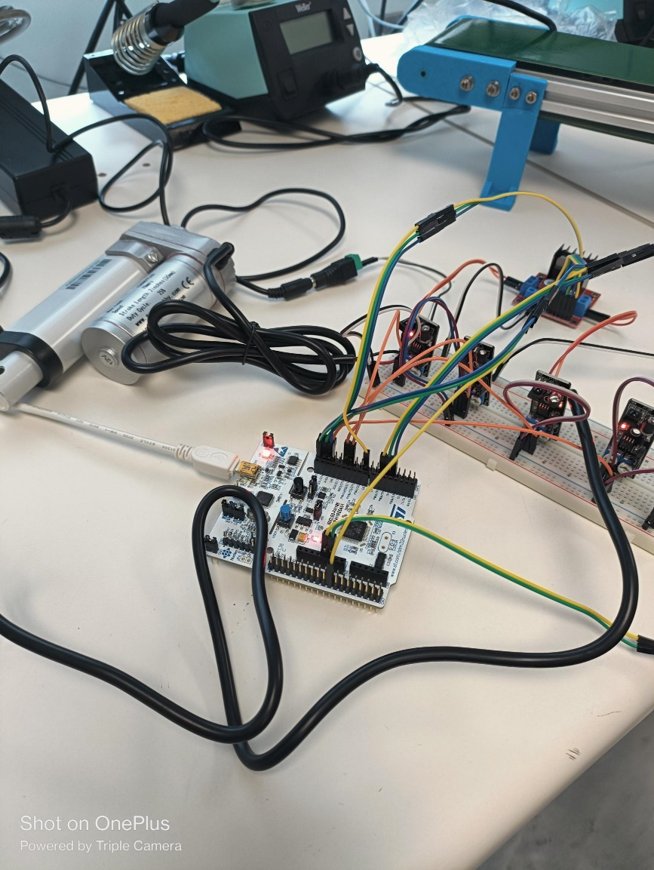
Figure 2: STM32 connections

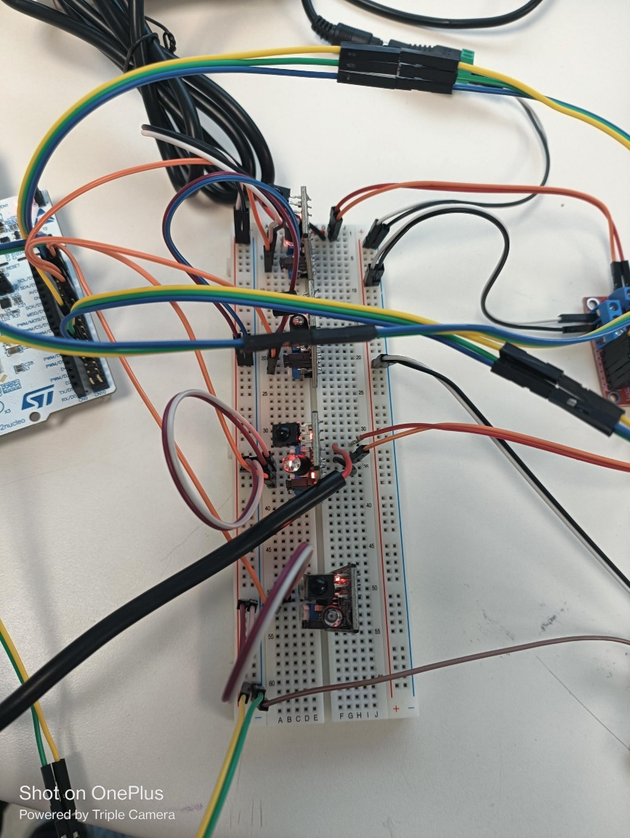
Figure 3: Breadboard's connection

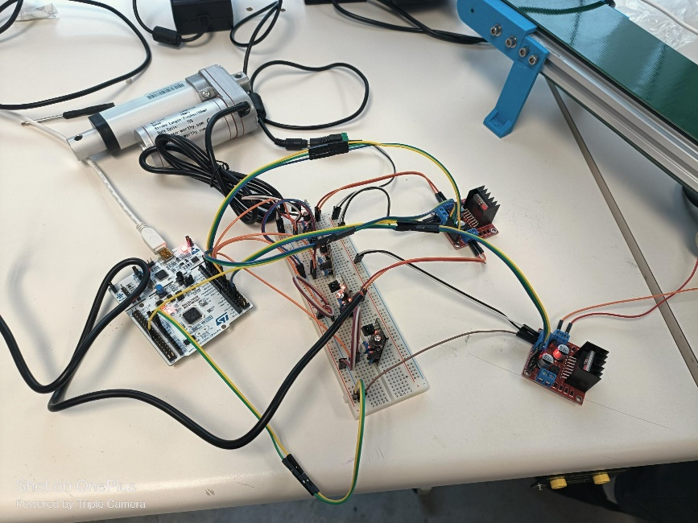
Figure 4: Full components wiring

2.1. Problems occur:
No problem

2.2. Resolve:
Not Applicable
- Goal for Week 7
- Start on the coding for state machine of STM32
- Draft wiring diagram of the system.
- Create a direct connection from Raspberry Pi 4 to STM32 and configure AWSIoT as a log.

