Student Name:
Minh Quan Tran
Susheela Narayan Hegde
Team Name:
Bin There, Done That
Project Name:
Smart parcel sorting system

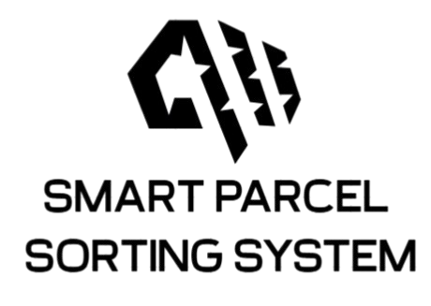
Date: June 12, 2025

LOGBOOK WEEK 7
- Goal Past Week
- Start on the coding for state machine of STM32
- Draft wiring diagram of the system.
- Create a direct connection from Raspberry Pi 4 to STM32 and use AWSIoT as a log.
- Achievement
- Drafted a new state machine for STM32 and Raspberry Pi 4 from Allan suggestion of connecting directly STM32 and Rasp 4 for camera usage.
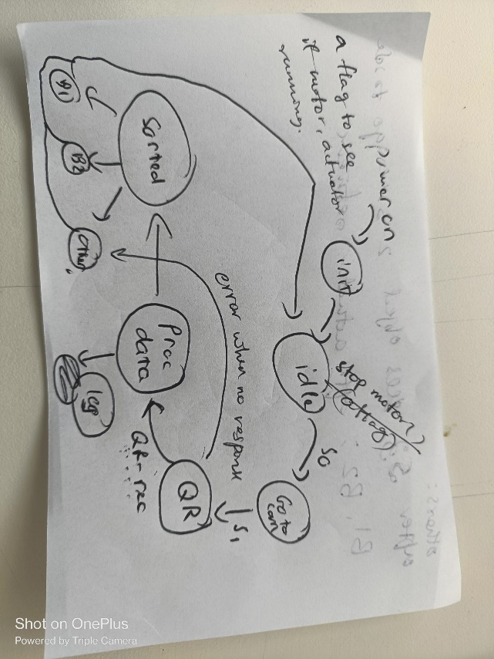
Figure 1: STM32's state machine
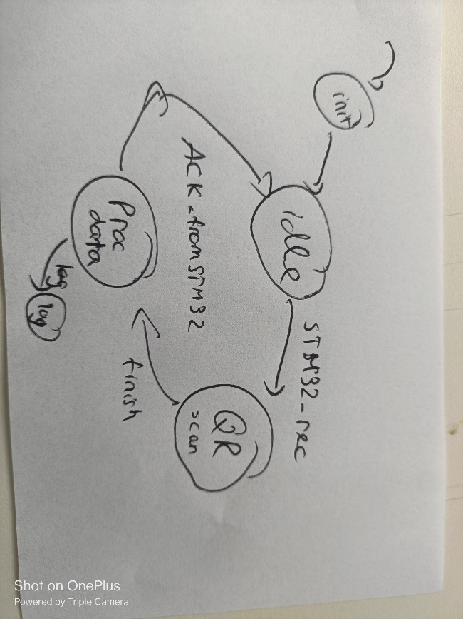
Figure 2: Raspberry Pi 4's state machine
- Initial software creation for SPI connection between STM32 and Raspberry Pi 4
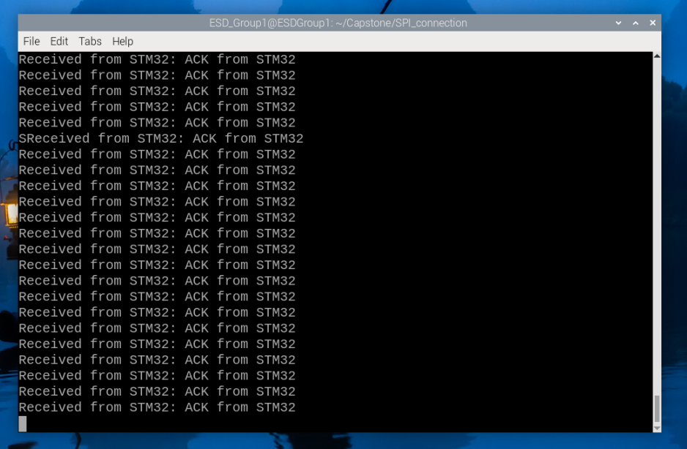
Figure 3: Raspberry Pi received ACK from STM32
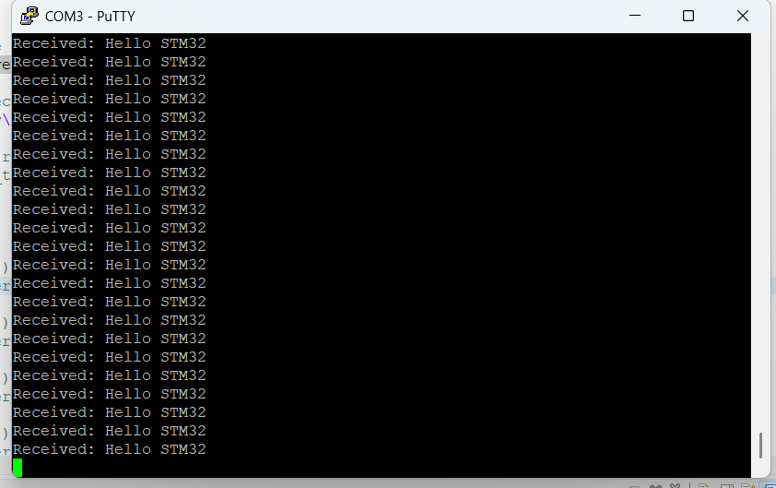
Figure 4: STM32 received message from Raspberry Pi 4
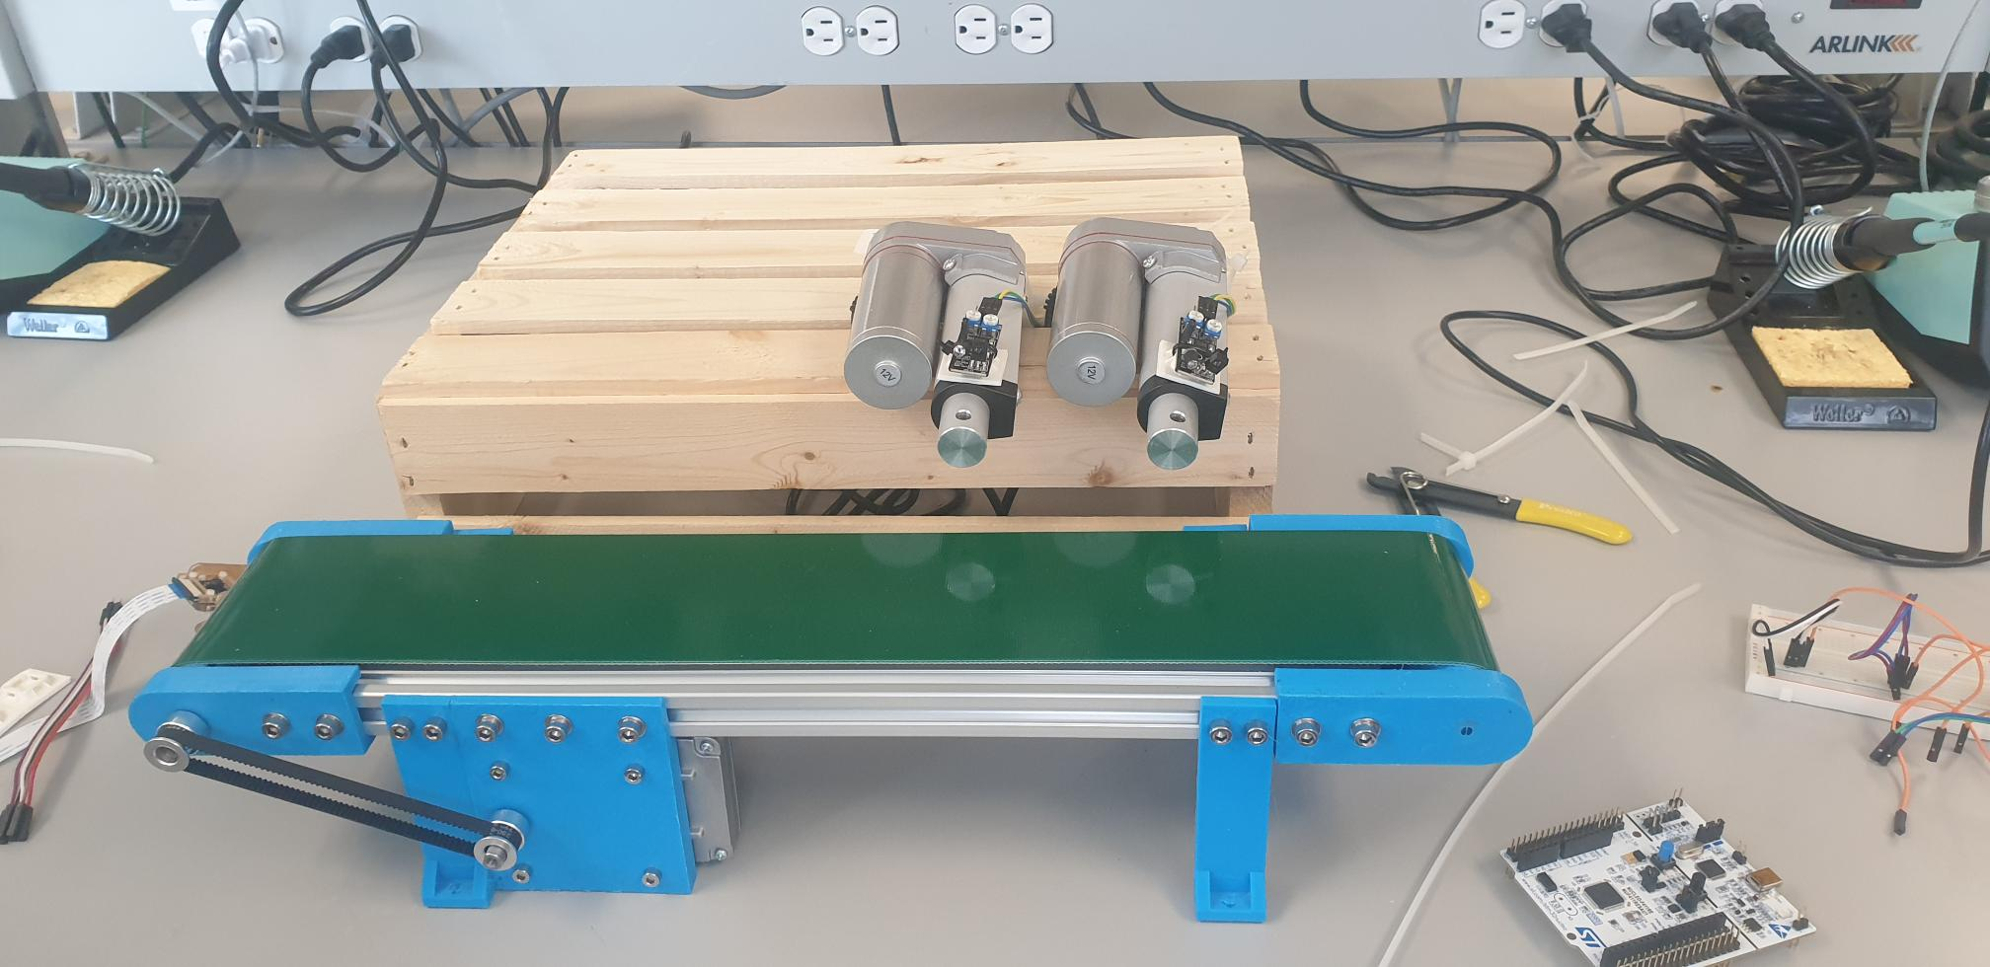
Figure 5: Mounted hardware (In progress)

2.1. Problems occur:
No problem

2.2. Resolve:
Not Applicable
- Goal for Week 8
- Continued to mount all the hardware.
- Start coding for the new state machine
- If time permits, start coding and testing on all of the mounted hardware.

