Low Level Software Working

Student Name:
Minh Quan Tran
Susheela Narayan Hegde
Team Name:
Bin There, Done That
Project Name:
Smart parcel sorting system

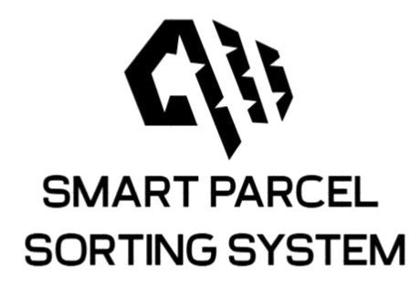

Contents
Change logs 3
Week 1 – Initial Setup Raspberry Pi 4B and AWS MQTT Testing 3
Week 2 – MQTT Subscription and Topic Handling 5
Week 3 – UART Communication Between ESP32 and STM32 and Initial draft of every state machine 7
Week 4 – Initial State Machines code and Motor Control 11
Week 5 – Sensor Integration and Actuator Control 13
Week 6 – Updated Flow: STM32 ↔ Raspberry Pi, SPI Setup 16
Proof of Software Working: 18

Table of Figures
Figure 1: ESP32_WiFI Thing 4
Figure 2: Tested QR code 5
Figure 3: Output test_QR.py 5
Figure 4: Esp32 build and flash code 6
Figure 5: ESP32 serial port debug messages after bootup 6
Figure 6: Week 2's tested QR code 7
Figure 7: Output main.py script 7
Figure 8: data printed on esp32/subtopic from Raspberry pi 7
Figure 9: STM32 UART console connected to ESP32 8
Figure 10: ESP32's state machine 9
Figure 11: ESP32's state machine functionalities 9
Figure 12: STM32's state machine 10
Figure 13: STM32's state machine functionalities 10
Figure 14: Rasp 4's state machine 11
Figure 15: output of subscriber.py 12
Figure 16: Idle state (Waiting for msg from STM32) 13
Figure 17: QR state (Read QR) 13
Figure 18: Send data's state 13
Figure 19: L298's wiring 14
Figure 20: STM32's connection 15
Figure 21: Sensor's connection 16
Figure 22: Full system wiring connection 16
Figure 23: Raspberry directly connected to STM32 through SPI 17
Figure 24:Updated state machine for Raspberry Pi 18
Figure 25:Updated state machine for STM32 18
Figure 26: RealVNC installed 19
Figure 27: Installing Python 20
Figure 28: Testing Camera 20
Figure 29: Running Python's code to read QR code 21
Figure 30: Publishing message to AWSIoT 21
Figure 31: Proof that the cloud receives the data 21

Change logs

Week 1 – Initial Setup Raspberry Pi 4B and AWS MQTT Testing
Tasks Completed:
- Installed Arduino IDE, set up ESP32 board and serial port.
- Created AWS IoT Thing, downloaded certificates, attached policies.
- Wrote and uploaded C code to ESP32 for MQTT publish/subscribe to AWS.
- Verified two-way MQTT communication with AWS from ESP32.
- Successfully set up Raspberry Pi 4B and accessed it remotely via RealVNC.
- Connected and verified the functionality of the Raspberry Pi Camera Module 3.
- Developed and tested a Python script that captures and decodes QR codes using the camera.
Design Notes:
- Verified that both ESP32 and Raspberry Pi can connect independently to AWS IoT Core via MQTT.
- Certificates and policies handled manually and securely stored.
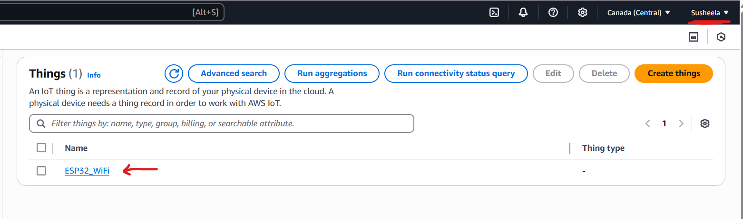
Figure 1: ESP32_WiFI Thing
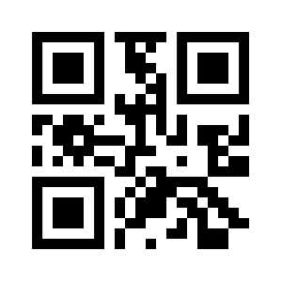
Figure 2: Tested QR code
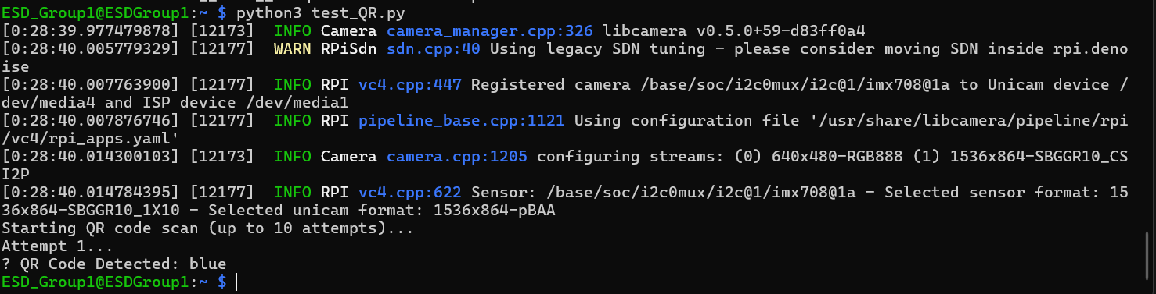
Figure 3: Output test_QR.py

Week 2 – MQTT Subscription and Topic Handling
Tasks Completed:
- Wrote C++ code in Arduino IDE to subscribe to MQTT topics.
- Successfully printed received MQTT messages on ESP32 serial monitor.
- Understood AWS IoT policy permissions: Connect, Subscribe, Publish, Receive.
- Successfully expanding Raspberry Pi Python code to both read the QR data and publish to AWS IoT topics.
Design Notes:
- Validated real-time message reception.
- Started considering multi-topic architecture for device coordination.
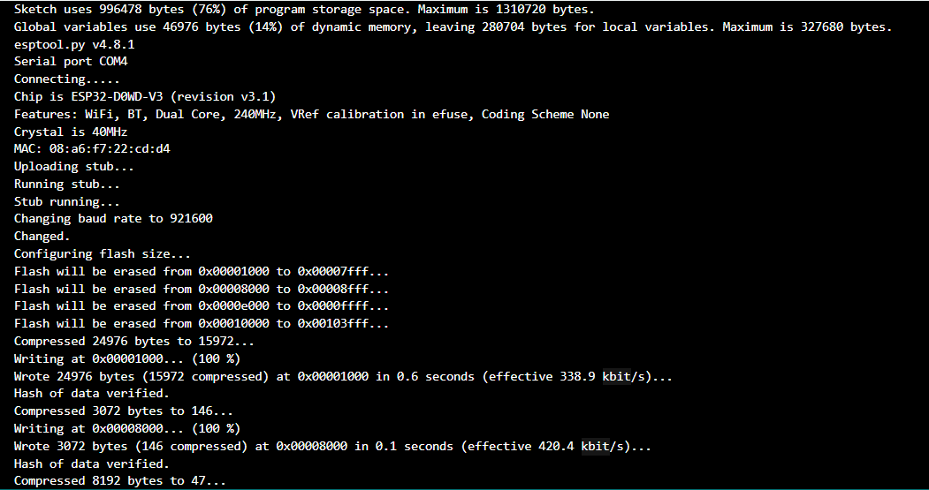
Figure 4: Esp32 build and flash code
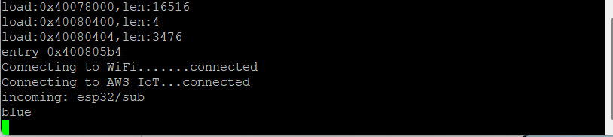
Figure 5: ESP32 serial port debug messages after bootup

Figure 6: Week 2's tested QR code
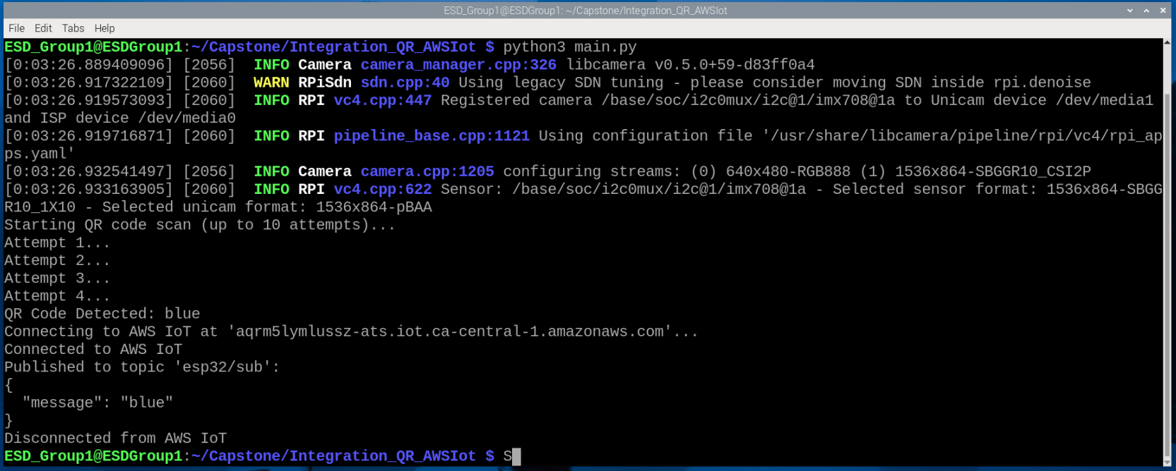
Figure 7: Output main.py script
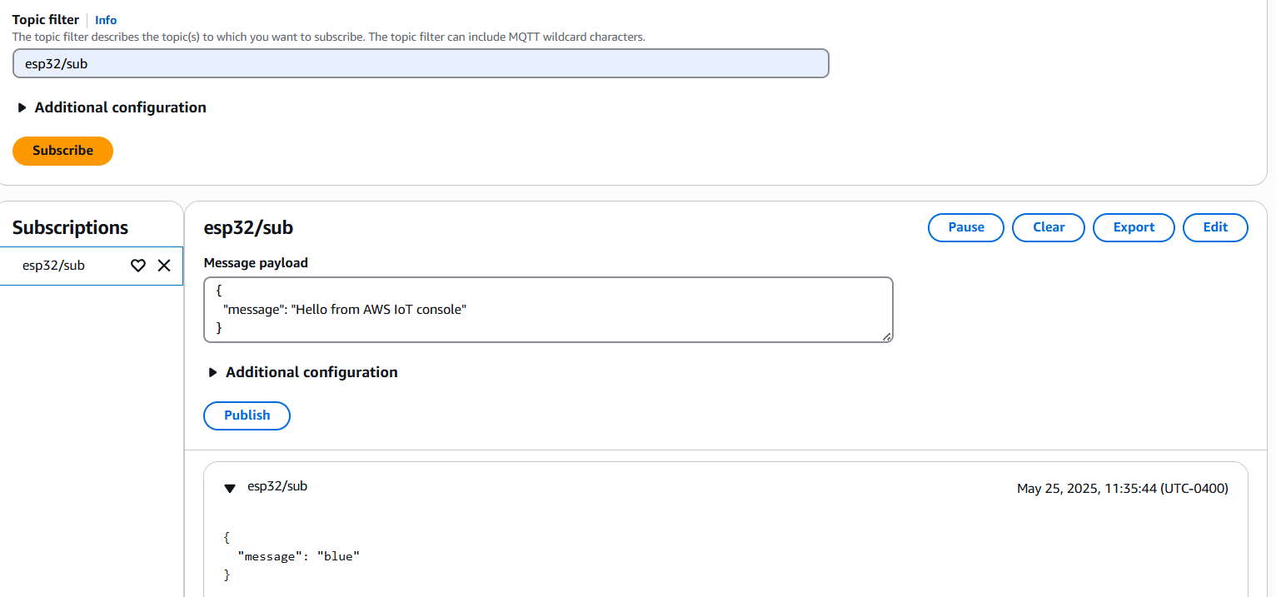
Figure 8: data printed on esp32/subtopic from Raspberry pi

Week 3 – UART Communication Between ESP32 and STM32 and Initial draft of every state machine
Tasks Completed:
- Configured ESP32 UART1 on GPIO16 (RX) and GPIO17 (TX).
- Connected ESP32 TX to STM32 RX, verified signal transmission.
- Wrote STM32 firmware to enable UART1, store message in buffer, and print to USB serial terminal.
- Finished drafting the state machine for the whole system.
Design Notes:
- Developed a basic UART driver interface for STM32.
- Validated data integrity from ESP32 to STM32.
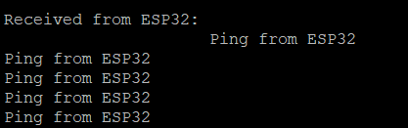
Figure 9: STM32 UART console connected to ESP32
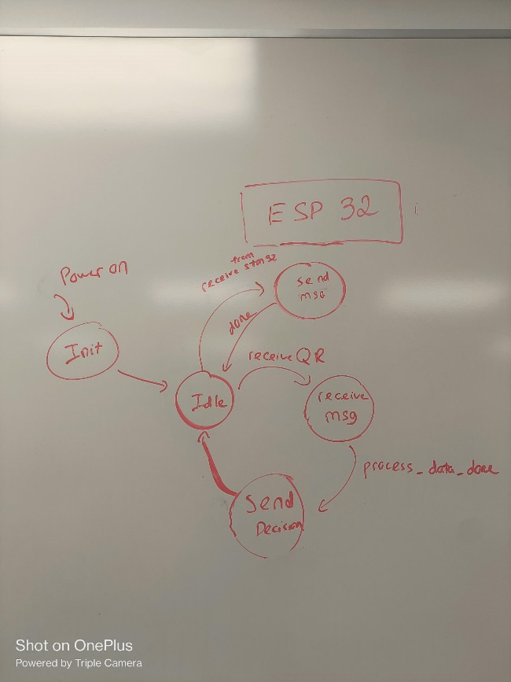
Figure 10: ESP32's state machine
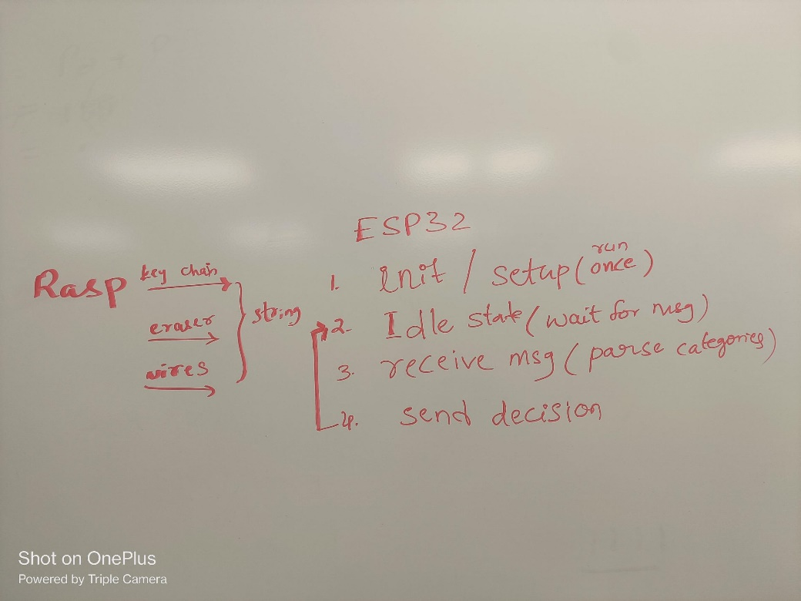
Figure 11: ESP32's state machine functionalities
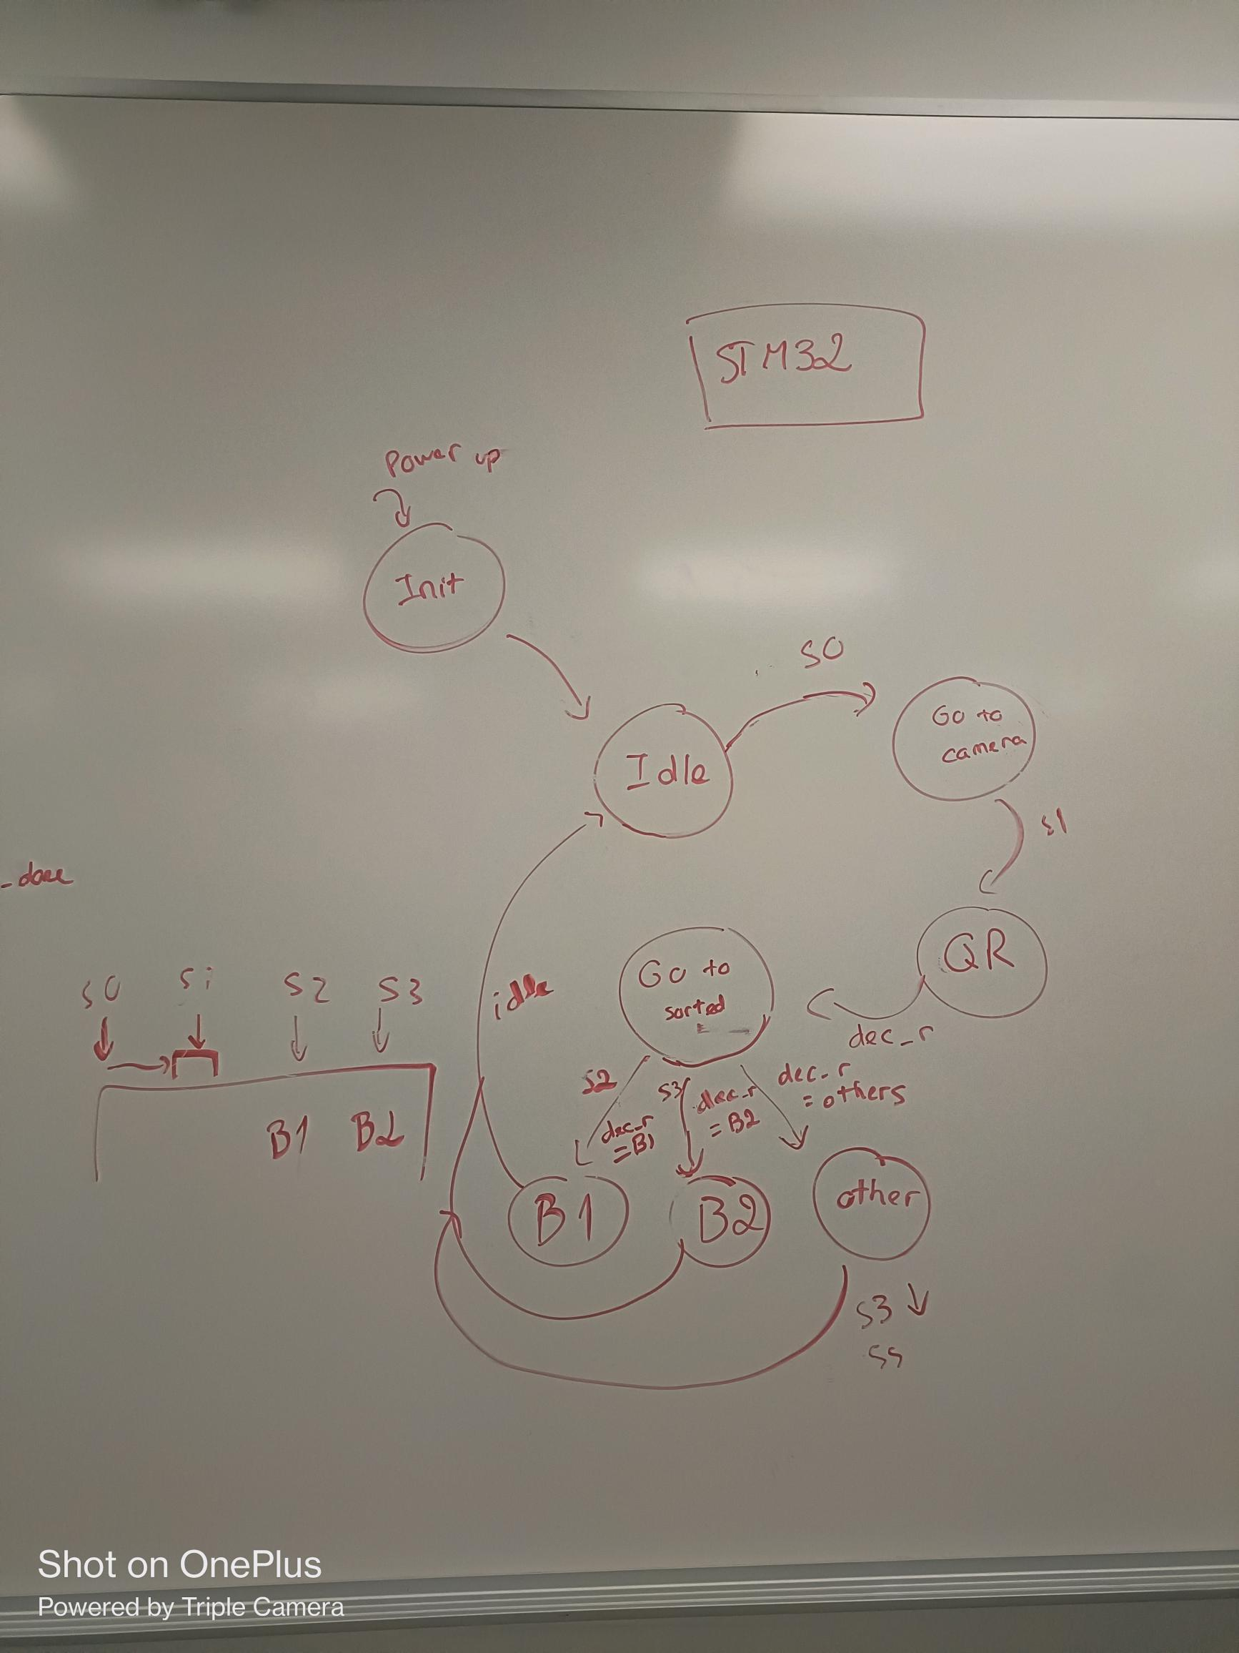
Figure 12: STM32's state machine
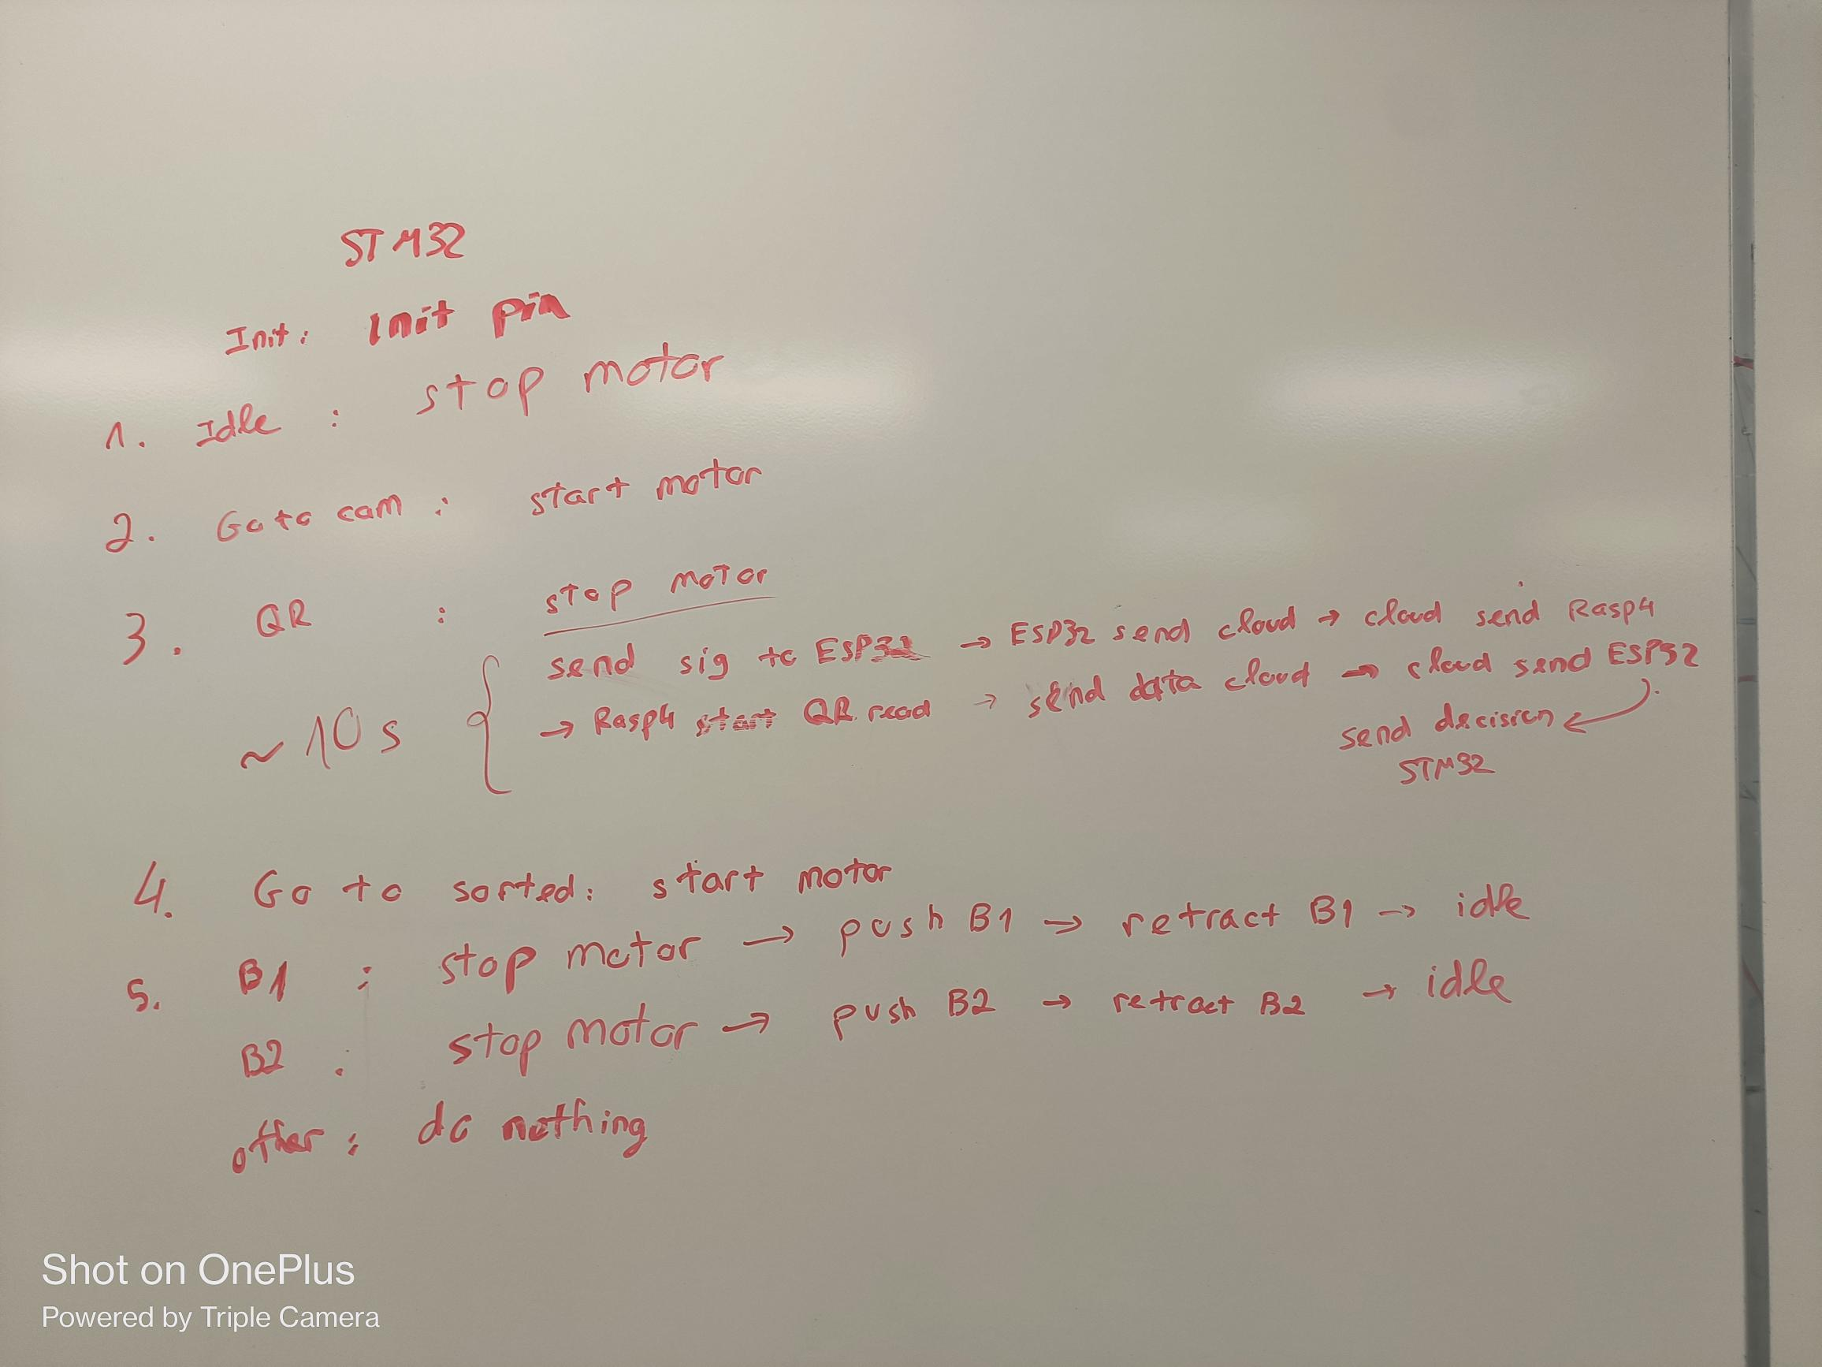
Figure 13: STM32's state machine functionalities
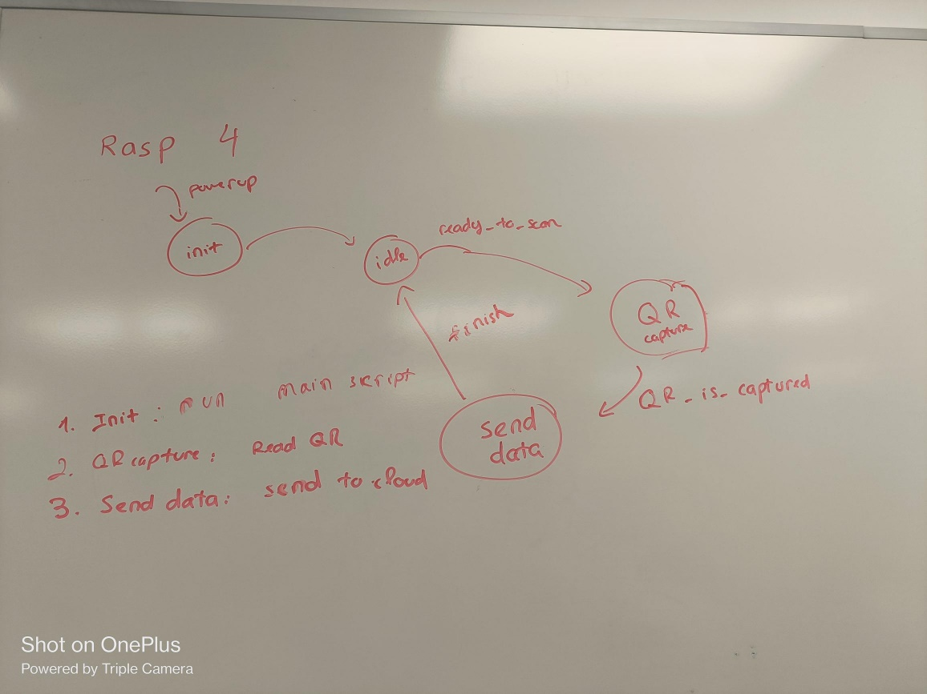
Figure 14: Rasp 4's state machine

Week 4 – Initial State Machines code and Motor Control
Tasks Completed:
- Developed initial state machine code for both ESP32 and STM32.
- Created and tested DC motor driver code using L298N module.
- Verified motor movement based on control input from code.
- Successfully write and test wiring and coding to control the DC motor in the conveyor.
- Expand the Raspberry pi 4B to work as a state machine.
  - “Idle” state (waiting for esp32_pub signal)
  - “QR” state (Read QR data)
  - “Send data” state (Publish QR data to AWSIoT cloud).
  - Back to “Idle” state after publishing data.
Design Notes:
- Motor state transitions integrated into STM32 state machine.
- Initial control logic tied to UART message parsing.
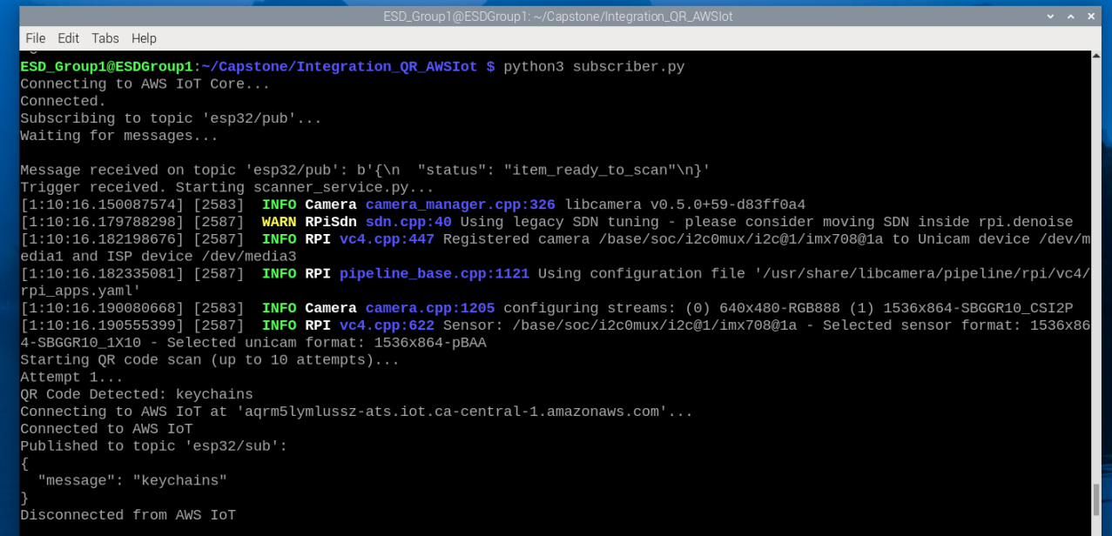
Figure 15: output of subscriber.py
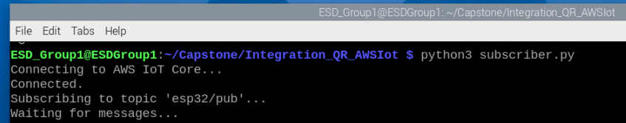
Figure 16: Idle state (Waiting for msg from STM32)
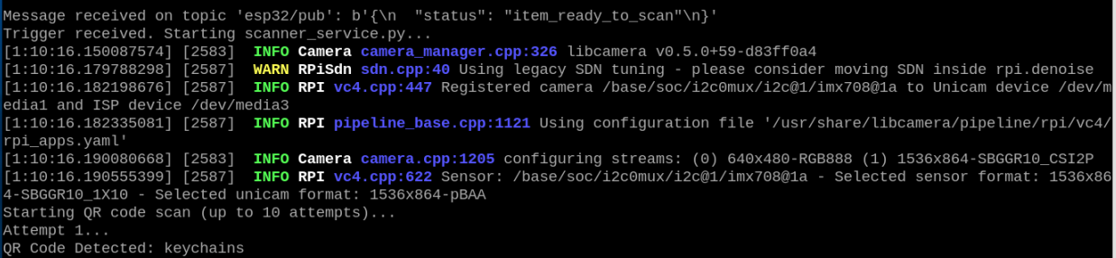
Figure 17: QR state (Read QR)
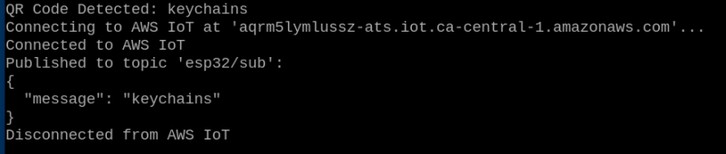
Figure 18: Send data's state

Week 5 – Sensor Integration and Actuator Control
Tasks Completed:
- Wrote sensor reading code on STM32 (likely using GPIO/ADC).
- Developed forward and reverse logic for linear actuator.
- Finalized GPIO pin assignments for all STM32 peripherals.
- Test and confirm all components are in working condition.
- Wiring and successfully run test when all components are connected to STM32.
Design Notes:
- Emphasis on accurate pin mapping for later PCB integration.
- Validated individual actuator behaviors using PWM and direction control.
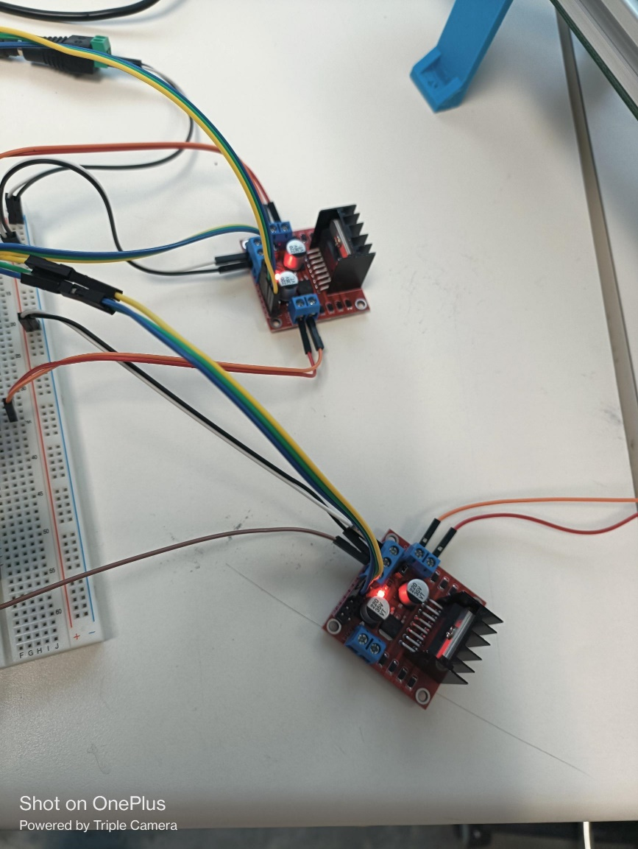
Figure 19: L298's wiring
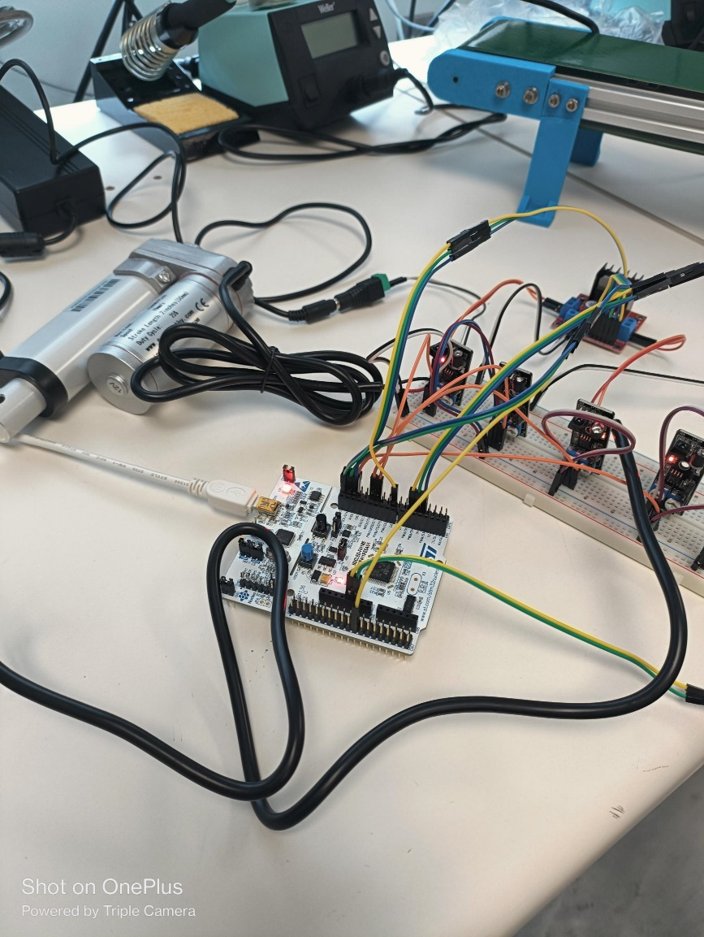
Figure 20: STM32's connection
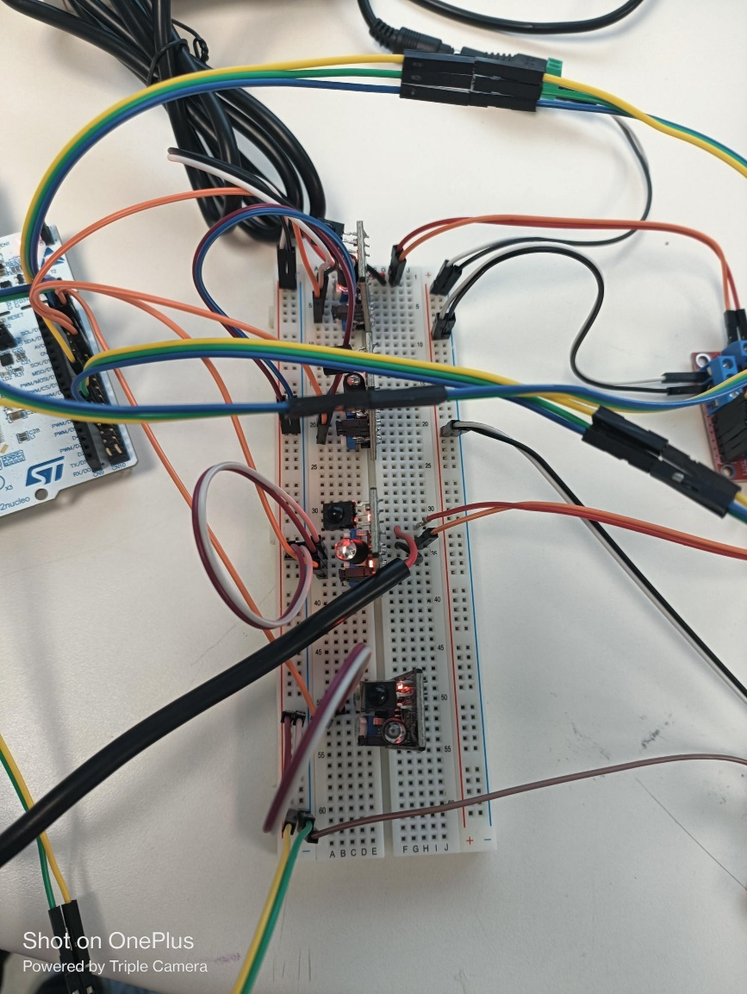
Figure 21: Sensor's connection
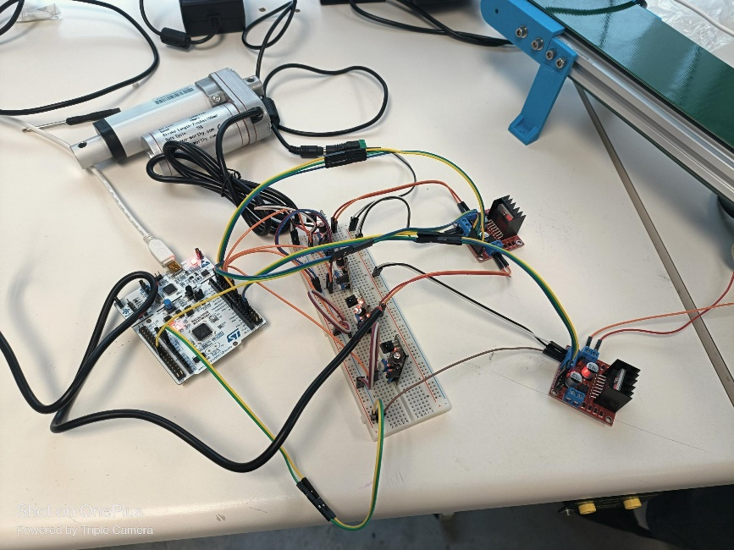
Figure 22: Full system wiring connection

Week 6 – Updated Flow: STM32 ↔ Raspberry Pi, SPI Setup
Tasks Completed:
- Updated state machine logic for direct STM32-Raspberry Pi communication (ESP32 now used only for AWS logging).
- Wrote bidirectional messaging code over UART between Raspberry Pi and STM32.
- Selected and configured SPI pins for inter-device communication.
Design Notes:
- Created state machine diagrams to reflect the new system architecture.
- Streamlined ESP32 role to AWS logging only.
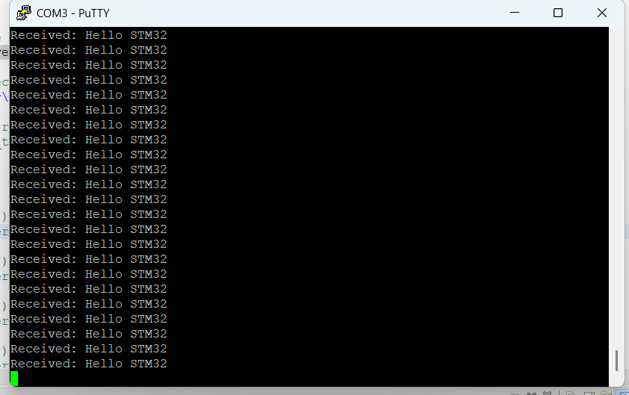
Figure 23: Raspberry directly connected to STM32 through SPI
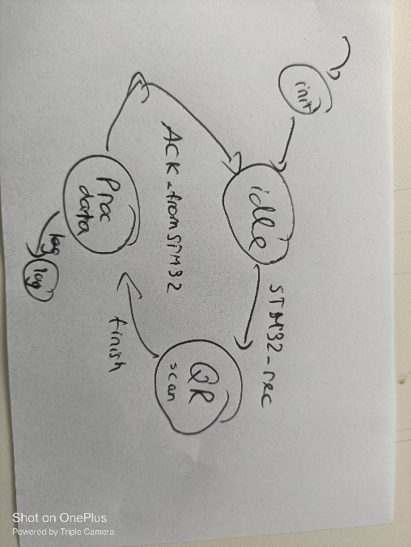
Figure 24:Updated state machine for Raspberry Pi
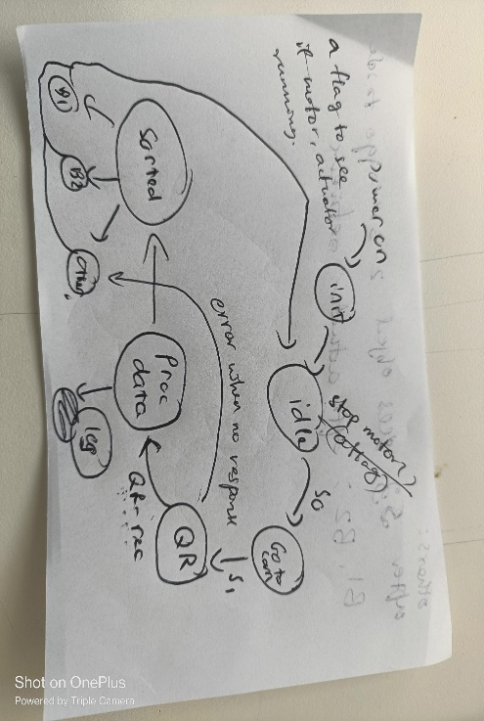
Figure 25:Updated state machine for STM32
Screenshots and video links:
- DC Motor, Conveyor working : video link
- All the sensors, Actuator and Conveyor working: video link

Proof of Software Working:

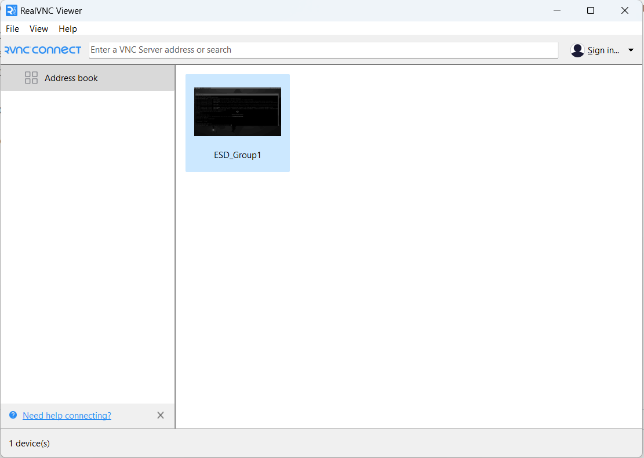
Figure 26: RealVNC installed

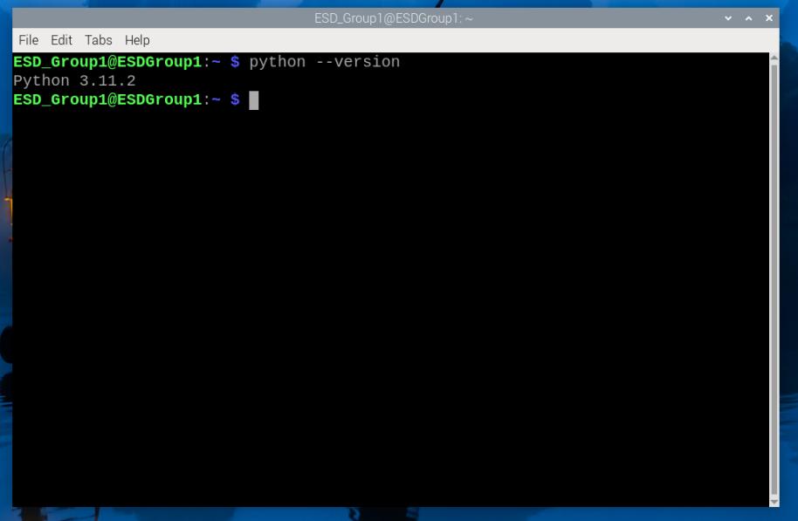
Figure 27: Installing Python
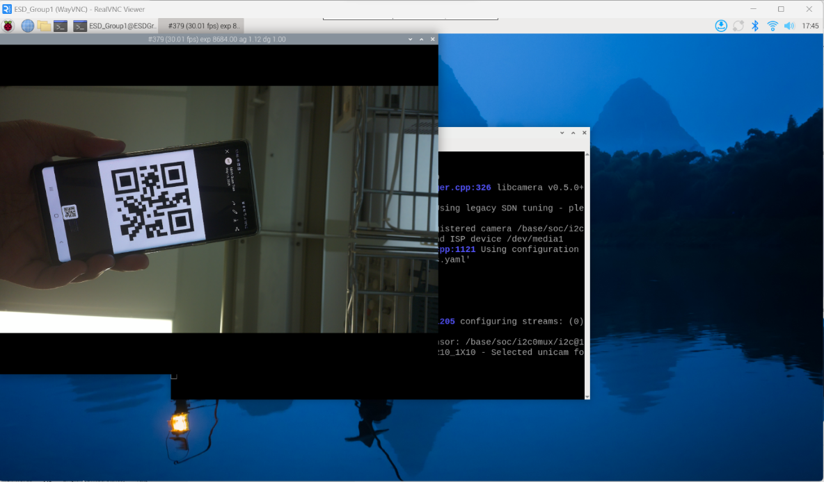
Figure 28: Testing Camera

Figure 29: Running Python's code to read QR code
Expand the python script to include publishing the QR data to AWSIoT cloud.

Figure 30: Publishing message to AWSIoT

Figure 31: Proof that the cloud receives the data

