2. Simulate the following CPU scheduling algorithms to find turnaround time and waiting time a) FCFS b) SJF c) Round Robin d) Priority.

a)FCFS

#include<stdio.h>

int main() {

intn,bt[20],wt[20],tat[20],avwt=0,avtat=0,i,j;

printf("Enter total number of processes(maximum 20): ");

scanf("%d",&n);

printf("\nEnter Process Burst Time:\n");

for(i=0;i<n;i++) {

printf("P[%d]: ",i+1);

scanf("%d",&bt[i]); }

wt[0]=0;

for(i=1;i<n;i++) {

wt[i]=0;

for(j=0;j<i;j++)

wt[i]+=bt[j]; }

printf("\nProcess\t\tBurst Time\tWaiting Time\tTurnaround Time");

//calculating turnaround time

for(i=0;i<n;i++) {

tat[i]=bt[i]+wt[i];

avwt+=wt[i];

avtat+=tat[i];

printf("\nP[%d]\t\t%d\t\t%d\t\t%d",i+1,bt[i],wt[i],tat[i]); }

avwt/=i;

avtat/=i;

printf("\n\nAverage Waiting Time:%d",avwt);

printf("\nAverage Turnaround Time:%d",avtat);

return 0;

}

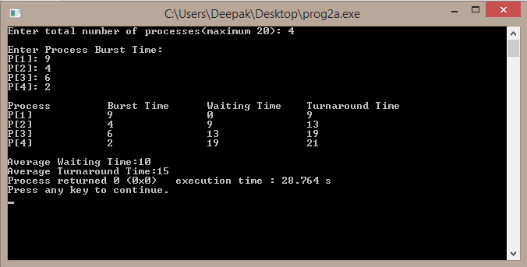

b) SJF

#include<stdio.h>

int main() {

intbt[20],p[20],wt[20],tat[20],i,j,n,total=0,pos,temp;

floatavg_wt,avg_tat;

printf("Enter number of process: ");

scanf("%d",&n);

printf("\nEnter Burst Time:\n");

for(i=0;i<n;i++) {

printf("p%d: ",i+1);

scanf("%d",&bt[i]);

p[i]=i+1; }

for(i=0;i<n;i++)

{ pos=i;

for(j=i+1;j<n;j++)

{ if(bt[j]<bt[pos])

pos=j; }

temp=bt[i];

bt[i]=bt[pos];

bt[pos]=temp;

temp=p[i];

p[i]=p[pos];

p[pos]=temp; }

wt[0]=0;

for(i=1;i<n;i++)

{ wt[i]=0;

for(j=0;j<i;j++)

wt[i]+=bt[j];

total+=wt[i]; }

avg_wt=(float)total/n;

total=0;

printf("\nProcess\t Burst Time \tWaiting Time\tTurnaround Time");

for(i=0;i<n;i++) {

tat[i]=bt[i]+wt[i];

total+=tat[i];

printf("\np%d\t\t %d\t\t %d\t\t\t%d",p[i],bt[i],wt[i],tat[i]);

}

avg_tat=(float)total/n;

printf("\n\nAverage Waiting Time=%f",avg_wt);

printf("\nAverage Turnaround Time=%f\n",avg_tat);

return 0; }

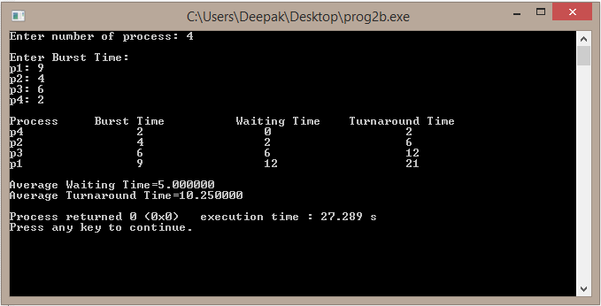

c) Round Robin

#include<stdio.h>

int main() {

intcount,j,n,time,remain,flag=0,time_quantum;

intwait_time=0,turnaround_time=0,at[10],bt[10],rt[10];

printf("Enter Total Process:\t ");

scanf("%d",&n);

remain=n;

for(count=0;count<n;count++)

{

printf("Enter Arrival Time and Burst Time for Process Process Number %d :",count+1); scanf("%d",&at[count]);

scanf("%d",&bt[count]);

rt[count]=bt[count]; }

printf("Enter Time Quantum:\t");

scanf("%d",&time_quantum);

printf("\n\nProcess\t|TurnaroundTime|Waiting Time\n\n");

for(time=0,count=0;remain!=0;) {

if(rt[count]<=time_quantum&&rt[count]>0) {

time+=rt[count]; rt[count]=0; flag=1; }

else if(rt[count]>0) {

rt[count]-=time_quantum;

time+=time_quantum; }

if(rt[count]==0 && flag==1) {

remain--;

printf("P[%d]\t|\t%d\t|\t%d\n",count+1,time-at[count],time-at[count]-bt[count]); wait_time+=time-at[count]-bt[count];

turnaround_time+=time-at[count]; flag=0; }

if(count==n-1)

count=0;

else

if(at[count+1]<=time)

count++;

else

count=0; }

printf("\nAverage Waiting Time= %f\n",wait_time*1.0/n);

printf("Avg Turnaround Time = %f",turnaround_time*1.0/n);

return 0; }

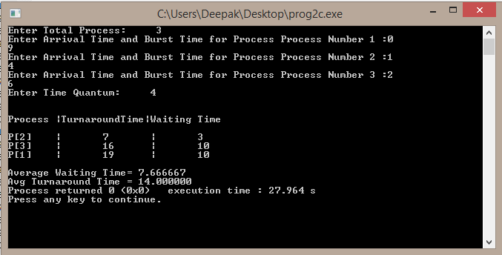

d) Priority

#include<stdio.h>

int main()

{

int bt[20],p[20],wt[20],tat[20],pr[20],i,j,n,total=0,pos,temp,avg_wt,avg_tat;

printf("Enter Total Number of Process:");

scanf("%d",&n);

printf("\nEnter Burst Time and Priority\n");

for(i=0;i<n;i++)

{

printf("\nP[%d]\n",i+1);

printf("Burst Time:");

scanf("%d",&bt[i]);

printf("Priority:");

scanf("%d",&pr[i]);

p[i]=i+1;

}

for(i=0;i<n;i++)

{

pos=i;

for(j=i+1;j<n;j++)

{

if(pr[j]<pr[pos])

pos=j;

}

temp=pr[i];

pr[i]=pr[pos];

pr[pos]=temp;

temp=bt[i];

bt[i]=bt[pos];

bt[pos]=temp;

temp=p[i];

p[i]=p[pos];

p[pos]=temp;

}

wt[0]=0;

for(i=1;i<n;i++)

{

wt[i]=0;

for(j=0;j<i;j++)

wt[i]+=bt[j];

total+=wt[i];

}

avg_wt=total/n;

total=0;

printf("\nProcess\t Burst Time \tWaiting Time\tTurnaround Time");

for(i=0;i<n;i++)

{

tat[i]=bt[i]+wt[i];

total+=tat[i];

printf("\nP[%d]\t\t %d\t\t %d\t\t\t%d",p[i],bt[i],wt[i],tat[i]);

}

avg_tat=total/n;

printf("\n\nAverage Waiting Time=%d",avg_wt);

printf("\nAverage Turnaround Time=%d\n",avg_tat);

return 0;

}

