Assignment 26/09/2025
(BHARATH T mr.bharath.t@gmail.com Reva University)

Step 1: Registering/Singing-up to the Chatbot Portal
I’m using the following credentials to register into that portal:
- Username: user2
- Password: 1234
- And after entering the username and password when I click on the Register, it’ll create a new account and display message like “Account created successfully! Please login.”
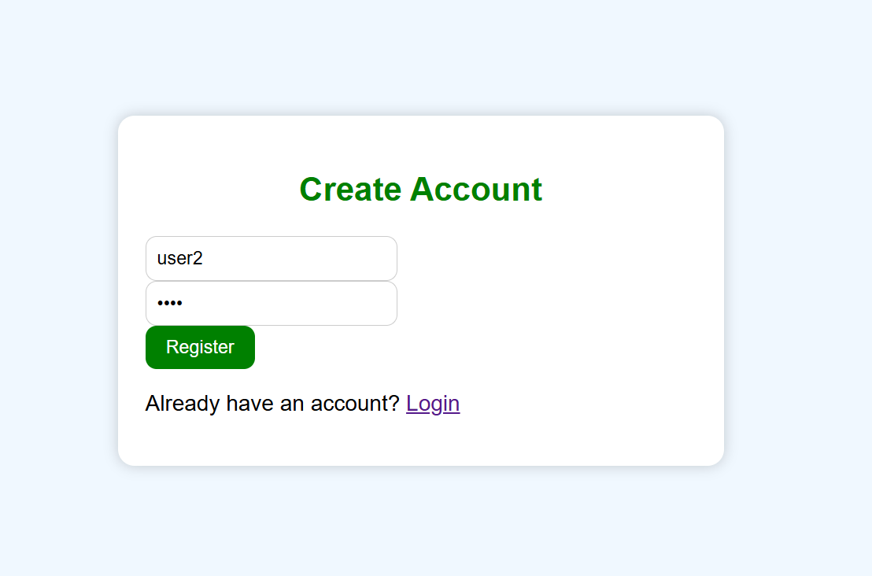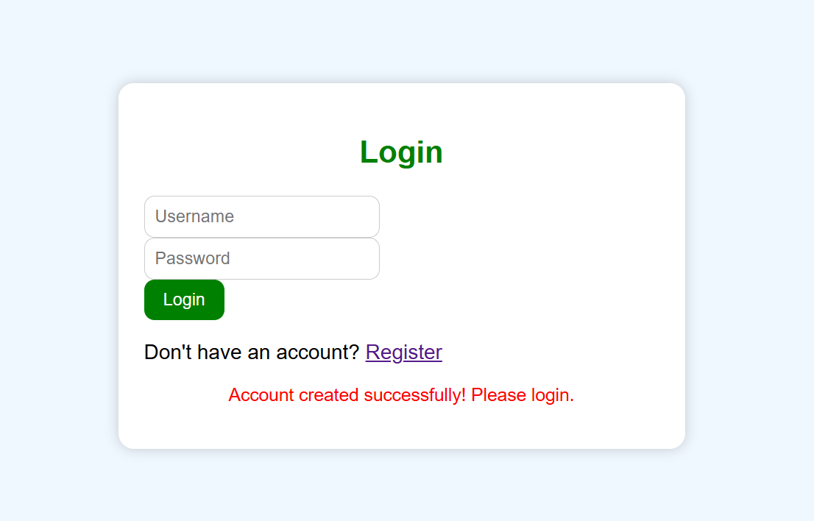

Step 2: Loging into the Chatbot portal using the user credentials (created while registering into the portal)
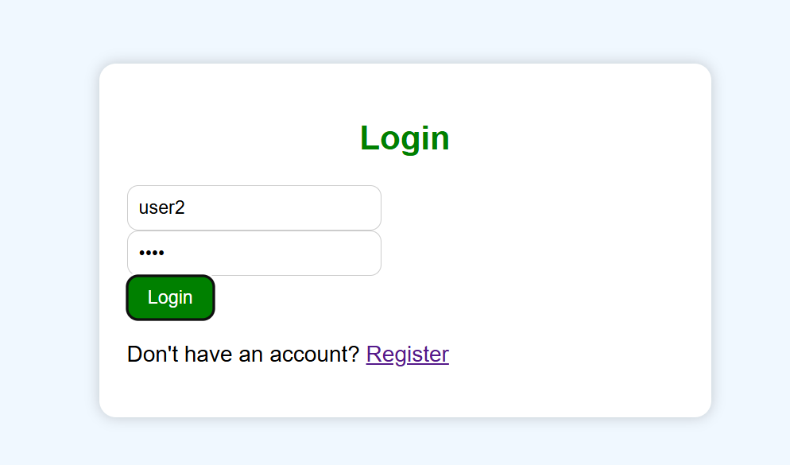
Step 3: After logging into the Chatbot portal, it navigates into the Chatbot interface it looks like a below image.
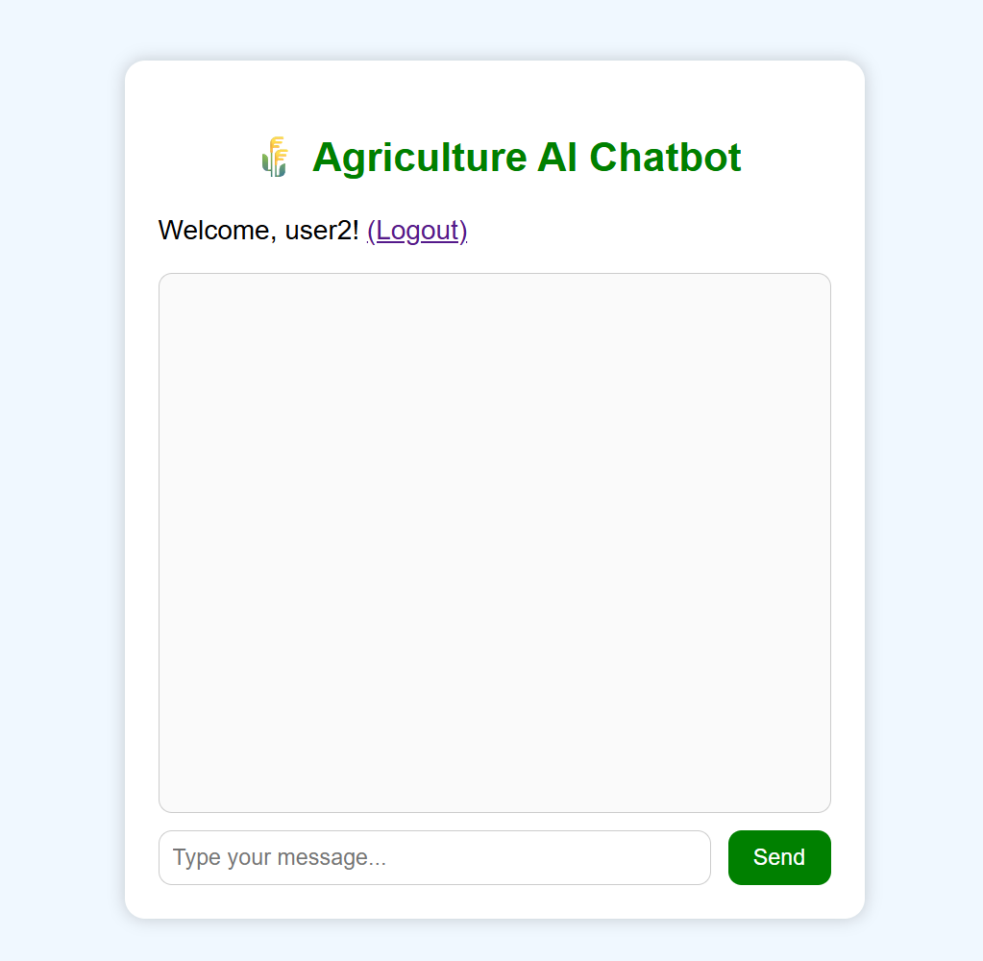

Step 4: After navigating to the Chatbot interface, user can ask queries to the bot which we have created!

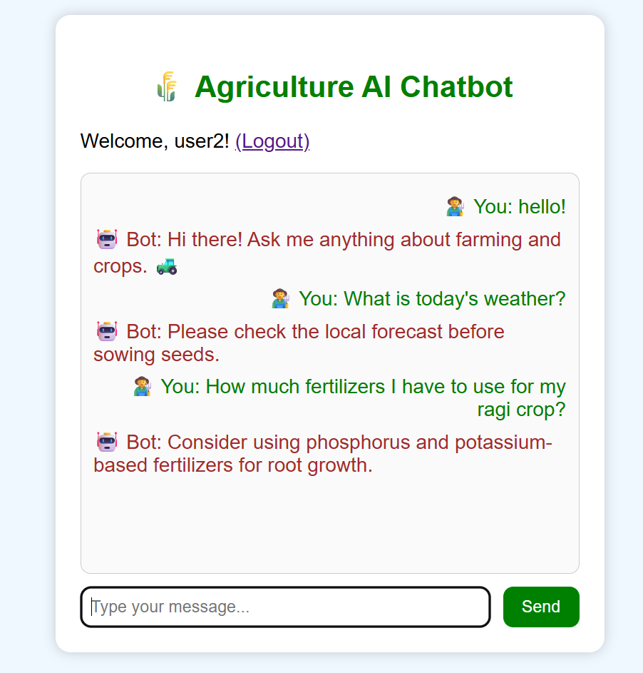

Step 5: Whenever you enter the unmatched pre-defined key words, it’ll display the default message like:
- "I'm not sure about that. Could you please rephrase?"
- "Sorry, I don't understand. Can you ask another question?"
You can see the image below:

