3rd Milestone Project Report

Title:
AI AgroBot – An Intelligent Agriculture Chat Assistant

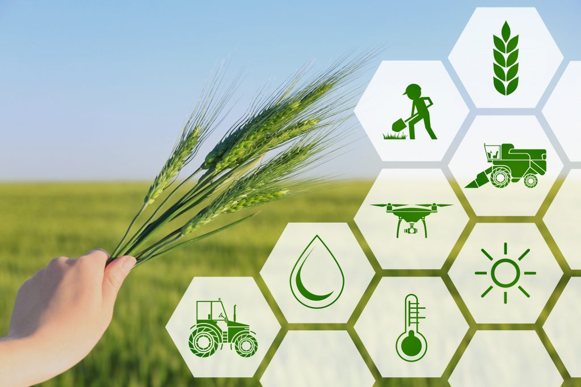

Student Name: BHARATH T
Mentor Name: V MANJULADEVI
Student Email: mr.bharath.t@gmail.com
College: REVA University
Location: Bengaluru
Project Statement
The AI AgroBot is an intelligent chatbot designed to assist farmers and agricultural enthusiasts by providing context-aware, multilingual guidance on farming practices such as crop management, soil health, fertilizer recommendations, and pest control.
The motivation behind this project is to bridge the information gap between farmers and reliable agricultural data sources using the power of Natural Language Processing (NLP) and Machine Learning (ML).
This system enables farmers to ask natural-language questions (in English or regional languages) and receive precise answers, even when offline, through a locally maintained knowledge base.
Key innovations:
- Bilingual/multilingual text processing
- Hybrid AI + offline knowledge-base architecture
- Flask-based real-time web chat interface
- Scalable modular backend with SQLite database integration

Outcomes
- Developed an AI-powered chatbot that responds intelligently to agricultural queries.
- Integrated multilingual support (English, Tamil, Hindi, Kannada, Malayalam, Telugu).
- Enabled offline knowledge-based fallback for when AI API is unavailable.
- Implemented chat history tracking and user session management.
- Designed a modular Flask-based architecture suitable for scaling to cloud deployment.

Modules to be Implemented
1. User Interface Module
- Built using HTML, CSS, and JavaScript within Flask templates.
- Allows farmers to enter queries and view AI or KB-based responses.
- Displays chat history and supports multilingual input.

2. Chat Processing Module
- Receives user input, processes it through either the AI model (OpenRouter/GPT API) or local KB.
- Performs text cleaning, keyword matching, and fallback response generation.
- Returns structured JSON responses to the frontend.

3. Database Module
- Manages user messages, AI responses, timestamps, and query types (AI or offline).
- Uses SQLAlchemy ORM for interaction with SQLite.
- Ensures data persistence and easy migration using flask db migrate.

4. Knowledge Base Module
- Uses a CSV file (knowledge_base.csv) containing multilingual agricultural data.
- Performs keyword matching to return the most relevant offline responses.
- Supports combined responses when multiple topics (e.g., soil + fertilizer) are detected.

5. Backend API Module
- Flask REST API with routes for chat requests, history fetching, and file downloads.
- Handles both synchronous and real-time token streaming responses.
- Ensures graceful fallback when the online AI model is unavailable.

Architecture Diagram

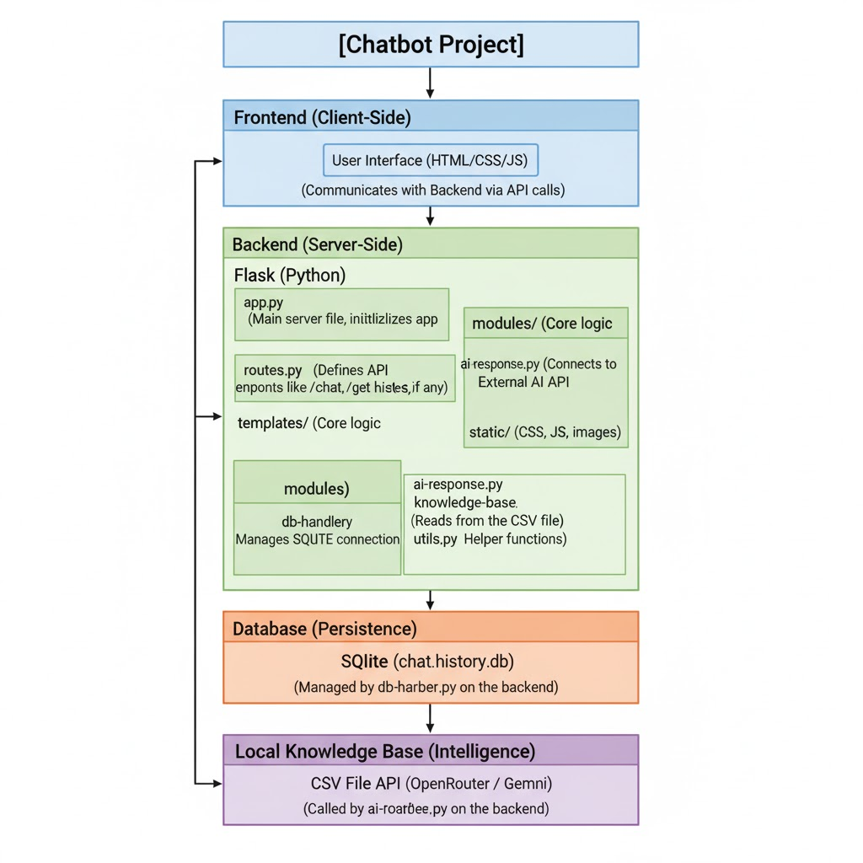

Database Schema
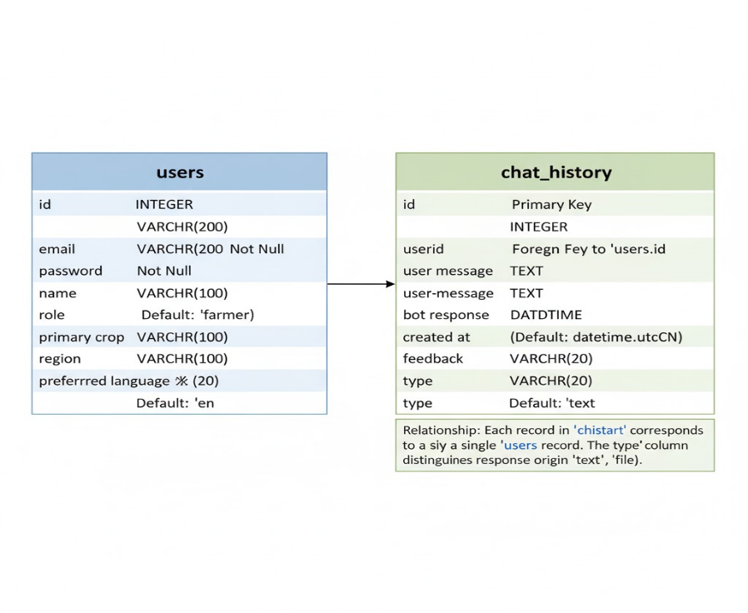
Code Snippet

database.py:
class User(UserMixin, db.Model):
__tablename__ = "users"
id = db.Column(db.Integer, primary_key=True)
email = db.Column(db.String(200), unique=True, nullable=False)
password = db.Column(db.String(200), nullable=False)
name = db.Column(db.String(100))
role = db.Column(db.String(20), default="farmer")
primary_crop = db.Column(db.String(100))
region = db.Column(db.String(100))
preferred_language = db.Column(db.String(20), default="en")

class ChatHistory(db.Model):
__tablename__ = "chat_history"
id = db.Column(db.Integer, primary_key=True)
user_id = db.Column(db.Integer, db.ForeignKey("users.id"), nullable=True)
user_message = db.Column(db.Text)
bot_response = db.Column(db.Text)
created_at = db.Column(db.DateTime, default=datetime.utcnow)
feedback = db.Column(db.String(20), nullable=True)

app.py:
@app.route("/api/image-analyze", methods=["POST"])
def image_analyze():
file = request.files.get("image")
if not file or not allowed_file(file.filename):
return jsonify({"error":"invalid_image"}), 400
filename = secure_filename(file.filename); save_path = os.path.join(app.config['UPLOAD_FOLDER'], filename); file.save(save_path)
try:
from PIL import Image
im = Image.open(save_path).convert('RGB').resize((200,200))
pixels = list(im.getdata())
greens = sum(1 for r,g,b in pixels if g>r+10 and g>b+10); total=len(pixels)
healthy_ratio = greens/total
if healthy_ratio < 0.05:
label="Severe discoloration / possible disease"; advice="Image shows low green content. Inspect plants."
elif healthy_ratio < 0.4:
label="Partial damage / early symptoms"; advice="Signs of stress. Check for pests."
else:
label="Likely healthy leaf"; advice="Leaf appears healthy."
return jsonify({"label":label,"advice":advice})
except Exception as e:
print("Image analyze error:",e)
return jsonify({"label":"image_received","advice":"Install Pillow for local analysis."})

chatbot_model.py:
def analyze_uploaded_file(file_path: str) -> str:
"""
Analyze an uploaded file (.pdf, .docx, .txt, .csv, .xlsx, .png, .jpg)
Extract text using textract/pytesseract and generate a summary (max 5000 chars).
"""
import mimetypes, csv, pandas as pd, pdfplumber
from PIL import Image
import pytesseract, textract, traceback

file_path = os.path.abspath(file_path)
ext = os.path.splitext(file_path)[1].lower()
text_content = ""

try:
# --- TEXT EXTRACTION BY FILE TYPE ---
if ext in [".txt"]:
with open(file_path, "r", encoding="utf-8", errors="ignore") as f:
text_content = f.read()

elif ext in [".pdf"]:
try:
with pdfplumber.open(file_path) as pdf:
pages = [page.extract_text() or "" for page in pdf.pages]
text_content = "\n".join(pages)
except Exception:
text_content = textract.process(file_path).decode("utf-8", errors="ignore")

elif ext in [".docx"]:
try:
doc = Document(file_path)
text_content = "\n".join(p.text for p in doc.paragraphs)
except Exception:
text_content = textract.process(file_path).decode("utf-8", errors="ignore")

elif ext in [".csv"]:
try:
with open(file_path, newline="", encoding="utf-8", errors="ignore") as f:
reader = csv.reader(f)
rows = list(reader)
text_content = "\n".join([", ".join(row) for row in rows[:100]]) # limit to first 100 rows
except Exception:
text_content = textract.process(file_path).decode("utf-8", errors="ignore")

elif ext in [".xlsx"]:
try:
df = pd.read_excel(file_path)
text_content = df.to_string(index=False)[:20000] # limit size
except Exception:
text_content = textract.process(file_path).decode("utf-8", errors="ignore")

elif ext in [".png", ".jpg", ".jpeg"]:
try:
img = Image.open(file_path)
text_content = pytesseract.image_to_string(img)
except Exception:
text_content = "Unable to extract text from the image."

else:
text_content = textract.process(file_path).decode("utf-8", errors="ignore")

# --- CLEAN & LIMIT TEXT ---
text_content = re.sub(r"\s+", " ", text_content or "").strip()
if not text_content:
return "No readable text could be extracted from the uploaded file."

# --- SUMMARIZATION PROMPT ---
summary_prompt = (
f"Analyze and summarize the following content in a clear, concise, AI-style manner. "
f"Limit the result to around 5000 characters. Preserve any important data, entities, or insights.\n\n"
f"=== FILE CONTENT START ===\n{text_content[:15000]}\n=== FILE CONTENT END ==="
)

# --- TRY AI SUMMARIZATION VIA OPENROUTER / OPENAI ---
summarized_text = ""
try:
if OPENROUTER_API_KEY:
headers = {
"Authorization": f"Bearer {OPENROUTER_API_KEY}",
"HTTP-Referer": APP_URL,
"X-Title": APP_NAME,
"Content-Type": "application/json"
}
payload = {
"model": OPENROUTER_MODEL,
"messages": [
{"role": "system", "content": "You are an intelligent summarization assistant."},
{"role": "user", "content": summary_prompt}
],
"max_tokens": 2000
}
resp = requests.post("https://openrouter.ai/api/v1/chat/completions", headers=headers, json=payload)
if resp.status_code == 200:
summarized_text = resp.json()["choices"][0]["message"]["content"].strip()

elif HAS_OPENAI:
import openai
resp = openai.ChatCompletion.create(
model="gpt-4o-mini",
messages=[
{"role": "system", "content": "You are an intelligent summarization assistant."},
{"role": "user", "content": summary_prompt},
],
max_tokens=2000
)
summarized_text = resp["choices"][0]["message"]["content"].strip()
except Exception as e:
print("AI summarization error:", e)

# --- FALLBACK (LOCAL BASIC SUMMARIZER) ---
if not summarized_text:
sentences = re.split(r'(?<=[.!?]) +', text_content)
summarized_text = " ".join(sentences[:20])
summarized_text = f"📄 Summary (local fallback):\n{summarized_text[:5000]}"

# Final limit
return summarized_text[:5000]

except Exception as e:
print("❌ analyze_uploaded_file() error:", e)
traceback.print_exc()
return "An error occurred while analyzing the uploaded file."

def process_message(user_profile: Dict[str,Any], message_text: str) -> str:
if not message_text or not message_text.strip(): return 'Please ask a question about crops, soil, or pests.'
detected = detect_language(message_text)
if HAS_GOOGLETRANS and detected != 'en':
try: english_text = translate_text(message_text, 'en')
except Exception: english_text = message_text
else:
english_text = message_text
kb_item = find_in_kb(english_text)
if kb_item:
lang = (user_profile.get('preferred_language') or detected or 'en')[:2]
ans = kb_item.get(lang) or kb_item.get('en') or next(iter(kb_item.values()), '')
if not ans and kb_item.get('en') and lang!='en' and HAS_GOOGLETRANS:
ans = translate_text(kb_item.get('en'), lang)
return ans
if HAS_OPENAI:
resp = openai_fallback(user_profile or {}, english_text, target_lang=(user_profile.get('preferred_language') or detected or 'en')[:2])
if resp: return resp
# Try OpenRouter next
resp = openrouter_fallback(user_profile or {}, english_text, target_lang=(user_profile.get('preferred_language') or detected or 'en')[:2])
if resp:
return resp

return "I don't have that answer in KB. Try asking about a specific crop or pest."

Index.html:
<div class="container">
<aside class="sidebar">
<h3>Your profile</h3>
{% if current_user.is_authenticated %}
<p><strong>{{ current_user.name or current_user.email }}</strong></p>
<p>Crop: {{ current_user.primary_crop or "—" }}</p>
<p>Region: {{ current_user.region or "—" }}</p>
<p>Lang: {{ current_user.preferred_language or "en" }}</p>
<a class="btn" href="{{ url_for('profile') }}">Edit profile</a>
{% else %}
<p><a href="{{ url_for('login') }}">Login</a> to save chat & see profile.</p>
{% endif %}
{% if recent_users %}
<hr>
<h4>Recent users (admin)</h4>
<ul class="user-list">
{% for u in recent_users %}
<li><a href="{{ url_for('admin_view_user', user_id=u.id) }}">{{ u.email }} - {{ u.name or '—' }}</a></li>
{% endfor %}
</ul>
{% endif %}
</aside>

<section class="chat-panel">
<div id="messages" class="messages" aria-live="polite"></div>

<!-- ✅ Chat form with file upload support -->
<form id="chatForm" class="chat-form" onsubmit="return false;">
<div class="input-group">
<!-- Attach button -->
<button id="attachBtn" type="button" class="btn attach-btn" title="Attach a file">📎</button>

<!-- Hidden file input -->
<input type="file" id="file-input"
accept=".jpg,.jpeg,.png,.pdf,.docx,.txt,.csv,.xlsx"
style="display:none;">

<!-- Message input -->
<input id="msg"
aria-label="Type your question"
placeholder="Ask about crops, pests or soil (e.g. 'best soil for cotton')"
autocomplete="off">

<!-- Send button -->
<button id="sendBtn" type="button" class="btn send-btn">Send</button>
</div>

admin_dashboard.html

<h2>Admin dashboard</h2>
<div class="admin-grid">
<section class="admin-kb">
<h3>Knowledge Base</h3>
<form method="post" action="{{ url_for('admin_edit_kb') }}">
<textarea name="kb_data" rows="14">{{ kb_content }}</textarea>
<div class="actions"><button class="btn" type="submit">Save KB</button></div>
</form>
<h4>Import KB (CSV)</h4>
<form method="post" action="{{ url_for('admin_upload_kb_csv') }}" enctype="multipart/form-data">
<input type="file" name="csv_file" accept=".csv" required><div class="actions"><button class="btn" type="submit">Upload CSV</button></div>
<small>CSV columns: keywords,answer_en,answer_hi,answer_ta,answer_ka,answer_ma,answer_te</small>
</form>
</section>
<section class="admin-chats">
<table class="table"><thead><tr><th>ID</th><th>Email</th><th>Name</th><th>Role</th><th>Action</th></tr></thead><tbody>{% for u in users %}<tr><td>{{ u.id }}</td><td>{{ u.email }}</td><td>{{ u.name }}</td><td>{{ u.role }}</td><td>{% if u.role!='admin' %}<form method="post" action="{{ url_for('admin_delete_user', user_id=u.id) }}"><button class="btn small" type="submit" onclick="return confirm('Delete user?')">Delete</button></form>{% endif %}</td></tr>{% endfor %}</tbody></table>
</section>
</div>
<h3>Recent Conversations</h3>

<form method="post" action="{{ url_for('admin_clear_chats') }}" onsubmit="return confirm('Are you sure you want to delete all chat history?');">
<button class="btn danger" type="submit">🧹 Clear All Chat History</button>
</form>
<br>

<table class="table">
<thead>
<tr><th>User</th><th>Message</th><th>Reply</th><th>Time</th></tr>
</thead>
<tbody>
{% for c in chats %}
<tr>
<td>{{ c.user_id or 'Guest' }}</td>
<td>{{ c.user_message }}</td>
<td>{{ c.bot_response }}</td>
<td>{{ c.created_at }}</td>
</tr>
{% endfor %}
</tbody>
</table>

login.html:
<div class="auth-card">
<h2>Login</h2>
<form method="post">
<label>Email<input name="email" type="email" required></label>
<label>Password<input name="password" type="password" required></label>
<div class="actions"><button type="submit" class="btn">Login</button><a href="{{ url_for('register') }}" class="muted">Register</a></div>
</form>
</div>

register.html:
<div class="auth-card">
<h2>Create account</h2>
<form method="post">
<label>Name<input name="name" type="text"></label>
<label>Email<input name="email" type="email" required></label>
<label>Password<input name="password" type="password" required></label>
<label>Primary crop<input name="primary_crop" type="text"></label>
<label>Region<input name="region" type="text"></label>
<label>Preferred language<select name="preferred_language"><option value="en">English</option><option value="hi">Hindi</option><option value="ta">Tamil</option><option value="ka">Kannada</option><option value="ma">Malayalam</option><option value="te">Telugu</option></select></label>
<div class="actions"><button class="btn" type="submit">Register</button></div>
</form>
</div>

admin_view_user.html:

<h2>User Details</h2>
<p><strong>Email:</strong> {{ user.email }}</p>
<p><strong>Name:</strong> {{ user.name }}</p>
<p><strong>Role:</strong> {{ user.role }}</p>

<h3>Chat History</h3>
{% if chats %}
<ul>
{% for c in chats %}
<li><b>You:</b> {{ c.user_message }}<br><b>Bot:</b> {{ c.bot_response }}</li>
{% endfor %}
</ul>
{% else %}
<p>No chats found for this user.</p>

Output (Simulation)

For The Guest User:
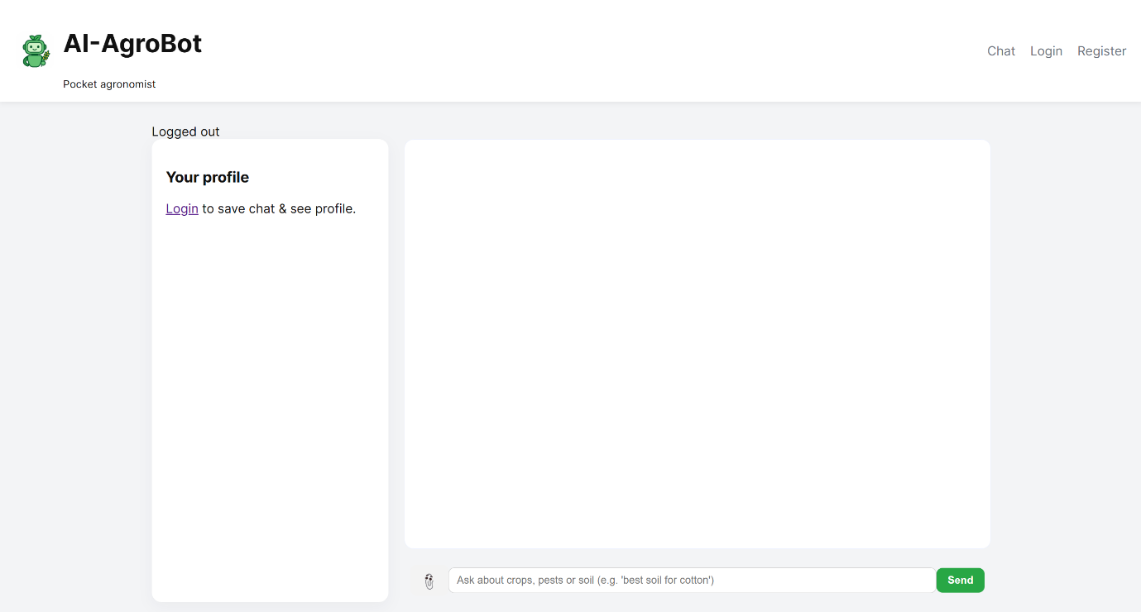

Registration Page: Users can Register into portal using this!
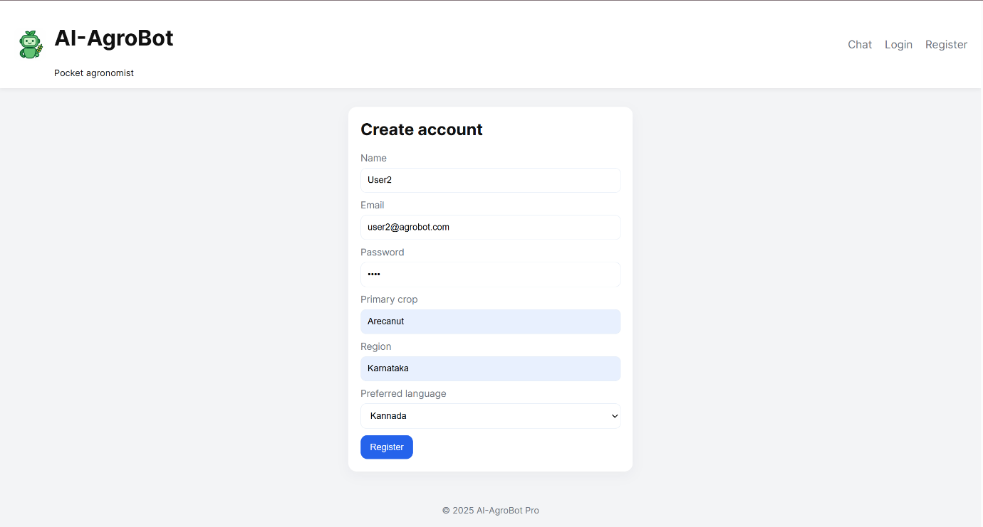
Login Page: Registered users can login with their credentials!

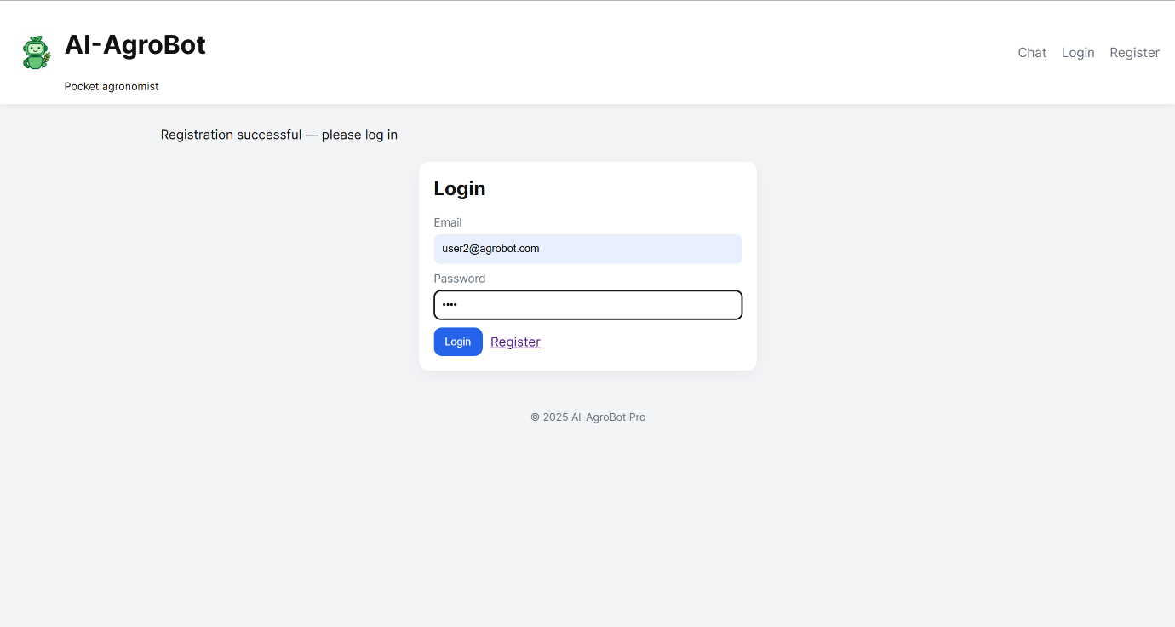
ChatBot Interface: This is a common interface for everyone!
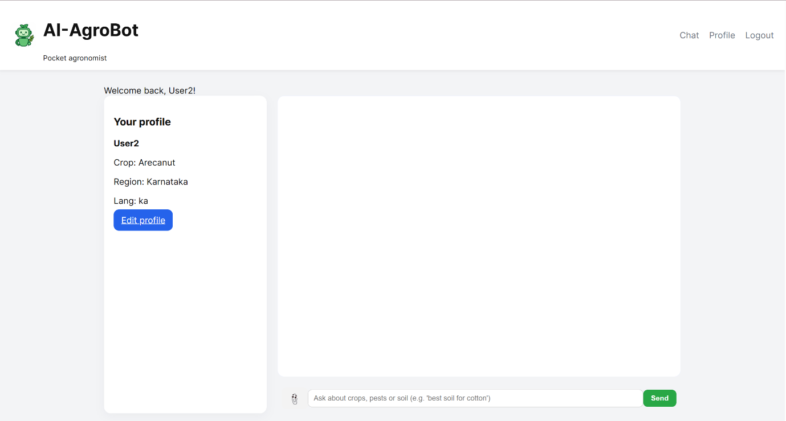

Admin ChatBot Interface: This can only be accessed by admin!

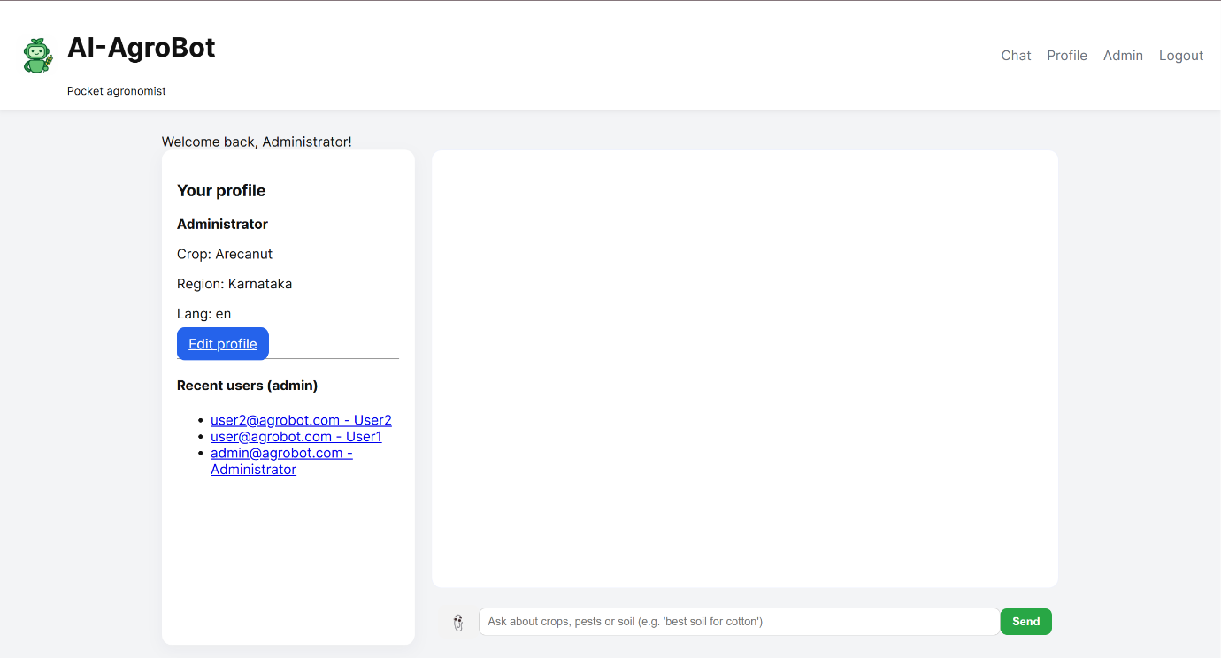

Admin Dashboard: Admin can handle knowledge base, user’s account and their recent conversations!
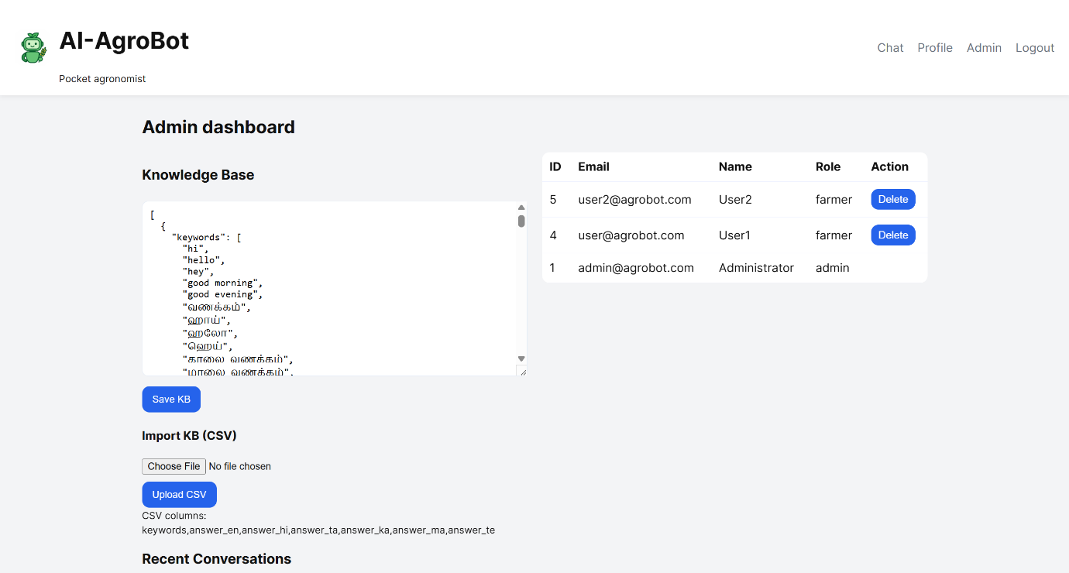

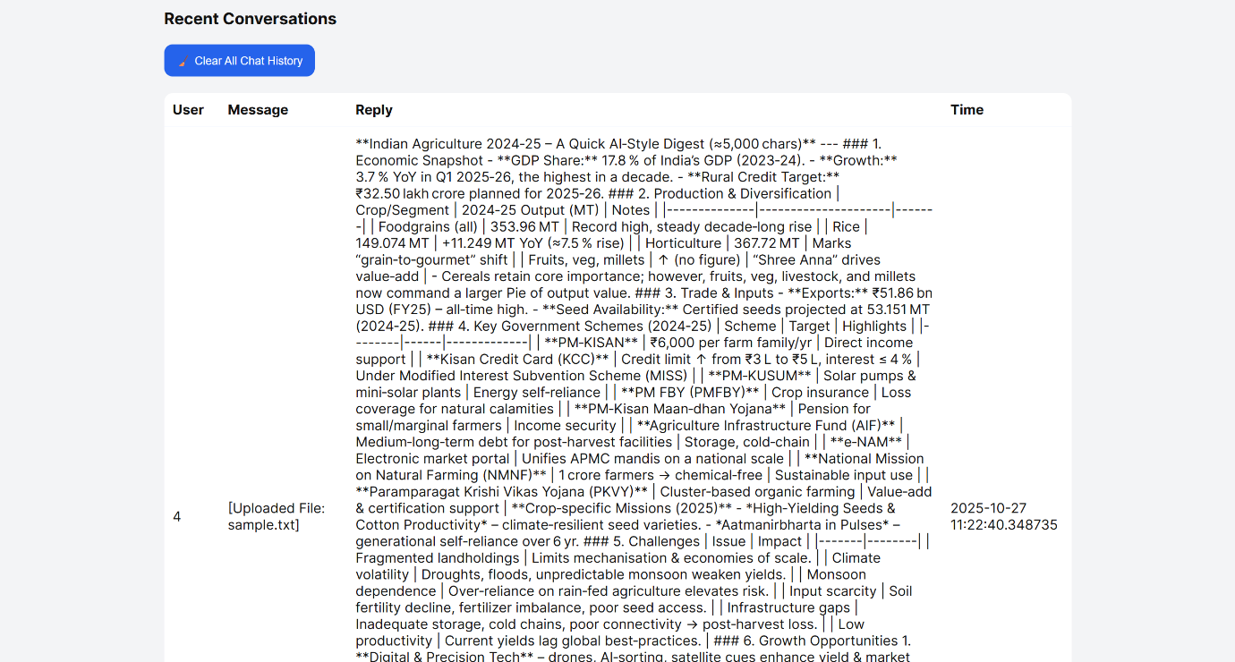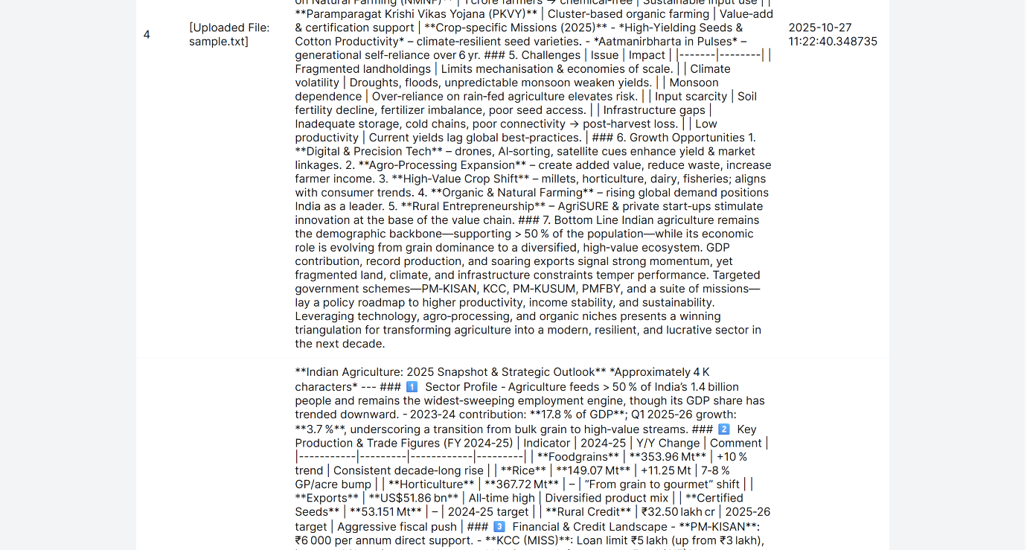

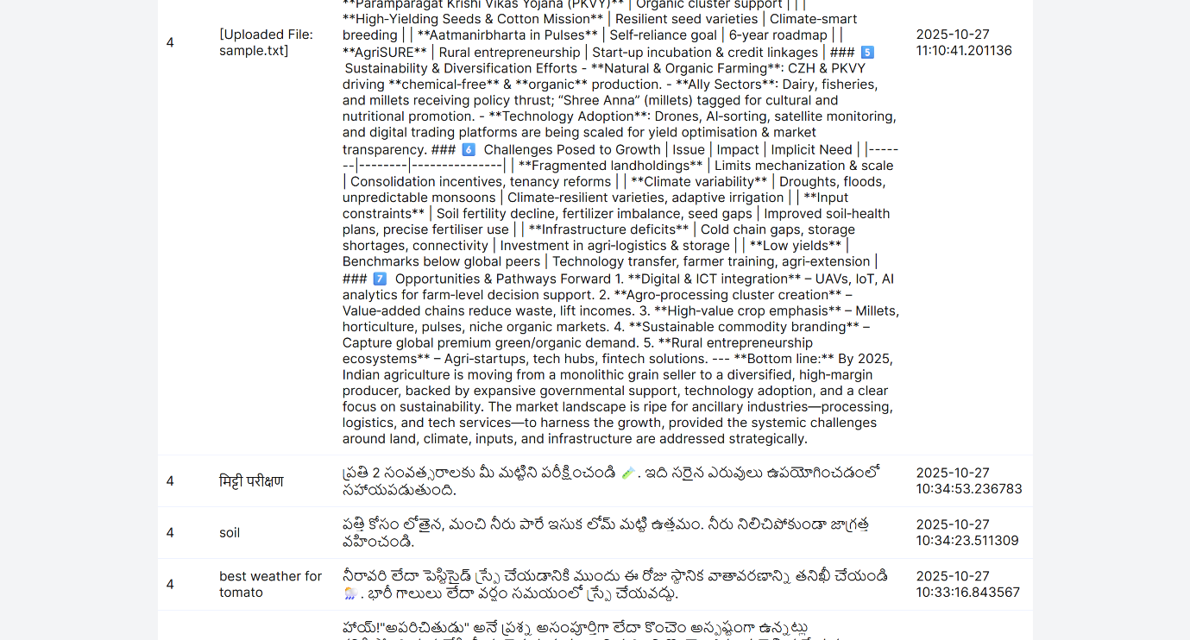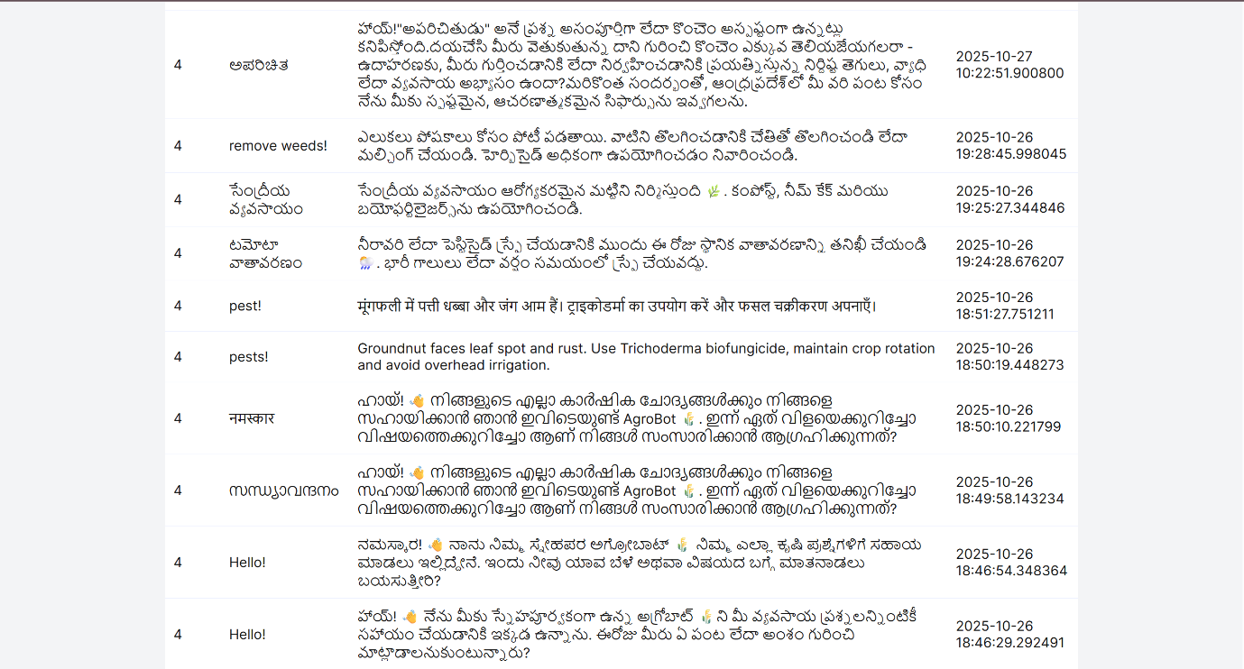

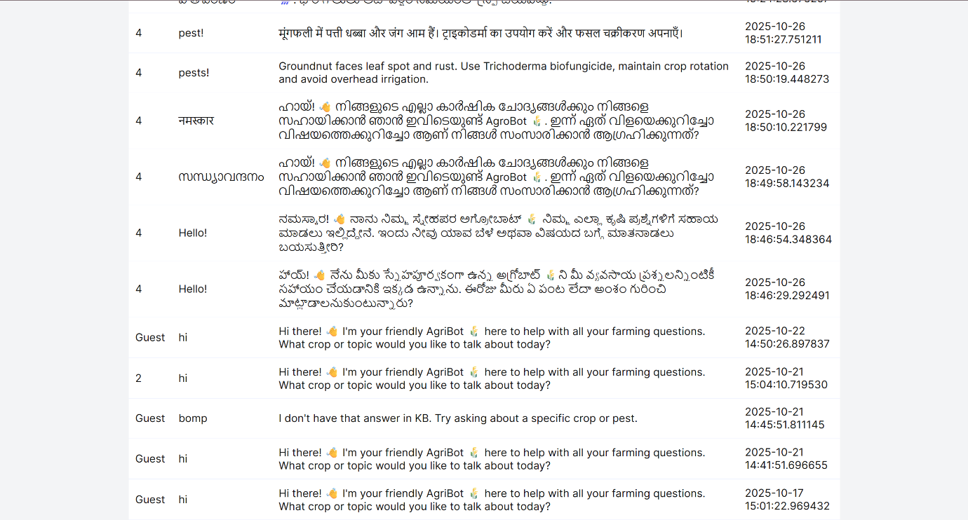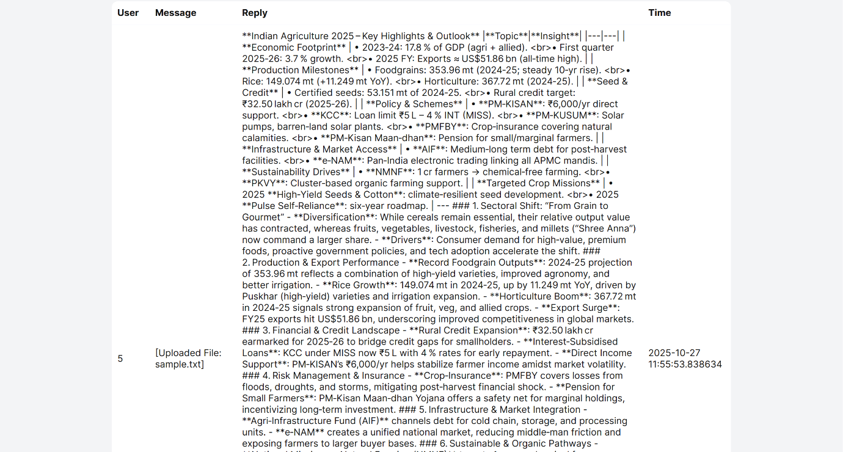

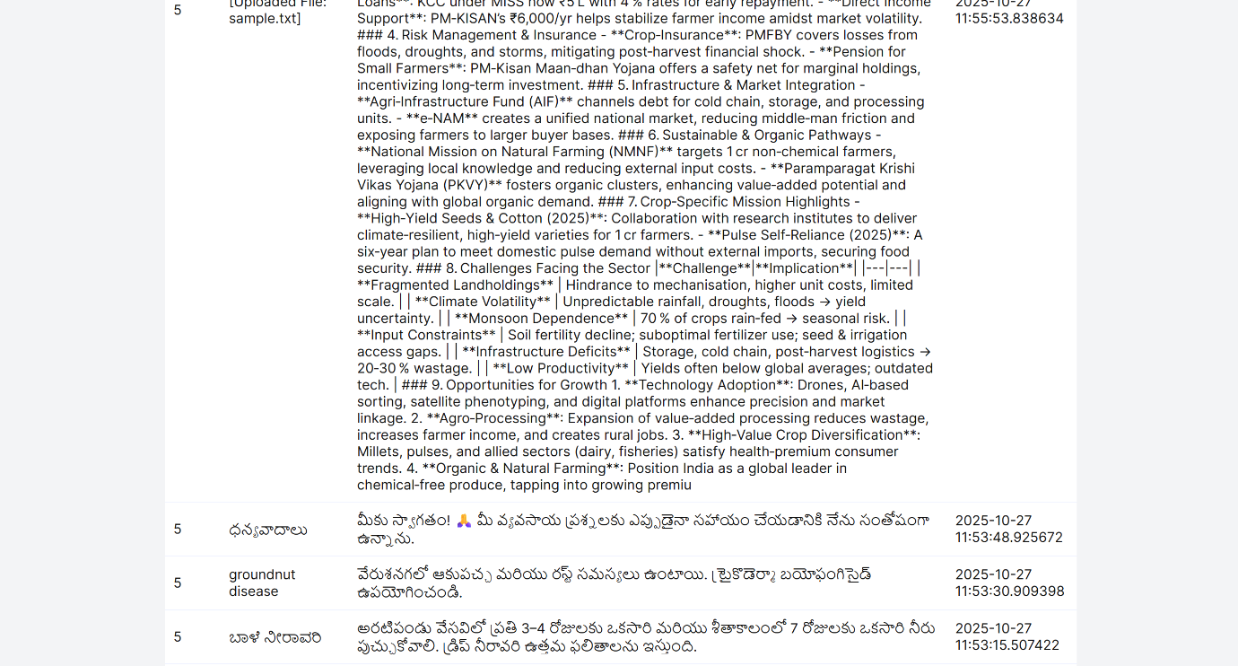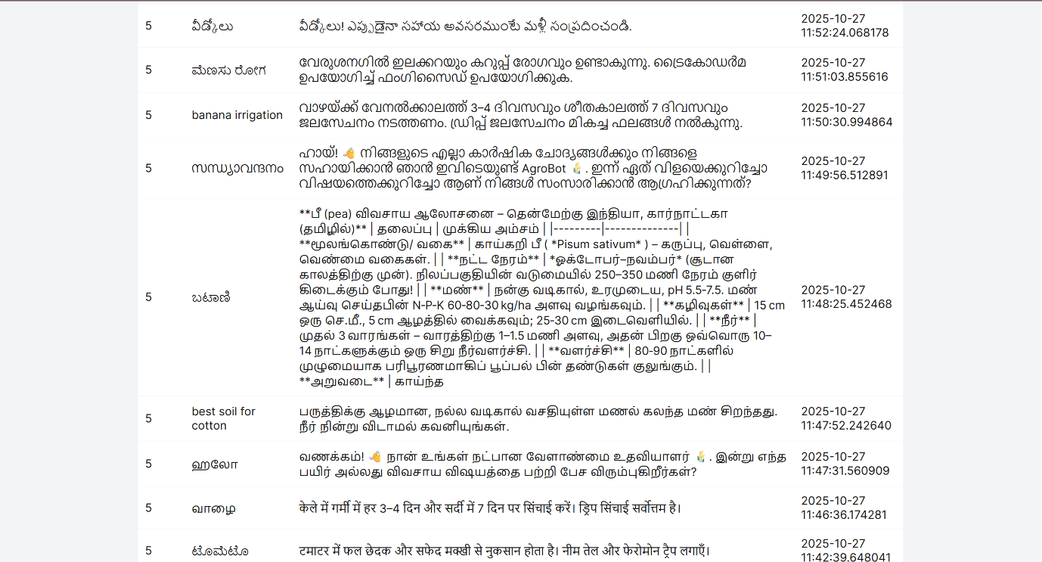

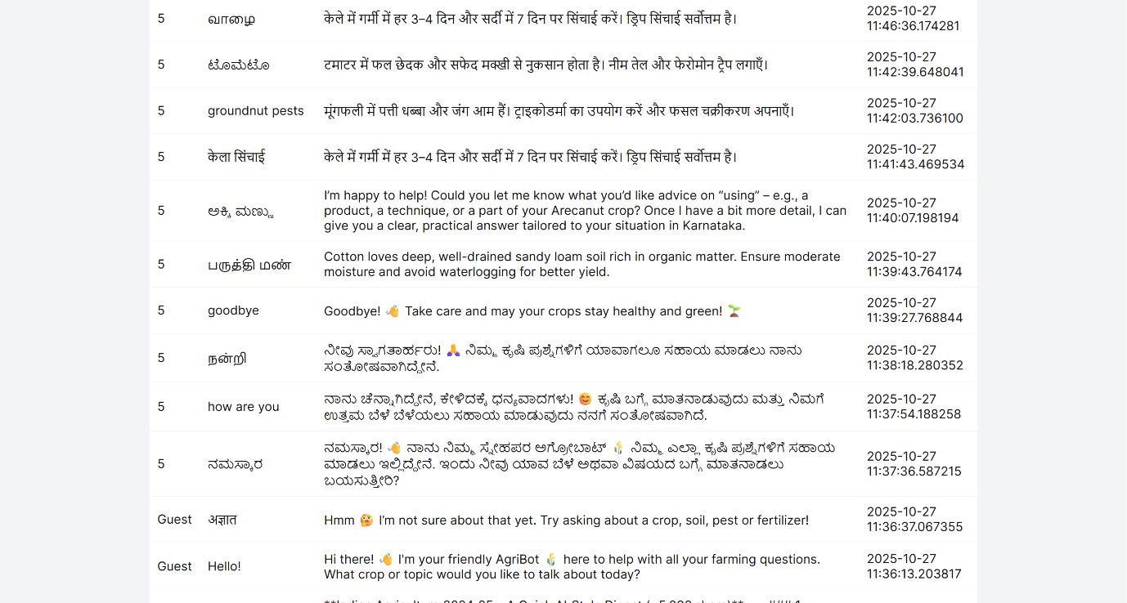
A user interacting with a bot in KANNADA:
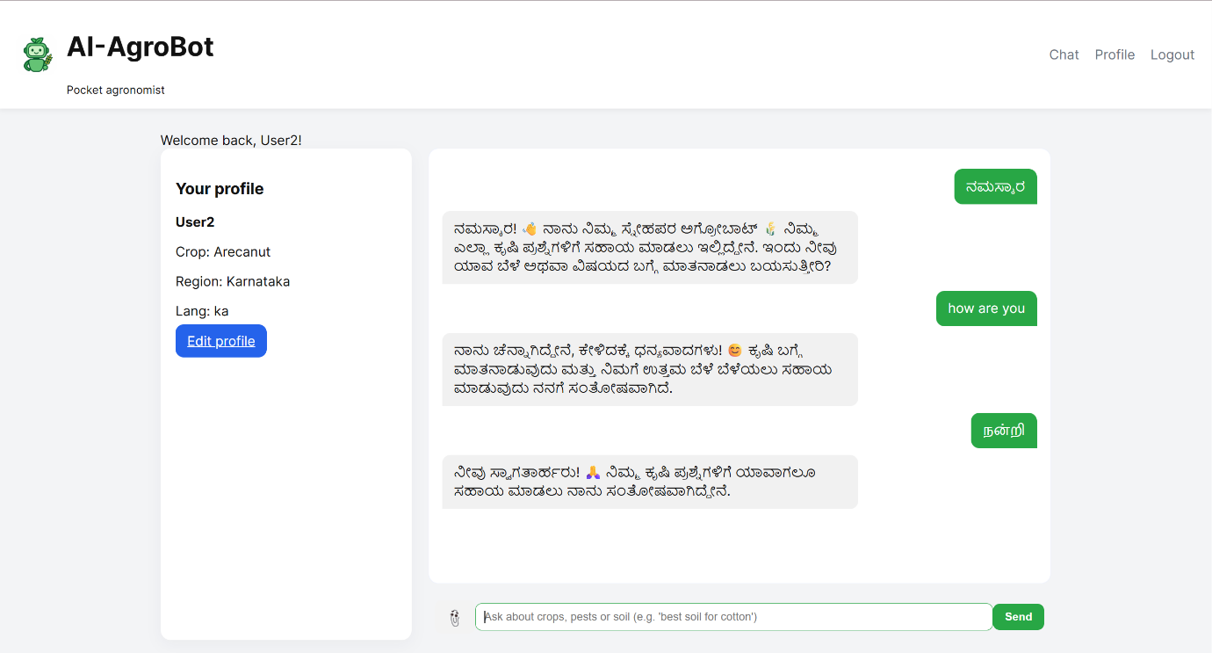
A user interacting with a bot in ENGLISH: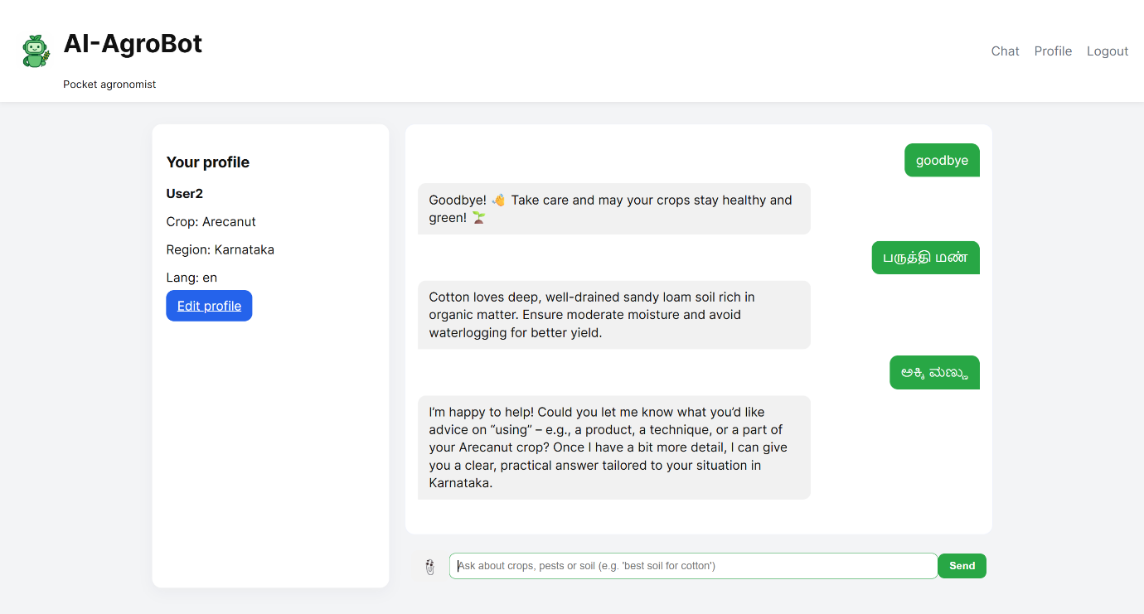
A user interacting with a bot in HINDI:
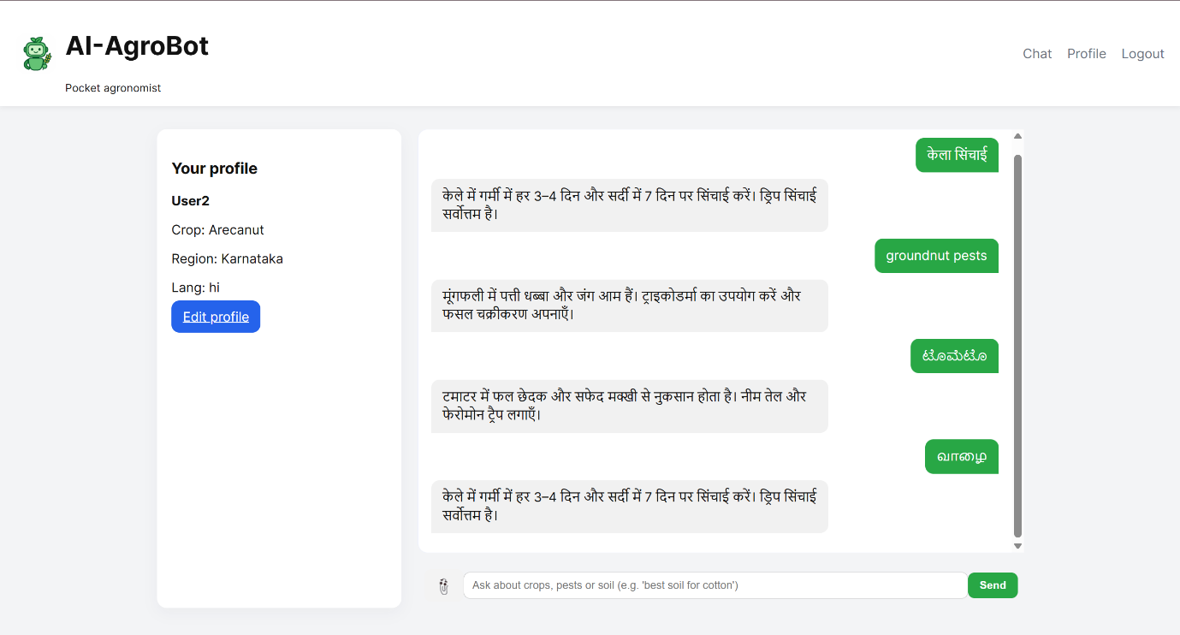
A user interacting with a bot in TAMIL:
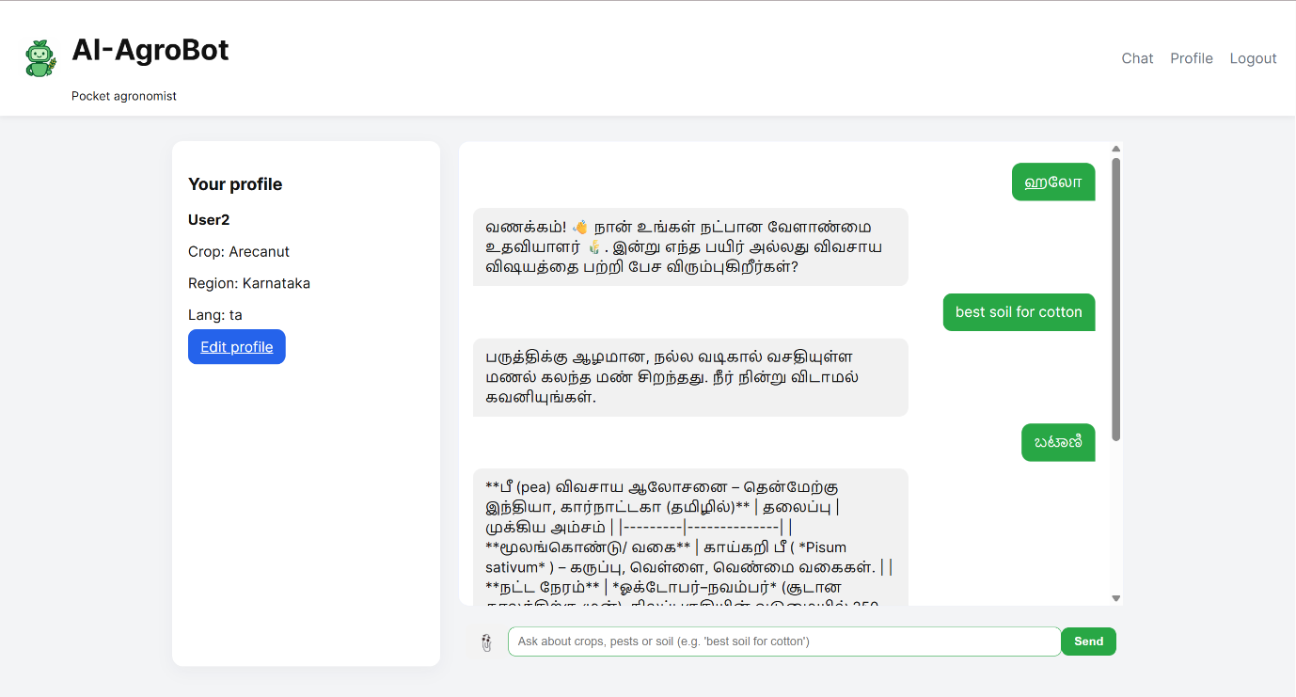
A user interacting with a bot in TAMIL: (Continued)
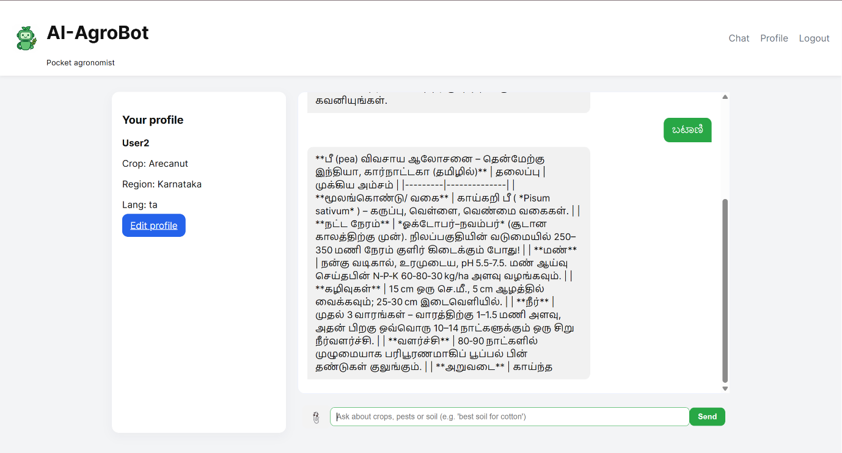
A user interacting with a bot in MALAYALAM:
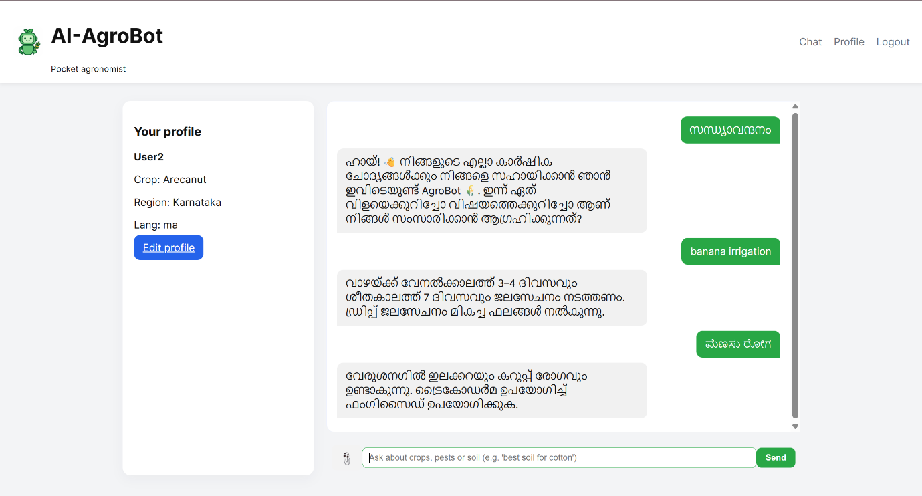
A user interacting with a bot in TELUGU:
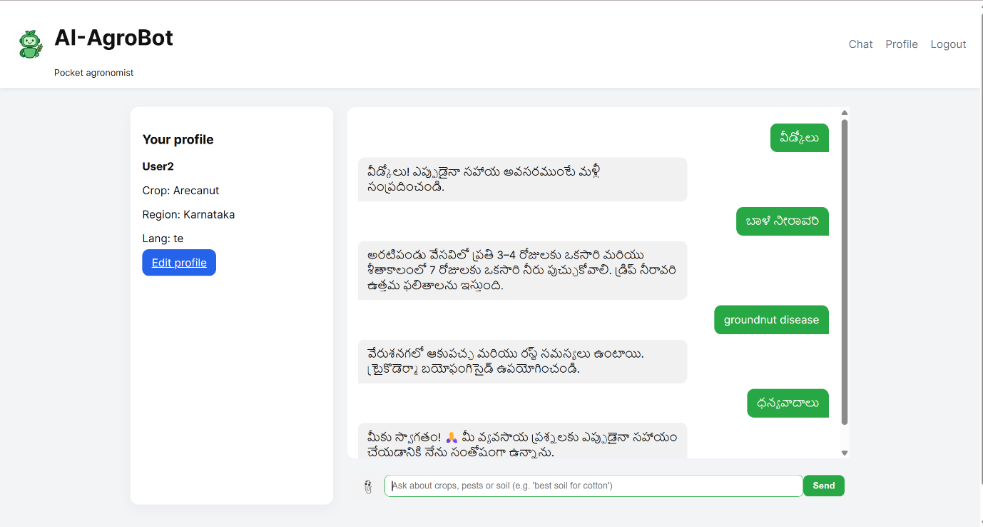
The user attached the file (.txt, .xlsx, .csv, .pdf, .jpg, .jpeg, .png, .docx, etc.) and asked the model to summarize the attached file within 5000 characters with the help of AI (OpenRouter):
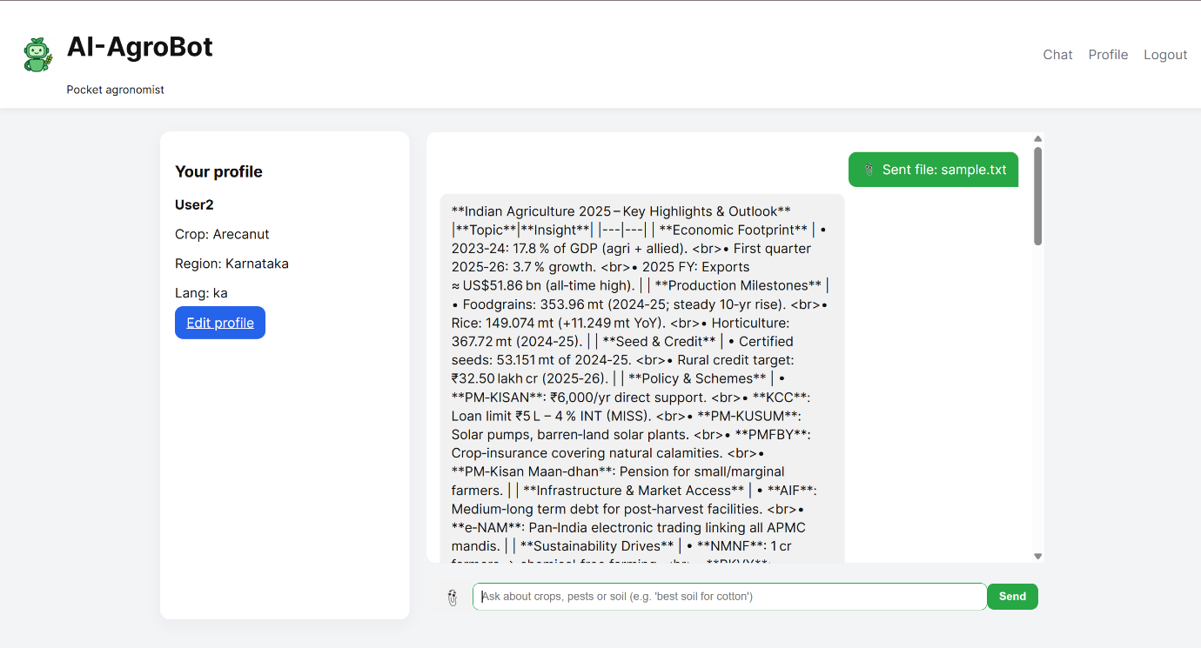
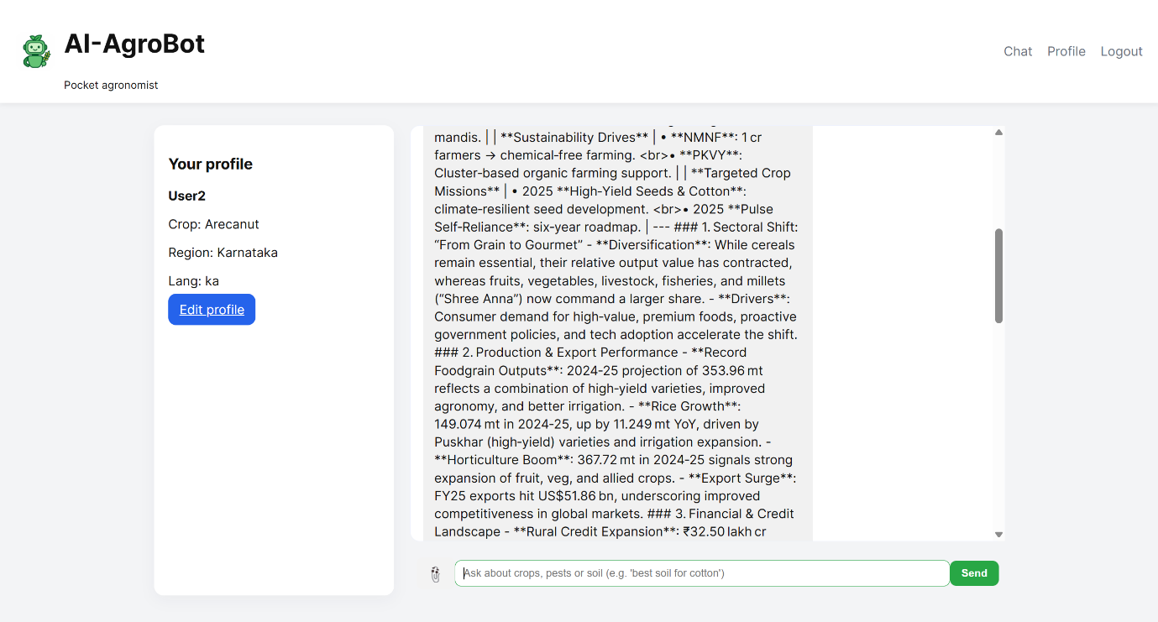
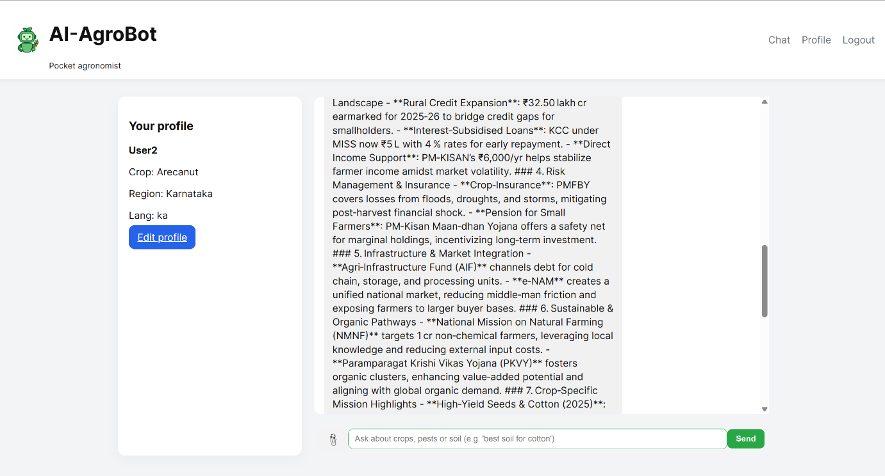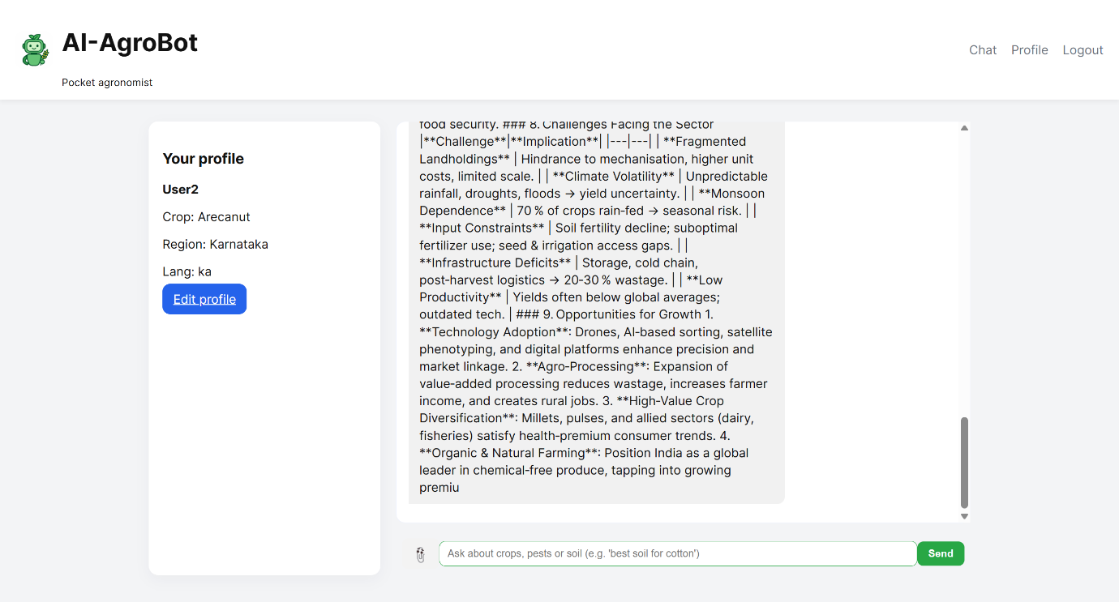

Conclusion
The AI AgroBot successfully demonstrates how NLP and AI can empower the agricultural sector by delivering expert guidance instantly.
Its hybrid online–offline architecture ensures reliability even in low-connectivity rural environments.
Key achievements:
- Functional multilingual AI assistant
- Robust database-backed architecture
- Scalable, modular design ready for cloud deployment

Future Enhancements:
- Integration of voice-based input and TTS (text-to-speech) for accessibility
- Mobile app and IoT sensor integration for real-time crop monitoring
- Enhanced KB with periodic cloud synchronization and community-driven updates

