2nd Milestone Project Report

Title
🌾 Agro Chatbot — AI-Powered Agriculture Assistant

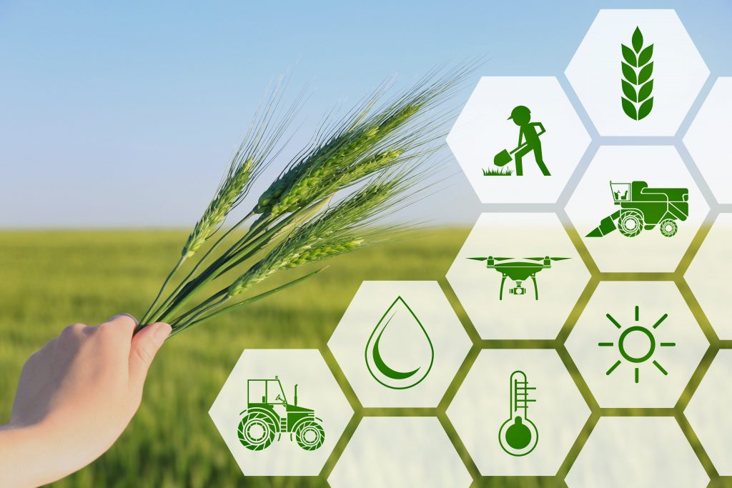

Student Name: BHARATH T
Mentor Name: V MANJULADEVI
Student Email: mr.bharath.t@gmail.com
College: REVA University
Location: Bengaluru
Project Type: Full-Stack Web Application

Technologies Used:
- Backend: Python, Flask, Flask-SQLAlchemy
- Database: SQLite
- Frontend: HTML, CSS, jQuery, Bootstrap (optional)
- AI/ML: DeepSeek (OpenRouter API), Google Translator, LangDetect
- Other Libraries: Requests, dotenv, werkzeug.security

Project Description:
Agro Chatbot is an AI-driven agriculture assistant designed to help farmers and agriculture students interactively. It provides guidance on crops, soil, pests, fertilizers, harvest, and more. The system supports multiple languages and keeps a history of user interactions for both users and administrators.

Key Features
- Multi-Language AI Chatbot
  - Supports English, Tamil, Hindi, Telugu, Malayalam, Kannada.
  - Answers questions related to agriculture using a combination of:
    - Offline knowledge base (predefined responses from agro_queries.py)
    - DeepSeek OpenRouter AI model for dynamic and intelligent responses
  - Automatically detects user input language and translates AI responses to the desired language using GoogleTranslator.

ChatBot User Interface:
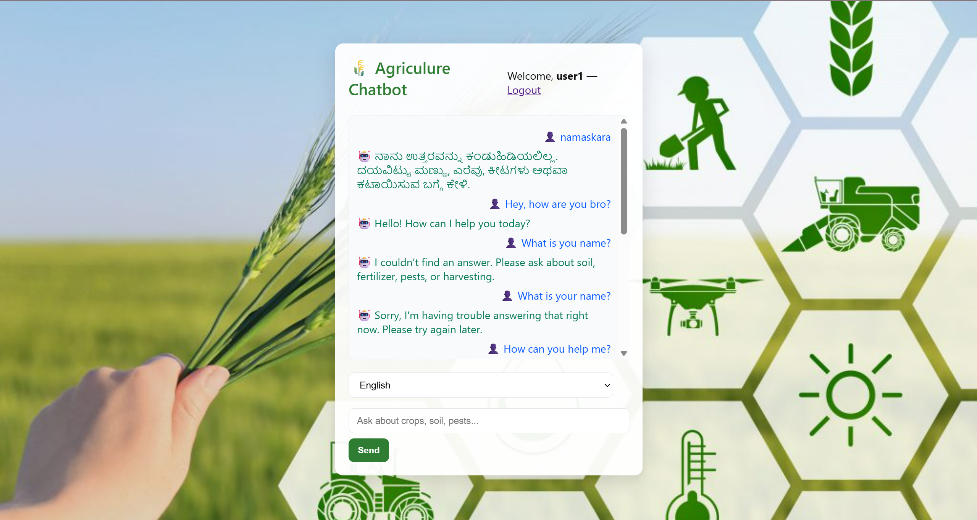

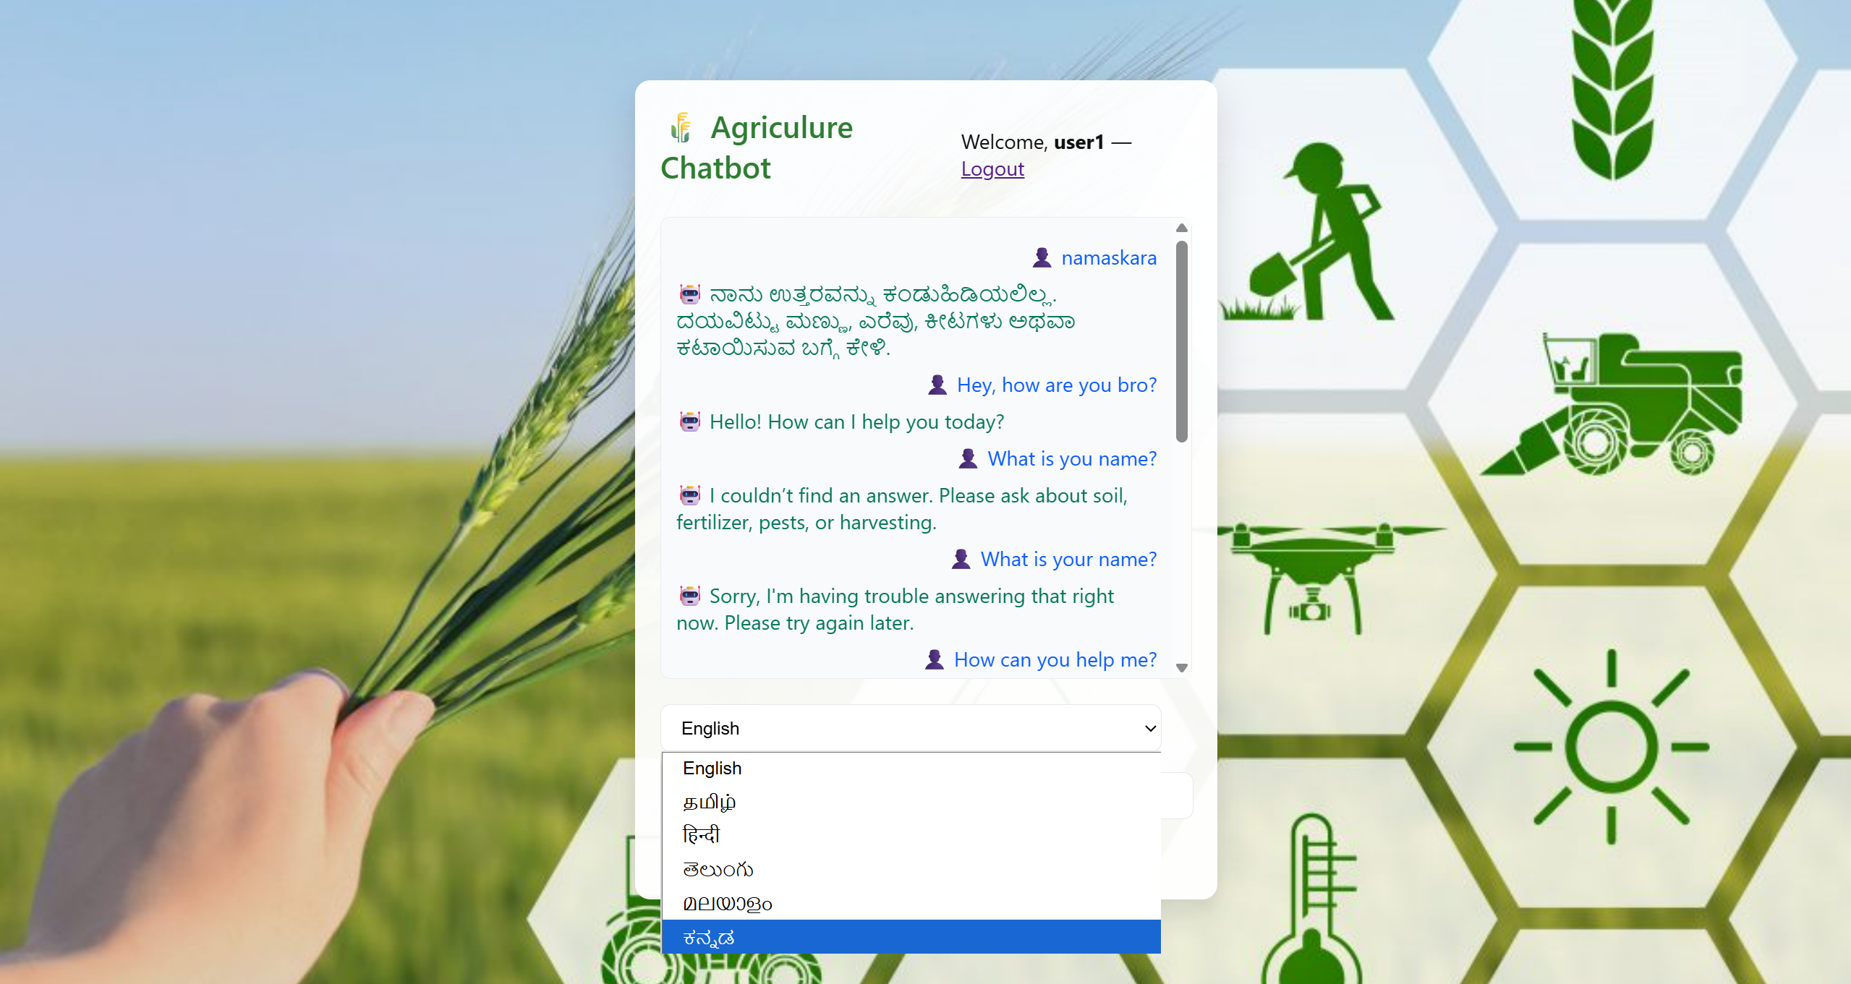

- User Authentication & Registration
  - Users can register and login securely.
  - Passwords are hashed using werkzeug.security.

Register Page:
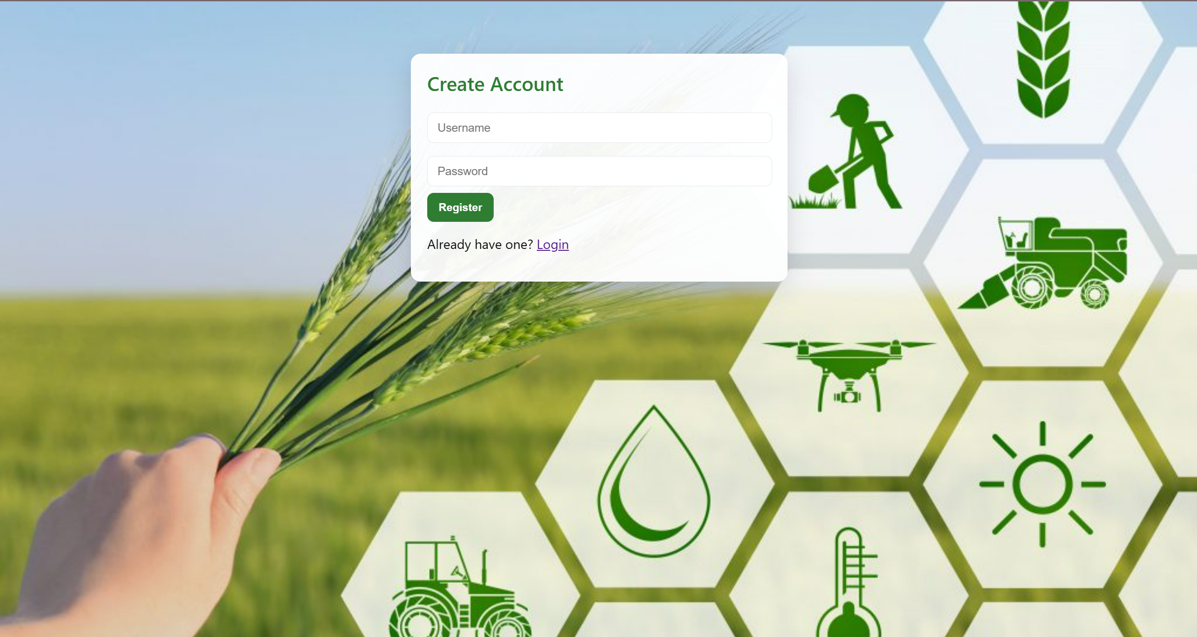

Login Page:
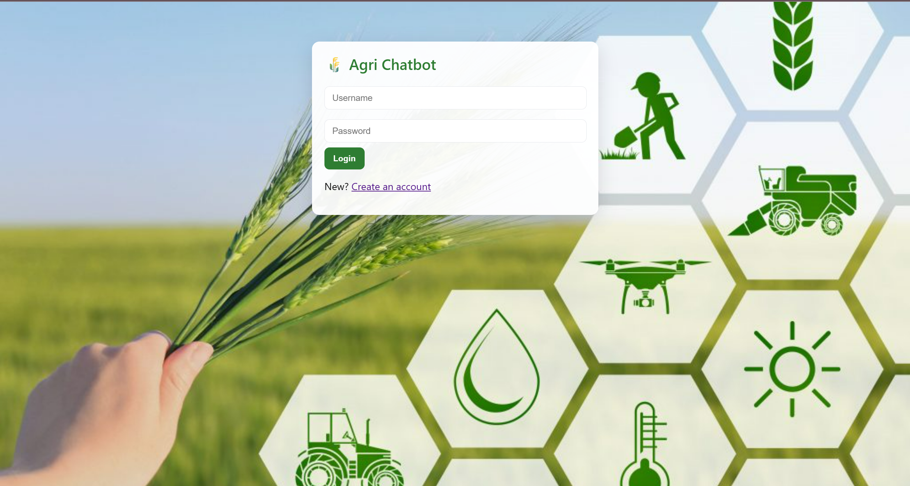

Admin Login Page:
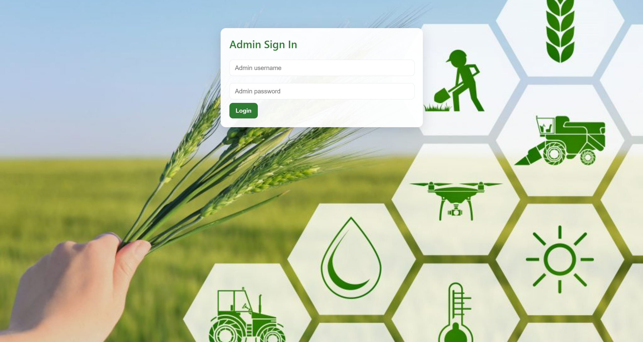

- Admin Dashboard
  - Admin can login using a separate credential (admin/admin123 by default).
  - Admin can view chat history, search messages, download CSV, and clear chat history.

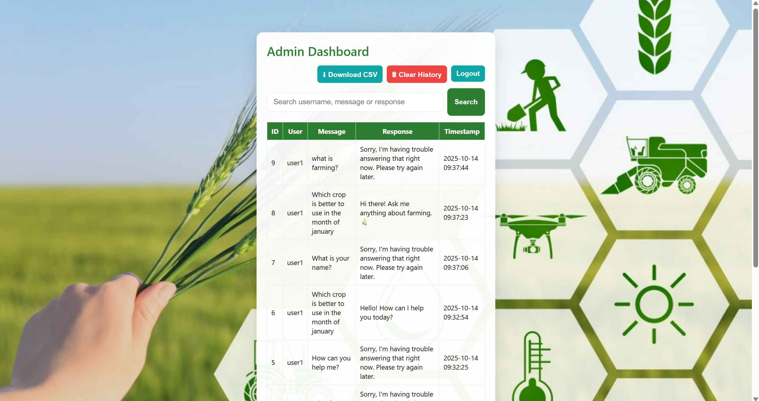
- Persistent Chat History
  - User queries and AI responses are stored in SQLite database using SQLAlchemy ORM.
  - Admin can analyze all interactions.

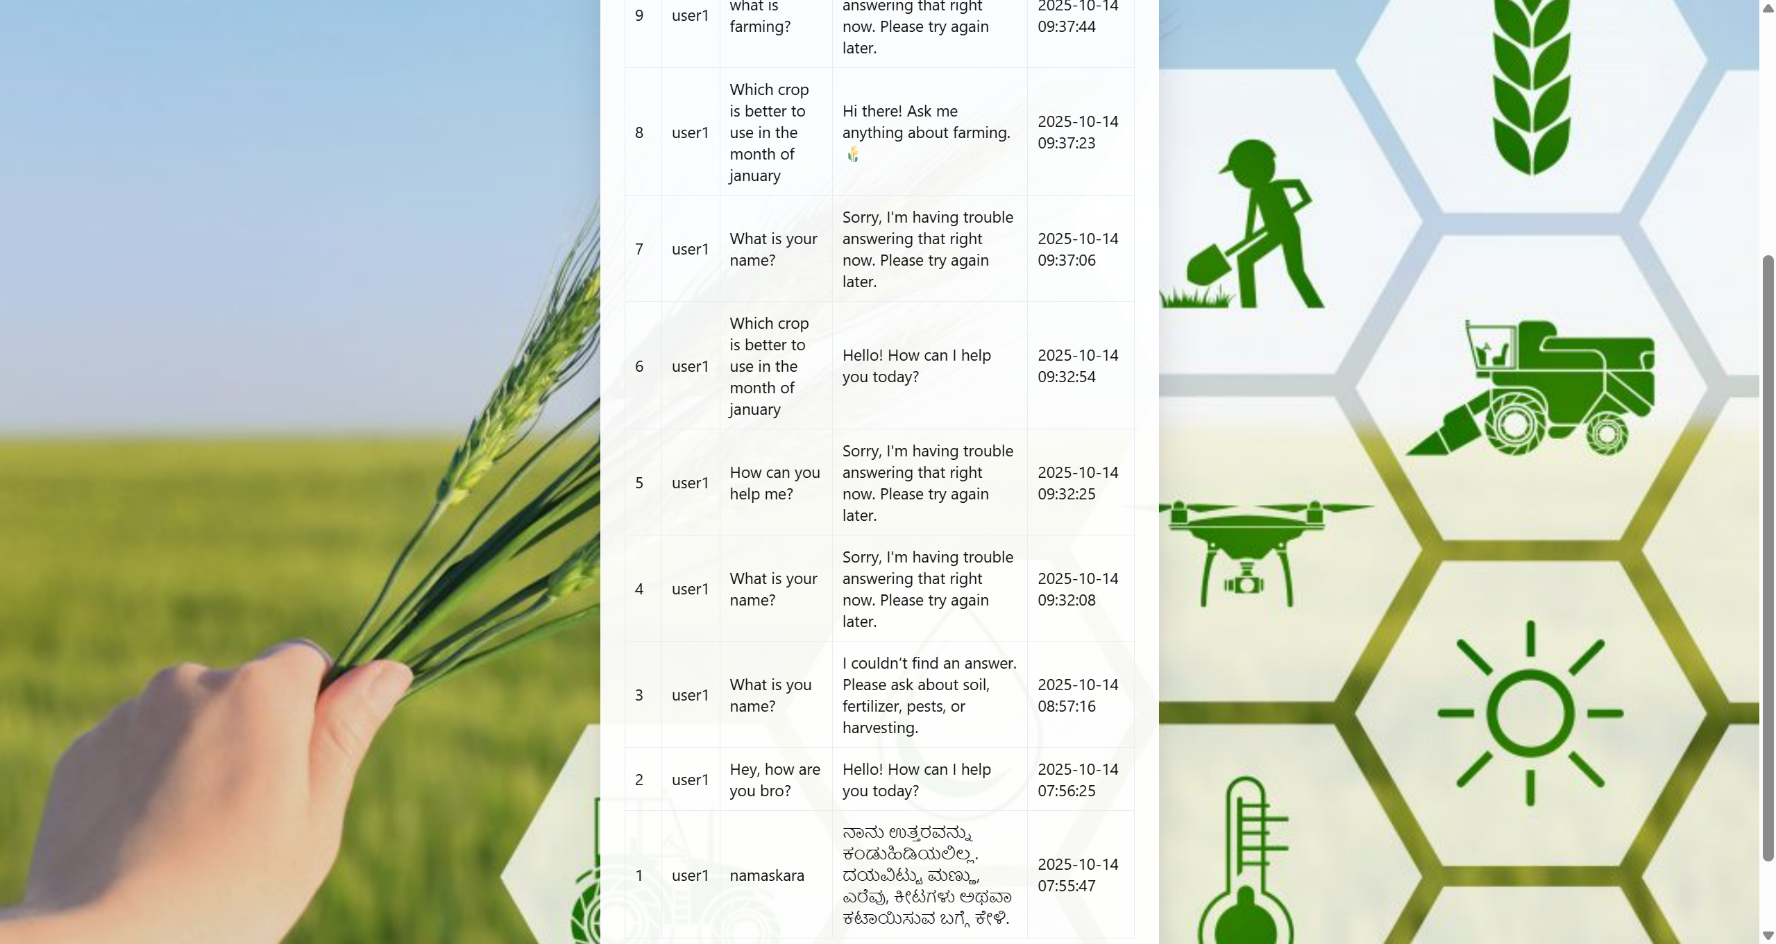

- Fallback & Greetings Handling
  - Handles greetings (hello, hi) and farewells (bye, thanks) automatically with predefined responses.
  - Fallback message is used if AI cannot generate a response.

Project Structure

AgroChatBot/
│
├── app.py # Main Flask application
├── database.py # DB models and initialization
├── chatbot_model.py # Chat processing logic (AI + offline)
├── agro_queries.py # Offline agriculture knowledge base
├── translator_util.py # Translation & language detection
├── .env # Environment variables (API keys)
├── static/
│ └── style.css # CSS styles
└── templates/
├── index.html # Login page
├── register.html # User registration
├── chat.html # Chat UI
├── admin_login.html # Admin login
└── admin_dashboard.html # Admin dashboard

Detailed Feature Explanation: Multi-Language AI Chatbot

Objective:
Allow users to ask questions about agriculture in any supported language and receive answers in the same or a selected language.

How It Works:
- User Input Handling (Frontend)
  - User selects a language and types a question in the chat UI.
  - Using jQuery AJAX, the input is sent to the Flask backend via /chat.

- Backend Processing (chatbot_model.py)
  - Language Detection:
  - user_lang = detect_language(user_input)
    - Detects the language of the input automatically.
  - Greeting & Farewell Handling:
    - Checks if input matches any predefined greetings/farewells in multiple languages and responds accordingly.
  - Offline Knowledge Base Check:
    - If input matches predefined keywords (e.g., soil, fertilizer, pest), returns a relevant response.
  - AI Model Query (DeepSeek via OpenRouter):
  - ai_response = ask_deepseek_openrouter(user_input)
    - Calls the DeepSeek AI model for dynamic responses when offline KB does not match.
  - Translation:
    - If the detected language differs from the target language, response is translated using GoogleTranslator.
  - translated = translate_text(ai_response, dest_lang)

- Response Storage & Return
  - Stores the message and AI response in the database:
  - ChatHistory.create(session["user_id"], user_input, bot_response)
  - Returns the response as JSON to the frontend for display.

Outcome:
Users can seamlessly chat with the bot in their preferred language, and the system intelligently provides helpful agriculture-related responses.

Admin Features
- View Chat History: Search by username, message, or response.
- Download CSV: Export all chat logs for analysis.
- Clear History: Remove all chat records from the database.
- Authentication: Only admin can access these routes.

Database Design

User Table:
Field | Type | Description
id | Integer | Primary key
username | String | Unique username
password_hash | String | Hashed password

ChatHistory Table:
Field | Type | Description
id | Integer | Primary key
user_id | Integer | Foreign key to User
message | Text | User message
response | Text | Bot response
timestamp | DateTime | When message was sent

Conclusion
This project demonstrates a real-time, multi-language AI chatbot integrated with a database and admin interface. It combines:
- Predefined offline knowledge
- AI-powered dynamic responses (DeepSeek)
- Multi-language support (Google Translator)
- Persistent chat logging (SQLite + SQLAlchemy)
- Admin monitoring and management

The system can be extended for:
- New crops, fertilizers, or agricultural practices
- Other AI models like LLaMA 3 or Mixtral for better performance
- Voice input/output for an interactive experience

