3rd Milestone Project Output

Title
🌾 Agro Chatbot — AI-Powered Agriculture Assistant

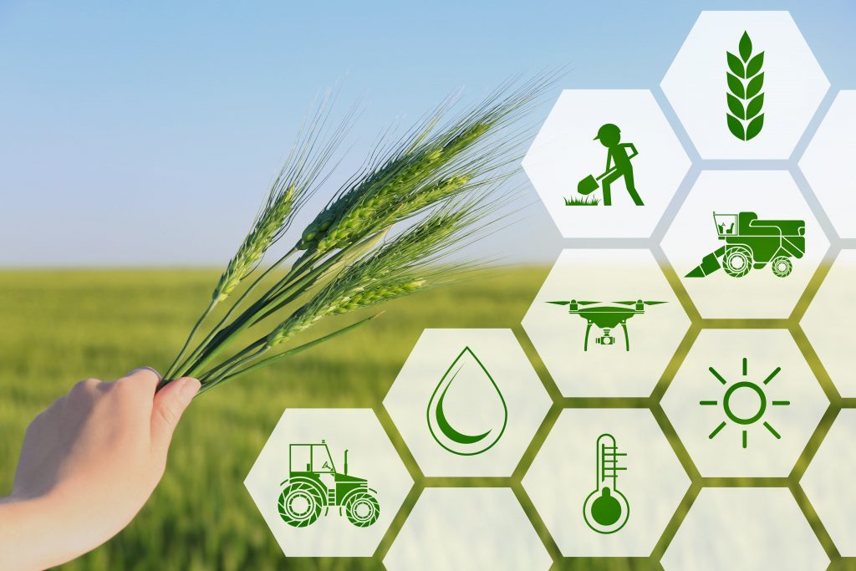

Student Name: BHARATH T
Mentor Name: V MANJULADEVI
Student Email: mr.bharath.t@gmail.com
College: REVA University
Location: Bengaluru
For The Guest User:
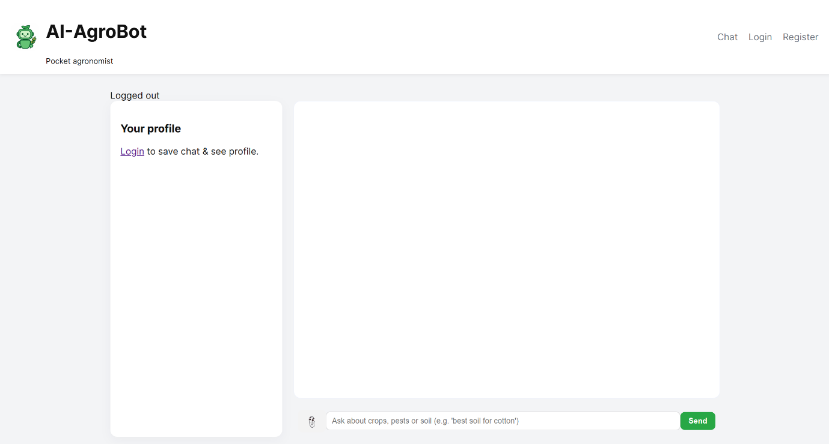

Registration Page: Users can Register into portal using this!
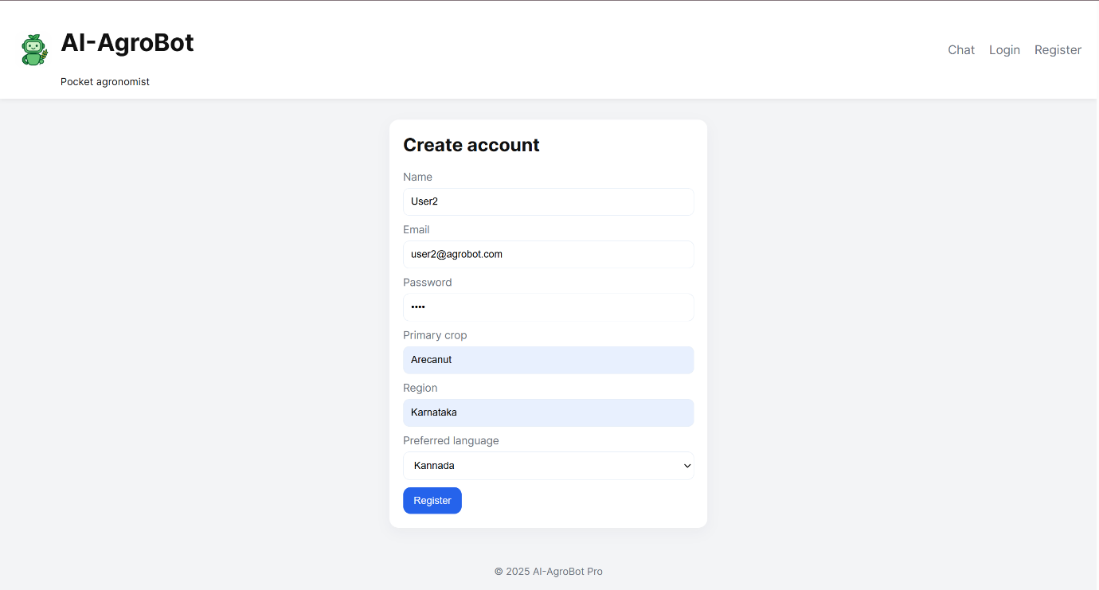
Login Page: Registered users can login with their credentials!

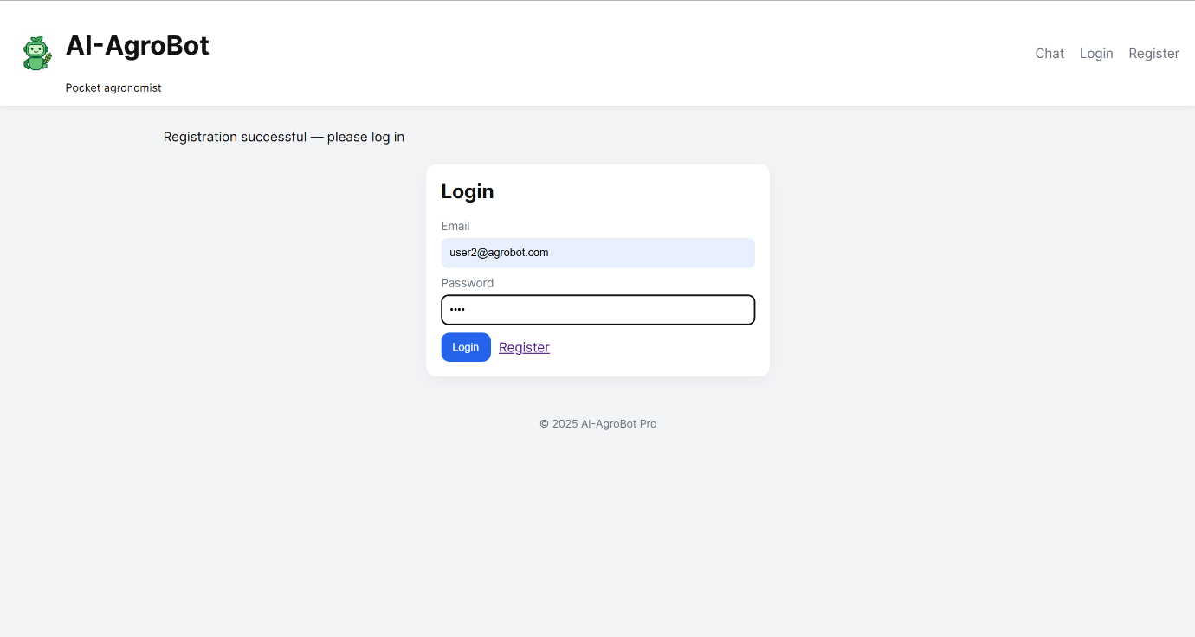

ChatBot Interface: This is a common interface for everyone!
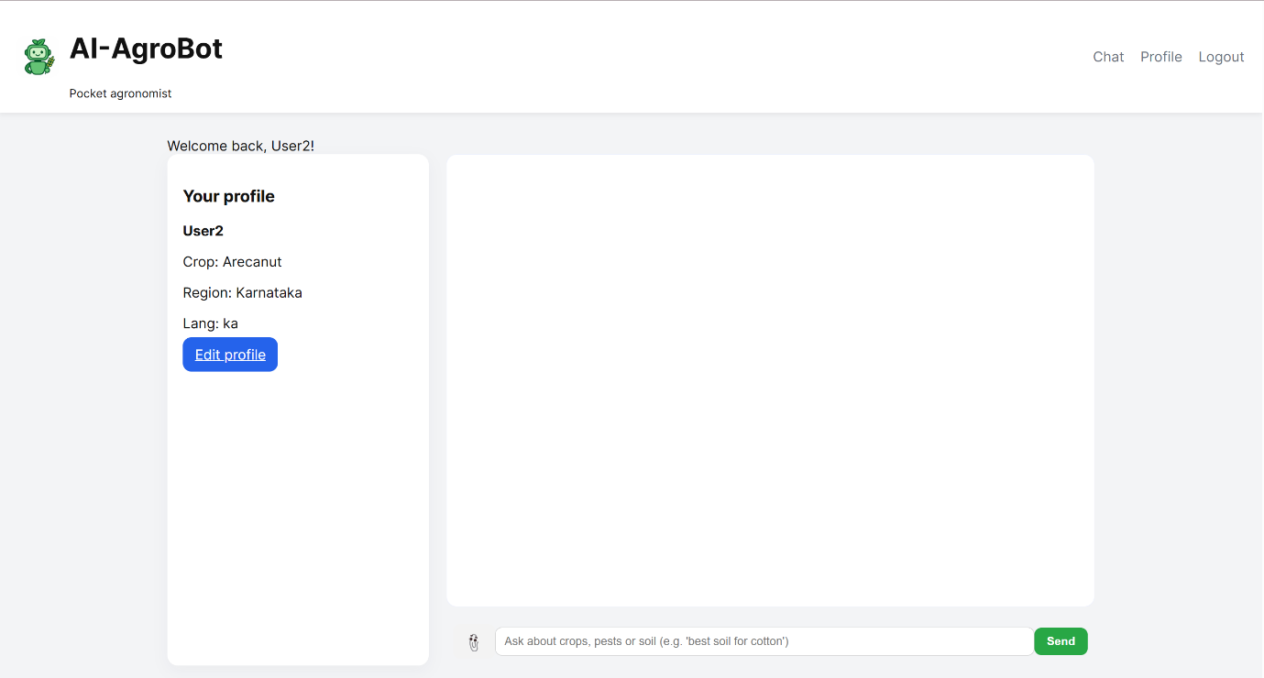

Admin ChatBot Interface: This can only be accessed by admin!

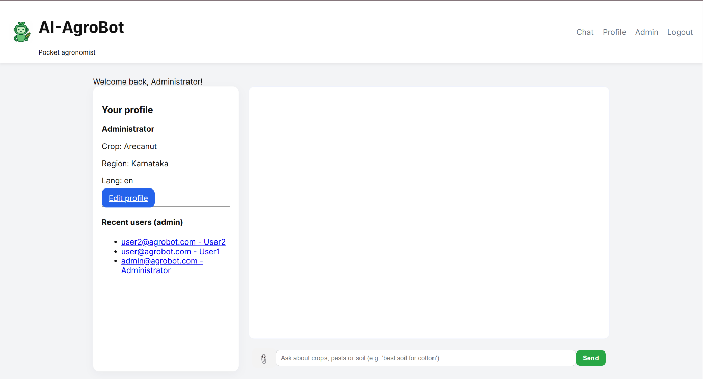

Admin Dashboard: Admin can handle knowledge base, user’s account and their recent conversations!
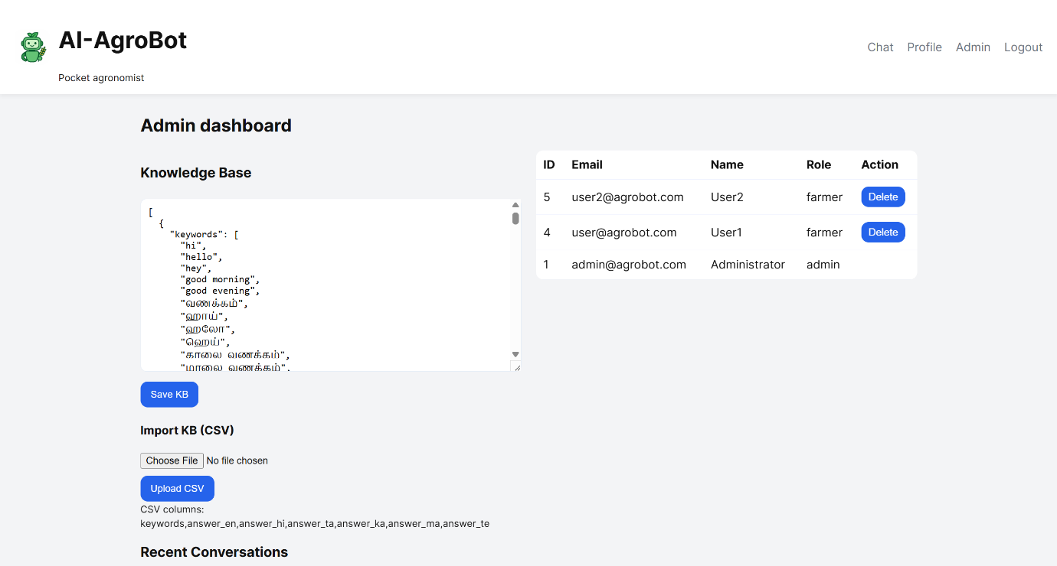

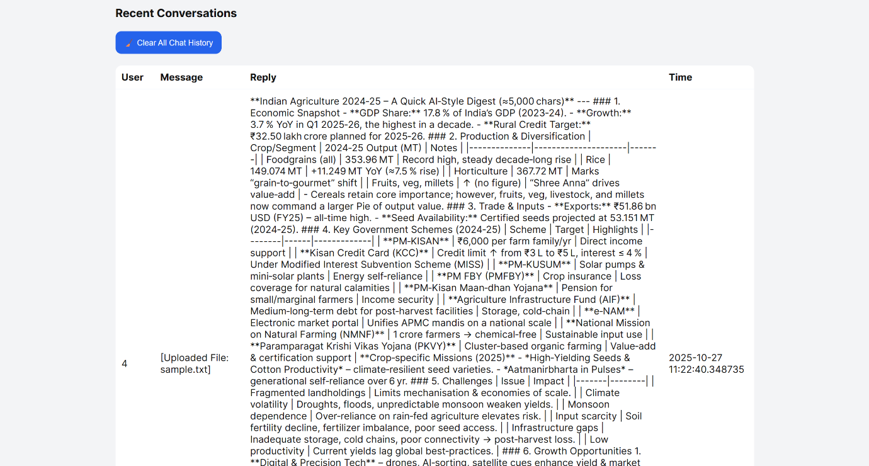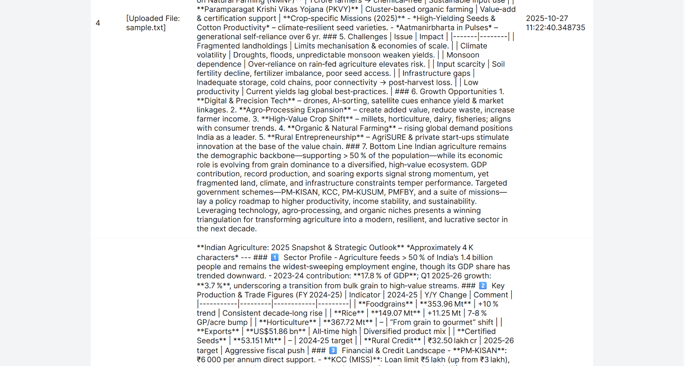

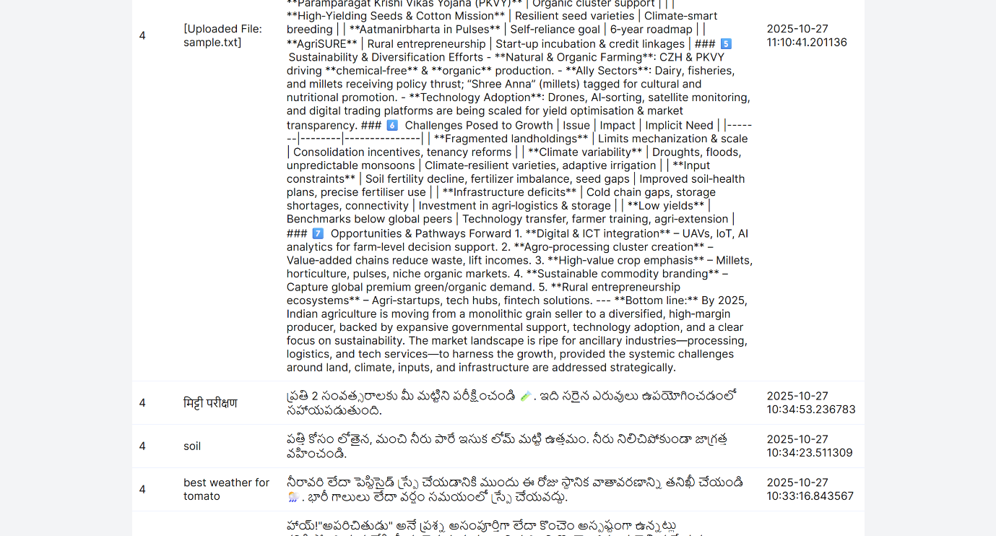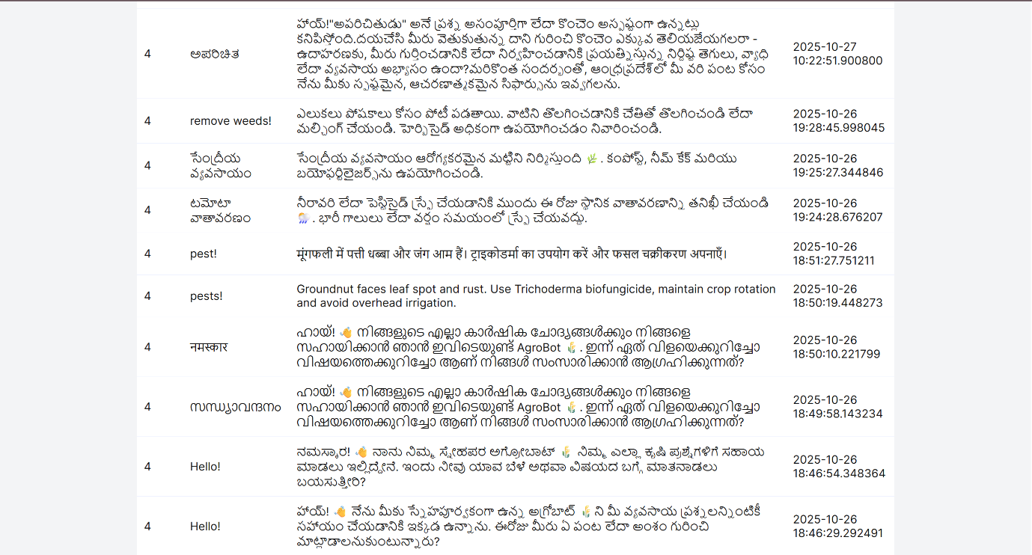

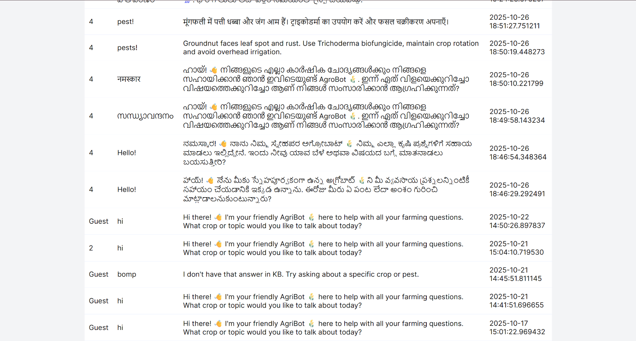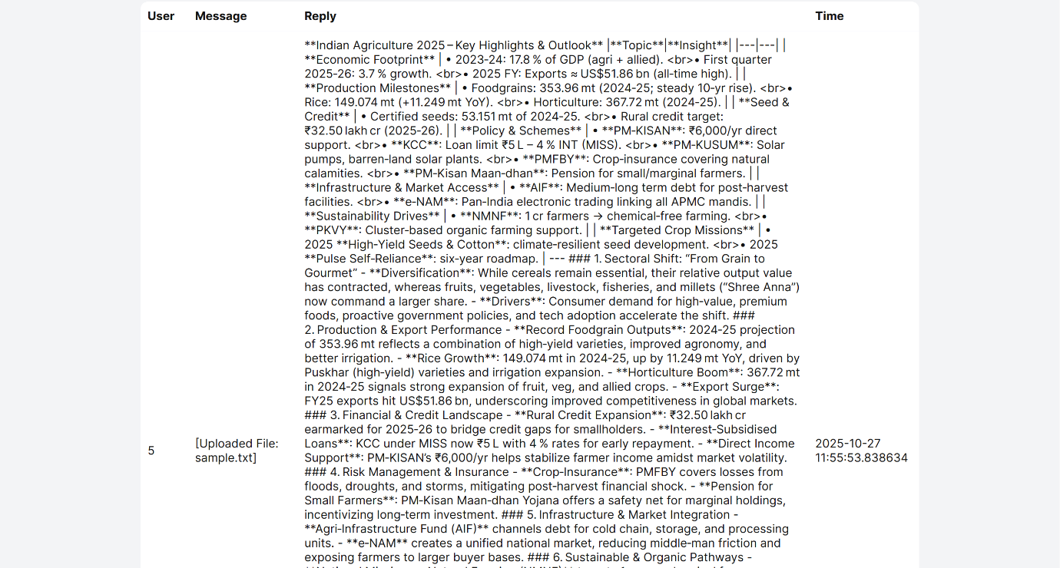

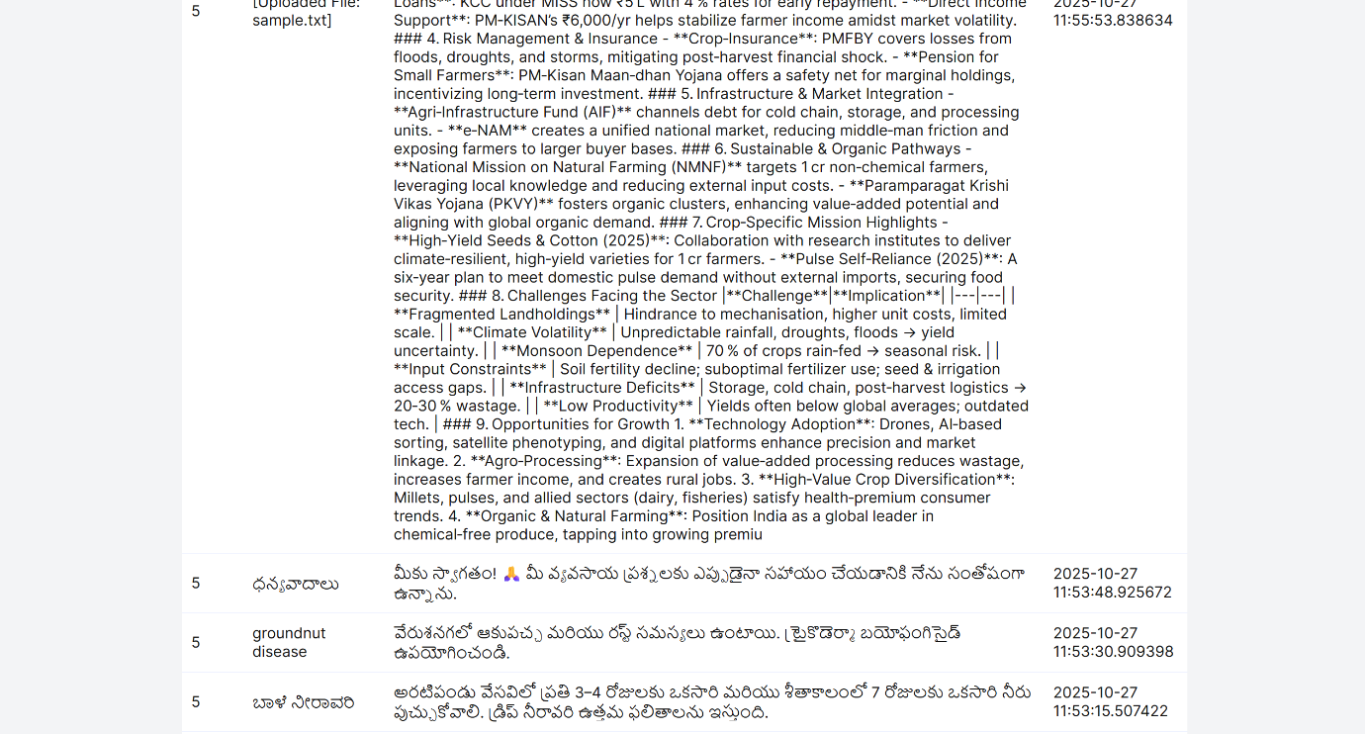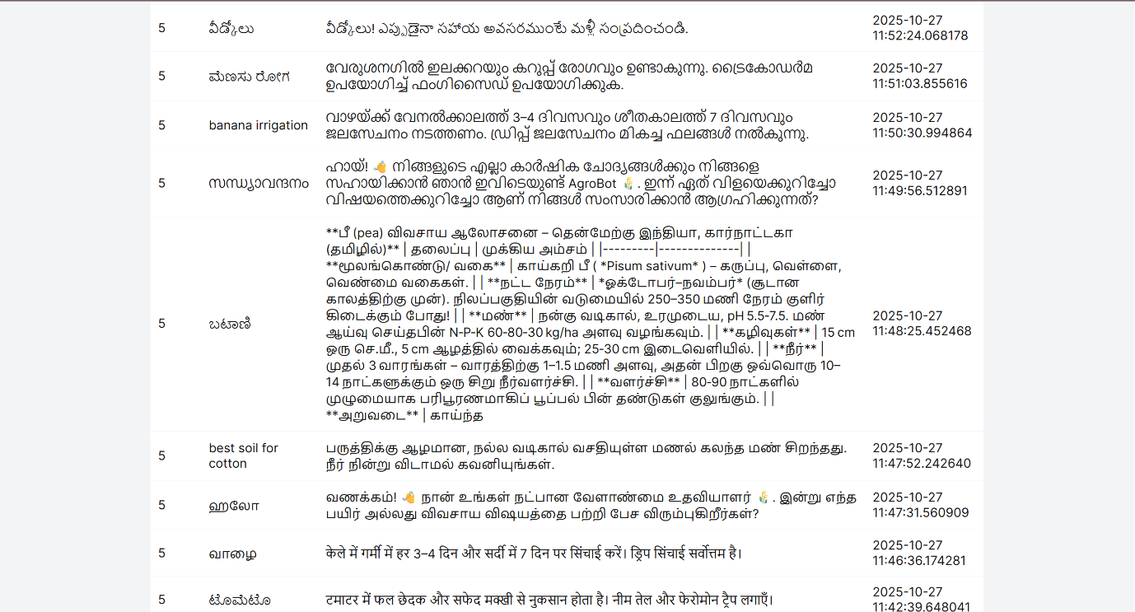

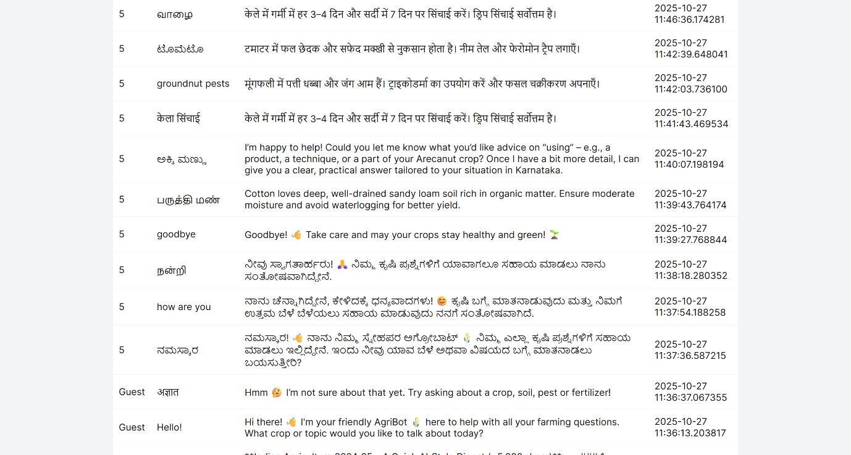
A user interacting with a bot in KANNADA:
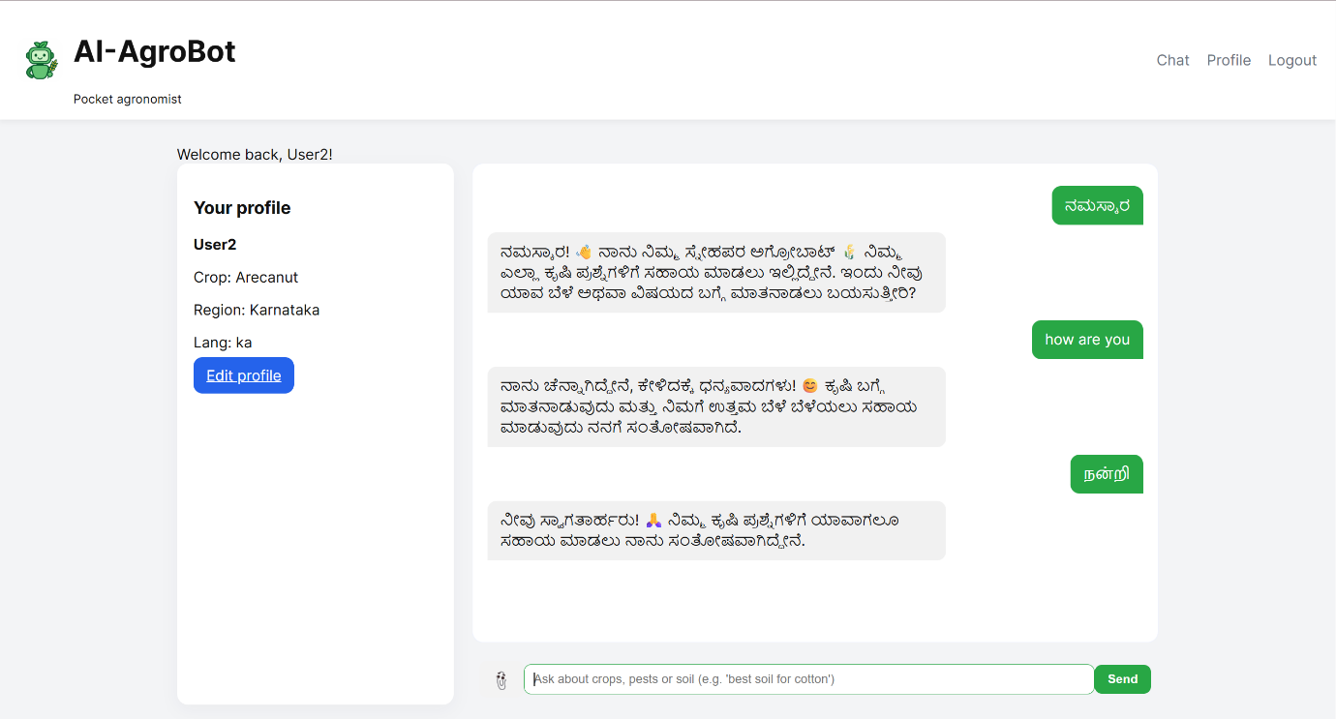
A user interacting with a bot in ENGLISH:
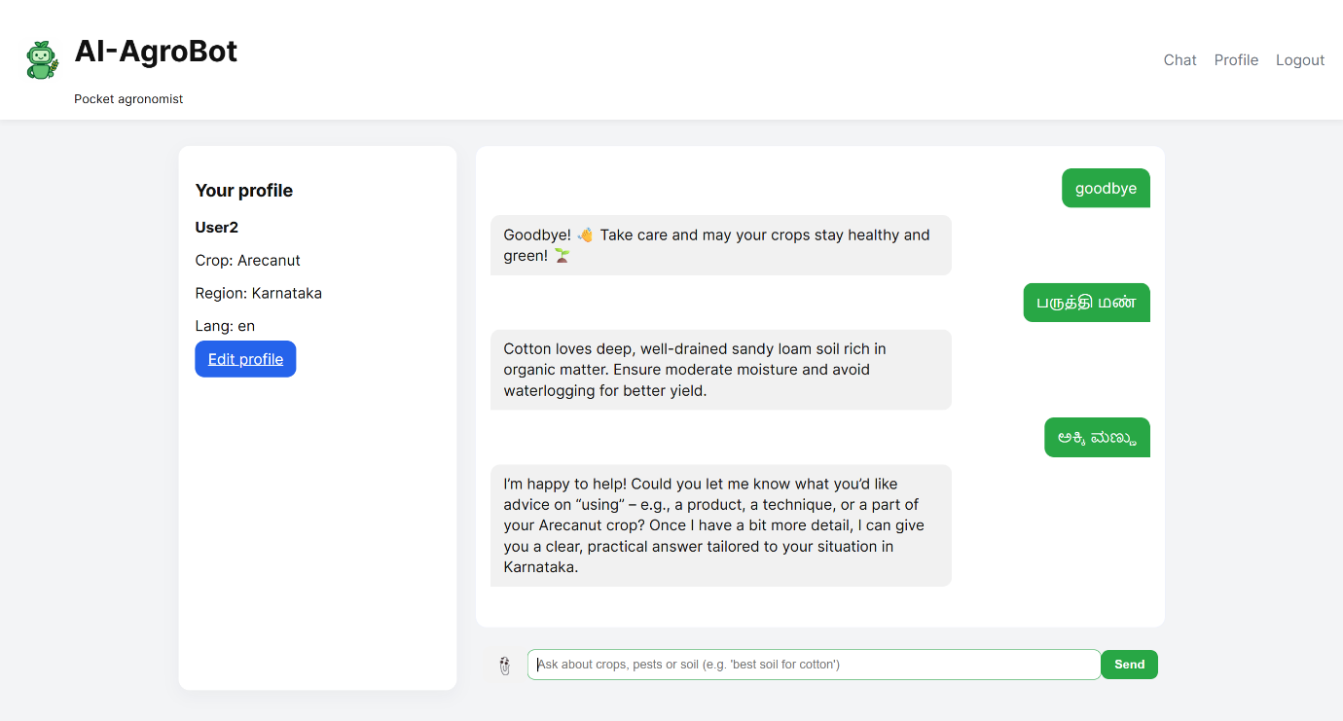
A user interacting with a bot in HINDI:
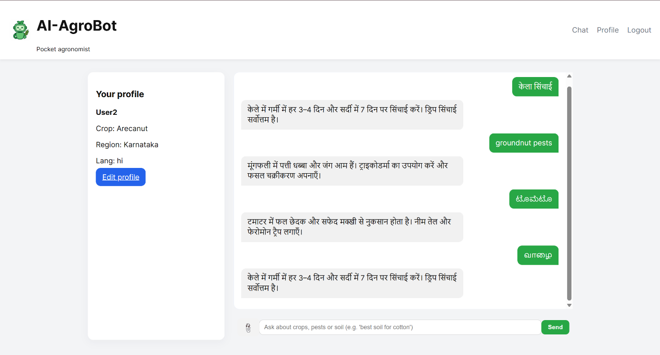
A user interacting with a bot in TAMIL:
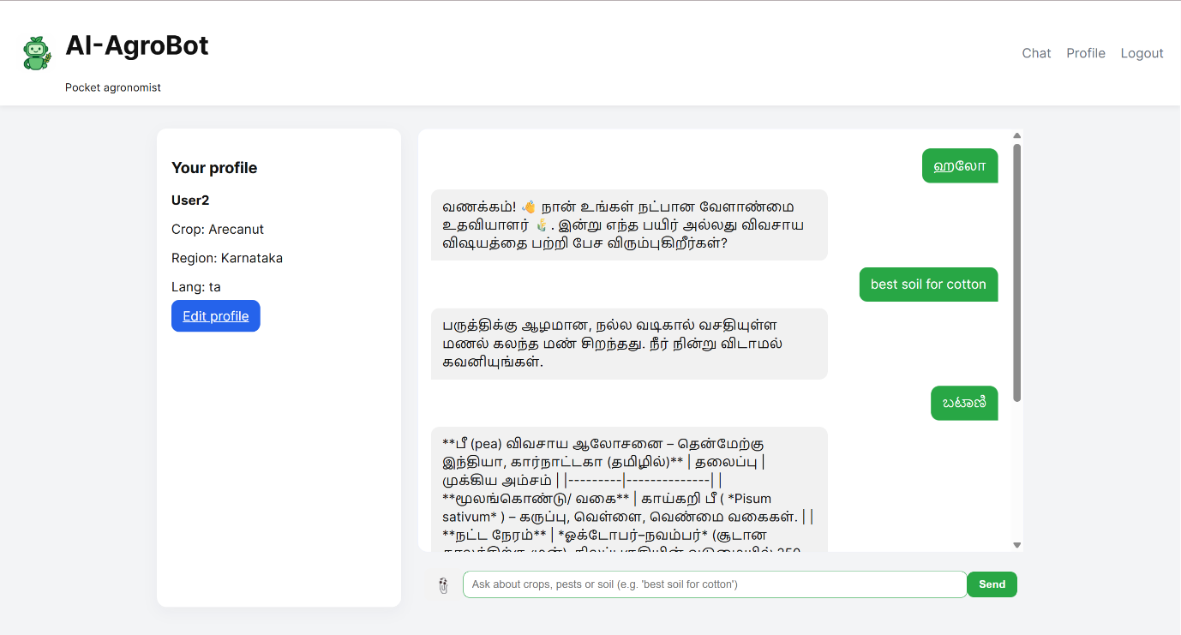
A user interacting with a bot in TAMIL: (Continued)
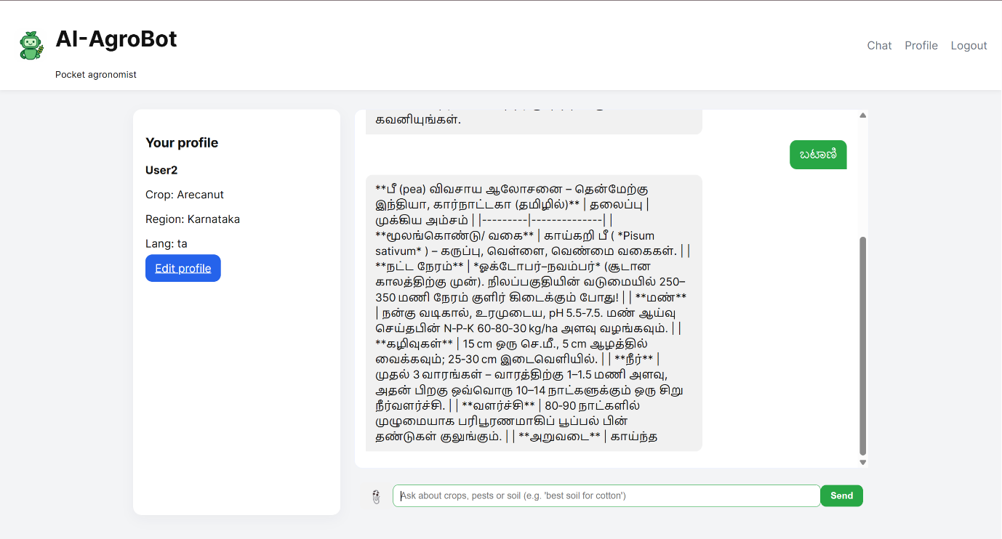
A user interacting with a bot in MALAYALAM:
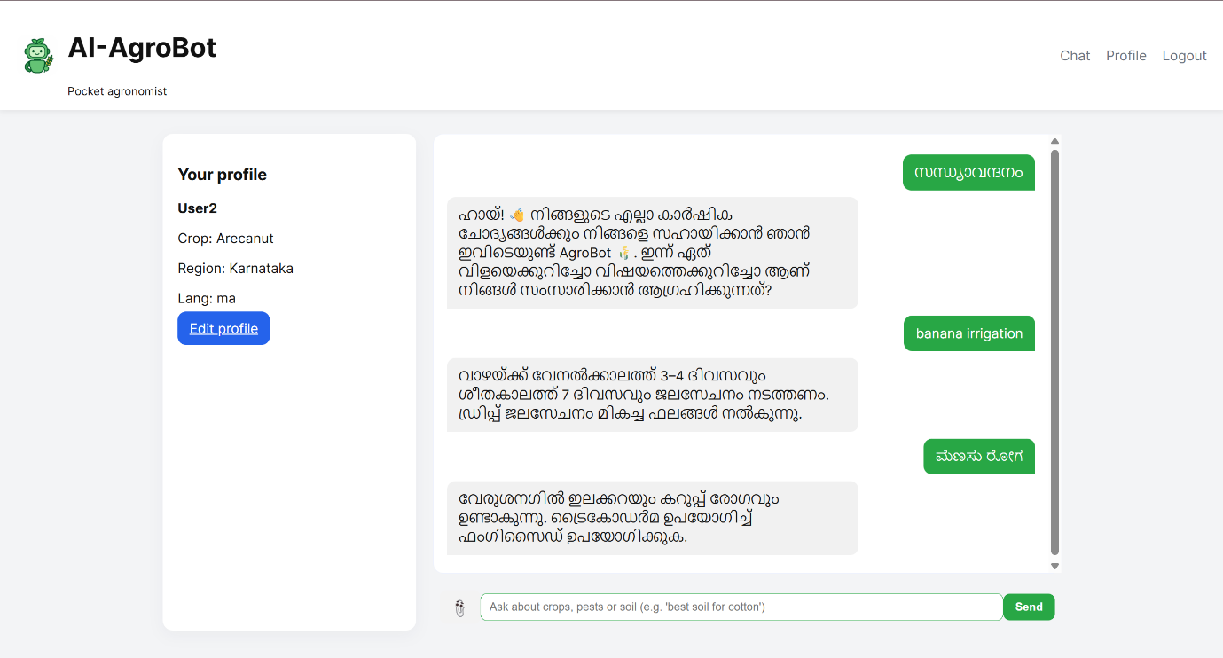
A user interacting with a bot in TELUGU:
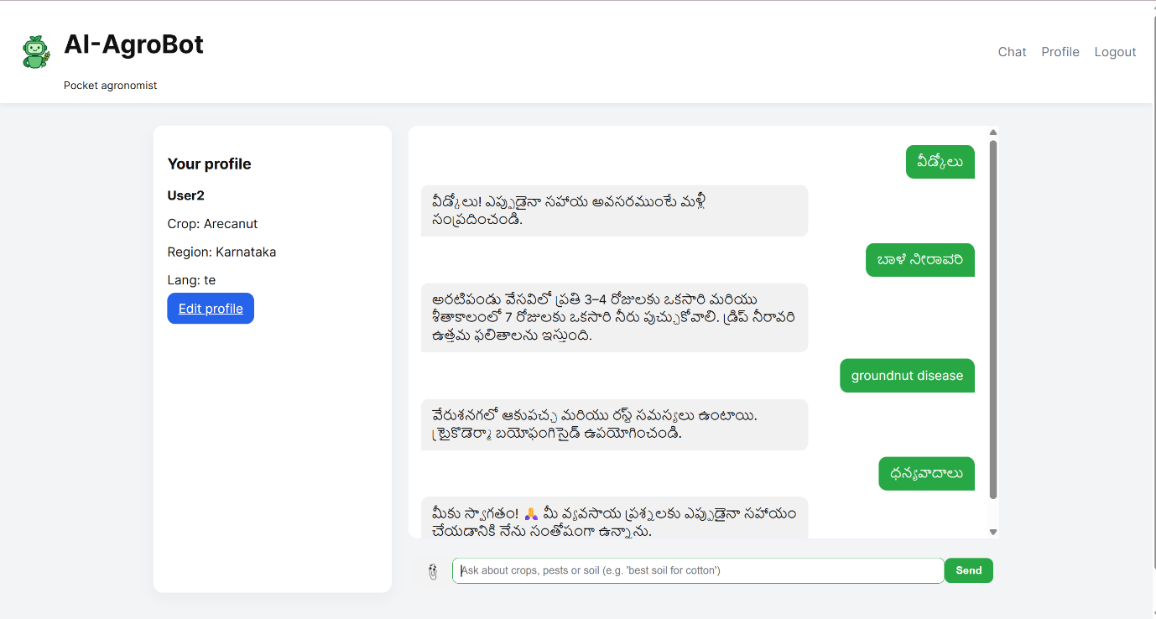

The user attached the file (.txt, .xlsx, .csv, .pdf, .jpg, .jpeg, .png, .docx, etc.) and asked the model to summarize the attached file within 5000 characters with the help of AI (OpenRouter):
