ACKNOWLEDGEMENT

It is not possible to prepare a project without the assistance and encouragement of other people. The Satisfaction and Euphoria that accompany the successful completion of any task would be incomplete without mention of people who made it possible. On the very outset of this report, we would like to extend our sincere & heartfelt obligations towards all the persons who have helped us in this endeavor. Without their active guidance, help, cooperation & encouragement, we would nothave made headway into the project.
We are extremely thankful and express our gratitude to the Head of the Computer Science Department, PROF.RAVI HEGDE for his valuable guidance and support. We are ineffably indebted to our project guide PROF.JAGADEESHA B G for his invaluable guidance and encouragement to accomplish this successful application.
We extend our gratitudeto both teaching and non-teaching staff of Computer Science Department for their cooperation and patience during all stages of this project.
We also acknowledge with a deep sense of reverence, to all who directly or indirectly helped us to complete this successful application. Any omission in this brief acknowledgement does not mean lack of gratitude.

BY:
RANJITH B BHARATH T

CONTENTS

SL.NO | CONTENTS | PAGE NO.
1. | Introduction to project | 4-8
2. | Existing system and proposed system | 9
3. | Software requirement specification | 10-13
4. | System Analysis | 14-18
5. | System Design | 19-25
6. | Database Design | 26-28
7. | Implementation | 29-33
8. | Testing | 34-36
9. | Fututure Enhancement and Conclusion | 37 – 38
10. | Bibliography | 39
11. | Appendices | 40-81

ABSTRACT

There are different events that take place in and around the campus. This College Event Management System provide an efficient, centralized, user-friendly and comprehensive solution for managing college events. It will help in maintain all the matters that are related to the particular event and ensure success. It will also help in maintain the workforce and the job roles that are assigned to them. It displays Information about an event such as it’s Time, Place and Date along with the Event Invitation. Also displays the Articles and Reports published by various Departments across the years. We can keep the track of all the events using this system and the Faculties can manage events, articles and reports of their respective Departments.

This application will be of great help to the colleges in carrying out the events effectively and smoothly. Our aim is to produce software which acts as a medium for accessing details of events in college and provide reports to viewers. It also enables the Admin to manage Departments and respective Faculties efficiently.

The "College Event Management System" has been developed to override the problems prevailing in the practicing manual system. This software is supported to eliminate and in some cases reduce the hardships faced by this existing system. Moreover this system is designed for the particular need of the Institution to carry out operations in a smooth and effective manner.

INTRODUCTION

INTRODUCTION TO PROJECT
The College Event Management System is developed to digitize and streamline the process of managing intercollege events, using a responsive and user-friendly web interface. Built with PHP for the server-side logic, MySQL for database management, and Bootstrap 5 for responsive design, this system ensures a smooth and efficient handling of all event-related activities. The application leverages HTML, CSS, and JavaScript to create an intuitive front-end experience, and it runs on the XAMPP server environment.

The main purpose of this project is to simplify the process of handling each event by providing a web interface for admin, teacher and students. The admin part consists of multiple modules where admin can create departments and assign the Head of the Department and other staffs. The respective faculty can manage Events, Reports and Articles related to their Department. The Admin can also manage Events, Reports and Articles of the college and can also manage the users that is faculties. The Viewer or Visitor can View the Events, Reports and Articles.

The application is reduced as much as possible to avoid errors while entering the data. It also provides error message while entering invalid data. No formal knowledge is needed for the user to use this system. Thus by this all it proves it is user-friendly. College Event Management System, as described above, can lead to error free, secure, reliable and fast management system. It can assist the college to concentrate on their other activities rather to concentrate on the manual record keeping as it is an efficient, centralized, user-friendly and comprehensive solution for managing college events. Thus it will help organization in better utilization of resources.

Every Institution, whether big or small, has challenges to overcome and managing the information of Event, College, Theme, Services, Registration. Every College Event Management System has different College needs, therefore we design exclusive Event management systems that are adapted to your managerial requirements.

STATEMENT OF THE PROBLEM
Managing college events manually can be a time-consuming and error-prone process. The traditional methods of handling event registrations, scheduling, and participant management often lead to inefficiencies, miscommunications, and administrative burdens. Additionally, manually keeping track of event details and outcomes is cumbersome and prone to errors. There is a need for a system that automates these processes, providing a reliable and efficient way to manage college events while reducing administrative workload and improving user experience.

OBJECTIVE OF THE STUDY

The objective of the study for the College Event Management System is to develop a comprehensive, user-friendly, and efficient web-based application that automates and streamlines the management of college events. This system aims to simplify event creation, scheduling, and management. Provide visitors a platform to view all Event Information, Reports and Articles all within a responsive design compatible with various devices. Ultimately, the goal is to reduce administrative burdens and promote better resource utilization, enabling administrators and teachers to focus on strategic activities and improving overall event management.

METHODOLOGY
AGILE METHODOLOGY
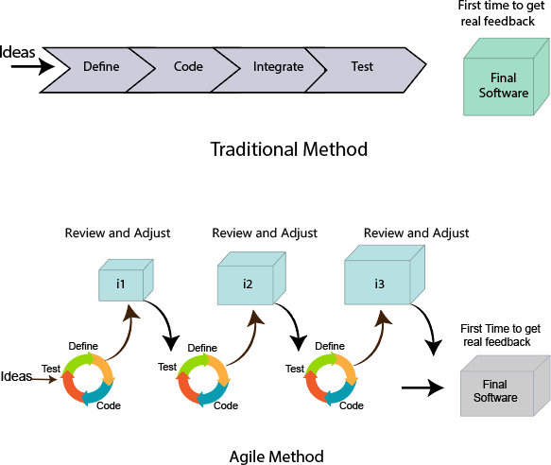
An agile methodology is an iterative approach to software development. Each iteration of agile methodology takes a short time interval of 1 to 4 weeks. The agile development process is aligned to deliver the changing business requirement. It distributes the software with faster and fewer changes.

An Agile methodology is not a specific set of ceremonies or specific development techniques. Rather, it is a group of methodologies that demonstrate a commitment to tight feedback cycles and continuous improvement. An Agile team works in iterations to deliver the customer requirement, and each iteration takes 10 to 15 days.
The meaning of Agile is swift or versatile. "Agile process model" refers to a software development approach based on iterative development. Agile methods break tasks into smaller iterations, or parts do not directly involve long term planning. The project scope and requirements are laid down at the beginning of the development process. Plans regarding the number of iterations, the duration and the scope of each iteration are clearly defined in advance.
Agile methodology is a popular approach to software development that emphasizes flexibility, collaboration, and customer satisfaction. It involves iterative development, where requirements and solutions evolve through the collaborative effort of cross-functional teams.

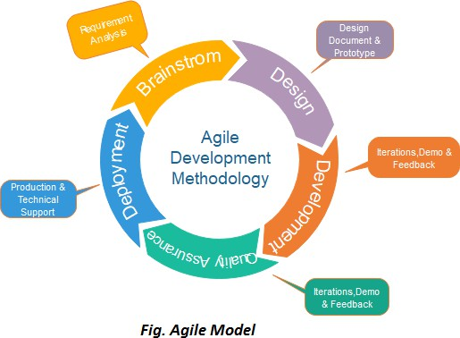

PHASES

- Requirements gathering: In this phase, you must define the requirements. You should explain business opportunities and plan the time and effort needed to build the project. Based on this information, you can evaluate technical and economic feasibility.
- Design the requirements: When you have identified the project, work with stakeholders to define requirements. You can use the user flow diagram or the high-level UML diagram to show the work of new features and show how it will apply to your existing system.
- Construction/ Iteration: When the team defines the requirements, the work begins. Designers and developers start working on their project, which aims to deploy a working product. The product

will undergo various stages of improvement, so it includes simple, minimal functionality.
- Testing: In this phase, the Quality Assurance team examines the product's performance and looks for the bug.
- Deployment: In this phase, the team issues a product for the user's work environment.
- Feedback: After releasing the product, the last step is feedback. In this, the team receives feedback about the product and works through the feedback

Each iteration is considered as a short time "frame" in the Agile process model, which typically lasts from one to four weeks. The division of the entire project into smaller parts helps to minimize the project risk and to reduce the overall project delivery time requirements. Each iteration involves a team working through a full software development life cycle including planning, requirements analysis, design, coding, and testing before a working product is demonstrated to the client.

SCOPE AND LIMITATION OF THE STUDY
SCOPE
The college event management system will support college administrators, students, and staff in planning and managing various events. It will allow event organizers to create events, schedule them, and manage registrations. The system will also provide reporting and analytics features. The Admin has the ability to create, remove and manage departments and assign HOD or Teacher in- charge.
LIMITATION
The study on the College Event Management System has several limitations. Firstly, the system's performance is dependent on a stable internet connection, which may not always be available, potentially disrupting access and functionality. Additionally, while the system is designed to be compatible with major web browsers, older or less common browsers may not support all features, leading to potential usability issues. Ensuring data privacy and security is another critical challenge, requiring regular updates and audits to comply with evolving regulations and safeguard user information.

HARDWARE AND SOFTWARE REQUIREMENTS

Hardware Requirements:
- Processor: Intel Core i3 (Third Generation or higher)
- Processor Speed: 1GHz to 2.5GHz

- RAM: 4GB or more
- Hard Disk: 250GB or more
- Input Devices: Keyboard and mouse

Software Requirements:
- Frontend Technologies: HTML, CSS, JavaScript
- Frontend Framework: Bootstrap 5
- Backend Technology: PHP
- Database Management System: MySQL
- Server Environment: XAMPP
- Development Environment: Visual Studio Code (or any suitable code editor)
- Web Browsers: Chrome, Firefox, Microsoft Edge, Brave (compatibility with major browsers)
- Operating System: Windows, macOS, or Linux

EXISTING SYSTEM AND PROPOSED SYSTEM

Existing System:

The manual College Event Management has so many inconveniences and limitations. It includes lots of paper works, requires more manpower, time consuming and updating is very difficult.

Proposed System:

Computerization has many advantages: It enhances control through increased accuracy, consistency and better security. Processing is faster. Enabling is quicker retrieval of information. A planned system will have the capacity to handle the project increase in volume of information overtime.
Documentation and report generation will be simplified, provide specialized links to essential information spread across numerous databases.

Advantages:

  - Reduced processing cost due to reduction of stationary items.
  - Error reductions as the calculations are computerized.
  - Improved report generation and statistical analysis.
  - Reduction of manual work.
  - Faster response time.
  - Database Recovery and Backup.
  - Secure access.

Aim:

To produce software which acts as a medium for accessing details of events in college and provide reports to viewers. Basically, colleges are responsible for the different events that take place in and around the campus. There will be many things that need to be fulfilled when a particular event is to be conducted. The resources related to the decorations, caterers and list continues like this. This college event management system will help in maintain all the matters that are related to the particular event and ensure success. It will also help in maintain the workforce and the job roles that are assigned to them. This application will be of great help to the colleges in carrying out the events effectively and smoothly.

SOFTWARE REQUIREMENTS SPECIFICATION (SRS)

A college event management system (EMS) is designed to streamline the process of planning, organizing, and managing events of the college ABC. The system can handle various types of events such as cultural, academic, sports, and more. It would also be able to upload and view reports of various events across the years.

Purpose
The purpose of this document is to outline the requirements for a college event management system. This system will facilitate the organization and management of events in a college, including event creation, scheduling, registration, feedback, uploading reports and view the reports and snapshots of previous events.

Scope
The college event management system will support college administrators, students, and staff in planning and managing various events. It will allow event organizers to create events, schedule them, and manage registrations. The system will also provide reporting and analytics features. The Admin has the ability to create, remove and manage departments and assign HOD or Teacher in- charge.

FUNCTIONAL REQUIREMENTS
ADMIN
- Create Departments: Admins can create Departments with details such as name and description.
- Assign Teacher in-charge: Admins can assign the Teacher in-charge for particular department by creating credentials.
- Manage Department: Admins can Manage the department by assigning new teacher or regenerate credential.
- Delete Department: Admins can delete Department.
- Delete Faculty: Admin can delete Faculty
- Create Event: Admin can create events with details such as name, date, time, location, and

description.
- Edit Event: Admin can edit event details.
- Delete Event: Admin can delete events.
- Upload Report: Admin can upload with details such as name, date, time and description.
- Edit Report: Admin can report event details.
- Delete Report: Admin can delete report.
- Publish Article: Admin can publish article.
- Edit Article: Admin can edit Article.
- Delete Article: Admin can delete Article.
- View Event Details, Reports and Articles Uploaded by various departments across years

Teacher in-charge or HOD
- Create Event: Teacher can create events with details such as name, date, time, location, and description.
- Edit Event: Teacher can edit event details.
- Delete Event: Teacher can delete events.
- Upload Report: Teacher can upload with details such as name, date, time and description.
- Edit Report: Teacher can report event details.
- Delete Report: Teacher can delete report.
- Publish Article: Teacher can publish article.
- Edit Article: Teacher can edit Article.
- Delete Article: Teacher can delete Article.
- View Event Details, Reports and Articles Uploaded by various departments across years

Viewer
View Event Details, Reports and Articles Uploaded by various departments across years

NON-FUNCTIONAL REQUIREMENTS

Performance
- The system should be able to handle simultaneous registrations and queries efficiently.

Security
- Access control: Users should have different levels of access based on their role (admin, student, staff).

- Data privacy: Protect user data according to regulations and best practices.

Usability
- The system should be user-friendly and easy to navigate.
- Provide intuitive interfaces for creating and managing events.
- Should be Responsive.
- Should be Compatible to view on Mobile devices.

DOMAIN REQUIREMENTS

- The system should comply with college policies and legal requirements regarding data privacy and accessibility.
- The system should be compatible with major browsers and mobile devices.
- The system must authentic
- ate users (administrators, teachers, and students) through secure login.
- The system must protect user data through encryption and secure storage.
- The system should be scalable to accommodate an increasing number of users and events.
- The system should provide user-friendly error messages and validation to prevent incorrect data entry.
- Keyboard Navigation should be included
- The user interface must be responsive to ensure usability on desktops, tablets, and smartphones.

HARDWARE AND SOFTWARE REQUIREMENTS

Hardware Requirements:
- Processor: Intel Core i3 (Third Generation or higher)
- Processor Speed: 1GHz to 2.5GHz
- RAM: 4GB or more
- Hard Disk: 250GB or more
- Input Devices: Keyboard and mouse

Software Requirements:
- Frontend Technologies: HTML, CSS, JavaScript
- Frontend Framework: Bootstrap 5

- Backend Technology: PHP
- Database Management System: MySQL
- Server Environment: XAMPP
- Development Environment: Visual Studio Code (or any suitable code editor)
- Web Browsers: Chrome, Firefox, Microsoft Edge, Brave (compatibility with major browsers)
- Operating System: Windows, macOS, or Linux

SYSTEM ANALYSIS

EXISTING SYSTEM
The current manual College Event Management system is fraught with several inconveniences and limitations. It relies heavily on paper-based processes, which are not only time-consuming but also require a significant amount of manpower. This manual system makes event organization cumbersome, as it involves handling and maintaining a large volume of physical documents. Updating event details or information is particularly challenging, often leading to errors and inconsistencies. The lack of a centralized system results in inefficient communication and coordination among administrators, teachers, and students.

LIMITATION OF EXISTING SYSTEM

- Time-Consuming Processes: Manual entry and management of event data are slow and inefficient.
- High Manpower Requirement: A significant number of staff is needed to manage and maintain event records.
- Prone to Errors: Manual processes increase the likelihood of errors in data entry and record keeping.
- Difficulty in Updating Information: Updating event details or participant information is cumbersome and error-prone.
- Lack of Centralization: Information is scattered, leading to poor communication and coordination.
- Inefficient Record Keeping: Paper-based documentation is difficult to manage and retrieve, especially as the volume of data grows.
- Security Issues: Physical documents are more susceptible to loss, damage, or unauthorized access.

PROPOSED SYSTEM
The proposed computerized College Event Management System offers numerous advantages over the existing manual process. By automating event management, the system enhances control through increased accuracy, consistency, and better security. Processing event information becomes faster, and retrieval of data is significantly quicker. The system is designed to handle an increase in the volume of information over time, ensuring scalability. Documentation and report generation are simplified, and the system provides specialized links to essential information spread across numerous databases, improving accessibility and coordination.

FEASIBILITY STUDY

Technical Feasibility:

The proposed system is technically feasible as it utilizes widely adopted technologies such as PHP, MySQL, HTML, CSS, JavaScript, and Bootstrap 5, all of which are well-supported and have extensive documentation. The system will be hosted on the XAMPP server environment, which is compatible with multiple operating systems and provides an integrated development environment.

Operational Feasibility:

The system will significantly reduce the workload of administrators and teachers by automating routine tasks, thus enhancing overall efficiency. It will also improve the user experience for students by providing a streamlined, online registration process. The user- friendly interface ensures that minimal training is required for users to become proficient in using the system.

Economic Feasibility:

While there will be initial costs associated with developing and deploying the system, these will be offset by long-term savings from reduced manpower requirements and increased efficiency. The reduction in paper usage and administrative overheads will also contribute to

cost savings. Additionally, the system's scalability ensures that it can accommodate future growth without requiring significant additional investment.

4.4 USE CASE ANALYSIS ADMIN
- Manage Users: Add, edit, delete users and assign roles.
- Manage Departments: Create, update, delete departments and assign department heads.
- Assign Teacher in-charge: Admins can assign the Teacher in-charge for particular department by creating credentials.
- Manage Department: Admins can Manage the department by assigning new teacher or regenerate credential.
- Delete Department: Admins can delete Department.
- Create Event: Admin can create events with details such as name, date, time, location, and description.
- Edit Event: Admin can edit event details.
- Delete Event: Admin can delete events.
- Upload Report: Admin can upload with details such as name, date, time and description.
- Edit Report: Admin can report event details.
- Delete Report: Admin can delete report.
- Publish Article: Admin can publish article.
- Edit Article: Admin can edit Article.
- Delete Article: Admin can delete Article.
- View Event Details, Reports and Articles Uploaded by various departments across years

HOD AND TEACHER IN CHARGE

- Create Event: Teacher can create events with details such as name, date, time, location, and description.
- Edit Event: Teacher can edit event details.
- Delete Event: Teacher can delete events.
- Upload Report: Teacher can upload with details such as name, date, time and description.
- Edit Report: Teacher can report event details.
- Delete Report: Teacher can delete report.

- Publish Article: Teacher can publish article.
- Edit Article: Teacher can edit Article.
- Delete Article: Teacher can delete Article.
- View Event Details, Reports and Articles Uploaded by various departments across years
VIEWER
- View Event Details, Reports and Articles Uploaded by various departments across years

To manage Department, User, Events, Reports, Articles the Admin must Login To manage Events, Reports, Articles the HOD or Teacher in-charge must Login

USE CASE DIAGRAM

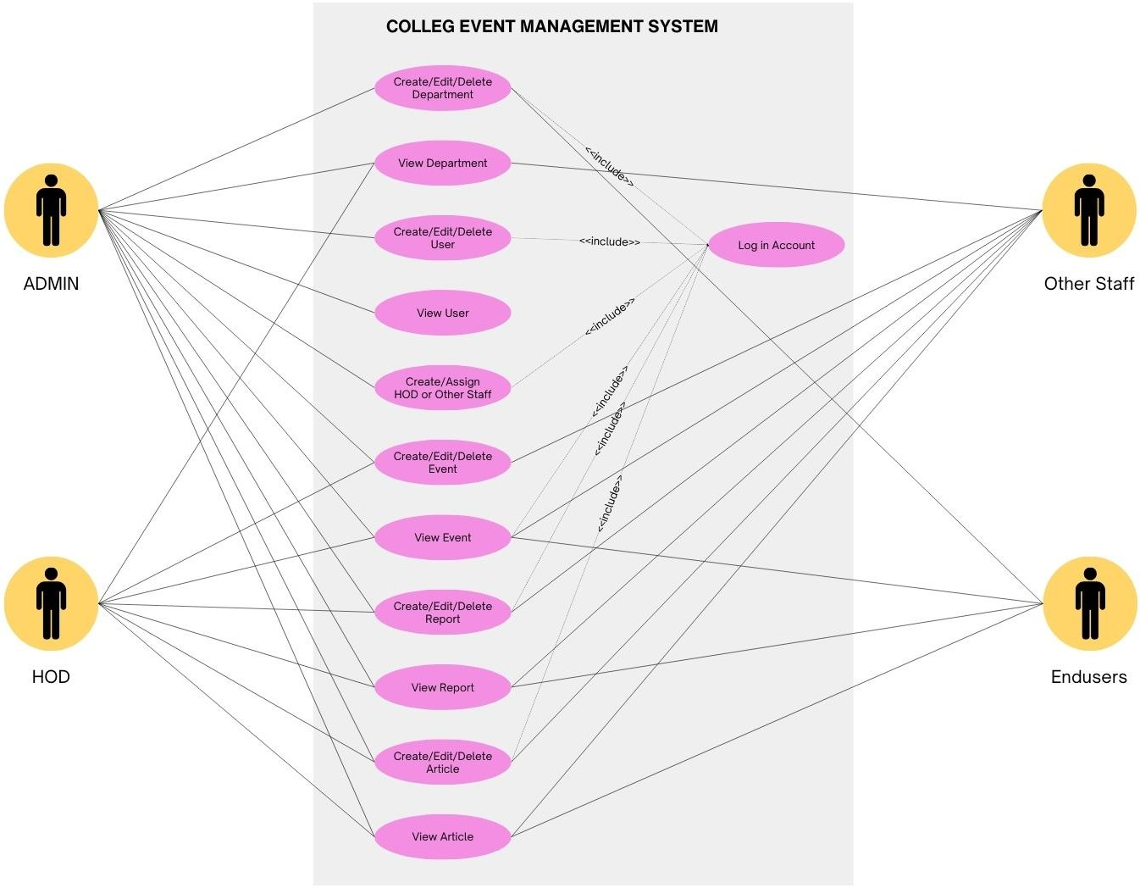

SYSTEM DESIGN

The College Event Management System is designed to streamline event management through a multi- layered architecture, encompassing various modules and user interfaces. The system includes key modules such as User Management, Event Management, Reports Management, Department Management etc. Each module addresses specific functionalities like creating and managing events, and generating reports etc. The user interface is tailored for different roles: students can view events articles and reports, while administrators and teachers have dashboards to create and manage events, departments, users, and articles. The design ensures a responsive, user-friendly experience, supported by HTML, CSS, Bootstrap 5, PHP, and MySQL, facilitating efficient data handling and seamless interaction.

SYSTEM ARCHITECTURE
The College Event Management System (CEMS) follows a multi-tier architecture, typically consisting of the following layers:

Presentation Layer:
This layer includes the user interface (UI) components that interact with users. It uses HTML, CSS, Bootstrap 5 for styling, and JavaScript for client-side scripting to provide a responsive and interactive experience.

Application Layer:
The application logic resides in this layer, developed using PHP. It handles user requests, processes inputs, and communicates with the database layer to fetch or store data.

Database Layer:
This layer manages data storage and retrieval. It uses MySQL as the database management system to store data related to events, users, reports, articles and departments.

Server Layer:
The server environment, such as XAMPP, hosts the application and database, providing the necessary infrastructure for the system to run.

MODULES DETAILS

Admin Module

This module allows administrators to manage various aspects of the system.

Articles:

Functionality: Create, edit, view and delete articles.

Contact Information:

Functionality: Manage the contact information of the college.

Default Contents:

Functionality: Manage default content displayed on the home page or other default sections.

Departments:

Functionality: Create, edit, view, delete departments (only Admin).

Events:

Functionality: Create, edit, view, delete, schedule events.

Reports:

Functionality: Upload and view reports related to college Activities.

System Info (Profile Page):

Functionality: View and edit system profile information (only Admin).

User Management:

Functionality: Manage user accounts (add, edit, delete), assign HOD/teachers (only Admin).

Authentication Pages:

Files: home.php, login.php, index.php

Assets Module

Contains static assets for the front-end.

  - CSS:

Functionality: Stylesheets for the system.

JavaScript:

Functionality: JavaScript files for interactivity.

Blogs Module

  - Functionality: View Articles .

Classes Module

Contains PHP classes for the system's core functionality.

DBconnection.php:

Functionality: Manages database connections.

Login.php:

Functionality: Handles user authentication.

Master.php:

Functionality: Contains master settings and configurations and contains functions for all activities.

SystemSettings.php:

Functionality: Manages system-wide settings.

Users.php:

Functionality: Manages user-related operations.

Database Module

  - Functionality: Manages database schema and queries.

Departments Module

  - Functionality: To display Departments in the home page .

Events Module

  - Functionality: To display Events in the home page.

Reports Module

  - Functionality: To display Reports in the home page.

Inc Module

Contains reusable components for the layout.

aside.php:

Functionality: Sidebar component.

footer.php:

Functionality: Footer component.

header.php:

Functionality: Header component.

topBarNav.php:

Functionality: Top bar navigation.

sess_auth.php:

Functionality: Session authentication.

Pages Module

Manages different web pages of the system.

Articles:

Functionality: Contains article pages.

Default:

Functionality: Contains default article pages.

Events:

Functionality: Contains events pages.

Reports:

Functionality: Contains report pages.

Uploads (Images) Module

  - Functionality: Stores uploaded images.

Home.php

  - Functionality: Homepage of the system.

Initialize.php

  - Functionality: Initialization script for setting up environment variables and configurations.

Index.php

  - Functionality: Entry point of the application.

About.php

  - Functionality: About page providing information about the system.

Contact_us.php

  - Functionality: Contact page for users to reach out.

Config.php

  - Functionality: Configuration file for setting up system-wide configurations.

Conclusion

Each module in the College Event Management System is designed to handle specific functionalities, ensuring a well-organized and maintainable codebase. The admin module handles most of the backend management tasks, while the assets, classes, and pages modules provide the necessary support and structure for the entire system.

USER INTERFACE DESIGN

Admin/HOD/Teacher in-charge Interface:

- Dashboard: Summary of activities, events, departments, users, articles, and reports. (department and user only for Admin)
- Manage Departments: Interface to create, edit, view and delete departments.(only Admin)
- Manage Users: Interface to add, edit, view and delete users and assign HODs/teachers.(only Admin)
- Event Management: Form to create new events, list view to manage existing events, and options to edit or delete events.
- Article Management: Form to create new articles, list view to manage existing articles and edit or delete it.
- Report Uploading: Form to upload new report, list view to manage existing report, and options to edit or delete report.

Common User Interface Elements:

- Event View: List of available events with details.
- Report View: Access to view College reports.
- Article View: List of articles to read.
- Navigation Bar: Links to different modules based on user roles.
- Footer: Contact information and useful links.
- Home Page: Introduction to the system and links to different sections.

DATA FLOW DIAGRAM
A Data Flow Diagram (DFD) is a visual representation of the flow of data within a system, illustrating how data moves from inputs to processes and outputs. It uses standardized symbols such as arrows for data flow, circles or ovals for processes, rectangles for external entities (sources and destinations of data), and open-ended rectangles for data stores. DFDs help in understanding the system’s data processing and identifying potential bottlenecks, inefficiencies, or redundancies

DATA FLOW DIAGRAM

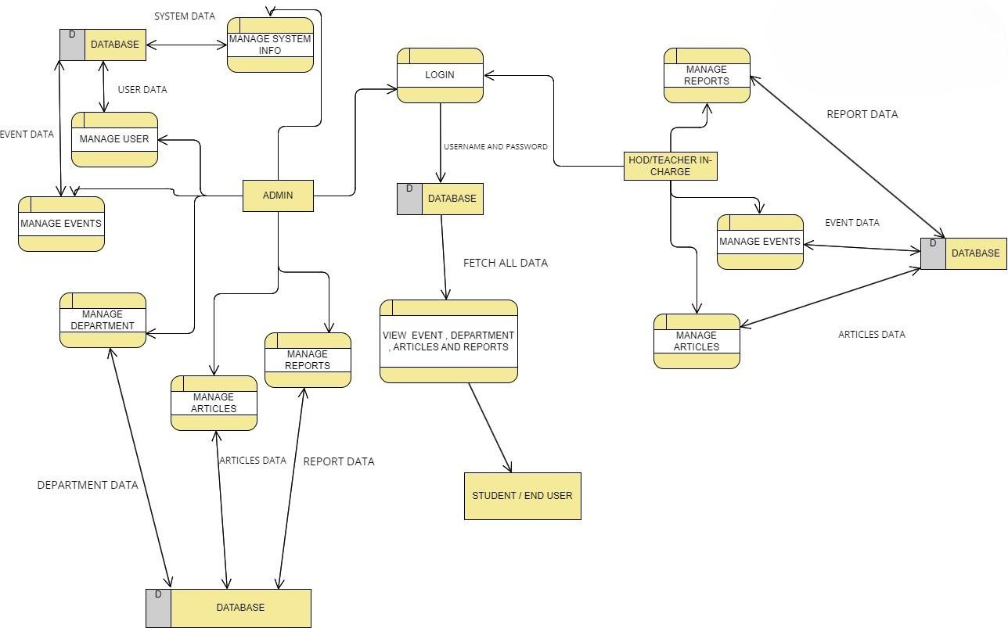

DATABASE DESIGN

TABLE STRUCTURE

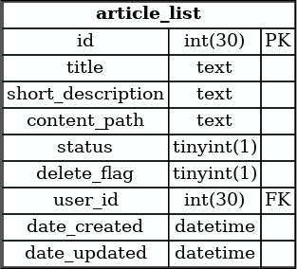
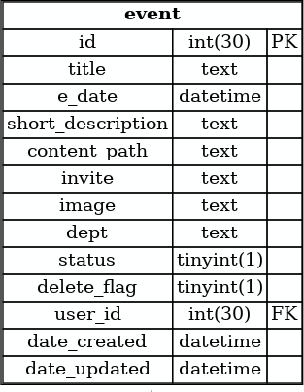

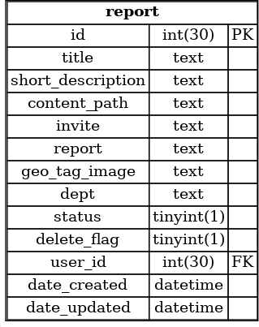


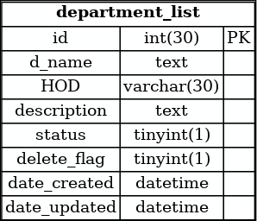
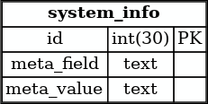

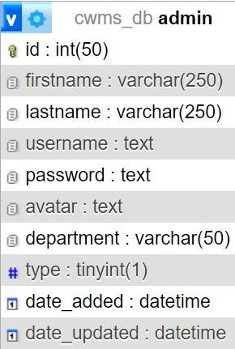

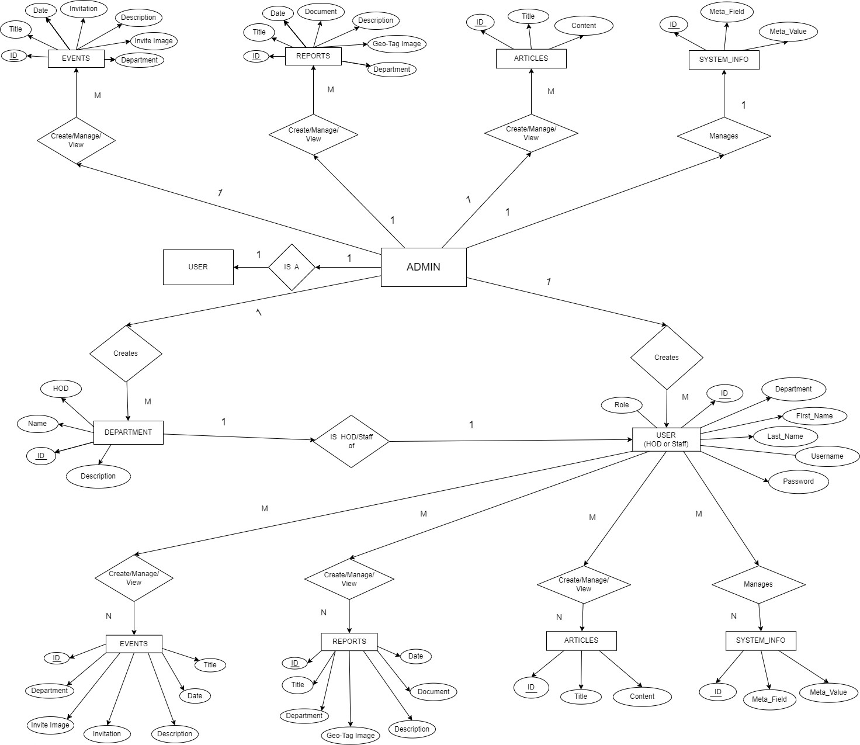
ENTITY-RELATIONSHIP (ER) DIAGRAM

IMPLEMENTATION

The implementation of the College Event Management System was carried out using a combination of the bottom-up approach and modular development. This approach was chosen to ensure that each component of the system was thoroughly tested and integrated, resulting in a robust and scalable solution.

DEVELOPMENT OF THE SYSTEM

Bottom-Up Approach
The bottom-up approach involves developing and testing the system’s fundamental components first, then integrating them to form higher-level functionalities. This method ensures that each component is functioning correctly before it becomes part of a larger system.

Component Development:
  - Database Layer:
    - The MySQL database schema was designed and created first. Tables were defined for users, events, departments, and articles.
    - Relationships between tables were established using primary keys and foreign keys to maintain data integrity.
    - Sample data was populated to facilitate testing of database operations.

Classes and Backend Logic:
    - PHP classes were developed for managing database connections (DBconnection.php), user authentication (Login.php), system settings (SystemSettings.php), and user operations (Users.php).
    - Each class was tested independently to ensure it performed its intended functions correctly, such as handling CRUD operations and session management.

Module Development and Integration:
  - User Management Module:
    - User registration, login, profile management, and role assignment were implemented.
    - Integration with the database to store and retrieve user data securely.

Event Management Module:
    - Creation, editing, deletion, and viewing of events.

    - Integration with the user management module to allow users to register for events.

Department Management Module:
    - Handling the creation and management of departments.
    - Assigning users (teachers/HODs) to specific departments.

Article and Report Management:
    - Uploading, editing, and viewing articles and reports.
    - Ensuring that data is consistently retrieved and displayed.

Modular Development
To maintain clarity and facilitate parallel development, the system was divided into distinct modules. Each module was developed as an independent unit with well-defined interfaces for interaction with other modules.

Frontend and User Interface:
  - Developed using HTML, CSS, and Bootstrap 5 for a responsive and user-friendly design.
  - JavaScript was used to enhance interactivity and handle client-side validation.
  - User interfaces were designed for students, teachers, and administrators, each tailored to their specific needs.

Backend and Server-Side Scripting:
  - PHP was used to implement server-side logic, handling data processing and interactions with the MySQL database.
  - Scripts were written to manage user sessions, process form submissions, and generate dynamic content.

Integration and Testing:
  - Unit testing was conducted on individual components to ensure they function correctly in isolation.
  - Integration testing ensured that different modules work together seamlessly.
  - User acceptance testing (UAT) was performed to validate the system against the initial requirements and user expectations.

Deployment
After thorough testing, the system was deployed using the XAMPP server platform, which integrates Apache, MySQL, and PHP.

Configuration:
  - The XAMPP environment was configured to host the CEMS application.
  - Database configurations were set up, and initial data was migrated to the production

server.

Deployment:
  - The codebase was deployed to the server, and necessary adjustments were made to ensure the application runs smoothly.
  - Continuous integration practices were established to manage updates and patches.

Documentation :
  - Comprehensive documentation was provided to facilitate system maintenance and future enhancements.

CODING CONVENTIONS

Naming Conventions for College Event Management System

Using consistent naming conventions is crucial for maintaining code readability, understandability, and manageability. The following conventions will be adhered to throughout the CEMS project:

Variables

  - CamelCase: Variables will be named using camelCase, starting with a lowercase letter and capitalizing the first letter of each subsequent word.

Example: $userName, $eventDetails, $departmentList

Functions

  - CamelCase: Functions will be named using camelCase to denote actions or processes.

Example: function getUserData(), function createEvent(), function deleteDepartment()

Classes and Objects

  - PascalCase: Classes and objects will be named using PascalCase, starting with an uppercase letter and capitalizing the first letter of each subsequent word.

Example: class UserManager, new EventManager(), class DepartmentController

File and Folder Names

  - Lowercase with Hyphens or Underscores: File and folder names will be written in lowercase letters, with hyphens or underscores separating words.

Example: user_manager.php, event-controller.php, department_list.php

Database Tables

  - Singular Nouns in Lowercase: Database tables will be named using singular nouns in lowercase letters, with underscores separating words.

Example: user, event, department, article

Database Columns

  - Lowercase with Underscores: Columns in database tables will be named using lowercase letters, with underscores separating words.

Example: user_id, event_name, department_head, article_content

HTML/CSS/JS IDs and Classes

  - Kebab-Case: IDs and classes in HTML, CSS, and JavaScript will be named using kebab-case (lowercase with hyphens separating words).

Example: #main-header, .event-list, #user-profile

File Structure:

  - Files are organized into directories based on their function (e.g., assets/css, classes, inc, pages).
  - Each file is named to reflect its content and purpose (e.g., user.php, events.php, DBconnection.php).

Code Formatting:
  - Indentation is consistently used, with 4 spaces per indentation level and well commented.
  - Braces {} are used for all control structures, even if they contain a single statement.

Security Practices:
  - User inputs are sanitized and validated to prevent SQL injection and cross-site scripting (XSS) attacks used prepared statements for the same.
  - Passwords are hashed using secure algorithms before storing them in the database.
  - Sessions are managed securely to prevent unauthorized access.

TESTING

Testing is a vital part of the development lifecycle for the College Event Management System (CEMS), ensuring that the application functions correctly, efficiently, and securely. Different testing strategies are used to cover various aspects of the system.

TESTING STRATEGIES

White Box Testing:
White Box Testing is a test case design method that uses the control structure of the procedural design to derive test cases.

Black Box Testing:
Black Box testing focuses functional requirements of the software. It derives set of input conditions that will exercise all requirements of a program.
    - UNIT TESTING
Unit testing involves verifying individual components or units of code, such as functions or methods, to ensure they perform as expected. It focuses on the smallest testable parts of an application, typically done by developers during the coding phase. Unit tests use mock data to validate each unit's functionality independently, ensuring that the foundational building blocks of the software are correct before integration. For example, testing whether the Admin can add, delete, edit and view Department.

    - INTEGRATION TESTING

Integration testing assesses the interactions between integrated units or modules to ensure they work together as intended. This phase tests the data flow and interfaces between components, identifying issues that arise from the combination of different modules. By focusing on the integration points, this testing ensures that modules, when combined, function correctly and cohesively within the system. For example, Integrating Event, Report, Article etc modules and test whether they work as intended.
    - REGRESSION TESTING

Regression testing is conducted to ensure that new code changes or enhancements do not

adversely affect the existing functionalities of the software. This involves re-running previously executed test cases to verify that the system's behavior remains consistent after updates.

    - SYSTEM TESTING

System testing is a comprehensive evaluation of the entire system to verify that it meets the specified requirements and performs well under various conditions. This phase encompasses functional testing to check all features, performance testing to assess load handling, security testing to identify vulnerabilities, and user acceptance testing (UAT) to ensure the system meets user needs. It validates the system's overall functionality, performance, and security before deployment.

  - SAMPLE TEST CASES

Test Case  ID | Description | Preconditions | Test Steps | Expected Results | Actual Results | Status
TC_01 | Verify login functionality | User must have valid login credentials | - Navigate to login page.  - Enter valid username and password.  - Click 'Login' button. | User should be successfully logged in and redirected to the dashboard. | User successfully logged in and redirected to the dashboard. | Passed
TC_02 | Verify invalid login | None | - Navigate to login page.  - Enter invalid username and/or password.  - Click 'Login' button. | Error message should be displayed indicating invalid login credentials. | Error message displayed indicating invalid login credentials. | Passed
TC_03 | Add new department | Admin must be logged in | - Navigate to 'Departments' page.  - Click 'Add Department' button.  - Enter department details  - Click 'Save'. | Department should be added successfully and visible in the departments list. | Department added successfully and visible in the departments list. | Passed
TC_04 | Delete department | Admin must be logged in | - Navigate to 'Departments' page.  - Select a department.  - Click 'Delete'. | Department should be deleted successfully and no longer visible in the departments  list. | Department deleted successfully and no longer visible in the departments list. | Passed
TC-05 | Add new user | Admin must be logged in | - Navigate to 'Users' page.  - Click 'Add User' button. | User should be added successfully | User added successfully and visible in the users list. | Passed

 |  |  | - Enter user details.  - Click 'Save'. | and visible in the users list.
TC-06 | Delete user | Admin must be logged in | - Navigate to 'Users' page.  - Select a user.  - Click 'Delete'. | User should be deleted successfully and no longer visible in the  users list. | User deleted successfully and no longer visible in the users list. | Passed
TC-07 | Create new event | Admin or HOD/Teacher must be logged in | - Navigate to 'Events' page.  - Click 'Create Event' button.  - Enter event details.  - Click 'Save'. | Event should be created successfully and visible in the events list. | Event created successfully and visible in the events list. | Passed
TC-08 | Manage event | Admin or HOD/Teacher must be logged in | - Navigate to 'Events' page.  - Select an event.  - Edit event details.  - Click 'Save'. | Event details should be updated successfully and changes should be visible in the  events list. | Event details updated successfully and changes visible in the events list. | Passed
TC-09 | Create new report | Admin or HOD/Teacher must be logged in | - Navigate to 'Reports' page.  - Click 'Create Report' button.  - Enter report details.  - Click 'Save'. | Report should be created successfully and visible in the reports list. | Report created successfully and visible in the reports list. | Passed
TC-10 | Manage report | Admin or HOD/Teacher must be logged in | - Navigate to 'Reports' page.  - Select a report.  - Edit report details.  - Click 'Save'. | Report details should be updated successfully and changes should be visible in the  reports list. | Report details updated successfully and changes visible in the reports list. | Passed
TC-11 | Create new article | Admin or HOD/Teacher must be logged in | - Navigate to 'Articles' page.  - Click 'Create Article' button.  - Enter article details.  - Click 'Save'. | Article should be created successfully and visible in the articles list. | Article created successfully and visible in the articles list. | Passed
TC-12 | Manage article | Admin or HOD/Teacher must be logged in | - Navigate to 'Articles' page.  - Select an article.  - Edit article details.  - Click 'Save'. | Article details should be updated successfully and changes should be visible in the  articles list. | Article details updated successfully and changes visible in the articles list. | Passed

FUTURE ENHANCEMENT AND CONCLUSION

FUTURE ENHANCEMENT

The College Event Management System (CEMS) has the potential to evolve with several enhancements to better meet the needs of users and improve overall functionality. Future enhancements could include:

- Automatic Report Generation: Implementing a feature for automatic report generation would greatly benefit the admin and department heads. This functionality would allow the system to automatically generate detailed reports on event participation, departmental performance, and financial summaries at specified intervals. These reports can be exported in various formats such as PDF, Excel, and Word, and can be scheduled to be sent via email to relevant stakeholders.
- Search Enhancement: Enhancing the search functionality to allow users to filter events, articles, and reports based on specific time frames (e.g., searching from specified years) would provide more precise and relevant results. This improvement would help users to quickly locate historical data, past events, and archived articles, making the system more user-friendly and efficient.
- NAAC Data Management: Integrating NAAC (National Assessment and Accreditation Council) data management into the system would assist colleges in maintaining and organizing data required for accreditation. This module would enable the collection, storage, and retrieval of data related to institutional performance, faculty achievements, student outcomes, and other NAAC criteria. The system could also facilitate the generation of NAAC reports, streamlining the accreditation process for institutions.

CONCLUSION

The College Event Management System (CEMS) aims to transition the traditionally manual process of managing college events into a streamlined, efficient, and user-friendly digital platform. By incorporating core functionalities for admin, department heads, teachers, and students, CEMS simplifies event management, enhances accuracy, and improves data security.

The system's modules cover a wide range of operations, from user and department management to event creation, reporting, and article management, all accessible via an intuitive interface. Through

careful implementation of best practices in coding and design, CEMS ensures reliability and ease of use, supporting better resource utilization within educational institutions.

Future enhancements, such as automatic report generation, advanced search capabilities, and NAAC data management, will further augment the system's utility and robustness. These improvements will make CEMS an indispensable tool for college administration, enabling them to focus more on strategic activities rather than administrative tasks. With these advancements, CEMS will continue to evolve, meeting the ever-growing demands of educational event management and institutional accreditation.

BIBLIOGRAPHY

Books and Articles:
- HTML & CSS: THE COMPLETE REFERENCE Paperback – 1 July 2017
- HTML and CSS: Design and Build Webs by Duckett, Jon
- JavaScript: The Definitive Guide by David Flanagan
- DBMS – Fundamentals of Database Systems, Ramez Elmasri and Shamkant B Navathe
- Software Testing, Principles and Practices by Srinivasan Desikan and Gopalaswamy Ramesh
- Head First PHP & MySQL: A Brain-Friendly Guide Paperback – 1 December 2011

Web Resources:
  - W3Schools. (2023). HTML, CSS, JavaScript Tutorials. Retrieved from https://www.w3schools.com
  - MDN Web Docs. (2023). HTML: HyperText Markup Language. Retrieved from https://developer.mozilla.org/en-US/docs/Web/HTML
  - PHP Manual. (2023). PHP Documentation. Retrieved from https://www.php.net/manual/en/index.php
  - MySQL Documentation. (2023). MySQL 8.0 Reference Manual. Retrieved from https://dev.mysql.com/doc/refman/8.0/en/
  - Bootstrap. (2023). Introduction. Retrieved from https://getbootstrap.com/docs/5.3/getting-started/introduction/

Web references:
- GeeksforGeeks

  - https://www.geeksforgeeks.org/html-tutorials/
  - https://www.geeksforgeeks.org/css-tutorials/
  - https://www.geeksforgeeks.org/javascript-tutorial/
  - https://www.geeksforgeeks.org/php-tutorials/

Bootstrap 5 Tutorial by W3Schools

  - https://www.w3schools.com/bootstrap5/

MySQL Tutorial by W3Schools
  - https://www.w3schools.com/mysql/

APPENDICES

APPENDIX I – SCREEN SHOTS

HOME PAGE
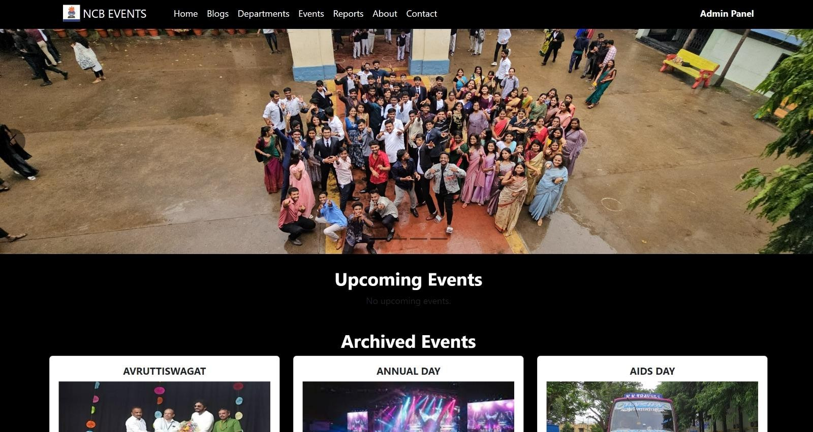

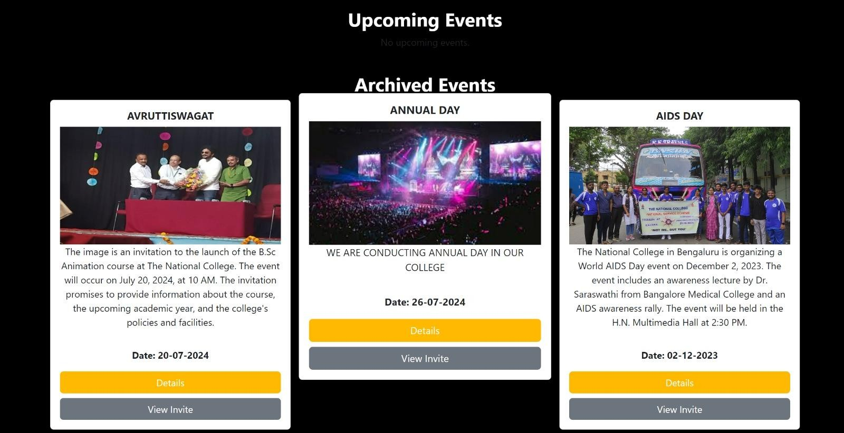

VIEW DEPARTMENT PAGE
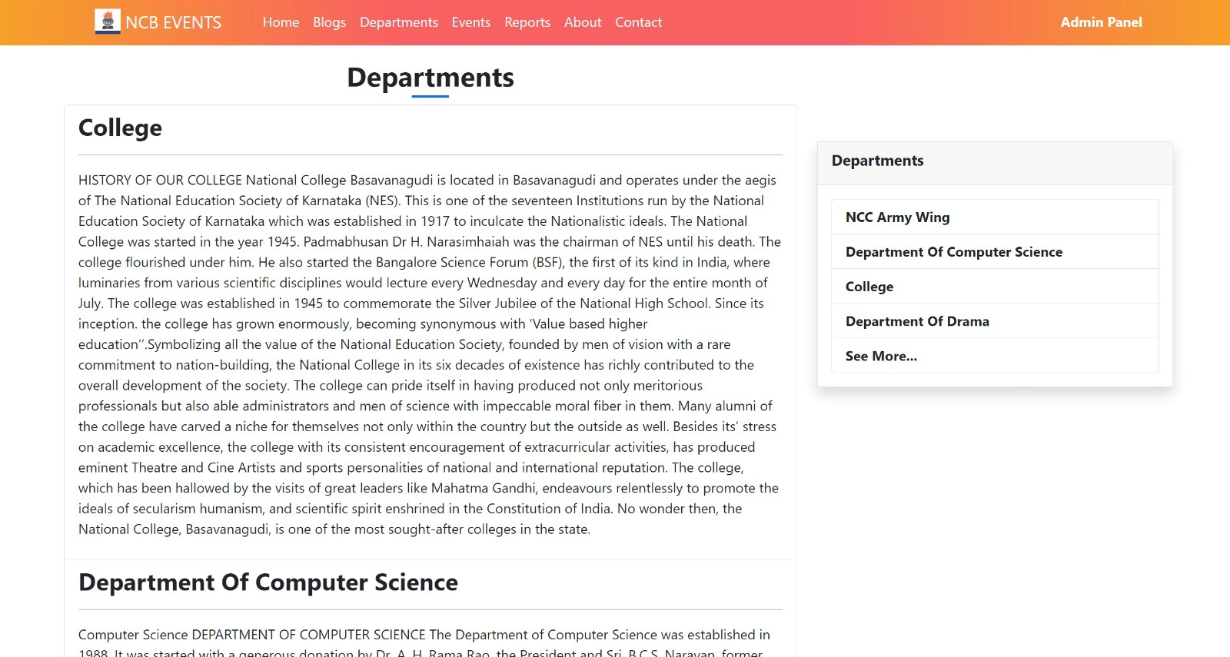

VIEW EVENT PAGE
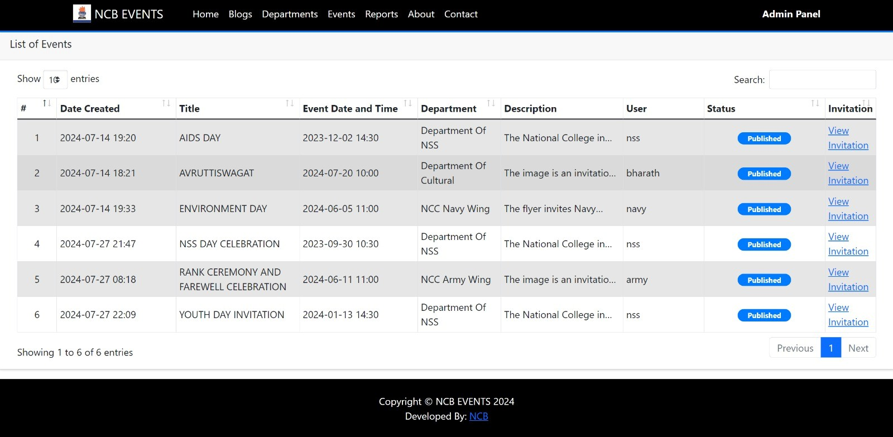

VIEW REPORTS PAGE
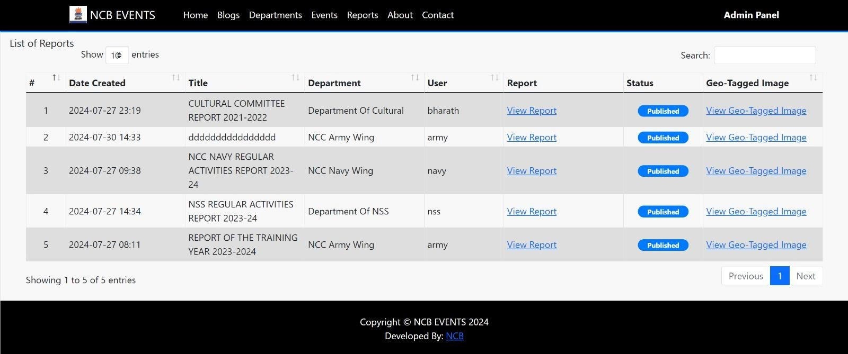

VIEW ARTICLES PAGE

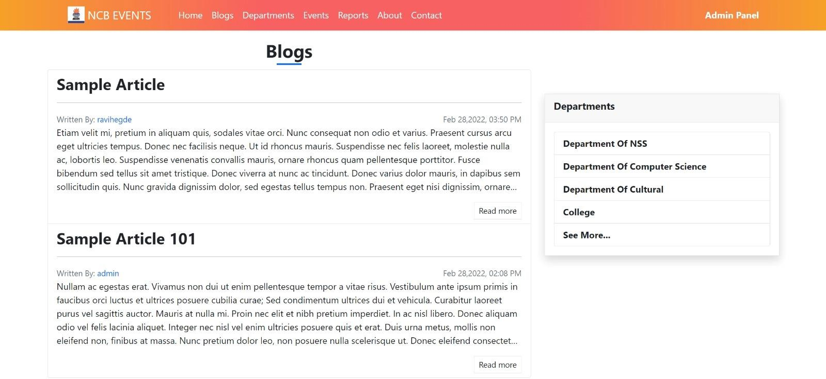

ADMIN DASHBOARD PAGE
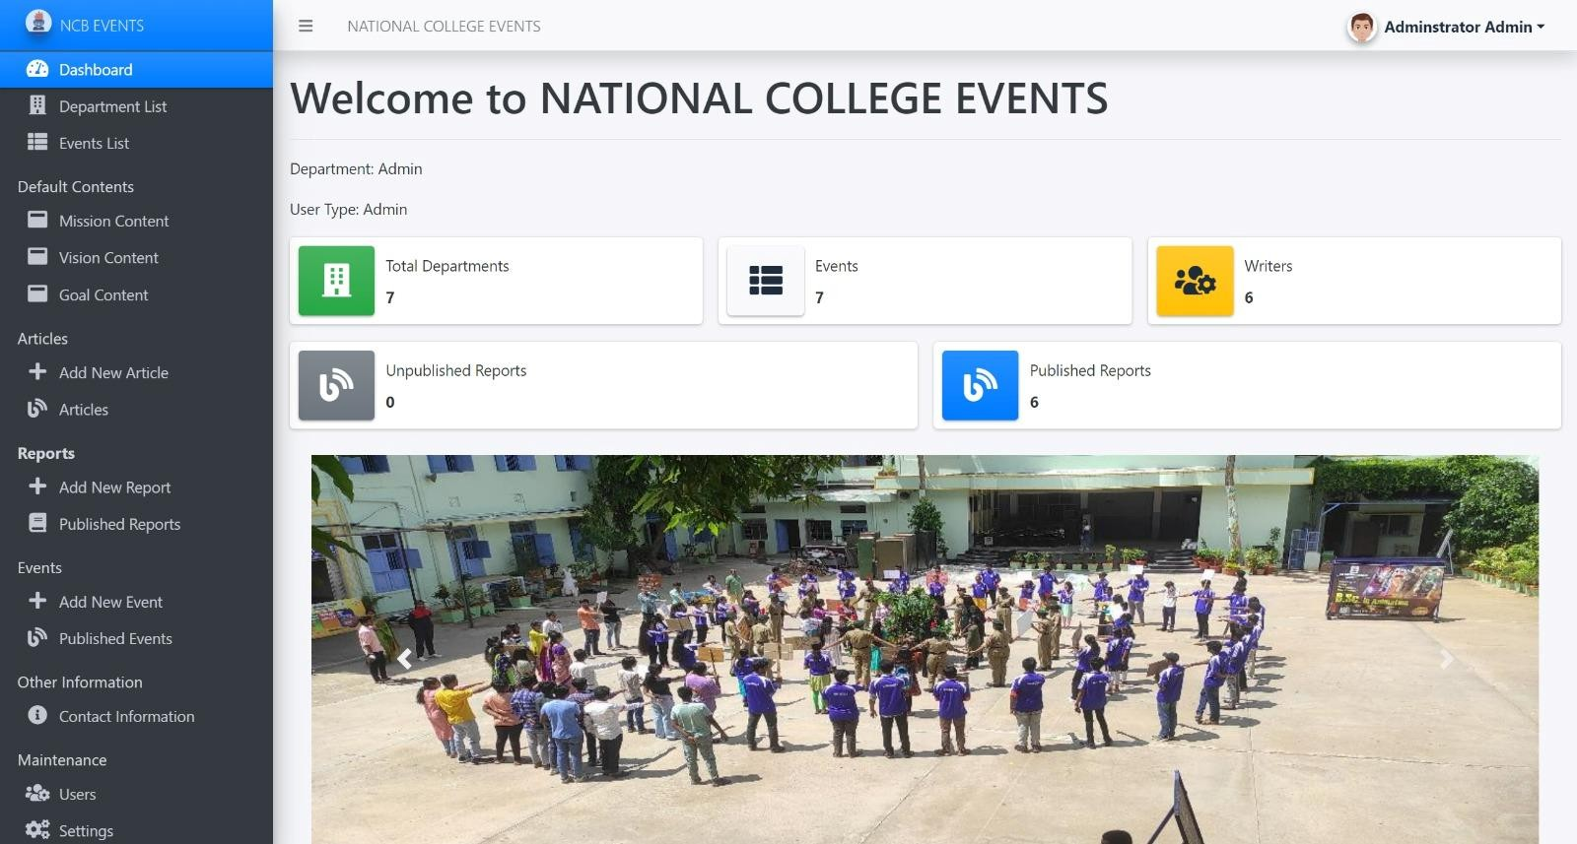

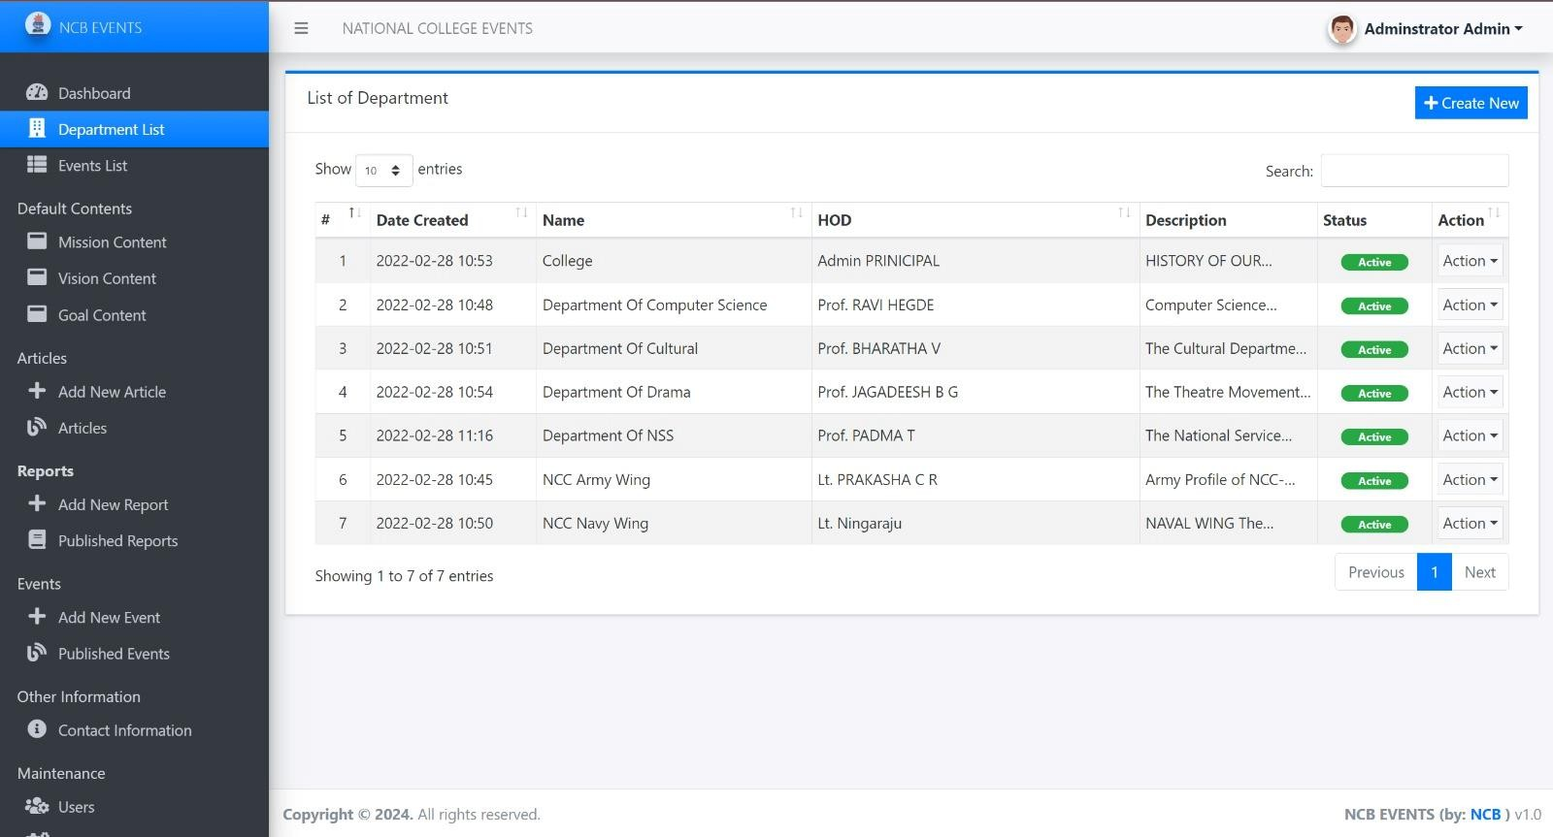
MANAGE DEPARTMENT ADMIN PAGE

MANAGE ARTICLE PAGE
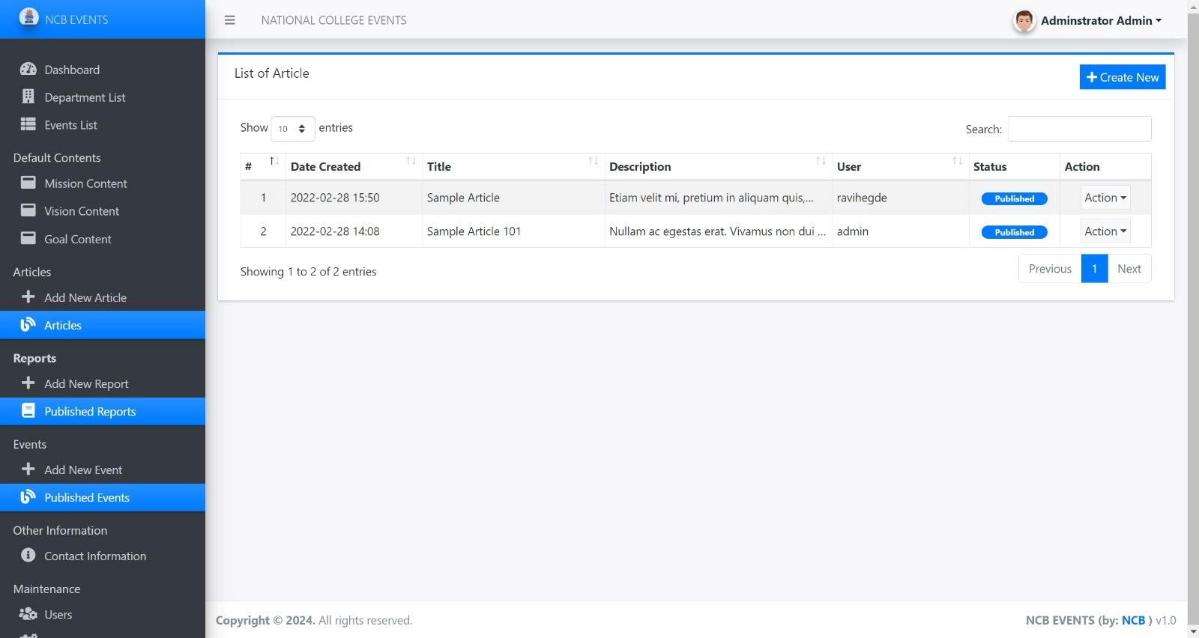

REPORT UPLOPADING PAGE
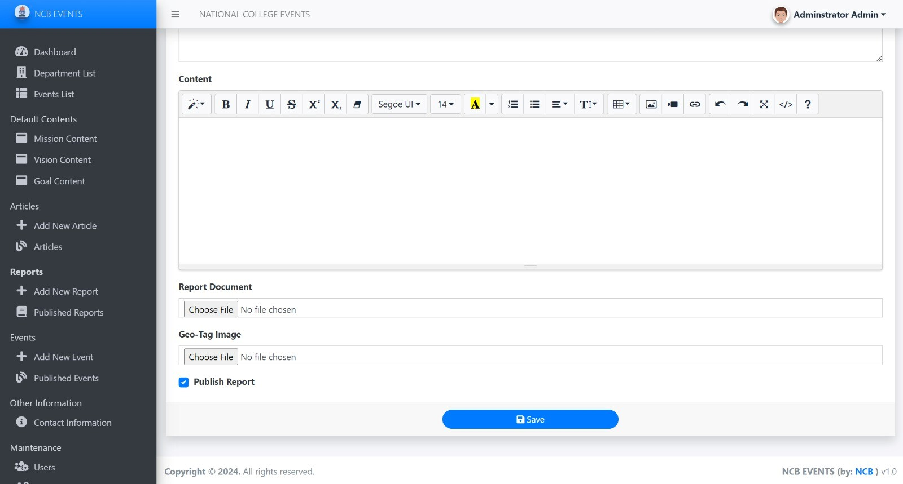

EVENT CREATION PAGE
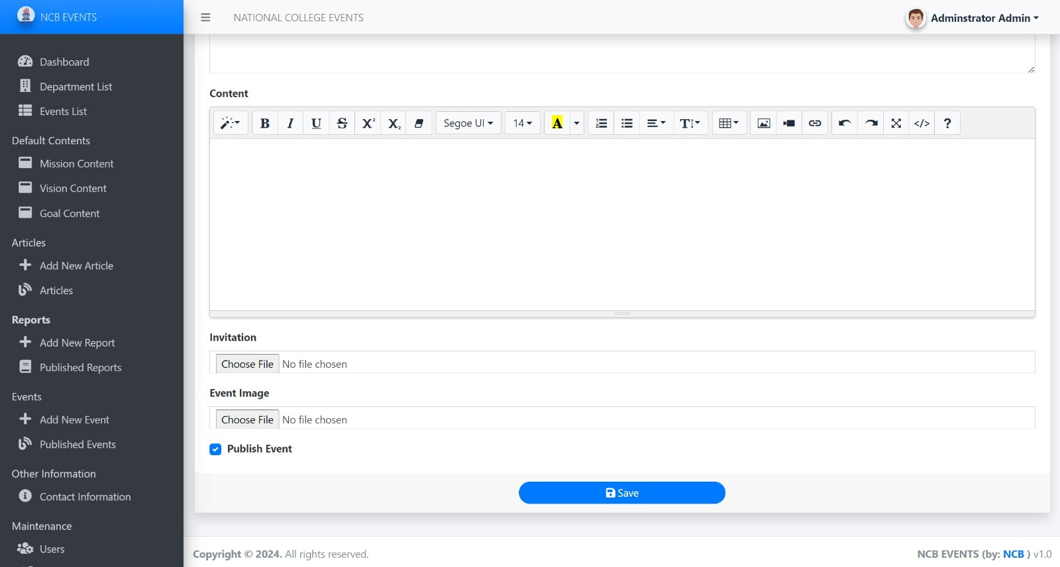
MANAGE USER PAGE (ADMIN)
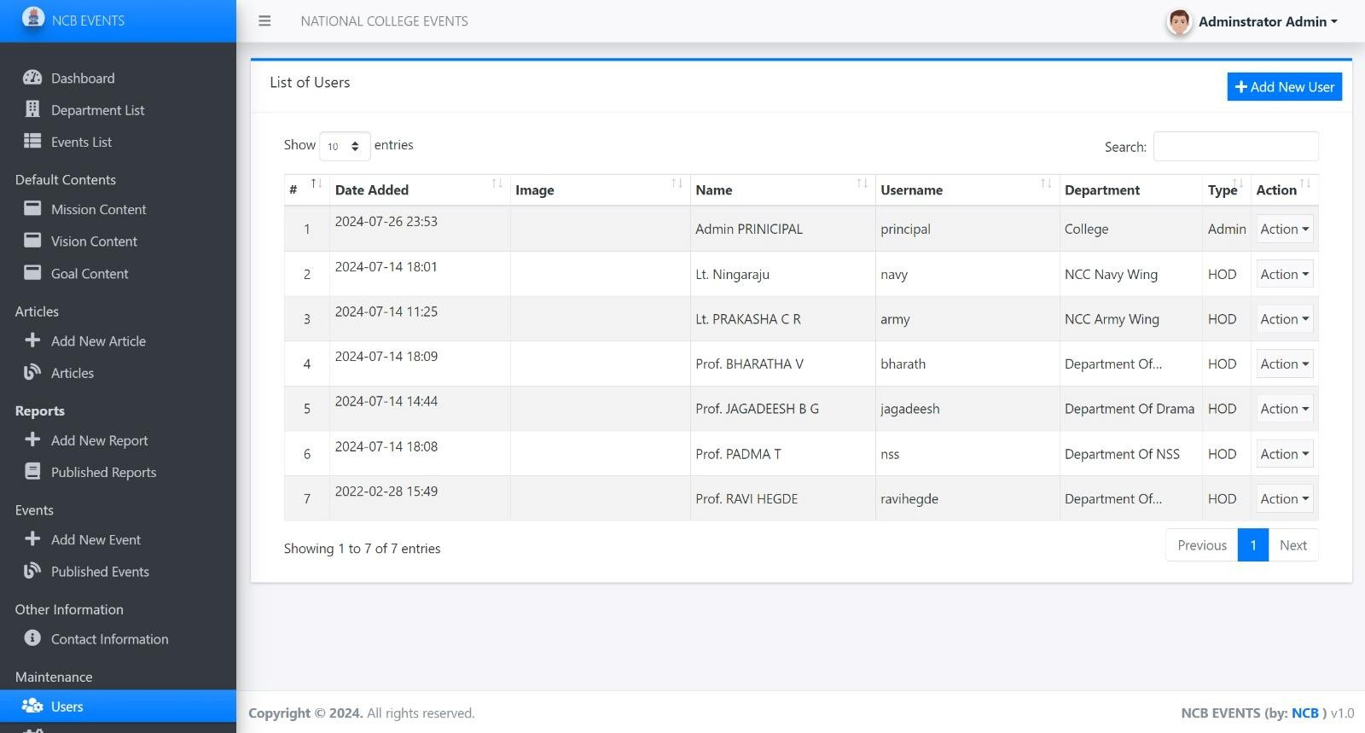

MANAGE SYSTEM INFO PAGE (ADMIN)

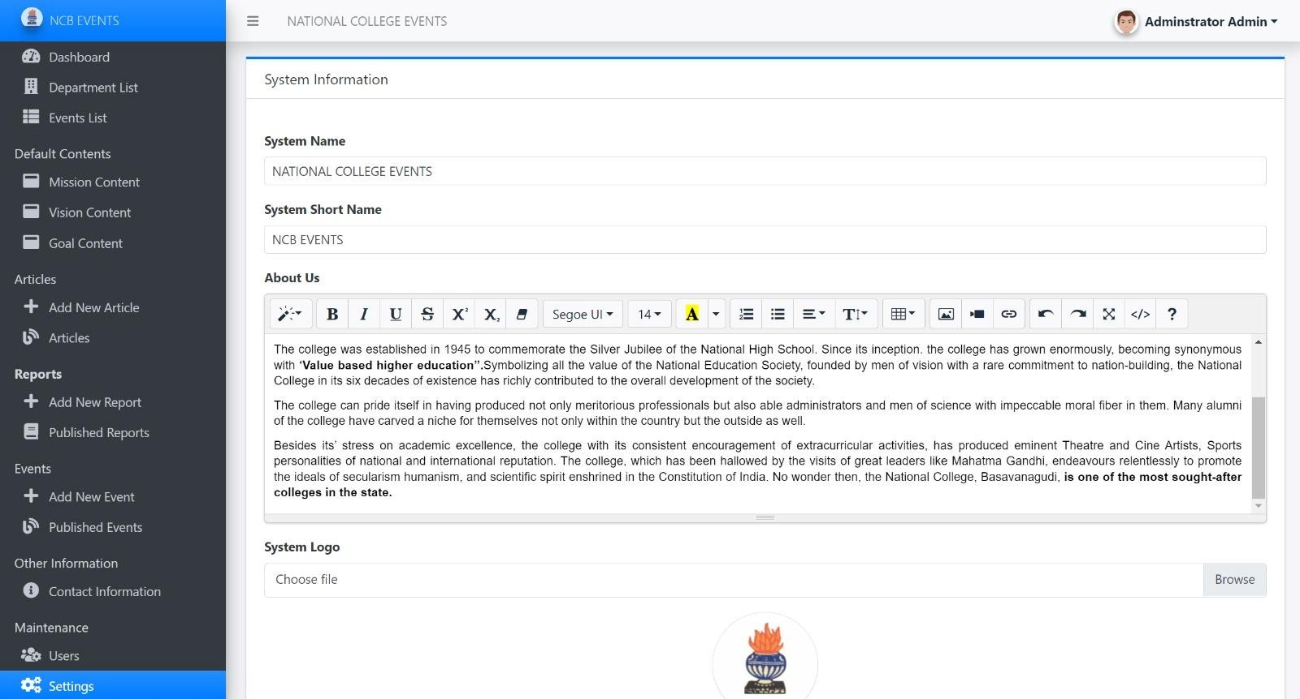

MANAGE CONTACT INFO PAGE (ADMIN)
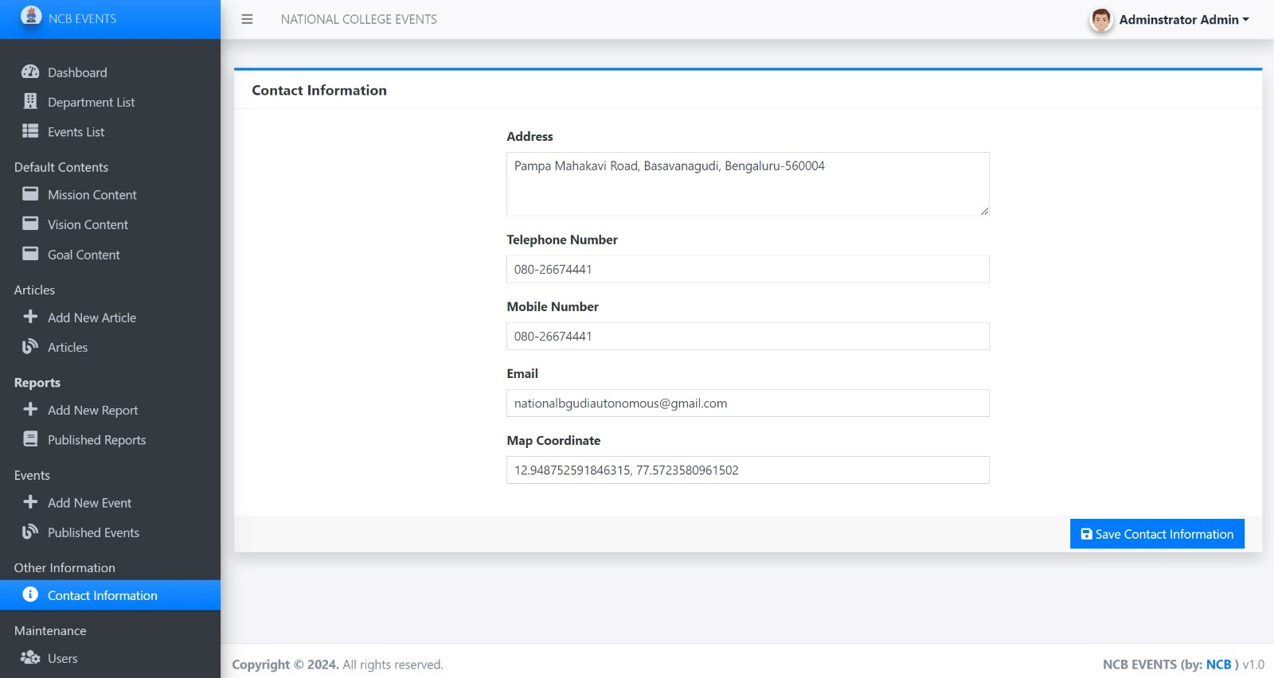

APPENDIX II – SOURCE CODE

manage_article.php (ADMIN):
<?php if(isset($_GET['id'])){
$qry = $conn->query("SELECT * FROM `article_list` where id = '{$_GET['id']}'"); if($qry->num_rows > 0){
foreach($qry->fetch_array() as $k => $v){
$$k = $v;
}
}
}
?>
<div class="content py-3">
<div class="card card-outline card-primary rounded-0 shadow">
<div class="card-header">
<h5 class="card-title"><b><?= isset($id) ? "Update Article" : "New Article" ?></b></h5>
</div>
<div class="card-body">
<form action="" id="article-form">
<input type="hidden" name="id" value="<?= isset($id) ? $id : "" ?>">
<input type="hidden" name="content_path" value="<?= isset($content_path) ?
$content_path : "" ?>">
<div class="row">
<div class="col-md-6">
<div class="form-group">
<label for="title" class="control-label">Title</label>
<input type="text" class="form-control form-control-sm rounded-0" name="title" value="<?= isset($title) ? $title : "" ?>" required>
</div>
</div>
</div>
<div class="row">
<div class="col-md-12">
<div class="form-group">
<label for="short_description" class="control-label">Summary</label>
<textarea rows="5" class="form-control form-control-sm rounded-0" name="short_description" required><?= isset($short_description) ? $short_description : ""
?></textarea>
</div>
</div>
</div>
<div class="row">
<div class="col-md-12">
<div class="form-group">
<label for="content" class="label-control-label">Content</label>
<textarea name="content" id="content" cols="30" rows="10" class="form-control form-control-sm rounded-0 summernote"><?= isset($content_path) && !empty($content_path) &&

is_file(base_app.$content_path) ? file_get_contents(base_app.$content_path) : "" ?></textarea>
</div>
</div>
</div>
<div class="row">
<div class="col-md-12">
<div class="custom-control custom-checkbox">
<input class="custom-control-input" type="checkbox" id="status" value="1" name="status" <?= isset($status) && $status == 1 ? "checked" : (!isset($status) ? 'checked' : "") ?>>
<label for="status" class="custom-control-label">Publish Article</label>
</div>
</div>
</div>
</form>
</div>
<div class="card-footer text-center"><button class="btn btn-primary rounded-pill btn-sm w-25" type="submit" form="article-form"><i class="fa fa-save"></i> Save</button></div>
</div>
</div>

manage_department.php (ADMIN):
<?php require_once('../../config.php');
if(isset($_GET['id']) && $_GET['id'] > 0){
$qry = $conn->query("SELECT * from `department_list` where id = '{$_GET['id']}' "); if($qry->num_rows > 0){
foreach($qry->fetch_assoc() as $k => $v){
$$k=$v;
}
}
}
?>
<div class="container-fluid">
<form action="" id="department-form">
<input type="hidden" name ="id" value="<?php echo isset($id) ? $id : '' ?>">
<div class="form-group">
<label for="d_name" class="control-label">Name</label>
<input type="text" name="d_name" id="d_name" class="form-control form-control-sm rounded-0" value="<?php echo isset($d_name) ? $d_name : ''; ?>" required/>
</div>
<div class="form-group">
<label for="description" class="control-label">Description</label>
<textarea rows="5" name="description" id="description" class="form-control form-control- sm rounded-0" required><?php echo isset($description) ? $description : ''; ?></textarea>
</div>
<div class="form-group">
<label for="status" class="control-label">Status</label>
<select name="status" id="status" class="form-control form-control-sm rounded-0" required>

<option value="1" <?php echo isset($status) && $status == 1 ? 'selected' : ''
?>>Active</option>
<option value="0" <?php echo isset($status) && $status == 0 ? 'selected' : ''
?>>Inactive</option>
</select>
</div>
</form>
</div>

manage_event.php (ADMIN):

<?php if(isset($_GET['id'])){
$qry = $conn->query("SELECT * FROM `event` where id = '{$_GET['id']}'"); if($qry->num_rows > 0){
foreach($qry->fetch_array() as $k => $v){
$$k = $v;
}
}
$q = $conn->query("SELECT a.*,u.username as writer ,u.department as dept FROM `event` a inner join users u on a.user_id = u.id where a.id = '{$_GET['id']}'");
$d=isset($dept) ? $dept : "" ;
$id = $_GET['id']; // Make sure this is sanitized or validated before using
// Replace with the actual department value you want to set
// $user_id = $_settings->userdata('id');
// $user_type = $_settings->userdata('type');
// $user_query = $conn->query("SELECT type, department FROM users WHERE id =
{$user_id}");
// $user_data = $user_query->fetch_assoc();
// $department_name = $user_data['department'];
// $stmt = $conn->prepare("INSERT into `event` `dept` = ? WHERE `id` = ?");
// $stmt->bind_param('si', $department_name, $id); // 'si' means string, integer
// $stmt->execute();
$id = $_GET['id']; // replace with the actual id
$dept = isset($dept) ? $dept : "" ; // replace with the actual department name

$stmt = $conn->prepare("UPDATE `event` SET `dept` = ? WHERE `id` = ?");
$stmt->bind_param("si", $dept, $id);
$stmt->execute();
}

?>
<div class="content py-3">
<div class="card card-outline card-primary rounded-0 shadow">
<div class="card-header">
<h5 class="card-title"><b><?= isset($id) ? "Update Event" : "New Event" ?></b></h5>
</div>
<div class="card-body">

<form action="" id="article-form">
<input type="hidden" name="id" value="<?= isset($id) ? $id : "" ?>">
<input type="hidden" name="content_path" value="<?= isset($content_path) ?
$content_path : "" ?>">
<div class="row">
<div class="col-md-6">
<div class="form-group">
<label for="title" class="control-label">Title</label>
<input type="text" class="form-control form-control-sm rounded-0" name="title" value="<?= isset($title) ? $title : "" ?>" required>
</div>
</div>
</div>
<div class="row">
<div class="col-md-6">
<div class="form-group">
<label for="e_date" class="control-label">Date</label>
<input type="DateTime-local" class="form-control form-control-sm rounded-0" name="e_date" value="<?= isset($e_date) ? $e_date : "" ?>" required>
</div>
</div>
</div>
<div class="row">
<div class="col-md-12">
<div class="form-group">
<label for="short_description" class="control-label">Summary</label>
<textarea rows="5" class="form-control form-control-sm rounded-0" name="short_description" required><?= isset($short_description) ? $short_description : ""
?></textarea>
</div>
</div>
</div>
<div class="row">
<div class="col-md-12">
<div class="form-group">
<label for="content" class="label-control-label">Content</label>
<textarea name="content" id="content" cols="30" rows="10" class="form-control form-control-sm rounded-0 summernote"><?= isset($content_path) && !empty($content_path) && is_file(base_app.$content_path) ? file_get_contents(base_app.$content_path) : "" ?></textarea>
</div>
</div>
</div>
<div class="row">
<div class="col-md-12">
<div class="form-group">
<label for="invite" class="label-control-label">Invitation</label>
<input type="file" accept=".pdf,.doc,.docx,.jpg,.jpeg" name="invite" id="invite" = class="form-control form-control-sm rounded-0 "><?= isset($invite) && !empty($invite) && is_file(base_app.$invite) ? "" : "" ?>

</div>
</div>
</div>
<div class="row">
<div class="col-md-12">
<div class="form-group">
<label for="image" class="label-control-label">Event Image</label>
<input type="file" accept=".jpg,.jpeg,.png,.gif" name="image" id="image" class="form- control form-control-sm rounded-0">
<div id="image-preview" class="mt-3 center">
<?php if(isset($image) && !empty($image) && is_file(base_app.$image)): ?>
<img src="https://placehold.co/600x400" alt="Current Image" style="max-width: 200px; display: block;">
<?php endif; ?>
</div>
</div>
</div>
</div>

<div class="row">
<div class="col-md-12">
<div class="custom-control custom-checkbox">
<input class="custom-control-input" type="checkbox" id="status" value="1" name="status" <?= isset($status) && $status == 1 ? "checked" : (!isset($status) ? 'checked' : "") ?>>
<label for="status" class="custom-control-label">Publish Event</label>
</div>
</div>
</div>

</form>
</div>
<div class="card-footer text-center"><button class="btn btn-primary rounded-pill btn-sm w-25" type="submit" form="article-form"><i class="fa fa-save"></i> Save</button></div>
</div>
</div>

manage_report.php (ADMIN):

<?php if(isset($_GET['id'])){
$qry = $conn->query("SELECT * FROM `report` where id = '{$_GET['id']}'"); if($qry->num_rows > 0){
foreach($qry->fetch_array() as $k => $v){
$$k = $v;
}
}

}

?>
<div class="content py-3">
<div class="card card-outline card-primary rounded-0 shadow">
<div class="card-header">
<h5 class="card-title"><b><?= isset($id) ? "Update Report" : "New Report" ?></b></h5>
</div>
<div class="card-body">
<form action="" id="article-form">
<input type="hidden" name="id" value="<?= isset($id) ? $id : "" ?>">
<input type="hidden" name="content_path" value="<?= isset($content_path) ?
$content_path : "" ?>">
<div class="row">
<div class="col-md-6">
<div class="form-group">
<label for="title" class="control-label">Title</label>
<input type="text" class="form-control form-control-sm rounded-0" name="title" value="<?= isset($title) ? $title : "" ?>" required>
</div>
</div>
</div>
<!-- <div class="row">
<div class="col-md-6">
<div class="form-group">
<label for="e_date" class="control-label">Date</label>
<input type="DateTime-local" class="form-control form-control-sm rounded-0" name="e_date" value="<?= isset($e_date) ? $e_date : "" ?>" required>
</div>
</div>
</div> -->
<div class="row">
<div class="col-md-12">
<div class="form-group">
<label for="short_description" class="control-label">Summary</label>
<textarea rows="5" class="form-control form-control-sm rounded-0" name="short_description" required><?= isset($short_description) ? $short_description : ""
?></textarea>
</div>
</div>
</div>
<div class="row">
<div class="col-md-12">
<div class="form-group">
<label for="content" class="label-control-label">Content</label>
<textarea name="content" id="content" cols="30" rows="10" class="form-control form-control-sm rounded-0 summernote"><?= isset($content_path) && !empty($content_path) && is_file(base_app.$content_path) ? file_get_contents(base_app.$content_path) : "" ?></textarea>
</div>
</div>
</div>

<div class="row">
<div class="col-md-12">
<div class="form-group">
<label for="invite" class="label-control-label">Report Document</label>
<input type="file" accept=".pdf,.doc,.docx,.jpg,.jpeg" name="invite" id="invite" = class="form-control form-control-sm rounded-0 "><?= isset($invite) && !empty($invite) && is_file(base_app.$invite) ? "" : "" ?>
</div>
</div>
</div>
<div class="row">
<div class="col-md-12">
<div class="form-group">
<label for="image" class="label-control-label">Geo-Tag Image</label>
<input type="file" accept=".jpg,.jpeg,.png,.gif" name="image" id="image" class="form- control form-control-sm rounded-0">
<div id="image-preview" class="mt-3 center">
<?php if(isset($image) && !empty($image) && is_file(base_app.$image)): ?>
<img src="https://placehold.co/600x400" alt="Current Image" style="max-width: 200px; display: block;">
<?php endif; ?>
</div>
</div>
</div>
</div>
<div class="row">
<div class="col-md-12">
<div class="custom-control custom-checkbox">
<input class="custom-control-input" type="checkbox" id="status" value="1" name="status" <?= isset($status) && $status == 1 ? "checked" : (!isset($status) ? 'checked' : "") ?>>
<label for="status" class="custom-control-label">Publish Report</label>
</div>
</div>
</div>

</form>
</div>
<div class="card-footer text-center"><button class="btn btn-primary rounded-pill btn-sm w-25" type="submit" form="article-form"><i class="fa fa-save"></i> Save</button></div>
</div>
</div>

System info(index.php):
<?php if($_settings->chk_flashdata('success')): ?>
<script>
alert_toast("<?php echo $_settings->flashdata('success') ?>",'success')
</script>
<?php endif;?>

<style>
img#cimg{ height: 15vh; width: 15vh;
object-fit: cover;
border-radius: 100% 100%;
}
img#cimg2{ height: 50vh; width: 100%;
object-fit: contain;
/* border-radius: 100% 100%; */
}
</style>
<div class="col-lg-12">
<div class="card card-outline rounded-0 card-primary">
<div class="card-header">
<h5 class="card-title">System Information</h5>
<!-- <div class="card-tools">
<a class="btn btn-block btn-sm btn-default btn-flat border-primary new_department" href="javascript:void(0)"><i class="fa fa-plus"></i> Add New</a>
</div> -->
</div>
<div class="card-body">
<form action="" id="system-frm">
<div id="msg" class="form-group"></div>
<div class="form-group">
<label for="name" class="control-label">System Name</label>
<input type="text" class="form-control form-control-sm" name="name" id="name" value="<?php echo $_settings->info('name') ?>">
</div>
<div class="form-group">
<label for="short_name" class="control-label">System Short Name</label>
<input type="text" class="form-control form-control-sm" name="short_name" id="short_name" value="<?php echo $_settings->info('short_name') ?>">
</div>
<!-- <div class="form-group">
<label for="" class="control-label">Welcome Content</label>
<textarea name="content[welcome]" id="" cols="30" rows="2" class="form-control summernote"><?php echo is_file(base_app.'welcome.html') ? file_get_contents(base_app.'welcome.html') : "" ?></textarea>
</div> -->
<div class="form-group">
<label for="" class="control-label">About Us</label>
<textarea name="content[about]" id="" cols="30" rows="2" class="form-control summernote"><?php echo is_file(base_app.'about.html') ? file_get_contents(base_app.'about.html') : "" ?></textarea>
</div>

<div class="form-group">

<label for="" class="control-label">System Logo</label>
<div class="custom-file">
<input type="file" class="custom-file-input rounded-circle" id="customFile" name="img" onchange="displayImg(this,$(this))">
<label class="custom-file-label" for="customFile">Choose file</label>
</div>
</div>
<div class="form-group d-flex justify-content-center">
<img src="<?php echo validate_image($_settings->info('logo')) ?>" alt="" id="cimg" class="img-fluid img-thumbnail">
</div>
<div class="form-group">
<label for="" class="control-label">Website Cover</label>
<div class="custom-file">
<input type="file" class="custom-file-input rounded-circle" id="customFile" name="cover" onchange="displayImg2(this,$(this))">
<label class="custom-file-label" for="customFile">Choose file</label>
</div>
</div>
<div class="form-group d-flex justify-content-center">
<img src="<?php echo validate_image($_settings->info('cover')) ?>" alt="" id="cimg2" class="img-fluid img-thumbnail">
</div>
<div class="form-group">
<label for="" class="control-label">Banner Images</label>
<div class="custom-file">
<input type="file" class="custom-file-input rounded-circle" id="customFile" name="banners[]" multiple accept=".png,.jpg,.jpeg" onchange="displayImg3(this,$(this))">
<label class="custom-file-label" for="customFile">Choose file</label>
</div>
<small><i>Choose to upload new banner immages</i></small>
</div>
<?php
$upload_path = "uploads/banner"; if(is_dir(base_app.$upload_path)):
$file= scandir(base_app.$upload_path); foreach($file as $img):
if(in_array($img,array('.','..'))) continue;

?>
<div class="d-flex w-100 align-items-center img-item">
<span><img src="<?php echo base_url.$upload_path.'/'.$img."?v=".(time()) ?>" width="150px" height="100px" style="object-fit:cover;" class="img-thumbnail" alt=""></span>
<span class="ml-4"><button class="btn btn-sm btn-default text-danger rem_img" type="button" data-path="<?php echo base_app.$upload_path.'/'.$img ?>"><i class="fa fa- trash"></i></button></span>
</div>
<?php endforeach; ?>

<?php endif; ?>
</form>
</div>
<div class="card-footer">
<div class="col-md-12">
<div class="row">
<button class="btn btn-sm btn-primary" form="system-frm">Update</button>
</div>
</div>
</div>

</div>
</div>

manage_user.php (ADMIN):
<?php require_once("./../../config.php");
if(isset($_GET['id'])){
$user = $conn->query("SELECT * FROM users where id ='{$_GET['id']}'"); foreach($user->fetch_array() as $k =>$v){
$meta[$k] = $v;
}
}
?>
<div class="container-fluid">
<div id="msg"></div>
<form action="" id="manage-user">
<input type="hidden" name="id" value="<?= isset($meta['id']) ? $meta['id'] : '' ?>">
<div class="form-group">
<label for="name">First Name</label>
<input type="text" name="firstname" id="firstname" class="form-control" value="<?php echo isset($meta['firstname']) ? $meta['firstname']: '' ?>" required>
</div>
<div class="form-group">
<label for="name">Last Name</label>
<input type="text" name="lastname" id="lastname" class="form-control" value="<?php echo isset($meta['lastname']) ? $meta['lastname']: '' ?>" required>
</div>
<div class="form-group">
<label for="username">Username</label>
<input type="text" name="username" id="username" class="form-control" value="<?php echo isset($meta['username']) ? $meta['username']: '' ?>" required autocomplete="off">
</div>
<div class="form-group">
<label for="password">Password</label>
<input type="password" name="password" id="password" class="form-control" value="" autocomplete="off" <?= isset($password) ? "" : "required" ?>>

<?php if(isset($password)): ?>
<small><i>Leave this blank if you dont want to change the password.</i></small>
<?php endif; ?>
</div>
<div class="form-group">
<label for="type" class="control-label">User Role</label>
<select name="type" id="type" class="form-control form-control-sm rounded-0" required>
<option value="1" <?php echo isset($type) && $type == 1 ? 'selected' : ''
?>>Administrator</option>
<option value="2" <?php echo isset($type) && $type == 2 ? 'selected' : '' ?>>HOD</option>
<option value="3" <?php echo isset($type) && $type == 3 ? 'selected' : '' ?>>Other Staff</option>
</select>
</div>

<?php
// Check if the form was submitted
if ($_SERVER["REQUEST_METHOD"] == "POST") {
// Get the selected department ID from the form submission
$department_id = $_POST['department'];

// Database connection settings
$host = 'localhost'; // Database host
$username = 'root'; // Database username
$password = ''; // Database password (leave blank if none)
$database = 'cwms_db'; // Database name

// Create a MySQLi connection
$conn = new mysqli($host, $username, "", $database);

// Check for connection errors if ($conn->connect_error) {
die("Connection failed: " . $conn->connect_error);
}

// Prepare SQL statement to insert data into the user database
$sql = "INSERT INTO users (department) VALUES (?)";
$stmt = $conn->prepare($sql);

// Bind the parameter to the statement
$stmt->bind_param("s", $department_name);
// Execute the statement if ($stmt->execute()) {
echo "Data inserted successfully.";
} else {
echo "Error: " . $sql . "<br>" . $conn->error;
}

// Close the statement and connection

$stmt->close();
$conn->close();
}
?>

<?php
// Fetch department names from the database
$sql = "SELECT id, d_name FROM department_list where delete_flag=0";
$result = $conn->query($sql);

if ($result && $result->num_rows > 0) { echo '<div class="form-group">';
echo '<label for="department" class="control-label">Department</label>';
echo '<select name="department" id="department" class="form-control form-control-sm rounded- 0">';
echo '<option value="">Select Department</option>';
// Populate the dropdown with department names while ($row = $result->fetch_assoc()) {
$department_id = $row['id']; // Store the department ID in a variable
$department_name = htmlspecialchars($row['d_name']); // Store the department name in a variable
echo '<option value="' . $department_name . '">' . $department_name . '</option>';
}

echo '</select>'; echo '</div>';
} else {
echo '<div class="form-group">';
echo '<p>No departments found.</p>'; echo '</div>';
}
?>

<div class="form-group">
<label for="" class="control-label">Avatar</label>
<div class="custom-file">
<input type="file" class="custom-file-input rounded-circle" id="customFile" name="img" onchange="displayImg(this,$(this))" accept="image/png, image/jpeg">
<label class="custom-file-label" for="customFile">Choose file</label>
</div>
</div>
<div class="form-group d-flex justify-content-center">
<img src="<?php echo validate_image(isset($meta['avatar']) ? $meta['avatar'] :'') ?>" alt="" id="cimg" class="img-fluid img-thumbnail">
</div>
</form>
</div>
<style>

img#cimg{ height: 15vh; width: 15vh;
object-fit: cover;
border-radius: 100% 100%;
}
</style>

Admin(home.php):

<h1>Welcome to <?php echo $_settings->info('name') ?></h1>
<hr>
<?php
// Fetch user data
$user_id = $_settings->userdata('id');
$user_type = $_settings->userdata('type');
$user_query = $conn->query("SELECT type, department FROM users WHERE id = {$user_id}");
$user_data = $user_query->fetch_assoc();
$department_name = $user_data['department'];
$type_name = $user_type == 1 ? 'Admin' : ($user_type == 2 ? 'HOD' : 'Other Faculty');
?>

<p>Department: <?php echo $department_name; ?></p>
<p>User Type: <?php echo $type_name; ?></p>

<?php if($user_type == 1): ?>
<div class="row">
<div class="col-12 col-sm-4 col-md-4 col-sm-12 col-xs-12">
<div class="info-box">
<span class="info-box-icon bg-gradient-success elevation-1"><i class="fas fa- building"></i></span>
<div class="info-box-content">
<span class="info-box-text">Total Departments</span>
<span class="info-box-number">
<?php
$department = $conn->query("SELECT * FROM department_list WHERE delete_flag = 0")-
>num_rows;
echo format_num($department);
?>
</span>
</div>
</div>
</div>

<div class="col-12 col-sm-4 col-md-4 col-sm-12 col-xs-12">
<div class="info-box">
<span class="info-box-icon bg-gradient-light elevation-1"><i class="fas fa-th-list"></i></span>
<div class="info-box-content">
<span class="info-box-text">Events</span>

<span class="info-box-number">
<?php
$events = $conn->query("SELECT * FROM event WHERE `status` = 1 AND delete_flag = 0")->num_rows;
echo format_num($events);
?>
</span>
</div>
</div>
</div>

<div class="col-12 col-sm-4 col-md-4 col-sm-12 col-xs-12">
<div class="info-box">
<span class="info-box-icon bg-gradient-warning elevation-1"><i class="fas fa-users- cog"></i></span>
<div class="info-box-content">
<span class="info-box-text">Writers</span>
<span class="info-box-number">
<?php
$users = $conn->query("SELECT * FROM users WHERE `type` = 2")->num_rows; echo format_num($users);
?>
</span>
</div>
</div>
</div>

<div class="col-12 col-sm-6 col-md-6 col-sm-12 col-xs-12">
<div class="info-box">
<span class="info-box-icon bg-gradient-secondary elevation-1"><i class="fas fa- blog"></i></span>
<div class="info-box-content">
<span class="info-box-text">Unpublished Reports</span>
<span class="info-box-number">
<?php
$reports = $conn->query("SELECT * FROM report WHERE `status` = 0 AND delete_flag = 0")->num_rows;
echo format_num($reports);
?>
</span>
</div>
</div>
</div>

<div class="col-12 col-sm-6 col-md-6 col-sm-12 col-xs-12">
<div class="info-box">
<span class="info-box-icon bg-gradient-primary elevation-1"><i class="fas fa- blog"></i></span>
<div class="info-box-content">
<span class="info-box-text">Published Reports</span>

<span class="info-box-number">
<?php
$reports = $conn->query("SELECT * FROM report WHERE `status` = 1 AND delete_flag = 0")->num_rows;
echo format_num($reports);
?>
</span>
</div>
</div>
</div>
</div>
<?php else: ?>
<div class="row">
<div class="col-12 col-sm-6 col-md-6 col-sm-12 col-xs-12">
<div class="info-box">
<span class="info-box-icon bg-gradient-secondary elevation-1"><i class="fas fa- blog"></i></span>
<div class="info-box-content">
<span class="info-box-text">Unpublished Reports</span>
<span class="info-box-number">
<?php
$reports = $conn->query("SELECT * FROM report WHERE `status` = 0 AND delete_flag = 0")->num_rows;
echo format_num($reports);
?>
</span>
</div>
</div>
</div>

<div class="col-12 col-sm-6 col-md-6 col-sm-12 col-xs-12">
<div class="info-box">
<span class="info-box-icon bg-gradient-primary elevation-1"><i class="fas fa- blog"></i></span>
<div class="info-box-content">
<span class="info-box-text">Published Reports</span>
<span class="info-box-number">
<?php
$reports = $conn->query("SELECT * FROM report WHERE `status` = 1 AND delete_flag = 0")->num_rows;
echo format_num($reports);
?>
</span>
</div>
</div>
</div>
</div>
<?php endif; ?>

<div class="container">

<?php
$files = array();
$fopen = scandir(base_app.'uploads/banner'); foreach($fopen as $fname){ if(in_array($fname, array('.', '..')))
continue;
$files[] = validate_image('uploads/banner/'.$fname);
}
?>
<div id="tourCarousel" class="carousel slide" data-ride="carousel" data-interval="2500">
<div class="carousel-inner h-100">
<?php foreach($files as $k => $img): ?>
<div class="carousel-item h-100 <?php echo $k == 0 ? 'active' : '' ?>">
<img class="d-block w-100 h-100" style="object-fit: contain" src="<?php echo $img ?>" alt="">
</div>
<?php endforeach; ?>
</div>
<a class="carousel-control-prev" href="#tourCarousel" role="button" data-slide="prev">
<span class="carousel-control-prev-icon" aria-hidden="true"></span>
<span class="sr-only">Previous</span>
</a>
<a class="carousel-control-next" href="#tourCarousel" role="button" data-slide="next">
<span class="carousel-control-next-icon" aria-hidden="true"></span>
<span class="sr-only">Next</span>
</a>
</div>
</div>

Admin(index.php):

<?php require_once('../config.php'); ?>
<!DOCTYPE html>
<html lang="en" class="" style="height: auto;">
<?php require_once('inc/header.php') ?>
<body class="sidebar-mini layout-fixed control-sidebar-slide-open layout-navbar-fixed sidebar- mini-md sidebar-mini-xs text-sm" data-new-gr-c-s-check-loaded="14.991.0" data-gr-ext-installed="" style="height: auto;">
<div class="wrapper">
<?php require_once('inc/topBarNav.php') ?>
<?php require_once('inc/navigation.php') ?>
<?php if($_settings->chk_flashdata('success')): ?>
<script>
alert_toast("<?php echo $_settings->flashdata('success') ?>",'success')
</script>
<?php endif;?>
<?php $page = isset($_GET['page']) ? $_GET['page'] : 'home'; ?>
<!-- Content Wrapper. Contains page content -->
<div class="content-wrapper pt-3" style="min-height: 567.854px;">

<!-- Main content -->
<section class="content text-dark">
<div class="container-fluid">
<?php
if(!file_exists($page.".php") && !is_dir($page)){ include '404.html';
}else{ if(is_dir($page))
include $page.'/index.php'; else
include $page.'.php';

}
?>
</div>
</section>
<!-- /.content -->
<div class="modal fade" id="uni_modal" role='dialog'>
<div class="modal-dialog modal-md modal-dialog-centered" role="document">
<div class="modal-content rounded-0">
<div class="modal-header">
<h5 class="modal-title"></h5>
</div>
<div class="modal-body">
</div>
<div class="modal-footer">
<button type="button" class="btn btn-sm btn-flat btn-primary" id='submit' onclick="$('#uni_modal form').submit()">Save</button>
<button type="button" class="btn btn-sm btn-flat btn-secondary" data- dismiss="modal">Cancel</button>
</div>
</div>
</div>
</div>
<div class="modal fade" id="uni_modal_right" role='dialog'>
<div class="modal-dialog modal-full-height modal-md" role="document">
<div class="modal-content rounded-0">
<div class="modal-header">
<h5 class="modal-title"></h5>
<button type="button" class="close" data-dismiss="modal" aria-label="Close">
<span class="fa fa-arrow-right"></span>
</button>
</div>
<div class="modal-body">
</div>
</div>
</div>
</div>

<div class="modal fade" id="confirm_modal" role='dialog'>

<div class="modal-dialog modal-md modal-dialog-centered" role="document">
<div class="modal-content rounded-0">
<div class="modal-header">
<h5 class="modal-title">Confirmation</h5>
</div>
<div class="modal-body">
<div id="delete_content"></div>
</div>
<div class="modal-footer">
<button type="button" class="btn btn-sm btn-flat btn-primary" id='confirm' onclick="">Continue</button>
<button type="button" class="btn btn-sm btn-flat btn-secondary" data- dismiss="modal">Close</button>
</div>
</div>
</div>
</div>
<div class="modal fade" id="viewer_modal" role='dialog'>
<div class="modal-dialog modal-md" role="document">
<div class="modal-content">
<button type="button" class="btn-close" data-dismiss="modal"><span class="fa fa- times"></span></button>
<img src="" alt="">
</div>
</div>
</div>
</div>
<!-- /.content-wrapper -->
<?php require_once('inc/footer.php') ?>
</body>
</html>

DBConnection.php:

<?php if(!defined('DB_SERVER')){
require_once("../initialize.php");
}
class DBConnection{

private $host = DB_SERVER;
private $username = DB_USERNAME; private $password = DB_PASSWORD; private $database = DB_NAME;

public $conn;

public function construct(){

if (!isset($this->conn)) {
$this->conn = new mysqli($this->host, $this->username, $this->password, $this->database); if (!$this->conn) {
echo 'Cannot connect to database server'; exit;
}
}

}
public function destruct(){
$this->conn->close();
}
}
?>

Master.php:
<?php require_once('../config.php');
Class Master extends DBConnection { function save_event(){
if(empty($id)){
$_POST['user_id'] = $this->settings->userdata('id');
}
if(!isset($_POST['status'])){
$_POST['status'] = 0;
}
extract($_POST);
$data = "";
foreach($_POST as $k => $v){
if(!in_array($k,['id','content','content_path','invite','image']) && !is_array($_POST[$k])){ if(!empty($data)) $data .=", ";
$v = $this->conn->real_escape_string($v);
$data .= "`{$k}` = '{$v}'";
}
}

if(empty($id) && !is_numeric($id)){
$sql = "INSERT INTO `event` set {$data}";
}else{
$sql = "UPDATE `event` set {$data} where id = '{$id}'";
}
$save = $this->conn->query($sql); if(empty($id) && !is_numeric($id)){
$sql = "INSERT INTO `event` set {$data}";
}else{
$sql = "UPDATE `event` set {$data} where id = '{$id}'";

}
$save = $this->conn->query($sql); if($save){
$aid = empty($id) ? $this->conn->insert_id : $id;
$resp['aid'] = $aid;
$resp['status'] = 'success'; if(empty($id))
$resp['msg'] = " New Event successfully added."; else
$resp['msg'] = " Event's Details has been updated successfully.";

// Save content if(empty($content_path)){
if(!is_dir(base_app.'pages/events')) mkdir(base_app.'pages/events');
$fname = strtolower(str_replace(["/"," "],"_",$title));
$i = 0; while(true){
if(is_file(base_app.'pages/events/'.$fname.($i > 0 ? "_".$i : "").'.html')){
$i++;
}else{
$fname ='pages/events/'.$fname.($i > 0 ? "_".$i : "").'.html'; break;
}
}
}else{
$fname = $content_path;

file.";
}
$save_content = file_put_contents(base_app.$fname,$content); if(!$save_content){
if(!empty($id)){
$resp['msg'] = " Event's Details has been updated successfully but content has failed.";
}else{
$resp['status'] = 'failed';
$resp['msg'] = " Event has failed to add due to an error occurred while saving the content

$this->conn->query("DELETE FROM `event` where id = '{$aid}'");

");
}
}else{
$this->conn->query("UPDATE `event` set content_path = '{$fname}' where id = '{$aid}'

}

// Handle invite file upload
if(isset($_FILES['invite']) && $_FILES['invite']['error'] == 0){ if(!is_dir(base_app.'pages/events/invite')){
mkdir(base_app.'pages/events/invite', 0777, true);
}
$file_name = strtolower(str_replace(["/"," "],"_",basename($_FILES["invite"]["name"])));
$invite_path = 'pages/events/invite/'.time().'_'.$file_name;

if(move_uploaded_file($_FILES["invite"]["tmp_name"], base_app.$invite_path)){
$this->conn->query("UPDATE `event` set invite = '{$invite_path}' where id =
'{$aid}'");
}else{
$resp['msg'] = " Event's Details has been updated successfully but invite file upload has
failed.";
}
}

// Handle image upload
if(isset($_FILES['image']) && $_FILES['image']['error'] == 0){ if(!is_dir(base_app.'pages/events/images')){
mkdir(base_app.'pages/events/images', 0777, true);
}
$image_name = strtolower(str_replace(["/"," "],"_",basename($_FILES["image"]["name"])));
$image_path = 'pages/events/images/'.time().'_'.$image_name; if(move_uploaded_file($_FILES["image"]["tmp_name"], base_app.$image_path)){
$this->conn->query("UPDATE `event` set image = '{$image_path}' where id =
'{$aid}'");
}else{
$resp['msg'] = " Event's Details has been updated successfully but image upload has
failed.";
}
}
}else{
$resp['status'] = 'failed'; if(empty($id))
$resp['msg'] = " New Event has failed to save."; else
$resp['msg'] = " Event's Details has failed to update.";
$resp['error'] = $this->conn->error;
}
if(isset($resp['status']) && $resp['status'] == 'success')
$this->settings->set_flashdata('success', $resp['msg']);

return json_encode($resp);
}

function delete_event(){ extract($_POST);
$update = $this->conn->query("UPDATE `event` set delete_flag = 1 where id = '{$id}'"); if($update){
$resp['status'] = 'success';
$resp['msg'] = ' Event has been deleted successfully.';
}else{
$resp['status'] = 'failed';
$resp['msg'] = ' Event has failed to delete.';
$resp['error'] = $this->conn->error;
}

if(isset($resp['status']) && $resp['status'] == 'success')
$this->settings->set_flashdata('success', $resp['msg']); return json_encode($resp);
}

function save_report(){ if(empty($id)){
$_POST['user_id'] = $this->settings->userdata('id');
}
if(!isset($_POST['status'])){
$_POST['status'] = 0;
}
extract($_POST);
$data = "";
foreach($_POST as $k => $v){
if(!in_array($k,['id','content','content_path','invite','image']) && !is_array($_POST[$k])){ if(!empty($data)) $data .=", ";
$v = $this->conn->real_escape_string($v);
$data .= "`{$k}` = '{$v}'";
}
}
if(empty($id) && !is_numeric($id)){
$sql = "INSERT INTO `report` set {$data}";
}else{
$sql = "UPDATE `report` set {$data} where id = '{$id}'";
}
$save = $this->conn->query($sql); if($save){
$aid = empty($id) ? $this->conn->insert_id : $id;
$resp['aid'] = $aid;
$resp['status'] = 'success'; if(empty($id))
$resp['msg'] = " New Report successfully added."; else
$resp['msg'] = " Report's Details has been updated successfully.";
// Save content if(empty($content_path)){
if(!is_dir(base_app.'pages/reports')) mkdir(base_app.'pages/reports');
$fname = strtolower(str_replace(["/"," "],"_",$title));
$i = 0; while(true){
if(is_file(base_app.'pages/reports/'.$fname.($i > 0 ? "_".$i : "").'.html')){
$i++;
}else{
$fname ='pages/reports/'.$fname.($i > 0 ? "_".$i : "").'.html'; break;

}
}
}else{
$fname = $content_path;
}
$save_content = file_put_contents(base_app.$fname,$content); if(!$save_content){
if(!empty($id)){
$resp['msg'] = " Report's Details has been updated successfully but content has failed.";
}else{
$resp['status'] = 'failed';
$resp['msg'] = " Report has failed to add due to an error occurred while saving the content file.";
$this->conn->query("DELETE FROM `report` where id = '{$aid}'");

");
}
}else{
$this->conn->query("UPDATE `report` set content_path = '{$fname}' where id = '{$aid}'

}

// Handle invite file upload
if(isset($_FILES['invite']) && $_FILES['invite']['error'] == 0){ if(!is_dir(base_app.'pages/reports/invite')){
mkdir(base_app.'pages/reports/invite', 0777, true);
}
$file_name = strtolower(str_replace(["/"," "],"_",basename($_FILES["invite"]["name"])));
$invite_path = 'pages/reports/invite/'.time().'_'.$file_name; if(move_uploaded_file($_FILES["invite"]["tmp_name"], base_app.$invite_path)){
$this->conn->query("UPDATE `report` set invite = '{$invite_path}' where id =
'{$aid}'");
}else{
$resp['msg'] = " Report's Details has been updated successfully but invite file upload has
failed.";
}
}

// Handle image upload
if(isset($_FILES['image']) && $_FILES['image']['error'] == 0){ if(!is_dir(base_app.'pages/reports/images')){
mkdir(base_app.'pages/reports/images', 0777, true);
}
$image_name = strtolower(str_replace(["/"," "],"_",basename($_FILES["image"]["name"])));
$image_path = 'pages/reports/images/'.time().'_'.$image_name; if(move_uploaded_file($_FILES["image"]["tmp_name"], base_app.$image_path)){
$this->conn->query("UPDATE `report` set image = '{$image_path}' where id =
'{$aid}'");
}else{
$resp['msg'] = " Report's Details has been updated successfully but image upload has
failed.";

}
}
}else{
$resp['status'] = 'failed'; if(empty($id))
$resp['msg'] = " New Report has failed to save."; else
$resp['msg'] = " Report's Details has failed to update.";
$resp['error'] = $this->conn->error;
}
if(isset($resp['status']) && $resp['status'] == 'success')
$this->settings->set_flashdata('success', $resp['msg']);

return json_encode($resp);
}

function delete_report(){ extract($_POST);
$update = $this->conn->query("UPDATE `report` set delete_flag = 1 where id = '{$id}'"); if($update){
$resp['status'] = 'success';
$resp['msg'] = ' Report has been deleted successfully.';
}else{
$resp['status'] = 'failed';
$resp['msg'] = ' Report has failed to delete.';
$resp['error'] = $this->conn->error;
}

if(isset($resp['status']) && $resp['status'] == 'success')
$this->settings->set_flashdata('success', $resp['msg']); return json_encode($resp);
}

config.php:

<?php ob_start();
ini_set('date.timezone','Asia/Manila'); date_default_timezone_set('Asia/Manila'); session_start();

require_once('initialize.php'); require_once('classes/DBConnection.php'); require_once('classes/SystemSettings.php');
$db = new DBConnection;
$conn = $db->conn;

function redirect($url=''){ if(!empty($url))

echo '<script>location.href="'.base_url .$url.'"</script>';
}
function validate_image($file){ if(!empty($file)){
// exit;
$ex = explode("?",$file);
$file = $ex[0];
$ts = isset($ex[1]) ? "?".$ex[1] : ''; if(is_file(base_app.$file)){
return base_url.$file.$ts;
}else{
return base_url.'dist/img/no-image-available.png';
}
}else{
return base_url.'dist/img/no-image-available.png';
}
}
function format_num($number = '' , $decimal = ''){ if(is_numeric($number)){
$ex = explode(".",$number);
$decLen = isset($ex[1]) ? strlen($ex[1]) : 0; if(is_numeric($decimal)){
return number_format($number,$decimal);
}else{
return number_format($number,$decLen);
}
}else{
return "Invalid Input";
}
}
function isMobileDevice(){
$aMobileUA = array( '/iphone/i' => 'iPhone', '/ipod/i' => 'iPod', '/ipad/i' => 'iPad', '/android/i' => 'Android',
'/blackberry/i' => 'BlackBerry', '/webos/i' => 'Mobile'
);

//Return true if Mobile User Agent is detected foreach($aMobileUA as $sMobileKey => $sMobileOS){
if(preg_match($sMobileKey, $_SERVER['HTTP_USER_AGENT'])){ return true;
}
}
//Otherwise return false.. return false;
}
ob_end_flush();

?>

home.php:

<!DOCTYPE html>
<html lang="en">

<head>
<meta charset="UTF-8">
<meta name="viewport" content="width=device-width, initial-scale=1.0">
<title>Homepage</title>
<link rel="stylesheet" href="https://cdnjs.cloudflare.com/ajax/libs/font- awesome/5.15.4/css/all.min.css">
<link href="https://cdn.jsdelivr.net/npm/bootstrap@5.3.0/dist/css/bootstrap.min.css" rel="stylesheet">
<style>
body {
background:rgba(0, 0, 0);
/* background: rgb(255,138,138);
background: linear-gradient(90deg, rgba(255,138,138,1) 37%, rgba(252,176,69,1) 100%); */
}

.carousel-item img { object-fit: cover; height: 400px;
}

.carousel-control-prev,
.carousel-control-next {
background-color: rgba(0, 0, 0, 0.5);
border-radius: 50%; width: 45px; height: 45px;
top: 50%;
transform: translateY(-50%);
}

.carousel-control-prev:hover,
.carousel-control-next:hover { background-color: #ffb900;
}

.carousel-indicators button { background-color: #ffb900;
}

.card:hover {
transform: scale(1.05); transition: transform 0.3s ease;

box-shadow: 0 8px 16px rgba(0, 0, 0, 0.2);
}

.btn-primary {
background-color: #ffb900; border-color: #ffb900;
}

.btn-primary:hover { background-color: #ff9f00; border-color: #ff9f00;
}
</style>
</head>

<body>
<!-- <div class="container-fluid mt-4">
<?php
// Connect to database
$conn = new mysqli("localhost", "root", "", "cwms_db"); if ($conn->connect_error) {
die("Connection failed: " . $conn->connect_error);
}

// Fetch banner images
$files = array();
$fopen = scandir(base_app.'uploads/banner'); foreach($fopen as $fname){
if(in_array($fname,array('.','..'))) continue;
$files[] = validate_image('uploads/banner/'.$fname);
}
?>
<div id="tourCarousel" class="carousel slide" data-bs-ride="carousel" data-bs-interval="2500">
<div class="carousel-inner h-100">
<?php foreach($files as $k => $img): ?>
<div class="carousel-item h-100 <?php echo $k == 0? 'active': '' ?>">
<img class="d-block w-100 h-100" style="object-fit:contain" src="<?php echo $img ?>"

alt="">

</div>
<?php endforeach; ?>
</div>
<a class="carousel-control-prev" href="#tourCarousel" role="button" data-bs-slide="prev">
<span class="carousel-control-prev-icon" aria-hidden="true"></span>
<span class="visually-hidden">Previous</span>
</a>
<a class="carousel-control-next" href="#tourCarousel" role="button" data-bs-slide="next">
<span class="carousel-control-next-icon" aria-hidden="true"></span>
<span class="visually-hidden">Next</span>

</a>
</div>
</div> -->

<div id="carouselExampleDark" class="carousel carousel-dark slide" data-bs-ride="carousel" >
<div class="carousel-indicators">
<button type="button" data-bs-target="#carouselExampleDark" data-bs-slide-to="0" class="active" aria-current="true" aria-label="Slide 1"></button>
<button type="button" data-bs-target="#carouselExampleDark" data-bs-slide-to="1" aria- label="Slide 2"></button>
<button type="button" data-bs-target="#carouselExampleDark" data-bs-slide-to="2" aria- label="Slide 3"></button>
<button type="button" data-bs-target="#carouselExampleDark" data-bs-slide-to="3" aria- label="Slide 4"></button>
</div>
<div class="carousel-inner">
<div class="carousel-item active" data-bs-interval="3000">
<img src="uploads/main_cover1.jpeg" class="d-block w-100" alt="First slide">
<div class="carousel-caption d-none d-md-block">

</div>
</div>
<div class="carousel-item" data-bs-interval="3000">
<img src="uploads/main_cover2.jpeg" class="d-block w-100" alt="Second slide">
<div class="carousel-caption d-none d-md-block">

</div>
</div>
<div class="carousel-item" data-bs-interval="3000">
<img src="uploads/main_cover3.jpeg" class="d-block w-100" alt="Third slide">
<div class="carousel-caption d-none d-md-block">
</div>
</div>
<div class="carousel-item" data-bs-interval="3000">
<img src="uploads/main_cover4.jpeg" class="d-block w-100" alt="Fourth slide">
<div class="carousel-caption d-none d-md-block">

</div>
</div>
</div>
<button class="carousel-control-prev" type="button" data-bs-target="#carouselExampleDark" data- bs-slide="prev">
<span class="carousel-control-prev-icon" aria-hidden="true"></span>
<span class="visually-hidden">Previous</span>
</button>
<button class="carousel-control-next" type="button" data-bs-target="#carouselExampleDark" data- bs-slide="next">
<span class="carousel-control-next-icon" aria-hidden="true"></span>
<span class="visually-hidden">Next</span>

</button>
</div>

<div class="container">
<div class="row mt-4" style="text-align: center;">
<h2 style="font-weight: bold; color: white;" >Upcoming Events</h2>
<div class="row">
<?php
$sql = "SELECT title, e_date, short_description, content_path, invite, image FROM event WHERE e_date > NOW() and delete_flag='0'";
$result = $conn->query($sql); if ($result->num_rows > 0) {
while($row = $result->fetch_assoc()) {
?>
<div class="col-md-4">
<div class="card p-3 mb-3">
<h5 class="card-title"><b><center><?php echo $row['title']; ?></center></b></h5>
<img src="<?php echo $row['image']; ?>" class="img-top d-block w-100" style="height: 200px; object-fit: cover;">
<p class="card-text"><?php echo $row['short_description']; ?></p>

<p class="card-text"><b><center>Date: <?php echo date("d-m-Y", strtotime($row['e_date'])); ?></center></b></p>
<a href="<?php echo $row['content_path']; ?>" class="btn btn-primary">Details</a>
<a href="<?php echo $row['invite']; ?>" class="btn btn-secondary mt-2">View
Invite</a>
</div>
</div>
<?php
}
} else {
echo "<p >No upcoming events.</p>";
}
?>
</div>
</div>

<div class="row mt-4" style="text-align: center;">
<h2 style="font-weight: bold; color: white;" >Archived Events</h2>
<div class="row">
<?php
// Assuming archived events are older ones, modify the query as per your logic
$sql = "SELECT title, e_date, short_description, content_path, invite, image FROM event WHERE e_date < NOW() and delete_flag='0'";
$result = $conn->query($sql); if ($result->num_rows > 0) {
while($row = $result->fetch_assoc()) {
?>
<div class="col-md-4">
<div class="card p-3 mb-3">

<h5 class="card-title"><b><center><?php echo $row['title']; ?></center></b></h5>
<img src="<?php echo $row['image']; ?>" class="img-top d-block w-100" style="height: 200px; object-fit: cover;">
<p class="card-text"><?php echo $row['short_description']; ?></p>

<p class="card-text"><b><center>Date: <?php echo date("d-m-Y", strtotime($row['e_date'])); ?></center></b></p>
<a href="<?php echo $row['content_path']; ?>" class="btn btn-primary">Details</a>
<a href="<?php echo $row['invite']; ?>" class="btn btn-secondary mt-2">View
Invite</a>
</div>
</div>
<?php
}
} else {
echo "<p>No archived events.</p>";
}
?>
</div>
</div>
</div>

<script src="https://cdn.jsdelivr.net/npm/@popperjs/core@2.11.6/dist/umd/popper.min.js"></script>
<script src="https://cdn.jsdelivr.net/npm/bootstrap@5.3.0/dist/js/bootstrap.min.js"></script>

</body>

</html>

index.php:
<!DOCTYPE html>
<html lang="en">

<head>
<meta charset="UTF-8">
<meta name="viewport" content="width=device-width, initial-scale=1.0">
<title>Homepage</title>
<link rel="stylesheet" href="https://cdnjs.cloudflare.com/ajax/libs/font- awesome/5.15.4/css/all.min.css">
<link href="https://cdn.jsdelivr.net/npm/bootstrap@5.3.0/dist/css/bootstrap.min.css" rel="stylesheet">
<style>
body {
background:rgba(0, 0, 0);
/* background: rgb(255,138,138);
background: linear-gradient(90deg, rgba(255,138,138,1) 37%, rgba(252,176,69,1) 100%); */
}

.carousel-item img { object-fit: cover; height: 400px;
}

.carousel-control-prev,
.carousel-control-next {
background-color: rgba(0, 0, 0, 0.5);
border-radius: 50%; width: 45px; height: 45px;
top: 50%;
transform: translateY(-50%);
}

.carousel-control-prev:hover,
.carousel-control-next:hover { background-color: #ffb900;
}

.carousel-indicators button { background-color: #ffb900;
}

.card:hover {
transform: scale(1.05); transition: transform 0.3s ease;
box-shadow: 0 8px 16px rgba(0, 0, 0, 0.2);
}

.btn-primary {
background-color: #ffb900; border-color: #ffb900;
}
.btn-primary:hover { background-color: #ff9f00; border-color: #ff9f00;
}
</style>
</head>

<body>

<!-- <div class="container-fluid mt-4">
<?php
// Connect to database
$conn = new mysqli("localhost", "root", "", "cwms_db"); if ($conn->connect_error) {
die("Connection failed: " . $conn->connect_error);

}

// Fetch banner images
$files = array();
$fopen = scandir(base_app.'uploads/banner'); foreach($fopen as $fname){
if(in_array($fname,array('.','..'))) continue;
$files[] = validate_image('uploads/banner/'.$fname);
}
?>
<div id="tourCarousel" class="carousel slide" data-bs-ride="carousel" data-bs-interval="2500">
<div class="carousel-inner h-100">
<?php foreach($files as $k => $img): ?>
<div class="carousel-item h-100 <?php echo $k == 0? 'active': '' ?>">
<img class="d-block w-100 h-100" style="object-fit:contain" src="<?php echo $img ?>"

alt="">
</div>
<?php endforeach; ?>
</div>
<a class="carousel-control-prev" href="#tourCarousel" role="button" data-bs-slide="prev">
<span class="carousel-control-prev-icon" aria-hidden="true"></span>
<span class="visually-hidden">Previous</span>
</a>
<a class="carousel-control-next" href="#tourCarousel" role="button" data-bs-slide="next">
<span class="carousel-control-next-icon" aria-hidden="true"></span>
<span class="visually-hidden">Next</span>
</a>

</div>
</div> -->

<div id="carouselExampleDark" class="carousel carousel-dark slide" data-bs-ride="carousel" >
<div class="carousel-indicators">
<button type="button" data-bs-target="#carouselExampleDark" data-bs-slide-to="0" class="active" aria-current="true" aria-label="Slide 1"></button>
<button type="button" data-bs-target="#carouselExampleDark" data-bs-slide-to="1" aria- label="Slide 2"></button>
<button type="button" data-bs-target="#carouselExampleDark" data-bs-slide-to="2" aria- label="Slide 3"></button>
<button type="button" data-bs-target="#carouselExampleDark" data-bs-slide-to="3" aria- label="Slide 4"></button>
</div>
<div class="carousel-inner">
<div class="carousel-item active" data-bs-interval="3000">
<img src="uploads/main_cover1.jpeg" class="d-block w-100" alt="First slide">
<div class="carousel-caption d-none d-md-block">

</div>
</div>
<div class="carousel-item" data-bs-interval="3000">

<img src="uploads/main_cover2.jpeg" class="d-block w-100" alt="Second slide">
<div class="carousel-caption d-none d-md-block">

</div>
</div>
<div class="carousel-item" data-bs-interval="3000">
<img src="uploads/main_cover3.jpeg" class="d-block w-100" alt="Third slide">
<div class="carousel-caption d-none d-md-block">

</div>
</div>
<div class="carousel-item" data-bs-interval="3000">
<img src="uploads/main_cover4.jpeg" class="d-block w-100" alt="Fourth slide">
<div class="carousel-caption d-none d-md-block">

</div>
</div>
</div>
<button class="carousel-control-prev" type="button" data-bs-target="#carouselExampleDark" data- bs-slide="prev">
<span class="carousel-control-prev-icon" aria-hidden="true"></span>
<span class="visually-hidden">Previous</span>
</button>
<button class="carousel-control-next" type="button" data-bs-target="#carouselExampleDark" data- bs-slide="next">
<span class="carousel-control-next-icon" aria-hidden="true"></span>
<span class="visually-hidden">Next</span>
</button>
</div>

<div class="container">
<div class="row mt-4" style="text-align: center;">
<h2 style="font-weight: bold; color: white;" >Upcoming Events</h2>
<div class="row">
<?php
$sql = "SELECT title, e_date, short_description, content_path, invite, image FROM event WHERE e_date > NOW() and delete_flag='0'";
$result = $conn->query($sql); if ($result->num_rows > 0) {
while($row = $result->fetch_assoc()) {
?>
<div class="col-md-4">
<div class="card p-3 mb-3">
<h5 class="card-title"><b><center><?php echo $row['title']; ?></center></b></h5>
<img src="<?php echo $row['image']; ?>" class="img-top d-block w-100" style="height: 200px; object-fit: cover;">
<p class="card-text"><?php echo $row['short_description']; ?></p>

<p class="card-text"><b><center>Date: <?php echo date("d-m-Y", strtotime($row['e_date'])); ?></center></b></p>

Invite</a>
<a href="<?php echo $row['content_path']; ?>" class="btn btn-primary">Details</a>
<a href="<?php echo $row['invite']; ?>" class="btn btn-secondary mt-2">View

</div>

</div>
<?php
}
} else {
echo "<p >No upcoming events.</p>";
}
?>
</div>
</div>

<div class="row mt-4" style="text-align: center;">
<h2 style="font-weight: bold; color: white;" >Archived Events</h2>
<div class="row">
<?php
// Assuming archived events are older ones, modify the query as per your logic
$sql = "SELECT title, e_date, short_description, content_path, invite, image FROM event WHERE e_date < NOW() and delete_flag='0'";
$result = $conn->query($sql); if ($result->num_rows > 0) {
while($row = $result->fetch_assoc()) {
?>
<div class="col-md-4">
<div class="card p-3 mb-3">
<h5 class="card-title"><b><center><?php echo $row['title']; ?></center></b></h5>
<img src="<?php echo $row['image']; ?>" class="img-top d-block w-100" style="height: 200px; object-fit: cover;">
<p class="card-text"><?php echo $row['short_description']; ?></p>
<p class="card-text"><b><center>Date: <?php echo date("d-m-Y", strtotime($row['e_date'])); ?></center></b></p>
<a href="<?php echo $row['content_path']; ?>" class="btn btn-primary">Details</a>
<a href="<?php echo $row['invite']; ?>" class="btn btn-secondary mt-2">View
Invite</a>
</div>
</div>
<?php
}
} else {
echo "<p>No archived events.</p>";
}
?>
</div>
</div>
</div>

<script

src="https://cdn.jsdelivr.net/npm/@popperjs/core@2.11.6/dist/umd/popper.min.js"></script>
<script src="https://cdn.jsdelivr.net/npm/bootstrap@5.3.0/dist/js/bootstrap.min.js"></script>

</body>

</html>

initialize.php:

<?php
$dev_data = array('id'=>'- 1','firstname'=>'Developer','lastname'=>'','username'=>'NCB','password'=>'5da283a2d990e8d8512cf9 67df5bc0d0','last_login'=>'','date_updated'=>'','date_added'=>'');
if(!defined('base_url')) define('base_url','http://localhost/cwms/'); if(!defined('base_app')) define('base_app', str_replace('\\','/', DIR ).'/' );
// if(!defined('dev_data')) define('dev_data',$dev_data); if(!defined('DB_SERVER')) define('DB_SERVER',"localhost"); if(!defined('DB_USERNAME')) define('DB_USERNAME',"root"); if(!defined('DB_PASSWORD')) define('DB_PASSWORD',""); if(!defined('DB_NAME')) define('DB_NAME',"cwms_db");
?>

