LessonShelf feature and UX guide
QA working copy | 4 November 2026 | signed 0.3.1 and companion a6664f7
This guide records the product controls and the evidence available so far. Mac screenshots show the earlier e455372 preview. Source 80be2e8 adds 480p, Deno display and narrow layout fixes. The signed 0.3.1 popup was checked in Zen with installed companion a6664f7; provider results and known failures are listed on the final pages. Companion a889ca6 was installed later with the queue preserved; signed-popup clip and X retests are recorded below. This is not release acceptance.

Save a lesson video
- Open a permitted video page and select LessonShelf.
- Check the detected title and choose Download video. On first use, read the local transfer notice and allow access if appropriate.
- Open Downloads to follow a job. When Saved appears, use Show in Finder or Show in folder.
The companion handles video pages and the local queue. Protected media is unsupported. A direct media link can also be saved by the browser without conversion or the companion queue.
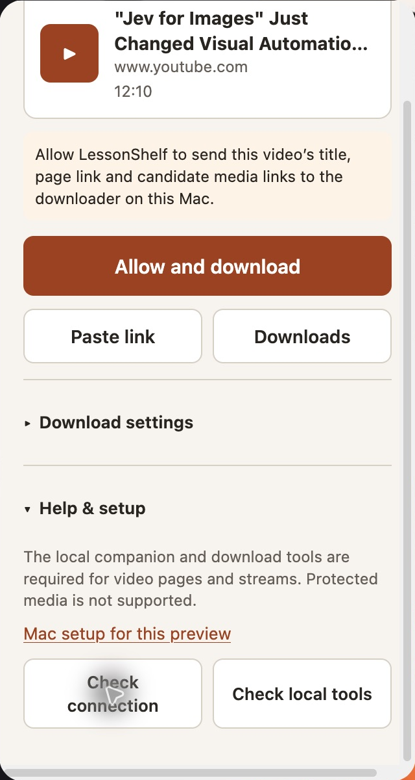
Mac Zen, live public YouTube page, e455372. The notice names the information sent to the local companion.

Choose output and a clip
Open Download settings. The default is up to 720p and standard MP4. The cap applies to the shorter dimension, so portrait video is limited by width. The signed 0.3.1 popup offers 480p. An installed native 480p job passed on the earlier 781e325 companion.
Choose audio only, English captions when available, or a video format. Original source avoids conversion; AV1 is smaller but may not play on some projectors. A course folder is optional. Captions are unavailable for clips.
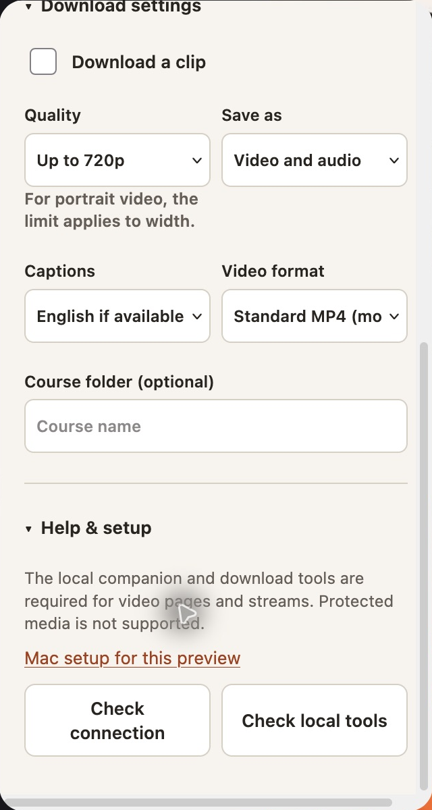
Mac Zen settings on e455372. The format value is clipped at this width; inspect the menu and narrow layouts in the next UX pass.

Narrow popup layout
The earlier Mac popup clipped selected format text and showed a horizontal scrollbar. Source 80be2e8 gives the format its own row, lets the body fit available width, and stacks settings below 360 px. The image is a source-rendered Chromium fixture with simulated scrollbar space. It is not a native Zen acceptance screenshot.
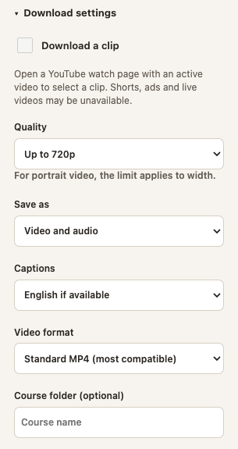
Source-rendered 320 px fixture after layout changes. This image is a source-rendered fixture; the signed popup was separately checked in Zen.

Select a clip
On a supported YouTube watch page, open Download settings and select Download a clip. In starts at the current playhead and Out starts at the end. Drag either handle, enter a time, or use the arrow keys on a handle. Confirm the range before Download.
Editing the next range does not change a running job. A new Download submits the new range; the same active range is deduplicated. The signed 0.3.1 queue retained its 0:05–0:15 range when the next draft changed. That provider clip job failed; its cause was not recorded. A later signed-popup job on a889ca6 saved a 10.000-second H264/AAC clip that fully decoded. This does not explain the earlier failure.
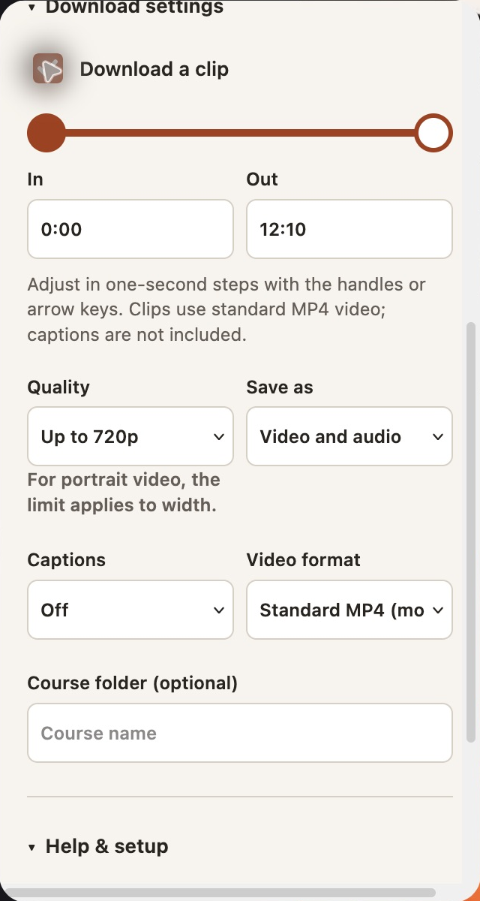
Mac Zen clip controls, e455372. The default shown is 0:00 to 12:10. The disabled output fields show clip constraints.

Paste a direct link
Choose Paste link and enter one HTTP or HTTPS link. For a direct MP4, WebM, MP3, M4A or WAV link, Download original in browser uses the browser download folder and does not apply conversion or quality settings. The link must still be accessible to the browser.
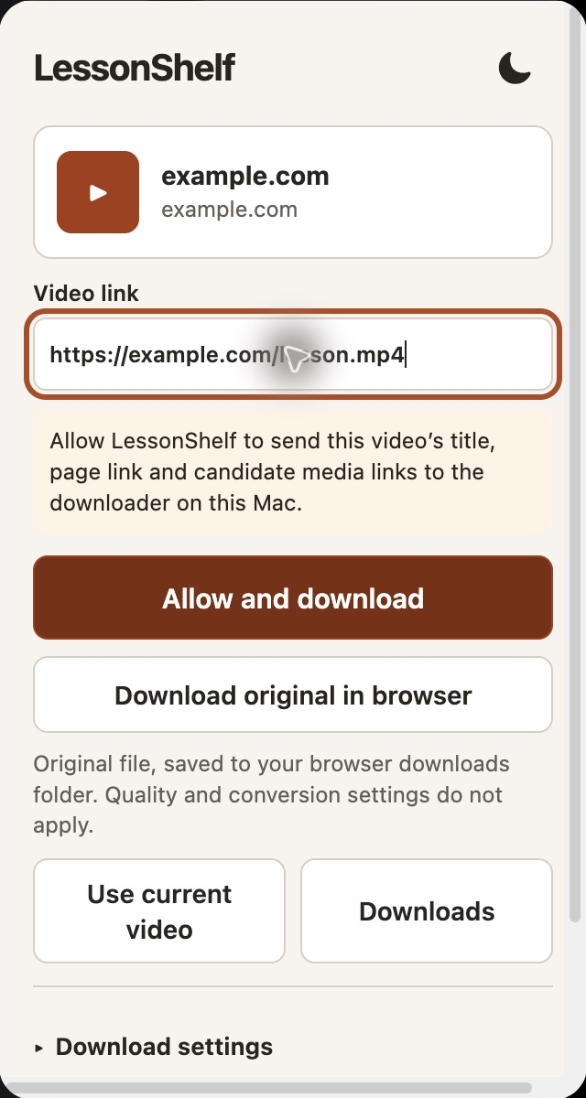
Mac Zen, e455372. The example URL is illustrative and no transfer was attempted.

Queue and setup
Downloads lists job state and provides actions appropriate to that state. Pause or cancel retains partial data; resume or retry uses the existing job. Closing the popup does not stop a started companion job while the Mac is awake. After interruption, reconnect and resume a paused job.
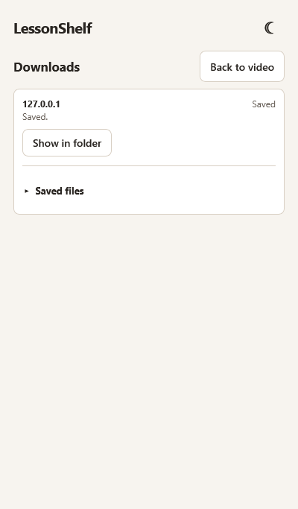
Windows x64 Firefox, signed 0.3.1, local fixture, run 41810534004 on 406c096. Saved job remained visible after reopening.

Pause, resume and cancel
Open Downloads and choose Pause for an active job. Resume starts it again using retained partial files. Cancel stops the job and retains its partial files. Retry queues a cancelled or failed job again.
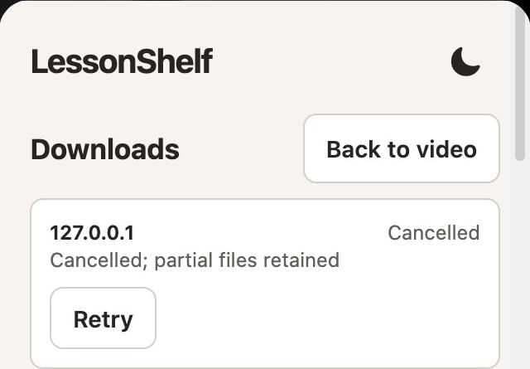
Mac Zen queue, local fixture. Cancel retained partial files and offered Retry.
Help & setup contains connection and local-tool checks. N is checked per video. Build 781e325 adds Deno to the tool-check display. The signed 0.3.1 popup displayed all five tools with installed companion a6664f7.

Permission and theme
Firefox may ask for additional data collection when the companion is first used. Read the browser prompt before choosing. A denied request leaves the queue inaccessible and LessonShelf reports that permission was not granted.
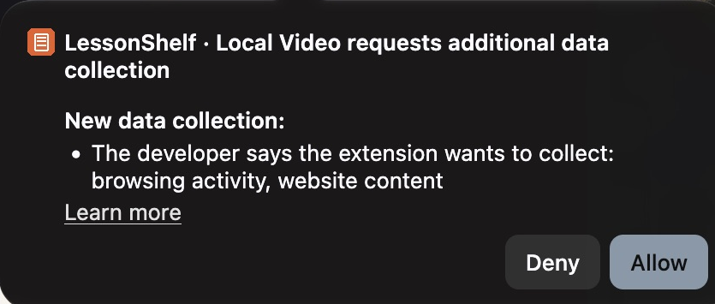
Mac Zen browser permission prompt, e455372. Denial, grant, revocation and regrant were tested.
The moon button switches the popup to dark. Select the sun to return to light. Keyboard Tab and Space switched themes in the live preview.
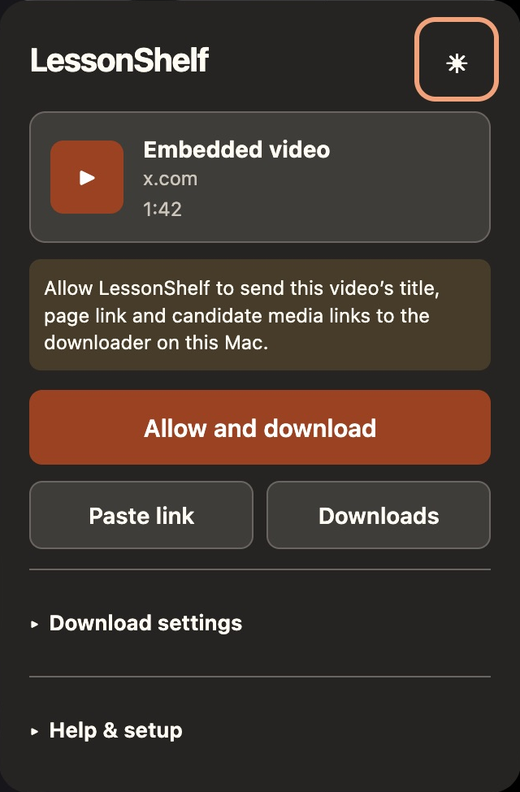
Mac Zen dark view, live X page discovery, e455372.

Coverage and handoff
Evidence | Result
Mac Zen, Jev | Full 720p saved. Earlier clip failed; a new signed-popup 10-second clip saved and fully decoded. Earlier cause unknown.
Mac Zen direct fixture | Browser fallback saved a local MP4 with matching SHA-256.
Windows Firefox, signed 0.3.1 | Final run 41812245946 on a889ca6: signed local fixture and N pipe diagnostic passed in headless Firefox.
480p and Deno | Signed popup offers 480p and reports Deno. Installed 480p job passed on 781e325.
Provider outcomes | Shorts and Instagram saved with warnings; X retest saved verified silent video. Mudflats player is Canada-only.
Consent and queue controls | Grant, deny, revoke, regrant and local pause/resume/cancel/retry passed.
Clear local HLS | Installed a6664f7: N completed local HLS without fallback; output fully decoded, no adjacent JSON.
Narrow and dark views | Dark toggle passed in prior Zen preview. New narrow layout passed source-rendered checks.

Next UI review
- Check whether connection feedback remains visible when Help is below the fold.
- Verify the new 320-400 px layout and keyboard focus in the native popup.
- Capture live error and progress states with isolated data after privacy review.
The machine-readable evidence file lists individual scenarios and separates live, automated and Windows evidence. Screenshots are cropped to product content; local media examples use synthetic fixtures.

Website test matrix
Status applies only to the action named in each row. The Mac browser checks used Zen 1.24b and temporary extension e455372; the installed companion was 781e325 when used. Signed 0.3.1 and installed a6664f7 were tested in Mac Zen. Results apply to these cases only; provider coverage remains incomplete.
Website or case | Status | Evidence and build
YouTube: Jev full | PASS | Signed 0.3.1 / Mac a6664f7: 720p H264/AAC fully decoded.
YouTube: Jev 0:05–0:15 clip | PASS | Signed popup / a889ca6: new job produced 10.000s H264/AAC, full decode. Earlier job failed; cause unknown.
YouTube: why is claude like this | PASS | Signed 0.3.1 / Mac a6664f7: 720x1280 H264/AAC fully decoded; caption request rate-limited.
Knowledge Network: Mudflats Living | BLOCKED | Earlier page returned 403. Later player stated the program is available only in Canada; stopped.
Knowledge Network: other two titles | NOT TESTED | No attempt in this run.
X public post | PASS | Signed popup / a889ca6: verified silent 101.923s H264 video fully decoded; warning shown. Earlier job failed.
Instagram reel | PASS | Signed 0.3.1 / Mac a6664f7: 8.37s H264/AAC decoded; caption warning. Multiple reels were present; identity unverified.
Local direct MP4 fixture | PASS | Mac Zen, e455372: browser fallback saved a synthetic file with matching SHA-256.

