What is Software Quality?
Definition: Software quality refers to how well a software product meets requirements and user expectations, encompassing attributes like functionality, reliability, and usability.

Why is Software Quality Important in Software Development?
- User Satisfaction: High-quality software enhances user experience.
- Cost Efficiency: Early defect detection reduces maintenance costs.
- Risk Management: Mitigates performance and security risks.
- Competitive Advantage: Differentiates products in the market.
- Reputation and Trust: Builds customer loyalty and brand trust.

Maintaining Quality in the Software Testing Life Cycle (STLC)
- Requirement Analysis: Ensure requirements are clear and testable.
- Test Planning: Develop a comprehensive test plan with objectives and resources.
- Test Case Development: Create thorough test cases covering all scenarios.
- Test Environment Setup: Prepare an environment that mimics production.
- Test Execution: Execute test cases accurately and document results.
- Defect Reporting: Log and prioritize defects for resolution.
- Test Closure: Evaluate results, analyze metrics, and document lessons learned.

Why Manual Testing is Important
- Exploratory Testing: Enables testers to explore the application dynamically, discovering unexpected issues that automation might miss.
- User Experience Evaluation: Assesses usability, interface design, and overall user satisfaction, which are difficult to automate.
- Adaptability to Changes: Quickly accommodates changes in requirements without needing to rewrite automation scripts.
- Cost-Effective for Smaller Projects: More affordable than setting up automated testing for short-term or smaller applications.
- Critical for New Features: Essential for testing newly developed features before they stabilize and can be automated.

Example of Manual Testing Identifying a Bug
Case: A Mobile Banking Application
- Scenario: During manual testing, a tester attempted to add a new payee by entering a special character in the "Payee Name" field.
- Issue Identified: The application crashed unexpectedly, leading to data loss.
- Root Cause: The input validation logic failed to handle special characters, which was not covered by automated tests that focused only on typical inputs.

Impact:
- This issue, if undetected, could have resulted in a poor user experience, causing frustration and potentially leading to loss of customers.

Open-Source Software vs. Proprietary Software
Feature | Open-Source Software | Proprietary Software
Definition | Software with publicly accessible source code that users can modify and distribute. | Software owned by an individual or company, with restricted access to the source code.
Licensing | Distributed under licenses allowing free use, modification, and distribution (e.g., GPL, MIT). | Distributed under licenses that restrict use, modification, and sharing; often requires purchase.
Cost | Generally free to use, though some may offer paid support. | Usually requires a purchase or subscription fee.
Development Model | Community-driven, with contributions from various developers. | Controlled by the owning entity, with a dedicated development team.
Customization | Highly customizable as users can modify the code. | Limited customization; users cannot alter the software.
Examples | Linux, Mozilla Firefox, WordPress. | Microsoft Windows, Adobe Photoshop, Oracle Database.

Project vs. Product
Feature | Project | Product
Definition | A temporary endeavor with a specific goal, time frame, and resources to create a unique outcome. | A tangible or intangible item created to meet customer needs and generate value.
Duration | Temporary, with a defined start and end date. | Ongoing, often with continuous development and iterations.
Focus | Delivering specific objectives or outputs. | Delivering value to users and solving problems.
Change Management | Managed through a defined process and scope. | Evolves based on market demands and user feedback.
Success Criteria | Measured by timely delivery, budget adherence, and meeting specifications. | Measured by user satisfaction, market success, and profitability.
Examples | Building a software application, organizing an event. | A mobile app, a software suite, or a physical product like a smartphone.

Difference Between Bug, Error, and Failure
Feature | Bug | Error | Failure
Definition | A flaw in the software code that causes incorrect behavior. | A mistake made by a developer or tester during coding or testing. | The inability of the software to perform as intended or meet requirements.
Origin | Originates from coding, design, or requirements issues. | Arises from human action, like incorrect coding or miscommunication. | Occurs during runtime when the software does not function as expected.
Nature | An inherent defect in the software. | A specific instance of incorrect implementation or logic. | A result of executing faulty code or logic.
Visibility | Not visible to end users until detected. | Typically visible in the development or testing phases. | Often visible to end users when the software fails to perform its task.
Impact | Can lead to errors and failures. | Directly causes bugs in the software. | Directly affects user experience and system performance.
Resolution | Requires debugging and fixing the code. | Fixed by correcting the mistake in the code or documentation. | Resolved by fixing the underlying bug in the code.
Examples | A syntax mistake in code. | Using an incorrect variable name. | The application crashes when a user tries to save data.

How Communication Between Testers and Developers Reduces Bugs
- Clear Requirements: Ensures testers understand expectations, minimizing misunderstandings.
- Early Issue Identification: Allows testers to raise concerns early, preventing bugs from accumulating.
- Collaborative Problem Solving: Fosters teamwork to brainstorm solutions, reducing defects.
- Immediate Feedback: Enables quick feedback on builds for timely issue resolution.
- Knowledge Sharing: Testers share insights on risks, guiding developers to focus on critical areas.
- Efficient Bug Reporting: Clear channels help testers report bugs effectively, aiding quicker fixes.
- Enhanced Test Cases: Developer input improves the relevance and coverage of test cases.
- Quality Culture: Promotes shared responsibility for quality, encouraging bug prevention.

Difference Between waterfall agile and spiral
Model | Benefits | Drawbacks
Waterfall | - Simple and easy to manage  - Clear milestones  - Best for small projects with stable requirements | - Inflexible to changes  - Late testing may incur costs  - Assumes known requirements
Agile | - Highly flexible and adaptable  - Faster delivery  - Improved quality through continuous feedback | - Requires strong collaboration  - Potential for scope creep  - Less predictable timelines
Spiral | - Strong focus on risk management  - Iterative refinement  - Adaptable for large projects | - Complexity in management  - Potentially higher costs  - Extensive documentation required

Difference Between QA (Quality Assurance) and QC (Quality Control)
Aspect | Quality Assurance (QA) | Quality Control (QC)
Definition | A process-oriented approach focused on preventing defects through well-defined processes. | A product-oriented approach focused on identifying and fixing defects in the final product.
Goal | Ensure processes are followed to meet quality standards. | Ensure the product meets customer expectations by finding defects.
Focus | Prevention: Avoid defects in the development phase. | Detection: Identify and correct defects before release.
Responsibility | Involves the entire team, including developers, testers, and managers. | Primarily handled by the testing team.
When Applied | Throughout the development process (early stages). | After development is complete (testing stage).
Activities | Process design, audits, training, documentation reviews. | Functional testing, performance testing, defect tracking.
Example | Establishing a coding standard to prevent errors. | Identifying a bug during functional testing.

Summary
- QA focuses on processes to ensure quality from the start (prevent defects).
- QC focuses on products to identify and fix defects after they occur.
Both are essential for delivering high-quality software.

What is Linear Approach
- Definition: A sequential and step-by-step approach to software development where each phase (planning, design, development, testing, etc.) is completed before moving to the next.
- Model Example: Waterfall Model
- When to Use:
  - Stable Requirements: When project requirements are well-defined and unlikely to change.
  - Smaller Projects: With limited scope and strict deadlines.
  - Low Risk Projects: Minimal uncertainty or complexity.
Advantages:
- Simple to manage with clear milestones.
- Suitable for projects with predictable workflows.
Disadvantages:
- Inflexible to changes.
- Late discovery of defects increases risks.

What is Risk-Driven Approach
- Definition: A flexible and iterative approach where project decisions and development cycles are guided by identified risks, with a focus on managing uncertainty.
- Model Example: Spiral Model
- When to Use:
  - Complex Projects: With high uncertainty or evolving requirements.
  - High-Risk Projects: Where risks (technical, financial, etc.) need to be mitigated at each phase.
  - Large Projects: Involving multiple iterations and stakeholders.
Advantages:
- Early identification and management of risks.
- Allows iterative refinement and adaptation.
Disadvantages:
- Requires expertise in risk assessment.
- Can be time-consuming and costly.

Which Model to Use and Why?
Model | Approach | When to Use | Reason
Waterfall | Linear | - Stable, well-defined requirements  - Simple projects with predictable outcomes | Predictable, clear structure, and easy management
Agile | Iterative & Adaptive | - Requirements likely to change  - Need for fast delivery and customer collaboration | Provides flexibility, continuous feedback, and quick iterations
Spiral | Risk-Driven | - Complex, high-risk projects  - Projects needing extensive risk management | Focus on minimizing risks through iterative prototyping
V-Model | Linear with Verification | - Projects with strict validation requirements  - Safety-critical systems (e.g., medical, aerospace) | Ensures early testing and strong validation mechanisms

Summary
- Linear models (like Waterfall) work best for simple projects with fixed requirements.
- Risk-driven models (like Spiral) are ideal for complex projects with uncertainties.
- Agile models excel when frequent changes are expected, while V-Model emphasizes early testing and suits critical systems.

Difference Between V-Model and W-Model
Aspect | V-Model | W-Model
Approach | A linear process with parallel validation and verification stages. | An enhanced version of the V-Model with more focus on continuous testing during each development phase.
Structure | Follows a V-shaped structure where each development phase corresponds to a related testing phase. | Uses a W-shaped structure, emphasizing more granular testing at multiple points.
Testing Involvement | Testing begins after development phases complete. | Testing is integrated throughout all development stages.
When to Use | Suitable for small to medium-sized projects with clear requirements. | Used in complex projects that require continuous validation during development.
Risk Management | Moderate risk management as testing starts later. | Improved risk mitigation through early and continuous testing.
Example | Used in medical software or aerospace systems that need strict validation and testing post-development. | Suitable for complex software where issues need to be detected early (e.g., banking or ERP systems).

V-Model Diagram
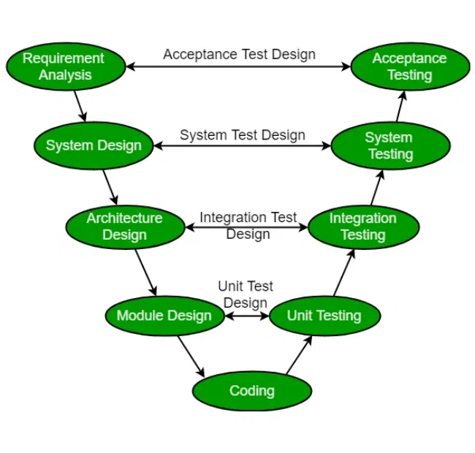

- Explanation:
  - Left side: Requirement gathering, design, and coding.
  - Right side: Corresponding testing activities (e.g., unit, integration, system testing).
  - Focus: Early planning of tests aligned with development stages.

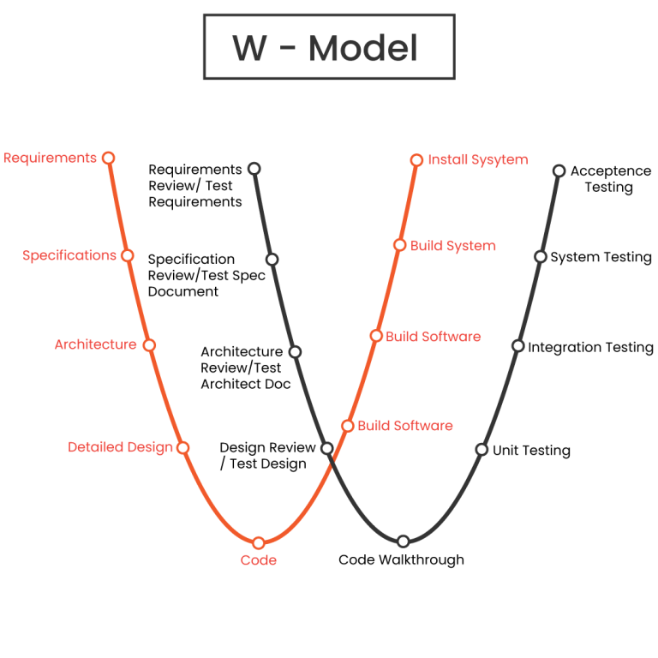
W-Model Diagram

- Explanation:
  - Each development phase (requirements, design, coding) has associated tests.
  - Testing is performed continuously throughout the development lifecycle.
  - Focus: Early identification of defects and faster feedback loops.

Summary
- V-Model: Sequential testing with test phases aligned to development stages. Best for smaller projects with well-defined requirements.
- W-Model: Continuous testing integrated into all phases of development. Ideal for complex projects where early detection of defects is crucial.
Both models emphasize verification and validation but differ in testing frequency and risk management.

Examples Where a Product Passes Verification but Fails Validation
- Technical Example: Mobile Banking App
  - Verification Passes:
    - The code is bug-free, follows the technical specifications, and passes unit and integration testing.
    - All backend services (login, fund transfer, transaction history) function correctly in test environments.
  - Validation Fails:
    - Users complain that the app's interface is confusing, making it difficult to locate critical features like "Fund Transfer" or "Account Balance."
  - Reason: The product works as intended (verification) but fails to meet user expectations, leading to a poor user experience.

- Non-Technical Example: Online Grocery Store Delivery Service
  - Verification Passes:
    - The website's ordering system works according to design, confirming purchases and sending notifications.
    - Payment gateway processes transactions without errors.
  - Validation Fails:
    - Customers receive incorrect items (e.g., wrong brand or size), or items are delivered late, frustrating users.
  - Reason: The system behaves correctly (verification), but it fails to deliver value by meeting customer expectations (validation).

Summary
- Technical Example: The app functions correctly but is hard to use.
- Non-Technical Example: The system processes orders accurately but fails to meet delivery expectations.
These examples emphasize the difference between "building the product right" (verification) and "building the right product" (validation).

