**Week1:**

Process Oriented versus Object Oriented

Process Orientation

• Divide programs into structured processes

• Focus on the structure of the processes “procedure”

• Data is scattered as needed.

• Data & operations on data are loosely coupled.

Object-orientation

• Divide programs into units of data

• Focus on the structure of data units (The fundamental unit is Object)

• Spread operations (processes) to associate with data

(an object has data and behavior)

• Based on models built from real-world concepts.

Objects & Classes

Objects Identity “each object can be uniquely identified andtreated as a distinct entity”

Object Orientation Concepts

• Encapsulation

• inheritance;

• polymorphism;

• abstract classes.

Abstract Class

• An abstract class is a class without instances.

Interfaces versus abstract classes?

Interfaces:

• A class may implement many interfaces.

• An interface only defines public methods properties.

• Used to organize objects that share some common property.

Abstract classes:

• A class has one single superclass.

• An abstract class may also specify private methods and properties.

• Used to group closely related objects.

**Week 2&3: change to Rick’s application using Encapsulation concept and enumerations, and interface.**

**Fat Interfaces?**

• Fat interface = general purpose interface ≠ client-

specific interface

• can cause bizarre couplings between its clients

• when one client forces a change, all other clients are affected

Break a fat interface into many separate interfaces

• targeted to a single client or a group of clients

• clients depend only on the methods they use (and not on other clients’needs)

• impact of changes to one interface are not as big

• probability of a change reduces

• no interface pollution

1. D: Dependency inversion principle

Entities must depend on abstractions, not on concretions. It states that the high-level module must not depend on the low-level module, but they should depend on abstractions.

**Design Patterns.**

1. **The Factory Method Pattern Defined and Abstract Factory (Creational Pattern)**

**• The Factory Method Pattern defines an interface for creating an object, but lets**

**subclasses decide which class to instantiate.**

**• Factory Method lets a class defer instantiation to subclasses.**

**• abstract Factory Method defines an interface for creating a family of the same category of objects, but lets subclasses decide which class to instantiate.**

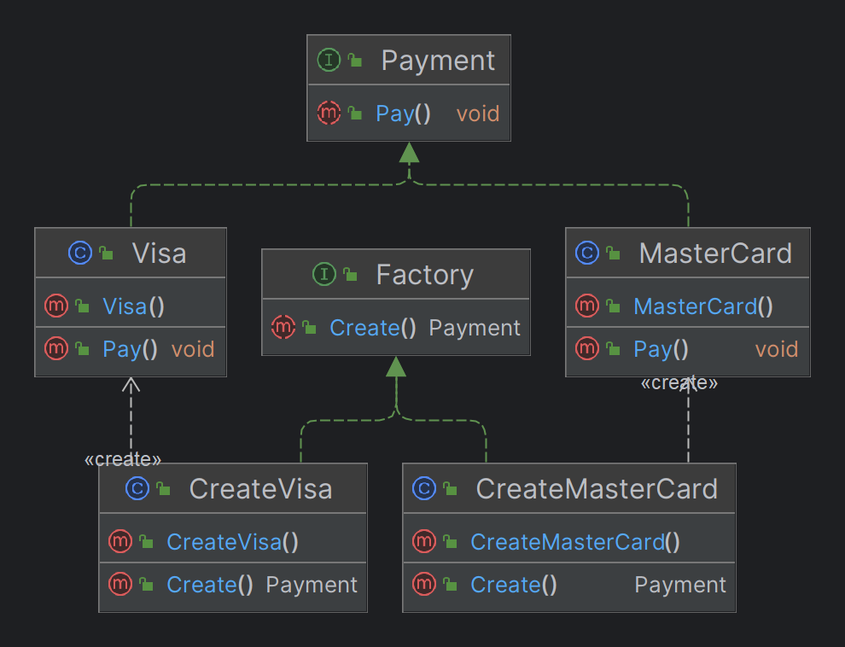

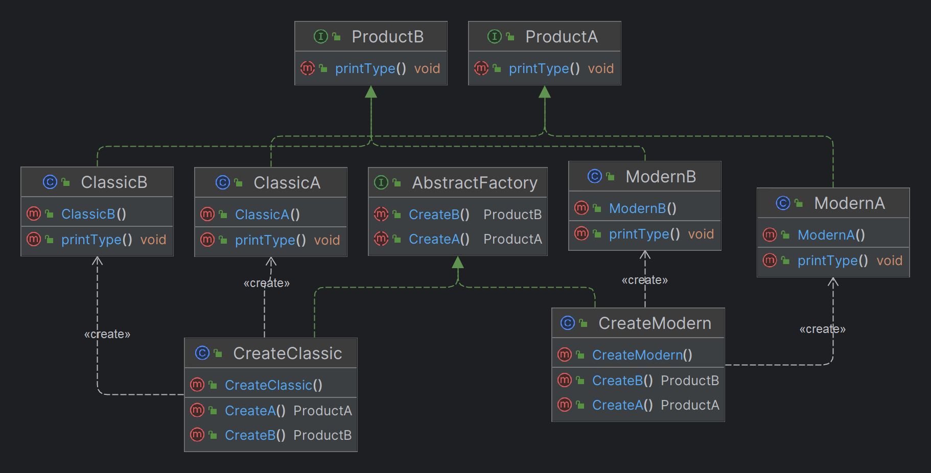

**The Strategy Pattern (Behavioural Pattern).**

**• Strategy pattern’s intent (According to GOF).**

**Define a family of algorithms, encapsulate each one, and make them interchangeable. Strategy lets the algorithm vary independently from the clients that use it.**

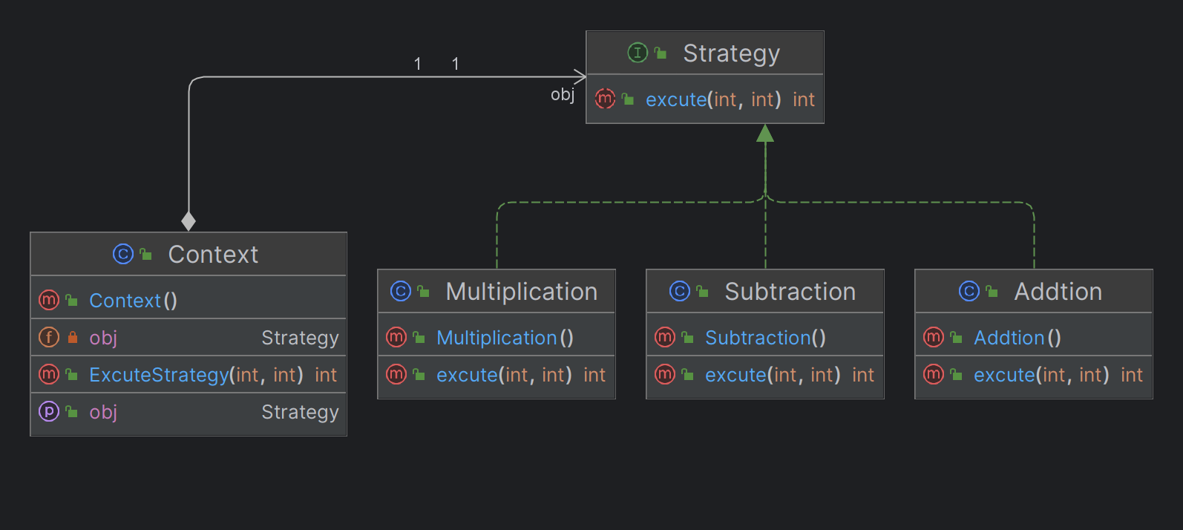

**Template Method (Behavioural Pattern).**

**Define an abstract class that has one algorithm of some steps (concrete,abstract) and some subclasses that implement this abstract methods**

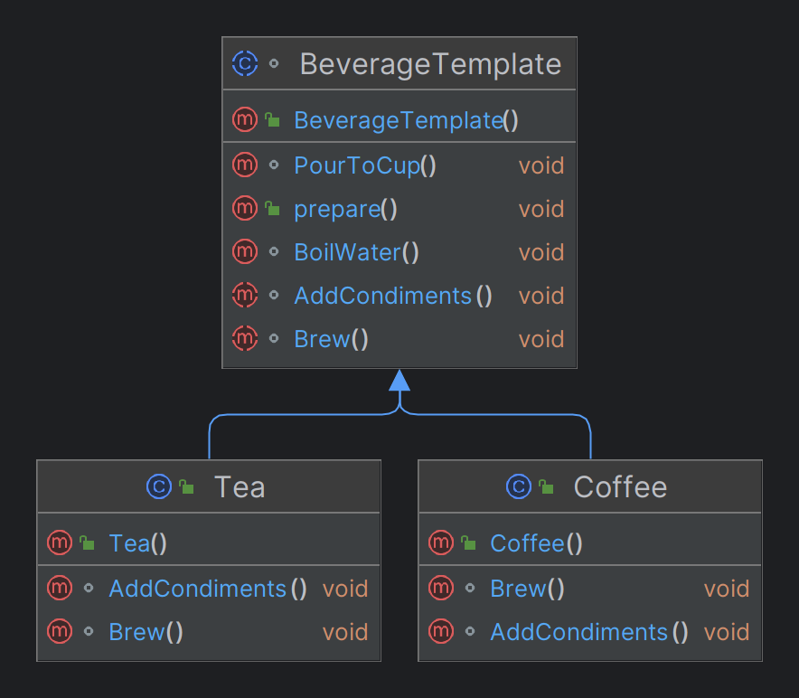

**Façade Design Pattern (Structural Pattern).**

**Define the class that encapsulate some related or independent subsystems and the client deal with this subsystem by object from this class**

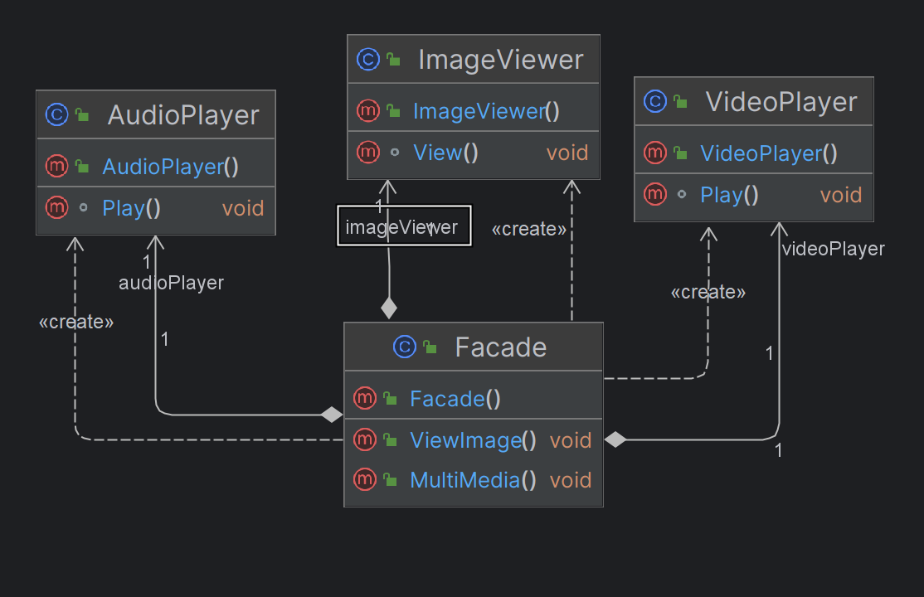

**observer Design Pattern (Behavioural Pattern).**

**Define an subject (Store) that has array of Observers (Customer) and some operations such that addcustomer, remove customer and notify customer and the class observers that has attribute and update to update the customer with news**

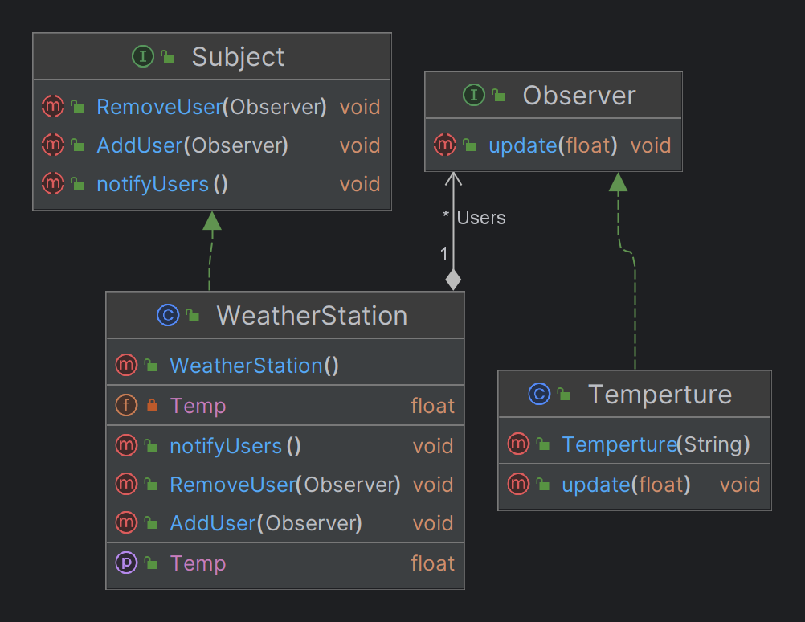

**Command Design Pattern (Behavioural Pattern).**

**– Encapsulate a request as an object, thereby letting you parameterize clients with different requests, queue or log requests, and support undoable operations.**

**– A request is turned into a stand-alone object that contains all information about the request**

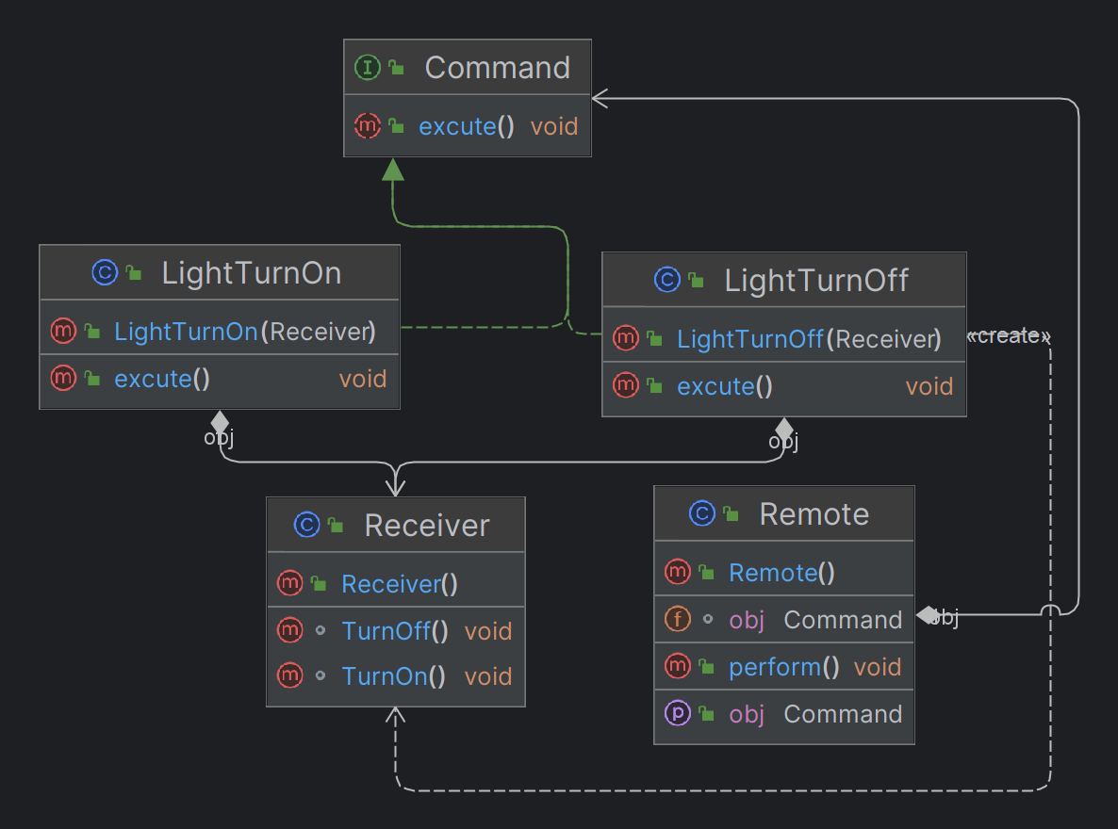

**Decorated Design Pattern (Structual Pattern)**

**-is a structural design pattern that lets you attach new behaviors to objects by placing these objects inside special wrapper objects that contain the behaviors**

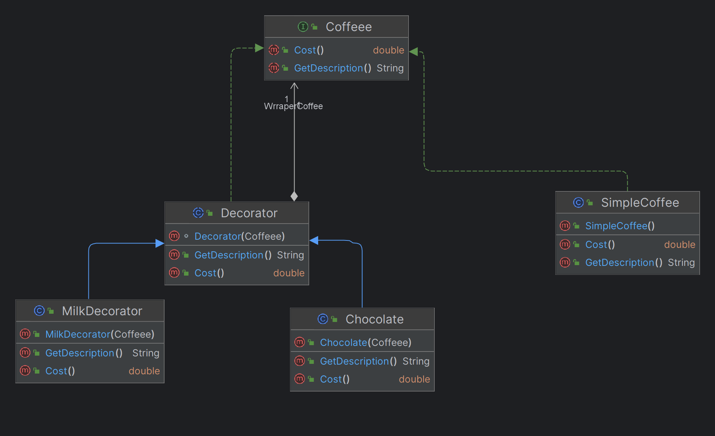

**Composite Design Pattern (Structual Pattern)**

* **Compose objects into tree structures to represent part-whole hierarchies with arbitrary depth and width.**
* **Treat individual objects and compositions of**

**objects uniformly**

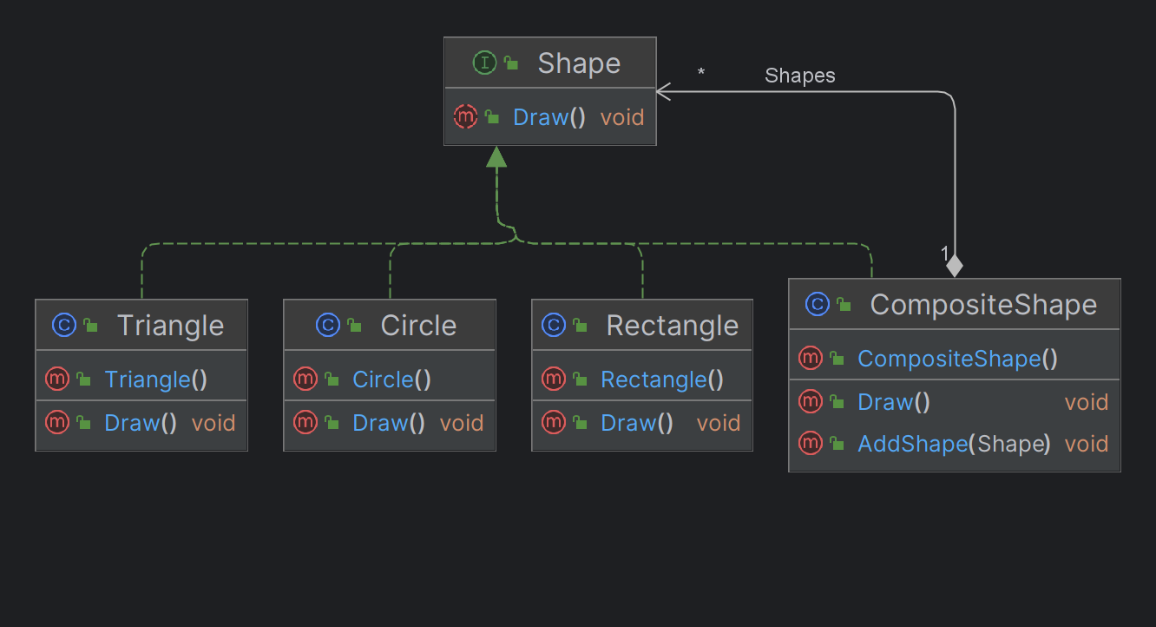

**Classification of design Pattern (Important)**

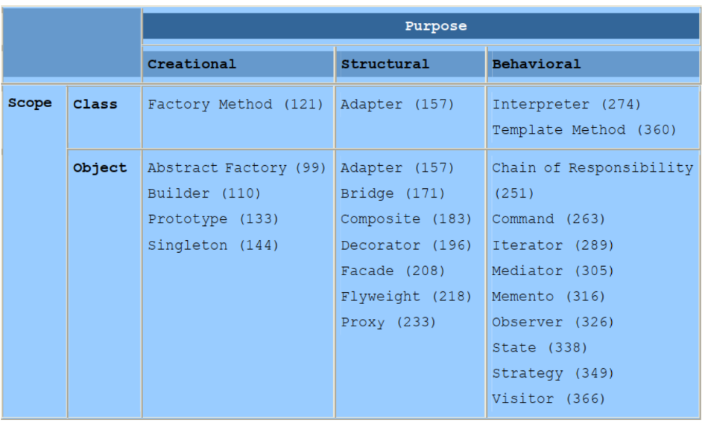

**We classify design patterns by two criteria.**

1. **Scope: specifies whether the pattern applies mainly to classes or objects.**

**• Class patterns: deal with relationships between classes and their subclasses Relationships are established through inheritance, and they are static-fixed at compile time.**

**• Object patterns: deal with object relationships, which can be changed at runtime and are more dynamic.**

1. **Purpose: reflects what a pattern does.**

**• Creational**

**• Structural**

**• Behavioural**

**Solid Principles**



