Set 6: Burp Suite & VAPT Tools

Task 1: Install Burp Suite Community Edition
Download from portswigger.net/burp/communitydownload (free, no account needed for Community Edition). Launch it, choose 'Temporary project' -> 'Use Burp defaults' to reach the main dashboard.

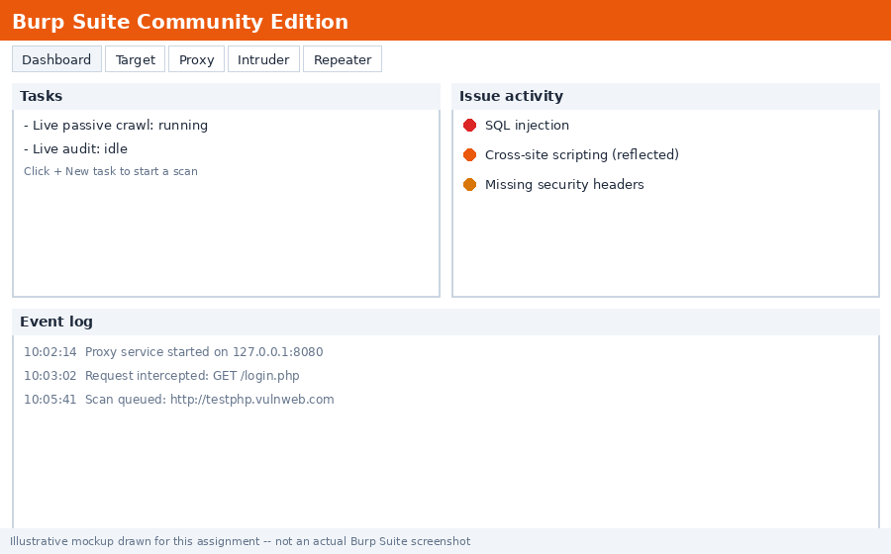
Reference layout (illustrative mockup, not a real screenshot) — your installed dashboard will look similar

[Insert your own screenshot of the Burp Suite main dashboard here]

Task 2: Intercept HTTP Requests with Burp Proxy
Steps:
- In Burp, go to the Proxy tab, then Intercept, and make sure Intercept is on
- Configure your browser to use Burp's proxy (127.0.0.1:8080), or open Burp's embedded browser via Proxy -> Intercept -> Open Browser
- Navigate to http://testphp.vulnweb.com/login.php
- Each request pauses in Burp until you click Forward

Typical intercepted request headers:
GET /login.php HTTP/1.1
Host: testphp.vulnweb.com
User-Agent: Mozilla/5.0 ...
Accept: text/html,application/xhtml+xml...
Accept-Language: en-US,en;q=0.5
Accept-Encoding: gzip, deflate
Connection: keep-alive
Cookie: ...

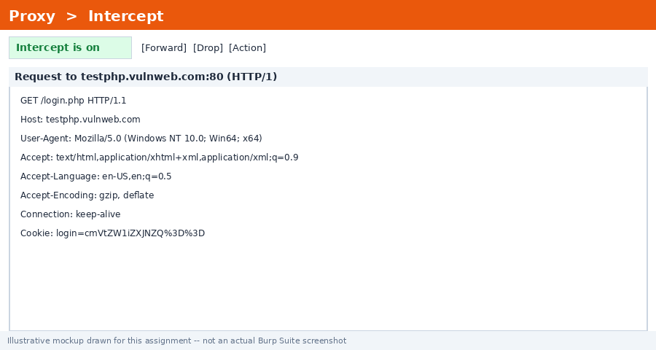
Reference layout (illustrative mockup, not a real screenshot) — your intercepted request pane will look similar

Headers from your own capture:

Task 3: Three OWASP-Listed Open-Source VAPT Tools (Besides Burp)
Tool | Main Purpose
OWASP ZAP (Zed Attack Proxy) | A free web app scanner for finding vulnerabilities like SQLi and XSS through automated and manual testing
OWASP Amass | A reconnaissance tool for mapping an organization's attack surface via subdomain enumeration and network mapping
OWASP Dependency-Check | Scans a project's dependencies/libraries to identify known publicly-disclosed vulnerabilities (CVEs)

Other valid picks from the OWASP site: OWASP Nettacker, OWASP DefectDojo, OWASP Juice Shop

Task 4: Vulnerability Scan on testphp.vulnweb.com with OWASP ZAP
Steps:
- Open ZAP -> Quick Start tab -> enter http://testphp.vulnweb.com -> click Attack (runs spider + active scan)
- Once finished, check the Alerts tab

Vulnerabilities/alerts typically found on this site:

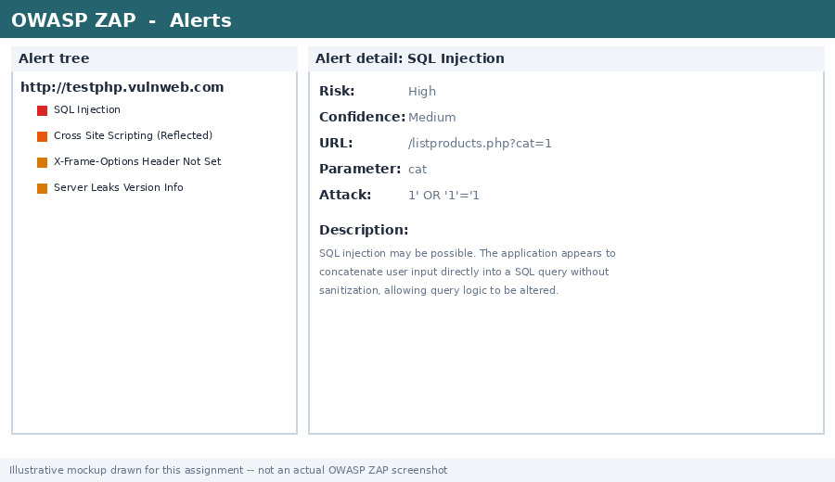
Reference layout (illustrative mockup, not a real screenshot) — your ZAP Alerts tab will look similar

Vulnerability/Alert | Where/Notes
SQL Injection | Reflected in parameters like 'artist' or 'cat' on product pages
Cross-Site Scripting (XSS) | Reflected XSS in search/guestbook fields

Task 5: SQL Injection Test Using Burp on the Demo Site
Step-by-step guide:
- With Burp Proxy intercepting, browse to http://testphp.vulnweb.com/listproducts.php?cat=1 — this loads product listings based on the cat parameter
- Send that request to Repeater (right-click -> Send to Repeater)
- In Repeater, change the request to cat=1' (adding a single quote) and send it — look for a SQL error message in the response
- Try cat=1 OR 1=1-- and compare the response — if it returns all products instead of just category 1, that confirms the injection works
- Also test the search box (http://testphp.vulnweb.com/search.php?test=query) with payloads like ' UNION SELECT null,null-- to see column count errors

Common differences/issues to watch for: Response pages may differ from a generic AI-generated tutorial depending on this site's exact table structure; WAF/filtering may have changed since the tutorial was written; Burp Community edition lacks the automated SQLi scanner that Burp Pro has, so this is done manually via Repeater instead.

Your observations (differences/issues you faced):

