Assignment 2: Cloud Basics and EC2
Name: Harsh | Course: B.Tech CSE (Cyber Security) | Date: ____________

Task 1: IaaS vs PaaS vs SaaS
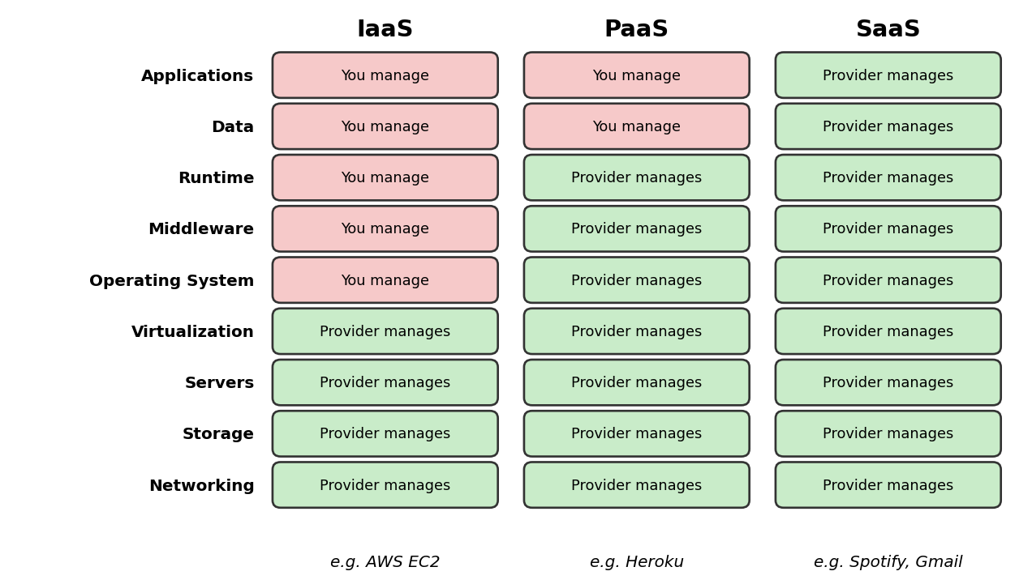
Figure 1: Who manages what in IaaS, PaaS and SaaS
Aspect | IaaS | PaaS | SaaS
Full form | Infrastructure as a Service | Platform as a Service | Software as a Service
What you get | Virtual servers, storage, networking | Platform to build, test and deploy apps | Ready-to-use software over the internet
User manages | OS, runtime, apps and data | Only app code and data | Only usage and settings
Provider manages | Hardware and virtualization | Hardware, OS, runtime, middleware | Everything
Flexibility / control | Highest | Medium | Lowest
Target users | Sysadmins, DevOps engineers | Software developers | End users
Real-world example | AWS EC2 (Flipkart runs its backend on cloud IaaS) | Google App Engine, Heroku | Spotify, Gmail, Netflix

Task 2: Cloud Computing in Daily Apps

Zomato
Zomato runs order-matching and delivery-routing services on cloud servers that auto-scale during dinner-time rush. Restaurant data, menus and photos are kept in cloud databases and object storage.

Instagram
Instagram stores photos and videos in cloud object storage and delivers them through a CDN for fast loading. Cloud servers run feed ranking, recommendations and notifications for millions of users at once.

Task 3: AWS Free Tier Account
An AWS Free Tier account was created at aws.amazon.com using my own email and phone number, then I logged in to the AWS Management Console.
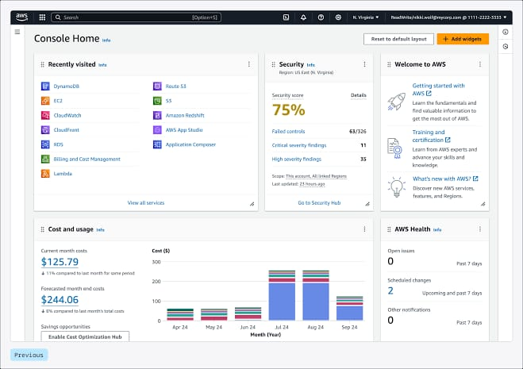

Task 4: Launch an EC2 Instance
Setting | Value
Name | my-first-ec2
AMI | Amazon Linux (Amazon Linux 2023 if Amazon Linux 2 is not offered)
Instance type | t2.micro (Free Tier eligible)
Key pair | New key pair created and downloaded
Security group | Default (SSH, port 22)

Once the instance state showed Running, the instance details page was captured.
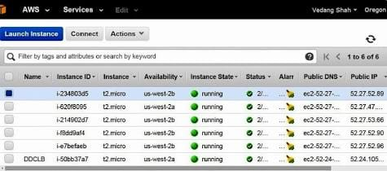

Task 5: Stop the Instance and Observe Changes
The instance was stopped from Instance state > Stop instance. Observations:
Item | Before (Running) | After (Stopped)
Instance state | Running | Stopped
Compute (instance-hour) charges | Counted against Free Tier hours | No longer accrue
EBS storage volume | Attached, billed for storage | Still attached, small storage cost continues
Public IPv4 address | Assigned | Released (unless an Elastic IP is used)
Estimated charges (Billing) | About $0.00 under Free Tier | About $0.00, updates after some hours

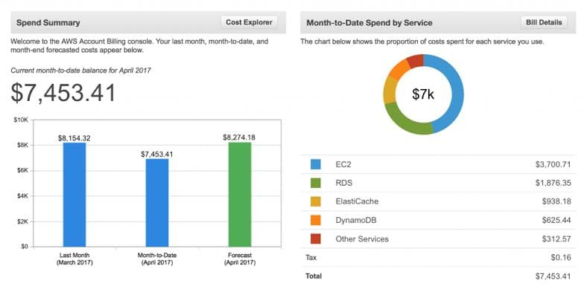

Note: the instance was terminated afterwards to avoid any leftover charges.

