Assignment 1: Virtualization
Name: Harsh | Course: B.Tech CSE (Cyber Security) | Date: ____________

Task 1: Install VirtualBox
Oracle VirtualBox was downloaded from virtualbox.org and installed on the host computer. VirtualBox Manager opens successfully, which confirms the installation.
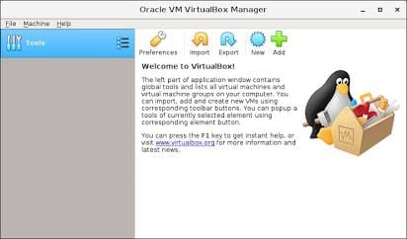

Task 2: Create an Ubuntu Virtual Machine
The Ubuntu Desktop ISO was downloaded from the official website (ubuntu.com). A new VM was created in VirtualBox with the following configuration:
Setting | Value
Name | Ubuntu-VM
Type / Version | Linux / Ubuntu (64-bit)
Installation media | Ubuntu Desktop ISO (official)
Memory (RAM) | 4096 MB (minimum required: 2 GB)
Virtual hard disk | 25 GB, VDI, dynamically allocated (minimum required: 20 GB)
Processors | 2 CPUs

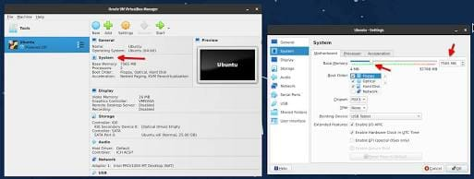

Task 3: Start the Ubuntu VM
The VM was started, the Ubuntu installer was completed, and the Ubuntu desktop is now running inside the VirtualBox window.
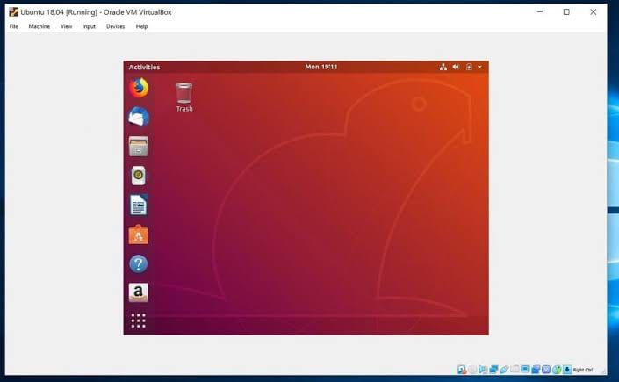

Task 4: Type 1 vs Type 2 Hypervisors
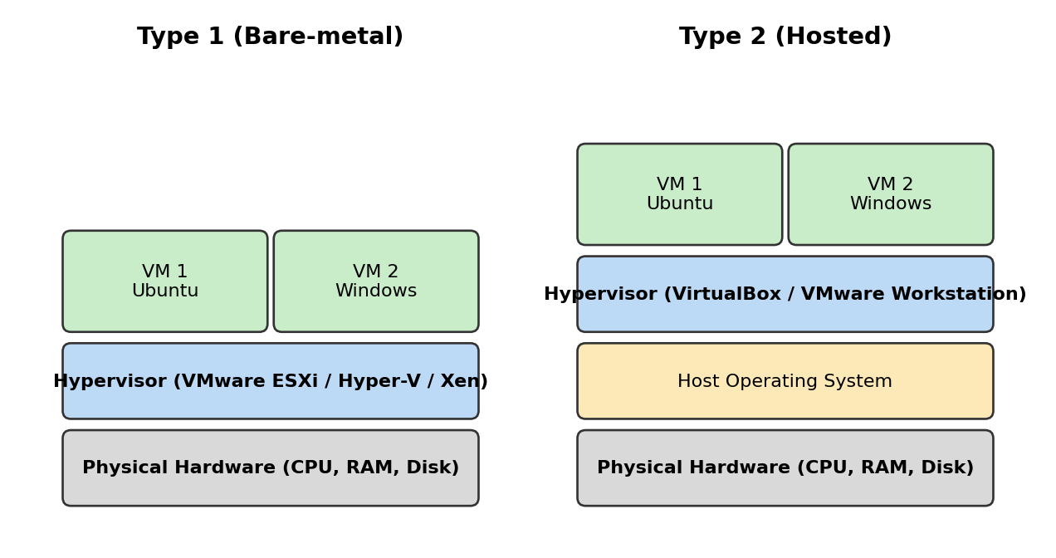
Figure 1: Type 1 (bare-metal) vs Type 2 (hosted) hypervisor architecture
Difference | Type 1 (Bare-metal) | Type 2 (Hosted)
Installation | Runs directly on physical hardware | Runs as an application on top of a host OS
Performance | Higher, with no host OS layer in between | Lower, because requests pass through the host OS
Typical use | Data centers, cloud providers, production servers | Desktops, testing, development, learning
Security / stability | More secure and stable, with a smaller attack surface | Depends on the security of the host OS
Real-world example | VMware ESXi (also Microsoft Hyper-V, Xen, KVM) | Oracle VirtualBox (also VMware Workstation)

Conclusion: VirtualBox is a Type 2 hypervisor, so the Ubuntu VM in this assignment runs on top of the host operating system.

