Assignment 3: Amazon S3 and IAM
Name: Harsh | Course: B.Tech CSE (Cyber Security) | Date: ____________

Task 1: Create an S3 Bucket and Upload a File
An S3 bucket named swiggy-files-harsh123 was created (bucket names must be globally unique), with Block all public access left enabled. One image file was uploaded to it.
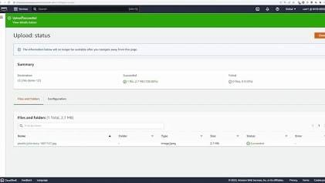

Task 2: Spotify-style Folder Structure
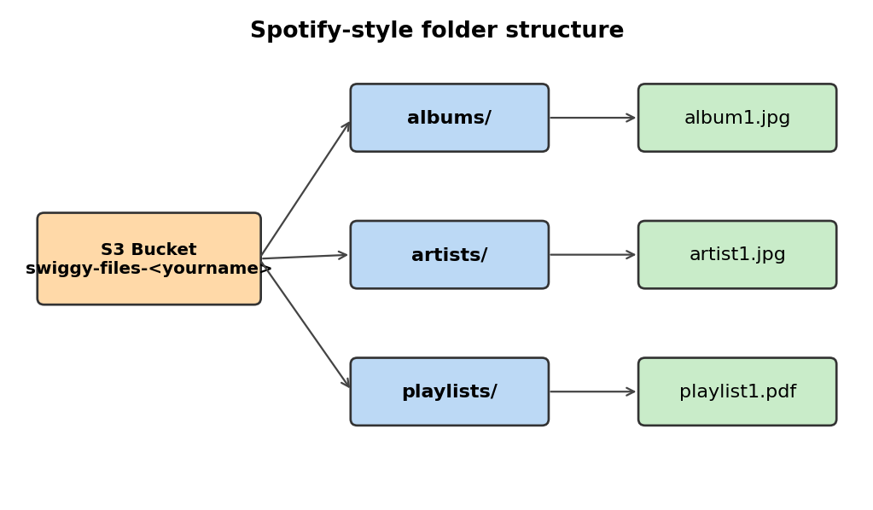
Figure 1: Folder layout inside the S3 bucket
Three folders (albums, artists, playlists) were created, and at least one sample file was uploaded into each.

Task 3: Create IAM User zomatoUploader with Custom Policy
An IAM user named zomatoUploader was created with console access. A custom policy (ZomatoUploaderPolicy) allowing only s3:PutObject and s3:ListBucket was attached.
{
"Version": "2012-10-17",
"Statement": [
{ "Effect": "Allow", "Action": "s3:PutObject",
"Resource": "arn:aws:s3:::swiggy-files-harsh123/*" },
{ "Effect": "Allow", "Action": "s3:ListBucket",
"Resource": "arn:aws:s3:::swiggy-files-harsh123" }
]
}

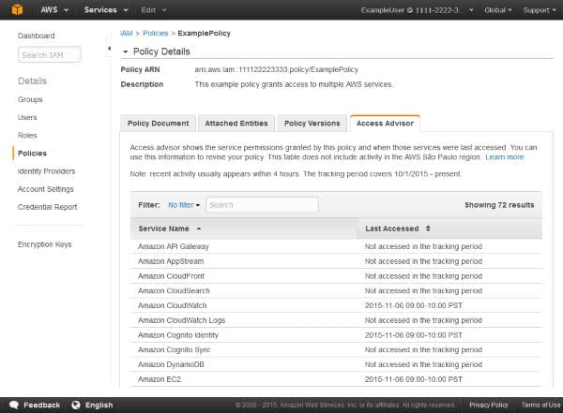

Task 4: Test the IAM Setup
I logged in as zomatoUploader and tried an upload, a file listing, a delete and a download.
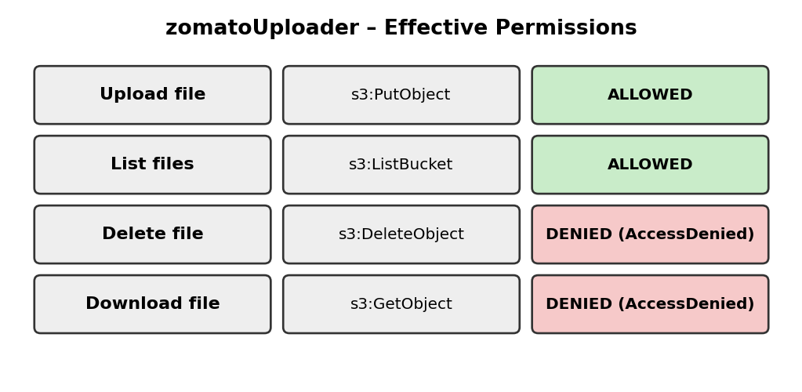
Figure 2: Test results for zomatoUploader
Action | Result | Reason
Upload a file | Succeeds | s3:PutObject is allowed by the policy
List files | Succeeds | s3:ListBucket is allowed by the policy
Delete a file | Denied (AccessDenied) | s3:DeleteObject is not granted, so it is implicitly denied
Download a file | Denied (AccessDenied) | s3:GetObject is not granted

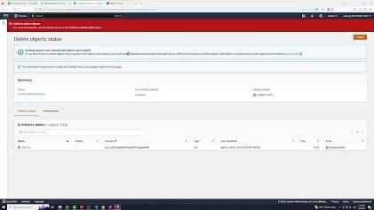

Task 5: How IAM Protects User Data in Cloud Apps
IAM (Identity and Access Management) decides who can access which cloud resources and what they can do with them. Apps like Paytm and PhonePe run many services, such as payments, user profiles and KYC document storage. IAM roles and policies follow the principle of least privilege: every service and employee gets only the permissions they need. If one component or account is compromised, the attacker cannot reach everything else, so sensitive data such as bank details stays protected.

Real-world security risk
In the 2019 Capital One breach, which affected over 100 million customers, a misconfigured firewall let an attacker obtain credentials for an over-permissive IAM role. That role could read data in many S3 buckets. Tightly scoped IAM permissions would have limited the damage.

