**Milestone 7**

**Activity 1: Amount of Data Rendered to Tableau**

**“As on the input files”**

**Activity 2: Number of calculation fields**

**We can see at the left side of the picture.**

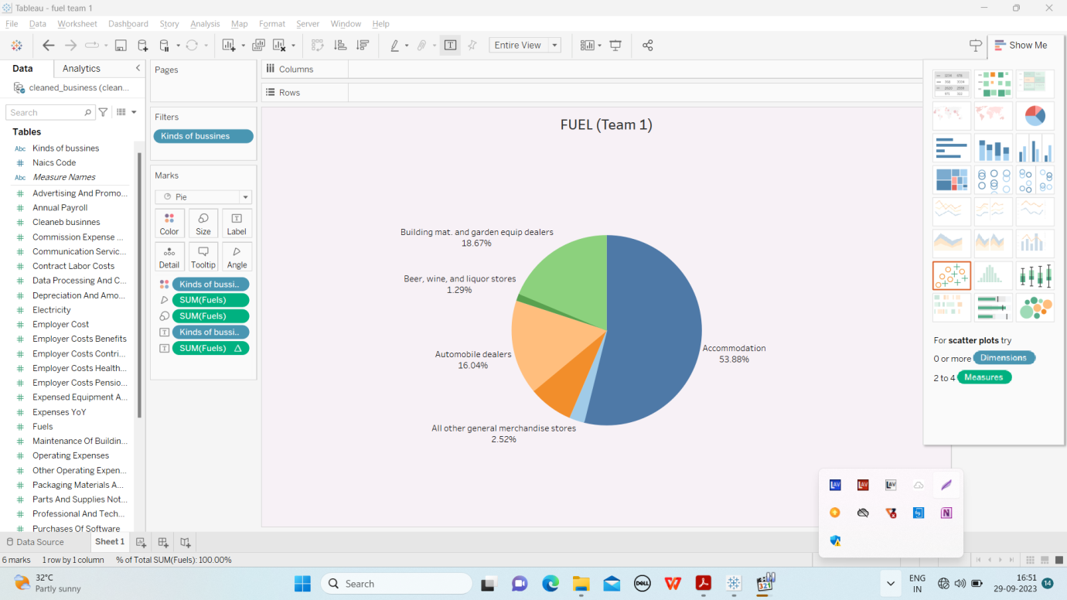

**Activity 3: Number of visualizations**

We (Team 1) prepared the following sheets.

1. Advertisement cost
2. Building maintains
3. Contract Vs Employee
4. Electricity cost
5. Employee (Insurance vs Pension)
6. Equipment costs
7. Fuel costs
8. Payroll
9. Rental cost.