**RESUME**

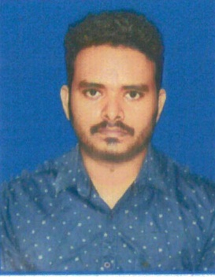**Name: Maheswar Rana**

**At : Behind of Bijaya Market**

**Badapadia,**

**Po : Paradip**

**Ps. : Paradip**

**Dist : Jagatsinghpur**

**State : Odisha-754142**

**Mob : 6372510121**

**Email id:maheswarrana49@gmail.com**

**CAREER OBJECTIVE:**

Being given to understand that you have been recruiting personal for the above post. I am taking as opportunity to submit my candidate with relevant details.

**ACADEMIC QUALIFICATION:**

* 10th Passed under B.S.E, Odisha and 1st division (67%)
* +2 Science Passed under C.H.S.E, Odisha and 2nd division (55%)
* PGDCA Computer course completed under ITCT, Paradip.
* +3 Science Chemistry Hons passed under Utkal University with 7.81 CGPA (73%)

**PERSONAL DETAIL:**

* Father’s Name : **Rabindranath Rana**
* Date of birth : 04.09.2001
* Marital Status : Unmarried
* Nationality : Indian
* Sex : Male
* Category : General
* Religion : Hindu
* Language Known : Oriya, Hindi & English

**PERMANENT ADDRESS :**

* At : Hatiapala
* Po : Ambiki
* Ps. : Erasama
* Dist : Jagatsinghpur
* State : Odisha-754139

**HOBBIES & SOCIAL WORK:**

* Reading Newspaper
* Playing Cricket

**DECLARATION**

I do hereby declare that the above statement are true & correct to my knowledge & belief.

**Date:**

**Place: Signature Of Candidate**