About this utility:

* This tool is used to compare the 2 PDFs

Scope of the utility:

* Content validation of both the pdfs
* Alignment validation.
* Font size, Font style of each word.
* Bulk validation of all the pdf placed in the source and destination folder

Out – of - Scope of the utility:

* Header section which contains the Customer information section is excluded from the current approach. As including that would result in lot of re-work and in-accurate results.
* Image validation like Standard chartered logo, any images like official stamp etc.

Pre-condition:

* Create a folder called ‘PDF_Macro’ and place in the ‘Documents’ folder (C:\Users\XXXXXXX\Documents\PDF_Macro).
* Place the below mentioned excel in the created folder



* The original files should be placed in the folder whose name should be ‘Source’
* The micro (migrated/latest) file should be in the folder whose name should be ‘Destination
* Save and close any open excel and notepad files before executing this utility.

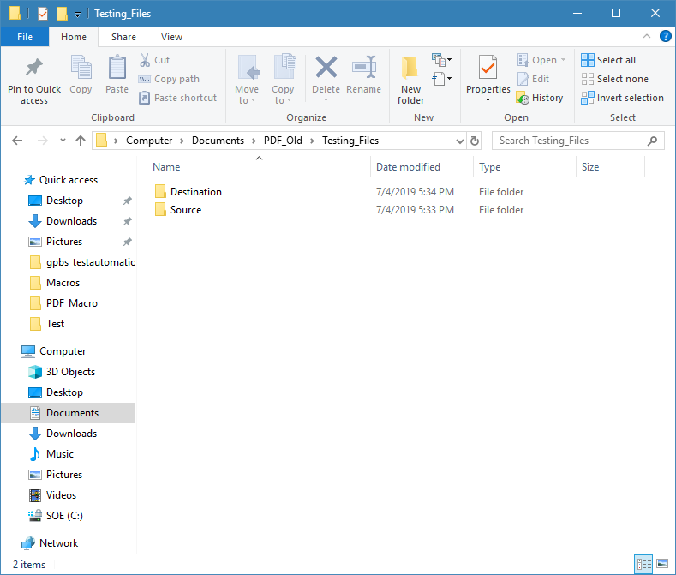

Important folders

|  |  |  |  |
| --- | --- | --- | --- |
| S_no | Folder Name | Description | File Name |
| 1 | C:\Users\ XXXXXXX \Documents\Imp_Files\Current_File | Contains a text file which contains the details of which PDF is currently being validated | CurrentFile.txt |
| 2 | C:\Users\ XXXXXXX \Documents\Imp_Files\Missing_File | Contains a text file which contains the details of all the files that are present in the source folder but not in the destination folder | MissingFiles.txt |
| 3 | C:\Users\ XXXXXXX \Documents\PDF | Contains the text extracted from original pdf, migrated pdf and the consolidated data from both the pdfs | output_old.txt  output_new.txt  Final_txt_file_output.txt |
| 4 | C:\Users\ XXXXXXX \Documents\PDF_Macro | The above mentioned excel file should be placed in this folder | Compare_9_0_V8.xlsm |
| 5 | C:\Users\ XXXXXXX \Documents\PDF_Results_Path | The final results of the compared PDF are placed in this folder. The File name has the same name as the PDF along with the timestamp | Example : HK_1082998_CUSTOMER_18495389_20190430_7_12_2019_4_20_50_PM |

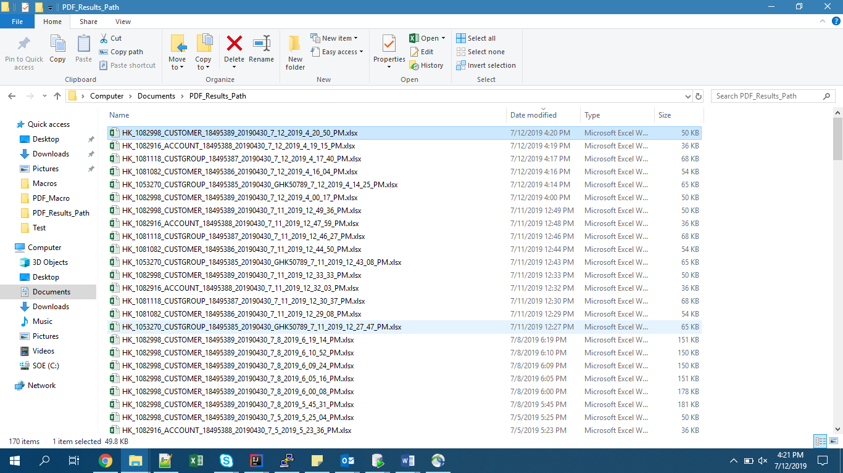

User Guidelines

1. Navigate to <https://bitbucket.global.standardchartered.com/projects/GPBS_AUTOMATION/repos/gpbs_testautomation/browse/PDF_Compare_jar.zip?at=feature/PDF-COMPARISON> Download the file (PDF_Compare_jar.zip) to your desktop folder and extract it.

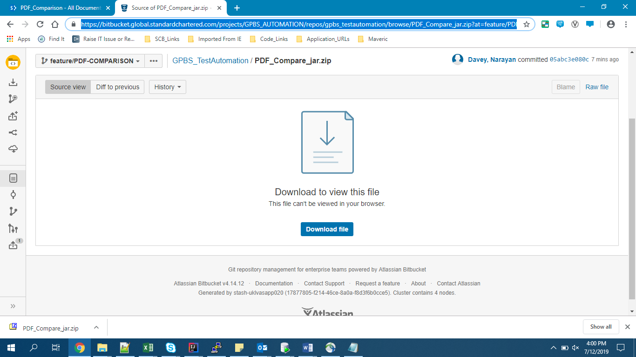

1. Then double click on the extracted jar file, within few seconds the utility will open asking the user to select the source and the destination folder . Please select the folders correctly.

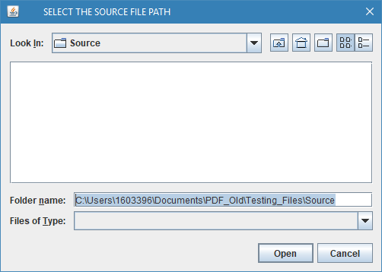

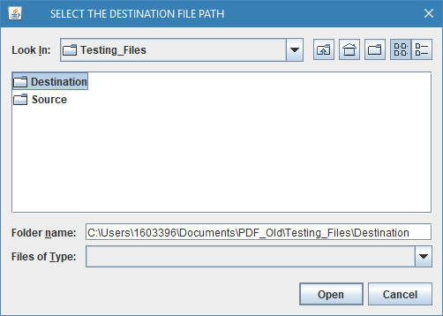

1. Now, the comparison starts, Each file takes approximately 2 minutes to validate. To view the results please navigate to “C:\Users\ XXXXXXX \Documents\PDF_Results_Path”
2. To view the files that are not compared , please check the Missing files path “C:\Users\ XXXXXXX \Documents\Imp_Files\Missing_File”
3. Sample output, please refer to ‘Adjustment_Sheet’ for the final results.

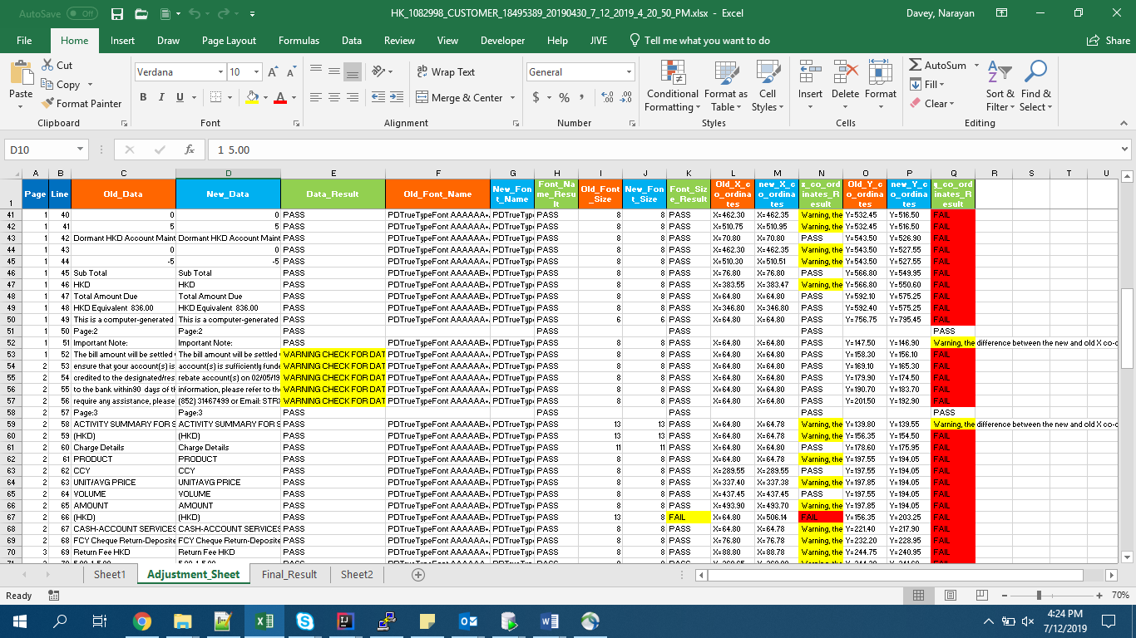

Contact person for issues/modification

* Please contact Narayan Davey incase of any issues/ further modifications required in this tool.