The Social Media Impact on Sales in the National Football League (NFL)
BMSO601
Samarth Tuli, Pearson Roberts, Alyssa Miller, Diana Kim, Matthew Robert Rutigliano, Justin Mejia
Application Description

Dashboard #1 - Social Media Engagements and Sales Volumes
Our goal with this dashboard was to determine how a team’s combined social media presence correlates to sales figures, in order to better identify areas where the league can refine current marketing strategies and ultimately drive revenue growth. This dashboard highlights the relationship between total engagement and sales value for both product types: tickets and merchandise. Total engagement is quantified as the sum of likes, comments, shares, and views for all posts made by a team’s verified social media account, or that of its coach or affiliated athletes. Sales value is an aggregate of the item quantity multiplied by its price.
The first set of graphs display the relationship between total engagement and ticket sales. The two bar graphs display ticket sales value and total engagement by team respectively, with the teams’ total engagement sorted in descending order. In comparing the two bar graphs, we uncovered that a team’s overall team social media engagement has no bearing on its ticket sales earnings. We observed that, despite having the highest total engagement numbers, the Philadelphia Eagles generated nearly $5 million less in ticket sales revenue than the New York Jets who rank 7th in terms of engagement. The scatter plot below, with each point representing a different team, enables us to better visualize this trend that ticket sales act independently of engagements. The second set of graphs explores the effect of total engagement on merchandise sales. Here, we see a positive correlation between the two variables; those teams with the highest engagement numbers are also generating the most revenue from merchandise sales.
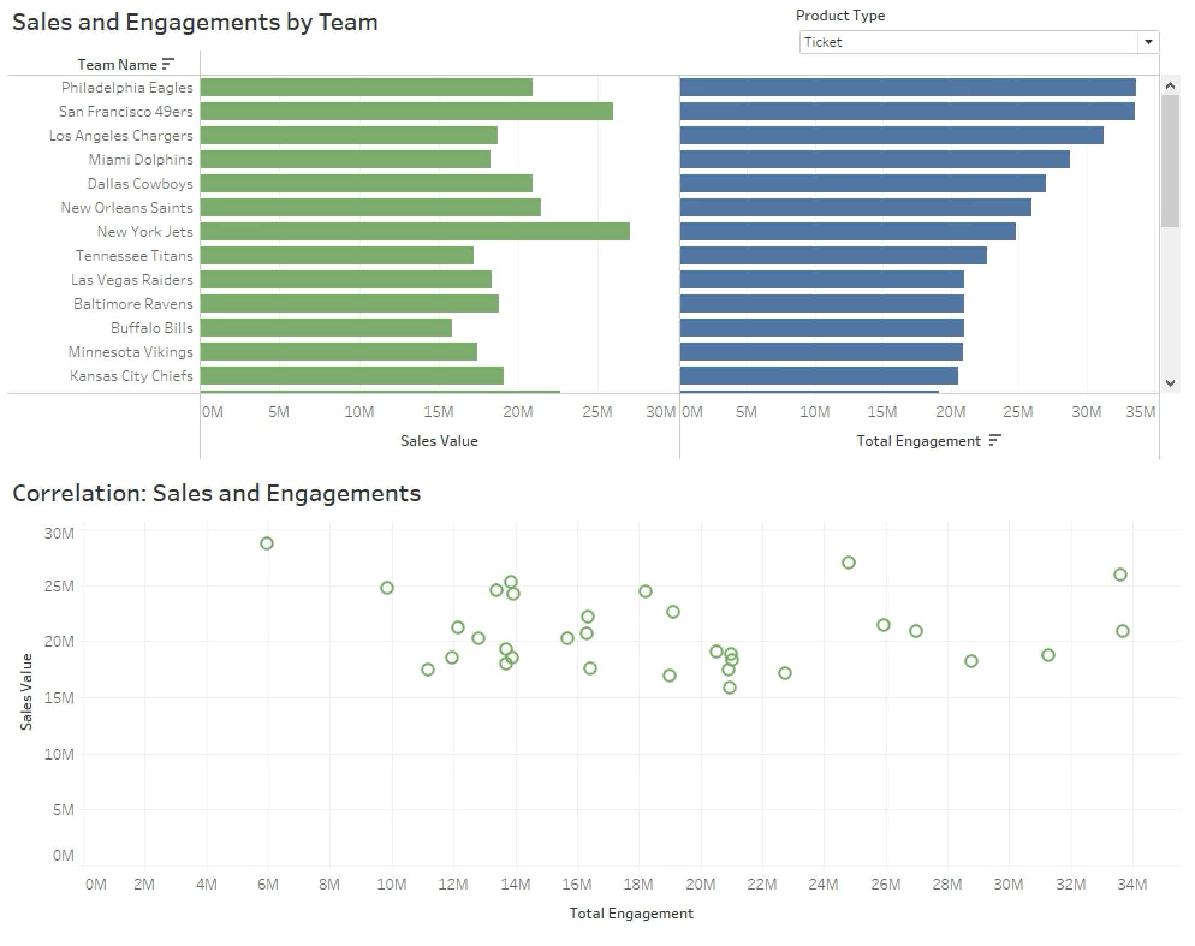

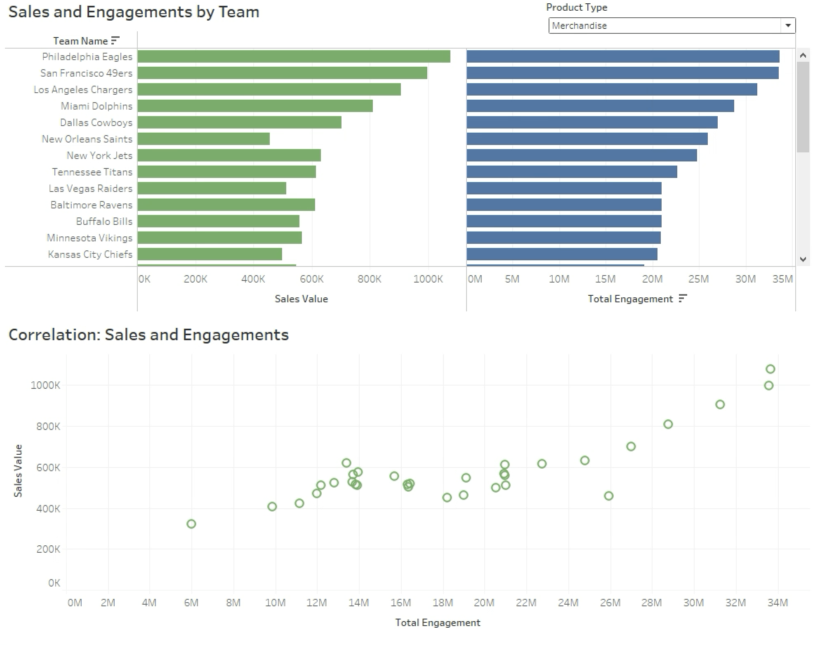

Dashboard #2 - Social Media Engagements by Account Type and Merchandise Sales by Product Type
Dashboard #1 outlines the positive correlation between total social media engagements and merchandise sales. Dashboard #2 takes that analysis one step further to help us understand what social media account types are driving the most engagements for teams with high merchandise sales versus teams with low merchandise sales. By understanding this dynamic, the league can make appropriate marketing recommendations to teams who are struggling to generate merchandise sales. We have determined in previous analysis and SQL queries that jerseys are the most important merchandise items, as they generate the most revenue for teams. Our dashboard will also examine the proportion of jersey sales to total merchandise sales to see how this may be linked to social media engagement types.
This dashboard has three main visual elements. The first is a packed bubble chart representing social media engagements by account type. Total engagements per type are labeled in each bubble. The second visual is a tree map used to display merchandise sales by product type. The labels represent total sales value per merchandise type in each section of the tree map. While sales and engagement labels are used to communicate the scale of these metrics, the real benefit lies in the viewer’s ability to analyze the proportion of sales and engagements by type. Finally the bar chart displays each team’s total merchandise sales, ranked highest to lowest. The primary function of this visual is for interactive filtering so we can analyze proportional trends in the ‘by-type’ visuals for teams with high or low merchandise sales.

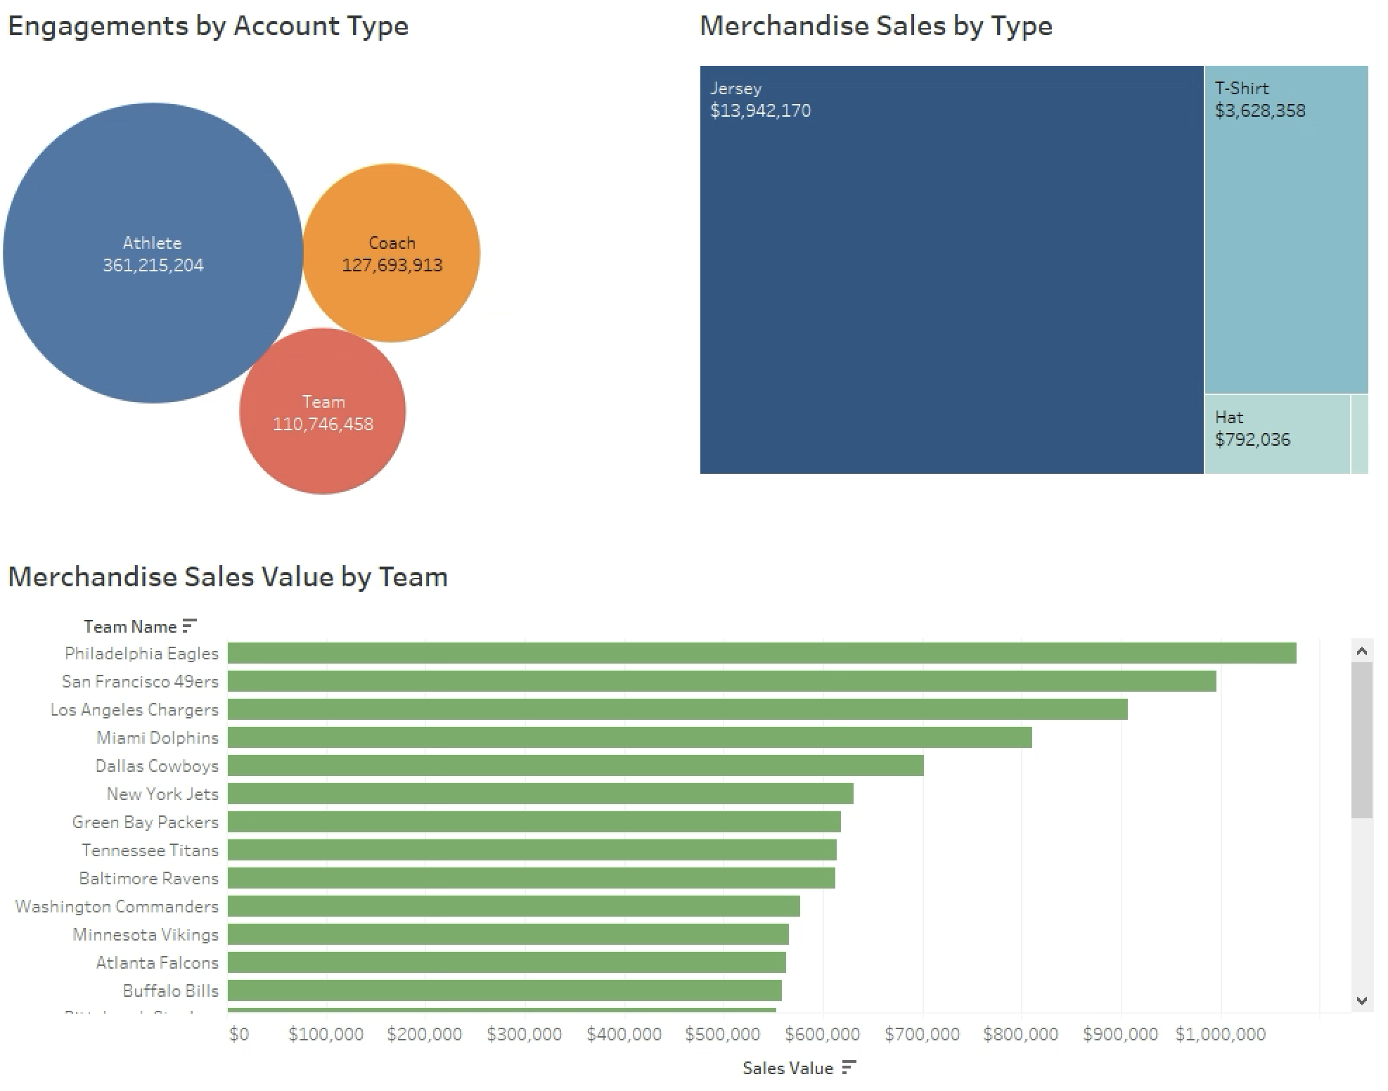

When filtering on the Philadelphia Eagles, who have the top merchandise sales in the league, the sales values and social media engagements change accordingly. We notice that Jersey sales make up a large proportion of sales, but more importantly, the social media engagement activity is dominated by the athlete accounts.

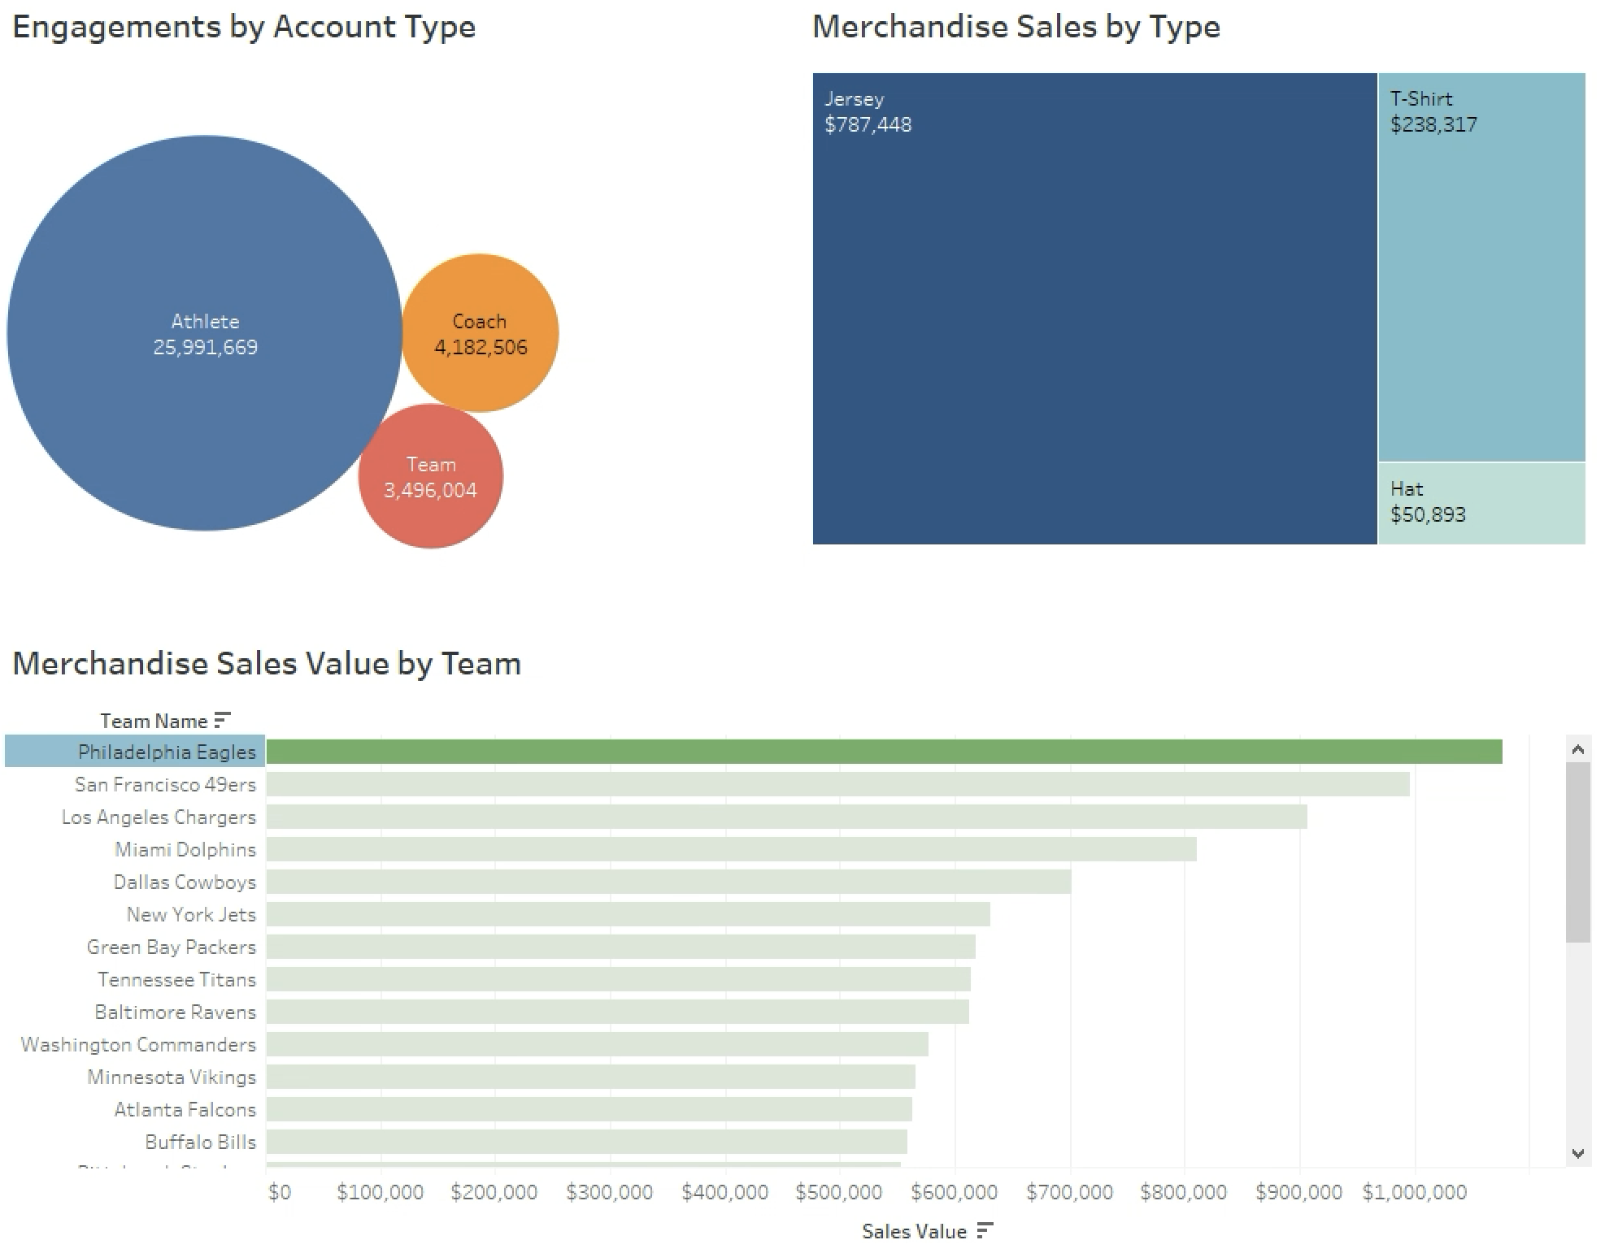

We can do the same for the Houston Texans, who have the lowest merchandise sales in the league, and find that the jerseys still make up a majority of the sales, but to a lesser degree than the Philadelphia Eagles. We also notice that the proportion of engagements being generated by the Texans’ athlete accounts is significantly smaller than the Eagles’ athlete engagements.
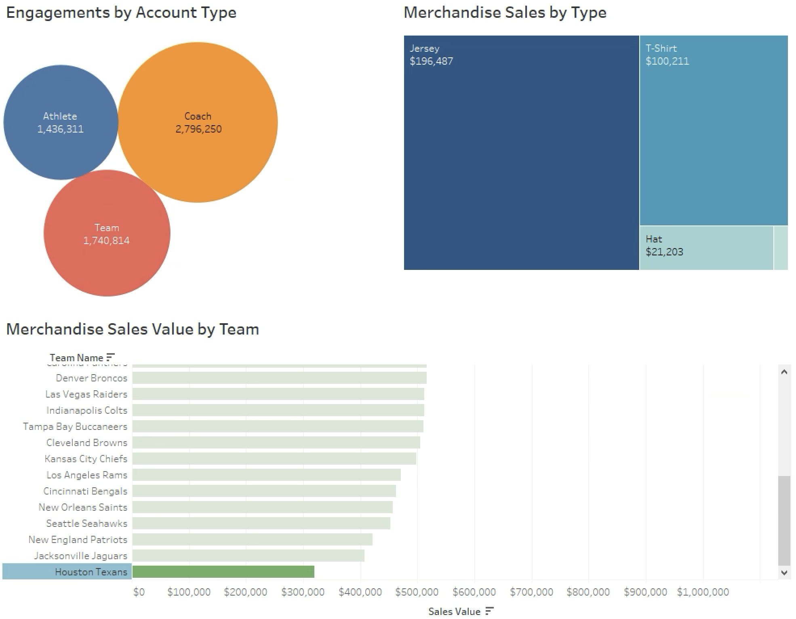

Based on our findings in these dashboards we first determined that more engagements lead to more merchandise sales. Next we uncovered that as teams are developing their social media engagements, they should prioritize their athlete social media presence, as athlete accounts are most popular among teams with high sales volumes. We would also suggest that the activity surrounding the athlete's social media posts feature the team jerseys in order to positively influence jersey sales volumes.

