**User guide for validation process**

**The Validation folder contains:**

Validate.accdb - MS Access application

AEL.xls - OpenClinica (OC) data dictionary to re-create CRF

adverse_events_download.xml - Dummy data downloaded from OC

This guide describes an example validation exercise and includes all the files required.

Open the application by double clicking on Validate.accdb (See Appendix I for security warnings).

**Create XML table for upload**

This assumes that the adverse event log CRF (OC meta-data is in the file AEL.xls) exists in OC. The table adverse_events contains dummy data for two subjects with adverse events.



Click the ‘Create XML file for upload to OC’ to transform this data to an OC compatible XML data file adverse_evenst.xml (Note this file will be created in the same folder location as the database)

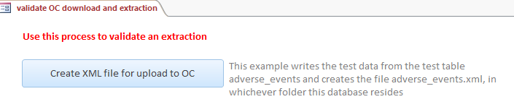

**Upload adverse_events.xml to adverse event log CRF**

From OC upload adverse_events.xml to the previously created adverse events log CRF.

**Download data from OC**

Using the "CDISC ODM XML 1.3 Clinical Data” download option in OC save the records on the CRF as adverse_events_download.xml.

**Extract data using DataExtractor.accdb**

Extract all the data from adverse_events_download.xml using the data extraction tool to table (DataExtractor.accdb). The download was part of a wider validation exercise and contains all CRFs in the study. Select the CRF Adverse event log as shown below and all study events and item groups.

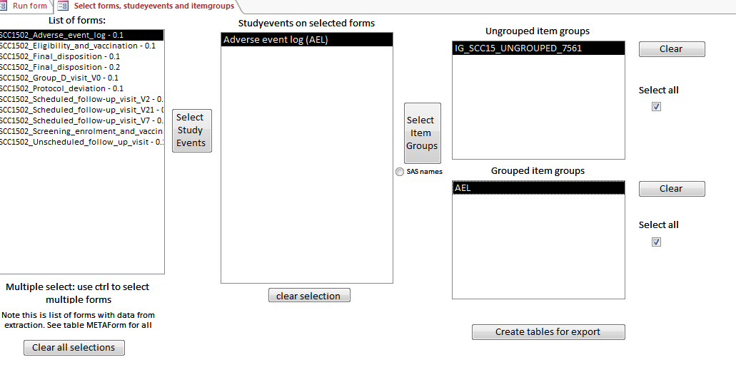

Then extract the data in wide format to the table data_out_validate and upload the table to the validation database Validate.accdb, using the ‘Export tables’ option of the data extraction tool.

**Compare imported and exported data**

The imported and exported data should now reside in tables adverse_events and data_out_validate. Click the button shown below to compare the values in every field and every record.

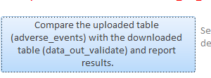

This button runs a function run_validation (in VBA module validate) to compare the tables and reports identical uploaded and download data (PASS) or gives the number of discrepancies (FAIL).

**Appendix I Microsoft security warnings**

If the application is opened in anew folder for the first time a security warning will appear (exact format will depend on the version of windows), but have the form of below.

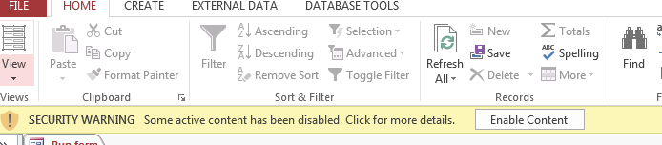

To allow the application to run, user must click on the Enable Content button. An alternative is to declare the folder where the application resides a ‘trusted location’, using the Microsoft Trust Center tool.