PWID FAQs

What are the main effects of preventative interventions?
They reduce the risk of infection/infectiousness and so decreases the incidence of new chronic cases.

How are DAA modeled?
Subjects who are treated with DAA are moved from the chronic compartments to treatment compartments and then the uninfected susceptible compartments if the treatment is successful.

At what stages does excess liver related mortality occur?
The model assumes excess mortality in the DC,HCC and LT stages.

How many compartments are in the model?
The disease progression model consists of 20 compartments simulating progression from susceptible through to liver transplant. Age is stratified into stages from 20 years old upwards, giving 180 compartments. There are four groups in the PWID model. Current/Former * Never failed treatment/Treatment failures, resulting in 720 compartments.

Is under-reporting of HCV accounted for?
Due to the lack of symptoms in the acute (additionally spontaneous recovery) and early chronic stages HCV incidence is extremely difficult to measure, with prevalence estimates also similarly affected. We have taken evidence from a wide variety of literature, including both survey and modeled data that account for under-reporting. It should be noted that the confidence intervals for prevalence and incidence are extremely wide, typical more than the 25% of the estimates in each direction.

Is re-infection accounted for?
After successful treatment subjects return to the susceptible population where they can again be infected. There is no strong evidence to support different risk of infection between primary and re-infection (from page 34 of the Heffernan supplement).
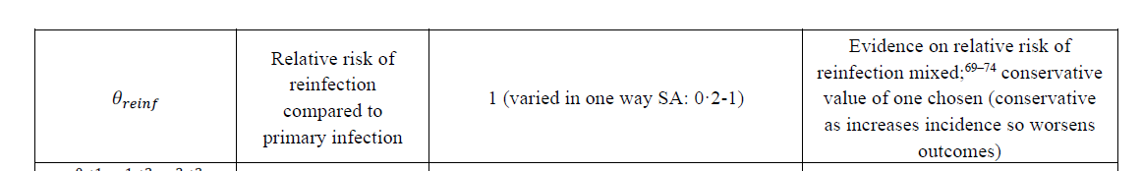
Heffernan, A., Cooke, G. S., Nayagam, S., Thursz, M. & Hallett, T. B. Scaling up prevention and treatment towards the elimination of hepatitis C: a global mathematical model. The Lancet 393, 1319–1329 (2019).

Are re-treatments modeled?
Subjects who fail treatment are moved to a parallel set of compartments, no delay is assumed in their re-treatment.

How are DAA treatments allocated?
For user entry a simple approach of the number of DAA treatments per 1,000 PWID for each stage are assumed. This allows comparison with other studies and is is easy to implement in the user interface.

Are allocation scenarios important?
Very. The US has an enormous pool of HCV infection and to reduce this quickly requires a very high initial DAA coverage followed by years of constant DAA coverage. The disadvantage of this is that early costs are high and perhaps logistically difficult. An alternative is to implement medium DAA coverage for a longer time. Both these scenarios can be simulated by the current user input. (This is why the DAA coverage is per stage to allow high DAA coverage early in a treatment campaign).

Can other treatment campaigns be simulated?
Not currently as there are so many different strategies. Complex strategies can be programmed and added to the automated output.

What is the attack rate?
The attack rate measures the % of chronically infected HCV current PWID among the current PWID population.

Why is the attack rate important?
The HCV infected current PWID from the reservoir of subjects that infect other subjects, and the size drives the infection rate.

Cases per treatment?
The case per treatment output measures the number of cases averted per DAA treatment. Primarily useful when there are only DAA interventions. If there are preventative interventions the additional cases averted are included in the numerator and the cases per treatment increases.

Cumulative output?
This shows the number of cases averted (from DAA and preventative interventions) cumulatively over year on the left y-axis. On the right y-axis the number of DAA treatments are shown on the same scale.

