Model structure for gen pop, prison and PWID populations.

This is a complex model with models for the three populations linked by flow rates between the populations. Additionally all models are stratified by age and subjects step through the relevant compartments as they age. In this description the model is divided into five layers beginning with an overview of the top level, progressing down to individual population models.

Flows between the top levels

In total there are 3,800 compartments in the model, divided between the models as below.

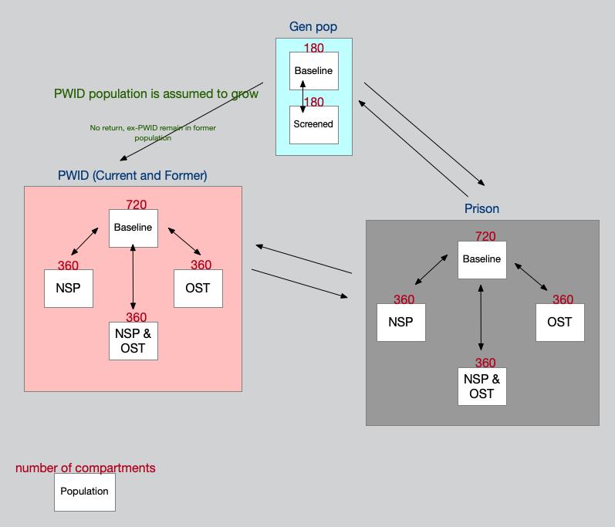
General population model

The general population models two groups – the baseline general HCV population and a screened population, with flow back and fore between the two strata.

Additionally the population is subdivided into 9 age strata. Within each age strata subject progress through the disease stages shown in the HCV progression model section

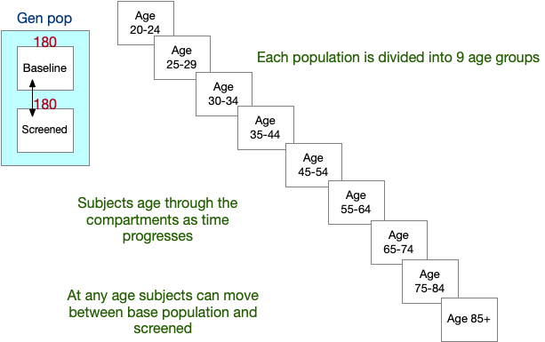

PWID and Prison models

The same structure is used for both the PWID and prison populations, split into baseline populations and three intervention strata. The structure of the baseline model is further described in the PWID and Prison baseline model section.

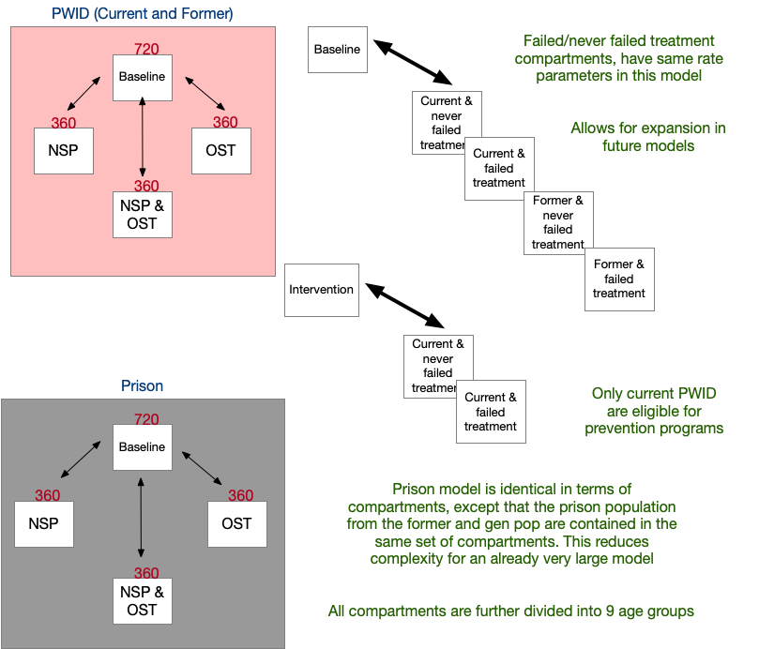

PWID and Prison baseline model

Subjects are divided into current and former populations (former and gene pop are combined in the prison model) as former injecting drug users have a higher risk for relapse to drug use than the general population. The current and former populations are also subdivided into those who have never failed and those who have failed (efficacy and compliance are not perfect) a DAA treatment. Currently these two populations are modeled with the same rates, but are included to allow for future expansion. All compartments at all stages in all models are subject to background mortality and DC,HCC and the LT compartments have an additional increased liver related mortality rate.

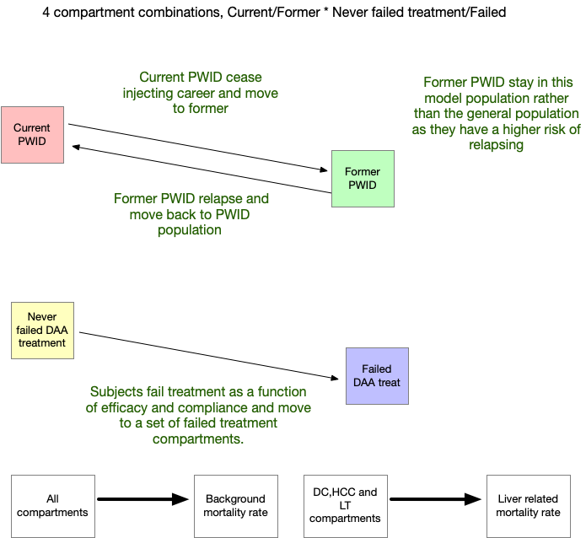

Disease progression model

At the lowest level subjects move between 20 compartments representing the HCV disease progression.
