REACH

Reach is the maximum available coverage of DAA treatment. The maximum will not always be utilized as it maybe greater than the number of HCV infected subjects.

Reach is quoted as DAA treatments per 1,000 PWID subjects. This is the coverage available for each disease stage, F0 to F4, DC, HCC and LT.

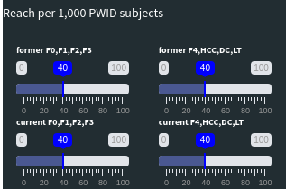
This allows both catch-up campaigns where initial DAA treatment investment is high and constant DAA treatment coverage.

For example, choosing the following reach, for a population with high number of HCV infections, allows a large number of DAA treatments initially, flattening to a constant level and finally declining as the epidemic stalls. The average DAA coverage in this example is 62/1000.

