Summary
The primary objective of this event-driven, multi-country trial is to estimate vaccine efficacy (VE) against infection among participants who are seronegative at baseline. Although enrollment occurs across multiple countries and sites, efficacy evaluation, interim monitoring, and early stopping decisions are based on the global accumulation of endpoint events. Interim analyses and final analysis are triggered by the accrual of a prespecified number of endpoint events among baseline seronegative participants, rather than by calendar time or total enrollment.

Vaccine efficacy is defined as one minus the cumulative relative risk of infection in the vaccine arm compared with the control arm. Participants who are seropositive at baseline will not be excluded from the trial and will be included in relevant analysis sets, but primary efficacy inference will be conducted in the baseline seronegative population, as seropositive participants are unlikely to contribute endpoint events.
Because interim analyses are planned and zero cases in the vaccine arm are plausible, the primary inferential procedure is based on an exact conditional method rather than large-sample approximations. Hypothesis testing is performed using an exact binomial case-split procedure that conditions on the total number of observed endpoint cases and evaluates the allocation of cases between treatment arms. This approach directly targets inference on cumulative vaccine efficacy and avoids assumptions regarding hazards, person-time, or proportional risks. One-sided hypothesis testing is conducted at the 2.5% significance level.
The trial uses a group-sequential design with analyses planned after approximately 50%, 75%, and 100% of the maximum number of endpoint events. Interim monitoring is implemented through an O’Brien–Fleming–type alpha-spending approach adapted to the exact binomial testing framework. Because the test statistic is discrete, rejection boundaries are defined in terms of the minimum number of vaccine-arm cases required for rejection at each analysis. This ensures strong control of the one-sided type I error rate across all interim analyses, although power may exhibit non-monotonic “saw-tooth” behaviour as a function of the planned number of events.
Sample size and power are evaluated through simulation. The simulation framework incorporates individual-level heterogeneity in infection risk and latent clustering of exposure, reflecting realistic transmission dynamics. Baseline seroprevalence is allowed to vary across exposure clusters, with higher seropositivity in high-risk clusters, a conservative assumption that reduces the number of susceptible individuals available to contribute endpoint events. This mechanism increases the number of seronegative participants required to observe the target number of endpoint cases and is therefore expected to yield conservative sample size estimates.

Primary Objective
The primary objective of the trial is to estimate vaccine efficacy (VE). Given that participants who are seropositive at baseline are likely to have pre-existing immunity and are therefore not expected to contribute incident endpoint cases, the primary VE analysis will be conducted in the sub-population of participants who are seronegative at baseline. Randomisation between the vaccine and control arms will be balanced at 1:1
Participants who are seropositive at baseline will not be excluded from trial enrollment and will be included in the overall trial population and relevant analysis sets, but they will not contribute to the primary VE estimate.
Statistical analysis for primary objective
The primary outcome is the relative incidence of infection among baseline seronegative participants. Because interim analyses are planned and zero events in the vaccine arm are plausible, the primary analysis must remain valid under sparse data and potential separation.
It is unlikely that the proportional hazards assumption will be satisfied, and therefore Cox proportional hazards regression is not a suitable primary analysis method. Modified Poisson regression, with variance adjustment appropriate for binary data, provides a useful modelling framework that can incorporate covariates and reduces to a simple closed-form estimator in the two-arm, no-covariate setting. Vaccine efficacy (VE) is defined as
$$VE=1-RR,$$
where RR denotes the cumulative relative risk of infection in the vaccine arm compared with the control arm.
However, Poisson-based approaches cannot accommodate separation (i.e., zero events in one study arm) without introducing ad hoc corrections, making them unsuitable for exact interim monitoring in this setting. As a multi-look early stopping rule will be implemented, null cases are likely in the vaccine arm. Consequently, the null hypothesis H₀: VE ≤ 20% will be tested against the alternative H₁: VE > 20% using an exact conditional binomial case-split procedure.
The binomial case-split test conditions on the total number of observed endpoint cases at a given analysis and models the number occurring in the vaccine arm as a binomial random variable. The probability that a case occurs in the vaccine arm is defined by the vaccine efficacy threshold under evaluation, through the corresponding cumulative risk ratio between the vaccine and control arms. This formulation directly targets inference on cumulative vaccine efficacy and does not rely on assumptions about person-time, hazards, or proportional risks. Follow-up is assumed to be comparable between treatment arms by design, and the conditional binomial model therefore depends only on the cumulative relative risk and not on individual-level follow-up times.
For an analysis assume:

$v$ = number of endpoint events (cases) observed in the vaccine arm among baseline sero-negatives
$N$= total number of endpoint events among baseline sero-negatives across both arms
RR₀ = the cumulative risk ratio at the null threshold, 1-0.2 (${VE}_{0}$) = 0.8 in this case.
$n_{v},n_{c}$ = total recruited sero-negative subjects in each arm. Likely very close in this design as randomisation is 1:1
To test the null hypothesis $H_{0}:VE≤{VE}_{0}$, where ${VE}_{0}=20\%$, the corresponding null cumulative risk ratio is ${RR}_{0}=1-{VE}_{0}=0.80$. Under $H_{0}$, the conditional probability that an observed endpoint occurs in the vaccine arm is:
$$θ_{0}=\frac{n_{v}RR_{0}}{n_{v}RR_{0}+n_{c}}.$$
Conditional on the total number of observed cases $N$, the number of vaccine-arm cases $V$follows a binomial distribution,
$$V∣N∼Binomial(N,θ_{0}).$$
The one-sided exact p-value is then defined as
$$p=\underset{θ_{0}}{Pr}(V≤v∣N)=\sum_{j=0}^{v}{\left({N \atop j}\right)}θ_{0}^{ j}(1-θ_{0})^{N-j}.$$
and the null hypothesis $H_{0}:VE≤{VE}_{0}$is rejected at significance level $α$if $p≤α$.
This test can equivalently be expressed in an interval-based form. The one-sided Clopper–Pearson upper confidence bound $θ_{U}$is defined as the solution to
$$\underset{θ_{U}}{Pr}(V≤v∣N)=α$$
which has the closed form (where qBeta denotes the quantile function of the Beta distribution, which arises from inversion of the binomial distribution)
$$θ_{U}=qBeta(1-α; v+1, N-v).$$
and can then inverted to obtain a one-sided lower confidence bound for vaccine efficacy,:
$$VE_{L}=1-\frac{θ_{U} n_{c}}{n_{v}(1-θ_{U})}.$$
If VE_{L} >0.2 the null hypothesis will be rejected at a significance level alpha.

Early stopping and significance level
The trial will be conducted across multiple countries and sites. All primary analyses, interim monitoring, and early stopping decisions will be performed globally, pooling endpoint events across all participating countries. No country-specific interim analyses or stopping rules are planned.

The trial uses a group-sequential design with two interim analyses conducted after approximately 50% and 75% of the planned total number of endpoint events, followed by a final analysis at 100% The primary hypothesis is test of VE>20% and is evaluated using an exact conditional binomial (case-split) test at each analysis.

In standard group-sequential designs, interim monitoring is typically performed using Z-statistics derived from large-sample normal approximations, with stopping boundaries expressed as critical Z-values determined by an alpha-spending function such as O’Brien–Fleming. This approach is not appropriate in the present setting because the primary inferential procedure is an exact conditional test based on the binomial distribution of vaccine-arm cases given the total number of observed cases. The test is discrete and is not based on an asymptotic score or Wald statistic.
Consequently, classical Z-score-based group-sequential methods cannot be directly applied. Instead, stopping boundaries are calculated directly from the binomial distribution at each interim analysis, conditional on the number of events observed at approximately 50% and 75% of the planned maximum.
Overall strong control of the one-sided type I error rate at a level of 2.5% is achieved using an O’Brien–Fleming type alpha-spending approach, with the cumulative nominal alpha at each analysis determined as:
Let $K=3$ denote the total number of analyses. Analyses are conducted after observing cumulative numbers of events
$$N_{1}=0.50 N_{max}, N_{2}=0.75 N_{max}, N_{3}=N_{max},$$
where $N_{max}$ is the planned maximum total number of endpoint events.
Define the information fraction at analysis $k$ as
$$t_{k}=\frac{N_{k}}{N_{max}}, k=1,2,3.$$
A one-sided O’Brien–Fleming alpha-spending function is specified as
$$α(t)=1-Φ​\left(\frac{z_{1-α}}{\sqrt{t}}\right),$$
where $Φ(⋅)$ denotes the standard normal cumulative distribution function and $z_{1-α}$ is the $(1-α)$ quantile of the standard normal distribution.
The cumulative nominal type I error available at analysis $k$ is then
$$α_{k}=α(t_{k}), k=1,2,3,$$
representing the maximum cumulative probability of rejecting the null hypothesis by analysis $k$.
Although the O’Brien–Fleming alpha-spending function is traditionally defined in terms of Z-statistics, in this trial it is used solely to determine the cumulative type I error allocated to each analysis. The spending function specifies the maximum allowable probability of rejecting the null hypothesis by each analysis time, independent of the form of the test statistic. These cumulative alpha levels are then translated into exact discrete rejection boundaries using the binomial distribution at each look.
Strong control is ensured by two properties of the design:
- Cumulative alpha constraint
At each analysis, the stopping boundary is chosen so that the probability of rejection under the null hypothesis, accumulated over all analyses up to that point, does not exceed the cumulative alpha specified by the spending function.
- Exact finite-sample inference
Rejection probabilities at each analysis are computed exactly from the binomial distribution, conditional on the observed total number of events. As a result, the true type I error is never underestimated. Because the binomial distribution is discrete, the achieved type I error is typically less than or equal to the nominal alpha, making the procedure conservative rather than anti-conservative.
Together, these features ensure that the overall probability of falsely declaring vaccine efficacy is bounded by 2.5%, even in the presence of early stopping and discrete endpoint counts.
Exact discrete boundaries
In the absence of a Z-statistic, the alpha spending described above is used to determine discrete rejection boundaries at each analysis.
At each look $k$, an integer rejection boundary $c_{k}$ is determined such that
Prθ0(Vk≤ck∣Nk)≤αk-j<k​Prθ0(reject at look j).
Operationally, this is implemented by:
- Computing the exact binomial distribution of $V_{k}$ under $θ_{0}$.
- Identifying the largest integer $c_{k}$ such that rejection for $V_{k}≤c_{k}$ does not cause the cumulative type I error to exceed $α_{k}$.
- Rejecting the null hypothesis at look $k$ if $V_{k}≤c_{k}$.
Because $V_{k}$ is discrete, the achieved cumulative type I error at each look is generally less than or equal to the nominal $α_{k}$, resulting in conservative error control.
Power simulation
With no closed form for test power and a stochastic epidemiological process generating the events, simulation was used to estimate sample size was assuming a power of 80%.
Time to infection data is simulated for Rift Valley fever (RVF) during an outbreak given an attack rate, using an exponential distribution. Individual-level heterogeneity (“frailty”) is included by assuming a gamma-distributed random effect with variance = 0.5. This models variation in susceptibility among participants that is not explained by observed covariates (e.g., differences in exposure, host-factors, immune status). Although the true frailty variance for RVF infection in a future trial is unknown, a variance of 0.5 represents a moderate level of heterogeneity and is well within values commonly used in survival-analysis modelling. A variance of 0.5 corresponds to a coefficient of variation in individual hazard of √0.5 ≈ 0.71, indicating roughly 70 % variability around the mean hazard. This is consistent with the range typically considered moderate in frailty-model applications (Balan et al., 2020). This choice therefore provides a realistic allowance for inter-individual variation in RVF susceptibility without overstating uncertainty. It is a parameter in the model and can be easily changed.
To be conservative:
1. Individual randomisation is assumed to have an underlying cluster-level correlation.
2. Baseline seropositivity is modeled as more common in higher-hazard clusters, consistent with the interpretation that clusters with higher ongoing exposure are also those with greater cumulative past exposure.
Participants are still individually randomised, but people within the same cluster share cluster-level frailty (It is likely that the clusters will be latent). Because incident endpoints are accrued only among baseline seronegative (susceptible) participants, enrichment of baseline seropositivity within hotspots reduces the number of susceptible individuals available within clusters that would otherwise contribute a disproportionate share of incident infections. Consequently, as baseline seroprevalence increases, the yield of observable seronegative endpoints per enrolled seronegative participant decreases in hotspot settings, which can increase the number of seronegative participants required to observe the planned number of seronegative infection events, even when the planned event count for statistical power is unchanged.
Power of the test in the exact discrete boundaries (which matches the primary analysis) was estimated by simulation across 121 parameter combinations (true vaccine cumulative risk ratios of 25% to 5% in steps of 2%, where VE = 1 - RR, and baseline seroprevalences of 10%–50% in steps of 4%) for each attack rate of 0.1% and 1%. For each combination, a grid search algorithm was used to determine the total number of endpoint events required to achieve 80% power. At each grid cell, the model simulated 10,000 independent trials, each continuing until the current candidate number of events ($N_{max}$) was reached or an interim efficacy boundary was crossed at 50% or 75% of $N_{max}$. The estimated power was the proportion of simulated trials in which the null hypothesis was rejected (at first look, second look or final analyses). Simulations were performed in R on the MRC Gambia HPC.

Sawtooth power
When estimating power as a function of the planned maximum number of events $N_{max}$, the discreteness of the exact binomial boundaries leads to a characteristic sawtooth pattern:
- As $N_{max}$ increases by one event, the stopping boundaries $(c_{1},c_{2})$ may remain unchanged over a range of values.
- At certain values of $N_{max}$, a boundary $c_{k}$ increases by one, producing an abrupt change in rejection probability.
- Consequently, power as a function of $N_{max}$ is not monotone and exhibits small downward and upward jumps.
For this reason, root-finding or bisection methods are inappropriate for determining ${N_{1},N_{2} and N}_{max}$, and power must instead be evaluated over a local integer grid of candidate event counts, taking the minimum number of events to give power ≥ 80%.
Sample size
This is an event-driven trial. Statistical power and interim monitoring are governed entirely by the accumulation of a prespecified number of endpoint events among baseline seronegative participants, not by calendar time or a fixed number of enrolled subjects.
Figure 1 shows the number of events amongst the sero-negative participants against vaccine efficacy, to achieve 80% power at a one-sided 2.5% significance level to reject the Null hypothesis that that the VE<20%. Attack rate and baseline sero-status do not affect the events required, but influence the person years of observation necessary to accrue these events. The black line shows the maximum planned number of total events required if the trial runs to completion without early stopping. The red line shows the average (expected) number of events observed, accounting for the possibility of early stopping for efficacy at interim analyses. When a boundary is crossed, the trial stops and fewer total events are accumulated on average.
Figure 1 Number of events required
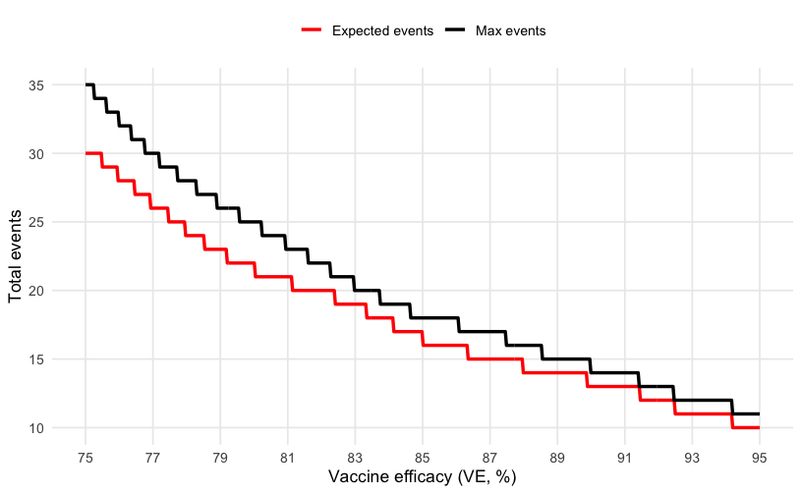
The simulations allow baseline seropositivity to be higher in high-risk clusters, reflecting the plausible situation in RVF that individuals living/working in settings with greater exposure to infected mosquitoes or livestock may be more likely to have been previously infected. Under latent clustering, infections tend to concentrate in a limited number of high-risk clusters (hotspots). Only baseline seronegative individuals can contribute endpoint events in the primary analysis. Therefore, when baseline seroprevalence increases, fewer susceptible (baseline seronegative) individuals are present in these high-risk clusters. If baseline seropositivity is additionally enriched within hotspots, this effect is amplified and hotspots contain an even smaller susceptible pool. Higher baseline seroprevalence increases required enrolment because it reduces the number of susceptible individuals in the very clusters that contribute most endpoint events.
Lower seropositivity in low-risk clusters does not compensate, as these clusters contribute few events. As a result, each hotspot produces fewer observable endpoint events among seronegatives, and more seronegative participants must be enrolled to accrue the same target number of seronegative endpoint events. This is evident in Figure 2 which shows the person time required to accrue the necessary observations. Despite a mild enrichment of seropositivity in hotspots, the increasing seroprevalence demonstrates a strong effect on the observation time required.
The black curve corresponds to a scenario in which baseline serostatus is independent of cluster-level transmission intensity. Under this assumption, although clusters differ in their underlying infection risk, each cluster contains, on average, the same proportion of seronegative individuals as the trial population overall. As baseline seropositivity increases, seronegative follow-up time is therefore reduced proportionally across both high- and low-risk clusters. Importantly, the relative contribution of high-risk clusters to the total seronegative person-time remains the same, so the expected event yield per seronegative person-year is unchanged. As a result, the number of seronegative person-years required to accrue a given number of events does not depend on baseline seropositivity. In contrast, when seropositivity is enriched in high-risk clusters, seronegatives are preferentially depleted from those clusters, reducing the event yield per seronegative person-year and increasing the required follow-up.
Figure 2 Required person time to accrue the events in Figure 1 for baseline seronegative subjects
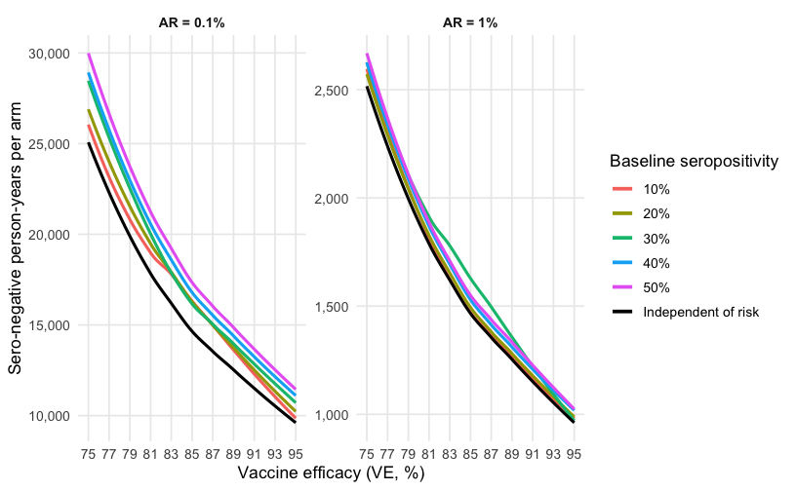
The simulation shows that hotspots with high baseline seropositivity can potential heavily inflate the person time, which with relatively quick outbreaks will greatly increase the number of recruited and vaccinated subjects.
Total enrolment sizes (including both seronegative and seropositive participants) are derived by assuming that participants are enrolled independently of baseline serostatus, with the baseline seroprevalence representing a fixed population proportion. Under this assumption, the total person-years required per arm are obtained by inflating the required seronegative person-years by a factor of $1/(1-p_{\text{sero}\text{ +}})$. Seropositive participants are assumed not to contribute endpoint events and are not explicitly simulated. Assuming that sero-status is correlated to risk (a mild enrichment of seropositivity in hotspots in this case), Figure 3 inflates the estimates in Figure 2 to give approximate total observation time required in each arm.
Figure 3 Total person time for varying baseline serostatus.
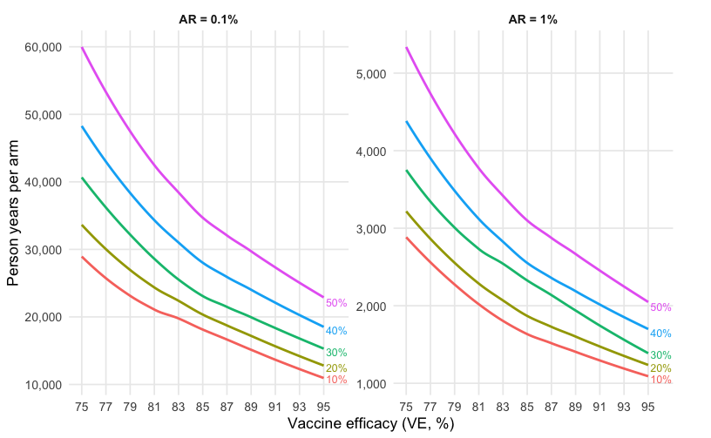
This implies potentially very large total enrolment across participating countries, particularly under lower attack rates or higher baseline seroprevalence.
All enrolment figures are expressed in terms of person-years of observation. For example, 4,000 person-years may correspond to 4,000 participants followed for one year, or 8,000 participants followed for six months. The analysis is based on cumulative incidence, and the use of person-years here reflects the total observation time required to accrue events and NOT an assumption of proportional hazards.

Analysis plan
The primary objective follows exactly the method used in the sample size simulation - a conditional exact test for comparing two binomial proportions (Chan).
We consider the one-sided hypothesis
$$H_{0}:VE≤VE_{0} \text{equivalently} H_{0}:RR≥RR_{0}, RR_{0}=1-VE_{0},$$
against
$$H_{1}:VE>VE_{0} \text{equivalently} H_{1}:RR<RR_{0}.$$
Given observed $v$ events out of a total N, allocation counts $(n_{v},n_{c})$, a null threshold $VE_{0}$ (so $RR_{0}=1-VE_{0}$), and one-sided significance level $α$:
- The risk ratio is estimated by the cumulative risk ratio (n_{v} and n_{c} planned as 1:1):
$$RR=\frac{{E_{v}}/{n_{v}}}{{E_{c}}/{n_{c}}},$$
- Null split probability:
$$θ_{0}=\frac{n_{v}RR_{0}}{n_{v}RR_{0}+n_{c}}.$$
- All probabilities are conditional on the observed total number of endpoint events $N$, consistent with the conditional case-split framework. Exact one-sided p-value for testing $H_{0}:VE≤VE_{0}$:
$$p=\underset{θ_{0}}{Pr}(V≤v∣N)=\sum_{j=0}^{v}{\left({N \atop j}\right)}θ_{0}^{ j}(1-θ_{0})^{N-j}.$$
- The hypothesis test is equivalently conducted by inversion of the exact conditional distribution to obtain a one-sided confidence bound for vaccine efficacy. One-sided Clopper–Pearson upper bound for $θ$:
$$θ_{U}=qBeta(1-α; v+1, N-v).$$
- One-sided lower bound for vaccine efficacy:
$$VE_{L}=1-\frac{θ_{U} n_{c}}{n_{v}(1-θ_{U})}.$$
- The null hypothesis will be rejected if VE_{L} > VE₀ (=20%)
The trial uses a group-sequential monitoring design with analyses triggered when approximately 50%, 75%, and 100% of the planned maximum number of primary endpoint events among baseline seronegative participants have accrued. Hypothesis testing is performed using the exact conditional (binomial case-split) procedure at each analysis with efficacy stopping boundaries calibrated to control the overall one-sided type I error at 0.025 under an O’Brien–Fleming alpha-spending approach. Inference will be reported in a manner consistent with the sequential design. Ff the trial stops early for efficacy at analysis $k$, vaccine efficacy will be accompanied by a sequentially adjusted one-sided lower confidence bound constructed using the cumulative alpha spent at that analysis (i.e., the look-specific nominal level implied by the spending function and the discrete boundary actually achieved). If the trial does not stop early and proceeds to the final analysis, the reported confidence bound will similarly correspond to the final-look nominal level (approximately 0.025 one-sided under O’Brien–Fleming). Because the conditional test is discrete, the achieved alpha spending at each analysis may be conservative relative to the target; the reported confidence bounds will align with the achieved (conservative) spending to maintain strong control of the family-wise type I error.
Enrolment will be distributed across multiple countries and sites, with endpoint events pooled globally for interim monitoring and final analysis.
Secondary analyses will use modified Poisson regression with robust (sandwich) variance estimation to obtain covariate-adjusted estimates of the cumulative relative risk. For sparse outcomes or complete separation (e.g. zero infections in one arm), small-sample corrections such as continuity corrections or penalized likelihood (Firth) approaches will be used as sensitivity analyses.
It is unlikely that a proportional hazards model will be tenable, given the outbreak-driven, time-varying force of infection, but this will be formally tested using Schoenfeld residuals. If the proportional hazards assumption is violated, exploratory analyses using time-varying Cox models with spline-based effects will be conducted.
References
Balan, T.A., Putter, H., et al. (2020). Frailty models in medical research: A review and practical guide. Statistical Methods in Medical Research, 29(10), 3114–3154.
Chan, I.S.F. & Bohidar, N.R. (1998).Exact power and sample size for vaccine efficacy studies. Communications in Statistics – Theory and Methods, 27, 1305–1322.
Firth, D. (1993). Bias reduction of maximum likelihood estimates. Biometrika, 80, 27–38.
Appendix
Simulation code and description available at https://github.com/MRCG-djeffries/rvf_power_sim

