Literature review

|  |  |  |  |  |
| --- | --- | --- | --- | --- |
| **who** | **category** | **pmid** | **title** | **source** |
|  | dish | 38355791 | **Smoking changes adaptive immunity with persistent effects.** | Nature |
| Sarah | dnmage | 38176546 | Prenatal and childhood lead exposure is prospectively associated with biological markers of aging in adolescence. | Sci Total Environ |
|  | dnmage | 38243142 | **Causality-enriched epigenetic age uncouples damage and adaptation.** | Nat Aging |
| Sarah | ewas | 38324238 | Perceived Experiences of racism in Relation to Genome-Wide DNA Methylation and Epigenetic Aging in the Black Women's Health Study. | J Racial Ethn Health Disparities |
|  | methods | 38187520 | Methylation Array Signals are Predictive of Chronological Age Without Bisulfite Conversion. | bioRxiv |
| Anza/Onur | methods | 38225268 | Biologically informed deep learning for explainable epigenetic clocks. | Sci Rep |
| Onur | methods | 38262949 | A novel approach toward optimal workflow selection for DNA methylation biomarker discovery. | BMC Bioinformatics |
|  | methods | 38267438 | Anti-correlated feature selection prevents false discovery of subpopulations in scRNAseq. | Nat Commun |
| Onur | methods | 38168992 | Discovery of sparse, reliable omic biomarkers with Stabl. | Nat Biotechnol |
|  | multi-omic | 38215789 | Identifying BMI-associated genes via a genome-wide multi-omics integrative approach using summary data. | Hum Mol Genet |
| Sam | multi-omic | 38287030 | Unraveling the epigenetic code: human kidney DNA methylation and chromatin dynamics in renal disease development. | Nat Commun |
| Jasmine | multi-omic | 38383592 | Blood and urine multi-omics analysis of the impact of e-vaping, smoking, and cessation: from exposome to molecular responses. | Sci Rep |
|  | review | 38253763 | [**Seven technologies to watch in 2024.**](https://www.nature.com/articles/d41586-024-00173-x) | Nature |
|  | review | 38321342 | Roadmap for a European cancer data management and precision medicine infrastructure. | Nat Cancer |

Saint-André, V., Charbit, B., Biton, A., Rouilly, V., Possémé, C., Bertrand, A., Rotival, M., Bergstedt, J., Patin, E., Albert, M. L., Quintana-Murci, L., Duffy, D., & Milieu Intérieur Consortium (2024). **Smoking changes adaptive immunity with persistent effects.** Nature, 626(8000), 827–835. <https://doi.org/10.1038/s41586-023-06968-8>

Background

* It is known that individuals respond to immune challenges differently and that this is partially explained by aging, sex differences and genetic variation.
* Other factors are suspected to play a role, especially lifestyle and past infections, but little is known about them or the mechanisms by which they influence immune response.

Methods

* Used blood samples and data from 955 participants in the The Milieu Intérieur Consortium
* Immune response was measured as the activation of 13 well-known cytokines in blood 22h after collected blood was exposed (’stimulated’) to
  + microbial agents (4) and viral agents (2) — innate response
  + T cell activators (2) — adaptive response
  + cytokines (3)
* Associations between cytokine activation following stimulation and 136 factors were tested (while adjusting for age, sex and batch)

Results

* Smoking, cytomegalovirus latent infection and body mass index were associated with cytokine activation — **surprising how few**
* Smoking accounted for most associations (2 innate and 2 adaptive)—**already known that smoking influences both immune responses (see e.g. PMID: 27902485)**
* However, innate stimulation (of CXCL5) was not observed in former smokers, while adaptive stimulation (of IL2 and IL13) was observed in both former and current smokers.
* Propose ‘epigenetic’ explanation for long-term adaptive difference in smokers
* Found 11 smoking-associated CpG sites (including AHRR and F2LR3) that (1) when included as covariates eliminated associations of IL-2 CpG sites with smoking, (2) are associated with years smoking and cigarettes smoked, (3) negatively with years since cessation in former smokers and (4) associated with IL-2 following innate stimulation—**however this follows entirely from the fact that the 11 smoking-associated CpG sites are those most strongly associated with cigarette exposure including pack-years and time since cessation … also unclear how these 11 were identified.**
* Limitations of the study
* Immune stimulations were done ‘in the tube’ — I’m not an immunologist so I’m not sure if similar cytokine responses would be observed in the bodies of individuals who provided the blood samples following infection
* Findings apply to a genetically homogeneous population
* No replication—**how can study published in Nature not include replication?**
* Mechanistic finding for DNA methylation is purely observational. A real mechanistic analysis would require reversing smoking-induced DNAm and asking if this reversed smoking-associated immune responses—**how can purely observational study with mechanistic conclusions not include mechanistic evaluation?**
* What can we do with these findings? **They are interesting to researchers, but it’s not immediately clear what the public or medicine gains. The real novelty is finding that the innate response differences due to smoking are short-term (i.e. depend on continued smoking) but the adaptive are more long-term.**

Ying, K., Liu, H., Tarkhov, A. E., Sadler, M. C., Lu, A. T., Moqri, M., Horvath, S., Kutalik, Z., Shen, X., & Gladyshev, V. N. (2024). **Causality-enriched epigenetic age uncouples damage and adaptation.** Nature aging, 4(2), 231–246. <https://doi.org/10.1038/s43587-023-00557-0>

Methods

* Genetic aging score/clock named Aging-GIP1 (previously published)

1. GWAS of aging traits—healthspan, parental lifespan, longevity, frailty, self-rated health
2. Calculate genetic correlations between traits
3. Calculate first principal component

* For each CpG site:

1. Calculate observational associations with aging traits
2. Calculate causal effect on aging traits (via methylome-wide Mendelian randomization)  
   (identified about 3000 such CpG sites)

* Protective effect = observational and causal effects both positive or both negative
* Damaging effect = observational and causal effects are opposite

Clocks

* CausAge = elastic net applied to all CpG with causal effects to predict Aging-GIP1  
  (parameter tau=0 means elastic net as usual, tau=1 model coefficients are causal effects)
* DamAge = as above but restricted to CpG sites with damaging effects
* AdaptAge = as above but restricted to CpG sites with protective effects

Results

* Magnitudes of observational and causal effects are not correlated
* Epigenetic clocks are **not** enriched for CpG sites that have a causal effect on aging traits
* Clock accuracy **decreases** as tau increases from 0 to 1
* Tau = 0.3 is largest with MAE < 5 years that maximizes association with mortality

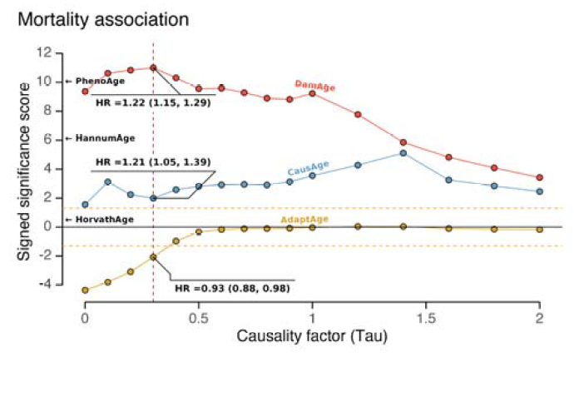

* DamAge associated with (more so than AdaptAge and CausAge)
  + mortality (best of all clocks)
  + Programming time of induced pluripotent stem cells
  + Atherosclerosis
  + Cancer prognosis
  + Heart disease
  + Smoking
  + Progeroid syndrome (rare genetic disorders that mimic aging)
  + Uv exposure