**DNA methylation signatures and coagulation factors in the peripheral blood of epithelial ovarian cancer**

Lian Li1, Hong Zheng1, Yubei Huang1, Caiyun Huang1, Shuang Zhang1, Jing Tian2, Pei Li1, Anil K. Sood3, Wei Zhang4, Kexin Chen1

1Department of Epidemiology and Biostatistics, National Clinical Research Center for Cancer, Key Laboratory of Cancer Prevention and Therapy of Tianjin, Tianjin Medical University Cancer Institute and Hospital, Tianjin, China.

2Department of Urology, National Clinical Research Center for Cancer, Key Laboratory of Cancer Prevention and Therapy of Tianjin, Tianjin Medical University Cancer Institute and Hospital, Tianjin, China.

3Gynecologic Oncology and Reproductive Medicine and Center for RNAi and Non-Coding RNA, The University of Texas MD Anderson Cancer Center, Houston, TX 77030, USA

4Department of Cancer Biology, Wake Forest Baptist Comprehensive Cancer Center, Winston-Salem, North Carolina, USA.

**Correspondence to**:Kexin Chen, M.D., Ph.D., Professor and Chair, Department of Epidemiology and Biostatistics, National Clinical Research Center for Cancer, Key Laboratory of Cancer Prevention and Therapy of Tianjin, Tianjin Medical University Cancer Institute and Hospital, Tianjin, P.R. China 300060. Tel.: ++86 (0)2223372231; Fax: ++86 (0)2223372231; E-mail: [chenkexin@tjmuch.com](mailto:chenkexin@tjmuch.com); or Wei Zhang, PhD, Department of Cancer Biology, Wake Forest Baptist Comprehensive Cancer Center, 1 Medical Center Blvd., Winston-Salem, NC 27157, USA; Tel: +1 336 713 7508; e-mail: [wezhang@wakehealth.edu](mailto:wezhang@wakehealth.edu)

**Supplemental Figure Legends**

Figure S1. Replicate correlation of thirteen pairs of replicated samples.

Figure S2. Volcano plots of differentially methylated CpG sites between epithelial ovarian cancers and controls.

Figure S3. ROC curves of the 40 differentially methylated CpG sites in validation stage.

Figure S4. ROC curves of the 24 differentially methylated CpG sites in early stage (stage I-II) EOC cases and controls in validation stage.

Figure S5. ROC curves of the 39 differentially methylated CpG sites in advanced stage (stage III-IV) EOC cases and controls in validation stage.

Figure S6. ROC curves of the 32 differentially methylated CpG sites in Serous ovarian cancer cases and controls in validation stage.

Figure S7. ROC curves of the 34 differentially methylated CpG sites in Endometrioid ovarian cancer cases and controls in validation stage.

Figure S8. ROC curves of the 11 differentially methylated CpG sites in Mucinous ovarian cancer cases and controls in validation stage.

Figure S9. DNA methylation and related gene expression level of the three immune system process genes. DNA methylation levels were significantly different in *LYST* (A), *CADM1* (B), and *NFATC1* (C) between ovarian cases and controls. The expression of *CADM1* (*P*=2.87E-04) in blood cells was significantly lower in EOC patients than controls (E). But no significant expression differences in blood cells were observed in *LYST* (*P*=0.30) (D) and *NFATC1* (*P*=0.25) (F).

Figure S10. Correlation between DNA methylation and coagulation factors/blood cell counts. The degree of correlation and ovarian cancer risk/survival was represented based on –log10 (FDR) values in the heat map. For risk and survival, the color code in each heat map has been denoted with white/light red as the lowest risk and dark red as the highest risk for ovarian cancer. For coagulation factors and platelet counts, a color code range from blue over white to red, red indicating positive correlation and blue indicating negative correlation. The increased positive correlation was shown in white to dark red, and negative correlation was shown in white to dark blue as indicated by the color scale. PLCR: platelet large cell ratio, PDW: platelet distribution width, MPV: mean platelet volume, DD: D-dimer, PLT: platelet counting, PCT: plateletcrit, Fbg: plasma fibrinogen, PT: prothrombin time, AT III：Antithrombin III, RBC: red blood cell, HGB: hemoglobin, WBC: white blood cell, NEUT: Neurtophil, LYMPH: Lymphocyte, MONO: Monocyte, EO: Eosinophil, BASO: Basophil, IG: immature granulocyte.

**SUPPLEMENTAL TABLES**

Table S1. Demographic and clinical characteristics of the participants for Epigenome-wide scan and validation study.

|  |  |  |  |  |  |  |  |
| --- | --- | --- | --- | --- | --- | --- | --- |
|  | Epigenome-wide scan | | |  | Validation | | |
|  | Cases (n=24) | Controls (n=24) | *P* |  | Cases (n=206) | Controls (n=205) | *P* |
| Age | 54.04±7.79 | 54.08±7.67 | 0.985 |  | 53.68±11.08 | 54.36±10.51 | 0.523 |
| BMI(kg/m2) | 24.41±3.17 | 24.38±3.35 | 0.973 |  | 24.54±3.58 | 25.09±3.45 | 0.116 |
| Smoking status |  |  | 0.348 |  |  |  | 0.832 |
| Never Smokers | 23 (95.83) | 20 (83.33) |  |  | 186 (93.00) | 188 (93.53) |  |
| Ever Smokers | 1 (4.17) | 4 (16.67) |  |  | 14 (7.00) | 13 (6.47) |  |
| Family history of cancer* |  |  | 0.318 |  |  |  | 0.332 |
| No | 16 (66.67) | 20 (83.33) |  |  | 162 (80.20) | 167 (83.92) |  |
| Yes | 8 (33.33) | 4 (16.67) |  |  | 40 (19.80) | 32 (16.08) |  |
| Menopausal status |  |  | 0.712 |  |  |  | 0.620 |
| Premenopausal | 19 (79.17) | 20 (83.33) |  |  | 68 (34.52) | 65 (32.18) |  |
| Postmenopausal | 5 (20.83) | 4 (16.67) |  |  | 129 (65.48) | 137 (67.82) |  |
| FIGO stage |  |  |  |  |  |  |  |
| I-II | 12 (50.00) |  |  |  | 88 (43.35) |  |  |
| III-IV | 12 (50.00) |  |  |  | 115 (56.65) |  |  |
| Histology |  |  |  |  |  |  |  |
| Serous | 24 (100.00) |  |  |  | 85 (42.50) |  |  |
| Mucinous |  |  |  |  | 24 (12.00) |  |  |
| Endometrioid |  |  |  |  | 59 (29.50) |  |  |
| Other |  |  |  |  | 32 (16.00) |  |  |

* 1st or 2nd degree relative with cancer

Table S2. 96 differentially methylated CpG sites between EOC cases and controls in the discovery stage.

|  |  |  |  |  |  |  |  |  |  |  |  |  |  |  |
| --- | --- | --- | --- | --- | --- | --- | --- | --- | --- | --- | --- | --- | --- | --- |
| Illumina ID | Chr | Position  (bp) | Nearest  genes | Position in gene | Relation to CpG island | Total cases / controls (24/24) | | |  | Stage I-II cases / controls (12/24) | |  | Stage III-IV cases / controls (12/24) | |
| *P* | FDR | Hypo/ hyper | *P* | FDR | *P* | FDR |
| cg11792281 | 17 | 26443366 | *NLK* | *Body* |  | 1.57E-09 | 3.81E-04 | Hyper |  | 8.09E-07 | 1.96E-01 |  | 2.69E-06 | 5.93E-02 |
| cg08450091 | 3 | 82857215 | *CADM2* |  | *Island* | 2.92E-09 | 4.72E-04 | Hyper |  | 2.68E-06 | 3.26E-01 |  | 7.97E-07 | 3.52E-02 |
| cg14559409 | 10 | 65930703 | *CTNNA3* |  | *Island* | 4.69E-08 | 5.69E-03 | Hyper |  | 4.60E-04 | 9.70E-01 |  | 4.27E-08 | 6.91E-03 |
| cg13888226 | 9 | 108282477 | *FSD1L* | *Body* | *S_Shore* | 2.34E-07 | 1.62E-02 | Hyper |  | 3.42E-06 | 3.32E-01 |  | 3.61E-06 | 6.38E-02 |
| cg17383024 | 4 | 87797556 | *C4orf36* | *3'UTR* |  | 3.88E-07 | 2.35E-02 | Hyper |  | 1.56E-03 | 9.70E-01 |  | 3.21E-08 | 6.91E-03 |
| cg09182724 | 1 | 193075640 | *GLRX2* | *TSS1500* | *S_Shore* | 4.83E-07 | 2.60E-02 | Hyper |  | 1.22E-04 | 9.70E-01 |  | 4.68E-05 | 1.18E-01 |
| cg22639787 | 20 | 57464973 | *GNAS* | *TSS1500* | *Island* | 8.89E-07 | 3.93E-02 | Hypo |  | 2.27E-03 | 9.70E-01 |  | 9.50E-05 | 1.28E-01 |
| cg07786355 | 10 | 90913036 | *LIPA* |  |  | 1.42E-06 | 5.32E-02 | Hypo |  | 1.31E-03 | 9.70E-01 |  | 1.11E-04 | 1.33E-01 |
| cg04983687 | 16 | 88558223 | *ZFPM1* | *Body* | *Island* | 2.81E-06 | 7.56E-02 | Hyper |  | 1.93E-04 | 9.70E-01 |  | 2.18E-06 | 5.29E-02 |
| cg21933078 | 11 | 115024362 | *CADM1* |  | *N_Shore* | 3.90E-06 | 7.56E-02 | Hyper |  | 4.26E-04 | 9.70E-01 |  | 1.51E-04 | 1.35E-01 |
| cg26097381 | 6 | 31779598 | *HSPA1L* | *Body* | *N_Shelf* | 3.94E-06 | 7.56E-02 | Hyper |  | 2.54E-04 | 9.70E-01 |  | 2.02E-04 | 1.41E-01 |
| cg07930620 | 12 | 96431556 | *LTA4H* |  | *S_Shelf* | 4.14E-06 | 7.56E-02 | Hypo |  | 1.39E-03 | 9.70E-01 |  | 2.33E-04 | 1.45E-01 |
| cg05526438 | 5 | 174350112 | *FLJ16171* |  |  | 4.22E-06 | 7.56E-02 | Hyper |  | 1.76E-04 | 9.70E-01 |  | 1.26E-05 | 9.10E-02 |
| cg22119466 | 2 | 9331371 | *ASAP2* |  |  | 4.56E-06 | 7.56E-02 | Hypo |  | 3.98E-03 | 9.70E-01 |  | 7.00E-05 | 1.25E-01 |
| cg01381374 | 7 | 93474158 | *TFPI2* |  |  | 5.71E-06 | 8.68E-02 | Hyper |  | 1.00E-02 | 9.70E-01 |  | 9.76E-08 | 9.48E-03 |
| cg02488385 | 21 | 36042752 | *CLIC6* | *1stExon* | *Island* | 8.11E-06 | 1.03E-01 | Hypo |  | 1.44E-03 | 9.70E-01 |  | 4.39E-04 | 1.56E-01 |
| cg06415087 | 7 | 12726571 | *ARL4A* | *TSS1500* | *Island* | 8.25E-06 | 1.03E-01 | Hyper |  | 1.43E-03 | 9.70E-01 |  | 1.23E-04 | 1.33E-01 |
| cg00832928 | 3 | 150329458 | *SELT* | *Body* | *Island* | 8.48E-06 | 1.03E-01 | Hyper |  | 1.54E-04 | 9.70E-01 |  | 1.67E-03 | 1.82E-01 |
| cg19138325 | 12 | 129429698 | *GLT1D1* | *Body* | *Island* | 9.09E-06 | 1.03E-01 | Hyper |  | 4.77E-06 | 3.86E-01 |  | 2.09E-03 | 1.89E-01 |
| cg09770068 | 12 | 52294251 | *ACVRL1* |  | *Island* | 9.34E-06 | 1.03E-01 | Hyper |  | 3.51E-04 | 9.70E-01 |  | 1.15E-03 | 1.74E-01 |
| cg14645856 | 6 | 18368844 | *RNF144B* |  |  | 1.10E-05 | 1.14E-01 | Hyper |  | 2.56E-03 | 9.70E-01 |  | 5.65E-05 | 1.21E-01 |
| cg10408178 | 14 | 72219272 | *RGS6* |  |  | 1.19E-05 | 1.14E-01 | Hyper |  | 4.06E-04 | 9.70E-01 |  | 3.63E-06 | 6.38E-02 |
| cg16409562 | 14 | 21485900 | *NDRG2* | *Body* |  | 1.22E-05 | 1.14E-01 | Hypo |  | 4.59E-03 | 9.70E-01 |  | 1.99E-04 | 1.41E-01 |
| cg05091585 | 13 | 45507332 | *NUFIP1* |  |  | 1.25E-05 | 1.14E-01 | Hypo |  | 2.78E-03 | 9.70E-01 |  | 8.96E-04 | 1.67E-01 |
| cg09712234 | 16 | 30614413 | *ZNF689* |  | *N_Shore* | 1.58E-05 | 1.32E-01 | Hypo |  | 1.55E-03 | 9.70E-01 |  | 3.65E-04 | 1.54E-01 |
| cg25607383 | 6 | 30853569 | *DDR1* | *5'UTR* | *S_Shore* | 2.15E-05 | 1.41E-01 | Hyper |  | 6.90E-03 | 9.70E-01 |  | 5.28E-04 | 1.57E-01 |
| cg21581312 | 15 | 35529473 | *LOC723972* | *TSS200* |  | 2.15E-05 | 1.41E-01 | Hyper |  | 1.00E-02 | 9.70E-01 |  | 1.97E-04 | 1.41E-01 |
| cg20430870 | 10 | 52487619 | *A1CF* |  |  | 2.16E-05 | 1.41E-01 | Hyper |  | 9.14E-05 | 9.70E-01 |  | 9.99E-04 | 1.69E-01 |
| cg06749803 | 1 | 2360074 | *PLCH2* |  | *Island* | 2.39E-05 | 1.45E-01 | Hyper |  | 3.60E-04 | 9.70E-01 |  | 3.28E-04 | 1.51E-01 |
| cg21166544 | 14 | 93604463 | *C14orf142* |  |  | 2.45E-05 | 1.45E-01 | Hyper |  | 5.93E-03 | 9.70E-01 |  | 2.98E-04 | 1.51E-01 |
| cg19716090 | 22 | 17560707 | *IL17RA* |  | *N_Shelf* | 2.45E-05 | 1.45E-01 | Hypo |  | 3.61E-03 | 9.70E-01 |  | 4.95E-04 | 1.56E-01 |
| cg12946518 | 15 | 78189695 | *TBC1D2B* |  |  | 2.50E-05 | 1.45E-01 | Hyper |  | 8.10E-03 | 9.70E-01 |  | 5.43E-07 | 3.30E-02 |
| cg20391833 | 6 | 167116208 | *RPS6KA2* | *Body* |  | 2.61E-05 | 1.47E-01 | Hyper |  | 1.29E-02 | 9.70E-01 |  | 2.92E-04 | 1.51E-01 |
| cg17597901 | 7 | 39874082 | *CDK13* |  | *S_Shore* | 2.84E-05 | 1.55E-01 | Hypo |  | 1.63E-03 | 9.70E-01 |  | 7.57E-04 | 1.64E-01 |
| cg06023279 | 18 | 12896925 | *SEH1L* |  | *Island* | 3.02E-05 | 1.59E-01 | Hypo |  | 3.47E-03 | 9.70E-01 |  | 3.11E-05 | 1.05E-01 |
| cg24816464 | 3 | 86061715 | *CADM2* | *Body* |  | 3.22E-05 | 1.66E-01 | Hyper |  | 6.03E-03 | 9.70E-01 |  | 1.59E-03 | 1.82E-01 |
| cg15837838 | 17 | 20280166 | *CCDC144C* | *Body* |  | 3.37E-05 | 1.66E-01 | Hypo |  | 6.87E-04 | 9.70E-01 |  | 2.18E-03 | 1.91E-01 |
| cg15613100 | 5 | 72804620 | *ANKRA2* |  |  | 3.41E-05 | 1.66E-01 | Hyper |  | 6.09E-03 | 9.70E-01 |  | 8.42E-05 | 1.27E-01 |
| cg07455406 | 14 | 21077527 | *RNASE4* |  | *N_Shore* | 3.50E-05 | 1.66E-01 | Hyper |  | 8.75E-04 | 9.70E-01 |  | 1.59E-04 | 1.35E-01 |
| cg09249800 | 1 | 6341287 | *ACOT7* | *Body* | *Island* | 3.57E-05 | 1.66E-01 | Hyper |  | 2.07E-04 | 9.70E-01 |  | 1.70E-05 | 9.47E-02 |
| cg24908166 | 5 | 1268800 | *TERT* | *Body* | *N_Shore* | 3.66E-05 | 1.68E-01 | Hyper |  | 6.05E-03 | 9.70E-01 |  | 3.06E-05 | 1.05E-01 |
| cg22972055 | 7 | 872293 | *SUN1* | *5'UTR* |  | 3.80E-05 | 1.68E-01 | Hyper |  | 2.03E-02 | 9.70E-01 |  | 7.84E-05 | 1.27E-01 |
| cg03002688 | 4 | 26152723 | *RBPJ* |  |  | 3.82E-05 | 1.68E-01 | Hypo |  | 1.44E-02 | 9.70E-01 |  | 1.27E-05 | 9.10E-02 |
| cg26548134 | 22 | 41185283 | *SLC25A17* | *Body* | *Island* | 3.86E-05 | 1.68E-01 | Hyper |  | 7.43E-05 | 9.70E-01 |  | 2.31E-03 | 1.93E-01 |
| cg15591386 | 1 | 76265299 | *MSH4* | *Body* | *S_Shelf* | 4.34E-05 | 1.76E-01 | Hypo |  | 7.72E-03 | 9.70E-01 |  | 9.50E-05 | 1.28E-01 |
| cg10001590 | 17 | 21729117 | *FAM27L* |  | *N_Shore* | 4.36E-05 | 1.76E-01 | Hyper |  | 8.43E-04 | 9.70E-01 |  | 1.93E-04 | 1.40E-01 |
| cg26772894 | 16 | 85122558 | *KIAA0513* | *3'UTR* |  | 4.69E-05 | 1.79E-01 | Hypo |  | 1.89E-02 | 9.70E-01 |  | 1.75E-04 | 1.37E-01 |
| cg12397924 | 7 | 94287186 | *PEG10* | *5'UTR* | *S_Shore* | 4.93E-05 | 1.81E-01 | Hyper |  | 2.49E-02 | 9.70E-01 |  | 9.33E-06 | 8.55E-02 |
| cg06784563 | 18 | 77284509 | *NFATC1* | *Body* | *Island* | 5.00E-05 | 1.81E-01 | Hyper |  | 3.71E-02 | 9.70E-01 |  | 1.90E-05 | 9.60E-02 |
| cg00414077 | 20 | 35504511 | *SAMHD1* | *TSS200* |  | 5.05E-05 | 1.82E-01 | Hyper |  | 2.61E-03 | 9.70E-01 |  | 3.95E-06 | 6.38E-02 |
| cg26366833 | 17 | 72709500 | *RAB37* | *TSS1500* |  | 5.22E-05 | 1.84E-01 | Hyper |  | 1.28E-02 | 9.70E-01 |  | 1.18E-04 | 1.33E-01 |
| cg16898066 | 6 | 25726437 | *HIST1H2BA* | *TSS1500* | *N_Shore* | 5.35E-05 | 1.85E-01 | Hyper |  | 2.51E-03 | 9.70E-01 |  | 1.17E-04 | 1.33E-01 |
| cg00066854 | 10 | 113987376 | *TECTB* |  |  | 5.58E-05 | 1.87E-01 | Hypo |  | 2.02E-02 | 9.70E-01 |  | 1.13E-04 | 1.33E-01 |
| cg20956594 | 13 | 29202889 | *POMP* |  |  | 6.03E-05 | 1.93E-01 | Hypo |  | 1.90E-02 | 9.70E-01 |  | 5.71E-05 | 1.22E-01 |
| cg15125566 | 13 | 114876964 | *RASA3* | *Body* | *Island* | 6.03E-05 | 1.93E-01 | Hyper |  | 2.13E-03 | 9.70E-01 |  | 2.50E-03 | 1.96E-01 |
| cg05721476 | 10 | 46076550 | *MARCH8* | *5'UTR* |  | 6.15E-05 | 1.94E-01 | Hyper |  | 3.45E-03 | 9.70E-01 |  | 2.23E-03 | 1.91E-01 |
| cg00207226 | 5 | 126407100 | *C5orf63* | *5'UTR* | *N_Shore* | 6.30E-05 | 1.94E-01 | Hypo |  | 1.42E-02 | 9.70E-01 |  | 1.52E-04 | 1.35E-01 |
| cg23327334 | 5 | 176855304 | *GRK6* | *Body* | *S_Shore* | 6.35E-05 | 1.94E-01 | Hypo |  | 1.31E-02 | 9.70E-01 |  | 2.23E-04 | 1.43E-01 |
| cg03181118 | 3 | 128483840 | *RAB7A* | *5'UTR* | *Island* | 6.53E-05 | 1.94E-01 | Hyper |  | 7.60E-03 | 9.70E-01 |  | 1.44E-03 | 1.80E-01 |
| cg25784280 | 18 | 32289350 | *DTNA* | *TSS1500* |  | 6.53E-05 | 1.94E-01 | Hypo |  | 2.44E-02 | 9.70E-01 |  | 1.37E-04 | 1.34E-01 |
| cg15050398 | 6 | 28829182 | *LOC401242* |  | *N_Shelf* | 6.68E-05 | 1.94E-01 | Hyper |  | 8.23E-03 | 9.70E-01 |  | 2.73E-04 | 1.49E-01 |
| cg17833106 | 1 | 161060000 | *PVRL4* | *TSS1500* |  | 6.79E-05 | 1.94E-01 | Hypo |  | 1.12E-02 | 9.70E-01 |  | 2.55E-04 | 1.48E-01 |
| cg01535567 | 16 | 698936 | *WDR90* | *TSS1500* | *Island* | 7.18E-05 | 1.94E-01 | Hypo |  | 1.01E-03 | 9.70E-01 |  | 1.43E-05 | 9.33E-02 |
| cg20807852 | 17 | 48786231 | *ANKRD40* | *TSS1500* | *S_Shore* | 7.28E-05 | 1.94E-01 | Hypo |  | 6.32E-03 | 9.70E-01 |  | 1.45E-04 | 1.35E-01 |
| cg20595268 | 12 | 124901695 | *NCOR2* | *Body* | *Island* | 7.32E-05 | 1.94E-01 | Hyper |  | 2.98E-03 | 9.70E-01 |  | 7.29E-04 | 1.63E-01 |
| cg07588614 | 3 | 113604183 | *GRAMD1C* | *Body* | *Island* | 7.75E-05 | 1.94E-01 | Hyper |  | 4.33E-02 | 9.70E-01 |  | 8.04E-06 | 7.96E-02 |
| cg24059119 | 19 | 30715575 | *ZNF536* |  | *Island* | 7.75E-05 | 1.94E-01 | Hypo |  | 6.28E-03 | 9.70E-01 |  | 3.69E-04 | 1.54E-01 |
| cg18275732 | 6 | 170365320 | *LOC102724511* |  |  | 7.77E-05 | 1.94E-01 | Hypo |  | 9.55E-03 | 9.70E-01 |  | 6.52E-05 | 1.24E-01 |
| cg12717729 | 1 | 24071253 | *TCEB3* | *Body* | *S_Shore* | 7.79E-05 | 1.94E-01 | Hypo |  | 2.28E-02 | 9.70E-01 |  | 6.59E-05 | 1.24E-01 |
| cg08365438 | 10 | 21683093 | *CASC10* |  |  | 7.81E-05 | 1.94E-01 | Hyper |  | 2.50E-04 | 9.70E-01 |  | 1.68E-03 | 1.82E-01 |
| cg12104982 | 19 | 5592815 | *SAFB2* | *Body* | *N_Shore* | 7.86E-05 | 1.94E-01 | Hyper |  | 2.95E-03 | 9.70E-01 |  | 1.25E-05 | 9.10E-02 |
| cg01286319 | 19 | 2695343 | *GNG7* | *5'UTR* |  | 7.89E-05 | 1.94E-01 | Hypo |  | 8.60E-03 | 9.70E-01 |  | 1.22E-04 | 1.33E-01 |
| cg04515608 | 11 | 48129067 | *PTPRJ* | *Body* |  | 7.93E-05 | 1.94E-01 | Hypo |  | 8.47E-03 | 9.70E-01 |  | 2.01E-04 | 1.41E-01 |
| cg22534374 | 1 | 201511610 | *NAV1* |  | *S_Shelf* | 8.03E-05 | 1.94E-01 | Hypo |  | 1.55E-03 | 9.70E-01 |  | 4.21E-04 | 1.56E-01 |
| cg14380045 | 9 | 15527817 | *C9orf92* |  | *Island* | 8.26E-05 | 1.94E-01 | Hyper |  | 1.64E-03 | 9.70E-01 |  | 1.13E-03 | 1.74E-01 |
| cg16962115 | 1 | 236016383 | *LYST* | *TSS200* |  | 8.29E-05 | 1.94E-01 | Hypo |  | 1.43E-02 | 9.70E-01 |  | 9.75E-05 | 1.28E-01 |
| cg22441770 | 1 | 153929592 | *CRTC2* | *Body* | *N_Shore* | 8.45E-05 | 1.94E-01 | Hyper |  | 2.23E-02 | 9.70E-01 |  | 7.48E-05 | 1.27E-01 |
| cg12049550 | 1 | 65035261 | *CACHD1* | *Body* |  | 8.59E-05 | 1.94E-01 | Hypo |  | 1.33E-02 | 9.70E-01 |  | 4.13E-04 | 1.56E-01 |
| cg02756683 | 10 | 99449502 | *MARVELD1* |  | *S_Shelf* | 8.60E-05 | 1.94E-01 | Hypo |  | 1.71E-02 | 9.70E-01 |  | 2.04E-04 | 1.41E-01 |
| cg01950479 | 22 | 23528162 | *BCR* | *Body* | *S_Shelf* | 8.90E-05 | 1.94E-01 | Hypo |  | 8.61E-03 | 9.70E-01 |  | 1.40E-03 | 1.79E-01 |
| cg26313233 | 2 | 114415511 | *SLC35F5* |  |  | 8.91E-05 | 1.94E-01 | Hyper |  | 2.33E-03 | 9.70E-01 |  | 3.74E-03 | 2.12E-01 |
| cg13223682 | 2 | 174889929 | *OLA1* |  | *N_Shore* | 9.00E-05 | 1.94E-01 | Hypo |  | 1.80E-02 | 9.70E-01 |  | 4.96E-05 | 1.18E-01 |
| cg14023999 | 15 | 90543224 | *ZNF710* |  | *N_Shore* | 9.01E-05 | 1.94E-01 | Hypo |  | 2.89E-02 | 9.70E-01 |  | 1.20E-04 | 1.33E-01 |
| cg23045991 | 7 | 101943005 | *SH2B2* | *Body* | *N_Shore* | 9.13E-05 | 1.95E-01 | Hypo |  | 2.63E-02 | 9.70E-01 |  | 1.15E-04 | 1.33E-01 |
| cg12643917 | 1 | 44715958 | *ERI3* | *Body* |  | 9.25E-05 | 1.95E-01 | Hyper |  | 8.62E-03 | 9.70E-01 |  | 5.90E-06 | 7.66E-02 |
| cg16541275 | 17 | 78821754 | *RPTOR* | *Body* | *S_Shelf* | 9.31E-05 | 1.96E-01 | Hyper |  | 3.67E-02 | 9.70E-01 |  | 2.94E-04 | 1.51E-01 |
| cg22686939 | 19 | 54741710 | *LILRA6* | *3'UTR* |  | 9.49E-05 | 1.97E-01 | Hypo |  | 2.55E-02 | 9.70E-01 |  | 4.54E-05 | 1.18E-01 |
| cg21990144 | 2 | 201726666 | *CLK1* | *5'UTR* | *N_Shelf* | 9.80E-05 | 1.97E-01 | Hyper |  | 3.48E-03 | 9.70E-01 |  | 3.87E-03 | 2.14E-01 |
| cg11937033 | 7 | 155150681 | *BLACE* |  |  | 9.89E-05 | 1.97E-01 | Hypo |  | 2.03E-03 | 9.70E-01 |  | 1.98E-03 | 1.88E-01 |
| cg02659854 | 13 | 24824078 | *SPATA13* | *Body* |  | 9.94E-05 | 1.97E-01 | Hypo |  | 1.21E-02 | 9.70E-01 |  | 3.53E-04 | 1.54E-01 |
| cg17863551 | 19 | 43856594 | *CD177* | *TSS1500* |  | 9.94E-05 | 1.97E-01 | Hypo |  | 2.52E-02 | 9.70E-01 |  | 4.05E-06 | 6.38E-02 |
| cg27376514 | 17 | 17058422 | *MPRIP* | *Body* | *N_Shelf* | 9.96E-05 | 1.97E-01 | Hyper |  | 2.49E-02 | 9.70E-01 |  | 5.29E-04 | 1.57E-01 |
| cg20513976 | 20 | 62367893 | *LIME1* | *TSS200* | *N_Shore* | 1.01E-04 | 1.97E-01 | Hyper |  | 1.96E-02 | 9.70E-01 |  | 9.74E-04 | 1.69E-01 |
| cg27109284 | 17 | 45681383 | *NPEPPS* | *Body* |  | 1.02E-04 | 1.97E-01 | Hypo |  | 5.43E-03 | 9.70E-01 |  | 4.01E-04 | 1.56E-01 |
| cg11453546 | 21 | 43990049 | *SLC37A1* | *Body* | *Island* | 1.02E-04 | 1.97E-01 | Hyper |  | 1.78E-02 | 9.70E-01 |  | 1.60E-04 | 1.35E-01 |
| cg22211672 | 15 | 74610366 | *CCDC33* | *TSS1500* |  | 1.03E-04 | 1.97E-01 | Hypo |  | 1.65E-02 | 9.70E-01 |  | 1.61E-04 | 1.35E-01 |

Table S3. Result of the differential methylation between early/advanced ovarian cancers and controls in validation stage.

|  |  |  |  |  |  |  |  |  |  |  |  |  |  |  |  |  |  |
| --- | --- | --- | --- | --- | --- | --- | --- | --- | --- | --- | --- | --- | --- | --- | --- | --- | --- |
| Illumina ID | Chr | Position (bp) | Nearest genes | Position in gene | Relation to CpG island | Total cases / controls (206/205) | | | |  | Stage I-II cases / controls (88/205) | | |  | Stage III-IV cases / controls (115/205) | | |
| Diff Meth | Hyper/hypo | *P* | FDR_q | Diff Meth | *P* | FDR_q | Diff Meth | *P* | FDR_q |
| cg06749803 | 1 | 2349934 | *PLCH2* |  | *Island* | -0.001 | hypo | 6.74E-02 | 1.10E-01 |  | -0.001 | 2.84E-01 | 4.08E-01 |  | -0.002 | 1.34E-01 | 1.92E-01 |
| cg09249800 | 1 | 6263874 | *ACOT7* | *Body* | *Island* | 0.019 | hyper | 1.08E-02 | 2.32E-02 |  | 0.018 | 1.78E-02 | 5.45E-02 |  | 0.020 | 8.30E-03 | 2.18E-02 |
| cg12717729 | 1 | 23943840 | *TCEB3* | *Body* | *S_Shore* | -0.036 | hypo | 3.58E-06 | 4.32E-05 |  | -0.033 | 7.65E-05 | 1.76E-03 |  | -0.038 | 1.34E-06 | 2.03E-05 |
| cg12643917 | 1 | 44488545 | *ERI3* | *Body* |  | -0.009 | hypo | 6.06E-02 | 1.01E-01 |  | -0.015 | 1.57E-01 | 2.61E-01 |  | -0.004 | 1.31E-02 | 3.04E-02 |
| cg12049550 | 1 | 64807849 | *CACHD1* | *Body* |  | -0.013 | hypo | 1.20E-02 | 2.52E-02 |  | -0.008 | 2.36E-01 | 3.55E-01 |  | -0.015 | 2.61E-02 | 5.07E-02 |
| cg15591386 | 1 | 76037887 | *MSH4* | *Body* | *S_Shelf* | 0.007 | hyper | 2.19E-01 | 2.99E-01 |  | 0.008 | 1.52E-01 | 2.58E-01 |  | 0.006 | 2.80E-01 | 3.65E-01 |
| cg22441770 | 1 | 152196216 | *CRTC2* | *Body* | *N_Shore* | 0.025 | hyper | 3.32E-04 | 1.37E-03 |  | 0.015 | 1.11E-01 | 2.03E-01 |  | 0.032 | 1.94E-04 | 8.01E-04 |
| cg17833106 | 1 | 159326624 | *PVRL4* | *TSS1500* |  | -0.023 | hypo | 4.02E-04 | 1.59E-03 |  | -0.023 | 8.61E-04 | 6.29E-03 |  | -0.022 | 6.42E-04 | 2.35E-03 |
| cg09182724 | 1 | 191342263 | *GLRX2* | *TSS1500* | *S_Shore* | -0.001 | hypo | 8.35E-01 | 8.72E-01 |  | -0.007 | 5.28E-01 | 6.36E-01 |  | 0.003 | 3.51E-02 | 6.42E-02 |
| cg22534374 | 1 | 199778233 | *NAV1* |  | *S_Shelf* | -0.033 | hypo | 5.50E-07 | 1.74E-05 |  | -0.021 | 9.58E-03 | 3.50E-02 |  | -0.042 | 3.81E-07 | 1.21E-05 |
| cg16962115 | 1 | 234083006 | *LYST* | *TSS200* |  | -0.023 | hypo | 1.57E-05 | 1.24E-04 |  | -0.019 | 4.73E-03 | 2.36E-02 |  | -0.026 | 4.49E-05 | 2.67E-04 |
| cg22119466 | 2 | 9248822 | *ASAP2* |  |  | -0.006 | hypo | 1.85E-01 | 2.67E-01 |  | -0.001 | 8.13E-01 | 8.58E-01 |  | -0.009 | 6.11E-02 | 1.00E-01 |
| cg26313233 | 2 | 114131981 | *SLC35F5* |  |  | 0.000 | hyper | 9.07E-01 | 9.27E-01 |  | -0.002 | 7.62E-01 | 8.32E-01 |  | 0.002 | 6.97E-01 | 7.44E-01 |
| cg13223682 | 2 | 174598175 | *OLA1* |  | *N_Shore* | 0.048 | hyper | 1.01E-02 | 2.23E-02 |  | 0.061 | 2.13E-02 | 6.13E-02 |  | 0.039 | 1.04E-01 | 1.57E-01 |
| cg21990144 | 2 | 201434911 | *CLK1* | *5'UTR* | *N_Shelf* | -0.008 | hypo | 4.80E-01 | 5.77E-01 |  | -0.012 | 2.48E-01 | 3.62E-01 |  | -0.004 | 6.53E-01 | 7.22E-01 |
| cg08450091 | 3 | 82939905 | *CADM2* |  | *Island* | 0.080 | hyper | 1.64E-07 | 7.78E-06 |  | 0.078 | 3.01E-06 | 2.64E-04 |  | 0.081 | 2.99E-06 | 2.84E-05 |
| cg24816464 | 3 | 86144405 | *CADM2* | *Body* |  | -0.016 | hypo | 3.41E-02 | 6.01E-02 |  | -0.015 | 1.35E-01 | 2.34E-01 |  | -0.017 | 2.83E-02 | 5.28E-02 |
| cg07588614 | 3 | 115086873 | *GRAMD1C* | *Body* | *Island* | 0.000 | hyper | 9.52E-01 | 9.52E-01 |  | 0.001 | 9.12E-01 | 9.41E-01 |  | 0.001 | 9.45E-01 | 9.55E-01 |
| cg03181118 | 3 | 129966530 | *RAB7A* | *5'UTR* | *Island* | -0.036 | hypo | 1.36E-03 | 4.60E-03 |  | -0.035 | 1.07E-02 | 3.77E-02 |  | -0.038 | 8.65E-04 | 2.83E-03 |
| cg00832928 | 3 | 151812148 | *SELT* | *Body* | *Island* | -0.019 | hypo | 5.92E-02 | 1.00E-01 |  | -0.022 | 1.09E-01 | 2.03E-01 |  | -0.017 | 1.01E-01 | 1.54E-01 |
| cg03002688 | 4 | 25761821 | *RBPJ* |  |  | -0.027 | hypo | 5.39E-05 | 3.20E-04 |  | -0.021 | 1.32E-02 | 4.32E-02 |  | -0.031 | 1.34E-04 | 6.38E-04 |
| cg17383024 | 4 | 88016580 | *C4orf36* | *3'UTR* |  | 0.016 | hyper | 3.22E-02 | 5.78E-02 |  | 0.014 | 9.70E-02 | 1.84E-01 |  | 0.018 | 2.61E-02 | 5.07E-02 |
| cg24908166 | 5 | 1321800 | *TERT* | *Body* | *N_Shore* | -0.003 | hypo | 5.48E-01 | 6.31E-01 |  | -0.003 | 5.81E-01 | 6.82E-01 |  | -0.004 | 6.80E-01 | 7.34E-01 |
| cg15613100 | 5 | 72840376 | *ANKRA2* |  |  | -0.003 | hypo | 1.14E-01 | 1.75E-01 |  | -0.003 | 2.40E-01 | 3.57E-01 |  | -0.003 | 1.45E-01 | 2.06E-01 |
| cg00207226 | 5 | 126434999 | *C5orf63* | *5'UTR* | *N_Shore* | -0.028 | hypo | 7.84E-04 | 2.87E-03 |  | -0.028 | 2.27E-02 | 6.35E-02 |  | -0.028 | 1.43E-03 | 4.38E-03 |
| cg05526438 | 5 | 174282718 | *FLJ16171* |  |  | 0.010 | hyper | 4.72E-01 | 5.75E-01 |  | 0.010 | 5.16E-01 | 6.36E-01 |  | 0.009 | 5.33E-01 | 6.20E-01 |
| cg23327334 | 5 | 176787910 | *GRK6* | *Body* | *S_Shore* | -0.019 | hypo | 1.07E-06 | 2.54E-05 |  | -0.015 | 3.48E-04 | 3.67E-03 |  | -0.021 | 6.81E-08 | 3.24E-06 |
| cg14645856 | 6 | 18476823 | *RNF144B* |  |  | -0.001 | hypo | 6.17E-03 | 1.50E-02 |  | -0.001 | 1.77E-02 | 5.45E-02 |  | -0.001 | 2.80E-02 | 5.28E-02 |
| cg16898066 | 6 | 25834416 | *HIST1H2BA* | *TSS1500* | *N_Shore* | -0.041 | hypo | 2.26E-02 | 4.38E-02 |  | -0.044 | 5.50E-02 | 1.24E-01 |  | -0.043 | 3.83E-02 | 6.73E-02 |
| cg15050398 | 6 | 28937161 | *LOC401242* |  | *N_Shelf* | 0.001 | hyper | 1.37E-01 | 2.03E-01 |  | 0.001 | 2.89E-01 | 4.09E-01 |  | 0.001 | 1.52E-01 | 2.13E-01 |
| cg25607383 | 6 | 30961548 | *DDR1* | *5'UTR* | *S_Shore* | 0.081 | hyper | 3.64E-06 | 4.32E-05 |  | 0.073 | 3.73E-04 | 3.67E-03 |  | 0.087 | 5.87E-07 | 1.39E-05 |
| cg26097381 | 6 | 31887577 | *HSPA1L* | *Body* | *N_Shelf* | -0.028 | hypo | 3.04E-03 | 9.32E-03 |  | -0.025 | 2.49E-02 | 6.75E-02 |  | -0.029 | 2.64E-03 | 7.84E-03 |
| cg20391833 | 6 | 167036198 | *RPS6KA2* | *Body* |  | -0.004 | hypo | 5.98E-01 | 6.76E-01 |  | -0.002 | 8.04E-01 | 8.58E-01 |  | -0.006 | 4.68E-01 | 5.70E-01 |
| cg18275732 | 6 | 170207245 | *LOC102724511* |  |  | 0.034 | hyper | 9.62E-03 | 2.17E-02 |  | 0.039 | 1.27E-02 | 4.32E-02 |  | 0.032 | 2.51E-02 | 5.07E-02 |
| cg22972055 | 7 | 838819 | *SUN1* | *5'UTR* |  | 0.000 | hyper | 9.38E-01 | 9.48E-01 |  | -0.007 | 5.02E-01 | 6.35E-01 |  | 0.006 | 3.27E-05 | 2.07E-04 |
| cg06415087 | 7 | 12693096 | *ARL4A* | *TSS1500* | *Island* | 0.046 | hyper | 1.55E-04 | 7.01E-04 |  | 0.039 | 8.78E-03 | 3.34E-02 |  | 0.051 | 1.69E-04 | 7.62E-04 |
| cg17597901 | 7 | 39840607 | *CDK13* |  | *S_Shore* | 0.004 | hyper | 6.51E-01 | 7.28E-01 |  | 0.001 | 8.83E-01 | 9.22E-01 |  | 0.005 | 5.41E-01 | 6.20E-01 |
| cg01381374 | 7 | 93312094 | *TFPI2* |  |  | 0.012 | hyper | 2.97E-01 | 3.85E-01 |  | 0.000 | 9.88E-01 | 9.88E-01 |  | 0.020 | 4.92E-02 | 8.20E-02 |
| cg12397924 | 7 | 94125122 | *PEG10* | *5'UTR* | *S_Shore* | -0.019 | hypo | 1.30E-03 | 4.58E-03 |  | -0.021 | 6.25E-03 | 2.94E-02 |  | -0.018 | 1.04E-02 | 2.48E-02 |
| cg23045991 | 7 | 101729725 | *SH2B2* | *Body* | *N_Shore* | -0.012 | hypo | 1.05E-01 | 1.64E-01 |  | -0.010 | 3.04E-01 | 4.20E-01 |  | -0.013 | 1.16E-01 | 1.73E-01 |
| cg11937033 | 7 | 154843442 | *BLACE* |  |  | -0.055 | hypo | 4.71E-08 | 4.48E-06 |  | -0.039 | 3.05E-03 | 1.61E-02 |  | -0.066 | 5.26E-10 | 5.00E-08 |
| cg14380045 | 9 | 15517817 | *C9orf92* |  | *Island* | 0.013 | hyper | 1.03E-01 | 1.63E-01 |  | 0.008 | 5.13E-01 | 6.36E-01 |  | 0.017 | 9.59E-03 | 2.35E-02 |
| cg13888226 | 9 | 107322298 | *FSD1L* | *Body* | *S_Shore* | 0.014 | hyper | 3.14E-02 | 5.74E-02 |  | 0.006 | 4.43E-01 | 5.77E-01 |  | 0.019 | 4.98E-03 | 1.39E-02 |
| cg08365438 | 10 | 21723099 | *CASC10* |  |  | 0.036 | hyper | 1.42E-04 | 6.76E-04 |  | 0.036 | 4.25E-04 | 3.67E-03 |  | 0.036 | 2.93E-04 | 1.11E-03 |
| cg05721476 | 10 | 45396556 | *MARCH8* | *5'UTR* |  | 0.004 | hyper | 3.77E-01 | 4.78E-01 |  | -0.003 | 6.49E-01 | 7.40E-01 |  | 0.008 | 2.42E-01 | 3.19E-01 |
| cg20430870 | 10 | 52157625 | *A1CF* |  |  | 0.008 | hyper | 1.66E-02 | 3.36E-02 |  | 0.007 | 1.98E-02 | 5.89E-02 |  | 0.008 | 2.02E-02 | 4.45E-02 |
| cg14559409 | 10 | 65600709 | *CTNNA3* |  | *Island* | 0.051 | hyper | 7.13E-05 | 3.76E-04 |  | 0.051 | 9.26E-05 | 1.76E-03 |  | 0.051 | 7.98E-05 | 4.21E-04 |
| cg07786355 | 10 | 90903016 | *LIPA* |  |  | 0.004 | hyper | 5.15E-01 | 6.04E-01 |  | 0.007 | 3.05E-01 | 4.20E-01 |  | 0.002 | 7.37E-01 | 7.78E-01 |
| cg02756683 | 10 | 99439492 | *MARVELD1* |  | *S_Shelf* | -0.014 | hypo | 2.15E-05 | 1.57E-04 |  | -0.008 | 3.01E-02 | 7.74E-02 |  | -0.018 | 1.06E-06 | 2.02E-05 |
| cg00066854 | 10 | 113977366 | *TECTB* |  |  | -0.034 | hypo | 8.74E-06 | 7.68E-05 |  | -0.026 | 7.96E-03 | 3.15E-02 |  | -0.039 | 4.98E-06 | 4.30E-05 |
| cg04515608 | 11 | 48085643 | *PTPRJ* | *Body* |  | -0.016 | hypo | 5.01E-03 | 1.29E-02 |  | -0.012 | 7.04E-02 | 1.42E-01 |  | -0.019 | 3.66E-03 | 1.05E-02 |
| cg21933078 | 11 | 114529572 | *CADM1* |  | *N_Shore* | 0.019 | hyper | 4.63E-03 | 1.22E-02 |  | 0.015 | 8.41E-02 | 1.64E-01 |  | 0.023 | 1.17E-03 | 3.71E-03 |
| cg09770068 | 12 | 50580518 | *ACVRL1* |  | *Island* | 0.022 | hyper | 1.85E-01 | 2.67E-01 |  | 0.001 | 9.70E-01 | 9.80E-01 |  | 0.035 | 9.96E-02 | 1.54E-01 |
| cg07930620 | 12 | 94955687 | *LTA4H* |  | *S_Shelf* | 0.001 | hyper | 8.81E-01 | 9.10E-01 |  | 0.005 | 6.54E-01 | 7.40E-01 |  | -0.001 | 8.97E-01 | 9.26E-01 |
| cg20595268 | 12 | 123467648 | *NCOR2* | *Body* | *Island* | -0.005 | hypo | 4.63E-01 | 5.72E-01 |  | 0.004 | 5.78E-01 | 6.82E-01 |  | -0.010 | 3.97E-01 | 4.93E-01 |
| cg19138325 | 12 | 127995651 | *GLT1D1* | *Body* | *Island* | 0.040 | hyper | 2.26E-04 | 9.74E-04 |  | 0.036 | 2.79E-03 | 1.56E-02 |  | 0.043 | 9.28E-05 | 4.64E-04 |
| cg02659854 | 13 | 23722078 | *SPATA13* | *Body* |  | -0.003 | hypo | 6.95E-01 | 7.59E-01 |  | 0.003 | 6.97E-01 | 7.70E-01 |  | -0.007 | 4.00E-01 | 4.93E-01 |
| cg20956594 | 13 | 28100889 | *POMP* |  |  | -0.021 | hypo | 1.56E-02 | 3.23E-02 |  | -0.013 | 2.27E-01 | 3.55E-01 |  | -0.025 | 8.50E-03 | 2.18E-02 |
| cg05091585 | 13 | 44405332 | *NUFIP1* |  |  | 0.033 | hyper | 3.57E-03 | 1.06E-02 |  | 0.037 | 4.04E-04 | 3.67E-03 |  | 0.030 | 1.96E-02 | 4.42E-02 |
| cg15125566 | 13 | 113895066 | *RASA3* | *Body* | *Island* | 0.023 | hyper | 7.56E-03 | 1.79E-02 |  | 0.030 | 2.26E-03 | 1.41E-02 |  | 0.019 | 6.32E-02 | 1.02E-01 |
| cg07455406 | 14 | 20147367 | *RNASE4* |  | *N_Shore* | -0.001 | hypo | 7.13E-01 | 7.70E-01 |  | -0.003 | 5.92E-01 | 6.86E-01 |  | 0.000 | 9.28E-01 | 9.48E-01 |
| cg16409562 | 14 | 20555740 | *NDRG2* | *Body* |  | -0.016 | hypo | 1.50E-03 | 4.93E-03 |  | -0.012 | 6.45E-02 | 1.39E-01 |  | -0.020 | 7.70E-04 | 2.68E-03 |
| cg10408178 | 14 | 71289025 | *RGS6* |  |  | 0.009 | hyper | 2.20E-01 | 2.99E-01 |  | 0.011 | 6.68E-02 | 1.41E-01 |  | 0.007 | 4.83E-01 | 5.80E-01 |
| cg21166544 | 14 | 92674216 | *C14orf142* |  |  | 0.010 | hyper | 2.11E-01 | 2.95E-01 |  | 0.008 | 4.27E-01 | 5.64E-01 |  | 0.012 | 1.68E-01 | 2.28E-01 |
| cg21581312 | 15 | 33316765 | *LOC723972* | *TSS200* |  | 0.001 | hyper | 2.47E-01 | 3.30E-01 |  | 0.001 | 3.86E-01 | 5.24E-01 |  | 0.001 | 2.92E-01 | 3.75E-01 |
| cg22211672 | 15 | 72397419 | *CCDC33* | *TSS1500* |  | -0.021 | hypo | 2.64E-06 | 4.32E-05 |  | -0.021 | 7.38E-06 | 2.64E-04 |  | -0.021 | 1.14E-05 | 9.02E-05 |
| cg12946518 | 15 | 75976750 | *TBC1D2B* |  |  | -0.007 | hypo | 3.00E-01 | 3.85E-01 |  | -0.010 | 2.33E-01 | 3.55E-01 |  | -0.005 | 5.48E-01 | 6.20E-01 |
| cg14023999 | 15 | 88344228 | *ZNF710* |  | *N_Shore* | -0.029 | hypo | 1.28E-04 | 6.41E-04 |  | -0.025 | 7.18E-03 | 3.10E-02 |  | -0.032 | 2.21E-04 | 8.76E-04 |
| cg01535567 | 16 | 638937 | *WDR90* | *TSS1500* | *Island* | -0.019 | hypo | 3.21E-06 | 4.32E-05 |  | -0.019 | 8.34E-06 | 2.64E-04 |  | -0.020 | 2.89E-06 | 2.84E-05 |
| cg09712234 | 16 | 30521914 | *ZNF689* |  | *N_Shore* | 0.003 | hyper | 4.10E-01 | 5.13E-01 |  | 0.002 | 6.79E-01 | 7.59E-01 |  | 0.003 | 5.92E-01 | 6.62E-01 |
| cg26772894 | 16 | 83680059 | *KIAA0513* | *3'UTR* |  | -0.020 | hypo | 3.81E-03 | 1.08E-02 |  | -0.016 | 4.81E-02 | 1.11E-01 |  | -0.023 | 7.89E-04 | 2.68E-03 |
| cg04983687 | 16 | 87085724 | *ZFPM1* | *Body* | *Island* | 0.007 | hyper | 1.21E-01 | 1.82E-01 |  | 0.008 | 8.48E-02 | 1.64E-01 |  | 0.007 | 1.65E-01 | 2.27E-01 |
| cg27376514 | 17 | 16999147 | *MPRIP* | *Body* | *N_Shelf* | 0.017 | hyper | 4.43E-03 | 1.20E-02 |  | 0.015 | 5.87E-02 | 1.30E-01 |  | 0.018 | 2.06E-02 | 4.45E-02 |
| cg15837838 | 17 | 20220758 | *CCDC144C* | *Body* |  | 0.003 | hyper | 7.48E-01 | 7.98E-01 |  | 0.007 | 5.28E-01 | 6.36E-01 |  | 0.002 | 8.65E-01 | 9.03E-01 |
| cg10001590 | 17 | 21653244 | *FAM27L* |  | *N_Shore* | 0.006 | hyper | 3.54E-02 | 6.12E-02 |  | 0.006 | 3.13E-02 | 7.84E-02 |  | 0.006 | 3.76E-02 | 6.73E-02 |
| cg11792281 | 17 | 23467493 | *NLK* | *Body* |  | -0.033 | hypo | 2.63E-02 | 5.00E-02 |  | -0.030 | 1.17E-01 | 2.09E-01 |  | -0.038 | 2.23E-02 | 4.71E-02 |
| cg27109284 | 17 | 43036382 | *NPEPPS* | *Body* |  | 0.023 | hyper | 3.85E-03 | 1.08E-02 |  | 0.027 | 2.38E-03 | 1.41E-02 |  | 0.020 | 2.40E-02 | 4.95E-02 |
| cg20807852 | 17 | 46141230 | *ANKRD40* | *TSS1500* | *S_Shore* | -0.005 | hypo | 5.10E-01 | 6.04E-01 |  | -0.003 | 8.00E-01 | 8.58E-01 |  | -0.007 | 5.12E-01 | 6.08E-01 |
| cg16541275 | 17 | 76436349 | *RPTOR* | *Body* | *S_Shelf* | 0.028 | hyper | 5.16E-04 | 1.96E-03 |  | 0.015 | 2.22E-01 | 3.55E-01 |  | 0.038 | 2.30E-05 | 1.68E-04 |
| cg06023279 | 18 | 12886925 | *SEH1L* |  | *Island* | -0.005 | hypo | 5.51E-01 | 6.31E-01 |  | -0.011 | 2.31E-01 | 3.55E-01 |  | 0.000 | 9.65E-01 | 9.65E-01 |
| cg25784280 | 18 | 30543348 | *DTNA* | *TSS1500* |  | -0.003 | hypo | 7.93E-01 | 8.37E-01 |  | 0.001 | 9.57E-01 | 9.78E-01 |  | -0.005 | 5.48E-01 | 6.20E-01 |
| cg06784563 | 18 | 75385497 | *NFATC1* | *Body* | *Island* | 0.027 | hyper | 5.84E-03 | 1.46E-02 |  | 0.019 | 1.27E-01 | 2.24E-01 |  | 0.031 | 9.66E-03 | 2.35E-02 |
| cg01286319 | 19 | 2646343 | *GNG7* | *5'UTR* |  | -0.014 | hypo | 3.28E-05 | 2.07E-04 |  | -0.014 | 1.88E-04 | 2.98E-03 |  | -0.014 | 7.22E-05 | 4.04E-04 |
| cg12104982 | 19 | 5543815 | *SAFB2* | *Body* | *N_Shore* | 0.004 | hyper | 1.74E-03 | 5.52E-03 |  | 0.004 | 1.14E-03 | 7.77E-03 |  | 0.004 | 6.62E-03 | 1.80E-02 |
| cg24059119 | 19 | 35407415 | *ZNF536* |  | *Island* | -0.012 | hypo | 2.05E-02 | 4.06E-02 |  | -0.013 | 7.04E-02 | 1.42E-01 |  | -0.011 | 4.05E-02 | 7.00E-02 |
| cg17863551 | 19 | 48548434 | *CD177* | *TSS1500* |  | -0.015 | hypo | 2.70E-02 | 5.04E-02 |  | -0.016 | 3.84E-02 | 9.12E-02 |  | -0.015 | 4.37E-02 | 7.42E-02 |
| cg22686939 | 19 | 59433522 | *LILRA6* | *3'UTR* |  | -0.019 | hypo | 6.85E-02 | 1.10E-01 |  | -0.012 | 4.07E-01 | 5.45E-01 |  | -0.020 | 1.21E-01 | 1.77E-01 |
| cg00414077 | 20 | 34937925 | *SAMHD1* | *TSS200* |  | 0.007 | hyper | 2.51E-01 | 3.31E-01 |  | 0.010 | 3.48E-02 | 8.48E-02 |  | 0.004 | 6.70E-01 | 7.31E-01 |
| cg22639787 | 20 | 56898368 | *GNAS* | *TSS1500* | *Island* | -0.015 | hypo | 7.77E-03 | 1.80E-02 |  | -0.018 | 2.72E-02 | 7.18E-02 |  | -0.013 | 7.54E-02 | 1.19E-01 |
| cg20513976 | 20 | 61838337 | *LIME1* | *TSS200* | *N_Shore* | 0.004 | hyper | 6.61E-01 | 7.30E-01 |  | -0.010 | 5.01E-01 | 6.35E-01 |  | 0.014 | 3.38E-01 | 4.28E-01 |
| cg02488385 | 21 | 34964622 | *CLIC6* | *1stExon* | *Island* | -0.019 | hypo | 2.58E-05 | 1.75E-04 |  | -0.016 | 7.88E-03 | 3.15E-02 |  | -0.021 | 1.83E-06 | 2.18E-05 |
| cg11453546 | 21 | 42863118 | *SLC37A1* | *Body* | *Island* | 0.069 | hyper | 8.90E-06 | 7.68E-05 |  | 0.062 | 8.26E-04 | 6.29E-03 |  | 0.075 | 1.49E-06 | 2.03E-05 |
| cg19716090 | 22 | 15940707 | *IL17RA* |  | *N_Shelf* | -0.023 | hypo | 5.46E-06 | 5.76E-05 |  | -0.023 | 2.63E-04 | 3.57E-03 |  | -0.024 | 2.67E-05 | 1.81E-04 |
| cg01950479 | 22 | 21858162 | *BCR* | *Body* | *S_Shelf* | -0.038 | hypo | 5.96E-05 | 3.33E-04 |  | -0.035 | 6.49E-03 | 2.94E-02 |  | -0.041 | 1.93E-04 | 8.01E-04 |
| cg26548134 | 22 | 39515229 | *SLC25A17* | *Body* | *Island* | 0.006 | hyper | 2.06E-01 | 2.92E-01 |  | 0.006 | 1.92E-01 | 3.14E-01 |  | 0.006 | 2.23E-01 | 2.98E-01 |

Table S4. Result of the differential methylation between serous/endometriod/mucinous ovarian cancers and controls in validation stage.

|  |  |  |  |  |  |  |  |  |  |  |  |  |  |  |  |  |
| --- | --- | --- | --- | --- | --- | --- | --- | --- | --- | --- | --- | --- | --- | --- | --- | --- |
| Illumina ID | Chr | Position (bp) | Nearest genes | Position in gene | Relation to CpG island | Serous / controls (85/205) | | |  | Endometrioid / controls (59/205) | | |  | Mucinous / controls (24/205) | | |
| Diff Meth | *P* | FDR_q | Diff Meth | *P* | FDR_q |  | Diff Meth | *P* | FDR_q |
| cg06749803 | 1 | 2349934 | *PLCH2* |  | *Island* | 0.000 | 9.33E-01 | 9.43E-01 |  | -0.001 | 7.26E-02 | 1.23E-01 |  | -0.001 | 3.64E-01 | 5.02E-01 |
| cg09249800 | 1 | 6263874 | *ACOT7* | *Body* | *Island* | 0.019 | 1.13E-02 | 3.47E-02 |  | 0.020 | 9.31E-03 | 2.76E-02 |  | 0.022 | 3.89E-03 | 3.08E-02 |
| cg12717729 | 1 | 23943840 | *TCEB3* | *Body* | *S_Shore* | -0.037 | 3.50E-06 | 7.33E-05 |  | -0.038 | 1.80E-06 | 2.14E-05 |  | -0.035 | 1.59E-04 | 3.90E-03 |
| cg12643917 | 1 | 44488545 | *ERI3* | *Body* |  | -0.003 | 4.36E-02 | 9.87E-02 |  | -0.006 | 1.59E-03 | 6.57E-03 |  | -0.039 | 3.25E-01 | 4.75E-01 |
| cg12049550 | 1 | 64807849 | *CACHD1* | *Body* |  | -0.016 | 4.75E-02 | 1.03E-01 |  | -0.015 | 8.80E-02 | 1.42E-01 |  | -0.012 | 3.60E-01 | 5.02E-01 |
| cg15591386 | 1 | 76037887 | *MSH4* | *Body* | *S_Shelf* | 0.004 | 5.33E-01 | 6.10E-01 |  | 0.007 | 2.42E-01 | 3.43E-01 |  | 0.009 | 1.27E-01 | 2.53E-01 |
| cg22441770 | 1 | 152196216 | *CRTC2* | *Body* | *N_Shore* | 0.028 | 3.94E-03 | 1.56E-02 |  | 0.025 | 2.56E-02 | 5.78E-02 |  | 0.041 | 1.35E-02 | 6.76E-02 |
| cg17833106 | 1 | 159326624 | *PVRL4* | *TSS1500* |  | -0.021 | 5.16E-03 | 1.81E-02 |  | -0.027 | 2.42E-05 | 2.09E-04 |  | -0.024 | 2.40E-02 | 9.19E-02 |
| cg09182724 | 1 | 191342263 | *GLRX2* | *TSS1500* | *S_Shore* | 0.003 | 4.74E-02 | 1.03E-01 |  | 0.004 | 1.10E-02 | 3.05E-02 |  | -0.037 | 3.76E-01 | 5.11E-01 |
| cg22534374 | 1 | 199778233 | *NAV1* |  | *S_Shelf* | -0.037 | 1.13E-04 | 9.76E-04 |  | -0.038 | 7.28E-05 | 5.76E-04 |  | -0.024 | 4.62E-02 | 1.35E-01 |
| cg16962115 | 1 | 234083006 | *LYST* | *TSS200* |  | -0.022 | 1.86E-03 | 8.05E-03 |  | -0.016 | 2.99E-02 | 6.26E-02 |  | -0.023 | 3.00E-02 | 1.06E-01 |
| cg22119466 | 2 | 9248822 | *ASAP2* |  |  | -0.008 | 1.32E-01 | 2.06E-01 |  | -0.003 | 5.81E-01 | 6.65E-01 |  | -0.005 | 6.52E-01 | 7.20E-01 |
| cg26313233 | 2 | 114131981 | *SLC35F5* |  |  | 0.001 | 8.61E-01 | 8.99E-01 |  | -0.002 | 6.79E-01 | 7.41E-01 |  | -0.001 | 8.54E-01 | 8.91E-01 |
| cg13223682 | 2 | 174598175 | *OLA1* |  | *N_Shore* | 0.048 | 6.30E-02 | 1.30E-01 |  | 0.052 | 7.99E-02 | 1.33E-01 |  | 0.095 | 5.84E-02 | 1.45E-01 |
| cg21990144 | 2 | 201434911 | *CLK1* | *5'UTR* | *N_Shelf* | -0.009 | 4.09E-01 | 4.99E-01 |  | -0.009 | 3.75E-01 | 4.83E-01 |  | -0.013 | 4.59E-01 | 5.95E-01 |
| cg08450091 | 3 | 82939905 | *CADM2* |  | *Island* | 0.072 | 1.68E-04 | 1.23E-03 |  | 0.090 | 6.29E-08 | 5.98E-06 |  | 0.097 | 1.32E-05 | 1.30E-03 |
| cg24816464 | 3 | 86144405 | *CADM2* | *Body* |  | -0.012 | 2.05E-01 | 2.95E-01 |  | -0.014 | 1.26E-01 | 1.87E-01 |  | -0.049 | 1.48E-02 | 7.03E-02 |
| cg07588614 | 3 | 115086873 | *GRAMD1C* | *Body* | *Island* | -0.006 | 5.83E-01 | 6.59E-01 |  | 0.006 | 5.73E-01 | 6.65E-01 |  | 0.027 | 7.49E-02 | 1.78E-01 |
| cg03181118 | 3 | 129966530 | *RAB7A* | *5'UTR* | *Island* | -0.038 | 1.67E-03 | 7.91E-03 |  | -0.044 | 8.33E-04 | 3.96E-03 |  | -0.012 | 5.39E-01 | 6.46E-01 |
| cg00832928 | 3 | 151812148 | *SELT* | *Body* | *Island* | -0.024 | 3.12E-02 | 7.64E-02 |  | -0.030 | 6.14E-02 | 1.06E-01 |  | -0.024 | 3.10E-01 | 4.60E-01 |
| cg03002688 | 4 | 25761821 | *RBPJ* |  |  | -0.029 | 1.62E-03 | 7.91E-03 |  | -0.023 | 1.30E-02 | 3.44E-02 |  | -0.036 | 7.85E-03 | 5.14E-02 |
| cg17383024 | 4 | 88016580 | *C4orf36* | *3'UTR* |  | 0.015 | 9.64E-02 | 1.64E-01 |  | 0.015 | 9.63E-02 | 1.45E-01 |  | 0.009 | 4.32E-01 | 5.78E-01 |
| cg24908166 | 5 | 1321800 | *TERT* | *Body* | *N_Shore* | -0.005 | 6.75E-01 | 7.46E-01 |  | -0.002 | 7.53E-01 | 8.04E-01 |  | -0.012 | 3.37E-01 | 4.85E-01 |
| cg15613100 | 5 | 72840376 | *ANKRA2* |  |  | -0.005 | 7.58E-02 | 1.44E-01 |  | -0.005 | 9.48E-02 | 1.45E-01 |  | -0.003 | 5.44E-01 | 6.46E-01 |
| cg00207226 | 5 | 126434999 | *C5orf63* | *5'UTR* | *N_Shore* | -0.028 | 2.55E-02 | 6.56E-02 |  | -0.028 | 7.25E-03 | 2.22E-02 |  | -0.028 | 1.79E-01 | 3.14E-01 |
| cg05526438 | 5 | 174282718 | *FLJ16171* |  |  | 0.027 | 8.20E-02 | 1.49E-01 |  | 0.017 | 3.42E-01 | 4.58E-01 |  | -0.048 | 7.92E-02 | 1.83E-01 |
| cg23327334 | 5 | 176787910 | *GRK6* | *Body* | *S_Shore* | -0.019 | 2.50E-06 | 7.33E-05 |  | -0.021 | 4.67E-07 | 1.06E-05 |  | -0.014 | 1.79E-02 | 7.72E-02 |
| cg14645856 | 6 | 18476823 | *RNF144B* |  |  | -0.001 | 1.25E-01 | 2.02E-01 |  | -0.002 | 4.39E-03 | 1.49E-02 |  | -0.001 | 2.53E-01 | 4.00E-01 |
| cg16898066 | 6 | 25834416 | *HIST1H2BA* | *TSS1500* | *N_Shore* | -0.033 | 1.52E-01 | 2.33E-01 |  | -0.048 | 4.92E-02 | 8.99E-02 |  | -0.031 | 3.56E-01 | 5.02E-01 |
| cg15050398 | 6 | 28937161 | *LOC401242* |  | *N_Shelf* | 0.000 | 4.09E-01 | 4.99E-01 |  | 0.000 | 9.58E-01 | 9.58E-01 |  | 0.000 | 7.15E-01 | 7.64E-01 |
| cg25607383 | 6 | 30961548 | *DDR1* | *5'UTR* | *S_Shore* | 0.086 | 1.23E-06 | 7.33E-05 |  | 0.091 | 2.54E-07 | 1.06E-05 |  | 0.053 | 2.82E-01 | 4.25E-01 |
| cg26097381 | 6 | 31887577 | *HSPA1L* | *Body* | *N_Shelf* | -0.033 | 1.23E-03 | 7.29E-03 |  | -0.031 | 2.94E-03 | 1.16E-02 |  | -0.023 | 2.12E-01 | 3.56E-01 |
| cg20391833 | 6 | 167036198 | *RPS6KA2* | *Body* |  | -0.003 | 7.56E-01 | 8.16E-01 |  | -0.002 | 8.18E-01 | 8.45E-01 |  | 0.000 | 9.98E-01 | 9.98E-01 |
| cg18275732 | 6 | 170207245 | *LOC102724511* |  |  | 0.026 | 1.22E-01 | 2.00E-01 |  | 0.035 | 2.57E-02 | 5.78E-02 |  | 0.023 | 2.78E-01 | 4.25E-01 |
| cg22972055 | 7 | 838819 | *SUN1* | *5'UTR* |  | 0.004 | 5.87E-03 | 1.92E-02 |  | -0.010 | 5.36E-01 | 6.44E-01 |  | 0.004 | 5.44E-02 | 1.40E-01 |
| cg06415087 | 7 | 12693096 | *ARL4A* | *TSS1500* | *Island* | 0.048 | 1.14E-03 | 7.19E-03 |  | 0.052 | 6.12E-04 | 3.23E-03 |  | 0.028 | 1.72E-01 | 3.10E-01 |
| cg17597901 | 7 | 39840607 | *CDK13* |  | *S_Shore* | 0.003 | 7.91E-01 | 8.44E-01 |  | 0.003 | 7.47E-01 | 8.04E-01 |  | -0.003 | 8.20E-01 | 8.66E-01 |
| cg01381374 | 7 | 93312094 | *TFPI2* |  |  | 0.025 | 8.31E-02 | 1.49E-01 |  | 0.004 | 7.78E-01 | 8.22E-01 |  | 0.009 | 6.46E-01 | 7.20E-01 |
| cg12397924 | 7 | 94125122 | *PEG10* | *5'UTR* | *S_Shore* | -0.021 | 4.14E-03 | 1.57E-02 |  | -0.017 | 4.02E-02 | 7.79E-02 |  | 0.011 | 4.54E-01 | 5.95E-01 |
| cg23045991 | 7 | 101729725 | *SH2B2* | *Body* | *N_Shore* | -0.010 | 2.58E-01 | 3.55E-01 |  | -0.011 | 2.60E-01 | 3.58E-01 |  | -0.033 | 8.73E-02 | 1.93E-01 |
| cg11937033 | 7 | 154843442 | *BLACE* |  |  | -0.054 | 5.65E-06 | 8.95E-05 |  | -0.065 | 3.43E-07 | 1.06E-05 |  | -0.052 | 4.72E-02 | 1.35E-01 |
| cg14380045 | 9 | 15517817 | *C9orf92* |  | *Island* | 0.016 | 1.76E-02 | 4.79E-02 |  | 0.008 | 6.24E-01 | 6.96E-01 |  | 0.019 | 7.98E-03 | 5.14E-02 |
| cg13888226 | 9 | 107322298 | *FSD1L* | *Body* | *S_Shore* | 0.015 | 5.19E-02 | 1.10E-01 |  | 0.017 | 3.57E-02 | 7.07E-02 |  | 0.018 | 1.29E-01 | 2.53E-01 |
| cg08365438 | 10 | 21723099 | *CASC10* |  |  | 0.034 | 1.75E-03 | 7.91E-03 |  | 0.049 | 5.60E-07 | 1.06E-05 |  | 0.028 | 4.84E-02 | 1.35E-01 |
| cg05721476 | 10 | 45396556 | *MARCH8* | *5'UTR* |  | 0.011 | 1.92E-01 | 2.89E-01 |  | 0.004 | 6.30E-01 | 6.96E-01 |  | 0.008 | 5.44E-01 | 6.46E-01 |
| cg20430870 | 10 | 52157625 | *A1CF* |  |  | 0.007 | 3.87E-02 | 8.96E-02 |  | 0.008 | 1.09E-02 | 3.05E-02 |  | 0.008 | 1.21E-02 | 6.39E-02 |
| cg14559409 | 10 | 65600709 | *CTNNA3* |  | *Island* | 0.050 | 1.04E-04 | 9.76E-04 |  | 0.054 | 2.04E-05 | 1.94E-04 |  | 0.048 | 8.12E-04 | 1.20E-02 |
| cg07786355 | 10 | 90903016 | *LIPA* |  |  | -0.003 | 7.02E-01 | 7.67E-01 |  | 0.006 | 3.77E-01 | 4.83E-01 |  | 0.012 | 1.30E-01 | 2.53E-01 |
| cg02756683 | 10 | 99439492 | *MARVELD1* |  | *S_Shelf* | -0.016 | 2.50E-05 | 2.64E-04 |  | -0.012 | 4.31E-03 | 1.49E-02 |  | -0.014 | 1.33E-01 | 2.53E-01 |
| cg00066854 | 10 | 113977366 | *TECTB* |  |  | -0.031 | 1.64E-03 | 7.91E-03 |  | -0.039 | 2.31E-04 | 1.37E-03 |  | -0.041 | 4.04E-02 | 1.28E-01 |
| cg04515608 | 11 | 48085643 | *PTPRJ* | *Body* |  | -0.009 | 2.14E-01 | 3.04E-01 |  | -0.017 | 2.09E-02 | 4.97E-02 |  | -0.029 | 9.00E-03 | 5.14E-02 |
| cg21933078 | 11 | 114529572 | *CADM1* |  | *N_Shore* | 0.021 | 5.45E-03 | 1.85E-02 |  | 0.019 | 1.62E-02 | 3.94E-02 |  | 0.017 | 1.73E-01 | 3.10E-01 |
| cg09770068 | 12 | 50580518 | *ACVRL1* |  | *Island* | 0.017 | 4.83E-01 | 5.59E-01 |  | 0.022 | 4.08E-01 | 5.10E-01 |  | -0.016 | 6.80E-01 | 7.42E-01 |
| cg07930620 | 12 | 94955687 | *LTA4H* |  | *S_Shelf* | 0.008 | 4.65E-01 | 5.46E-01 |  | -0.011 | 3.98E-01 | 5.05E-01 |  | -0.008 | 5.57E-01 | 6.46E-01 |
| cg20595268 | 12 | 123467648 | *NCOR2* | *Body* | *Island* | -0.016 | 1.98E-01 | 2.94E-01 |  | -0.004 | 7.97E-01 | 8.32E-01 |  | 0.021 | 5.08E-02 | 1.38E-01 |
| cg19138325 | 12 | 127995651 | *GLT1D1* | *Body* | *Island* | 0.050 | 2.27E-05 | 2.64E-04 |  | 0.037 | 4.37E-03 | 1.49E-02 |  | 0.045 | 3.51E-03 | 3.03E-02 |
| cg02659854 | 13 | 23722078 | *SPATA13* | *Body* |  | -0.002 | 8.05E-01 | 8.50E-01 |  | -0.006 | 5.59E-01 | 6.64E-01 |  | -0.012 | 4.66E-01 | 5.95E-01 |
| cg20956594 | 13 | 28100889 | *POMP* |  |  | -0.019 | 7.20E-02 | 1.44E-01 |  | -0.021 | 5.95E-02 | 1.06E-01 |  | -0.003 | 8.67E-01 | 8.95E-01 |
| cg05091585 | 13 | 44405332 | *NUFIP1* |  |  | 0.024 | 1.01E-01 | 1.68E-01 |  | 0.037 | 4.49E-04 | 2.51E-03 |  | 0.036 | 1.35E-03 | 1.60E-02 |
| cg15125566 | 13 | 113895066 | *RASA3* | *Body* | *Island* | 0.016 | 1.32E-01 | 2.06E-01 |  | 0.030 | 7.13E-03 | 2.22E-02 |  | 0.011 | 6.39E-01 | 7.20E-01 |
| cg07455406 | 14 | 20147367 | *RNASE4* |  | *N_Shore* | -0.005 | 3.62E-01 | 4.59E-01 |  | 0.003 | 6.24E-01 | 6.96E-01 |  | -0.005 | 6.87E-01 | 7.42E-01 |
| cg16409562 | 14 | 20555740 | *NDRG2* | *Body* |  | -0.016 | 1.69E-02 | 4.73E-02 |  | -0.015 | 3.13E-02 | 6.34E-02 |  | 0.000 | 9.84E-01 | 9.95E-01 |
| cg10408178 | 14 | 71289025 | *RGS6* |  |  | 0.002 | 8.90E-01 | 9.09E-01 |  | 0.014 | 2.61E-02 | 5.78E-02 |  | 0.010 | 1.53E-01 | 2.86E-01 |
| cg21166544 | 14 | 92674216 | *C14orf142* |  |  | 0.009 | 3.08E-01 | 4.03E-01 |  | 0.016 | 8.48E-02 | 1.39E-01 |  | 0.024 | 5.44E-02 | 1.40E-01 |
| cg21581312 | 15 | 33316765 | *LOC723972* | *TSS200* |  | 0.001 | 2.76E-01 | 3.69E-01 |  | 0.001 | 3.26E-01 | 4.42E-01 |  | 0.001 | 5.34E-01 | 6.46E-01 |
| cg22211672 | 15 | 72397419 | *CCDC33* | *TSS1500* |  | -0.021 | 1.69E-05 | 2.30E-04 |  | -0.019 | 1.19E-04 | 7.56E-04 |  | -0.020 | 2.06E-04 | 3.90E-03 |
| cg12946518 | 15 | 75976750 | *TBC1D2B* |  |  | -0.007 | 4.36E-01 | 5.24E-01 |  | -0.006 | 4.71E-01 | 5.82E-01 |  | 0.002 | 8.92E-01 | 9.11E-01 |
| cg14023999 | 15 | 88344228 | *ZNF710* |  | *N_Shore* | -0.030 | 1.53E-03 | 7.91E-03 |  | -0.030 | 1.01E-03 | 4.36E-03 |  | -0.017 | 2.29E-01 | 3.76E-01 |
| cg01535567 | 16 | 638937 | *WDR90* | *TSS1500* | *Island* | -0.020 | 3.33E-06 | 7.33E-05 |  | -0.019 | 1.12E-05 | 1.18E-04 |  | -0.019 | 2.87E-05 | 1.40E-03 |
| cg09712234 | 16 | 30521914 | *ZNF689* |  | *N_Shore* | -0.005 | 4.50E-01 | 5.34E-01 |  | 0.014 | 2.98E-02 | 6.26E-02 |  | 0.014 | 8.10E-02 | 1.83E-01 |
| cg26772894 | 16 | 83680059 | *KIAA0513* | *3'UTR* |  | -0.020 | 6.13E-03 | 1.94E-02 |  | -0.020 | 5.77E-03 | 1.89E-02 |  | -0.022 | 9.10E-02 | 1.97E-01 |
| cg04983687 | 16 | 87085724 | *ZFPM1* | *Body* | *Island* | 0.006 | 2.03E-01 | 2.95E-01 |  | 0.006 | 2.58E-01 | 3.58E-01 |  | 0.011 | 1.93E-02 | 7.97E-02 |
| cg27376514 | 17 | 16999147 | *MPRIP* | *Body* | *N_Shelf* | 0.010 | 2.57E-01 | 3.55E-01 |  | 0.021 | 1.43E-02 | 3.68E-02 |  | 0.037 | 3.27E-02 | 1.11E-01 |
| cg15837838 | 17 | 20220758 | *CCDC144C* | *Body* |  | 0.000 | 1.00E+00 | 1.00E+00 |  | 0.002 | 9.02E-01 | 9.12E-01 |  | 0.030 | 1.33E-01 | 2.53E-01 |
| cg10001590 | 17 | 21653244 | *FAM27L* |  | *N_Shore* | 0.006 | 3.14E-02 | 7.64E-02 |  | 0.006 | 6.04E-02 | 1.06E-01 |  | 0.008 | 9.14E-03 | 5.14E-02 |
| cg11792281 | 17 | 23467493 | *NLK* | *Body* |  | -0.020 | 3.14E-01 | 4.03E-01 |  | -0.045 | 1.54E-02 | 3.85E-02 |  | -0.042 | 1.32E-01 | 2.53E-01 |
| cg27109284 | 17 | 43036382 | *NPEPPS* | *Body* |  | 0.016 | 7.45E-02 | 1.44E-01 |  | 0.020 | 4.90E-02 | 8.99E-02 |  | 0.027 | 3.95E-02 | 1.28E-01 |
| cg20807852 | 17 | 46141230 | *ANKRD40* | *TSS1500* | *S_Shore* | 0.010 | 3.85E-01 | 4.81E-01 |  | -0.022 | 9.45E-02 | 1.45E-01 |  | -0.028 | 2.35E-01 | 3.79E-01 |
| cg16541275 | 17 | 76436349 | *RPTOR* | *Body* | *S_Shelf* | 0.024 | 1.65E-02 | 4.73E-02 |  | 0.024 | 9.46E-02 | 1.45E-01 |  | 0.047 | 1.66E-02 | 7.50E-02 |
| cg06023279 | 18 | 12886925 | *SEH1L* |  | *Island* | -0.019 | 3.76E-02 | 8.94E-02 |  | 0.006 | 5.77E-01 | 6.65E-01 |  | 0.027 | 2.14E-01 | 3.56E-01 |
| cg25784280 | 18 | 30543348 | *DTNA* | *TSS1500* |  | -0.005 | 5.98E-01 | 6.69E-01 |  | -0.010 | 3.63E-01 | 4.79E-01 |  | -0.012 | 5.53E-01 | 6.46E-01 |
| cg06784563 | 18 | 75385497 | *NFATC1* | *Body* | *Island* | 0.022 | 8.93E-02 | 1.54E-01 |  | 0.033 | 3.03E-02 | 6.26E-02 |  | 0.056 | 9.19E-03 | 5.14E-02 |
| cg01286319 | 19 | 2646343 | *GNG7* | *5'UTR* |  | -0.013 | 3.46E-04 | 2.35E-03 |  | -0.015 | 8.66E-05 | 5.88E-04 |  | -0.015 | 8.88E-04 | 1.20E-02 |
| cg12104982 | 19 | 5543815 | *SAFB2* | *Body* | *N_Shore* | 0.004 | 3.53E-03 | 1.46E-02 |  | 0.004 | 9.06E-04 | 4.10E-03 |  | 0.003 | 5.96E-02 | 1.45E-01 |
| cg24059119 | 19 | 35407415 | *ZNF536* |  | *Island* | -0.015 | 4.72E-03 | 1.72E-02 |  | -0.006 | 5.08E-01 | 6.19E-01 |  | -0.008 | 2.72E-01 | 4.24E-01 |
| cg17863551 | 19 | 48548434 | *CD177* | *TSS1500* |  | -0.008 | 3.10E-01 | 4.03E-01 |  | -0.021 | 4.33E-03 | 1.49E-02 |  | -0.031 | 1.84E-04 | 3.90E-03 |
| cg22686939 | 19 | 59433522 | *LILRA6* | *3'UTR* |  | -0.027 | 8.54E-02 | 1.50E-01 |  | -0.020 | 2.26E-01 | 3.25E-01 |  | -0.049 | 4.41E-02 | 1.35E-01 |
| cg00414077 | 20 | 34937925 | *SAMHD1* | *TSS200* |  | 0.011 | 2.52E-02 | 6.56E-02 |  | 0.012 | 1.12E-02 | 3.05E-02 |  | -0.027 | 5.04E-01 | 6.30E-01 |
| cg22639787 | 20 | 56898368 | *GNAS* | *TSS1500* | *Island* | -0.014 | 8.17E-02 | 1.49E-01 |  | -0.019 | 4.29E-02 | 8.15E-02 |  | 0.006 | 6.50E-01 | 7.20E-01 |
| cg20513976 | 20 | 61838337 | *LIME1* | *TSS200* | *N_Shore* | 0.003 | 8.71E-01 | 8.99E-01 |  | 0.003 | 8.47E-01 | 8.65E-01 |  | 0.023 | 4.70E-01 | 5.95E-01 |
| cg02488385 | 21 | 34964622 | *CLIC6* | *1stExon* | *Island* | -0.015 | 1.50E-02 | 4.44E-02 |  | -0.022 | 7.24E-07 | 1.15E-05 |  | -0.016 | 3.51E-03 | 3.03E-02 |
| cg11453546 | 21 | 42863118 | *SLC37A1* | *Body* | *Island* | 0.072 | 3.86E-06 | 7.33E-05 |  | 0.077 | 1.15E-06 | 1.56E-05 |  | 0.061 | 2.42E-02 | 9.19E-02 |
| cg19716090 | 22 | 15940707 | *IL17RA* |  | *N_Shelf* | -0.024 | 1.58E-04 | 1.23E-03 |  | -0.026 | 8.65E-05 | 5.88E-04 |  | -0.020 | 3.02E-02 | 1.06E-01 |
| cg01950479 | 22 | 21858162 | *BCR* | *Body* | *S_Shelf* | -0.024 | 7.45E-02 | 1.44E-01 |  | -0.042 | 6.45E-04 | 3.23E-03 |  | -0.057 | 1.54E-03 | 1.63E-02 |
| cg26548134 | 22 | 39515229 | *SLC25A17* | *Body* | *Island* | 0.005 | 2.72E-01 | 3.69E-01 |  | 0.007 | 1.73E-01 | 2.53E-01 |  | 0.006 | 2.02E-01 | 3.50E-01 |

Table S5. Baseline levels of the blood cell counts and coagulation factors.

|  |  |  |  |  |  |  |  |  |  |  |  |  |  |  |  |  |  |  |  |  |  |  |  |
| --- | --- | --- | --- | --- | --- | --- | --- | --- | --- | --- | --- | --- | --- | --- | --- | --- | --- | --- | --- | --- | --- | --- | --- |
| Markers | Total | | |  | Early | | |  | Late | | |  | Serous | | |  | Endometrioid | | |  | Mucinous | | |
| N | Mean | SD |  | N | Mean | SD |  | N | Mean | SD |  | N | Mean | SD |  | N | Mean | SD |  | N | Mean | SD |
| PLT | 126 | 256.57 | 93.24 |  | 49 | 278.33 | 99.45 |  | 76 | 241.39 | 86.68 |  | 52 | 222.90 | 74.64 |  | 33 | 277.76 | 112.61 |  | 16 | 306.56 | 84.61 |
| PCT | 126 | 0.27 | 0.11 |  | 49 | 0.31 | 0.14 |  | 76 | 0.24 | 0.08 |  | 52 | 0.24 | 0.08 |  | 33 | 0.28 | 0.11 |  | 16 | 0.36 | 0.19 |
| MPV | 128 | 10.26 | 0.84 |  | 49 | 10.32 | 0.84 |  | 78 | 10.22 | 0.85 |  | 52 | 10.35 | 0.85 |  | 34 | 10.17 | 0.90 |  | 16 | 10.38 | 0.80 |
| PDW | 127 | 11.98 | 1.84 |  | 48 | 12.04 | 1.83 |  | 78 | 11.95 | 1.87 |  | 52 | 12.16 | 1.97 |  | 34 | 11.90 | 1.85 |  | 15 | 12.20 | 1.72 |
| PLCR | 128 | 26.82 | 6.61 |  | 49 | 27.33 | 6.69 |  | 78 | 26.48 | 6.62 |  | 52 | 27.50 | 6.66 |  | 34 | 26.23 | 6.99 |  | 16 | 27.66 | 6.27 |
| D-dimer | 112 | 301.04 | 932.80 |  | 42 | 142.72 | 631.66 |  | 69 | 401.76 | 1073.62 |  | 48 | 394.91 | 918.46 |  | 29 | 383.49 | 1313.18 |  | 15 | 0.33 | 0.53 |
| PT(INR) | 109 | 0.92 | 0.09 |  | 39 | 0.94 | 0.09 |  | 69 | 0.91 | 0.09 |  | 46 | 0.93 | 0.10 |  | 28 | 0.91 | 0.06 |  | 15 | 0.92 | 0.10 |
| Fbg | 109 | 3.55 | 0.80 |  | 39 | 3.47 | 0.88 |  | 69 | 3.58 | 0.76 |  | 46 | 3.57 | 0.75 |  | 28 | 3.44 | 0.73 |  | 15 | 3.87 | 0.93 |
| ATIII | 63 | 102.51 | 17.63 |  | 18 | 98.64 | 16.67 |  | 45 | 104.06 | 17.94 |  | 30 | 104.78 | 13.26 |  | 15 | 102.35 | 14.09 |  | 6 | 95.17 | 18.68 |
| RBC | 128 | 4.11 | 0.48 |  | 49 | 4.11 | 0.49 |  | 78 | 4.10 | 0.48 |  | 52 | 4.08 | 0.47 |  | 34 | 4.24 | 0.44 |  | 16 | 4.08 | 0.49 |
| HGB | 128 | 119.72 | 14.03 |  | 49 | 120.10 | 14.81 |  | 78 | 119.27 | 13.58 |  | 52 | 118.31 | 12.79 |  | 34 | 120.97 | 13.89 |  | 16 | 123.13 | 14.64 |
| WBC | 128 | 6.45 | 2.46 |  | 49 | 7.06 | 2.55 |  | 78 | 6.08 | 2.35 |  | 52 | 6.25 | 2.79 |  | 34 | 6.33 | 2.16 |  | 16 | 8.26 | 2.46 |
| Neutrophils | 127 | 4.10 | 2.34 |  | 49 | 4.57 | 2.54 |  | 77 | 3.80 | 2.18 |  | 52 | 3.91 | 2.74 |  | 33 | 3.95 | 1.80 |  | 16 | 5.74 | 2.43 |
| Lymphocytes | 128 | 1.68 | 0.58 |  | 49 | 1.82 | 0.58 |  | 78 | 1.58 | 0.56 |  | 52 | 1.69 | 0.61 |  | 34 | 1.63 | 0.67 |  | 16 | 1.81 | 0.56 |
| Monocytes | 127 | 0.50 | 0.22 |  | 49 | 0.51 | 0.22 |  | 77 | 0.50 | 0.23 |  | 52 | 0.50 | 0.26 |  | 33 | 0.51 | 0.21 |  | 16 | 0.53 | 0.20 |
| Eosinophils | 128 | 0.15 | 0.38 |  | 49 | 0.12 | 0.10 |  | 78 | 0.16 | 0.47 |  | 52 | 0.11 | 0.11 |  | 34 | 0.22 | 0.71 |  | 16 | 0.12 | 0.07 |
| Basophils | 128 | 0.04 | 0.19 |  | 49 | 0.03 | 0.03 |  | 78 | 0.05 | 0.24 |  | 52 | 0.06 | 0.28 |  | 34 | 0.04 | 0.12 |  | 16 | 0.03 | 0.02 |
| IG | 41 | 0.07 | 0.14 |  | 17 | 0.04 | 0.05 |  | 24 | 0.09 | 0.17 |  | 20 | 0.08 | 0.15 |  | 10 | 0.09 | 0.19 |  | 3 | 0.02 | 0.01 |

**SUPPLEMENTAL FIGURES**

**Figure S1.**

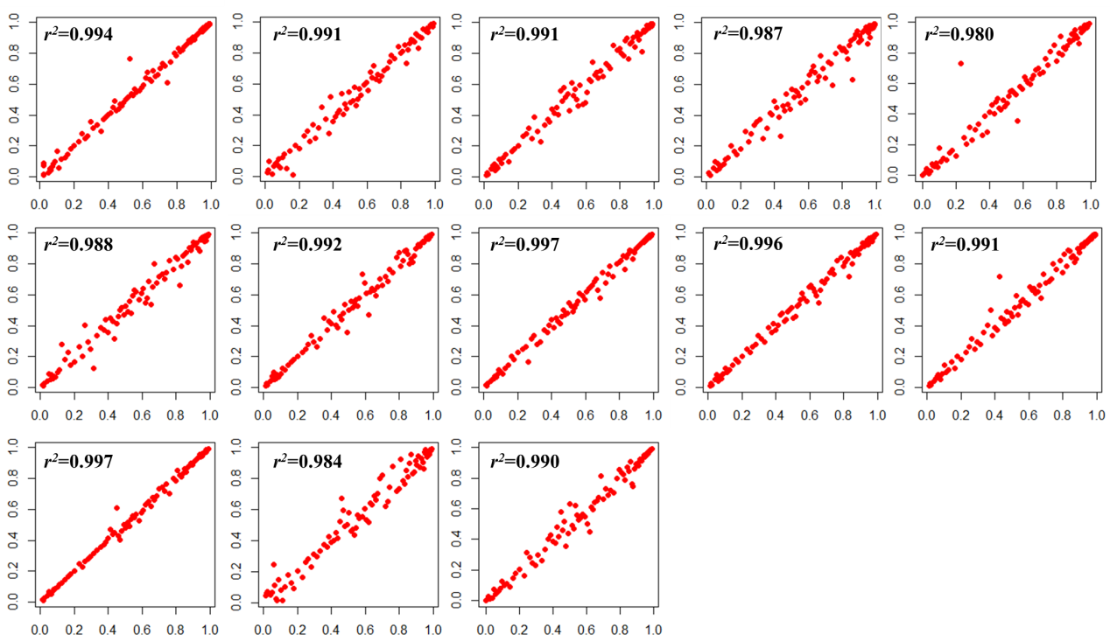

**Figure S2.**

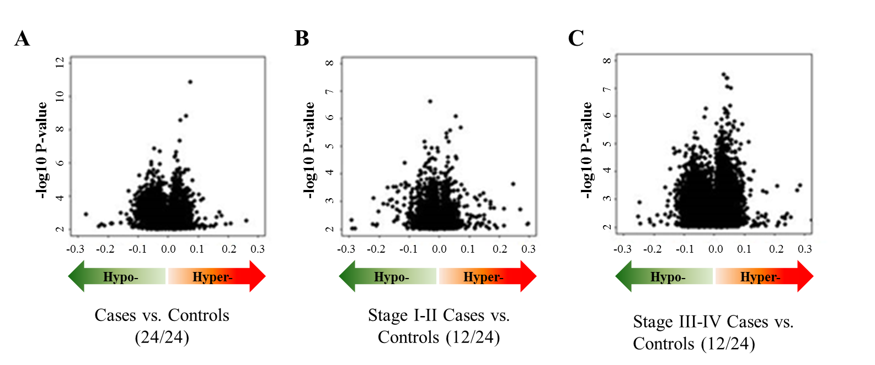

**Figure S3.**

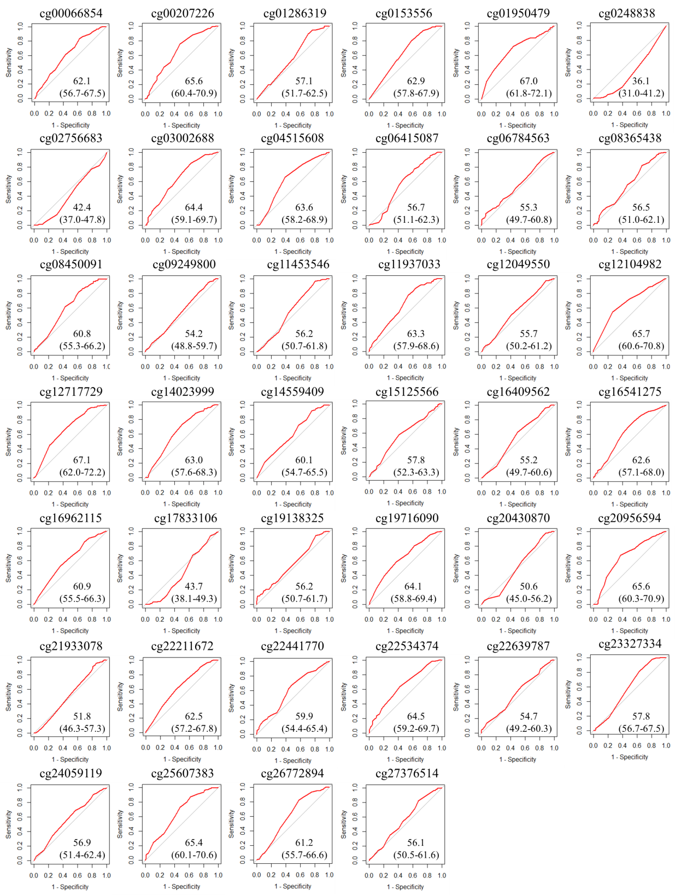

**Figure S4.**

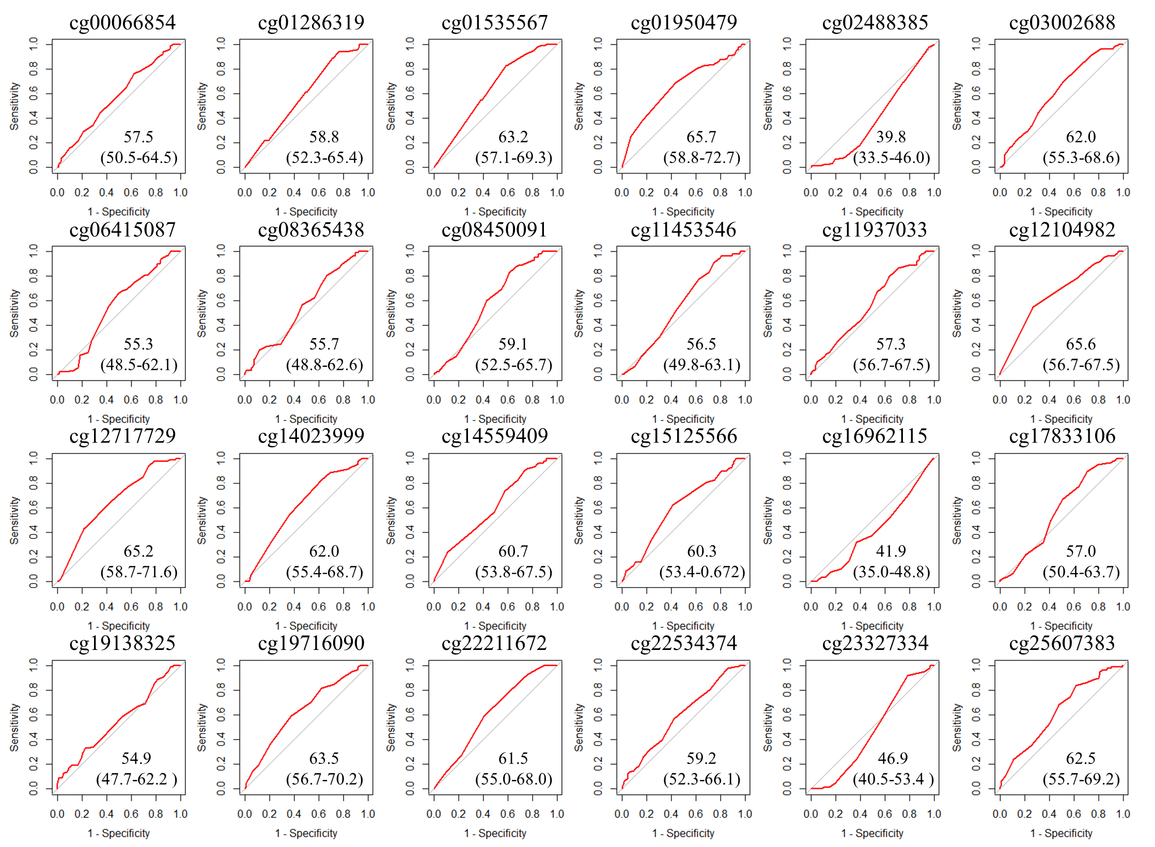

**Figure S5.**

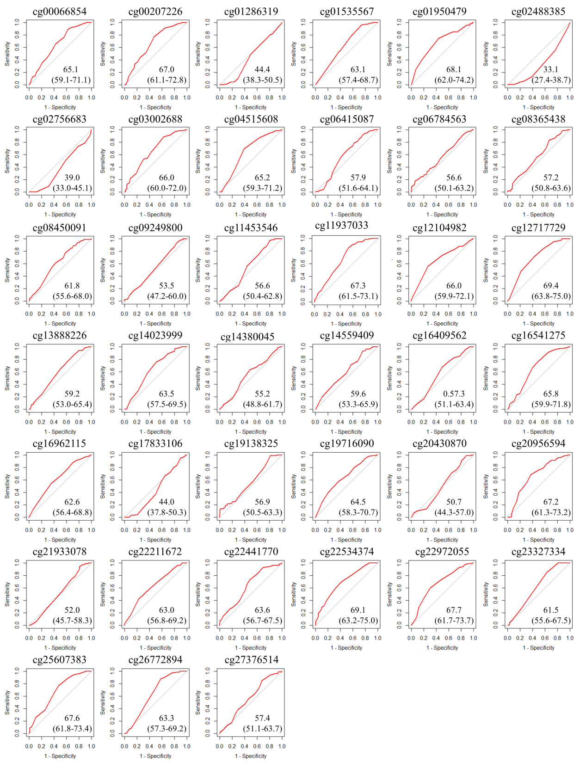

**Figure S6.**

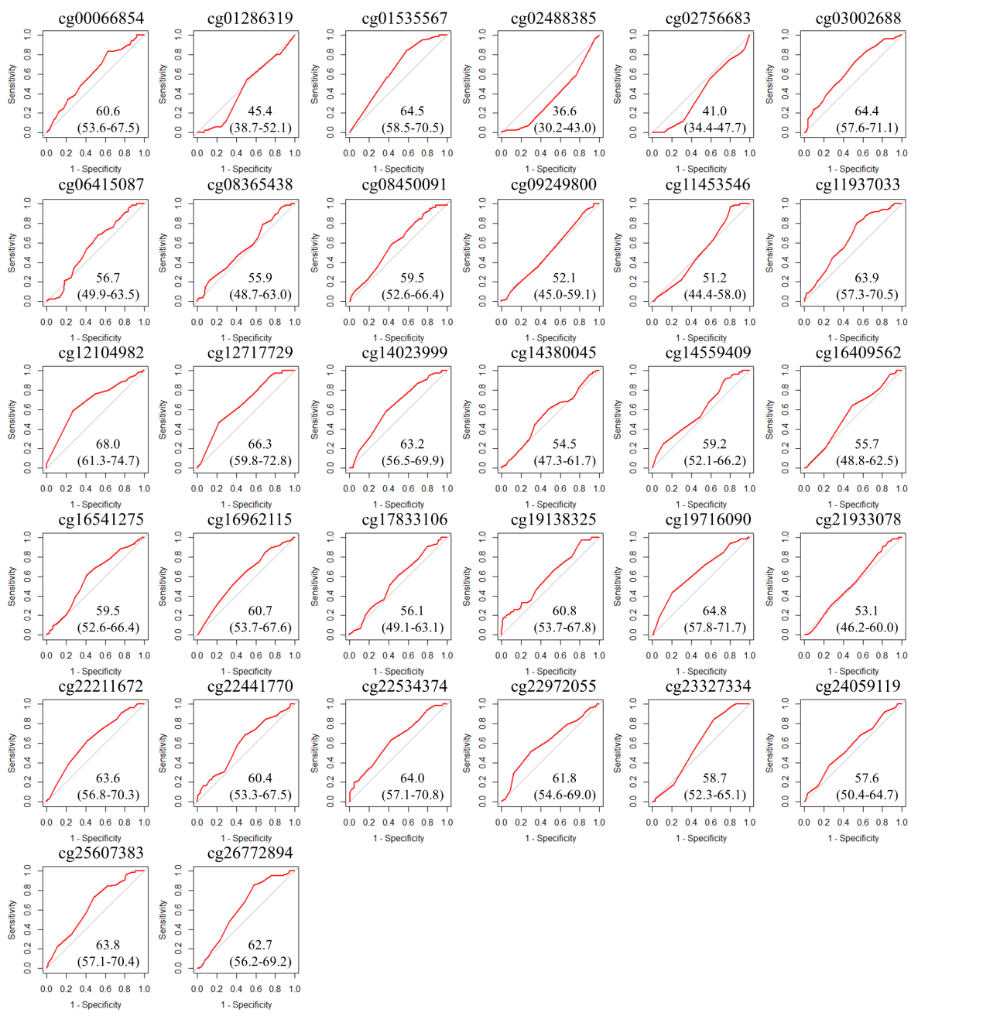

**Figure S7.**

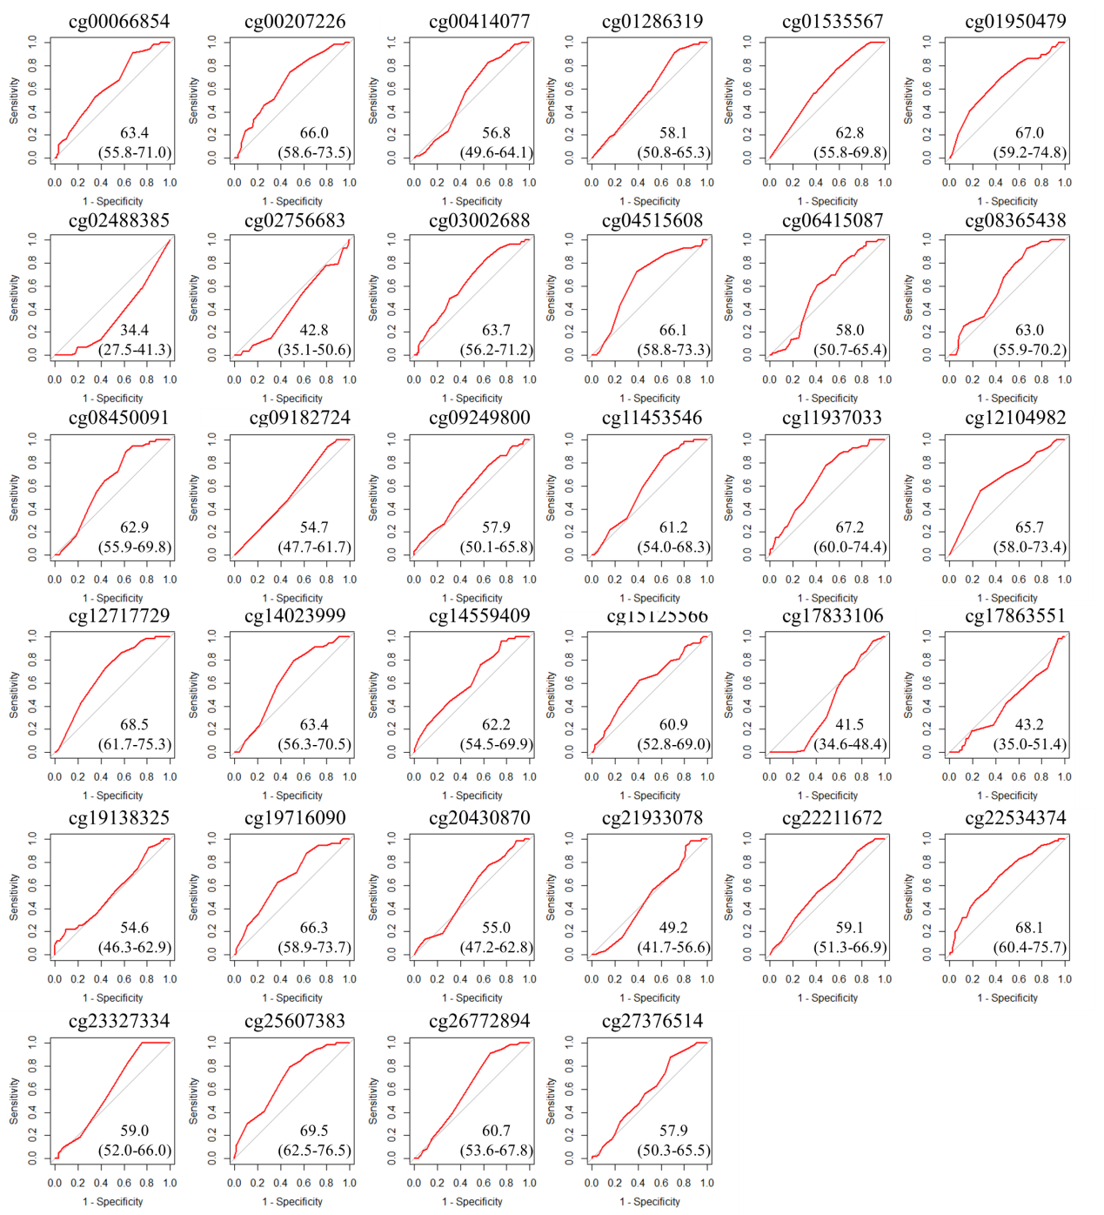

**Figure S8.**

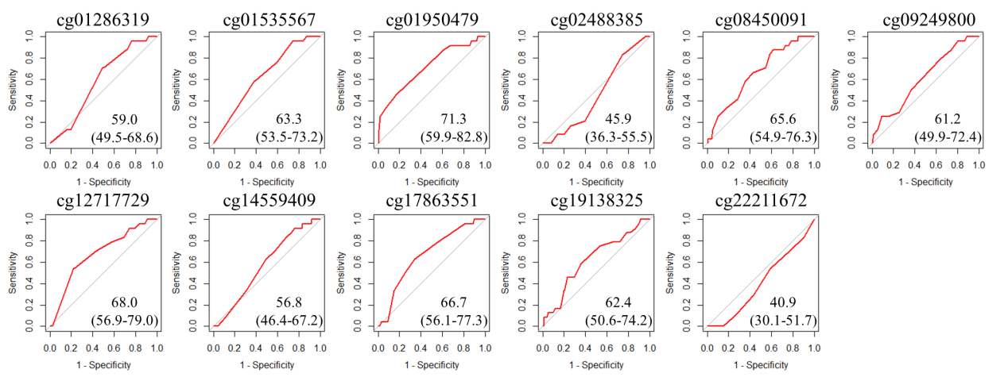

**Figure S9.**

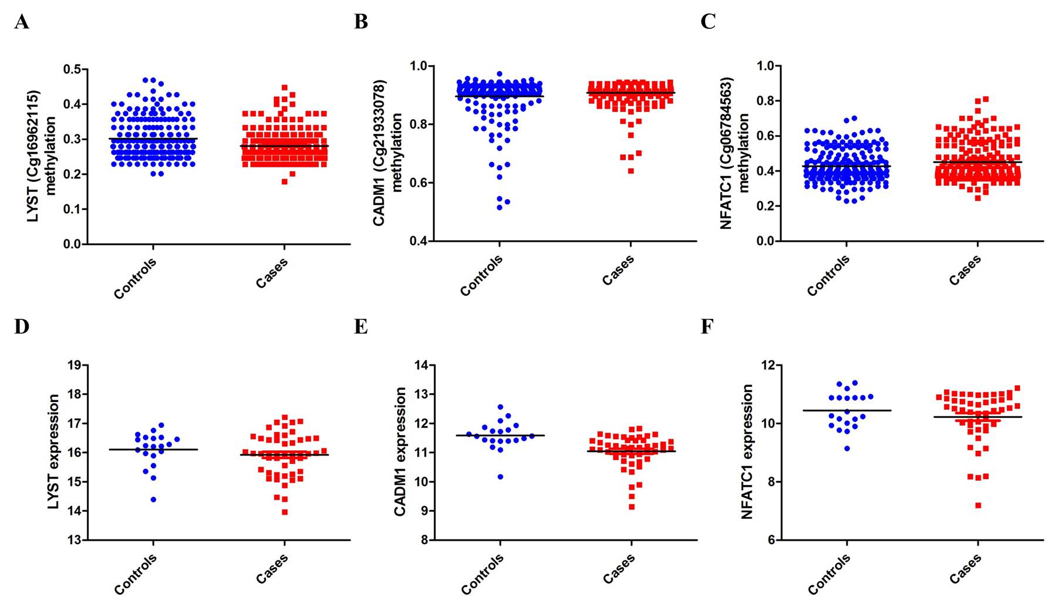

**Figure S10.**

