The variant call format provides efficient and robust storage of GWAS summary statistics

Matthew Lyon (0000-0002-2500-1013)^{1,2}*, Shea J Andrews (0000-0002-1921-9470)³*, Ben Elsworth (0000-0001-7328-4233)², Tom R Gaunt (0000-0003-0924-3247)^{1,2}, Gibran Hemani (0000-0003-0920-1055)²¥, Edoardo Marcora (0000-0002-3829-4927)³¥

- National Institute for Health Research Bristol Biomedical Research Centre, University of Bristol, Bristol, UK
- Medical Research Council (MRC) Integrative Epidemiology Unit (IEU), Bristol Medical School (Population Health Sciences), University of Bristol, Bristol, UK
- Ronald M. Loeb Center for Alzheimer’s disease, Department of Neuroscience, Icahn School of Medicine at Mount Sinai, New York, NY, USA

* These authors contributed equally to this work
¥ These authors contributed equally to this work
Genome-wide association study (GWAS) summary statistics are a fundamental resource for a variety of research applications ^{1–6}. Yet despite their widespread utility, no common storage format has been widely adopted, hindering tool development and data sharing, analysis and integration. Existing tabular formats ^{7,8} often ambiguously or incompletely store information about genetic variants and their associations, and also lack essential metadata increasing the possibility of errors in data interpretation and post-GWAS analyses. Additionally, data in these formats are typically not indexed, requiring the whole file to be read which is computationally inefficient. To address these issues, we propose an adaptation of the variant call format ⁹ (GWAS-VCF) and have produced a suite of open-source tools for using this format in downstream analyses. Simulation studies determine GWAS-VCF is 9-46x faster than tabular alternatives when extracting variant(s) by genomic position. Our results demonstrate the GWAS-VCF provides a robust and performant solution for sharing, analysis and integration of GWAS data. We provide open access to over 10,000 complete GWAS summary datasets converted to this format (available from: https://gwas.mrcieu.ac.uk).
Main

The GWAS is a powerful tool for identifying genetic loci associated with any trait, including diseases and clinical biomarkers, as well as non-clinical and molecular phenotypes such as height and gene expression ³ (eQTLs). Sharing of GWAS results as summary statistics (i.e. variant, effect size, standard error, p-value etc.) has enabled a range of important secondary research applications including: causal gene and functional variant prioritisation ¹, causal cell/tissue type nomination ², pathway analysis ³, causal inference (Mendelian randomization; MR) ⁴, risk prediction ³, genetic correlation ⁵ and heritability estimation ⁶. However, the utility of GWAS summary statistics is hampered by the absence of a universally adopted storage format and associated tools.

Historic lack of a common standard has resulted in GWAS analysis tools outputting summary statistics in different tabular formats (e.g. plink ¹⁰, GCTA ¹¹, BOLT-LMM ¹², GEMMA ¹³, Matrix eQTL ¹⁴ and meta-analysis tools e.g. METAL ¹⁵). As a consequence, various processing issues are typically encountered during secondary analysis. First, there is often inconsistency and ambiguity of which allele relates to the effect size estimate (the “effect” allele). Confusion over the effect allele can have disastrous consequences on the interpretation of GWAS findings and the validity of post-GWAS analyses. For example MR studies may provide causal estimates with incorrect effect directionality ¹⁶. Likewise, prediction models based on polygenic risk scores might predict disease wrongly or suffer reduced power if some of the effect directionalities are incorrect. Second, the schema (i.e. which columns/fields are included and how they are named) of these tabular formats varies greatly. Absent fields can limit analyses and although approaches exist to estimate the values of some of these missing columns (e.g. standard error from P value) imprecision is introduced reducing subsequent test power. Varying field names are easily addressed in principle, but the process can be cumbersome and error prone. Third, data are frequently distributed with no or insufficient metadata describing the study, trait(s), and variants (e.g., trait measurement units, variant id/annotation sources, etc.) which can lead to errors, impede integration of results from different studies and hamper reproducibility. Fourth, querying unindexed text files is slow and memory inefficient, making some potential applications computationally infeasible (e.g. systematic hypothesis-free analyses).

Some proposals for a standard tabular format have been made. The EBI-NHGRI GWAS catalog (www.ebi.ac.uk/gwas) developed a tab-separated values (TSV) text format with a minimal set of required (and optional) columns along with standardised headings ⁷. The SMR tool ⁸ introduced a binary format for rapid querying of quantitative trait loci. These approaches are adequate for storing variant level summary statistics but do not enforce allele consistency or support embedding of essential metadata. Learning from these examples and our experiences performing high-throughput analyses across two research centres, we developed a set of requirements for a suitable universal format (Table 1). These features place emphasis on consistency and robustness, capacity for metadata to provide a full audit trail, efficient querying and file storage, ensuring data integrity, interoperability with existing open-source tools and across multiple datasets to support data sharing and integration. We determined that adapting the variant call format (VCF) ⁹ was a convenient and constructive solution to address these issues. We provide evidence demonstrating how the VCF meets our requirements and showcase the capabilities of this medium (Table 1).

The VCF is organised into three components: a flexible file header containing metadata (lines beginning with ‘#’), and a file body containing variant- (one locus per row with one or more alternative alleles/variants) and sample-level information (one sample per column). We adapt this format to include GWAS-specific metadata and utilise the sample column to store variant-trait association data (Figure 1; Supplementary Table 1).

According to the VCF specification, the file header consists of metadata lines containing 1) the specification version number, 2) information about the reference genome assembly and contigs, and 3) information (ID, number, type, description, source and version) about the fields used to describe variants and samples (or variant-trait associations in the case of GWAS-VCF) in the file body. We take advantage of the VCF file header to store additional information about the GWAS including 1) source and date of summary statistics, 2) study IDs (e.g., PMID/DOI of publication describing the study, or accession number and repository of individual-level data), 3) description of the trait(s) studied (e.g., type, association test used, sample size, ancestry and measurement unit) as well as the source and version of trait IDs (e.g., Experimental Factor Ontology ¹⁷, Human Phenotyping Ontology ¹⁸ or Medical Subject Headings ¹⁹ IDs for clinical and other traits, or Ensembl Gene IDs for eQTL datasets).

Unlike VCF where a row can contain information about multiple alternative alleles observed at the same site/locus (and thus may store more than one variant), the GWAS-VCF specification requires that each variant is stored in a separate row of the file body. Each row contains eight mandatory fields: chromosome name (CHROM), base-pair position (POS), unique variant identifier (ID), reference/non-effect allele (REF), alternative/effect allele (ALT), quality (QUAL), filter (FILTER) and variant information (INFO). The ID, QUAL and FILTER fields can contain a null value represented by a dot. Importantly, the ID value (unless null) should not be present in more than one row. The FILTER field may be used to flag poor quality variants for exclusion in downstream analyses. The INFO column is a flexible data store for additional variant-level key-value pairs (fields) and may be used to store for example: population frequency (AF), genomic annotations and variant functional effects. We also use the INFO field to store the dbSNP ²⁰ locus identifier (rsid) for the site at which the variant resides. This is because (despite their common usage as variant identifiers) rsids uniquely identify loci (not variants!) and thus cannot be used in the ID field, as we will discuss further at the end of this manuscript. Following the INFO column is a format field (FORMAT) and one or more sample columns which we use to store variant-trait association data, with values for the fields listed in the FORMAT column for example: effect size (ES), standard error (SE) and -log10 P-value (LP).

This format has a number of advantages over existing solutions. First, the VCF provides consistent and robust approaches to storing genetic variants, annotations and metadata. Furthermore, variable type and number requirements reduce parsing errors and missing data and prevent unexpected program operation. Second, the VCF is well established and supported by existing tools providing a range of functions for querying, annotating, transforming and analysing genetic data. Third, the GWAS-VCF file header stores comprehensive metadata about the GWAS. Fourth, a GWAS-VCF file can store individual or multiple traits (in one or more sample columns) in a single file which is beneficial for the distribution of GWAS datasets where genotypes of each sample/individual have been tested for association with multiple traits (e.g., eQTL datasets).

Simulations of query performance demonstrate compressed GWAS-VCF is substantially quicker than unindexed and uncompressed TSV format for querying by genomic position. On average GWAS-VCF was 16x faster to extract a single variant using chromosome position (mean query duration in GWAS-VCF 0.08 seconds [95% CI 0.08, 0.08]) vs mean query duration in TSV 1.29 seconds [95% CI 1.29, 1.30]) and 9x quicker using the rsid (0.09 seconds [95% CI 0.09, 0.09] vs 0.81 seconds [95% 0.80, 0.82]). Using a 1Mb window of variants GWAS-VCF was 46x quicker (0.11 seconds [95% CI 0.11, 0.11] vs 5.02 seconds [95% CI 4.99, 5.04]). Although querying on association P value was faster using TSV (mean query duration in TSV 7.18 seconds [95% CI 7.09, 7.26] vs mean query duration in GWAS-VCF 18.04 seconds [95% CI 17.92, 18.16]) GWAS-VCF could be improved by using variant flags (i.e. in the INFO field) to highlight records below prespecified thresholds if the exact value is unimportant. For example, all variants below genome-wide significance (P < 5e-8) or a more relaxed threshold (e.g. P < 5e-5).

To automate the conversion of existing summary statistics files to the GWAS-VCF format, we developed open-source Python3 software (Gwas2VCF; Table 2). The application reads in metadata and variant-trait association data using a user-defined schema. During processing, variants are harmonised using a supplied reference genome file to ensure the non-effect allele matches the reference sequence enabling consistent directionality of allelic effects across studies. Insertion-deletion variants are left-aligned and trimmed for consistent representation using the vgraph library ²¹. Finally, the GWAS-VCF is indexed using tabix ²² and rsidx ²³ which enable rapid queries by genomic position and rsid , respectively. We have developed a freely available web application providing a user-friendly interface for this implementation and encourage other centres to deploy their own instance (Table 2).

Once stored in a GWAS-VCF file, summary statistics can be read and queried using R or Python programming languages with our open-source libraries (Table 2) or from the command line using for example: bcftools ²⁴, GATK ²⁵ or bedtools ²⁶. Alternatively, GWAS-VCF may be converted to NHGRI-EBI format ²⁷ or any other tabular format to support incompatible tools. Further, the gwasglue R package provides convenient programming functions to automate preparation of genetic association data for a range of downstream analyses (Table 2). Currently, methods exist for streamlining variant fine-mapping ^{28–32}, colocalization ³³, MR ³⁴ and data visualisation ³⁵. New methods are being actively added and users may request new features via the repository issues page.

To encourage adoption, we made openly available over 10,000 complete GWAS summary statistics in GWAS-VCF format as part of the IEU GWAS database. These studies include a broad range of traits, diseases and molecular phenotypes building on the initial collection for the MR Base platform ³⁴.

A limitation of current summary statistics formats, including GWAS-VCF, is the lack of a widely adopted and stable representation of sequence variants that can be used as universal unique identifier for said variants. Published summary statistics often use rsids ²⁰ to identify variants but this practice is inappropriate because rsids are locus identifiers and do not distinguish between multiple alternative alleles observed at the same site. Moreover, rsids are not stable as they can be merged and retired over time. The reason this is a problem is that in GWAS summary statistics every record represents the effect of a specific allele on one or more traits, and if a record identifier is used that is not unique for each allelic substitution it cannot technically be considered an identifier. An alternative approach is to concatenate chromosome, base-position, reference and alternative allele field values into a single string, but this is non-standardised, and genome build specific. Worst still is the common approach of mixing these types of identifiers within a single file. In version 1.1 of the GWAS-VCF specification we suggest querying variants by chromosome and base-position and filtering the output to retain the target substitution (implemented in our parsers), but we acknowledge that this approach can be cumbersome and difficult to interoperate with other software. The ideal solution would be to populate the ID column of a GWAS-VCF file using universally accepted and unique variant identifiers. We have reviewed several existing variant identifier formats as candidates for the variant identifier field, to be implemented in the next version of the specification (Supplementary Table 2). However, we refrain from making a unilateral choice at this juncture because successful implementation will require consultation from a range of stakeholders. The genetics community uses different approaches already to deal with the problem of sequence variant representation and there is a need to coalesce upon a single format.

Here we present an adaptation of the VCF specification for GWAS summary statistics storage that is amenable to high-throughput analyses and robust data sharing and integration. We implement open-source tools to convert existing summary statistics formats to GWAS-VCF, and libraries for reading or querying this format and integrating with existing analysis tools. Finally, we provide complete GWAS summary statistics for over 10,000 traits in GWAS-VCF. These resources enable convenient and efficient secondary analyses of GWAS summary statistics and support future tool development.

Code availability

Open-source query performance evaluation source code available from GitHub (https://github.com/MRCIEU/gwas-vcf-performance) or pre-built image available from DockerHub (mrcieu/gwas-vcf-performance)

Data availability

Version 1.1 of the GWAS -VCF format specification is available from: https://github.com/MRCIEU/gwas-vcf-spec/releases/tag/1.1

Full summary statistics for over 10,000 GWAS in VCF format are available from the IEU GWAS Database (https://gwas.mrcieu.ac.uk)

Method

Specification

The specification was developed through experience of collecting and harmonising GWAS summary data across two research centres at scale ³⁴ and performing a range of representative high throughput analyses on these data (for example LD score regression ³⁶, MR ³⁷, genetic colocalisation analysis ³⁸ and polygenic risk scores ³⁹).

Query performance simulation

Densely imputed summary statistics (13,791,467 variants) for a large GWAS of body mass index data were obtained from Neale et al ⁴⁰. The data were mapped to VCF using Gwas2VCF v1.1.1 and processed using bcftools v1.10 ²⁴ to remove multiallelic variants or records with missing dbSNP ²⁰ identifiers. A tabular (unindexed) file was prepared from the VCF to replicate a typical storage medium currently used for distributing summary statistics. Query runtime performance was compared between tabix v1.10.2 ²² and standard UNIX commands under the following conditions: single variant selection using dbSNP identifier ²⁰ or chromosome position, multi-variant selection by association P value (thresholds: P < 5e-8, 0.2, 0.4, 0.6, 0.8) or 1 Mb genomic interval. Tests were undertaken with 100 repetitions using VCF or unindexed text formats with and without GZIP compression on an Ubuntu v18.04 server with Intel Xeon(R) 2.0 Ghz processor. All comparisons were performed using singled thread operations and therefore differences in runtime performance were due to tool and/or file index usage.

References

1. Hou, L. & Zhao, H. A review of post-GWAS prioritization approaches. Front. Genet. 4, 280 (2013).
2. Finucane, H. K. et al. Partitioning heritability by functional annotation using genome-wide association summary statistics. Nat. Genet. 47, 1228–1235 (2015).
3. Visscher, P. M. et al. 10 Years of GWAS Discovery: Biology, Function, and Translation. American Journal of Human Genetics 101, 5–22 (2017).
4. Smith, G. D. & Ebrahim, S. ‘Mendelian randomization’: Can genetic epidemiology contribute to understanding environmental determinants of disease? International Journal of Epidemiology (2003). doi:10.1093/ije/dyg070
5. Bulik-Sullivan, B. et al. LD score regression distinguishes confounding from polygenicity in genome-wide association studies. Nat. Genet. (2015). doi:10.1038/ng.3211
6. Yang, J., Zeng, J., Goddard, M. E., Wray, N. R. & Visscher, P. M. Concepts, estimation and interpretation of SNP-based heritability. Nature Genetics 49, 1304–1310 (2017).
7. Buniello, A. et al. The NHGRI-EBI GWAS Catalog of published genome-wide association studies, targeted arrays and summary statistics 2019. Nucleic Acids Res. 47, D1005–D1012 (2019).
8. Zhu, Z. et al. Integration of summary data from GWAS and eQTL studies predicts complex trait gene targets. Nat. Genet. 48, 481–487 (2016).
9. Danecek, P. et al. The variant call format and VCFtools. Bioinformatics 27, 2156–2158 (2011).
10. Purcell, S. et al. PLINK: A tool set for whole-genome association and population-based linkage analyses. Am. J. Hum. Genet. (2007). doi:10.1086/519795
11. Yang, J., Lee, S. H., Goddard, M. E. & Visscher, P. M. GCTA: A tool for genome-wide complex trait analysis. Am. J. Hum. Genet. 88, 76–82 (2011).
12. Loh, P. R. et al. Efficient Bayesian mixed-model analysis increases association power in large cohorts. Nat. Genet. 47, 284–290 (2015).
13. Zhou, X. & Stephens, M. Genome-wide efficient mixed-model analysis for association studies. Nat. Genet. 44, 821–824 (2012).
14. Shabalin, A. A. Gene expression Matrix eQTL: ultra fast eQTL analysis via large matrix operations. 28, 1353–1358 (2012).
15. Willer, C. J., Li, Y. & Abecasis, G. R. METAL: fast and efficient meta-analysis of genomewide association scans. Bioinforma. Appl. NOTE 26, 2190–2191 (2010).
16. Hartwig, F. P., Davies, N. M., Hemani, G. & Smith, G. D. Two-sample Mendelian randomization: avoiding the downsides of a powerful, widely applicable but potentially fallible technique. Int. J. Epidemiol. 1717–1726 (2016). doi:10.1093/ije/dyx028
17. Malone, J. et al. Databases and ontologies Modeling sample variables with an Experimental Factor Ontology. 26, 1112–1118 (2010).
18. Köhler, S. et al. Expansion of the Human Phenotype Ontology (HPO) knowledge base and resources. Nucleic Acids Res. 47, D1018–D1027 (2019).
19. Medical Subject Headings - Home Page. Available at: https://www.nlm.nih.gov/mesh/meshhome.html. (Accessed: 16th April 2020)
20. Sherry, S. T. et al. dbSNP: the NCBI database of genetic variation. Nucleic Acids Research 29, (2001).
21. bioinformed/vgraph: vgraph is a command line application and Python library to compare genetic variants using variant graphs. ``vgraph`` utilizes a graph representation of genomic variants in to precisely compare complex variants that are refractory to comparison by conventional comparison methods. Available at: https://github.com/bioinformed/vgraph. (Accessed: 5th May 2020)
22. Li, H. Tabix: fast retrieval of sequence features from generic TAB-delimited files. Bioinforma. Appl. NOTE 27, 718–719 (2011).
23. bioforensics/rsidx: Library for indexing VCF files for random access searches by rsID. Available at: https://github.com/bioforensics/rsidx. (Accessed: 5th March 2020)
24. Li, H. A statistical framework for SNP calling, mutation discovery, association mapping and population genetical parameter estimation from sequencing data. Bioinformatics 27, 2987–93 (2011).
25. McKenna, A. et al. The genome analysis toolkit: A MapReduce framework for analyzing next-generation DNA sequencing data. Genome Res. (2010). doi:10.1101/gr.107524.110
26. Quinlan, A. R. & Hall, I. M. BEDTools: a flexible suite of utilities for comparing genomic features. Bioinforma. Appl. NOTE 26, 841–842 (2010).
27. MacArthur, J. et al. The new NHGRI-EBI Catalog of published genome-wide association studies (GWAS Catalog). Nucleic Acids Res. 45, D896–D901 (2017).
28. Benner, C. et al. Genetics and population analysis FINEMAP: efficient variable selection using summary data from genome-wide association studies. doi:10.1093/bioinformatics/btw018
29. Kichaev, G. et al. Integrating Functional Data to Prioritize Causal Variants in Statistical Fine-Mapping Studies. PLoS Genet. 10, e1004722 (2014).
30. Kichaev, G. & Pasaniuc, B. Leveraging Functional-Annotation Data in Trans-ethnic Fine-Mapping Studies. Am. J. Hum. Genet. 97, 260–271 (2015).
31. Kichaev, G. et al. Improved methods for multi-trait fine mapping of pleiotropic risk loci. Bioinformatics 33, 248–255 (2017).
32. Hormozdiari, F., Kostem, E., Kang, E. Y., Pasaniuc, B. & Eskin, E. Identifying causal variants at loci with multiple signals of association. Genetics 198, 497–508 (2014).
33. Wallace, C. Statistical Testing of Shared Genetic Control for Potentially Related Traits. Genet. Epidemiol. 37, 802–813 (2013).
34. Hemani, G. et al. The MR-base platform supports systematic causal inference across the human phenome. Elife 7, (2018).
35. jrs95/gassocplot: Regional association plotter for genetic and epigenetic data. Available at: https://github.com/jrs95/gassocplot. (Accessed: 21st April 2020)
36. Zheng, J. et al. Databases and ontologies LD Hub: a centralized database and web interface to perform LD score regression that maximizes the potential of summary level GWAS data for SNP heritability and genetic correlation analysis. Bioinformatics 33, 272–279 (2017).
37. Hemani, G. et al. Automating Mendelian randomization through machine learning to construct a putative causal map of the human phenome. bioRxiv 173682. (2017). doi:10.1101/173682
38. Richardson, T. G., Hemani, G., Gaunt, T. R., Relton, C. L. & Davey Smith, G. A transcriptome-wide Mendelian randomization study to uncover tissue-dependent regulatory mechanisms across the human phenome. Nat. Commun. 11, 1–11 (2020).
39. Richardson, T. G., Harrison, S., Hemani, G. & Smith, G. D. An atlas of polygenic risk score associations to highlight putative causal relationships across the human phenome. Elife 8, (2019).
40. UK Biobank — Neale lab. Available at: http://www.nealelab.is/uk-biobank/. (Accessed: 25th February 2020)
41. Li, H. et al. The Sequence Alignment/Map format and SAMtools. Bioinforma. Appl. NOTE 25, 2078–2079 (2009).
42. Obenchain, V. et al. Sequence analysis VariantAnnotation: a Bioconductor package for exploration and annotation of genetic variants. 30, 2076–2078 (2014).
43. Gentleman, R. C. et al. Open Access Bioconductor: open software development for computational biology and bioinformatics. Genome Biology 5, (2004).
44. Huber, W. et al. Orchestrating high-throughput genomic analysis with Bioconductor. Nat. Methods 12, 115–121 (2015).
45. Bioconductor - Home. Available at: https://www.bioconductor.org/. (Accessed: 27th March 2020)
46. pysam-developers/pysam: Pysam is a Python module for reading and manipulating SAM/BAM/VCF/BCF files. It’s a lightweight wrapper of the htslib C-API, the same one that powers samtools, bcftools, and tabix. Available at: https://github.com/pysam-developers/pysam. (Accessed: 10th March 2020)
47. IEU GWAS database. Available at: https://gwas.mrcieu.ac.uk/. (Accessed: 10th March 2020)
48. broadinstitute/picard: A set of command line tools (in Java) for manipulating high-throughput sequencing (HTS) data and formats such as SAM/BAM/CRAM and VCF. Available at: https://github.com/broadinstitute/picard. (Accessed: 25th February 2020)
49. GenomicsDB/GenomicsDB: Highly performant data storage in C++ for importing, querying and transforming variant data with Java/Spark. Used in gatk4. Available at: https://github.com/GenomicsDB/GenomicsDB. (Accessed: 25th February 2020)
50. Voss, K., Gentry, J. & Auwera, G. Van Der. GATK4 + WDL + Cromwell. F1000Research 6, 4 (2017).
51. Morales, J. et al. A standardized framework for representation of ancestry data in genomics studies, with application to the NHGRI-EBI GWAS Catalog. Genome Biol. 19, 21 (2018).
52. den Dunnen, J. T. et al. HGVS Recommendations for the Description of Sequence Variants: 2016 Update. Hum. Mutat. 37, 564–569 (2016).
53. Holmes, J. B., Moyer, E., Phan, L., Maglott, D. & Kattman, B. SPDI: data model for variants and applications at NCBI. doi:10.1093/bioinformatics/btz856
54. Wagner, A. et al. ga4gh/vr-spec: 1.0 GA4GH Approved. (2019). doi:10.5281/ZENODO.3572974

Acknowledgments

This study was funded by the NIHR Biomedical Research Centre at University Hospitals Bristol National Health Service Foundation Trust and the University of Bristol. The views expressed are those of the author(s) and not necessarily those of the NIHR or the Department of Health and Social Care.

M.L., B.E., T.R.G. work in the Medical Research Council Integrative Epidemiology Unit at the University of Bristol, which is supported by the Medical Research Council and the University of Bristol (MC_UU_00011/4). G.H. is supported by the Wellcome Trust and Royal Society [208806/Z/17/Z].

E.M. and S.J.A. are supported by the JPB foundation and by the National Institute of Health (U01AG052411 and U01AG058635; principal investigator Alison Goate).

Author contributions

All authors contributed the manuscript and storage format specification. G.H. and E.M. designed the research. M.L. and G.H. wrote software packages and performed query performance simulations. B.E. and G.H. prepared the GWAS data.

Competing interest

None.

Correspondence

Matthew Lyon (matt.lyon@bristol.ac.uk)
Population Health Sciences
Bristol Medical School
University of Bristol
Oakfield House
Oakfield Grove
Bristol
BS8 2BN

Table 1. Requirements for a summary statistics storage format and solutions offered by the VCF
Requirement | Solution using the variant call format
Human readable and easy to parse | Easily read with any text viewer. Mature open-source parsing libraries are available (HTSLIB ⁴¹ and HTSJDK ⁴¹) and implemented in most modern programming languages, for example: VariantAnnotation ⁴² R-package is available from Bioconductor ^{43–45} and python package pysam ⁴⁶. Bcftools ²⁴, GATK ²⁵, bedtools ²⁶ and others provides user-friendly functionality from the command line.
Unambiguous interpretation of the data | Data field descriptions, value types and number of values are required and defined in the file header. File validity is enforced during each read/write.
Unambiguous representation of bi-allelic, multi-allelic and insertion-deletion variants | Every variant substitution is represented by reference and alternative allele haplotypes defining the exact base change on the forward strand. The reference allele is required to match genome sequences defined in the file header. The alternative allele is always the effect allele allowing consistency between studies for ease of comparison.
Genomic information can be validated | The file header contains information about reference genome assembly and contigs. Reference alleles must match the sequence in the referenced genome build (in FASTA format). GATK ²⁵ ValidateVariants can be used to verify file format validity and compare reference allele information against the corresponding genome reference sequence.
Flexibility on which GWAS fields are recorded and enforcement of essential fields | All fields are defined in the file header and can be set optional or required as desired. The specification contains essential fields and their reserved names.
Capacity to store metadata about the study and trait(s) | The file header contains information about the source and date of summary statistics, study IDs (e.g., PMID/DOI of publication describing the study, or accession number and repository of individual-level data), description of the trait(s) studied (e.g., type, association test used, and measurement unit) as well as the source and version of trait IDs (e.g., IEU GWAS database ⁴⁷, Experimental Factor Ontology ¹⁷, Human Phenotyping Ontology ¹⁸ or Medical Subject Headings ¹⁹ IDs for clinical and other traits, or Ensembl Gene IDs for eQTL datasets).
Allows multiple traits to be stored together | The SAMPLE column was chosen to store variant-trait association data to allow for storage of multiple traits in a single VCF file, or as individual files if desired.
Rapid querying by variant identifier, genomic position interval or GWAS summary statistics value (range or exact value) | The file is sorted karyotypically and indexed by chromosome position using tabix ²² to enable fast queries by genomic position. Secondary indexing on dbSNP ²⁰ identifier is also provided using rsidx ²³. Refer to performance comparisons of indexed VCF files and standard UNIX tools.
File compression | VCF files may be compressed with block GZIP ²⁴ or converted to a binary call file which is a binary VCF companion format ²⁴.
Readable by existing open-source tools | A large number of tools support VCF files including: GATK ²⁵, Picard ⁴⁸, bcftools ²⁴, bedtools ²⁶, vcftools ⁹ and plink ¹⁰. Bcftools ²⁴ can also provide a tabular extract for use with non-compatible tools.
Amenable to cloud-based streaming and database storage | Genomic intervals may be extracted over a network using a range-request which extracts file segments without transferring the whole file. This enables rapid streaming of queries over the internet. For high-throughput and distributed storage and querying, VCF files can be easily imported into GenomicsDB ⁴⁹.
GWAS, genome-wide association study. dbSNP, database of single-nucleotide polymorphisms. HTSLIB, high-throughput sequencing data library. HTSJDK, high-throughput sequencing data java development kit. GATK, genome-analysis toolkit. dbSNP, single nucleotide polymorphism database. eQTL, expression quantitative trait loci.

Table 2. Open-source tools for working with GWAS-VCF
Program | Purpose | Implementation | Source code link
gwas2vcf | Mapping tabular GWAS summary statistics and NHGRI-EBI format to VCF | Python3 (Docker) | https://github.com/mrcieu/gwas2vcf
gwas2vcfweb http://vcf.mrcieu.ac.uk | Front-end and queue schedular for gwas2vcf | Python3, Cromwell ⁵⁰  (Docker) | https://github.com/mrcieu/gwas2vcfweb
R/gwasvcf | Library for querying and reading GWAS-VCF files | R | https://github.com/mrcieu/gwasvcf
pygwasvcf | Library for querying and reading GWAS-VCF files | Python3 | https://github.com/mrcieu/pygwasvcf
R/gwasglue | Library for processing GWAS summary statistics ready for secondary analysis | R | https://github.com/mrcieu/gwasglue
LD Score Regression ⁵ (patch) | Estimating genetic correlation and heritability | Python | http://github.com/explodecomputer/ldsc
GWAS, genome-wide association study. LD, linkage disequilibrium. VCF, variant call format. NHGRI-EBI, National Human Genome Research Institute and European Bioinformatics Institute.
Figure 1. VCF format adapted to store GWAS summary statistics (GWAS-VCF)
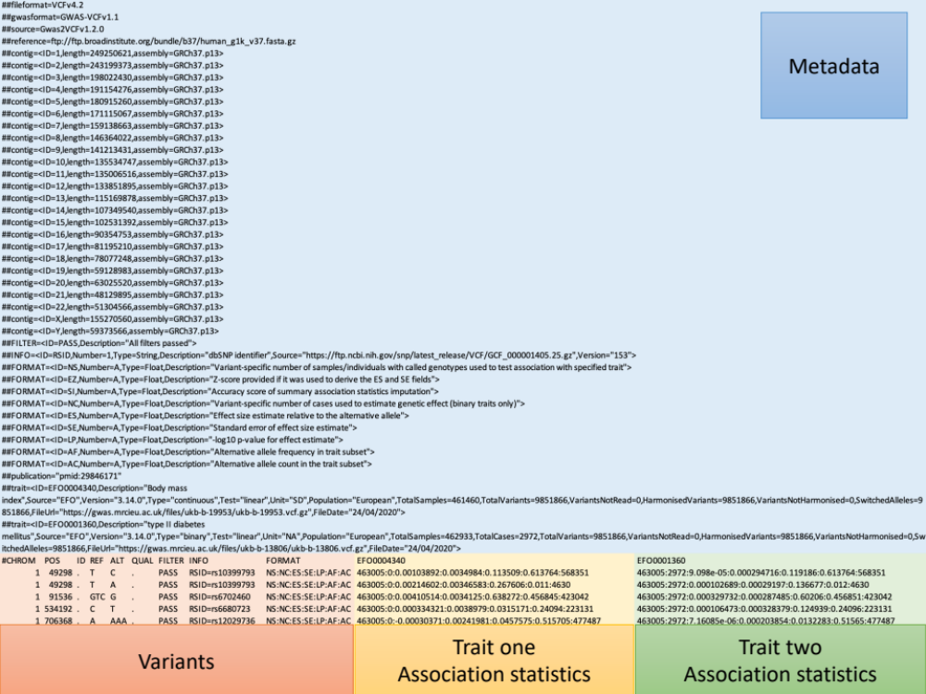
The GWAS-VCF file contains study and trait(s) metadata, variant-level data, and variant-trait association summary statistics. Each field is defined in the file header including variable type and number of values. The format can store the results of a GWAS with one or more traits in a single file.

Figure 2. Performance comparison for querying summary statistics in plain text and GWAS-VCF
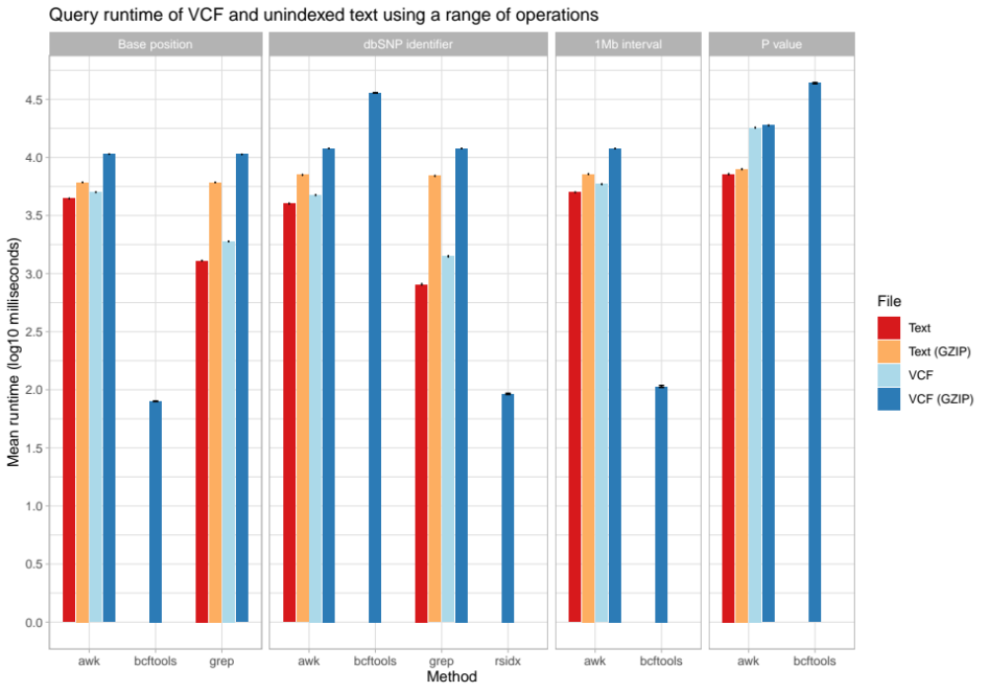
Mean query time (log milliseconds [lower is quicker]; repetitions n=100) to extract either: a single variant using the chromosome position or dbSNP ²⁰ identifier or multiple variants using a 1 Mb interval or association P value. AWK, grep, bcftools ²⁴ and rsidx ²³ were evaluated using uncompressed and GZIP/BGZIP ²⁴ compressed unindexed text and VCF. Error bars represent the 95% confidence interval.

Supplementary Table 1. Data fields in the GWAS-VCF
Field | Description
VCF Header
Publication | Reference to publication describing the study in compact uniform resource identifier (CURIE) format (prefix:reference) e.g. doi:10.1000/xyz123 or pmid:12345678
Trait ID* | Trait identifier e.g. an ontology or metadata repository identifier e.g. EFO0004340 (EFO) or ieu-a-835 (IGD)
Description | Trait description e.g. Body mass index
Source | Source of trait identifier e.g. EFO ¹⁷ or IGD ⁴⁷
Version | Version of trait ID source used to describe trait
Type | Outcome variable type (continuous or binary)
Test | Statistical test for association data e.g. linear regression
Unit | Phenotype units e.g. kg/m2 or SD
Population | Participant ancestry (or mixed ancestry) using the standardised framework ⁵¹
FileUrl | URL of GWAS summary statistics file
FileDate | Date GWAS summary statistics were produced
TotalSamples | Total number of samples/individuals in the study
TotalCases | Total number of cases in the study (if case-control)
TotalVariants | Total number of variants tested in the study
VariantsNotRead | Number of variants that could not be read
VariantsHarmonised | Number of harmonised variants
VariantsNotHarmonised | Number of variants that could not be harmonised
SwitchedAlleles | Number of variants strand switched
VCF FORMAT (per trait variant-level information)
NS | Variant-specific number of samples/individuals with called genotypes used to test association with specified trait
EZ | Z-score provided if it was used to derive the ES and SE fields
SI | Accuracy score of association statistics imputation
NC | Variant-specific number of cases used to estimate genetic effect (binary traits only)
ES* | Effect size estimate relative to the alternative allele
SE* | Standard error of effect size estimate
LP* | -log10 p-value for effect estimate
AF | Alternative allele frequency in trait subset
AC | Alternative allele count in the trait subset
ID, identifier. EFO, Experimental Factor Ontology. IGD, IEU GWAS database. * Required fields.

Supplementary Table 2. Possible variant identifier schemes for the ID column of GWAS-VCF
VCF row identifier (ID column) | Advantages | Disadvantages
dbSNP ²⁰ rsID with multiallelic variants on a single row  Example:  rs376272854 | - No duplication of information already in the row  - Rsidx ²³ provides fast dbSNP ²⁰ ID queries  - Widely used  - Short length  - Compatibility with existing tools (rsid is encouraged by VCF ⁹ v4.2 specification) | - Refers to a position rather than a substitution  - Complexity and ambiguity of manipulating multiallelic rows  - Does not distinguish between multiple alternative alleles and therefore a positional identifier  - Multiple rsids can point to the same position (e.g. new dbSNP ²⁰ entries awaiting merge with existing records)
No value in ID column with multiallelic variants on separate rows | - No duplication of information already in the row  - Avoids the complexities of a variant identifier | - Variant queries include multiple fields (chromosome, position, reference and alternative allele)  - No guarantees of row uniqueness  - Difficult to operate with other software that requires a unique substitution identifier
HGVS ⁵² DNA nomenclature with multiallelic variants on separate rows  Example:  chr2:g.84918761_84918811del | - Unique identifier for every substitution  - Supports one substitution per row in the VCF which is easier to parse  - Short insertion-deletion encoding  - Known format | - Duplicates information already stored in the row  - Not stable between genome builds  - Comparing between builds is difficult  - Not widely used for GWAS
Concatenation of chromosome, position and alleles with multiallelic variants on separate rows  Example:  chr2:84918760:  CCCAACCCTGCTGTCAT  AATGCATAAGCAGCCAC  AGACAGTAAGTGAATGAA:C | - Unique identifier for every substitution  - Supports one substitution per row in the VCF which is easier to parse  - Known format | - Duplicates information already stored in the row  - Comparing between builds is difficult  - Not stable between genome builds  - Long insertion-deletion coding
SPDI ⁵³ (Sequence-id, Position, Deleted Sequence, Insertion Sequence separated by a colon) with multiallelic variants on separate rows  Example:  NC_000002.12: 84918760: CCCAACCCTGCTGTCAT  AATGCATAAGCAGCCAC  AGACAGTAAGTGAATGAA:C | - Unique identifier for every substitution  - Supports one substitution per row in the VCF which is easier to parse  Known format | - Duplicates information already stored in the row  - Comparing between builds is difficult  - Not stable between genome builds  - Long insertion-deletion coding
Concatenation of chromosome, position and alleles using MD5 hash to shorten long alleles with multiallelic variants on separate rows  Example:  chr2:84918760-7c43e7284b58ba06e  7438bff62376edf:C | - Unique (almost) identifier for every substitution  - Supports one substitution per row in the VCF which is easier to parse  - Short insertion-deletion coding | - Duplicates information already stored in the row  - Not stable between genome builds  - Comparing between builds is difficult  - Cannot reverse hash without database  - Not widely used
GA4GH Variation Representation ⁵⁴ (SHA-512 message digest of the chromosome position and alternative allele with multiallelic variants on separate rows  Example:  ga4gh:VA.yOoxi7-uUnJyn4QkQ23h6RJuT4Zqarow | - Unique (almost) identifier for every substitution  - Supports one substitution per row in the VCF which is easier to parse  Short insertion-deletion coding | - Duplicates information already stored in the row  - Not stable between genome builds  - Comparing between builds is difficult  - Cannot reverse hash without database  - Not widely used
GWAS, genome-wide association study. VCF, variant call format. Rsidx, file index using the dbSNP identifier. MD5, message-digest algorithm. HGVS, Human Genome Variation Society. GA4GH, Global Alliance for Genomics and Health. SHA, Secure Hash Algorithm.

