**DL-ICP 5**

In this RNN, we have build the model with the sequential model for the given sentiment dataset.

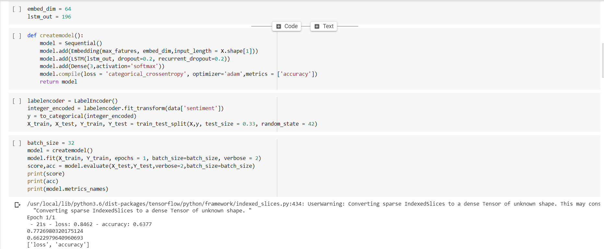

Note the accuracy and loss of the model built.

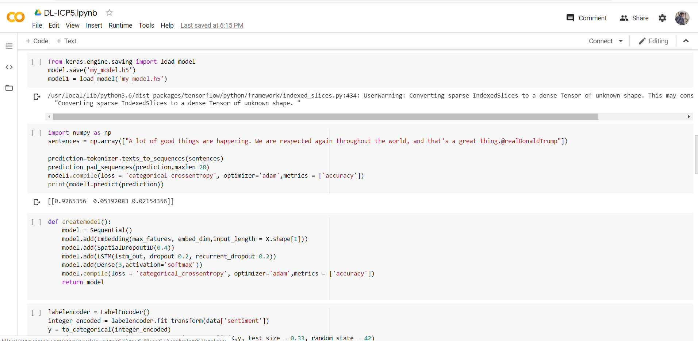

Next save the model and apply the input to the model saved and predict the accuracy and loss

Apply the grid search for hyper parameter tuning to get the best of the output.

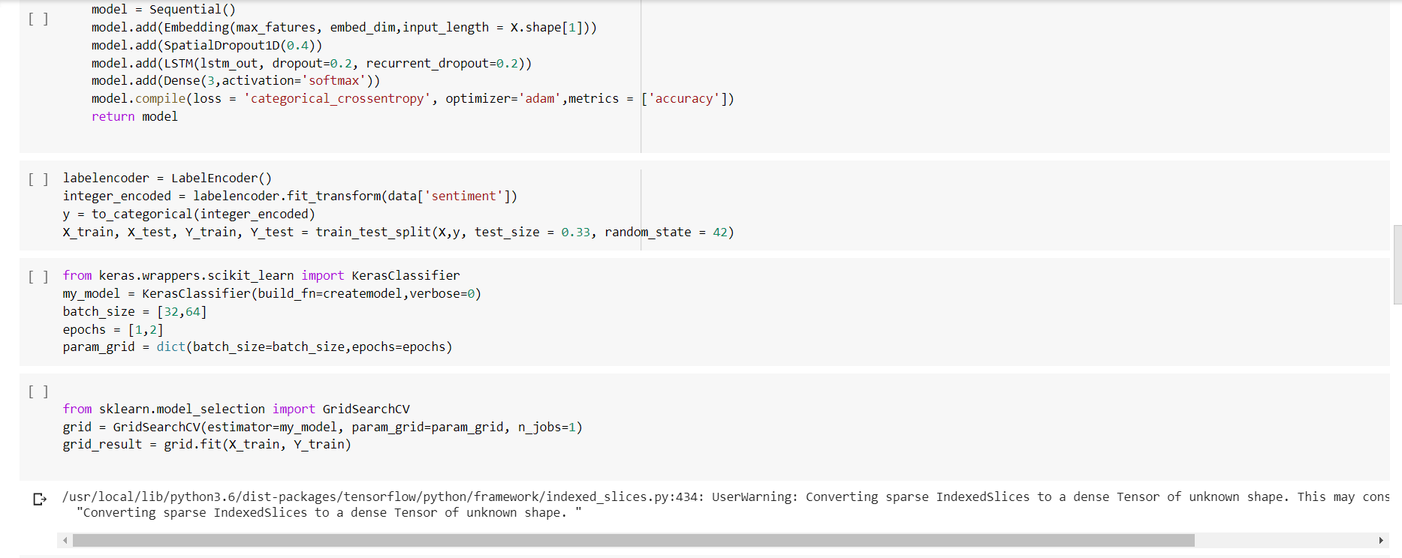

After applying grid search, we will get the best output as follows:

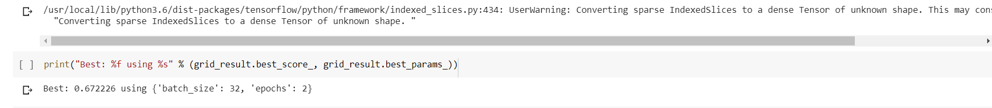

Similarly, apply the same to spam dataset, built the model and save the model to predict the output.

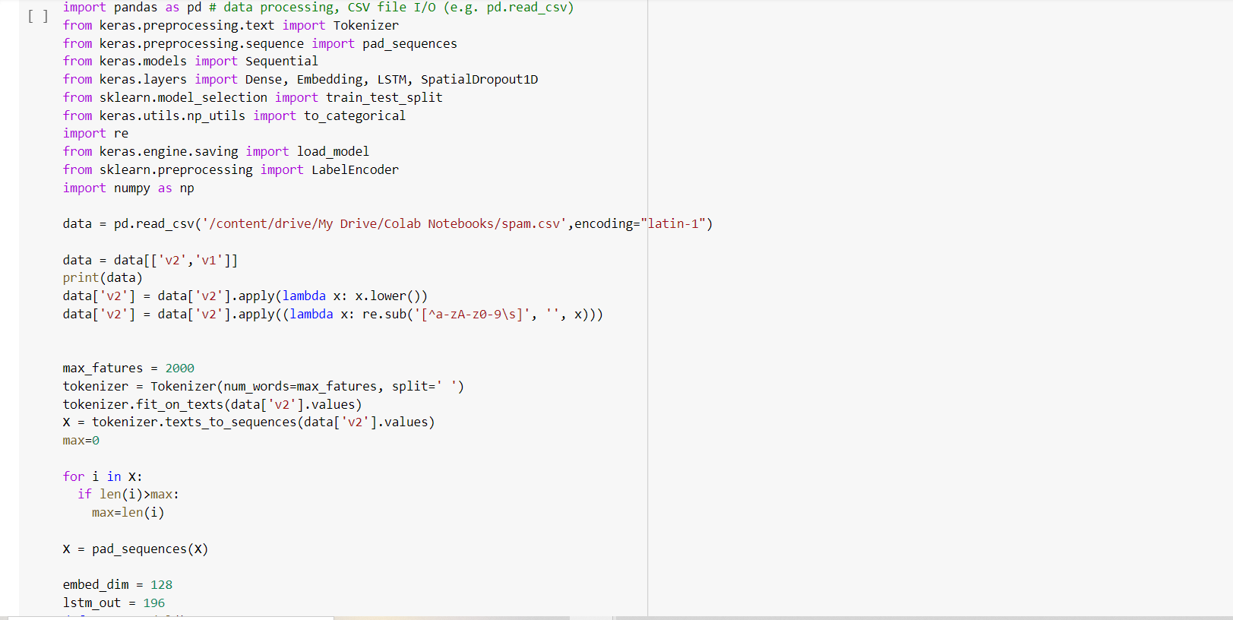

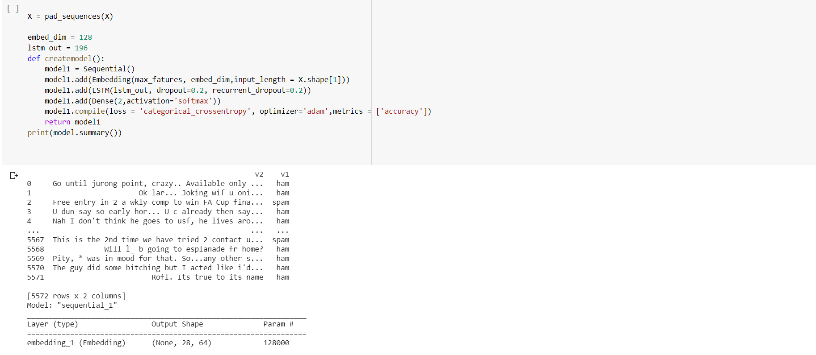

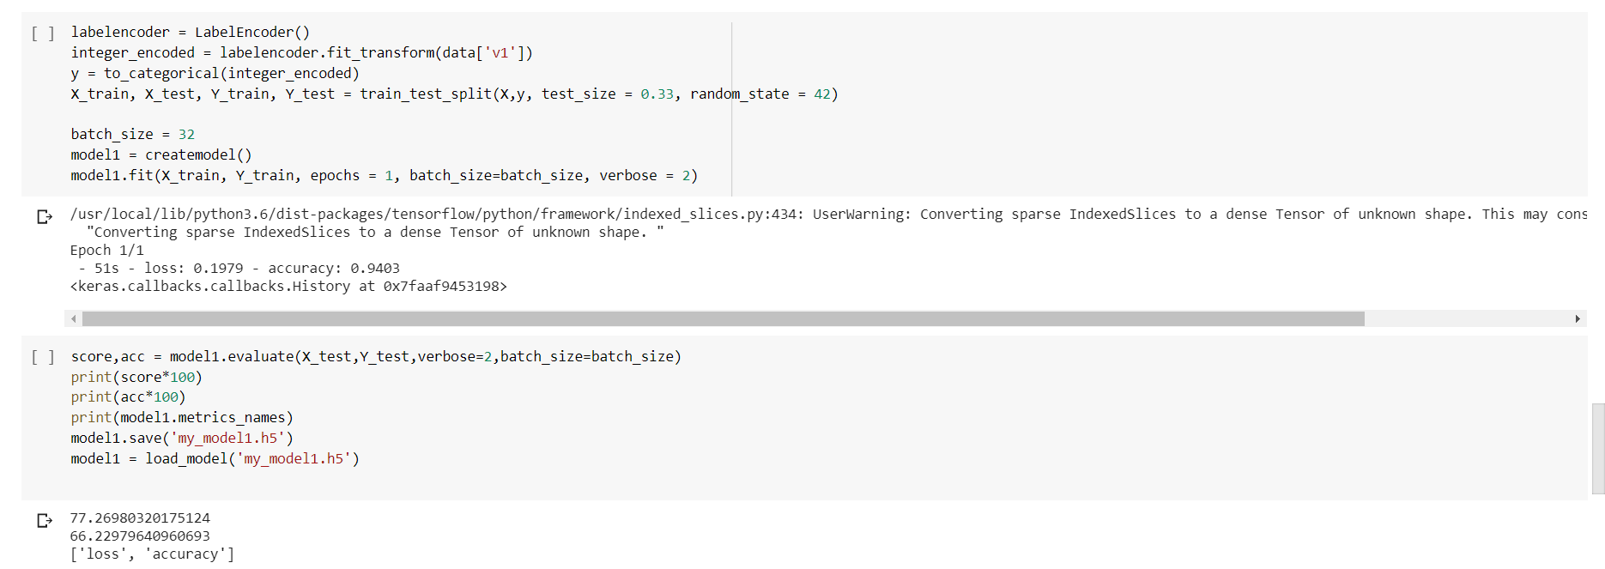

Now we can predict the output as above by using the built model.