# Deep Learning ICP – 6

We need to add the hidden layer to the Auto Encoder and plot the data

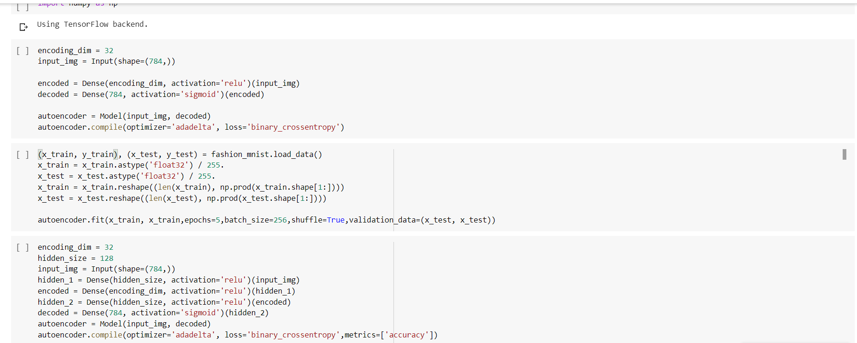

We will get the reconstructed representation of the images of the data.

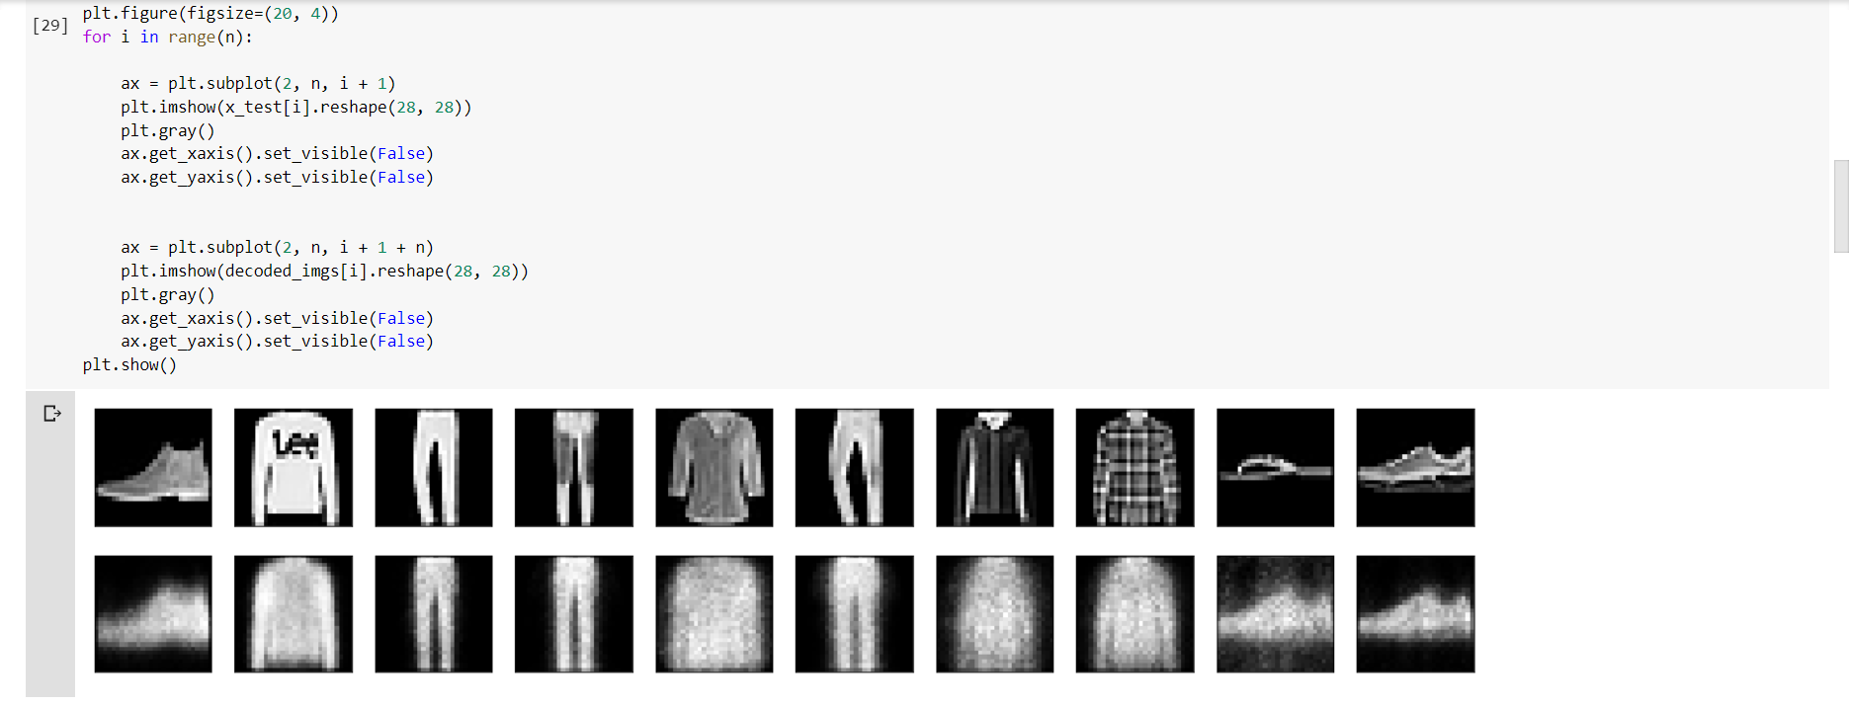

We will add the noise factor to the data and fit the data.

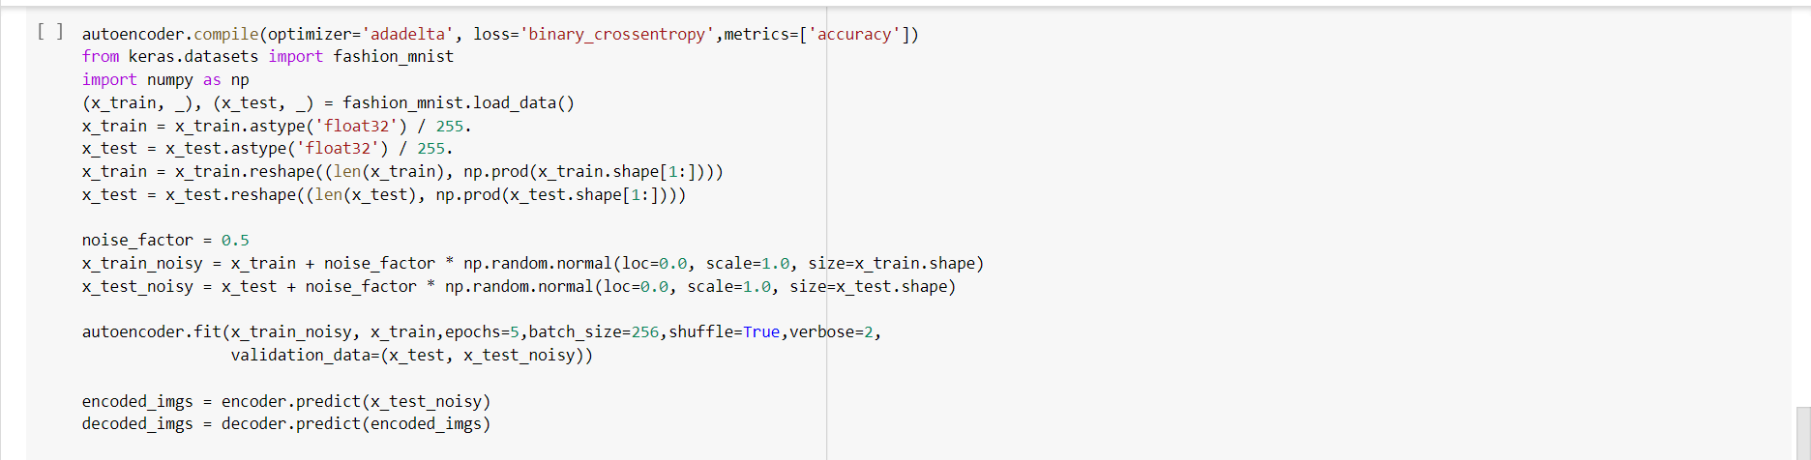

We had plot the original, noise images and the predicted encoded images as follows:

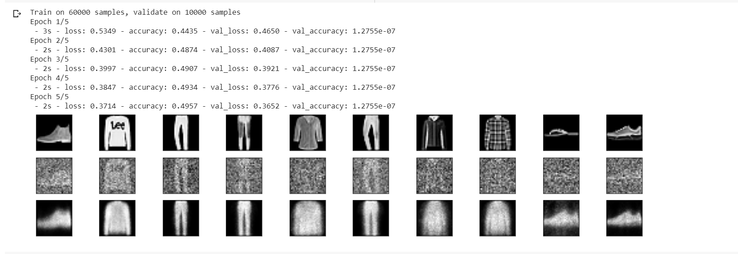

We will plot the history object as follows:

