Supplementary Material
Beyond Independent Shots on Goal: Risk Capacity, Synergy, and Concentration in Pharmaceutical R&D Portfolios
Michael R. Doane, D.Eng.

Supplementary Methods

Exact Matched-Heterogeneity Integration
The matched-heterogeneity analysis used 1,000 Latin hypercube opportunity sets. Each set contained six programs and was held fixed across diversified, pipeline-in-a-pill, and multiple-shots-on-goal topologies. Cumulative pTRS followed a triangular distribution with lower bound 0.075, mode 0.151, and upper bound 0.227. Development-cost multipliers ranged from 0.70 to 1.30, peak-sales multipliers from 0.50 to 1.50, and phase durations varied over prespecified half-year increments.
For every opportunity set, the analysis enumerated all 4^6 realized program-state combinations: Phase 2 failure, Phase 3 failure, regulatory failure, or launch. A 32-node Gauss-Hermite quadrature integrated the common Gaussian factor. Exact integration removed screening noise from the 1,000-cell frontier. Eight cells near decision boundaries were independently evaluated with 250,000 Monte Carlo paths each.

Decision and Validation Rules
A concentrated topology cleared the primary frontier when expected NPV was no worse than diversification within $25 million, fifth-percentile NPV was at least -$1,000 million, and high-capacity breach probability was at most 10%. Synergy was evaluated from 0% to 30% in one-percentage-point increments. Boundary-confirmation criteria were a maximum $25 million half-width for eNPV differences, a maximum 0.25-percentage-point half-width for probabilities, and at least 75% exact-estimate coverage by Monte Carlo intervals.
Launch-service analysis estimated the nominal breadth required for 70%, 80%, and 90% probabilities of achieving at least one, two, or three launches per rolling three-year period. Each portfolio geometry used 250,000 paths. Figure S1 shows the heterogeneous launch-service frontier.

Table S1. Numerical and reproducibility checks
Check | Observed | Criterion | Status
Unit tests | 18 passed | All pass | Pass
E8 exact-to-MC eNPV coverage | 75% | >=75% | Pass
E8 exact-to-MC breach coverage | 75% | >=75% | Pass
Maximum eNPV half-width | $6.90M | <=$25M | Pass
Maximum breach half-width | 0.082 pp | <=0.25 pp | Pass
Flat diversified eNPV reconciliation | $1.11M difference | <=$25M | Pass
Flat PIAP eNPV reconciliation | $0.74M difference | <=$25M | Pass
Flat PIAP breach reconciliation | 0.019 pp difference | <=0.50 pp | Pass
Abbreviations: eNPV, expected net present value; MC, Monte Carlo; PIAP, pipeline in a pill; pp, percentage points.

Table S2. Matched-heterogeneity input distributions
Input | Distribution or range | Mode or central value
Cumulative pTRS | Triangular: 0.075-0.227 | 0.151
Development-cost multiplier | Triangular: 0.70-1.30 | 1.00
Peak-sales multiplier | Triangular: 0.50-1.50 | 1.00
Phase 2 duration | 1.5-3.0 years | 1.5 years
Phase 3 duration | 2.0-4.0 years | 3.0 years
Regulatory duration | 0.5-1.5 years | 1.0 year
PIAP latent rho | Fixed | 0.415
MSOG latent rho | Fixed | 0.250
LOE year | Fixed | 15
Abbreviations: LOE, loss of exclusivity; MSOG, multiple shots on goal; PIAP, pipeline in a pill; pTRS, probability of technical and regulatory success.

Supplementary Figure Legend
Figure S1. Heterogeneous launch-service frontier. Nominal starts and variance-equivalent breadth required to reach 70%, 80%, and 90% service targets under matched opportunity heterogeneity. PIAP, pipeline in a pill; MSOG, multiple shots on goal.
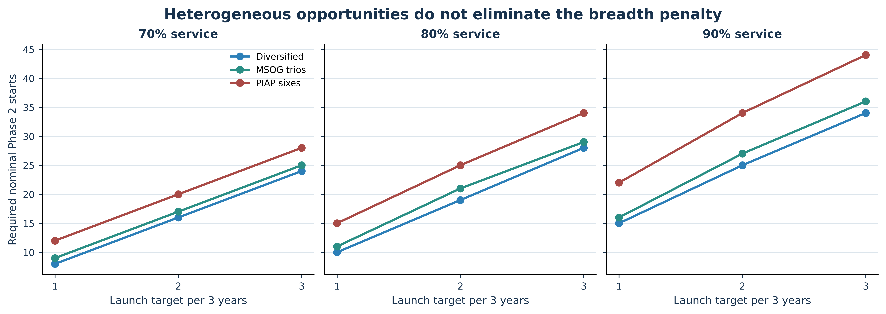

Supplementary Interpretation Guide
- Map topology before assigning dependence: shared asset, target, pathway, indication, platform, execution dependency, and commercial market.
- Keep technical dependence, cost synergy, acceleration, and cannibalization as separate mechanisms.
- State P5, CVaR, capacity-breach, and launch-service limits before evaluating a preferred strategy.
- Report the minimum synergy required and identify the binding decision constraint.
- Revalue the selected strategy under dependence and revenue assumptions that could reverse the decision.

