|  |
| --- |
| Sandia National Laboratories |
| SNL-SWAN Manual |
| Version 1.0 |
|  |
| **Kelley M Ruehl, Chris Chartrand, Aaron Porter** |
|  |

|  |
| --- |
|  |



Table of Contents

Implementation - 3 -

SET obcase=0 - 3 -

SET obcase=1 - 3 -

SET obcase=2 - 4 -

SET obcase=3 - 5 -

SET obcase=4 - 5 -

User Guide - 6 -

Input File - 6 -

SET obcase=0 - 6 -

SET obcase=1 - 6 -

SET obcase=2 - 6 -

SET obcase=3 - 6 -

SET obcase=4 - 6 -

Relative Capture Width Definition - 7 -

Wave Periods - 7 -

Relative Capture Width - 7 -

Power Matrix Definition - 8 -

Normalization Width - 8 -

Wave Heights - 8 -

Wave Periods - 8 -

WEC Power Matrix - 8 -

Example SNL-SWAN Files - 9 -

Example SNL-SWAN INPUT File - 9 -

Example RCW File - 9 -

Example Power Matrix File - 9 -

Best Practices - 10 -

Grid Treatment - 10 -

WEC Power Performance - 11 -

# Implementation

In this section, the implementation of the WEC Module within the SNL-SWAN code will be described in detail. This section explains how the WEC Module was formulated from the SWAN (Version 41.01) code.

SNL-SWAN models WEC devices as obstacles using the five “obcase” flags listed below to determine the appropriate obstacle transmission coefficient. The following section describes the SNL-SWAN treatment of WEC devices under each obstacle case model.

Section 3.10 of the SWAN [Scientific and Technical Documentation](http://swanmodel.sourceforge.net/online_doc/swantech/swantech.html) describes the effect of obstacles through a coefficient in the convection terms of the action density evolution equation. The action density equation is shown below Eq.(1) with the obstacle transmission coefficient boxed in red. The sole difference between the obstacle cases is the method of obtaining this value. The five methods are described below. A visual conceptual comparison is shown at the end of this section.

|  |  |
| --- | --- |
| $$\left(\frac{1}{∆t}+\left(D_{x,1}+D_{x,2}\right)c_{x,i,,j}^{+}+\left(D_{y,1}+D_{y,2}\right)c_{y,i,,j}^{+}\right)N_{i,,j}^{+}-\frac{N_{i,,j}^{-}}{∆t}-{D_{x,1}\left(c_{x}{K_{t,1}}^{2}N\right)}_{i-1,j}^{+}$$ $$-{D_{y,1}\left(c_{y}{K_{t,1}}^{2}N\right)}_{i-1,j}^{+}-{D_{x,2}\left(c_{x}{K_{t,2}}^{2}N\right)}_{i,j-1}^{+}-{D_{y,2}\left(c_{y}{K_{t,2}}^{2}N\right)}_{i,j-1}^{+}=S_{i,j}^{+}$$ | (1) |

## SET obcase=0

This is the standard, TUDelft SWAN, obstacle treatment. The value $K_{t}$ is a constant value entered into the SWAN input file. $K_{t}$ represents the ratio of wave heights incident to and lee of the obstacle (or WEC).

|  |  |
| --- | --- |
| $$K_{t}=\frac{H_{lee}}{H_{incident}}$$ | (2) |

## SET obcase=1

Obstacle case 1 uses the WEC power matrix to calculate the effective transmission coefficient. In this case, $K_{t}^{2}$ is calculated using the provided power matrix, and a constant value for this coefficient is used across all frequencies. $K_{t}^{2}$ represents the energy (or power) ratio incident and lee of the obstacle.

|  |  |
| --- | --- |
| $$K_{t}^{2}=\frac{P_{Lee}}{P_{Incident}}$$ | (3) |

The power matrix is a table of absorbed power (in Kilowatts, kW) by a WEC device over varying significant wave heights and peak wave periods. SNL-SWAN determines the incident significant wave height and the incident peak wave period and then linearly interpolates a value for absorbed power from the matrix. Note: if the incident values for wave height or period lie outside of the power matrix range, a value of zero is returned.

The absorbed power flux (power per unit width) of the obstacle is determined by dividing the interpolated value for absorbed power by the “width” value provided as the first entry in the Power.txt file. Note that the width value here should be thought of as a normalization value, and is only used to convert the power matrix entries of absorbed power (kW) into absorbed flux (kW/m) values. This value is calculated as follows.

|  |  |
| --- | --- |
| $$P_{Flux-Absorbed}=\frac{P_{Absorbed}}{W}$$ | (4) |

This value is then applied evenly across the entire obstacle, as defined in the main INPUT file. In most cases the width value in Power.txt should be the same as the length of the obstacle defined in the INPUT file, but this is not required by the model. *There are no checks in the code to guarantee or enforce this equality*.

SNL-SWAN then calculates the incident power fluxing across the obstacle (in kW/m). The power fluxing over the obstacle is calculated directly from the spectral information incident to the obstacle.

|  |  |
| --- | --- |
| $$P_{Flux-Incident}=ρg\int{\int{E(σ,θ)c_{g}}dσ}dθ$$ | (5) |

To determine the transmission coefficient, SWAN takes the incident power flux and subtracts off absorbed power flux. The transmission coefficient is the ratio of the remaining flux to the incident flux, and $K_{t}^{2}$ is calculated using the following equation:

|  |  |
| --- | --- |
| $$K_{t}^{2}=\frac{P_{Lee}}{P_{Incident}}=\frac{P_{Incident}-P_{Absorbed}}{P_{Incident}}=1-\frac{P_{Absorbed}}{P_{Incident}}=1-\frac{P_{Flux-Absorbed}}{P_{Flux-Incident}}$$ | (6) |

When the action balance equation is solved, the convection term, $N(σ,θ)c_{g}K_{t}^{2}$, will be applied (integrated) across the *computational* width of the obstacle. The computational width (as opposed to the width defined in the power matrix file) is determined by the obstacle dimensions defined in the main SWAN INPUT file and the grid discretization (See the section on Grid Treatment).

## SET obcase=2

Obstacle case 2 uses the WEC relative capture width curve to calculate the effective transmission coefficient. $K_{t}^{2}$ is again calculated using the provided curve, and a constant value is used across all frequencies.

The relative capture width curve is a table of absorbed power *ratios* by a WEC device at varying wave periods. In ways, this implementation is simpler than that or the power matrix. Since the relative capture width curve already provides power ratios, $K_{t}^{2}$ is more straightforward to calculate without the need to determine the incident power flux. For this case, SNL-SWAN linearly interpolates an RCW value from the curve given the peak incident wave period, and directly calculates a transmission coefficient using the following relation. As with obstacle case 1, any wave periods outside of the defined range are given a transmission coefficient of zero.

|  |  |
| --- | --- |
| $$K_{t}^{2}=1-\frac{P_{Absorbed}}{P_{Incident}}=1-RCW$$ | (7) |

## SET obcase=3

SNL-SWAN’s obstacle case 3 is just an extension of case 1. This case behaves exactly the same way as case 1, except that the routine to determine the transmission coefficient is performed separately for each binned frequency of the model. This in effect makes $K_{t}^{2}$ a function of frequency, resulting in varying power absorption for waves of different frequency. Note: while the power matrix is defined in terms of wave period, internal SWAN calculations are all performed using wave frequency. Each computational frequency is converted to a wave period as follows before interpolating from the power matrix.

|  |  |
| --- | --- |
| $$T=\frac{2π}{ω}$$ | (8) |

## SET obcase=4

SNL-SWAN’s obstacle case 4 is an extension of case 2. Again, the only difference is that the RCW curve is sampled independently for each frequency of the simulation, resulting in a frequency dependent obstacle transmission coefficient.

## Obcase cOMPARISON

Differences between SNL-SWAN OBCASE options are visualized in Figure XX. In this figure a conceptual frequency independent RCW curve which would be the case for OBCASE 1 and 2 is shown as the dotted red line in the top panel. The frequency dependent OBCASES 3 and 4 would have a RCW curve that is variable dependent on frequency, as indicated by the blue line in the top panel. The resultant wave spectra in the lee of the obstacle for these cases are shown in the bottom panel, as compared to the incident spectra (black line).

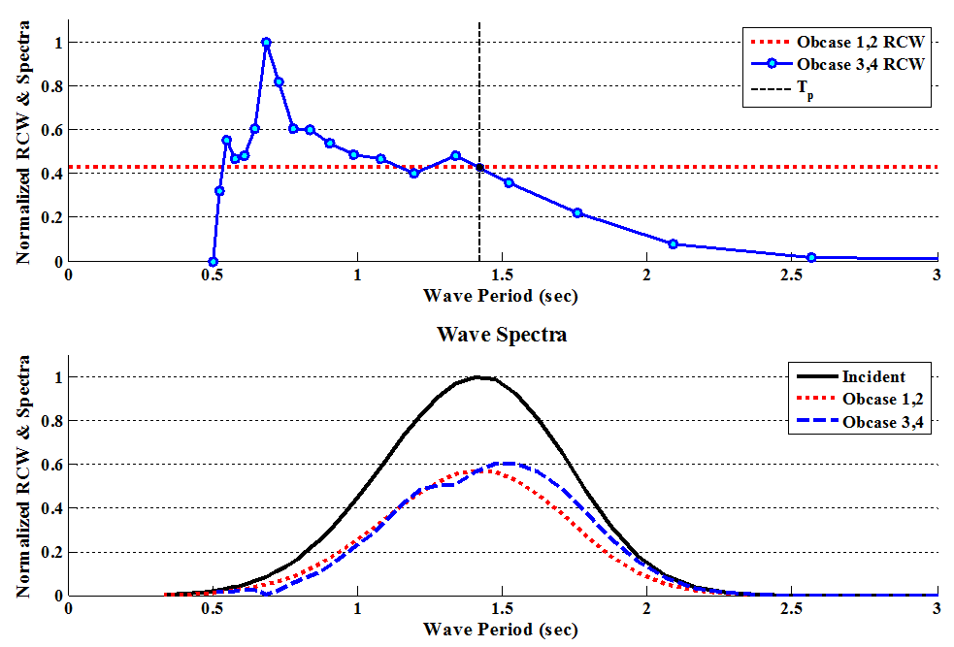

Figure 1 – OBCASE conceptual comparison visualization

# User Guide

In the following sections, descriptions on how to run the SNL-SWAN code are given. For additional information regarding how to set up and run and SWAN model, please refer to the SWAN documentation available online at <http://swanmodel.sourceforge.net/>.

## Input File

This is the SNL-SWAN input file (INPUT), which has the same settings as SWAN, as specified in the SWAN user’s manual, with the addition of the *SET obcase* line that sets which version of SNL-SWAN is run.

### SET obcase=0

Baseline SWAN, uses the SWAN constant transmission obstacle formulation.

### SET obcase=1

SNL-SWAN Power Matrix, uses the WEC power matrix to calculate the effective transmission coefficient, a constant value across all frequencies. This case requires *Power.txt*which is described in the power matrix section below.

### SET obcase=2

SNL-SWAN RCW, uses the WEC power matrix to calculate the effective transmission coefficient, a constant value across all frequencies. This case requires *Relative_Capture_Width.txt*which is described in the relative capture width section below.

### SET obcase=3

SNL-SWAN Power Matrix, uses the WEC power matrix to calculate the transmission coefficient for each frequency bin. Requires *Power.txt*

### SET obcase=4

SNL-SWAN RCW, uses the WEC power matrix to calculate the transmission coefficient for each frequency bin. Requires *Relative_Capture_Width.txt*

## Relative Capture Width Definition

If SNL-SWAN is run with option 2 or 4, the *Relative_Capture_Width.txt* file is required to run. This is the WEC power performance in the form of a relative capture width curve, in two vertical columns containing one the period and the one with Relative Capture Width Curve (RCW) value. This curve can be directly copied from excel into a *.txt file, see Example RCW File section.

|  |  |  |  |  |  |  |  |  |  |  |  |  |  |  |  |  |  |  |  |  |  |  |  |  |  |  |  |  |  |  |  |  |  |
| --- | --- | --- | --- | --- | --- | --- | --- | --- | --- | --- | --- | --- | --- | --- | --- | --- | --- | --- | --- | --- | --- | --- | --- | --- | --- | --- | --- | --- | --- | --- | --- | --- | --- |
| |  |  | | --- | --- | | **T [s]** | **RCW [-]** | | 3 | 0.05 | | 4 | 0.13 | | 5 | 0.22 | | 6 | 0.41 | | 7 | 0.53 | | 8 | 0.70 | | 9 | 0.86 | | 10 | 0.90 | | 11 | 0.97 | | 12 | 0.84 | | 13 | 0.77 | | 14 | 0.53 | | 15 | 0.38 | | 16 | 0.32 | | 17 | 0.30 | |  |

Figure 2 – Sample WEC RCW Curve from Excel and plotted

### Wave Periods

The wave period should be defined in seconds. The wave periods should be defined in the first column of the *Relative_Capture_Width.txt* file.

### Relative Capture Width

The RCW is a non-dimensionalized power ratio defining the WEC’s power performance. The RCW values should be defined in the second column of the *Relative_Capture_Width.txt* file.

## Power Matrix Definition

If SNL-SWAN is run with option 1 or 3, the *Power.txt* file is required to run. This is the WEC power performance in the form of a power matrix. The file starts with the normalization width, then the number of wave heights, followed by a list of wave heights, then the number of wave periods, followed by the list of wave periods, and finally the WEC power matrix is defined. These values can be directly copied from excel into a *.txt file, see Example Power Matrix File section.



Figure 3 - Sample WEC Power Matrix from Excel

### Normalization Width

The normalization width value should usually be the WEC’s physical dimension. This term is used to normalize the absorbed power value from the matrix by the width over which it is absorbed. This gives a value in terms of power per unit width which can be generally applied to an obstacle of any size. This is the first term defined in the *Power.txt* file.

### Wave Heights

The number of wave heights used to define the WEC power matrix is first defined, and then the wave heights defining the WEC power matrix are specified. Wave heights should be defined in meters. This is the second term defined in the *Power.txt* file.

### Wave Periods

The number of wave periods used to define the WEC power matrix is first defined, and then the wave periods defining the WEC power matrix are specified. The wave periods should be defined in seconds. This is the third term defined in the *Power.txt* file.

### WEC Power Matrix

The WEC power matrix should be defined in kW. This is the last term defined in the *Power.txt* file.

## Example SNL-SWAN Files

Double click on images below to open Text files

### SNL-SWAN INPUT File



### RCW File



### Power Matrix File



# Best Practices

In this section SNL-SWAN best practices are given for the use of the SNL-SWAN to model WECs. This section is meant to address frequently addressed questions.

## Grid Treatment

As noted in Section 3.10 of the SWAN [Scientific and Technical Documentation](http://swanmodel.sourceforge.net/online_doc/swantech/swantech.html), obstacles are treated as lines running through the computational grid. When calculating the action density flux from one grid point to its neighbors, SWAN first determines if the connecting grid line crosses an obstacle line. If and only if a grid line is crossed by an obstacle line, the transmission coefficient applied to the flux between those nodes.

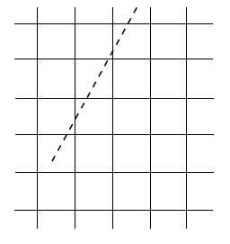

Figure 4 Obstacle lines cutting through a computational grid.

As described in Section 5.2.1 of the SWAN [Scientific and Technical Documentation](http://swanmodel.sourceforge.net/online_doc/swantech/swantech.html), SWAN uses a vertex centered grid, with volume cells defined by grid centers. Figure 4 below shows a computational grid (solid lines), a grid vertex, and the finite volume cell corresponding to that vertex (dashed lines). The finite volume cell edges are the fluxing faces between neighboring vertices.

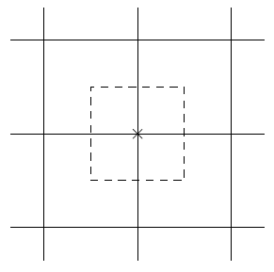

Figure 5 Obstacle lines cutting through a computational grid.

This grid treatment in combination with SWAN’s obstacle treatment has some implications which should be noted. Figure 5 shows the various ways in which obstacles can interact with the computational grid.



Figure 6 Obstacle lines cutting through a computational grid.

The two blue obstacles shown in Figure 5 will have the exact same influence on the model solution, even though they have much different widths. Since both obstacles cross the same computation grid line, SWAN will apply their transmission coefficient the same volumetric fluxing face. The straight dashed lines in Figure 4 show the fluxing faces of a cell volume. Both obstacles correspond to the same face, and thus their obstacle coefficients will have the same impact on the model calculation.

Due to grid discretization, the green obstacle in Figure 5 does not intersect and computational grid lines. In this situation it will have no effect, even though the obstacle is much larger than the small blue obstacle (which does have an effect).

The red line in Figure 5 shows the appropriate use of the obstacle implementation, where grid discretization is much finer than the obstacle length. This means that obstacles will span multiple grid lines and their length and transmission effects can be properly captured.

## WEC Power Performance

It should be noted that RCW values should be kept between zero and one (0<RCW<1) in order to produce physical transmission coefficients. Should RCW values be specified outside of these bounds, SNL-SWAN will enforce these limits in order to maintain realizable values for the transmission coefficient.

In choosing an obstacle case, attention should be paid to the way the Power Matrix or RCW curve was created. Using OBCASE equal to 3 or 4 is only appropriate when information is available about individual frequencies. Cases 1 and 2 are more appropriate when information is available about average sea states. Power Matrix curves may be populated with information derived from either regular waves, or irregular real sea waves. When working with a Power Matrix populated with regular waves it makes sense to use OBCASE=4. However, when working with a Power Matrix which has been populated using values aggregated over real sea waves, it is more appropriate to use OBCASE=3.

Transmission coefficients are obtained through interpolation between points in either the Power Matrix or the RCW curve. Any frequency or significant wave height lying outside the bounds specified in these files will be given a transmission coefficient of 1.0 (an absorption coefficient of 0.0). SNL-SWAN will not extrapolate values outside of these ranges, and the user is encouraged to modify their input curves should they desire this behavior.