02 — Project Overview

2.1 Summary
PakSentiment is an end-to-end social media scraper and sentiment analysis platform. Users register, authenticate with JWT, run analyses across Reddit, YouTube, web pages, and news integrations, and view dashboards with sentiment charts and KPIs. Subscription tiers (free, premium, super_premium) control access to richer data sources (e.g. Reddit JSON+proxy vs RSS).

2.2 System architecture
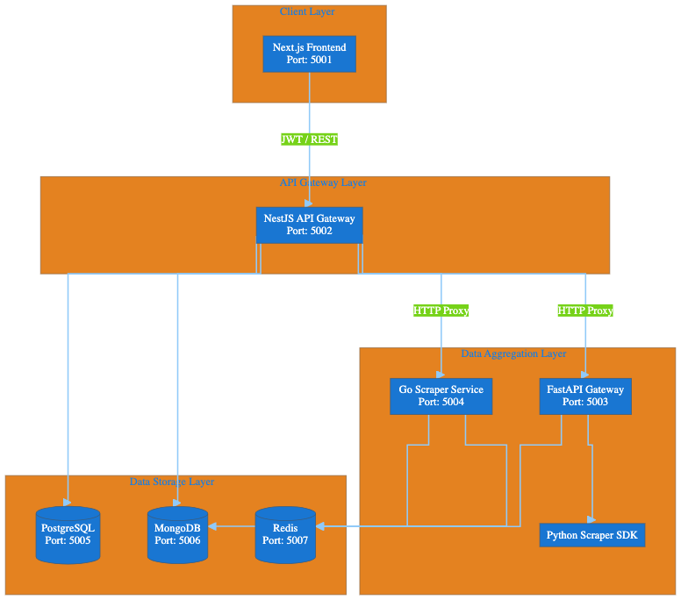

2.3 Component responsibilities
Component | Path | Role
Frontend | frontend/ | Dashboard, analytics, auth UI, Stripe/PayPal checkout UI
Main server | main-server/ | JWT auth, RBAC/tier logic, proxies to gateway/sidecar, payments, Swagger
Data gateway | new PakSentiment-data-gateway/ | Reddit/YouTube/Common Crawl/Scrapling, sentiment (Groq/local model)
Colly sidecar | colly-sidecar/ | High-throughput web crawl, NewsAPI/GDELT/RSS integrations
Scraper SDK | PakSentiment-scraper/ | Shared Python clients for social platforms

2.4 Data flow (typical analysis)
- User logs in via /auth/login-with-email-password or Google OAuth → receives JWT.
- Frontend stores JWT in localStorage (Zustand persist) and sends Authorization: Bearer on API calls.
- User submits analysis (e.g. Reddit subreddit) → POST /raw-data/reddit on NestJS.
- NestJS validates JWT, resolves user tier, proxies to FastAPI (FAST_API_BASE_URL).
- Gateway scrapes data, optionally runs sentiment; results stored in MongoDB via Nest providers.
- Frontend polls GET /raw-data/session/:sessionId and renders charts.

2.5 Trust boundaries
Boundary | Trust assumption | Risk if violated
Internet → Frontend | Public | XSS, token theft
Frontend → NestJS | JWT proves identity | Forged/stolen JWT
NestJS → FastAPI/Colly | Implicit trust (no mTLS/API key) | Direct gateway abuse
NestJS → Databases | Connection strings | Exposed DB ports
NestJS → Stripe | Secret key server-side | Payment bypass

2.6 Functional overview (original FYP)

User management
- Registration with password policy validation
- Email/password and Google OAuth login
- Roles: free, premium, admin; subscription tiers: free, premium, super_premium

Analytics
- Reddit, YouTube, web/scrapling, Common Crawl, smart search (AI planner)
- Sentiment via Groq, Ollama, or local Hugging Face classifier
- Urdu/English translation endpoints

Dashboard
- Pulse charts, lifetime analyses, recent sessions
- Tier-gated Reddit scaling (RSS vs JSON+proxy)

Payments
- Stripe PaymentIntents for subscription plans
- Client-side Stripe Elements in PaymentModal.tsx

2.7 Security controls already present
Control | Location
bcrypt password hashing | auth.service.ts
Global ValidationPipe (whitelist, forbid extra fields) | main.ts
CORS allowlist | main.ts
Google ID token verification | auth.service.ts
JWT on protected /raw-data, /crawler, /ai, /activity | Controllers + AuthGuard
TypeORM parameterized queries (no raw SQL in request path) | Entities / repositories

2.8 Documentation references
- Readme.md — setup and architecture
- Project WIKI.md — implementation manual
- docs/knowledge_base/architecture.md

2.9 Assessment focus areas
Given the architecture, the highest-risk surfaces are:
- Unauthenticated internal services (ports 5003, 5004)
- Open image proxy on NestJS
- Payment tier escalation without payment verification
- Docker misconfiguration (exposed databases, default secrets)
See 04-vulnerability-assessment-results.md for detailed findings.

