Robot Operating System
Date - 17/03/2026 Vedant Agrawal

What is ROS 2?

The Robot Operating System (ROS) is an open-source framework providing software libraries, tools, and conventions for building robot applications. Despite its name, ROS is not a traditional operating system; it is a middleware layer between robot hardware and application software, offering message-passing, hardware abstraction, device drivers, visualisers, and package management
Difference between ROS 1 and ROS 2
.
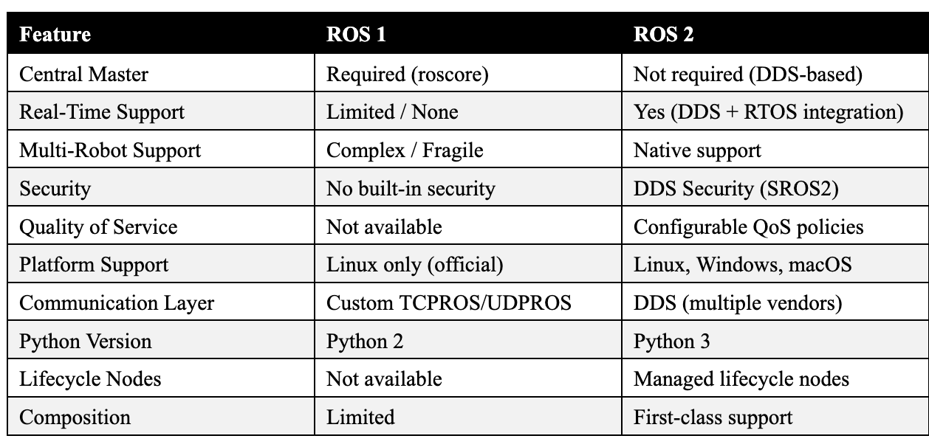
Key Improvements in ROS 2
- Real-Time Support: Real-time capability through integration with real-time operating systems (RTOS) and DDS determinism.
- Built-in Security: Security via SROS2, leveraging DDS Security for authentication, encryption, and access control.
- Lifecycle Nodes: Improved lifecycle management via managed nodes that transition through defined states.
- Intra-Process Comms: Intra-process communication allowing nodes in the same process to share data without serialisation overhead.
- Cross-Platform: Native Windows and macOS support, broadening the developer ecosystem considerably.
ROS 2 Workspace: Directory Structure and Build Process

A ROS 2 workspace is a directory on the filesystem containing ROS 2 packages and the build artifacts generated when those packages are compiled. Workspaces provide isolation between different projects or versions of packages and can be layered (sourced on top of one another) to create a dependency chain. Every ROS 2 installation itself constitutes an underlay workspace; developers create overlay workspaces on top to add or override packages.
Directory Structure:
A workspace is the top-level directory for a set of related ROS software. Upon building for the first time, several directories are automatically generated.
- src/: The source space is where all the ROS packages and source code files (C++, Python, etc.) reside. This is where developers spend most of their time.
- build/: The build space is where intermediate files, cache information, and other artifacts generated during the compilation process are stored.
- install/: The development/install space contains the compiled programs, libraries, and generated setup files. Sourcing the appropriate setup.bash file from this directory adds the packages to your ROS environment, making them available to use.
- log/: Automatically generated by the build system to keep track of build events and potential issues.
Building with colcon:
colcon (collective construction) is the standard build tool for ROS 2, replacing catkin_make and catkin_tools from ROS 1. It supports multiple build systems (CMake, Python setuptools, ament_cmake) and builds packages in topological order based on declared dependencies.
colcon build --symlink-install
After the build is finished, we should see the build, install, and log directories:

ROS 2 Nodes and Multi-Node Interaction
What Is a Node?
A node in ROS 2 is the fundamental unit of computation. Each node is a process (or a component within a process) that performs a specific, well-defined function. The ROS 2 design philosophy encourages a fine-grained, single-responsibility architecture: instead of one monolithic program, the system is decomposed into many specialised nodes that communicate through well-defined interfaces.
For example, a mobile robot might have separate nodes for laser scan processing, odometry estimation, path planning, motor control, and camera image processing. Each node is largely independent and can be developed, tested, and reused in isolation.
How Multiple Nodes Interact
In a robotic system, nodes interact through four primary mechanisms:
Topics: Asynchronous, many-to-many communication for data streams like sensor data
Services: Synchronous, two-way communication (client-server) used for quick requests.
Actions: Asynchronous, goal-oriented communication, ideal for long-running tasks like navigation.
Parameters: Shared configuration values to configure nodes.

ROS 2 Topics and the Publisher-Subscriber Model
What Is a Topic?
A topic is a named communication channel over which nodes exchange streams of messages. Topics implement the publish-subscribe (pub-sub) pattern: publishers send messages without knowing who receives them, and subscribers receive messages without knowing who sent them. This decoupling in both space and time is a hallmark of reactive, event-driven robotics software.
Publisher-Subscriber Model
When a publisher node advertises on a topic, it registers with the DDS discovery mechanism. Any subscriber that declares interest in the same topic name and message type automatically receives messages. Multiple publishers and multiple subscribers can co-exist on a single topic simultaneously.
Topic Introspection Commands
ros2 topic list # List all active topics
ros2 topic info /chatter # Publisher/subscriber count and type
ros2 topic echo /chatter # Print messages to terminal
ros2 topic hz /camera/image_raw # Measure message frequency
ros2 topic bw /camera/image_raw # Measure bandwidth usage

ROS 2 Messages and Custom Message Creation
What Are Messages?
Messages are the data structures exchanged over topics and used in service requests and responses. ROS 2 defines messages in .msg files using a simple interface definition language (IDL). At build time, these definitions are compiled into language-specific code (Python, C++) via the ament build system and the rosidl pipeline.
Built-In Message Packages

Package | Examples | Typical Usage
std_msgs | String, Int32, Float64, Bool, Header | Simple primitive data
geometry_msgs | Pose, Twist, Transform, Vector3 | Spatial quantities
sensor_msgs | LaserScan, Image, Imu, PointCloud2 | Sensor data streams
nav_msgs | Odometry, Path, OccupancyGrid | Navigation and mapping
tf2_msgs | TFMessage | Coordinate frame transforms
diagnostic_msgs | DiagnosticArray, DiagnosticStatus | Hardware health monitoring

Creating Custom Messages
When built-in types are insufficient, developers define custom messages in three steps: creating the .msg file, updating the package build configuration, and building the package.
Step 1 — Define the .msg file (e.g., my_interfaces/msg/RobotStatus.msg):
# my_interfaces/msg/RobotStatus.msg
std_msgs/Header header # Timestamp and frame ID
string robot_name # Unique identifier
float32 battery_level # 0.0 to 100.0
bool is_moving
float32[3] position # x, y, z in metres
int32 error_code # 0 = nominal

Step 2 — Update CMakeLists.txt:
find_package(rosidl_default_generators REQUIRED)
rosidl_generate_interfaces(${PROJECT_NAME}
"msg/RobotStatus.msg"
DEPENDENCIES std_msgs)

Step 3 — Update package.xml:
<build_depend>rosidl_default_generators</build_depend>
<exec_depend>rosidl_default_runtime</exec_depend>
<member_of_group>rosidl_interface_packages</member_of_group>

Step 4 — Build and use:
colcon build --packages-select my_interfaces
source install/setup.bash

from my_interfaces.msg import RobotStatus
msg = RobotStatus()
msg.robot_name = "robot_001"
msg.battery_level = 87.5
ROS 2 Services: Request-Reply Communication
What Is a Service?
A ROS 2 service is a synchronous, request-reply communication mechanism. One node acts as the service server (providing a capability) while another acts as the service client (calling that capability). Unlike topics, which stream data continuously, a service is transactional: the client sends a request and blocks until the server sends back a response.
Services vs Topics

Aspect | Topics (Pub-Sub) | Services (Req-Reply)
Communication | Asynchronous, one-to-many | Synchronous, one-to-one
Data Flow | Continuous stream | Single request / response
Blocking | Non-blocking | Client blocks until reply
Use Case | Sensor data, state updates | Configuration, discrete actions
Examples | LiDAR scans, joint states | Set speed, reset odometry

The ROS 2 Launch System
The ROS 2 launch system is a framework used to start and configure multiple nodes and processes together in a controlled way.
Instead of manually starting each node one by one, you define a launch file (usually in Python, XML, or YAML) that:
- Starts multiple nodes
- Sets parameters
- Handles namespaces
- Remaps topics
- Manages dependencies and startup order
ros2 run — Starting a Single Node
The ros2 run command is the simplest way to start a single node from a package:
While ros2 run is ideal for quick testing and debugging individual nodes, it starts exactly one node per invocation and provides no mechanism for orchestrating a full multi-node system.
ros2 launch — Orchestrating Multi-Node Systems
The ros2 launch command processes a launch file and starts multiple nodes, configures their parameters, sets up remappings, and manages their lifecycle. Launch files in ROS 2 are written in Python (recommended), XML, or YAML — providing far greater flexibility than the XML-only approach of ROS 1.
Node Discovery Without a Central Master
The Problem with roscore in ROS 1
In ROS 1, all node discovery passed through a central master process called roscore. Every node registered its topics and services with roscore, and every node queried roscore to locate communication peers. This introduced serious problems: roscore was a single point of failure (if it crashed, all communication broke), it did not scale to multi-robot systems on different network segments, and it made ROS 1 unsuitable for mission-critical deployments.
DDS-Based Decentralised Discovery
ROS 2 replaces roscore entirely with the Data Distribution Service (DDS) discovery protocol, specifically the Simple Discovery Protocol (SDP). DDS performs decentralised, peer-to-peer discovery using multicast UDP on the local network.
When a ROS 2 node starts, it broadcasts its presence on a well-known multicast address. All other running ROS 2 nodes on the same network receive this announcement and update their internal routing tables automatically — no central server is involved at any stage.
Quality of Service (QoS) in ROS 2
What Is QoS?
Quality of Service (QoS) policies are configurable parameters that govern how messages are sent and received over DDS topics. They allow developers to make precise trade-offs between reliability, latency, and resource consumption — trade-offs that are critical in robotics, where different data streams have fundamentally different requirements.

Why QoS Matters for Sensor Data
Sensor data in robotics presents a unique challenge: it is high-frequency, time-sensitive, and voluminous. Using RELIABLE QoS for a 60 Hz camera stream would cause the middleware to buffer and retransmit every dropped packet, quickly overwhelming network and CPU resources. Best practices are:
- Camera and LiDAR: BEST_EFFORT + KEEP_LAST(1) — always deliver the most recent frame with minimum latency, discarding older queued frames.
- IMU at 1000 Hz: BEST_EFFORT — any given sample is quickly superseded; reliability retransmission would cause lag and jitter.
- Robot state / diagnostics: RELIABLE + TRANSIENT_LOCAL — newly launched monitoring nodes receive the latest state immediately.
- Safety-critical commands (e-stop): RELIABLE with a deadline policy — if commands stop arriving, trigger a safe halt.
QoS Compatibility Rule: A publisher and subscriber can only connect if their QoS policies are compatible. A BEST_EFFORT publisher is only compatible with BEST_EFFORT subscribers. Mismatches produce a QoS incompatibility warning in ROS 2 logs.

Real-World Application: Autonomous Mobile Robots
A common real-world application of ROS 2 is in warehouse automation robots used by companies like Amazon.
An Autonomous Mobile Robot (AMR) navigates the warehouse using ROS 2.

System Components (Nodes)
- Sensor nodes → LiDAR, cameras, IMU for environment perception
- Localization node → Determines robot position (e.g., using AMCL)
- Mapping node → Builds or uses a map of the warehouse
- Path planning node → Computes optimal routes
- Control node → Sends velocity commands to motors

Role of ROS 2
ROS 2 manages:
- Communication between nodes (via DDS)
- Real-time performance for safe navigation
- Launch system to start the full robot stack
- QoS policies for reliable sensor data delivery

Why ROS 2 is Used
- No central master → robust in large fleets
- Scalable → multiple robots can operate together
- Real-time capable → critical for navigation safety
- Cross-platform → runs on embedded systems and servers

References:
https://docs.ros.org/en/humble/
https://docs.ros.org/en/rolling/Tutorials.html
https://docs.ros.org/en/humble/Tutorials/Beginner-Client-Libraries/Custom-ROS2-Interfaces.html
https://docs.ros.org/en/humble/Concepts/About-Quality-of-Service-Settings.html

