Predictive Manufacturing
Architecture Reference
Recommended architecture, block-by-block explanation, and design rationale
for a hackathon-ready capacity-and-sourcing solution
Document intent: provide a clean, explainable architecture that can be understood by human teammates and also parsed reliably by AI systems. The structure below is therefore both presentation-friendly and machine-oriented: each block has a clear purpose, inputs, processing logic, outputs, and source-sheet mapping.

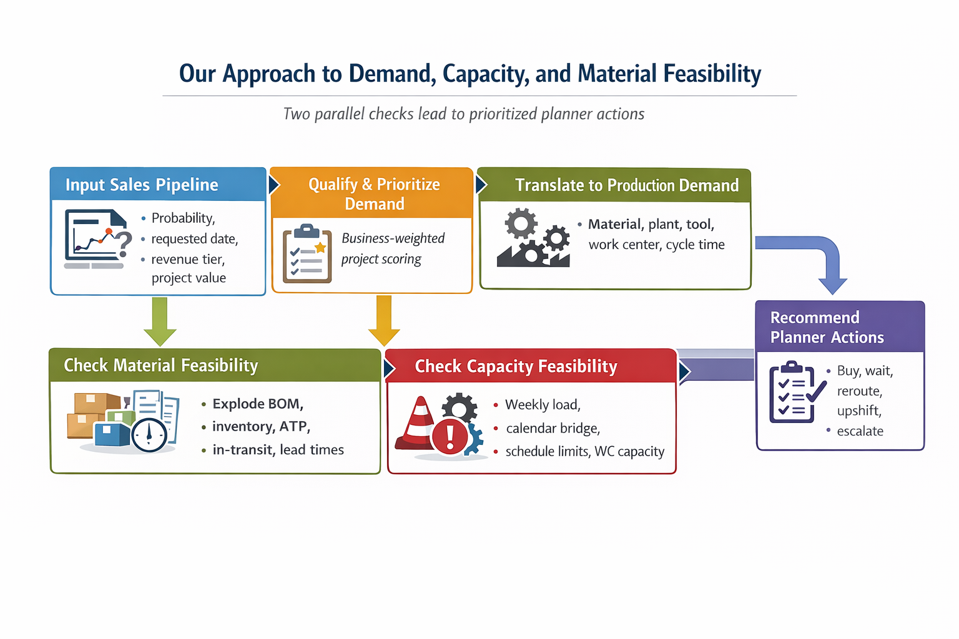
Figure 1. Recommended architecture: pipeline intake → qualification → translation → parallel material/capacity feasibility → risk synthesis → planner actions
Executive summary
The recommended architecture is intentionally organized around one conversion point and two feasibility branches. First, uncertain sales opportunities are qualified and translated into manufacturable demand. Then the architecture checks that demand in parallel against material feasibility and capacity feasibility. The two branches are merged into a single bottleneck-and-risk layer, which finally drives a planner action plan. This structure reflects the actual organization of the starter repository and avoids the common mistake of presenting demand forecasting, sourcing, and production capacity as disconnected dashboards.
This design is strong for a hackathon because it is explainable, faithful to the available data, and modular: even if the full end-to-end product is not completed, each major branch can still be demonstrated credibly.
Architecture at a glance
# | Block | Primary question answered | Main repo sheets
1 | Sales Pipeline Intake | What is the uncertain sales signal? | 1_1, 1_2, 1_3
2 | Demand Qualification & Prioritization | Which opportunities matter most? | 1_3
3 | Translate to Production Demand | What exactly would we need to produce? | 2_6 (+2_3)
4 | Material Feasibility | Do we have the required materials in time? | 3_2, 3_1, 2_3
5 | Capacity Feasibility | Can the network absorb the load? | 2_1, 2_4, 2_5, 2_6
6 | Bottleneck & Risk Synthesis | Where are the highest risks and bottlenecks? | Derived layer
7 | Planner Action Plan | What should the planner do next? | 2_5 + derived layer

Block-by-block architecture explanation
Each block below is described in a fixed schema so the document can be used both as a team briefing and as a machine-readable architecture reference.
Block 1 — Sales Pipeline Intake
Purpose
Capture the uncertain demand signal from the commercial pipeline and normalize it into a consistent project-level input layer.
Key inputs  - Unapproved project demand from 1_1 Export Plates and 1_2 Gaskets  - Project metadata from 1_3 Export Project list  - Core business fields such as probability, requested delivery date, customer segment, total expected PCS/EUR, and revenue tier | Core processing logic  - Standardize project identifiers, material references, dates, and quantity fields.  - Separate pipeline demand from already approved or baseline production plans.  - Treat the pipeline as uncertain demand rather than committed orders.
Outputs
- Unified pipeline dataset at project × material × time bucket grain
- Clean project metadata layer for downstream prioritization
Main repo sheets | 1_1 Export Plates, 1_2 Gaskets, 1_3 Export Project list
Architectural rationale for this block | The architecture must start from the sales pipeline because the case is explicitly about translating uncertain projects into operational decisions.

Block 2 — Demand Qualification & Prioritization
Purpose
Turn raw sales opportunities into decision-relevant demand by scoring each project according to business importance and execution urgency.
Key inputs  - Probability of conversion  - Requested delivery date  - Revenue tier and project value  - Customer segment / strategic importance | Core processing logic  - Build a business-weighted project score rather than relying on volume alone.  - Use probability as a core weight, but combine it with urgency and business value.  - Use customer importance and revenue tier to prioritize planning decisions, not to claim unsupported customer-lifetime forecasting.
Outputs
- Priority score per project
- Scenario-ready ranked demand set for conservative, expected-value, and aggressive planning views
Main repo sheets | 1_3 Export Project list
Architectural rationale for this block | This block ensures that the system remains business-aware and does not treat every opportunity as equally important.

Block 3 — Translate to Production Demand
Purpose
Convert the qualified sales signal into manufacturable demand that is meaningful for operations planning.
Key inputs  - Qualified project demand from Blocks 1–2  - Material-to-tool-to-work-center mapping  - Factory assignment and cycle times | Core processing logic  - Resolve each project/material combination to plant, tool, work center, and cycle time.  - Use the operational master mapping as the backbone of the architecture.  - Flag missing master-data cases instead of silently dropping them.
Outputs
- Production-demand layer with plant, tool, work center, and cycle-time context
- A clean handoff point for both sourcing and capacity analysis
Main repo sheets | 2_6 Tool_material nr master, 2_3 SAP MasterData (supporting attributes)
Architectural rationale for this block | This is the architectural hinge: once demand is translated into manufacturable form, the system can evaluate feasibility in parallel.

Block 4 — Material Feasibility
Purpose
Check whether the translated demand can actually be supplied with the required raw materials and components.
Key inputs  - Finished/header material demand from Block 3  - BOM relationships and effective component quantities  - Inventory, ATP, in-transit stock, safety stock, procurement type, and lead times | Core processing logic  - Explode finished/header demand through the BOM.  - Calculate raw-material demand using effective component quantity and scrap-aware logic.  - Compare demand against available stock, ATP, in-transit stock, and safety stock policies.  - Estimate order-by dates from lead-time logic.
Outputs
- Material coverage assessment
- Raw-material order quantities and order-by dates
- Shortage and stockout-risk alerts
Main repo sheets | 3_2 Component_SF_RM, 3_1 Inventory ATP, 2_3 SAP MasterData
Architectural rationale for this block | Material feasibility is a distinct constraint from capacity feasibility; the architecture treats it as its own decision branch.

Block 5 — Capacity Feasibility
Purpose
Check whether the same translated demand can be executed by the available production network in the required time horizon.
Key inputs  - Production-demand layer from Block 3  - Work-center capacity baseline  - Calendar bridge between monthly demand and weekly capacity  - Shift / schedule limits and cycle times | Core processing logic  - Convert demand into load at weekly work-center level.  - Bridge the monthly pipeline into weekly buckets using the model calendar.  - Compare incremental demand load against available capacity, final operations plan load, and schedule limits.  - Use upside/downside scenarios to estimate how much operational flexibility exists.
Outputs
- Weekly work-center load view
- Capacity-gap and overload metrics
- Bottleneck candidates by work center and tool
Main repo sheets | 2_1 Work Center Capacity Weekly, 2_4 Model Calendar, 2_5 WC Schedule_limits, 2_6 Tool_material nr master
Architectural rationale for this block | The case asks for bottleneck detection and capacity forecasting, so feasibility must be evaluated against real operational constraints rather than nominal demand alone.

Block 6 — Bottleneck & Risk Synthesis
Purpose
Merge material and capacity feasibility into one decision layer that highlights where the network is most exposed.
Key inputs  - Material-risk signals from Block 4  - Capacity-risk signals from Block 5  - Project priority scores from Block 2 | Core processing logic  - Combine shortage risk, late-order risk, work-center overload risk, and tool bottleneck risk.  - Weight the merged risk by project importance and timing.  - Produce a planner-facing ranking of the most critical issues.
Outputs
- Integrated bottleneck map
- Prioritized risk list
- Clear explanation of what is driving each risk
Main repo sheets | Derived layer; no single source sheet
Architectural rationale for this block | This block turns two separate analyses into one management view and prevents the team from presenting disconnected dashboards.

Block 7 — Planner Action Plan
Purpose
Translate analytics into concrete, explainable actions that planners, sourcing teams, and manufacturing leads can challenge and use.
Key inputs  - Integrated risks from Block 6  - Upside/downside schedule options  - Lead-time-aware material recommendations | Core processing logic  - Recommend actions such as buy now, wait, reroute, upshift, or escalate.  - Tie each recommendation back to a visible risk and its expected effect.  - Keep the action layer explainable rather than black-box.
Outputs
- Planner action list
- Suggested sourcing actions
- Suggested rerouting or upshift actions
- Escalation alerts for high-priority projects
Main repo sheets | 2_5 WC Schedule_limits (key execution lever), Derived layer
Architectural rationale for this block | The hackathon deliverable should end with decisions, not just analytics. This is the part judges will remember.

Why this architecture was chosen
We chose this architecture because the data naturally separates into two decision layers after demand translation: a material layer and a capacity layer. The repository contains a clear operational spine for translation (especially the tool–material–work-center master), a dedicated set of sourcing-oriented sheets (BOM, inventory, ATP, lead-time fields), and a dedicated set of capacity-oriented sheets (weekly work-center capacity, calendar bridge, schedule limits). The recommended design therefore follows the structure of the data instead of imposing an artificial all-in-one model.
The second reason is explainability. Judges and business stakeholders can follow the flow: first understand what might happen, then decide what matters, then translate that demand into operational terms, then test whether materials and capacity can support it, then surface the biggest risks, and finally recommend actions. This is much easier to defend than a black-box forecast that jumps directly from pipeline data to recommendations.
The third reason is robustness. By keeping material feasibility and capacity feasibility as parallel checks, the architecture avoids conflating two different failure modes: one project can be blocked by missing raw material even if there is enough machine time, while another can be blocked by a saturated work center even if material is fully available. The synthesis layer recombines those risks only after they have been assessed properly.
Main strengths of the architecture
Strength | Why it matters
Faithful to the repository | Each architectural stage maps cleanly to the actual source sheets instead of inventing unsupported abstractions.
Explainable end-to-end flow | Every recommendation can be traced back to business inputs, operational mappings, feasibility checks, and risk synthesis.
Modular for hackathon execution | The team can build and demo the branches incrementally without breaking the overall story.
Balanced business and operations logic | Probability, urgency, value, and strategic importance are included before the model drops into tools, work centers, BOMs, and lead times.
Usable by humans and AI systems | The block schema exposes purpose, inputs, logic, outputs, and source-sheet mapping in a stable structure.

Key assumptions and guardrails
- Customer tier / revenue tier should be used as a prioritization signal, not as a claim that the dataset supports future customer-order forecasting.
- Missing master-data cases should be surfaced explicitly rather than hidden; they are part of the business problem.
- Material feasibility and capacity feasibility should remain separate analytical branches until the risk-synthesis stage.
- The action layer must remain explainable: recommendations should always tie back to visible capacity or sourcing constraints.
- The architecture supports scenarios such as conservative, expected-value, and aggressive planning views without changing the structural flow.

AI-oriented architecture summary
The table below is intentionally structured as a compact reference for implementation planning, prompt grounding, or agentic workflows.
# | Block | Objective | Primary inputs | Primary outputs | Dependencies
1 | Sales Pipeline Intake | Normalize uncertain commercial demand | 1_1, 1_2, 1_3 | Unified pipeline layer | None
2 | Demand Qualification & Prioritization | Score business relevance and urgency | Probability, requested date, revenue tier, segment | Priority-scored projects | Block 1
3 | Translate to Production Demand | Resolve plant/tool/WC/cycle time | Qualified demand + 2_6 | Manufacturable demand layer | Blocks 1–2
4 | Material Feasibility | Check BOM, stock, ATP, lead time | Block 3 + 3_2 + 3_1 + 2_3 | Coverage + order-by actions | Block 3
5 | Capacity Feasibility | Check weekly load vs capacity | Block 3 + 2_1 + 2_4 + 2_5 | Overload + bottleneck metrics | Block 3
6 | Bottleneck & Risk Synthesis | Merge sourcing and capacity risk | Blocks 2, 4, 5 | Integrated risk ranking | Blocks 2, 4, 5
7 | Planner Action Plan | Generate explainable recommendations | Block 6 + execution levers | Buy/wait/reroute/upshift/escalate | Block 6

Closing note
In practical terms, this architecture says: start from uncertain projects, decide what matters, translate that demand into operational terms, verify in parallel whether materials and capacity can support it, merge the risks, and finish with an action plan. That sequence is simple enough to explain in a presentation, technical enough to impress a manufacturing audience, and structured enough to guide implementation by both humans and AI systems.

