Forty-four years ago I was introduced to computers in my Data Processing class conducted at our local Technical School. We didn’t have a STEM program back then and all we had was a NCR Century 200 Mainframe computer which was twelve years old and you had to write your programs in either COBOL or FORTRAN-I using punch cards. In my senior year of high school 1978-79 the very first 6502 personal computers arrived.

The introduction of graphical user interfaces on Windows based systems spoiled me. During college we were introduced to how databases were structured and how to use them. Populating a database is a major chore. Microsoft Access made the job much easier using forms. However, I had to populate a Microsoft SQL Server database for a start-up company without the use of forms. So I thought it would be nice if I had an application that could create table forms for me of the fly, which lead to the creation of this project.

Since I am familiar with both Microsoft Access and SQL Server I started the application based on these two database software packages, so let me give you an overall idea on how I pictured the operation of the application using a Microsoft Access database.

When you first open the application you are presented with this window.

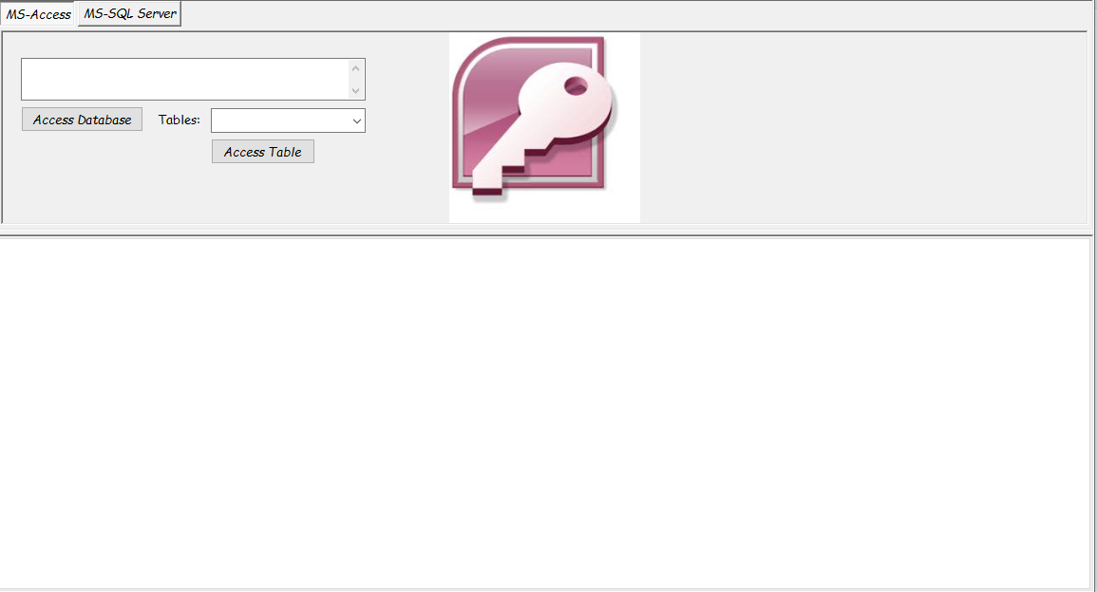

The two tabs are for either MS-Access database or MS-SQL Servers. The upper portion of the form is for tab page log-in for different database systems, the lower portion is for the dynamically created forms for selected tables.

Select the Access database you wish to use.

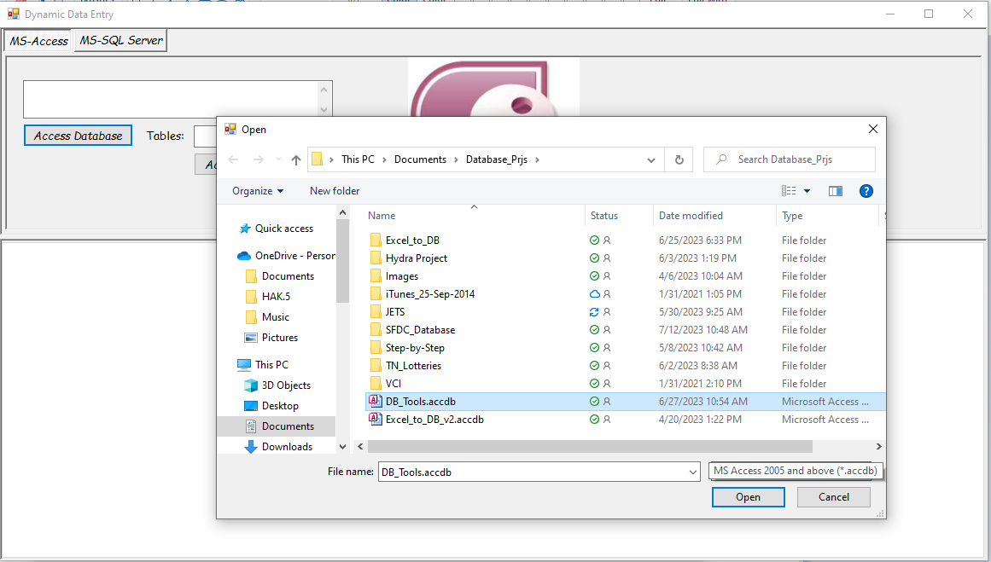

The upper part of the form will show the path of the selected Access database and the Tables pull-down box will be populated with the selected database’s tables.

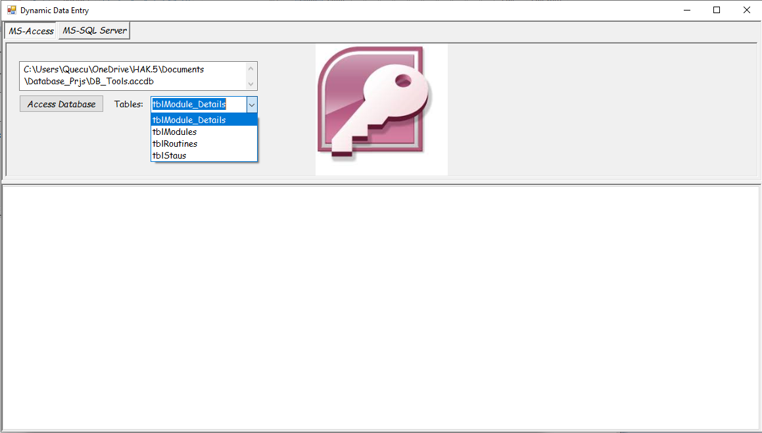

After selected a table clicking on the **Access Table** button will create a form based on the structure of the selected table.

The next image shows the two tables I selected.

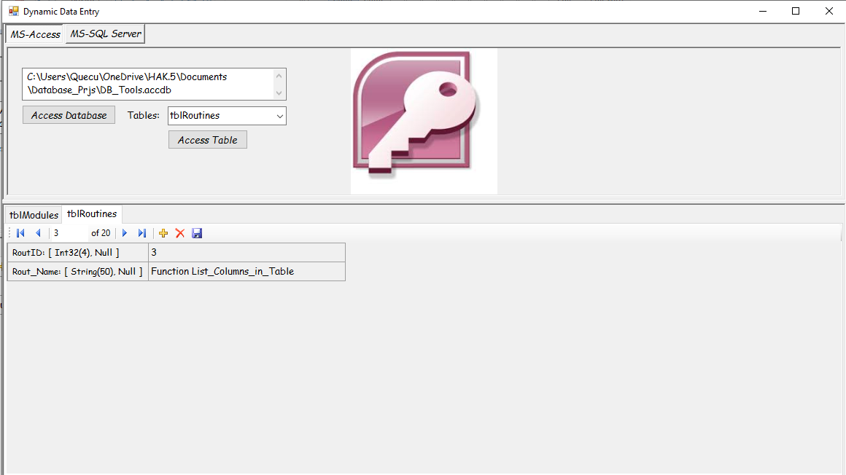

There is a context menu which will allow you to remove a table form from the lower screen by right clicking on the form.

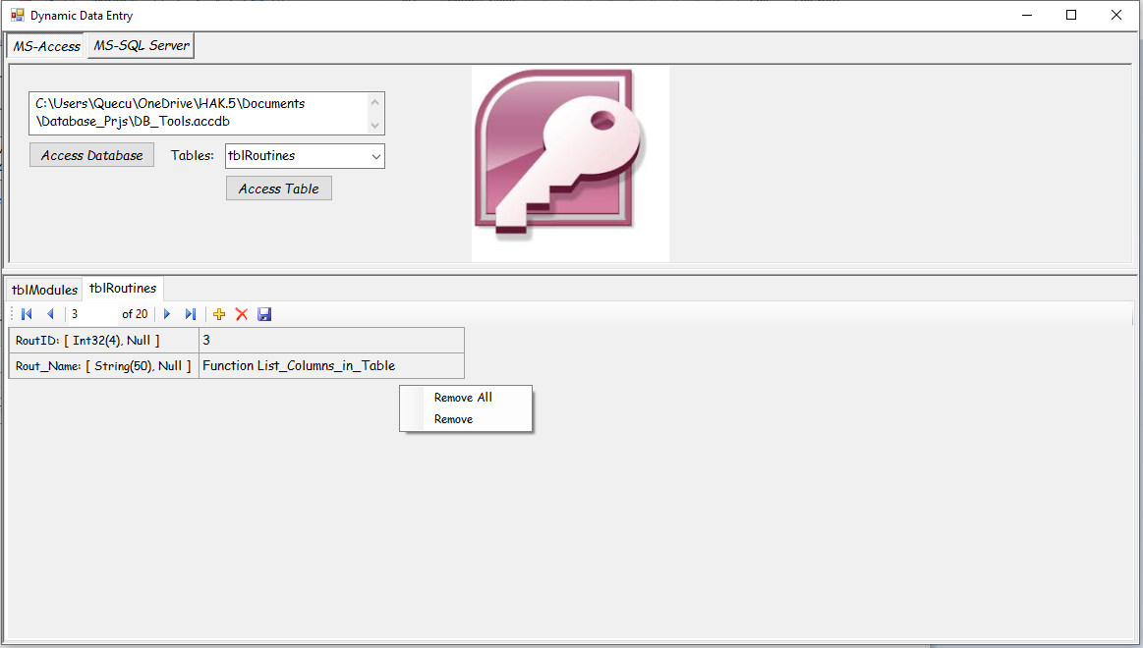

**Remove All** – Removes all table forms from the lower selection.

**Remove** – Only removes the active form.

A relational database is all about how the data is related. So I have some shortcuts to help you.

To look at a table’s structure (schema) hold down the keys **Ctrl + Alt + S** and a data grid will show you the structure of that table.

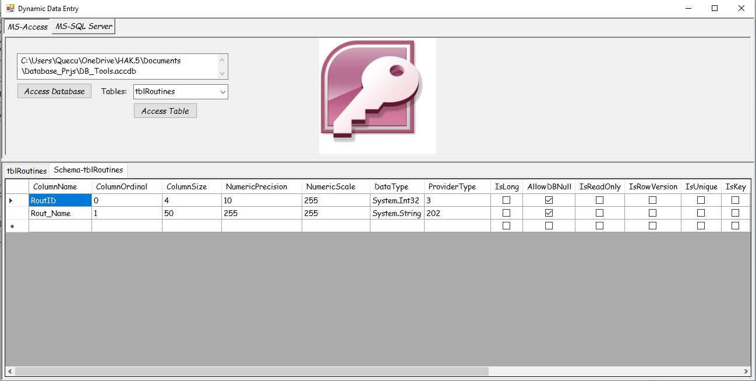

To see the data within a table hold down keys **Ctrl + Alt + D**.

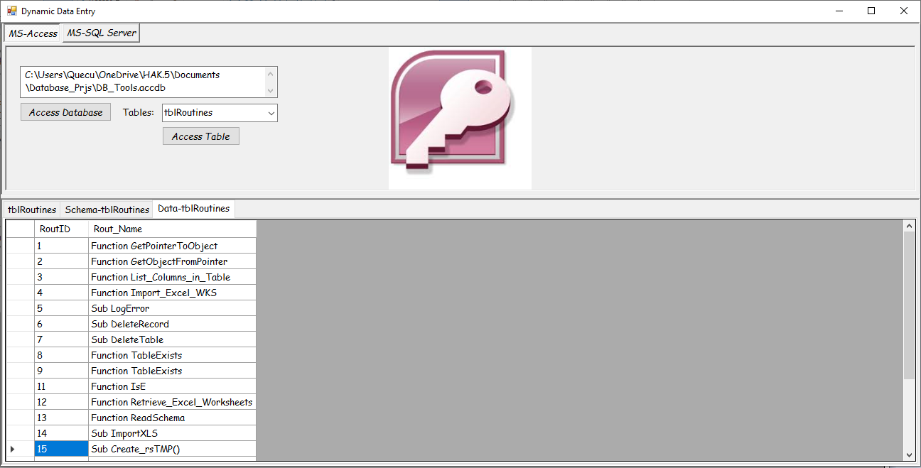

To see the table’s relationships hold down keys **Ctrl + Alt + R**.

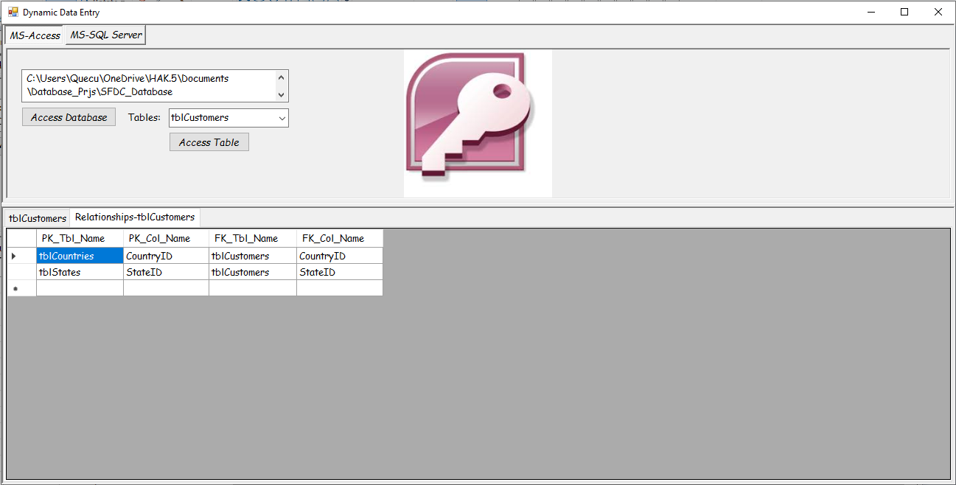

The Microsoft SQL Server side works identical to the Access side. However, there are some glitches I have not had the time to figure out. Here is the **MS-SQL Server** log-in tab page.

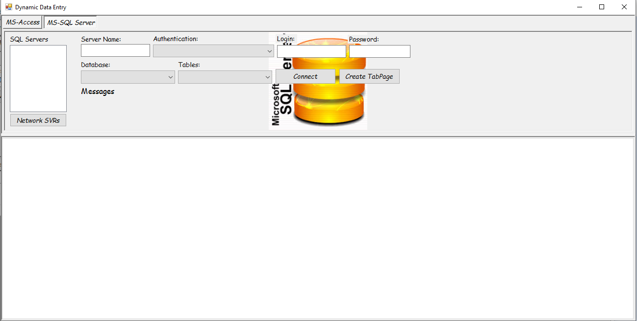

When you click on the **Network SVRs** button the application is suppose to scan your network and return a list of SQL Servers. This is my first glitch. I have s separate computer on my home network containing a developer’s version of SQL Server 2017; it will not be detected so I had to put in a work around.

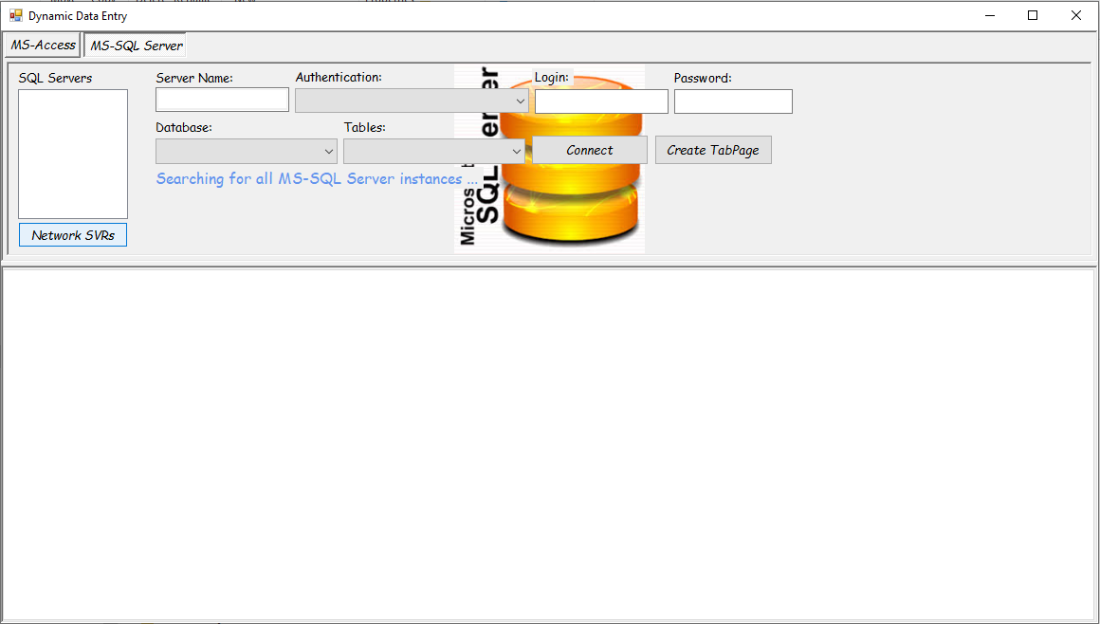

When the system times out a default SQL Server name is placed in the list box. This is the name of my PC containing the developer’s edition of SQL Server.

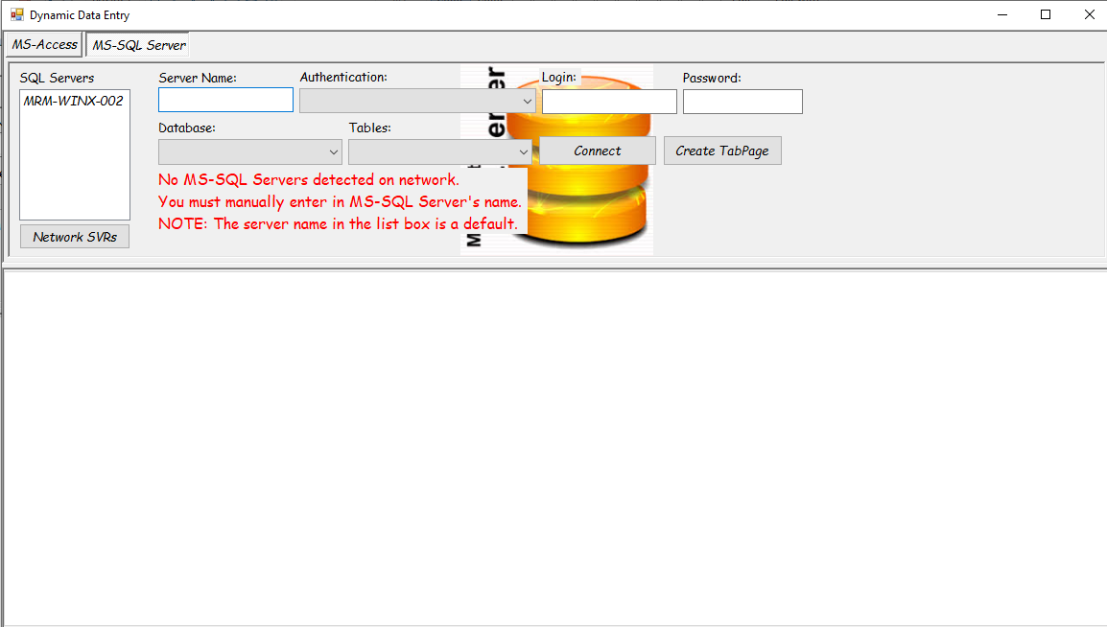

The work around is: If you know the name of the SQL Server you can enter it into the **Server Name** text box. I just have to select the name from the SQL Server list box and it will be placed into the **Server Name** text box.

Before I show how to log into a SQL Server database I must show you my **second** glitch; the Windows Authorization. Using the internet I looked up how different connection string are used for OLEDB, SQL Server, and Oracle along with others and found what was supposed to be the connection string for SQL Server Windows Authentication **it didn’t work**.

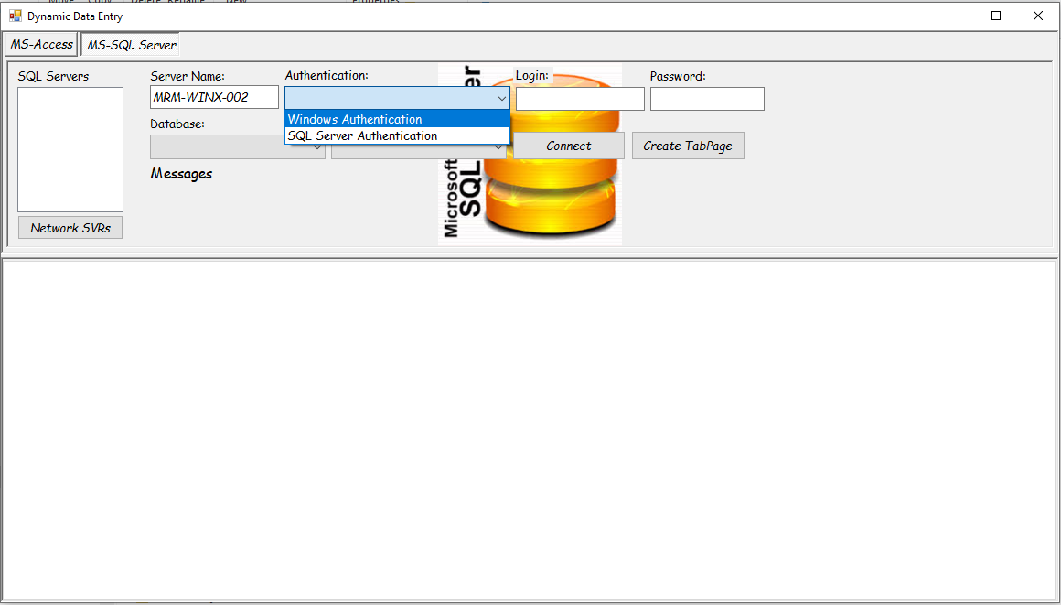

The SQL Server Authentication works just fine.

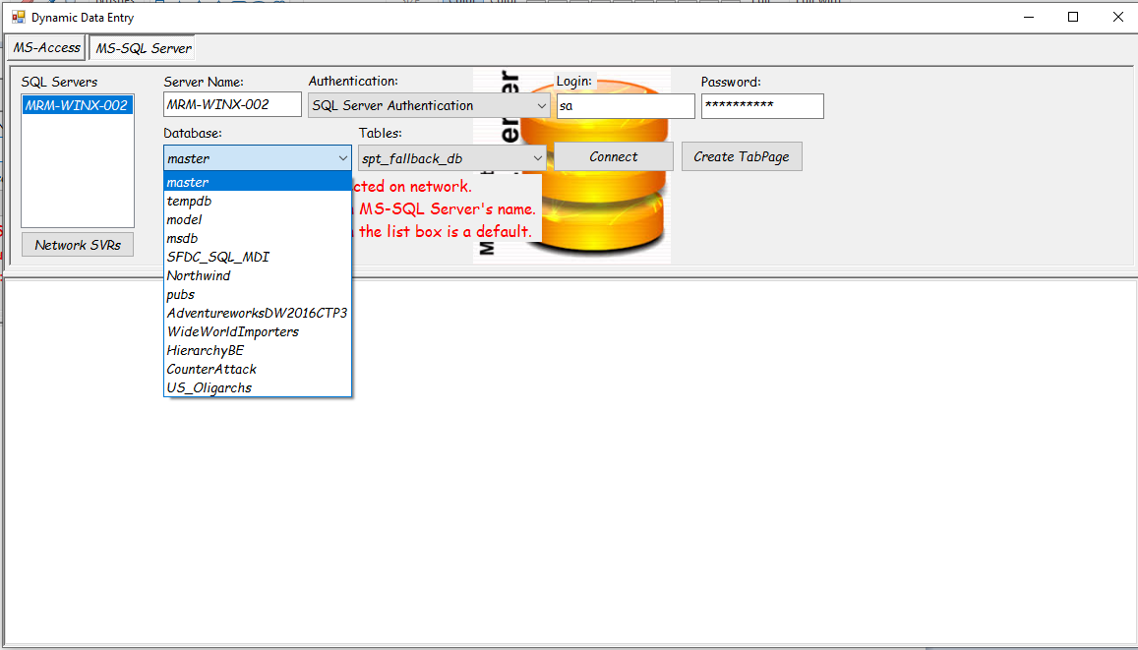

From this point on the application works just like the Access side.

