Speckle Noise Removal in SAR Images

Contents

Abstract 2

I. Introduction 2

II. Methods and Materials 3

III. analysis for speckle noise removal 7

IV. experimental results 9

A. Matlab Results 9

B. Python Results 13

V. Conclusion 18

# Abstract

Synthetic Aperture Radar (SAR) images are usually degraded by speckle noise that appears as granules in the image. Researchers implemented different image processing algorithms for speckle noise removal that usually degrades the fine details in the image. In this work; an algorithm based on the time domain processing of SAR images is proposed for better removal of speckle noise and better presence of fine details both using MATLAB and Python. The achieved results of the algorithm were sufficient enough based on the signal to noise ratio achieved and the removal for most of the speckle noise from the image.

# INTRODUCTION

Synthetic Aperture Radar (SAR) is a type of radars, which is used in different types of applications for the acquisition of images from the space. SAR images can provide high resolution for the required targets from the space after being processed and can be obtained by the movement of one/ more antennae (placed over a large area) over the targets of concern. Moreover, SAR can be used in remote sensing applications due to its importance of this field [1].

A type of noise called speckle noise degrades SAR images. Speckle noise results from the interference of the scattered wavelets caused by the fluctuations of microscopic type of the object’s surface within any single resolution element. This speckle noise appears as granules in the SAR images as the speckle noise appearing in the medical ultrasound images and degrades the fine details, which should be processed for optimal resolution and better visualization of the intended targets [2].

Researchers in this field have used different algorithms for the processing of SAR images and the removal of speckle noise for better visualization of the image details. In this work, an adaptive cascade filters is proposed which consists of time domain analysis for the image.

# METHODS AND MATERIALS

The authors in [3] discussed the high-resolution airborne SAR (Synthetic aperture radar) sensors and the problems that burden the interpretation of the SAR imagery like a layover, shadow, and multipath propagation. In addition, they discussed the requirement of high-resolution information about the 3D structure of the urban scene in order to analyze the SAR data and the benefits of the GIS (geographic information system) data for the SAR mission planning, then the analysis of acquired SAR data in two tasks. The first task is to optimize the SAR acquisition parameters where a large number of simulations with systematically varying aspect and viewing angles are carried out. The second task was the fusion of the 2D and 3D context information with the acquired SAR imagery to support the interpretation for a change detection task. Additionally, the feasibility of different kinds of GIS data for the tasks is also discussed.

Further, [4] described the implementation of a SAR simulation program which uses a DEM ( digital elevation models), sensor flight path and further SAR processing parameters to compute the output SAR image directly without intermediate raw signal representation. The implementation of this simulation program aims to achieve high geometric accuracy and employs a parametric mapping model based on SAR range and Doppler equations. Furthermore, particular attention was paid to the computational efficiency of the implemented algorithms. The paper discussed in some detail the generation and utilization of layover and shadow maps especially suited to applications in alpine terrain. In their research, tests were carried out on SAR images obtained from different sensors namely ERS-1, X-SAR, and JERS-1, the simulation results were judged by comparison with the corresponding real images along the achievements obtained. A future extension to the simulator was considered in the paper where the incorporation of further ground glasses such as different types of vegetation, traffic lines and built-up areas are planned, so that the simulation could be used for automated ground control point measurement, even in flat terrain.

Authors in [5] proposed and discussed the segmentation for SAR images combining MAP (maximum a posteriori) and AD (anisotropic diffusion) where the initial segmentation is obtained by MAP using intensity information of pixels; then multiscale anisotropic smoothing is implemented on the posterior probability matrixes derived from the initial segmentation. The results show the feasibility and efficiency of their method of segmentation. Additionally, they discussed the improvement of the technique proposed by smoothing the posterior probability matrixes using Yu and Acton or other AD filters. A simple and adaptive method that could improve the SAR image quality effectively and preserve polarimetry property was proposed by [6]; the method was sparse code shrinkage (SCS) based on independent component analysis (ICA) applied to polarimetric SAR images with abundant texture showing that this method has potential to become a general approach for polarimetric SAR image enhancement.

Further, the discrete Fourier filter (DFF) technique and applied it to reconstructions of digital holograms was developed by [7], this technique reduces the speckle content in reconstructed digital holograms, and it is based on a sequential sampling of the discrete Fourier transform of the reconstructed image field. In [8], a way for SAR image embedded compression was proposed. The method introduced speckle noise filtering in SAR image compression. They carried out experiments showing that the method can reduce the speckle noise and improve the computation precision and time. In their research paper, they explained the SAR image compression using the embedded zerotree wavelets algorithm, based on discrete wavelet transform (DWT).

Authors in [9] further compared different SAR algorithms with the ideal full-time domain approach. The focusing errors of the algorithms have been quantified in his study paper regarding residual quadratic phase errors for the Seasat and ERS-1 cases. Additionally, he confirmed that the conventional range-Doppler processor introduces range defocusing in images from Seasat like sensors even at a moderate squint. In his research, the secondary range compression used to fill the gap in focusing accuracy between range-Doppler processing and the optimum wave number domain (w-k) algorithm to a high degree. In their study in [10], some of the practical autofocus algorithms based on their estimation capability were compared. They covered the autofocusing technique for SAR images and how it improves the image focus by removing a large part of phase errors present after conventional motion compensation. Moreover, their implementation schemes and performance are evaluated in the presence of various phase errors, which include polynomial-like, high frequency sinusoidal and random phase noise.

In addition, in [11] a SAR autofocus algorithm based on particle swarm optimisation (PSO) was highlighted. Also, they presented an approach to solving the low-frequency high order polynomial and high frequency sinusoidal phased errors. Two standard tests applied to evaluate the performance of the proposed autofocus algorithm: the first test is the 2-D simulated SAR image test for a point target, the second is the 2-D actual SAR image test (raw data extracted from RADARSAT-1). The results of their work show significant improvement in SAR image focus quality after the proposed algorithm compensated the distorted SAR signal.

In their research paper, [12] presented an integrated SAR simulator and processor (iSARSIMP) software package and the performance of three SAR autofocus algorithms has been evaluated to manifest the usefulness of the iSARSIMP for SAR system designers. They used simulated and actual SAR raw data in the performance evaluation for further analysis and comparison of the three selected autofocus algorithms. It was also proposed by [13] the use of inherent characteristics of SAR images to enhance the traditional-MRF (Markov random field) model for the recovery of the SAR images. Further, to segment SAR image into target and shadow with the theory of connectivity in digital morphology. The method combines the Gamma distribution in the estimate of the MAP (maximum a posteriori) and the connectivity model of pixels intensity value relevance to extract goal better in the neighbourhood of SAR image pixel space. The proposed way of SAR image improvement eliminates isolated points and obtains good segment results.

The fuzzy logic dependent speckle noise reduction method of SAR images was developed by [14]. The method consists of two stages: the computation of the fuzzy edge for each pixel in the filter window and the use of these edges to weight the contributions of neighbouring pixel values to perform fuzzy filtration. For this method, they applied the fuzzy filter iteratively on the images for effective reduction of heavy noise. Their study averages the homogeneous areas and preserves edges better. Authors in [15] introduced SAR image speckle reduction based on FDCT (fast discrete curvelet transform) and comparisons are performed against wavelet-based methods. The method proposed transforms SAR image to curvelet domain by using FDCT, gets the curvelet coefficient, then estimates the curvelet coefficient threshold of different scale and direction (using adaptive threshold method), treatments on curvelet coefficient with hard and soft thresholds respectively, finally recovers the original image by using inverse-FDCT. The result shows that curvelet transform is better than wavelet; it can overcome the blocking problem of edge caused by wavelet and is more preferable to retain edge and texture information of the image.

Furthermore, [16] proposed a novel method for joint enhancement and despeckling of SAR images (JEDI) that employs an adaptive stochastic approach to overcome limitations inherent in local methods. The method uses an adaptive Monte Carlo sampling approach based on the local statistics to generate a set of pixels that exhibit potential information redundancy; these pixels are then aggregated using an adaptive similarity based weighting scheme to achieve speckle reduction as well as detail enhancement at the same time. The proposed JEDI method can attain greater levels of speckle attenuation while increasing the visibility of image structures. An image compression algorithm for SAR images, based on wavelet packet transform (WPT) was introduced in [17]. The algorithm exploits the inter and intraband correlations of WPT coefficients. Additionally, they proposed an image coding algorithm which uses rate-distortion optimised WPT. Further, in [18] an improved polarimetric SAR image filtering method to obtain better results for terrain classification, target detection and other applications; this method was based on combining independent component analysis (ICS) with least squares support vector machine (LSSVM) was proposed. The experimental results of their study show that the proposed method can reduce the speckle noise effectively, as well as preserving the edges in the SAR image.

Finally, the authors in [19] proposed a new segmentation algorithm that is dependent on the persistence and clustering in the contourlet domain. The developed algorithm captures the persistence first and then performs clustering of the contourlet transform modelled by hidden Markov tree (HMT) and Markov random field (MRF). Then, both models are fused by fuzzy logic and lastly to deduce maximum a posteriori (MAP) segmentation equation for the fusion model proposed. The results for the developed algorithm show improvement in the segmentation accuracy, reduced influence of multiplicative speckle noise and a better quality of visualization for SAR images.

# analysis for speckle noise removal

The source image will be further analyzed using time domain analysis filters. Three types of filters were chosen due to their efficiency in the removal of speckle noise; filters are diffusion, median and average and are arranged in a cascade to improve the quality of the results.

1. *Diffusion Filter*

Diffusion filter has been recently used for the speckle reduction and removal in the ultrasound images; this filter can reduce the speckle noise and preserve the edges as well because of the nonlinearity nature and the adaptive anisotropy [20].

1. *Median Filter*

This type of filters checks all the pixels in the image and replaces with the median neighboring pixels. By sorting the pixel values in the image into numerical order and replacing the considered pixel with the middle pixel value; the median value is calculated. This filter is also good in speckle noise removal and edge reserving for the image enhancement [21].

1. *Average Filter*

Average filter is used to filter out the noise involved and to enhance the image visualization and interpretation; it has been used recently for the speckle noise reduction and removal in the ultrasound images. Average in this filter is calculated by finding out the sum of all pixels in the image and then dividing the sum by the number of pixels, after that spatial filtering is performed on each pixel in the image window [22].

The filter’s arrangement was based on the correlation as well as the Peak Signal-to-Noise Ratio (PSNR) values obtained, the highest PSNR for any arrangement may refer to the best noise removal but selecting the cascade of values higher than 35dB is not preferred because some of the image contents won’t be seen clearly (removal of some contents in the image) hence the proper time domain analysis filtering cascade is (Median-Average-Diffusion) having 33.41dB PSNR value [23].

Table 1. Shows the PSNR values obtained in the arrangement of the filter types in different orders.

Table 1: PSNR values for the different filter’s arrangements

|  |  |  |  |
| --- | --- | --- | --- |
| **Arrangement** | **PSNR 1** | **PSNR 2** | **PSNR 3** |
| Average-Diffusion-Median | 21.55 | 30.42 | 39.52 |
| Average-Median-Diffusion | 21.55 | 32.66 | 33.15 |
| Median-Average-Diffusion | 21.75 | 28.54 | 33.41 |
| Median-Diffusion-Average | 21.75 | 29.44 | 33.00 |
| Diffusion-Median-Average | 24.70 | 26.75 | 32.02 |
| Diffusion-Average-Median | 24.70 | 26.12 | 36.89 |

It can be seen clearly that the third filter’s arrangement is the best for the time domain speckle removal from SAR images. The arrangement (Median-Average-Diffusion) gave the best result over all arrangements, where the PSNR after the median filter is 21.75dB, 28.54dB after the average filter and 33.41dB after the diffusion filter so that on the completion of the three filters respectively the PSNR is 33.41dB; which means that this cascade is the best to be applied on the SAR images for the speckle removal and preserve of the image’s contents.

# experimental results

The implemented method processes and removes the speckle noise from SAR images, based on MATLAB and Python.

## Matlab Results

First we load input image and convert it into gray image.

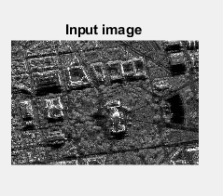

Fig1. Original image.

And then, we define the function which calculates PSNR. The formula to calculate the PSNR between two images is the following:

$$MSE=\frac{1}{mn}\sum_{i=0}^{m-1}{\sum_{j=0}^{n-1}{{\left[I\left(i,j\right)-K\left(i,j\right)\right]}^{2}}}$$

$$PSNR=10∙\log_{10}\left(\frac{MAX_{I}^{2}}{MSE}\right)=20∙\log_{10}\left(\frac{MAX_{I}}{\sqrt{MSE}}\right)$$

In Matlab, the function of PNSR is the following:

if A == B

error('Images are identical: PSNR has infinite value')

end

max2_A = max(max(A));

max2_B = max(max(B));

min2_A = min(min(A));

min2_B = min(min(B));

if max2_A > 1 || max2_B > 1 || min2_A < 0 || min2_B < 0

error('input matrices must have values in the interval [0,1]')

end

Next, we calculate the correlation coefficient between two images by matlab function “corr2”.

Next, we implement three filter algorithm. For every filter algorithm, we use the matlab standard function.

For each filtered image and its PNSR/corr2 values, we show the results in the below.

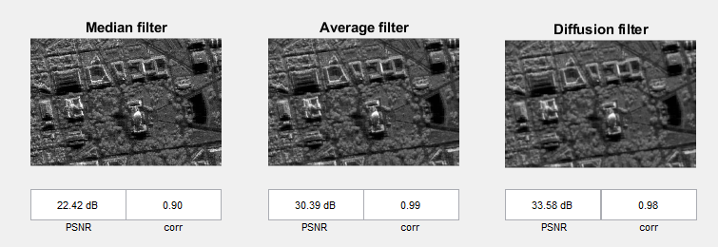

Fig2. Filtered images and PNSR, CORR values for Three filters.

The correlation value obtained at the end of the image processing is 0.987333 and the final PSNR obtained is 33.58dB. This shows that the obtained results are accurate and approximately perfect.

Next, we convert gray image into binary image by ‘sobel’ operator. The edge image by ‘sobel’ is one method to get the binary image from gray image.

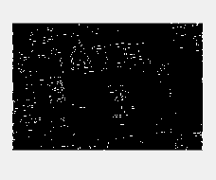

Fig3. Edge image by sobel operator.

With the given mask, we smooth image. The given mask matrix is the following:

msk=[0 0 0 0 0;

0 1 1 1 0;

0 1 1 1 0;

0 1 1 1 0;

0 0 0 0 0;];

Then, we remove some noise and small connected pixel group. The removed result is the following.

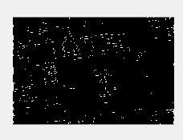

Fig4. Smoothed image

With special index, we can confirm the every connected component as the below.



Fig5. Connected component with index=34

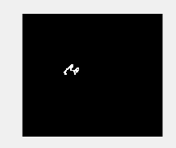

Fig6. Connected component with index=24

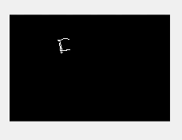

Fig7. Connected component with index=119

Finally, we show the labelled image with different color for each component. As shown, the background image is in a specific colors and the segmented objects in different colors depends on the density of each object.

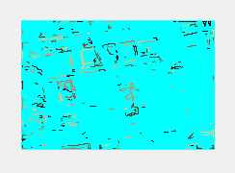

Fig8. Labelled Image with label colors.

## Python Results

First we load input image and convert it into gray image.

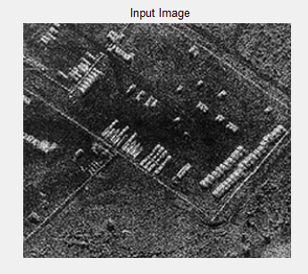

Fig9. Original image.

And then, we define the function which calculates PSNR. The formula to calculate the PSNR between two images is the following:

$$MSE=\frac{1}{mn}\sum_{i=0}^{m-1}{\sum_{j=0}^{n-1}{{\left[I\left(i,j\right)-K\left(i,j\right)\right]}^{2}}}$$

$$PSNR=10∙\log_{10}\left(\frac{MAX_{I}^{2}}{MSE}\right)=20∙\log_{10}\left(\frac{MAX_{I}}{\sqrt{MSE}}\right)$$

In Python, the function of PNSR is the following:

*def* psnr(*img1*, *img2*):  
 mse = numpy.mean( (*img1* - *img2*) ** 2 )  
 *if* mse == 0:  
 *return* 100  
 PIXEL_MAX = 1  
 *return* 20 * math.log10(PIXEL_MAX / math.sqrt(mse))

Next, we calculate the correlation coefficient between two images by python function “corr2”.

The function corr2 is the following.

*def* corr2(*a*,*b*):

AM = np.mean(*a*)

BM = np.mean(*b*)

c_vect = (*a* - AM) * (*b* - BM)

d_vect = (*a* - AM) ** 2

e_vect = (*b* - BM) ** 2

r_out = np.sum(c_vect) / float(np.sqrt(np.sum(d_vect) * np.sum(e_vect)))

*return* r_out

Next, we implement three filter algorithm. For every filter algorithm, we use the python standard function.

For each filtered image and its PNSR/corr2 values, we show the results in the below.

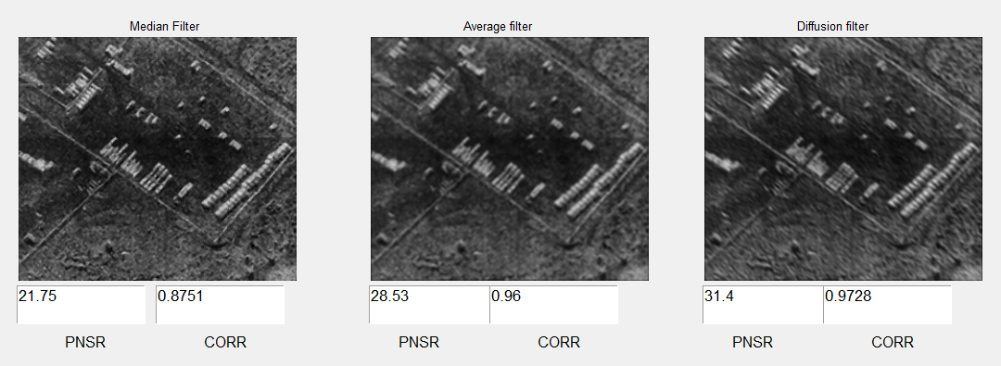

Fig10. Filtered images and PNSR, CORR values for three filters.

Next, we convert gray image into binary image by ‘sobel’ operator. The edge image by ‘sobel’ is one method to get the binary image from gray image.

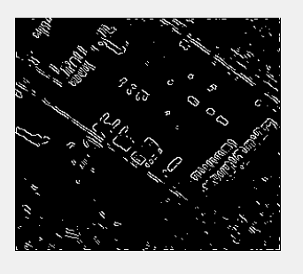

Fig11. Edge image by sobel operator.

With the given mask, we smooth image. The given mask matrix is the following:

msk = np.array([[0, 0, 0, 0, 0], [0, 1, 1, 1, 0], [0, 1, 1, 1, 0], [0, 1, 1, 1, 0], [0, 0, 0, 0, 0]])

Then, we remove some noise and small connected pixel group. The removed result is the following.

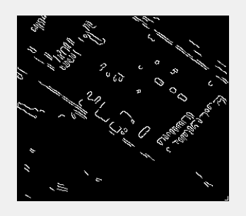

Fig12. Smoothed image

With special index, we can confirm the every connected component as the below.

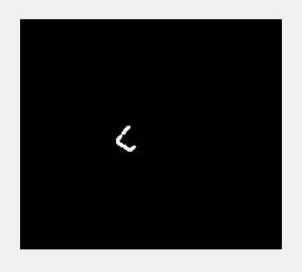

Fig13. Connected component with index=34

Finally, we show the labelled image with different color for each component.

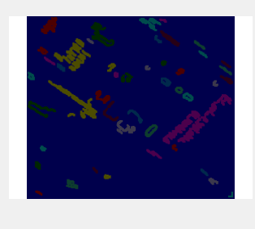

Fig14. Labelled Image with label colors.

# Conclusion

SAR images are widely used in different important applications; the speckle noise that appears as granules in the images degrades the fine details in the image. Researchers have put this issue into interest due to its importance and hence different algorithms were proposed in this field. Hybrid algorithm was proposed in this paper for the speckle noise removal. The implemented method of cascade filters algorithm consists of three main filters. The cascade consists of three filters median- average- diffusion. For the measurement of the accuracy of the implemented method, Peak Signal to Noise Ratio (PSNR) was measured after each processing step. PSNR was 22.4841dB after frequency domain analysis and 33.5dB at the end of the time domain analysis. This shows the strength of the implemented method since the normal value for the PSNR ranges between 30 dB and 35dB. Removing small areas were done both in MATLAB and Python and connected components were applied. Finally the segmentation to each index for the connected image were shown as well as the labeling section.

**References**

U. Soergel, S. Schulz, U. Thoennessen, and U. Stilla, “Integration of 3D Data in SAR Mission Planning and Image Interpretation in Urban Areas,” *Information Fusion*, Vol. 6, No. 4, Dec. 2005, pp. 301-310.

M. Gelautz, H. Frick, J. Raggam, J. Burgstaller, and F. Leberl, “SAR Image Simulation and Analysis of Alpine Terrain,” *ISPRS Journal of Photogrammetry and Remote Sensing*, Vol. 53, No. 1, Feb. 1998, pp. 17-38.

[3] Soergel, U., Schulz, S., Thoennessen, U. and Stilla, U. ‘Integration of 3D data in SAR

Mission planning and image interpretation in urban areas’. *Science Direct*, vol. 6, December

2005, pp. 301-310.

[4] Gelautz, M., Frick, H., Raggam, J., Burgstaller J. and Leberl, F. ‘SAR image simulation and

Analysis of alpine terrain’. *Elsevier Science,* vol. 53, February 1998, pp. 17-38.

[5] Gao, G., Zhao, L., Zhang, J., Zhou, D. and Huang, J. ‘A segmentation algorithm for SAR

Images based on the anisotropic heat diffusion equation’. *Science Direct*, vol. 41, October

2008, pp. 3035-3043.

[6] Chen, C., Ma, C. and Yao, Y. ‘Speckle reduction of polarimetric SAR image based on ICA-

SCS algorithm’. *IEEE*, vol. 1, December 2008, pp. 752-755.

[7] Maycock, J., Hennelly, B.M., McDonald, J.B., Frauel, Y., Castro, A., Javidi, B. and

Naughton, T. J. ‘Speckle reduction using the discrete Fourier filtering technique’. *IEEE*,

September 2007, pp. 201.

[8] Likun, WangShuang, HouBiao and JiaoLicheng. ‘An algorithm for SAR image embedded

Compression based on wavelet transform’. *IEEE*, vol. 1, July-August 2007, pp. 374-378.

[9] Bamler, R. ‘A SYSTEMATIC COMPARISON OF SAR FOCUSING ALGORITHMS’.

*IEEE*, vol. 2, June 1991, pp. 1005-1009.

[10] Koo, V. C., Lim, T. S. and Chuah, H. T. ‘A Comparison of Autofocus Algorithms for SAR

Imagery’. *PIERS Online*, Vol.1, August 2005, pp. 16-19.

[11] Lim, T. S., Koo, V. C., Ewe, H. T. and Chuah, H. T. ‘A SAR Autofocus Algorithm Based On

Particle Swarm Optimization’. *Progress In Electromagnetics Research B*, Vol. 1, 2008, pp.

159-176.

[12] Lim, T. S., Lim, C. S., Koo, V. C., Ewe, H. T. and Chuah, H. T. ‘Autofocus Algorithms

Performance Evaluations Using An Integrated SAR Product Simulator And Processor’.

*Progress In Electromagnetics Research B*, Vol. 3, 2008, pp. 315-329.

[13] Yingying, K. and Jianjiang, Z. ‘A New Method of SAR Image Reconstruction and

Segmentation’. *IEEE*, February 2009, pp. 249-253.

[14] Cheng, H. and Tian, J. ‘Speckle Reduction of Synthetic Aperture Radar Images Based on

Fuzzy Logic. *IEEE,* March 2009, pp. 933-937.

[15] Zhiyu, Z., Xiaodan, Z. and Jiulong, Z. ‘SAR Image Processing based on Fast Discrete

Curvelet Transform’. *IEEE,* May 2009, pp. 28-31.

[16] Zhang, w., Wong, A. and Clausi, D. A. ‘JEDI: Adaptive Stochastic Estimation for Joint

Enhancement and Despeckling of Images for SAR’. *IEEE*, May 2009, pp. 101-107.

[17] Agrawal, N. and Venugopalan, K. ‘SAR Image Compression using Wavelet Packets’. *IEEE*,

May 2009, pp. 343-347.

[18] Dingxue, W., and Wenping, F. ‘Combining ICA with LSSVM for Speckle Reduction of

SAR Image’. *IEEE*, July 2009, pp. 128-131.

[19] Wu, Y., Xiao, P., Zong, H., Wang, X. and Li, M. ‘Fusion Segmentation Algorithm for SAR

Images based on the Persistence and Clustering in the Contourlet Domain’. *IEEE*,

November 2009, pp. 402-406.

[20] K. Krissian, C.-F. Westin, R. Kikinis and K. Vosburgh, “Oriented Speckle Reducing Anisotropic Diffusion,” *IEEE Transactions on Image Processing*, Vol. 16, No. 5, May 2007, pp. 1412-1424.

[21] W. Hagg and M. Sties, “Efficient Speckle Filtering of SAR Images,” *IEEE Proceedings of International Geoscience and Remote Sensing Symposium*, 08-12 Aug. 1994, pp. 2140-2142.

[22] Zhao Chunhong, Liu Mingyu, Ji Hongbing, “A New Speckle Reduction Method of Medical Ultrasonic Image,” *IEEE Proceedings of International Conference on Bioinformatics and Biomedical Engineering*, Wuhan, China, 06-08 Jul 2007, pp. 1004-1006.

[23] J.M. Park, W.J. Song, W.A. Pearlman, “Speckle Filtering of SAR Images Based on Adaptive Windowing,” *IEEE Proceedings of Vision, Image and Signal Processing*, Vol. 146, No. 4, Aug. 1999, pp. 191-197.