Minjerribah and K’gari rainfall

Matt Harris

Kgari ENSO work

“Is there a different spatial origin of precipitation to K’gari and/or Minjerribah during ENSO events?”

Trajectories were run daily for 1950 - 2022 using HYSPLIT. Release height of 2000 m, duration 72 hr, NCEP/NCAR Reanalysis data. Reanalysis product should be appropriate given that we are specifically interested in large (>100 mm) rainfall events, which typically involve synoptic-scale weather systems, and thus 2.5 degree data should be sufficient to capture these. There is some fairly severe uncertainty in the NCEP/NCAR reanalysis prior to the late 1970s (erroneous inverted integration of SH pressure buoy data).

Rainall records from Sandy Cape and Point Lookout were used to filter the trajectories to those arriving at the sites on days where >100 mm of rainfall was recorded. Remaining trajectories were grouped into 5 clusters using an angle-based distance matrix based upon Sirois and Bottenheim (1995) through the openair package for R. Within-cluster frequencies were extracted and compared against the Nino3.4 index to determine possible spatial modulation by ENSO. A single outlier was removed from the Point Lookout trajectory dataset, with the trajectory associated with the rainfall event on 26/04/1956 consistently biasing the clustering calculations.

Frequencies were coerced to the annual scale to provide consistent

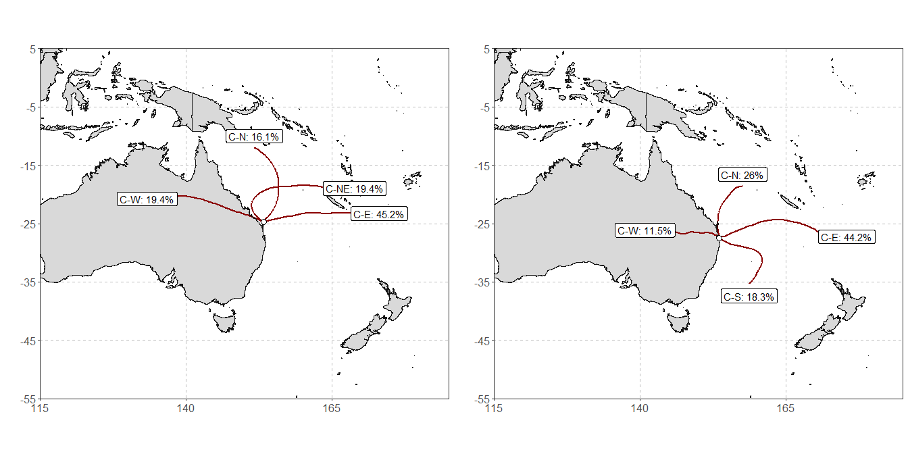

Fig 1. Trajectory clusters (n = 5) to Sandy Cape (left) and Point Lookout (right). Frequencies display the >100 mm within each cluster as a proportion of the total number at each site. Cluster names have no statistical significance and were designated to draw parity between each site where possible. Clusters are named based upon their approximate direction of travel. Note that this naming scheme (and any cluster designation method) is inherently and unavoidably reductive, and each cluster will be comprised of trajectories that, whilst similar spatially, will travel in different ways and from different directions. The clustering simply serves to reduce the dimensionality of the data in a meaningful way.

NINO3.4 time series

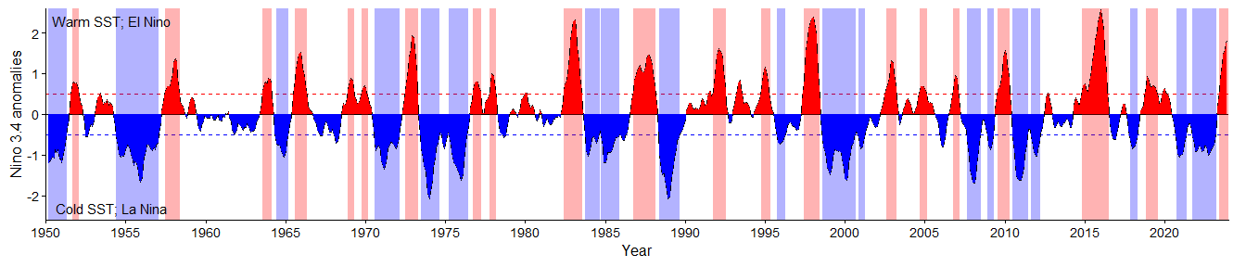

Rainfall time series

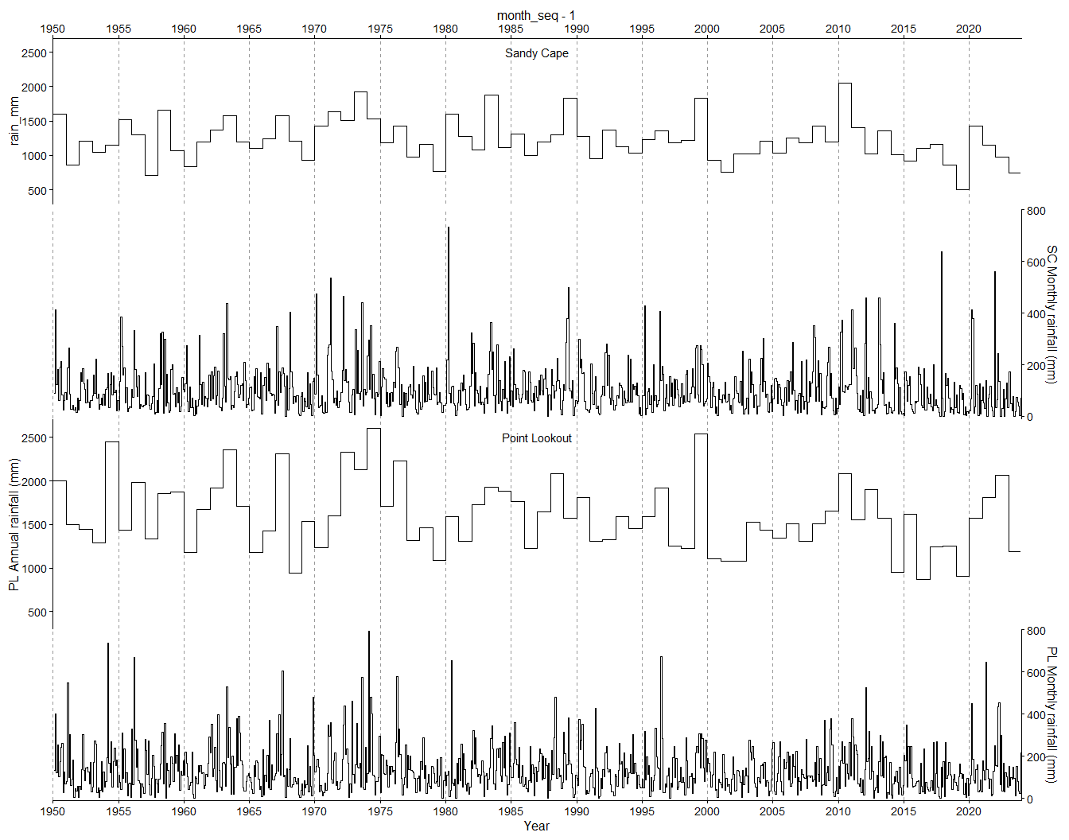

Cluster event time series (N/A for now)

Proportion (frequencies) overall

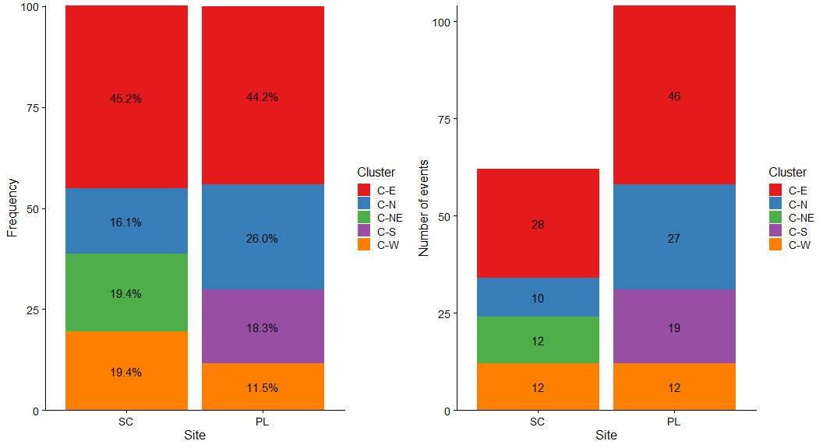

Fig. Proportions (frequencies) and quantities of large (>100 mm) rainfall events associated with trajectory clusters to Sandy Cape and Point Lookout, 1950-2022. Some similarities are immediately apparent - for instance, whilst Point Lookout received more large events during this period, both sites received an identical number of C-W events. Interestingly, none of these are on the same day! So, this

Rainfall proportions during different ENSO phases

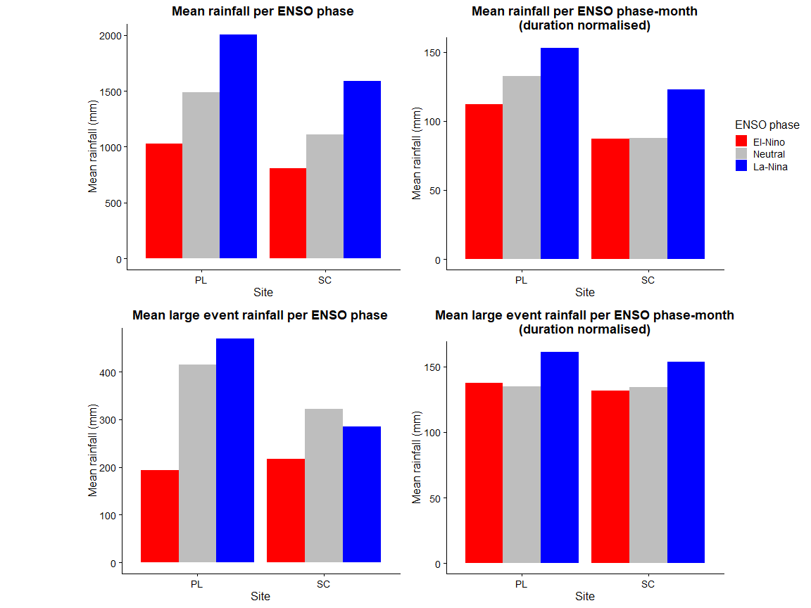

Proportion (frequencies) during different ENSO phases

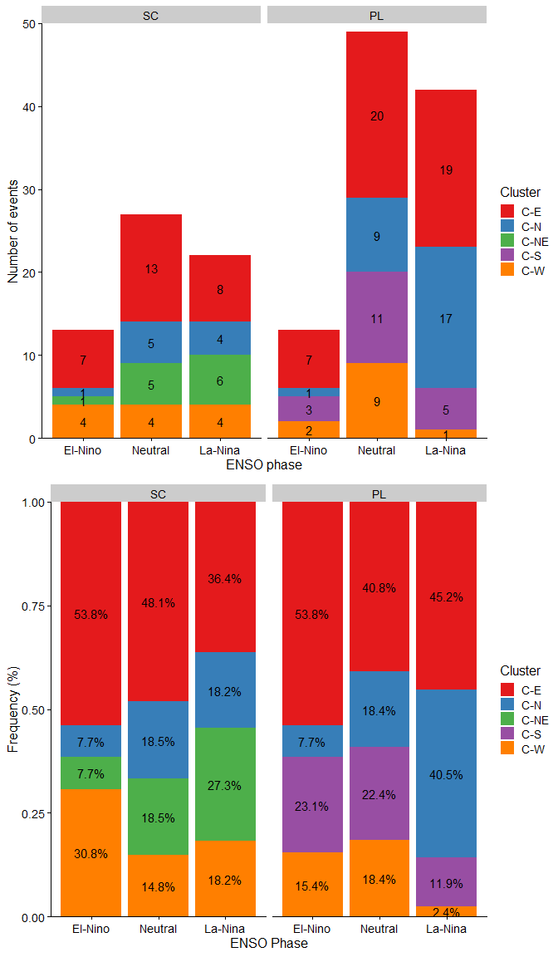

Fig. Proportions (frequencies) and quantities of large (>100 mm) rainfall events associated with trajectory clusters to Sandy Cape and Point Lookout, 1950-2022. Some similarities are immediately apparent - for instance, whilst Point Lookout received more large events during this period, both sites received an identical number of C-W events. Interestingly, none of these are on the same day! So, this

Rainfall correlations in different ENSO phases (with seasonal break down)