**Background**

* Rapid urbanization and urban growth are crucial global change issues affecting cities' physical dimensions, leading to unplanned urban sprawl, loss of green spaces, and reduced urban environment quality.
* Urbanization is closely related to the three dimensions of sustainable development: economic, societal, and environmental. Well-managed urbanization can maximize benefits while minimizing environmental degradation and adverse impacts.
* The linkages that cities and small towns establish with surrounding rural areas should be strengthened to facilitate sustainable development in both urban and rural areas by delivering services and infrastructure improvements and expanding opportunities for off-farm employment to rural dwellers.
* Rapid Urbanization in Rwanda: Urbanization in Rwanda has been increasing rapidly due to rural-urban migration, natural population growth, and government policies promoting urban development. The urban population has grown from 6.4% in 1991 to 17.3% in 2012, and is projected to reach 35% by 2032. This key point can be used to highlight the increasing trend of urbanization in Rwanda and the need to address the challenges associated with it.
* Impact of Urbanization on Environment and Natural Resources: The increasing population density and demands of urban environments exacerbate poor air and water quality, insufficient water availability, waste disposal issues, and high energy consumption. Topographic constraints also apply to urban areas located in valleys or basins. This key point can be used to highlight the impact of urbanization on the environment and natural resources and the need to promote sustainable urban development.

**Urbanization**

* Urbanization is the process of population concentration in small regions to build cities, and it has been a rapid feature of human history.
* Urbanization has been a consistent feature of human history, with a steady increase in the proportion of the population living in urban areas over time.
* Explanation: From the Neolithic Period to the present day, urbanization has been an ongoing process. Before the Classical antiquity, cities with a population of over 100,000 did not exist. However, with advancements in agriculture and transportation, small permanent settlements began to emerge. By the middle of the 20th century, about 25% of the world's population resided in cities with 20,000 or more inhabitants, and at the start of the 21st century, over half of the world's population lived in urban areas. This trend is expected to continue in the future.

**Problem statement**

* Urban expansion is a complex process influenced by various powerful elements, and forecasting urban growth patterns has become essential for sustainable development and ecological preservation. Machine learning techniques and models such as Cellular Automaton, CA-Markov, Logistic Regression, and Artificial Neural Network have been developed to anticipate land-use change and estimate urban expansion, which can inform urban planning and guide future land-use change plans.

**General Objective**

* The primary goal of this research is to identify the main driving forces behind Kigali's urban dynamics and to develop a predictive machine learning model that can forecast future urban growth and environmental features that may be affected in the targeted region.

**Specific Objectives**

The objectives of this study are to:

* To build a Machine learning model of urban growth in Kigali city and identify the relationship between environmental degradation and urban growth in Kigali city.
* To predict future urban growth patterns in Kigali city of land cover maps of Kigali city during the period 1990,2000,2010 and 2020.

**Significance**

* The research aims to predict future urban growth patterns in Kigali city and implement measures to protect the environment from potential impacts of urbanization

**Keywords Definition**

* CA-ANN- Cellular Automata-Artificial Neural Network
* EO- Earth Observation
* RSA- Rwanda Space Agency
* LULC- Land Use/Land Cover
* NISR- National Institute of Statistics of Rwanda
* TM- Thematic Mapper
* CA- Cellular Automata

**Scope**

* The integration of GIS, RS, and machine learning can be utilized to forecast urban growth by generating spatially consistent datasets, analyzing land cover status and patterns, and identifying primary drivers of city growth.
* Machine learning algorithms can be trained to learn spectral signatures of land features and assign each pixel to classes that best match the learned signatures, enabling the creation of urban growth probability maps that aid in predicting the city's future urban direction.

**Literature Review**

The chapter is dedicated to reviewing various research papers and studies on the use of machine learning and earth observation for urban growth prediction models, highlighting the gap in past studies that the current study aims to fill.

* Gharaibeh et al. utilized Artificial Intelligence (AI) models to simulate land-use change, specifically the Cellular Automata-Markov Chain (CAMC) and Artificial Neural Network (ANN) models, to increase the accuracy of future land-use change predictions.
* Anees et al.'s research on urban growth types provides a comprehensive understanding of the mechanisms affecting landscape alteration, classifying new urban patches into known growth types and emphasizing the significance of mapping and monitoring methods for future land-use planning.
* Liu et al. used the Markov model to predict and control changes in urban and non-urban regions threatening the existence of UNESCO world heritage sites worldwide, highlighting the integrated approach using remote sensing and GIS to assess environmental variables that affect global heritage sites.
* Mohammady et al. found that using GIS, remote sensing data, and artificial neural networks (ANN) together offers a powerful method for environmental modeling, such as simulating urban expansion, providing urban planners and decision-makers with the ability to assess how their decisions might impact urban dynamics.

**Gap in the past studies**

* Previous studies have shown limited use of artificial neural network (ANN) approaches in urban growth modeling.
* ANNs offer several advantages such as non-parametric modeling, quick generalization capabilities, and the ability to estimate nonlinear relationships.
* Logistic regression and random forest techniques are commonly used in urban growth modeling, but ANNs can improve the accuracy of the modeling process.
* Using ANN approaches can help policymakers and urban planners make more informed decisions regarding urban growth.
* Multispectral pictures captured using sensors that can detect multiple wavelengths or colors of light beyond what the human eye can see are used in various fields, including remote sensing, agriculture, geology, and environmental monitoring.

**Methodology & Implementation**

***Data and variable description***

* Rwanda Space Agency (RSA) provided Landsat imagery for the study due to their extensive archive and ability to conduct long-term research.
* Landsat 5 Thematic Mapper (TM) and Landsat 8 OLI/TIRS data were used to generate land-use and land-cover (LULC) maps for four different years and track changes over time.
* Photos were captured during the dry summer season to ensure clear images with no cloud shadows and were modified for atmospheric effects.
* Prior to image analysis, all sceneries were stacked and divided into subgroups based on the regions of interest.
* The study has a secondary research focus on the influence of urbanization on the environment in Kigali, and photographs from the same season were preferred for a more accurate comparison over time.
* Open Street Map (OSM) road network was used to determine the layer of "distance to the nearest road," which would be used later.

***Change detection***

The transition maps revealed the extent of changes that took place over the examined time periods in Kigali.

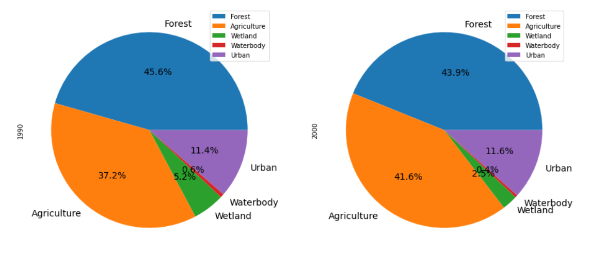

Figure 7: LULC Description 1990-2000

Figure 8 LULC Changes 1990 to 2000

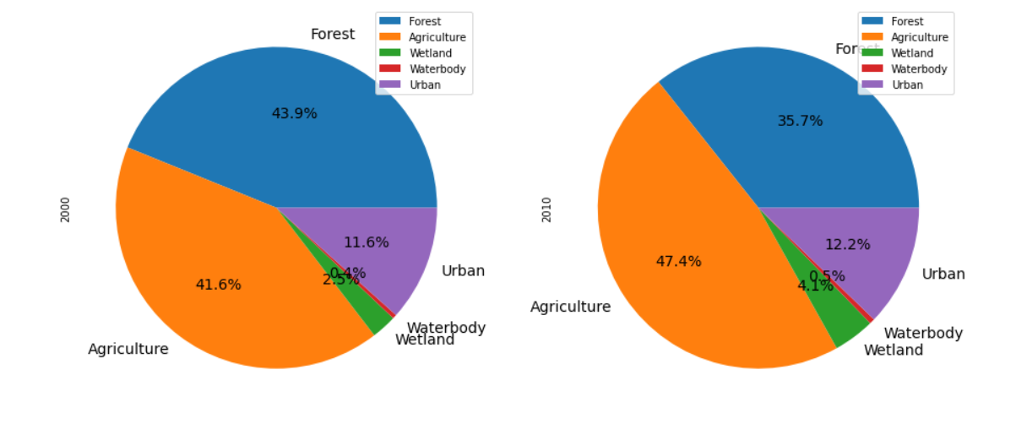

Figure 9:LULC Description of years 2000 and 2010

*Figure 10: LULC Changes from 2000 to 2010*

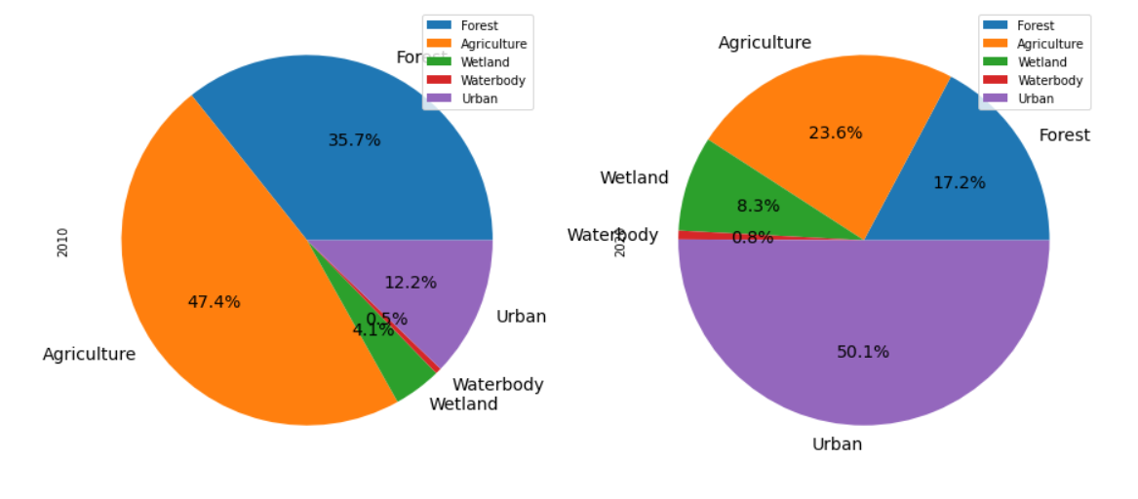

Figure 11:LULC description 2010-2020

Figure 12:LULC changes 2010-2020

## Future Projections

***Results and Discussion***

With the use of ANN and CA models we were able to generate prediction of the year 2030 by generalizing LULC from previous four decades from 1990 to 2020 and using CA as a great tool to construct a predicted feature to a raster map.

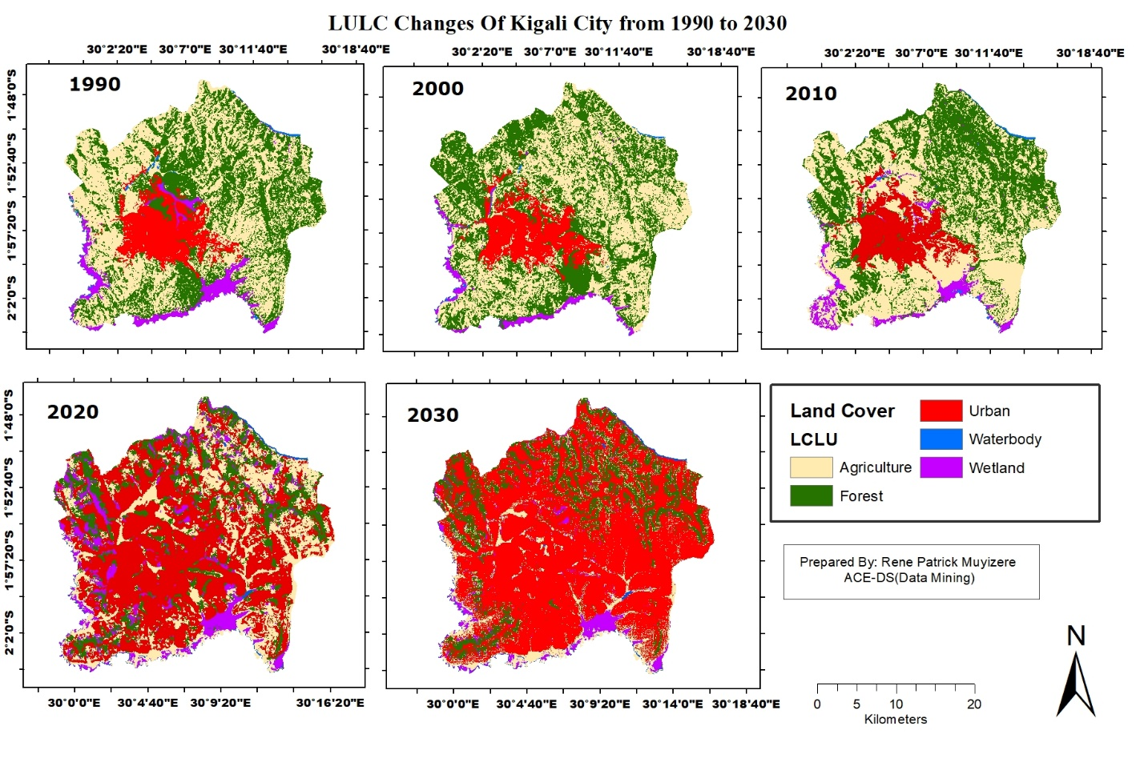

Figure 16: LULC Changes of Kigali from 1990 to 2030

The predicted 2030 LULC shows a significant change in landcover comparing to previous ten years period which is showing a drastic increase in Urban settlements with a widely reduction of agriculture areas and forest that are mostly concentrated in higher elevation of Kigali city toward to northern part and most wetlands seem to change into agricultural zones considering that most agricultural zones have transformed in urban built-up areas

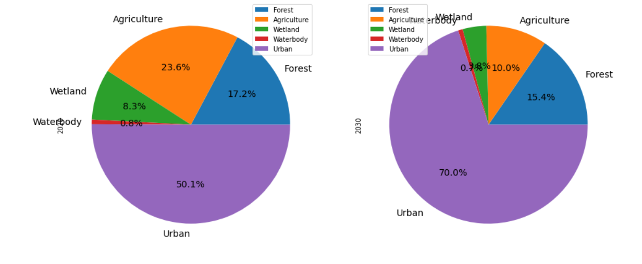

Figure 17: LULC 2020 to 2030

Figure 18:LULC changes 2020 to 2030

**LULC changes of different scenarios.**

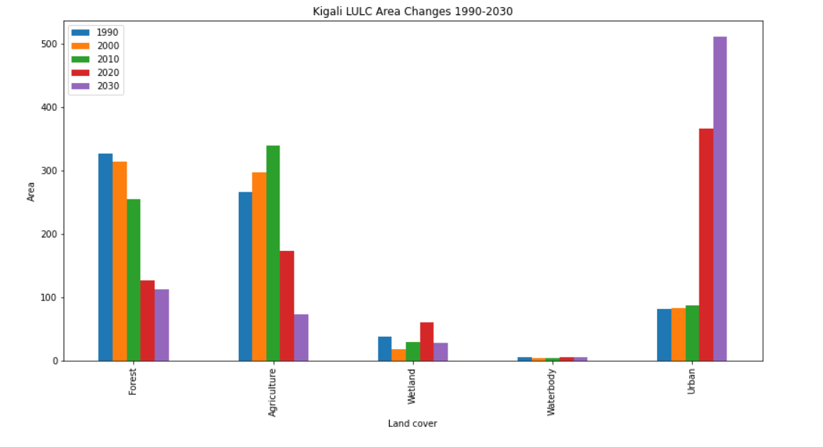

Figure 25:Kigali LULC changes 1990-2030

**Socioeconomic impact**

* Urbanization has had a significant impact on Kigali's GDP, with economic growth and development being fueled by increasing levels of investment.
* The expansion of Kigali's real estate market and growing tourism sector have contributed to the city's urban boom and job creation.
* The city's GDP has seen significant growth in recent decades, with an average annual growth rate of 7.7%, and services currently make up the largest share (45%) of the city's GDP.

**Infrastructures**

* Kigali's urban growth has significantly influenced the development of its resources and infrastructure.
* Investment has aided in the advancement of public services and infrastructure.
* The expansion of Kigali's transportation system is one of the primary ways urbanization has impacted resources and infrastructure.
* Considerable expenditures have been made in Kigali's transportation infrastructure over the past few decades, including the building of new highways, bridges, and public transportation systems.
* The growth of Kigali's housing and real estate sectors has been another significant driver of urbanization.
* Demand for homes, workplaces, and retail space has increased in tandem with population growth.
* Large expenditures in transportation, housing, and real estate infrastructure have improved the general quality of life for Kigali's citizens and fostered economic expansion.

**Nature Based Solution**

* Eco-tourism as a solution: Eco-tourism can be used as a nature-based solution to address environmental damage caused by urbanization in Kigali, Rwanda. It can help preserve natural areas and provide employment opportunities for locals while promoting sustainable tourism.
* Forest loss in Kigali: The forest landcover in Kigali has significantly reduced from 45.6% of the area in 1990 to around 15.4% in 2030. This highlights the urgent need for conservation efforts to protect the remaining forest areas and prevent further environmental damage.

**Conclusion**

* Artificial Neural Network (ANN) is a useful tool for identifying key factors influencing urban expansion and forecasting future growth patterns in a region.
* Kigali City's urban growth is expected to be considerably larger in the future than its current regions, which emphasizes the need for spatial policies to address horizontal growth and minimize its adverse effects.
* Steep slope locations in Kigali City are declared unsuitable for urban expansion due to the increased risk of landslides, erosion, and accessibility issues.
* The combination of GIS, earth observation data, and ANN as a computational method provides an effective method for environmental modeling such as urban growth modeling.
* The model outputs from this study will be used to validate the planned zoning in Kigali City, which will assist in determining where new infrastructure may be built to satisfy the needs of the people in the upcoming year.

1. Urban expansion in Kigali City: The study used an artificial neural network (ANN) to identify the key factors influencing urban expansion and predict how Kigali City will develop over the next 10 years. The findings showed that Kigali's future urban growth will be significantly larger than its current urban regions, resulting in an enlarged pattern.
2. Impact of spatial policies on urban growth: The study demonstrates the significance of spatial policies, such as zoning regulations, in addressing horizontal growth and minimizing its adverse effects on the adoption of a vertical urban growth pattern. The Kigali City Master Plan 2020 was cited as an example of such policies.
3. Factors influencing urban growth: The study found that low-slope areas, away from the central business district and wetlands, are more likely to see additional urban development. Similar studies in other cities have also reported proximity to urban areas, distance from major roads, and slope as primary factors influencing urban growth.
4. Environmental modeling: The study shows the effectiveness of combining geographic information systems (GIS), earth observation data, and ANN as a computational method for environmental modeling, such as urban growth modeling. This approach allows for the recognition of complicated and nonlinear patterns between data.
5. Use of model outputs: Despite some restrictions, the model outputs from this study can be used to validate planned zoning and assist in determining where new infrastructure may be built to satisfy the needs of the people in the upcoming year. This highlights the practical application of urban growth modeling in urban development planning.

**Recommendations**

* Sustainable urban planning strategies are essential for managing the city's growth, including zoning regulations, land use policies, and the establishment of green spaces.
* To reduce carbon emissions and traffic congestion, sustainable transportation options like cycling, walking, and public transportation should be promoted.
* Upgrading current informal settlements in the city can improve the quality of life for urban wetlands, and modern agriculture and beautification initiatives can increase agricultural output and the city's appeal.
* Local communities need to be involved in efforts to safeguard wetlands, forests, and waterbodies, and boosting scientific studies on biodiversity usage and management in urban settings can increase knowledge.
* Urban construction planners can reduce the overheating of cities by emphasizing more vertical construction and leaving enough area for waterbodies, wetlands, and forest conservation.

**Area of Further studies**

* Future research may be conducted to study the LULC changes in the other major cities of Rwanda.