Technical Design Document: PylypLyamov_ProgrammingExercise_5
Name: Pylyp Lyamov
Date created: October 25, 2026
Course: COP2373 - Programming Exercise 5

Program Description
This program breaks a paragraph into its individual sentences. The user types a paragraph, which may contain sentences that begin with numbers, such as "1. The rent went up." The program uses a regular expression to split the paragraph wherever one sentence ends and the next begins, then displays each sentence on its own line and reports how many sentences the paragraph contained. After that it runs a set of built-in tests that show the splitting is correct on known paragraphs.
The program is built from five functions. get_paragraph collects the paragraph from the user, split_into_sentences holds the regular expression and returns the list of sentences, display_sentences prints them with the count, run_sentence_tests checks the splitting against known paragraphs, and main ties the steps together.

How the paragraph is split
Splitting on every period would be wrong three times over. It would cut a numbered sentence such as "1. The rent went up" in half at the label, it would cut a decimal number such as 3.5 in half, and it would cut after an abbreviation such as Dr. The regular expression below is built from a series of lookarounds so that each of those periods is left alone. A lookaround tests the text around a position without consuming any of it, which is what lets the pattern look at the characters on both sides of a gap before deciding to split there.
Piece of the pattern | What it does
(?:(?<=[.!?])|(?<=[.!?][\"')\]])) | Only split just after a period, an exclamation point or a question mark, or after a closing quote or bracket that follows one. The lookbehind means the ending mark stays with its own sentence instead of being removed by the split.
(?<!^\d\.)(?<!^\d\d\.) | Do not split after a one or two digit number with a period at the very start of the paragraph, so "1. Alpha." stays whole.
(?<!\s\d\.)(?<!\s\d\d\.) | Do the same for a number that follows a space, which is how every later numbered sentence begins. Requiring the space is what keeps the "50." inside "$3.50." from being mistaken for a label.
(?<!\bMr\.)(?<!\bMs\.)(?<!\bDr\.) and so on | Do not split after a common abbreviation, because its period does not end a sentence.
\s+ | The gap between the sentences. This is the only part the split actually removes, so no text is lost.
A decimal in the middle of a sentence needs no rule of its own. The pattern only splits at whitespace, and a decimal such as 3.5 has no space after its period, so the split can never happen there. The one case the pattern cannot resolve is a sentence that genuinely ends in a short number, as in "I counted 12. Then I stopped." That period is impossible to tell apart from a label, and the program treats it as a label, which is the behavior this assignment asks for.

Function: split_into_sentences
Splits a paragraph into a list of its individual sentences.
Parameters:
paragraph (str): The paragraph entered by the user.
Variables:
pattern (str): The regular expression that describes the gap between the end of one sentence and the start of the next.
pieces (list of str): The parts returned by the split, before the blank ones are removed.
sentences (list of str): The finished sentences, trimmed of spaces.
Logic:
1. Build a pattern that splits on the whitespace following a period, an exclamation point or a question mark, allowing a closing quote or bracket to stay with the sentence it ends.
2. Refuse to split after a number that begins a sentence, such as the "1." in "1. The rent went up", because that period does not end a sentence.
3. Refuse to split after a common abbreviation such as Mr. or Dr.
4. Split the paragraph on that pattern.
5. Remove the spaces around each piece and drop any empty pieces.
6. Return the list of sentences.
Return:
list of str: Each sentence found in the paragraph, in order.

Function: get_paragraph
Asks the user to type a paragraph and returns it as a single string.
Parameters:
None
Variables:
lines (list of str): Every line the user has typed so far.
line (str): The most recent line typed by the user.
paragraph (str): All of the lines joined together with spaces.
Logic:
1. Explain how to enter the paragraph and how to finish.
2. Loop, reading one line at a time.
3. Stop when the user presses Enter on an empty line, but only after at least one line of text has been entered.
4. Join the lines with spaces so a sentence can run across two lines.
5. Return the paragraph.
Return:
str: The complete paragraph entered by the user.

Function: display_sentences
Displays each sentence on its own line and reports how many there are.
Parameters:
sentences (list of str): The sentences found in the paragraph.
Variables:
number (int): The position of the sentence being displayed.
sentence (str): The sentence being displayed.
word (str): The word "sentence" or "sentences", matched to the count.
Logic:
1. If the list is empty, say that no sentences were found and stop.
2. Loop through the sentences, displaying each one with its number.
3. Choose the singular or plural form of the word "sentence".
4. Display the total count.
Return:
None

Function: run_sentence_tests
Splits known paragraphs and reports whether each one produced the expected sentences.
Parameters:
None
Variables:
test_cases (list of tuple): Each test as the paragraph to split, the sentences expected from it and a short note explaining what the case checks.
passed (int): Accumulator counting the tests that produced the expected sentences.
paragraph (str): The paragraph being split by the current test.
expected (list of str): The sentences the split should produce.
note (str): What this case is checking.
actual (list of str): The sentences the split actually produced.
outcome (str): The word "PASS" or "FAIL" for the current test.
Logic:
1. Build the list of test cases, covering numbered sentences, decimals, abbreviations, quotes and missing punctuation.
2. Set the passed accumulator to zero.
3. Loop through the cases, splitting each paragraph.
4. Compare the result with the expected sentences and report it.
5. Add one to the accumulator for each test that passed.
6. Display how many of the tests passed.
Return:
None

Function: main
Asks the user for a paragraph, then displays its sentences and the count.
Parameters:
None
Variables:
paragraph (str): The paragraph entered by the user.
sentences (list of str): The sentences found in that paragraph.
Logic:
1. Display a title and an example of a numbered paragraph.
2. Ask the user for the paragraph.
3. Split the paragraph into sentences.
4. Display the sentences and the count.
Return:
None

Link to my COP2373 repository
https://github.com/MRPhillip007/COP2373

Output from testing the program
The paragraph entered below was typed on three lines and contains six sentences. Two of them begin with a number, one begins with the two-digit number 10, one contains the amount $1,250.75 and one contains the abbreviation Dr. together with the decimal 3.5. The program kept all of those periods intact and still found the six real sentence endings.
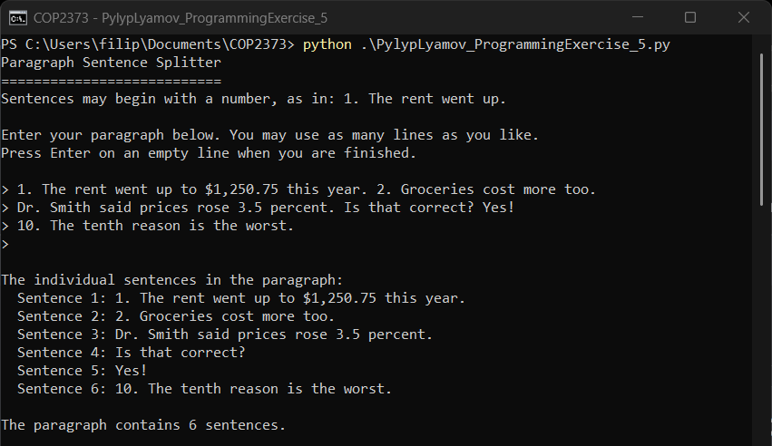

Output of the built-in tests
The same run continues with the built-in tests, which split ten known paragraphs and compare the result against the sentences each one should produce. The cases cover all three ending marks, sentences that begin with one and two digit numbers, decimals, abbreviations, a closing quotation mark, a paragraph with no ending punctuation and a paragraph padded with spaces. All ten produced the expected sentences.
