Debugging Exercise Report
Name: Pylyp Lyamov
Date created: September 6, 2026
Course: COP2373 - Debugging Exercise
Modified code: PylypLyamov_DebuggingExercise.py

1. The bug and how I identified it
Running the original Debugging_Exercise.py printed the Laptop and the Smartphone correctly and then stopped with a traceback. The program never reached the Headphones, so the failure happened on the third product, the Tablet.
Traceback (most recent call last):
File "Debugging_Exercise.py", line 36, in <module>
main()
File "Debugging_Exercise.py", line 26, in main
discount_amount = calculate_discount(price, discount_rate)
File "Debugging_Exercise.py", line 4, in calculate_discount
discount_amount = price * discount_rate
TypeError: can't multiply sequence by non-int of type 'float'
A traceback is read from the bottom up. The last line names the error, TypeError, and the frames above it show where it happened: line 4 of calculate_discount, which was called from line 26 of main. The wording is the useful part. Python calls a string a sequence, so "can't multiply sequence by non-int of type 'float'" means the left operand of the multiplication was text and the right operand was a float. In other words, price was a string rather than a number.
To confirm that rather than infer it from the message, I opened the file in PyCharm and ran it with Debug. PyCharm's Python debugger suspends the program when an exception reaches the top of the stack unhandled, so the session paused on the statement that raised it, line 4, with the program still alive and every value still inspectable. That is the step shown in the screenshots below. The editor highlighted line 4 and displayed the two operands inline as price: '500' and discount_rate: 0.2, and the Debug tool window confirmed both the call path and the types.
In that paused state price was a str holding '500', not the int 500. Every other product stored its price as a number, so only this one product failed. Tracing that value back to its source, the bug is in the product list itself, on line 18 of the original file:
{"name": "Tablet", "price": "500", "discount_rate": 0.2},
The quotation marks around 500 are the entire defect. calculate_discount and apply_discount were never wrong; they were handed a value they could not use. This matters for the fix, because correcting only the data would leave the program just as fragile the next time a price arrives as text.

Screenshot: the error in the PyCharm debugger
The debugger is paused on line 4, the statement that raises the TypeError, with the Debug tool window open at the bottom of the IDE.
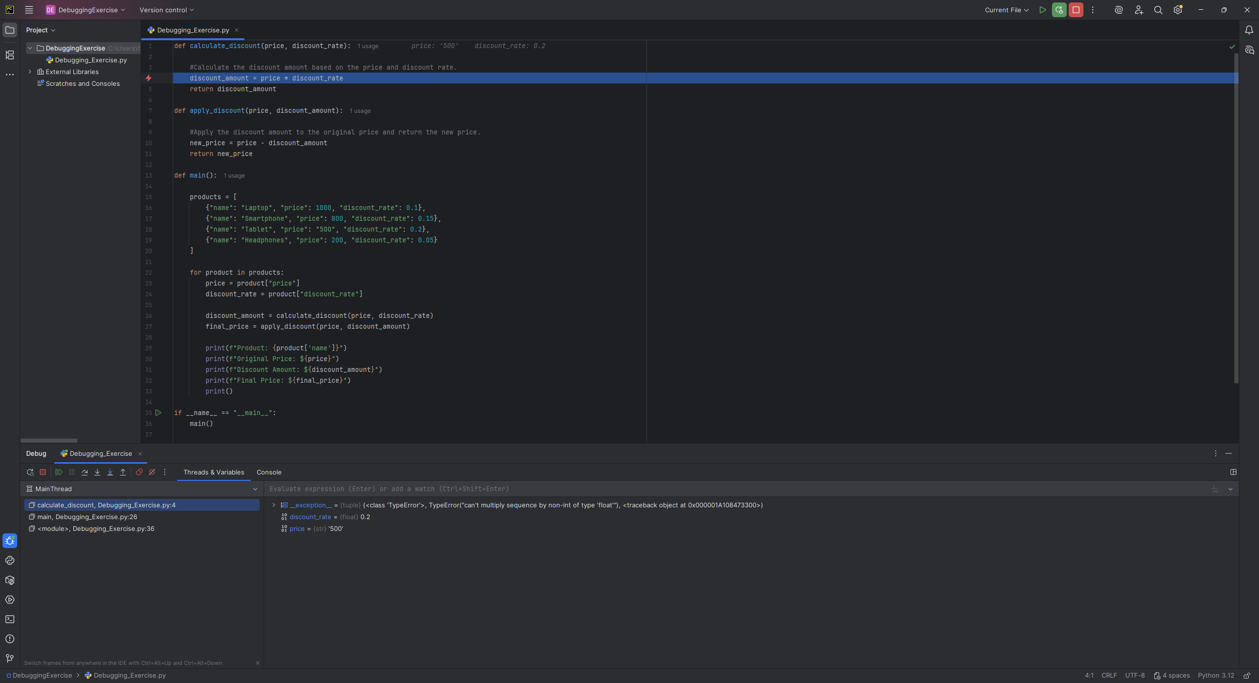
The two areas that identify the bug are small at full-window scale, so both are reproduced below at their original size.
The call stack, showing the same three frames the traceback listed:
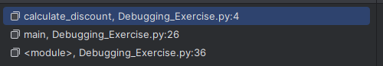
The Variables pane at that moment, naming the exception and the type of each operand:
price is a str holding '500' while discount_rate is a float, which is exactly the mismatch the error message describes. Every other product stores its price as a number, so the Tablet was the only one that failed.

2. The changes I made
I fixed the program so it accepts a numeric value written as text, and reports any value it genuinely cannot use instead of stopping. The product list is left exactly as it was given, including the Tablet's "500", so that the run itself demonstrates the fix working.
Change | Reason
Added to_number(value, field_name, product_name) | Converts a price or rate to a float inside a try/except. float() accepts 500, 500.0 and "500" alike, so the Tablet now works. A value that cannot convert raises ValueError carrying a message that names the field and shows the offending value.
to_number checks for None before converting | A missing dictionary key arrives as None. Reporting "the price is missing" tells the user what to fix, where "None is not a number" would not.
Added show_product_pricing(product) | Holds the try/except for one product. If the conversion fails it prints the message and returns, so the remaining products still print. This is the change that turns a crash into handled output.
Used product.get(...) instead of product[...] | A missing key returns None and flows into the same error message rather than raising a separate KeyError.
calculate_discount and apply_discount left unchanged | Neither function was defective. The debugger showed the bad value arrived from outside, so changing them would have hidden the real cause.
Prices printed with :.2f | The original printed $900.0 for money. Two decimal places read as currency.
Added test_error_handling() | Runs deliberately incorrect data through the same code path so the error handling can be seen working in the program's own output.
I chose try/except over checking the type with an if statement. An if would have to enumerate every wrong case, and isinstance(price, str) would still reject a perfectly good "500". Attempting the conversion and catching the failure covers text, None, missing keys and any other unusable type in one place, and it keeps the validation out of the two arithmetic functions.

3. How I tested it
I ran the modified program and checked every product, then fed it four deliberately broken products. Every case below is in test_error_handling() in the submitted file, so the results can be reproduced by running it.
Test data | Expected result | Actual result
The original four products, with "500" left as text | All four priced; Tablet at $500.00 | All four printed; Tablet $500.00, discount $100.00, final $400.00
price = "free" | Message naming the bad price, no crash | Cannot price Monitor: the price is 'free', which is not a number.
price = None | Message that the price is missing | Cannot price Keyboard: the price is missing.
discount_rate = "ten percent" | Message naming the bad rate | Cannot price Mouse: the discount rate is 'ten percent', which is not a number.
price key absent entirely | Message that the price is missing, no KeyError | Cannot price Webcam: the price is missing.
The program ran to completion in every case and exited with status code 0. No traceback appears anywhere in the output, and the four bad products were reported without preventing the good ones from printing.

Screenshot: output of the modified program
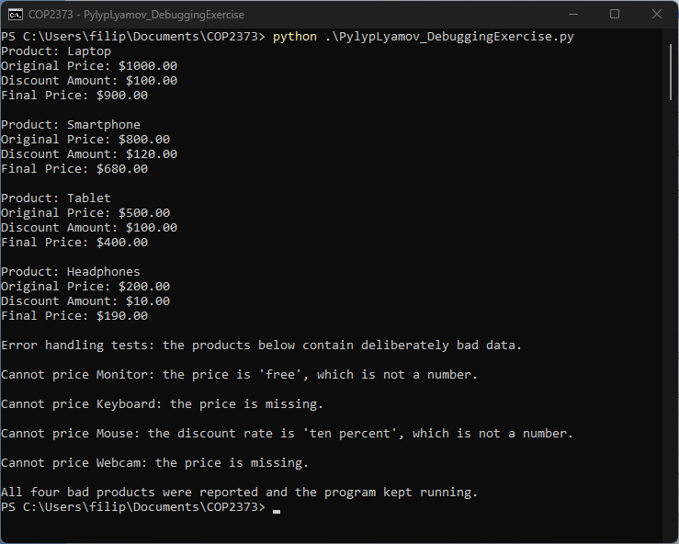

Repository
https://github.com/MRPhillip007/COP2373

