Output: PylypLyamov_ProgrammingExercise_7
Name: Pylyp Lyamov
Date created: November 8, 2026
Course: COP2373 - Programming Exercise 7 (BankAcct class)
Output of running PylypLyamov_ProgrammingExercise_7.py. The test function creates an account, which exercises __init__ and __str__, then calls deposit, withdraw, get_balance, set_interest_rate and calculate_interest with valid values and checks each answer. It then gives each method a value it must refuse and confirms the refusal message. All 11 checks passed, and the account is printed again at the end to show its final state.
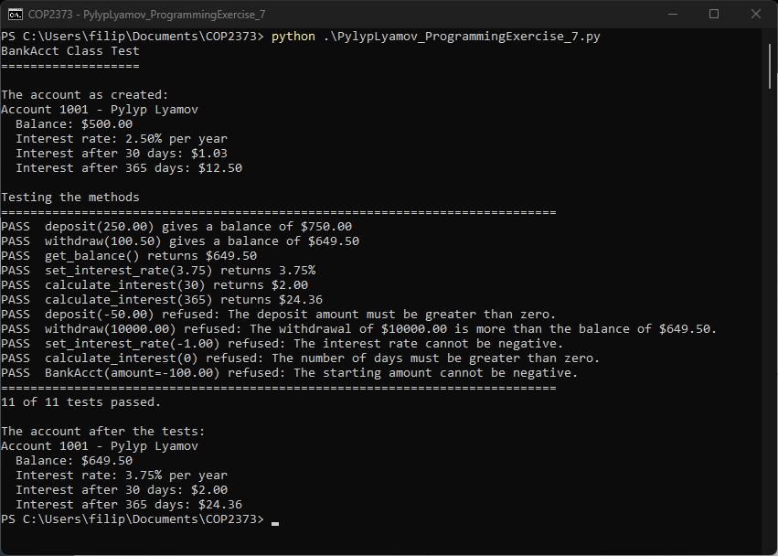
Link to my COP2373 repository
https://github.com/MRPhillip007/COP2373

